Valorization of reclaimed asphalt pavement (RAP) from the highway materials circularity

Abstract
The increasing demand for natural resources in highway construction presents significant environmental and economic challenges. A key issue is the disposal of reclaimed asphalt pavement (RAP), which is often discarded in landfills, despite its potential for reuse in new asphalt mixtures. Although several studies have investigated RAP incorporation, the influence of its particle size distribution on mechanical performance remains an underexplored area, creating a gap in understanding the material’s optimal reuse conditions. This study aims to evaluate the valorization of RAP in asphalt mixtures by characterizing its properties and analyzing the effects of partial aggregate replacement (0%, 25%, 50%, and 100%) on mechanical performance, considering both fine and coarse fractions. The methodology involved particle size distribution analysis, chemical and thermal characterization, and mechanical tests such as Marshall stability, flow, indirect tensile strength, and abrasion resistance. The results showed that increasing RAP content the need for new bituminous binder can be reduced, with a 50% RAP mixture requiring only 2.80% of new binder compared to 4.30% in the control sample. Marshall stability improved with RAP incorporation, reaching a maximum of 13312.63 N for a 50% RAP mixture with basaltic fines, while a 100% RAP mixture exhibited 11311.87 N stability. Indirect tensile strength also increased with RAP incorporation, reaching at 0.98MPa for the 50% RAP mixture with basalt fines. However, excessive RAP content led to higher deformation susceptibility, as evidenced by a 524 c.mm flow in the 100% RAP mixture. The findings indicate that RAP can be effectively incorporated into new asphalt layers, optimizing resource use and reducing environmental impact. The best balance between performance and sustainability was achieved at 50% RAP content, particularly when combined with basaltic fines. These insights contribute to advancing circular economy principles in road engineering, promoting more sustainable pavement solutions.

Keywords: Reclaimed asphalt paving. Waste valorization. Circular economy. Binder-aggregate interaction. Recycled aggregates.

Introduction
The demand for materials and natural resources for use in road construction is significant, as is the performance of these materials, since knowledge of their strength and durability are essential requirements [1]. However, the use of these resources generates environmental impacts, either through the use of large materials volumes or through their application in road pavements made from complex mixtures of bituminous binders and different mineral aggregates [2,3].
Considering the need to find sustainable ways to obtain alternative mineral resources, as well as the growing execution of road construction projects, the milled material reuse (reclaimed asphalt pavement - RAP), derived from deteriorated asphalt pavement surfaces, becomes an important strategy for reducing, reusing, recovering, and recycling materials and energy in order to meet the high demand for mineral resources from primary sources [4–7]. This waste valorization in the final activity of road reconstruction, used in new pavements, becomes a significant action to evaluate and improve engineering practices, encompassing a holistic view of the circular economy for road pavements [8,9].
Reclaimed Asphalt Pavement (RAP) is the material milled or removed during the maintenance or the asphalt pavements reconstruction, consisting of aggregates coated with aged bituminous binder [10]. This waste originates from processes such as milling of surface layers or deep removal, followed by crushing, screening, and controlled stockpiling. When properly processed, RAP provides high-quality aggregates with well-graded particle size distribution, ready to be reused in new asphalt mixtures [11].
From an engineering and sustainability perspective, the use of RAP offers two major advantages: the conservation of primary resources (aggregates and virgin binders) and the landfill disposal reduction , aligning with the circular economy principles [12,13]. In flexible pavement layers, RAP can partially replace coarse or fine aggregates (or both) and can also reduce the need for new binder by reusing the aged bitumen that coats the aggregate particles [14,15].
However, the performance of RAP in new mixtures depends on factors such as particle size control, the oxidation degree of the recycled binder, and the possible addition of rejuvenating agents to restore adequate viscoelastic properties. Therefore, it is essential to characterize the material in terms of composition, microstructure, and usage conditions to ensure that RAP provides strength, cohesion, and durability compatible with the engineering requirements of road paving [16].
Although the use of RAP has been widely studied in relation to the asphalt mixtures performance, the influence of RAP particle size distribution (gradation) on mechanical properties remains relatively underexplored. The gradation affects how the aged binder interacts with the virgin binder, the aggregate packing, and the void structure of the mixture, ultimately influencing flow, stability, and tensile strength. Finer RAP fractions tend to have a larger surface area, promoting more efficient binder reactivation and better interaction with the virgin binder, while coarser fractions may contribute more to the structural skeleton but less to binder blending [17,18].
Considering the current concerns of the market itself, as well as environmental and economic issues, the possibility of valorizing milled asphalt pavement waste in new coating layers emerges as a viable option to properly the waste dispose from the maintenance and restructuring process of pavements, which often end up in dumping sites [19–22].
Recent studies have deepened the understanding of the impact of using RAP and recycled materials on the mechanical asphalt mixtures performance, particularly regarding cracking resistance, permanent deformation (rutting) and moisture susceptibility. For instance, the cracking performance of asphalt mixtures containing RAP was investigated using different cracking indices, such as maximum load (P_{max}) and fracture energy until failure (FEUF), showing that the RAP incorporation can enhance cracking resistance, especially when combined with rejuvenating additives [23]. Other studies have evaluated the mechanical performance of asphalt mixtures containing an eco-friendly additive derived from recycled PET, observing significant improvements in resistance to permanent deformation and moisture, as well as increased low-temperature cracking resistance [24,25]. Furthermore, fracture assessments in modes I and II were conducted on green asphalt pavements containing plastic waste and RAP at low and intermediate temperatures, highlighting that the addition of plastic waste can improve cracking resistance in different fracture modes [26].
In this scenario, it is assumed that asphalt coating layers present variability due to different mixtures, materials, and weathering - more advanced in the upper layers - as well as wear, repairs, and other factors. Milled pavement waste is mainly composed of a stony aggregate, which provides strength and elastic behavior and is only slightly affected by time and external conditions. This aggregate is coated with a bituminous binder, responsible for deformation and viscoelastic behavior, which is significantly affected by aging. Through material characterization techniques, it is observed that the valorization of this waste is highly beneficial for its intended function [27–29].
A comprehensive assessment of milled asphalt pavement waste for reuse requires evaluating the conditions that enable its effective application, which depend closely on the material’s composition, microstructure, and inherent properties [30].
However, the use of RAP as recycled aggregate in new asphalt mixtures, either partially or entirely, which enables the savings of new bituminous materials, can directly affect the mixture performance due to the reactivation of the aged binder [31,32]. It is worth noting that the particle size of the milled material can play an important role in the effect of replacing these materials, as the aggregates in the milled material are agglomerated and coated with a film of the preexisting, aged bituminous binder, resulting in a particle distribution different from that observed when using natural aggregates after the reactivation of the original binder in the mixture. There is also the possibility that RAP may be incorporated into new mixes solely as a substitute for coarse aggregates, fine aggregates, or even as a simultaneous substitute for both groups, allowing for different approaches to the solution [33–36].
Although the literature presents a wide range of studies on the RAP reuse [37–40], applications in new asphalt coating layers rarely address the particle size influence of this waste on the reactivation of aged binder and mechanical performance. Given the heterogeneity of milled asphalt waste, analyzing the influence of different particle sizes through controlled substitutions, grouped by size ranges, and compared to reference mixtures with and without substitution, proves to be a valid option for studying the implications regarding the characteristics and properties of the materials used.
With a focus on valorization through the circular economy and considering that fractioning by particle size allows for better waste application control, this study aims to evaluate the response of milled waste in asphalt mixtures under different composition conditions. The particle size influence and substitution levels of the original aggregate, 0% (reference), 25%, 50%, and 100%, was assessed through three distinct substitution strategies: exclusive replacement of coarse aggregates, exclusive replacement of fine aggregates, and complete both fractions replacement. Additionally, the effect of fine aggregates from two mineral sources, granite and basalt, on the liquid-to-powder ratio of the asphalt mixture was also analyzed. The 25% substitution level was selected as a practical range commonly applied in industry, providing satisfactory results, while the 50% level was chosen to test the material under more ambitious conditions. The 0% and 100% groups served as reference and comparison points. Furthermore, the separation into coarse and fine aggregates reflects their functional roles: coarse aggregates provide the structural skeleton, while fine aggregates fill voids, promote interlocking, enhance cohesion, and increase interaction with the bituminous binder.
While many studies have examined RAP reuse, few have systematically analyzed the influence of RAP particle size distribution on the aged binder reactivation and the resulting mechanical performance of asphalt mixtures. By separating RAP into coarse and fine fractions, and evaluating their individual and combined effects at varying replacement levels, this study provides new insights into optimizing RAP incorporation for both structural performance and sustainability. Additionally, the performed research work highlights the importance of the fine aggregate type in modulating binder consumption and mechanical behavior, offering practical guidance for industry implementation within the framework of circular economy principles.

Materials and Methods
Fig. 1 presents a flowchart that summarizes the main stages of the experimental procedure to be applied in this study.

Step 2
Preparation and characterization of the best-performing mixtures, at the optimal content of new/complementary binder, for conducting additional physical tests.
Experimental procedure

Collection, sampling, and characterization of the materials

Statistical analysis of the results
Step 1
Proportioning and characterization of different mixtures to determine the optimal content of new/complementary binder

Fig. 1 - Flowchart summarizing the adopted experimental procedure.

Considering the coating layer composition of the flexible asphalt pavement, the associated dosage, and the research parameters, the following materials were required for the production of experimental test specimens: pavement milling waste - RAP, asphalt binder - CAP 50/70, coarse aggregate and fine aggregate - stone dust, in this case of granite and basaltic origin, to verify the variation of influence on the results.
The RAP was obtained from a surface section layer of the local road network undergoing maintenance. In this type of work, part of the thickness of the wearing course was removed with the help of a mechanical milling machine, and the waste was sent to dumping areas. The study region is located in the extreme south of Santa Catarina, Brazil. During the visit to the waste pile, as shown in Fig. 2, it was possible to observe that there is a significant range of RAP grain size, and that the larger particles tend to settle at the base, while finer particles tend to appear more superficially, at the top. The collection process followed solid waste sampling procedures, taking samples from three sections (top, middle, and base of the waste pile) using four equidistant aliquots with the aid of a manual scoop.

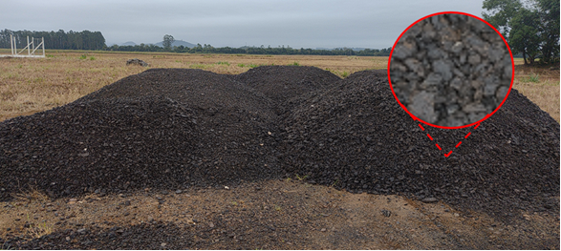
Fig. 2 - Record of the waste collection point (aspect of the study sample revealed in detail).

The stone materials for the production of test specimens consisted of natural rocks organized into fractions to comply with the grading curve. As for the stone dust, used as the fine aggregate in the mixtures, alternatives with basaltic and granite origins were considered, along with variations of incorporated RAP.
In order to eliminate residual moisture, all the stone materials were placed in a laboratory drying chamber (110 ± 10 °C) until they reached constant mass, except for the milled material waste, which was dried at room temperature to avoid altering the aged binder fraction, as this portion would be affected by the oven temperature before the actual characterization.
The supply of asphalt binder, CAP 50/70, was provided by a local asphalt plant. The sampling was carried out directly from the storage tank. A metal container with a volume of 18 l, equipped with a lid to prevent contamination and loss of the material properties, was used for the process.
All solid materials were sampled through the homogenization process and reduced by quartering according to technical standards [41].
The milled asphalt waste characterization was initiated with a granulometry test by sieving, aimed at analyzing the particle size distribution of the granular material. Considering the interaction between the aged binder and the aggregate, as well as the phases heterogeneity, the test was conducted in two stages. First, the RAP granulometry in its field state was determined, that is, the agglomerated aggregate coated with bituminous asphalt, where this raw condition is referred to as the black curve. Subsequently, using the same sample set, a new granulometry test was performed after extracting all the preexisting binder from the mixture, allowing for the verification of the unique natural aggregates’ distribution. This condition is referred to as the white curve, serving as a reference for aggregates free from the presence of any binder.
The ISO [42] series sieves with mesh sizes of 1" (25.4 mm), 3/4" (19.0 mm), 1/2" (12.7 mm), 3/8” (9.51 mm), 1/4" (6.35 mm), 4 (4.76 mm), 8 (2.38 mm), 16 (1.19 mm), 30 (0.595 mm), 50 (0.297 mm), 100 (0.149 mm), and 200 (0.074 mm) were used.
In order to determine the quantity and percentage of aged bituminous binder present in the milled asphalt waste, the RAP sample was subjected, after heating at 150 °C for 1 hour, to the Rotarex Atherectomy System, according to technical standards [43]. This equipment functions as an extractor through centrifugation. Even after heating the binder, there was little phase mobilization, which is why it was necessary to dissolve it using perchloroethylene reagent (tetrachloroethylene, Cl₂C=CCl₂).
The binder extracted in the test could not be analyzed rheologically, as its properties were compromised by the extraction process using solvents during the bitumen content determination.
The chemical analysis was performed using X-ray fluorescence spectrometry on an Epsilon 3^{XLE} Panalytical spectrometer with a fused pellet. The ADT/TG analysis was carried out in a nitrogen atmosphere, within the temperature range of 35 °C to 1000 °C, on a simultaneous analyzer (Netzsch 409 Jupiter F3). The crystalline phases were determined by X-ray diffraction on a Siemens X-ray diffractometer, model D-5000, equipped with a fixed anode Cu tube (λ = 1.5406 Å), operating at 40 kV and 30 mA, between 3-70° 2θ with a step size of 0.05°/1s, using divergence and anti-scatter slits of 1° and 0.6 mm in the detector. The quantitative analysis of the minerals was evaluated using Rietveld refinement [44].
The natural aggregates, compositional materials for preparing test specimens required for the physical results analysis, were primarily characterized through physical indices and the particle size distribution curve, in order to provide the mix design in terms of granulometric curve. For the test, the materials were pre-dried in an oven for 24 hours or until a constant mass was achieved. The procedure used sieves from the ISO [42] series with mesh sizes of 3/4" (19.0 mm), 1/2" (12.7 mm), 3/8” (9.51 mm), 4 (4.76 mm), 10 (2.00 mm), 40 (0.42 mm), 80 (0.177 mm), and 200 (0.074 mm). The agitation was performed manually to allow for inspection of the sieving process, followed by subsequent weighing of the material retained in each granulometric range.
The asphalt binder (PAC - petroleum asphalt cement) used in the study was primarily characterized by penetration (test method based on ASTM D5/D5M [45]), softening point (test method based on ASTM D36/D36M [46]), and rheology in terms of viscosity (ASTM E102/E102M [47]) using a Saybolt Furol viscosimeter at temperatures of 135 °C, 155 °C, and 175 °C. This approach allowed for proper characterization within the likely temperature range for milling and compaction, through an index measurement.
Experimentally, 13 dosage groups were defined, as shown in Table 1. For some of these groups, RAP was incorporated only into the fine aggregate fraction, for others into the coarse aggregate fraction, and for the remaining groups, into both fractions. Additionally, the influence of the natural fine aggregate type was considered: when sourced from granite and basalt rock. For each group, 6 experimental test specimens were prepared in the laboratory, with 2 test specimens for each variation of complementary binder (lower, intermediate, and upper levels). The goal was to determine the ideal content of new (or complementary) binder in the mixture for each group (or alternative), as heating causes part of the aged binder from the RAP to be functionally reactivated.
Thus, it was possible to evaluate the properties and results of the dosage considering the RAP variation in the mixtures and in the valorization fraction: when separated exclusively into the fine aggregate fraction, exclusively into the coarse aggregate fraction, and into both sizes simultaneously. Some dosage groups were defined as control or reference groups, where the results were compared with those of other substitutions to assess the variations obtained in the procedure.

Table 1 - Dosage groups matrix summarizing the characteristics (variation in the RAP percentage, and origin of the stone powder used as natural fine aggregate).
Dosage |  | RAP application content in the mix by aggregate range (%) |  | Fine aggregate (stone powder) used in the mixture |  | Description
Groups | Identification | Coarse aggregate | Fine aggregate | Granite | Basalt | Description
01 | 0% GR | 0% | 0% | ✓ | ✗ | Control group. Test specimens dosed with new materials, without the valorisation of milled asphalt pavement waste. Use of granite-originated stone dust.
02 | 0% BA | 0% | 0% | ✗ | ✓ | Control group. Test specimens dosed with new materials, without the valorisation of milled asphalt pavement waste. Use of basalt-originated stone dust.
03 | 25% GR | 25% | 25% | ✓ | ✗ | Group with the use of 25% of aggregates as milled asphalt pavement waste. Use of granite-originated stone dust.
04 | 25% BA | 25% | 25% | ✗ | ✓ | Group with the use of 25% of aggregates as milled asphalt pavement waste. Use of basalt-originated stone dust.
05 | 25% GR  C | 25% | 0% | ✓ | ✗ | Group with the replacement of 25% of coarse aggregates as milled asphalt pavement waste. Use of granite-originated stone dust.
06 | 25% GR  F | 0% | 25% | ✓ | ✗ | Group with the replacement of 25% of fine aggregates as milled asphalt pavement waste. Use of granite-originated stone dust.
07 | 50% GR | 50% | 50% | ✓ | ✗ | Group with the use of 50% of aggregates as milled asphalt pavement waste. Use of granite-originated stone dust.
08 | 50% BA | 50% | 50% | ✗ | ✓ | Group with the use of 50% of aggregates as milled asphalt pavement waste. Use of basalt-originated stone dust.
09 | 50% GR  C | 50% | 0% | ✓ | ✗ | Group with the replacement of 50% of coarse aggregates as milled asphalt pavement waste. Use of granite-originated stone dust.
10 | 50% GR  F | 0% | 50% | ✓ | ✗ | Group with the replacement of 50% of fine aggregates as milled asphalt pavement waste. Use of granite-originated stone dust.
11 | 100% | 100% | 100% | ✗ | ✗ | Group with the use of 100% of aggregates as milled asphalt pavement waste.
12 | 100%  C | 100% | 0% | ✓ | ✗ | Group with the replacement of 100% of coarse aggregates as milled asphalt pavement waste. Use of granite-originated stone dust.
13 | 100%  F | 0% | 100% | ✗ | ✗ | Group with the replacement of 100% of fine aggregates as milled asphalt pavement waste.

For each group, considering the aggregate particle size distribution curve, it was necessary to determine the optimum content of new binder (or complementary to the pre-existing binder in the RAP). For each alternative, three variations of new binder content were considered: a lower factor (~ 3% by mass), a medium factor (~ 5%), and a higher factor (~ 7%). The new binder proportions were adjusted for each group according to the expected reactivation of the pre-existing binders. In cases where milled asphalt was available in the mixture, it was assumed that 80% of the aged binder could be reactivated based on the literature, and the total estimated new binder content was subtracted from the total binder content in the mix.
For each variation, two test specimens were prepared to obtain the physical characterization indices and determine the stability-flow relationship using the Marshall method, which provides the parameters for determining the optimum binder content in the mixtures. This determination was particularly relevant since part of the aged binder in mixtures containing milled asphalt tends to be reactivated.
Based on the formulations described for each group and binder content, the aggregates and RAP were separated and weighed according to the appropriate granulometries to ensure that the test specimens produced for each mixture would be representative of the materials used. The test specimens preparation was based on the ASTM D6926-20 standard [48] using the Marshall compactor. After weighing and materials separating, they were placed in a container and subjected to a drying chamber at a temperature 10°C higher than the binder's mixing temperature.
Once temperature equilibrium was reached, the aggregates were mixed with the heated binder in the required quantity and homogenized for approximately 60 seconds. The materials were dosed for a test specimen of approximately 1.2 kg (Fig. 3). Afterward, using 100 mm diameter molds also heated in the oven and paper filters at the base and top (to prevent adhesion of the specimen to the mold), the mixture was subjected to Marshall mechanical compaction, with 75 blows per face using a 4.540 ± 1 g hammer falling freely from a height of 457.2 ± 1.5 mm.

(a) (b)
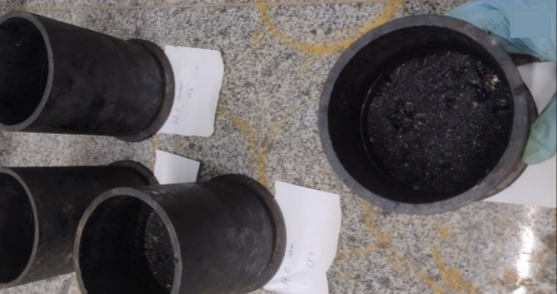 | 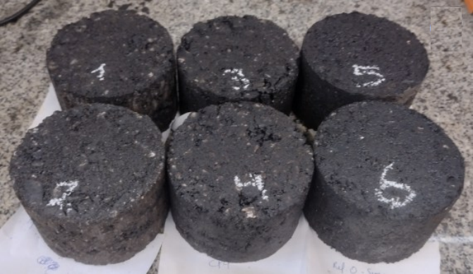
Fig. 3 - Specimens (a) in the mold after Marshall hammer compaction, and (b) after demolding using a mechanical extractor.

After compaction, the specimens were kept in the mold for 24 hours to cool and prevent damage. Demolding was done using a mechanical specimen extractor, requiring the outer walls of the mold to be slightly heated to ensure proper removal.
After demolding, the test specimens’ dimensions were measured with a caliper: diameter and height, and the average of the four diametrically opposite measurements was taken. The dry mass, submerged mass, and saturated surface-dry mass were also recorded for the necessary volumetric calculations.
The stability (maximum radial compression resistance presented by the specimen previously heated in a 60°C water bath for 30 min) and flow (total deformation of the specimen from zero load to maximum load) were determined based on ASTM D6927-15 standard [49], with the stability value corrected according to the specimen height.
Based on the obtained results, the optimum binder content for each mix design was determined to achieve a void volume close to 4% while simultaneously meeting other normative parameters. For specific mixes, tensile strength by diametral compression (based on ASTM D4867 standard [50]) and abrasion wear tests (based on ASTM D7064 standard [51]) were conducted at the experimentally defined optimum binder content.
After conducting the tests, the collected data were statistically processed with the help of Statistica Software, in relation to the analysis of variance (ANOVA). Based on the replicas availability and the freedom degrees, a linear model was adopted, considering the mixture in three elements: percentage of milled material, percentage of new/complementary binder, and other aggregates in the composition. The results were grouped among those mixtures that used granite-origin stone powder and those that used basalt-origin stone powder for the fine aggregate portion of the mix.

Results and Discussion
The graph in Fig. 4 presents the particle size distribution results obtained from the sieve analysis conducted. The black curve (without binder) represents the particle size distribution in the raw condition, characterized by the presence of aggregate and pre-existing aged binder. After the extraction of bitumen, the distribution curve changes, as shown by the blue curve (with binder). The shaded area illustrates the variation in the granulometric distribution spectrum resulting from the agglomeration of RAP.

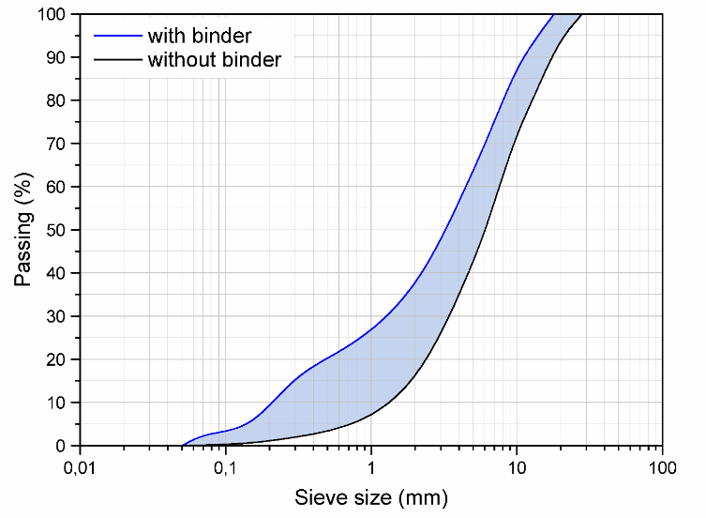
Fig. 4 - Granulometric distribution of milled asphalt waste.

It is observed that there is a higher presence of binder in the finer particle size ranges, due to the greater available surface area in the volume of smaller aggregate particles. It is easily identifiable that, after the extraction of the pre-existing bitumen, there was a significant change in the aggregate gradation. The shaded area represents the variation in particle size caused by the binder’s action and its associated agglomerations.
For the collected residue, the curve exhibits a fineness modulus of 1.13, while after bitumen extraction, this value increases to 1.98, indicating a more uniform distribution. This suggests that the binder in the milled material plays a greater role in agglomerating the smaller particles, and this property should be considered in mix design. The uniformity coefficient in the raw state is 5.06, while after binder extraction, the curve changes to 20.45. For the RAP collected, the characteristic maximum aggregate diameter was identified as 12.70 mm (19.10 mm when considering the agglomeration effect of particles with the presence of binder).
The effective diameter (or maximum diameter) refers to the diameter at which 95% of the material passes by mass. The uniformity coefficient is defined as the ratio between the diameter at which 60% of the material passes and the diameter at which only 10% passes. Values below 5 are considered uniform, 5 to 15 moderately uniform, and above 15 as non-uniform in terms of distribution. The curvature coefficient measures the gradation based on the diameters at which 30%, 60%, and 10% of the material passes. Values between 1 and 3 indicate good gradation, while higher values indicate poor gradation, with a more open curve [52].
Regarding the percentage of pre-existing aged bitumen in the samples, it was identified that the binder content is 5.49%. Concerning physical indices, the residue unit mass was determined to be 1.30 g/cm³, while the specific gravity was 2.53 g/cm³.
As for the shape index, the collected milled asphalt residue showed a coefficient of 2.163, placing it between cubic and flaky shapes, with a texture that exhibits some roughness. After the aged binder removal, the index decreased to 1.888, highlighting the effect of particle agglomeration and, in part, the formation of a flaky structure in the residue resulting from the milling process.
Table 2 presents the chemical characterization results of the samples performed through X-ray Fluorescence (XRF). It is evident that more than 55% of the residue is composed of silica and aluminum, originating from the aggregate in the mixture. Additionally, approximately 20% of the sample experienced a loss on ignition (LOI), attributed to organic compounds, including the bituminous binder itself, as also identified through thermal analysis.

Table 2 - Chemical analysis obtained by XRF of the studied RAP.
Oxides (%) | SiO₂ | Al₂O₃ | K₂O | Na₂O | Fe₂O₃ | TiO₂ | CaO | MgO | Mn₂O₃ | P₂O₅ | SO₃ | LOI
RAP | 46.43 | 9.56 | 1.54 | 1.54 | 9.20 | 1.17 | 7.04 | 2.96 | 0.15 | 0.16 | 0.85 | 19.4

Regarding the X-ray Diffraction (XRD) characterization results, the diffractograms presented in Fig. 5 show the obtained characterization, supporting the findings from the X-ray Fluorescence (XRF) analysis. It is observed that the sample contains approximately 42.2% Quartz (SiO₂), 45.8% Plagioclase (feldspar group), 5.4% Dolomite (CaMg(CO₃)₂), 6.3% Pyroxene (silicate group), and 0.3% Smectite (clay mineral group), in addition to amorphous phases that were excluded from the semi-quantitative method conducted by the laboratory.

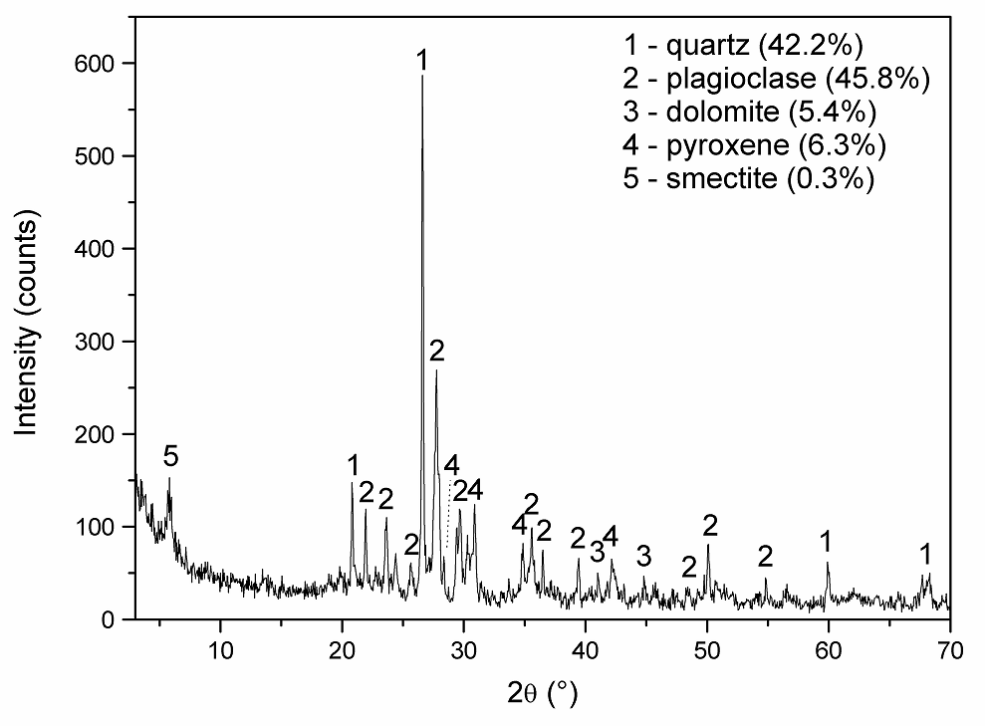
Fig. 5 - Mineralogical analysis obtained by XRD of the studied RAP.

Regarding the thermal characterization, as shown in Fig. 6, a significant mass loss is observed between 300 and 525 °C, which is attenuated up to 725 °C, at which point a mass loss of approximately 18.93% is recorded. This, in conjunction with the exothermic event observed in the Thermogravimetric Differential Analysis (TGA) at 525 °C, indicates the decomposition and loss of volatile and organic materials (such as a portion of the pre-existing binder, for instance). The variation in the curve, marked by two distinct mass loss events, suggests the possible presence of two different minerals in the waste composition.

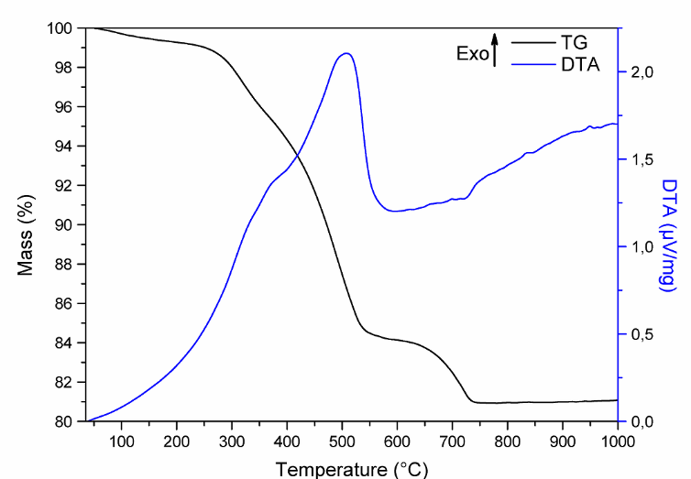
Fig. 6 - Differential Thermal and Thermogravimetric Analysis of RAP.

Regarding the physical characterization results of the other mineral aggregates, a variation in the specific gravity of certain materials is observed due to the different sources of origin, with higher values for basaltic aggregates compared to granitic ones. Additionally, the high-water absorption of granite powder material is noted, which is one of the explanations for the increased consumption of asphalt binder in mixtures that incorporated this powder in their design. The higher absorption is attributed to both the larger surface area and the greater volume of open pores in the material particles.
Water absorption refers to the increase in the mass of aggregates due to the filling of permeable pores with water, which is more pronounced in aggregates with smaller dimensions due to the larger exposed surface area and open porosity. Regarding the difference in densities, the dry condition specific gravity reflects the ratio between the mass of the dry aggregate and its volume, including both permeable and impermeable pores, but excluding voids between particles. The specific gravity in the saturated surface dry condition, in turn, reveals the same ratio, but in relation to the saturated surface dry condition, where the permeable pores are filled with water, without any free surface moisture.
As for the rheological aspects of the new binder used in the mixtures, the Saybolt Furol viscosity results are systematically presented in the graph of Fig. 7. According to the experimental results, the Saybolt Furol viscosity (SSF - Saybolt Furol seconds) at 135 °C is 115 SSF, at 155 °C it is 50 SSF, and at 175 °C it is 44 SSF. Based on the collected points average, a regression curve was used to determine the optimal working ranges for both molding and compaction of the sample specimens. In the graph, the red dashed line indicates the processing limits, while the blue dashed line represents the compaction limits.

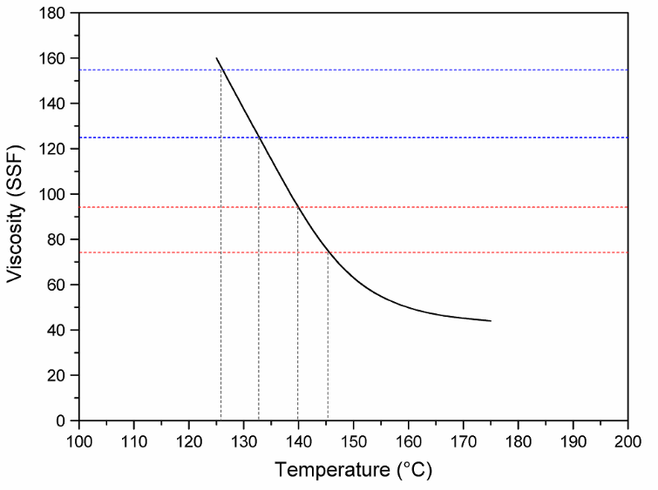
Fig. 7 - Saybolt Furol viscosity curve as a function of the temperature of the new asphalt binder used as a complement to the asphalt mixture for the specimen dosage.

As highlighted, based on the plotted curve, it can be inferred that the ideal temperatures for processing, i.e., molding the specimens, can be achieved in the range between 139 °C and 143 °C (red dashed lines), while the optimal compaction range is between 126 °C and 132.5 °C (blue dashed lines).
Regarding the new virgin binder content required for the asphalt mixture, as the RAP content in the composition varies, the percentage required to achieve the target air voids content of 4.0% changes. The graph in Fig. 8 illustrates the variation in the required new binder content as a function of the RAP replacement in the mixture. Following the observed trend, as the percentage of milled asphalt incorporated into the mixture increases, the amount of new binder required decreases. Additionally, considering the type of material used for fine aggregates, when granite powder is employed, the binder percentage needed to achieve adequate adhesion to all particles, at an air void volume of 4.0%, is higher than that required when basaltic powder is used. This is due to the surface texture (granite has a rougher and more angular surface, with a higher specific area compared to basalt, which may present adhesion issues), binder absorption, and mineralogical composition.
The graph in Fig. 9, in turn, shows this variation considering the RAP portion used: whether globally, replacing the entire aggregate set, isolated as coarse aggregate, or isolated as fine aggregate. According to the graph's behavior, in all cases where RAP was incorporated solely in the coarse aggregate fraction, the level of virgin binder required in the mixture was higher than that observed when RAP was used for all particle sizes. This is due to the lower surface area of the coarse aggregate, with most of the binder concentrating in the fine aggregate fraction.
As outlined by Ceratti, Bernucci, and Soares (2015) [53] and Querino & Carvalho (2020) [54], the increase in binder content when exclusively replacing coarse aggregates can be explained by the discontinuous gradation caused in the granulometric curve. In such cases, there is typically a need for a higher binder percentage to fill the voids that would otherwise be filled by fines, due to the false RAP distribution when collected in the field.

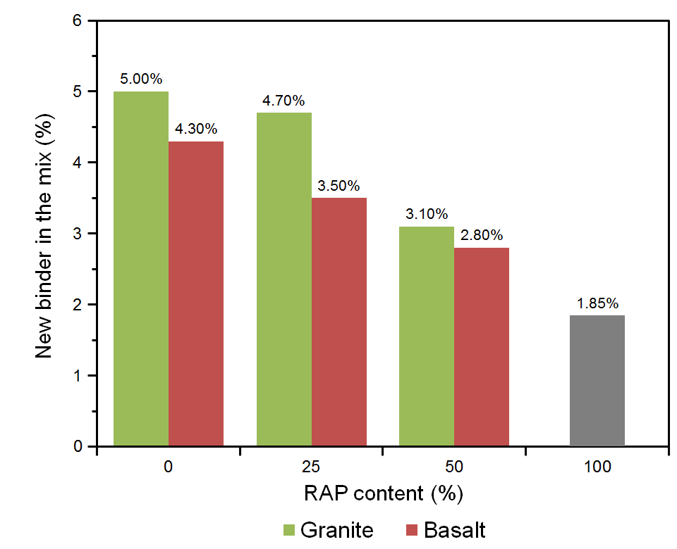
Fig. 8 - Reduction in the variation for the new binder content required in relation to the RAP replacement in the asphalt mixture.

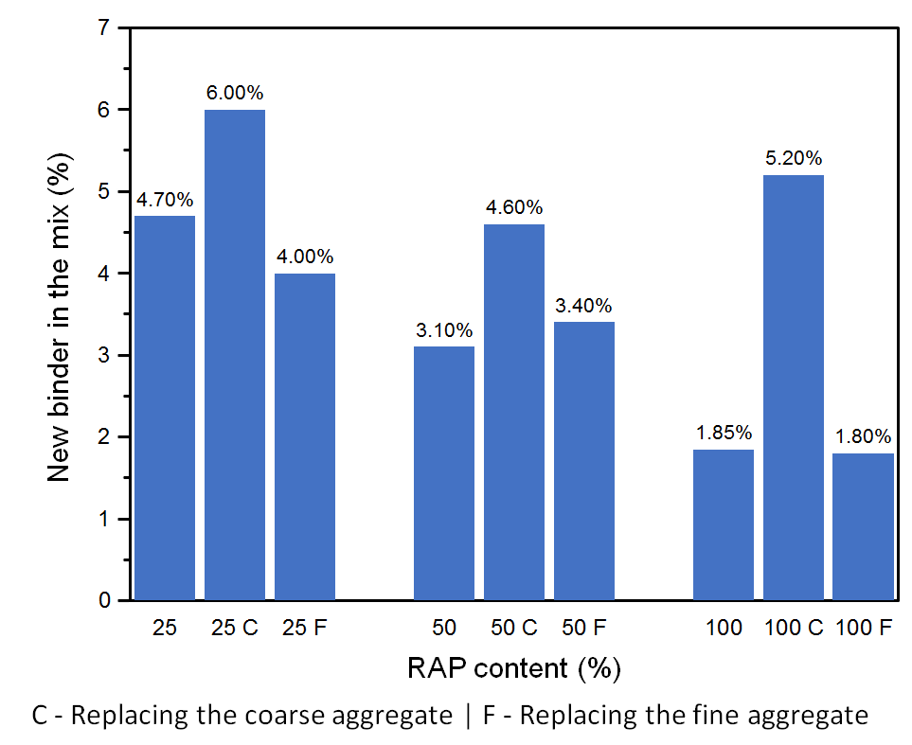
Fig. 9 - Variation in the new binder content required in relation to the RAP replacement portion in the asphalt mixture (total, coarse or fine aggregate).

Increasing the RAP content in asphalt mixtures inherently reduces the amount of virgin binder required, as part of the binder is already provided by the aged RAP material. While this can improve initial stiffness and potentially reduce costs, it may also influence the long-term mixture performance. Specifically, the reduced virgin binder content can lead to increased susceptibility to cracking and reduced fatigue resistance, as the aged binder is more brittle and less ductile than fresh binder. To mitigate these effects, some studies [55,56] have incorporated rejuvenating agents or softening additives to restore the binder’s flexibility and improve inter-particle cohesion, thereby enhancing durability and resistance to cracking under long-term traffic loading. This relationship highlights the importance of balancing RAP content and binder properties to ensure optimal mechanical performance and asphalt pavements longevity.
The false particle size distribution provided during the material separation process, considering the binder presence, which mobilizes during the new mixing process due to temperature, releasing the granules and altering the overall particle distribution, is one of the main issues when only the fine fraction is replaced by RAP. In Fig. 10, for example, it is evident that the sample during the stability test exhibited total specimen failure, without general aggregation of the entire set. In light of this, and considering that the savings in new binder occurred only with a 25% RAP substitution, which is negligible for other ranges, it is not considered viable to separate by granulometry when incorporating RAP into new asphalt mixtures. Thus, it is more advantageous for the RAP to be incorporated entirely within its granulometric range.

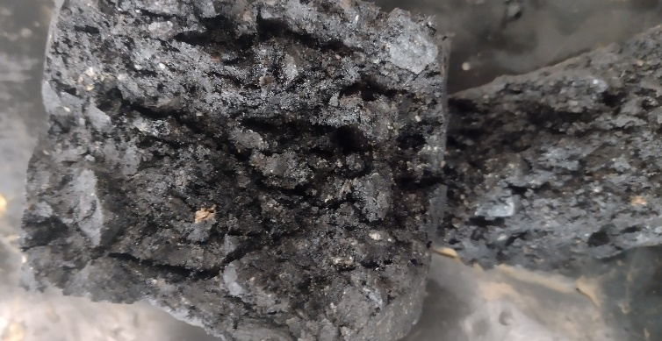
Fig. 10 - Test specimen after the Marshall stability test, demonstrating the sample rupture without adequate cohesion in which there is a lack of small pieces for the interlocking of the stone structure in the replacement.

Regarding the variation in stability relative to the different groups, the graph in Fig. 11 illustrates the stability variation of the mixtures considering the RAP incorporation fraction for a 4% air void volume. It is evident that improvements in stability were observed only in the fine aggregate substitution with RAP. The decrease when using RAP solely as coarse aggregate can be explained by the decomposition of coarse particles upon reactivation of the aged binder, leading to variations in the granulometric distribution and reduced the structure interlocking. It can also be attributed to the excessive binder consumption, which consequently results in greater flow and deformation of the mixture.
The differences observed in binder savings between basaltic and granite fines can be largely attributed to their distinct surface textures and mineral compositions. Basaltic fines typically exhibit a rougher surface texture and higher angularity, which enhances mechanical interlocking and increases the specific surface area in contact with the binder. This can lead to greater binder absorption and, consequently, more efficient utilization of the binder in the mixture. On the other hand, granite fines usually have smoother surfaces and lower absorption capacity, which may reduce the overall binder demand but can slightly affect particle-to-particle cohesion. Additionally, the mineralogical composition of the fines can influence chemical interactions with the bituminous binder, potentially affecting adhesion and the mixture’s mechanical performance.

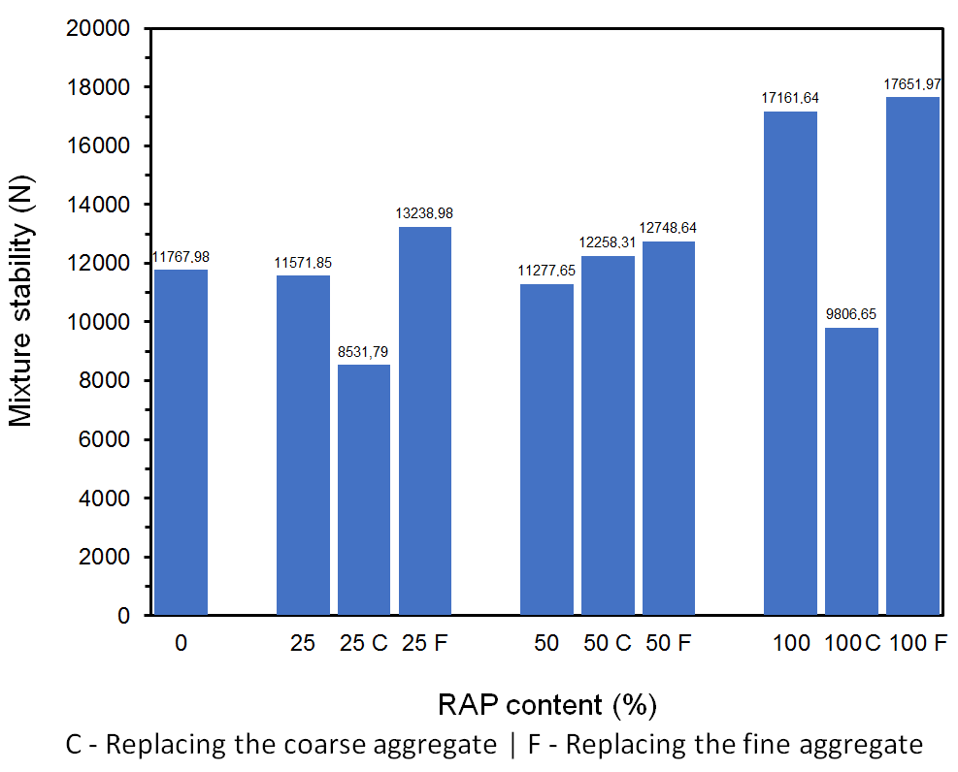
Fig. 11 - Marshall stability variation of mixtures considering the RAP location application for a void volume set at 4%.

Considering that the exclusive RAP substitution as coarse aggregate did not yield good results, and the difference between exclusive substitution as fine aggregates and total substitution was not significant, the RAP separation by granulometric range was abandoned for the other physical and mechanical characteristics. Thus, the full RAP incorporation in both fractions was prioritized. This approach is based on the fact that total substitution also results in a greater increase in the residual material in new mixtures.
Based on the above, following the complementary mechanical strength results required by the applicable standards, and having defined the optimal percentages of new binder for mixtures with full RAP incorporation across its entire granulometric range, the data in Table 3 present the laboratory results for the complementary characterizations. The Table 4, in turn, presents the results obtained from the Analysis of Variance (ANOVA) for the complementary characterizations, through the evaluation of statistical significance (F), reliability (p), and coefficient of determination (R²).

Table 3 - Physical-mechanical results of the test specimens based on the determined optimum binder content.
Mixture | New blinder (%) | Density (g/cm³) | Stability (N) | Creep (c.mm) | Wear  (%) | Tensile strength (MPa)
0% GR | 5.00 | 2.44 ± .01 | 9149.80 ± 457.11 | 213 ± 11 | 11.86 ± 2.63 | 0.96 ± .06
50% GR | 3.09 | 2.31 ± .04 | 11082.69 ± 803.00 | 299 ± 71 | 17.08 ± 0.15 | 0.72 ± .30
100% | 1.85 | 2.31 ± .02 | 11311.87 ± 638.24 | 524 ± 1 | 14.97 ± 1.56 | 1.47 ± .04
0% BA | 4.30 | 2.57 ± .01 | 10155.28 ± 74.20 | 255 ± 14 | 13.77 ± 0.55 | 0.72 ± .02
50% BA | 2.80 | 2.43 ± .01 | 13312.63 ± 984.54 | 288 ± 28 | 19.05 ± 1.7 | 0.98 ± .07

Table 4 - Analysis of Variance (ANOVA) for the different properties with the studied aggregates, presenting the best statistical models.
Properties | Aggregates | Model | F | p | R²
Density | Granite | Linear | 15.09 | 0.027 | 0.91
Density | Basalt | Linear | 206.87 | 0.0006 | 0.99
Stability | Granite | Linear | 6.71 | 0.078 | 0.82
Stability | Basalt | Linear | 11.08 | 0.041 | 0.88
Creep | Granite | Linear | 29.56 | 0.011 | 0.95
Creep | Basalt | Linear | 126.01 | 0.001 | 0.99
Wear | Granite | Linear | 4.41 | 0.128 | 0.75
Wear | Basalt | Linear | 8.13 | 0.061 | 0.84
Tensile strength | Granite | Linear | 8.96 | 0.054 | 0.86
Tensile strength | Basalt | Linear | 109.88 | 0.001 | 0.99

Regarding the indirect tensile strength, in Brazil, according to national standard DNIT 31/ES [57], the test result must meet a minimum of 0.65 MPa. It is observed that all mixtures comply the normative criteria.
Concerning the rheological properties of deformation in relation to the applied load, the graphs in Fig. 12 (a and b) present the deformation stability results for all the specimens tested. It should be noted that the graphs were generated from data recorded during the test, as the available equipment does not allow for automatic information extraction. It is clearly observed that with the increase in RAP content, there is an increase in deformation under higher applied loads.

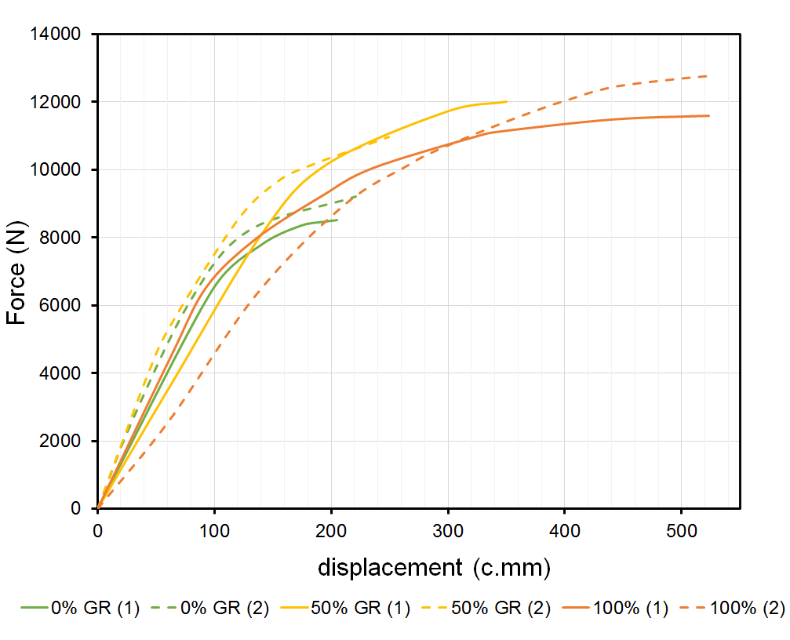  (a) (b) | 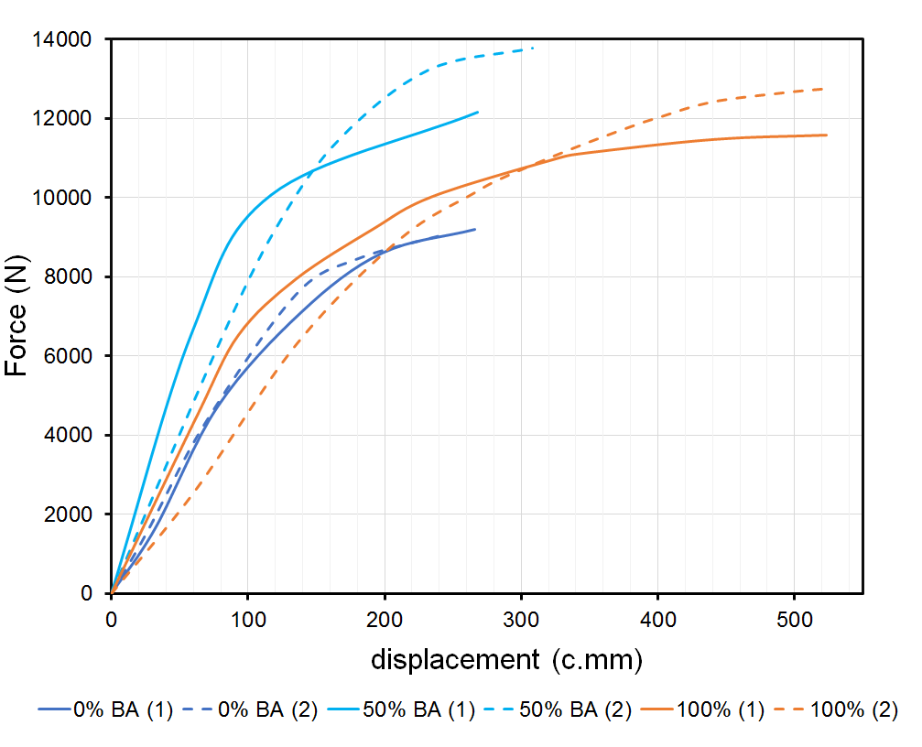
Fig. 12 - Deformation stability of test specimens using RAP in (a) granite powder and (b) basalt powder.

An increase in RAP content was observed to slightly elevate the susceptibility of asphalt mixtures to permanent deformation. This behavior can be attributed to the interactions between aged binders present in the RAP and the fresh binder added to the mixture. Aged binders tend to be stiffer and more brittle, which can lead to reduced overall flexibility of the asphalt matrix, limiting its ability to accommodate traffic-induced stresses. Additionally, higher RAP contents may result in incomplete blending between aged and new binders, creating zones with differential mechanical properties within the mixture. These microstructural heterogeneities contribute to localized deformation under load, explaining the observed increase in rutting susceptibility. Understanding this interaction is essential for optimizing RAP content while maintaining mechanical performance and long-term durability of asphalt pavements.
Excessive RAP incorporation increases the proportion of aged binder in the mixture, which is typically stiffer and more brittle due to oxidation and loss of volatiles over time. When blended with virgin binder, the aged binder may not fully rejuvenate, leading to heterogeneous binder distribution and localized stiff zones. These regions are more prone to permanent deformation under repeated loading, as the mixture exhibits less capacity to redistribute stresses. Additionally, the reduced binder flexibility in high-RAP mixtures can decrease inter-particle cohesion, further contributing to increased susceptibility to rutting and other deformation-related distresses.
Regarding the other physical-mechanical properties presented in Table 3, it can be observed that, the higher the level of RAP incorporation in the asphalt mixture, the lower the required amount of virgin binder. The savings are even greater when basaltic stone powder is used compared to granite stone powder, as long as the minimum adhesion parameters required are met.
Regarding the mixture density, there is a tendency for a reduction in specific gravity as the RAP content increases. The density is lower for the mixture with granite stone powder compared to basaltic stone powder, due to the intrinsic density of these constituent materials.
As for stability, the highest value observed was with 50% RAP and the use of basaltic stone powder. In the case of using granite stone powder, the higher the RAP content, the greater the stability observed. The same parameter is observed for flow, except for mixtures with basaltic stone powder. In both cases, for both types of stone powder, the highest wear was observed in the composition with 50% RAP incorporated.
In terms of indirect tensile strength, there was an increase in strength with the increase in RAP when using basalt powder. When granite powder was used, there was a slight decrease in the intermediate-level mixture.
Considering the analysis of collected data variance (ANOVA), normality of all variables and appropriate randomness in the execution of the experimental procedure were observed.
For the RAP incorporations in the specimens produced with granite powder, the specific gravity, with α ≤ 5% and a coefficient of determination of 90.96%, can be described as significantly influenced by the percentage of granite powder and the RAP content in the mixture; the same applies to stability, considering α ≤ 10% and a determination coefficient of 81.73%; the flow variable, with α ≤ 5% and a determination coefficient of 95.17%, is strongly influenced by the RAP content incorporated; the wear variable, the most sensitive, with α ≤ 15% and a determination coefficient of 74.62%, showed a direct influence from all components: stone powder, other constituent materials, RAP content, and new binder content; the same result, α ≤ 10% and a determination coefficient of 85.65%, was observed for the results of indirect tensile strength.
On the other hand, for the RAP incorporations in the specimens produced with basalt powder, the specific gravity, with α ≤ 5% and a determination coefficient of 99.28%, can be described as significantly influenced by the percentage of granite powder and the RAP content in the mixture; for the stability variable, considering α ≤ 5% and a determination coefficient of 88.07%, all constituent factors showed significance in the results; the same behavior was observed for the flow variable, with α ≤ 5% and a determination coefficient of 98.82%; the wear variable, the most sensitive, with α ≤ 10% and a determination coefficient of 84.42%, showed a direct influence from all components: stone powder, other constituent materials, RAP content, and new binder content; for indirect tensile strength, however, with α ≤ 5% and a determination coefficient of 98.65%, the results were more significant for the available RAP content in the mix design.
When the fractures of the test specimens were observed through microscopy, as shown in Fig. 13, it was noted that the fractures occurred, as expected, in the bituminous binder zone and/or at the interface between the binder and the aggregate. However, no fractures were observed within the aggregate itself.

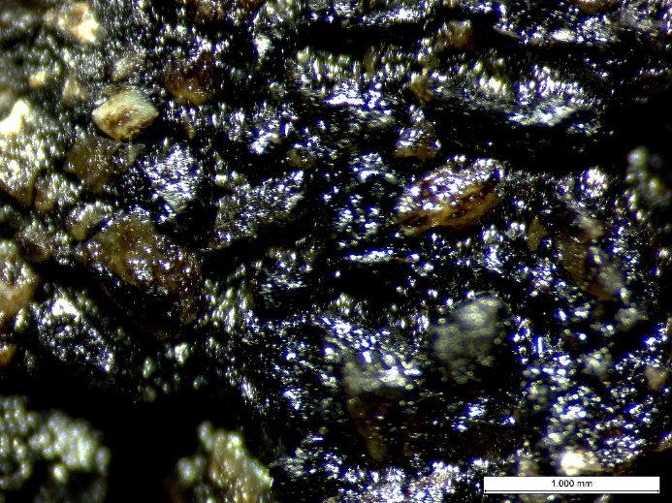  (a) (b) | 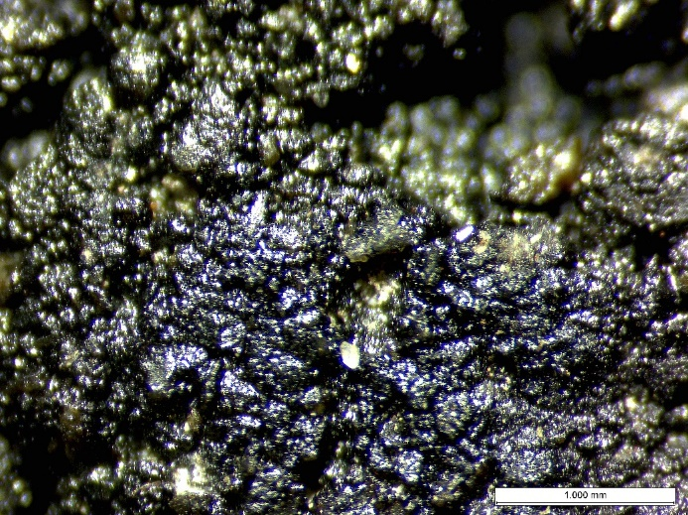
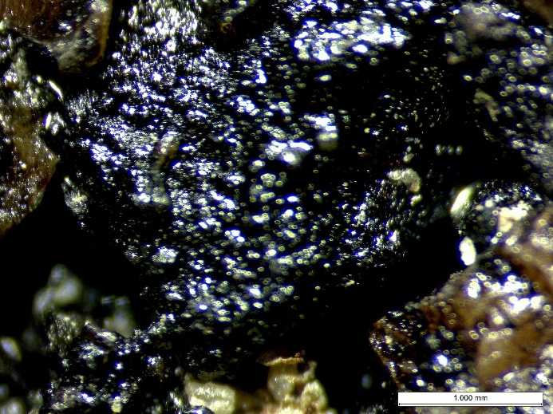  (c) (d) | 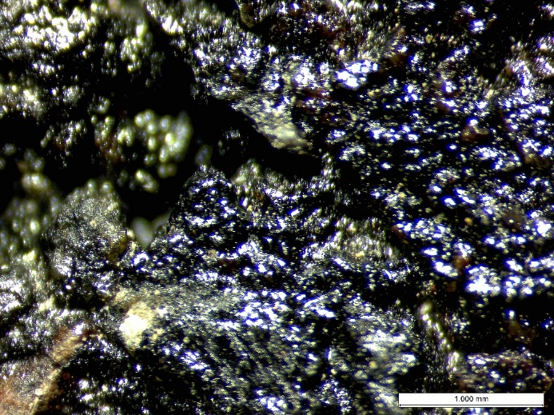
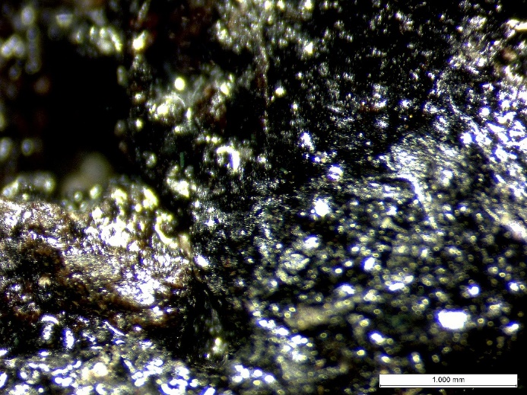
(e)
Fig. 13 - Optical microscopy of the fracture region in the test specimens. (a) 01 [0% GR], (b) 02 [0% BA], (c) 07 [50% GR], (d) 08 [50% BA], (e) 11 [100%].

For the mixes with basaltic gravel, some fractures occurred at the interface between the binder and the aggregate, which may indicate a lack of adequate adhesion. In these situations, the problem could be addressed by using adhesion-enhancing additives.

Conclusion
A reduction in new binder content was observed in mixtures where RAP was exclusively incorporated into the fine aggregate fraction, with values as low as 1.85% for a 100% RAP mixture, compared to 5.00% in the control group. This reduction also led to an increase in Marshall stability, with the highest recorded value reaching 13312.63 N for a 50% RAP mixture using basalt fines, compared to 9149.8 N in the reference mixture without RAP. In contrast, mixtures where RAP replaced only coarse aggregates showed a decline in stability, likely due to the breakdown of larger granules during heating.
The mixtures specific gravity decreased with increasing RAP content, reaching 2.31 g/cm³ for the 100% RAP mixture, compared to 2.44 g/cm³ in the control group. This effect is attributed to the presence of aged binder and differences in aggregate gradation. Additionally, mixtures using basaltic stone powder exhibited greater savings in binder content compared to those using granite stone powder, indicating a more favorable interaction with the asphalt binder.
The flow values increased with RAP incorporation, demonstrating higher deformation susceptibility in high-content RAP mixtures. The 100% RAP mixture recorded a flow of 524 c.mm, compared to 213 c.mm in the control mixture, suggesting that while RAP improves stability, excessive amounts may lead to more deformable pavements.
The indirect tensile strength increased with RAP incorporation, particularly in mixtures with basaltic fines. The highest value recorded was 0.98 MPa for the 50% RAP mixture with basalt, compared to 0.72 MPa in the control group. This increase is attributed to the aged and more viscous nature of the pre-existing binder, which enhances performance under stress and reduces strength loss when subjected to high temperatures and humidity.
The particle size of RAP significantly affects the reactivation of the aged binder, with finer fractions exhibiting greater surface area and more effective blending with new binder, which enhances mixture cohesion, stability, and tensile strength. Conversely, coarser RAP fractions may show reduced binder reactivation, potentially leading to higher flow values and lower resistance to permanent deformation and cracking.
In summary, the study confirms that RAP can be effectively incorporated into new asphalt layers, reducing the demand for virgin materials while maintaining or even improving key mechanical properties. The optimal balance between performance and sustainability was achieved at 50% RAP content, particularly when combined with basaltic stone powder, making it a viable strategy for sustainable pavement solutions within the circular economy framework.

Reference
[1] G.D. Taylor, Materials in Construction, 3rd Editio, Routledge, London, UK, 2013. https://doi.org/10.4324/9781315839158.
[2] K. Gharehbaghi, M. Georgy, Sustainable Construction by Means of Improved Material Selection Process, Acad. Res. Community Publ. 3 (2019) 85–94. https://doi.org/10.21625/archive.v3i1.433.
[3] T. Huang, F. Shi, H. Tanikawa, J. Fei, J. Han, Materials demand and environmental impact of buildings construction and demolition in China based on dynamic material flow analysis, Resour. Conserv. Recycl. 72 (2013) 91–101. https://doi.org/10.1016/j.resconrec.2012.12.013.
[4] R. Mariyappan, J.S. Palammal, S. Balu, Sustainable use of reclaimed asphalt pavement (RAP) in pavement applications—a review, Environ. Sci. Pollut. Res. 30 (2023) 45587–45606. https://doi.org/10.1007/s11356-023-25847-3.
[5] F. Qu, Z. Yang, Z. Liu, Characterization of Reclaimed Asphalt Pavement Material Properties for Hot In-Place Recycling, Materials (Basel). 18 (2025) 970. https://doi.org/10.3390/ma18050970.
[6] M.K.D. Rout, S.K. Sahdeo, S. Biswas, K. Roy, A.K. Sinha, Feasibility Study of Reclaimed Asphalt Pavements (RAP) as Recycled Aggregates Used in Rigid Pavement Construction, Materials (Basel). 16 (2023) 1504. https://doi.org/10.3390/ma16041504.
[7] C. Plati, M. Tsakoumaki, K. Gkyrtis, Physical and Mechanical Properties of Reclaimed Asphalt Pavement (RAP) Incorporated into Unbound Pavement Layers, Appl. Sci. 13 (2022) 362. https://doi.org/10.3390/app13010362.
[8] M. Tsakoumaki, C. Plati, A Critical Overview of Using Reclaimed Asphalt Pavement (RAP) in Road Pavement Construction, Infrastructures. 9 (2024) 128. https://doi.org/10.3390/infrastructures9080128.
[9] V. Mathias, T. Sedran, F. de Larrard, Recycling reclaimed asphalt pavement in concrete roads, in: Int. Rilem Conf. Use Recycl. Mater. Build. Struct., Rilem Proceedings PRO 40, Barcelona, Spain, 2004: p. 11.
[10] Y. Gao, X. Yu, Q. Xia, H. Zhang, Evaluation of Complex Shear Modulus of Recycled Asphalt Mortars Based on Euclidean Distance Method in the Mixing Process, Int. J. Pavement Res. Technol. (2024). https://doi.org/10.1007/s42947-024-00470-8.
[11] S. Lewis, E. Coleri, M. Sukhija, S. Sreedhar, Blending of Virgin and RAP Binder for Asphalt Mixes with High RAP Contents: A Pilot Study, Int. J. Pavement Res. Technol. (2024). https://doi.org/10.1007/s42947-023-00405-9.
[12] M. Ilyas, A. Hussain, N. Khan, H. Ding, Eco-Friendly Highways: Harnessing Waste Polystyrene and Reclaimed Asphalt Pavement for Sustainable Roadways and Environmental Mitigation, Int. J. Pavement Res. Technol. (2024). https://doi.org/10.1007/s42947-024-00467-3.
[13] S. Wasiq, A. Golroo, Development of a Circular Economy Index for a Pavement Management System, Int. J. Pavement Res. Technol. 17 (2024) 1327–1339. https://doi.org/10.1007/s42947-023-00304-z.
[14] A.L. Oss-Emer, A.G. dos Santos, Predicting the Performance of Semi-Rigid Pavement with Partial Replacement of RAP in RCC and Designed Using a Mechanistic–Empirical Method, Int. J. Pavement Res. Technol. (2024). https://doi.org/10.1007/s42947-024-00429-9.
[15] R.B. Mugume, Investigation of Foamed Bitumen Mixes Using Reclaimed Asphalt Pavement Materials for Cold Recycling Technology, Int. J. Pavement Res. Technol. 15 (2022) 98–110. https://doi.org/10.1007/s42947-021-00014-4.
[16] A.A. Abdulmawjoud, Evaluation of Fatigue Characteristics of Reclaimed Asphalt Pavement Mixtures Through Dissipated Energy, Int. J. Pavement Res. Technol. 16 (2023) 237–245. https://doi.org/10.1007/s42947-021-00128-9.
[17] H.P. Moyano-Ayala, M.S.F. Dinis-Almeida, Mechanical Performance of Sustainable Asphalt Mixtures Incorporating RAP and Panasqueira Mine Waste, Constr. Mater. 5 (2025) 52. https://doi.org/10.3390/constrmater5030052.
[18] M. Abdel-Jaber, R.A. Al-shamayleh, R. Ibrahim, T. Alkhrissat, A. Alqatamin, Mechanical properties evaluation of asphalt mixtures with variable contents of reclaimed asphalt pavement (RAP), Results Eng. 14 (2022) 100463. https://doi.org/10.1016/j.rineng.2022.100463.
[19] X. Chen, Q. Li, T. Sesay, Q. You, E. Bridget Chineche, Valorization of recycled wastes in pavement preventive maintenance: A review on reclaimed asphalt pavement and recycled waste tire, Heliyon. 10 (2024) e27776. https://doi.org/10.1016/j.heliyon.2024.e27776.
[20] F. Russo, C. Oreto, R. Veropalumbo, A Practice for the Application of Waste in Road Asphalt Pavements in an Eco-Friendly Way, Appl. Sci. 11 (2021) 9268. https://doi.org/10.3390/app11199268.
[21] L. He, M. Tao, Z. Liu, Z. Cao, J. Zhu, J. Gao, W. Van den Bergh, E. Chailleux, Y. Huang, K. Vasconcelos, A. Cannone Falchetto, R. Balieu, J. Grenfell, D.J. Wilson, J. Valentin, K.J. Kowalski, L. Rzek, L. Gaspar, T. Ling, Y. Ma, Biomass valorization toward sustainable asphalt pavements: Progress and prospects, Waste Manag. 165 (2023) 159–178. https://doi.org/10.1016/j.wasman.2023.03.035.
[22] L.A. de F. Pereira, E.F. Amorim, O. de Freitas Neto, Construction and demolition waste applied to road pavement layers: a systematic review, Res. Soc. Dev. 11 (2022) e28611426689. https://doi.org/10.33448/rsd-v11i4.26689.
[23] P. Sadeghi, A. Goli, Investigating the cracking performance of asphalt mixture containing RAP using different cracking indices, Case Stud. Constr. Mater. 19 (2023) e02340. https://doi.org/10.1016/j.cscm.2023.e02340.
[24] S. Baradaran, J. Rahimi, M. Ameri, A. Maleki, Mechanical performance of asphalt mixture containing eco-friendly additive by recycling PET, Case Stud. Constr. Mater. 20 (2024) e02740. https://doi.org/10.1016/j.cscm.2023.e02740.
[25] S. Baradaran, M.R.M. Aliha, A. Maleki, B.S. Underwood, Fracture properties of asphalt mixtures containing high content of reclaimed asphalt pavement (RAP) and eco-friendly PET additive at low temperature, Constr. Build. Mater. 449 (2024) 138426. https://doi.org/10.1016/j.conbuildmat.2024.138426.
[26] S. Baradaran, M.R.M. Aliha, Mode I and Mode II fracture assessment of green asphalt pavements containing plastic waste and RAP at low and intermediate temperature, Results Eng. 25 (2025) 103734. https://doi.org/10.1016/j.rineng.2024.103734.
[27] A.E. Alvarez, L. V. Espinosa, S. Caro, E.J. Rueda, J.P. Aguiar, L.G. Loria, Differences in asphalt binder variability quantified through traditional and advanced laboratory testing, Constr. Build. Mater. 176 (2018) 500–508. https://doi.org/10.1016/j.conbuildmat.2018.05.046.
[28] D. Xu, F. Ni, H. Du, Z. Zhao, J. Wang, S. Chen, Investigation of Factors Affecting the Intermediate-Temperature Cracking Resistance of In-Situ Asphalt Mixtures Based on Semi-Circular Bending Test, Coatings. 13 (2023) 384. https://doi.org/10.3390/coatings13020384.
[29] P.D. Valle, N. Thom, Pavement layer thickness variability evaluation and effect on performance life, Int. J. Pavement Eng. 21 (2020) 930–938. https://doi.org/10.1080/10298436.2018.1517873.
[30] H.A. Obaid, M. Enieb, A. Eltwati, M.A. Al-Jumaili, Prediction and Optimization of Asphalt Mixtures Performance Containing Reclaimed Asphalt Pavement Materials and Warm Mix Agents Using Response Surface Methodology, Int. J. Pavement Res. Technol. (2024). https://doi.org/10.1007/s42947-024-00464-6.
[31] G. Tarsi, P. Tataranni, C. Sangiorgi, The Challenges of Using Reclaimed Asphalt Pavement for New Asphalt Mixtures: A Review, Materials (Basel). 13 (2020) 4052. https://doi.org/10.3390/ma13184052.
[32] S. Bressi, J. Santos, M. Orešković, M. Losa, A comparative environmental impact analysis of asphalt mixtures containing crumb rubber and reclaimed asphalt pavement using life cycle assessment, Int. J. Pavement Eng. 22 (2021) 524–538. https://doi.org/10.1080/10298436.2019.1623404.
[33] T. Wang, X. Zhao, L. Zheng, C. Mao, L. Wang, A.C. Falchetto, D. Guo, Hot In-Place Recycled Asphalt Mixtures: RAP Analysis, Compaction Characteristics and Field Evaluation, Sustainability. 16 (2024) 1064. https://doi.org/10.3390/su16031064.
[34] G. Masi, A. Michelacci, S. Manzi, M.C. Bignozzi, Assessment of reclaimed asphalt pavement (RAP) as recycled aggregate for concrete, Constr. Build. Mater. 341 (2022) 127745. https://doi.org/10.1016/j.conbuildmat.2022.127745.
[35] S.-Y. Lee, Y.-M. Kim, T.H.M. Le, Laboratory and Field Testbed Evaluation of the Performance of Recycled Asphalt Mixture Using High-Penetration Asphalt, Buildings. 13 (2023) 529. https://doi.org/10.3390/buildings13020529.
[36] M. Bilema, M.Y. Aman, N.A. Hassan, Z.A. Memon, H.A. Omar, N.I.M. Yusoff, A. Milad, Mechanical Performance of Reclaimed Asphalt Pavement Modified with Waste Frying Oil and Crumb Rubber, Materials (Basel). 14 (2021) 2781. https://doi.org/10.3390/ma14112781.
[37] V. Antunes, A.C. Freire, J. Neves, A review on the effect of RAP recycling on bituminous mixtures properties and the viability of multi-recycling, Constr. Build. Mater. 211 (2019) 453–469. https://doi.org/10.1016/j.conbuildmat.2019.03.258.
[38] K.E. Hassan, J.J. Brooks, M. Erdman, The use of reclaimed asphalt pavement (RAP) aggregates in concrete, in: Waste Manag. Ser., Elsevier Ltd., Harrogate - UK, 2000: pp. 121–128. https://doi.org/10.1016/S0713-2743(00)80024-0.
[39] J. Zhang, T. Sesay, Q. You, H. Jing, Maximizing the Application of RAP in Asphalt Concrete Pavements and Its Long-Term Performance: A Review, Polymers (Basel). 14 (2022) 4736. https://doi.org/10.3390/polym14214736.
[40] C.H. Dager, R.H. Morro, J.F. Hubler, K.M. Sample-Lord, Review of Geotechnical Properties of Reclaimed Asphalt Pavement for Reuse in Infrastructure, Geotechnics. 3 (2023) 21–42. https://doi.org/10.3390/geotechnics3010003.
[41] ISO, 3082/2017: Iron ores — Sampling and sample preparation procedures, (2017) 83.
[42] ISO, 3310-1/2016: Test sieves - Technical requirements and testing - Part 1: Test sieves of metal wire cloth, (2016) 15.
[43] DNIT, DNER-ME 053/94 - Misturas betuminosas - percentagem de betume, (1994) 5.
[44] H.M. Rietveld, A Profile Refinement Method for Nuclear and Magnetic Structures, J. Appl. Crystallogr. 2 (1969) 65–71. https://doi.org/10.1107/S0021889869006558.
[45] ASTM, D5/D5M-20: Standard Test Method for Penetration of Bituminous Materials, (2020) 4.
[46] ASTM, D36/D36M-12: Standard Test Method for Softening Point of Bitumen (Ring-and-Ball Apparatus), (2014) 4.
[47] ASTM, E102/E102M-93(2021): Standard Test Method for Saybolt Furol Viscosity of Bituminous Materials at High Temperatures, (2021) 3.
[48] ASTM, D6926-20: Standard Practice for Preparation of Asphalt Mixture Specimens Using Marshall Apparatus, (2020) 8.
[49] ASTM, D6927-15: Standard Test Method for Marshall Stability and Flow of Asphalt Mixtures, (2022) 7.
[50] ASTM, D4867: Standard Test Method for Effect of Moisture on Asphalt Concrete Paving Mixtures, (2022) 5.
[51] ASTM, D7064-04: Standard Practice for Open-Graded Friction Course (OGFC) Mix Design, (2017) 7.
[52] R.D. Cadar, R.M. Boitor, M.L. Dragomir, An Analysis of Reclaimed Asphalt Pavement from a Single Source—Case Study: A Secondary Road in Romania, Sustainability. 14 (2022) 7057. https://doi.org/10.3390/su14127057.
[53] DNER, 383/99-ME: - Desgaste por abrasão de misturas betuminosas com asfalto polímero–ensaio Cantabro, (1999) 2.
[54] M.L. Querino, L.C. Carvalho, Traço de asfalto em uma mistura de concreto betuminoso usinado a quente (CBUQ) produzido por uma usina de asfalto para tapa-buracos, Fundação de Ensino e Pesquisa do Sul de Minas - FEPESMIG, 2020.
[55] M. Pasetto, A. Baliello, G. Giacomello, E. Pasquini, Towards very high RAP content asphalt mixes: A comprehensive performance-based study of rejuvenated binders, J. Traffic Transp. Eng. (English Ed. 8 (2021) 1022–1035. https://doi.org/10.1016/j.jtte.2020.12.007.
[56] A. Samad, X. Luo, J. Wang, M.W. Abid, Optimization of recycled asphalt binder with eco-friendly additives: Activation energy and bonding properties, Constr. Build. Mater. 497 (2025) 143795. https://doi.org/10.1016/j.conbuildmat.2025.143795.
[57] DNIT, 031/2024 – ES: Pavimentação – Concreto asfáltico – Especificação de serviço, (2024) 33.

