Ms Manneea Montsi

Ms Manneea Montsi is a PhD candidate in the Department of Civil Engineering and Geomatics at the Cape Peninsula University of Technology, Cape Town, South Africa. Her research focuses on agricultural waste modified asphalt mixtures. She holds an MEng, a BTech in Civil Engineering from Cape Peninsula University of Technology and a Diploma in Civil Engineering from Lerotholi Polytechnic, Maseru, Lesotho. She is a recipient of the DAAD grant for participating in the International PhD Week 2024 in Trier, Germany.
Dr Pamela Welz

Dr Pamela Welz is a Senior Researcher at the Cape Peninsula University of Technology. She holds a PhD in Biotechnology, and an MSc in Environmental Science and Management. Currently, her main research niches are centered around treatment, re-use, resource recovery, and valorization of industrial and agro-industrial residues and wastes. Projects include semi-passive remediation of winery effluent at small local wineries, resource recovery and anaerobic digestion from/of solid waste from wineries and tanneries, and the use of agro-industrial residues to synthesize biopolymers for plastics manufacturing.
Pamela Welz
ORCID iD
https://orcid.org/0000-0002-4825-408

Prof Kumar Pallav
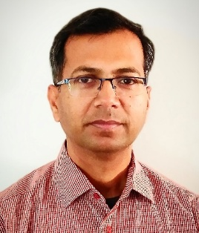
Prof. Kumar Pallav is an Associate Professor and Head of the Sustainable Heritage Research Unit (SHRU) in the Department of Civil Engineering and Geomatics at the Cape Peninsula University of Technology, Cape Town, South Africa. He is also an International Professional Engineer and a Chartered Engineer. He holds a PhD in Civil Engineering (Structural Engineering) from the Indian Institute of Technology Guwahati, India, an M.Tech. in Structural Engineering (Gold Medalist), and a B.E. in Civil Engineering (Honours). His research interests include sustainable construction materials, heritage structures, and seismic hazard assessment. He has supervised several postgraduate students and received international recognition through European Commission fellowships and research collaborations with European institutions. Prof. Kumar has published more than 50 papers in peer-reviewed journals and conference proceedings and holds a patent related to a water–energy-efficient building system.
ORCID iD: 0000-0003-3785-3181

