________________________________________________________________________________
Supplementary materials
Water availability modulates maximum canopy heights of low-elevation Amazonian second-growth forests
Midhun Mohan^{1,2*}, Gilberto Z Pastorello¹, Yanlei Feng³, Esmaeel Adrah^{4,5}, Michael Keller^{6,7}, Ewane Basil Ewane⁸, Marcos Longo¹, Ovidiu Csillik⁷, Antonio Ferraz^{7,9}, Abhilash Dutta Roy^{10,11}, Lin Meng¹², Jeffrey Q Chambers^{1,2}
¹Climate and Ecosystem Sciences Division, Lawrence Berkeley National Laboratory, 1 Cyclotron Rd, Berkeley, CA, 94720, USA
²Department of Geography, University of California – Berkeley, Berkeley, CA, United States mid_mohan@berkeley.edu (M.M.)
³Department of Civil and Environmental Engineering, MIT, USA
⁴Earth Observation Centre, Institute of Climate Change, Universiti Kebangsaan Malaysia, Bangi 43600, Selangor, Malaysia
⁵Department of Geography, Kent State University, USA
⁶USDA Forest Service, International Institute of Tropical Forestry, Rio Piedras, Puerto Rico USA
⁷Jet Propulsion Laboratory, California Institute of Technology, Pasadena, CA, 91109, USA
⁸Department of Geography, Faculty of Social and Management Sciences, University of Buea, P.O. Box 63, Buea, Cameroon
⁹University of California, Los Angeles, LaKretz Hall, 619 Charles E Young Dr E #300, Los Angeles, CA 90024, USA
¹⁰Mediterranean Forestry and Natural Resources Management, School of Agriculture, University of Lisbon, Lisbon, Portugal
¹¹School of Agrifood and Forestry Engineering and Veterinary Medicine, University of Lleida, Lleida, Spain
¹²Department of Earth and Environmental Sciences, Vanderbilt University, Nashville, USA
*Author to whom any correspondence should be addressed.
E-mail: mikey@ecoresolve.eco
Keywords: forest regeneration; carbon sequestration; tropical forests; NASA GEDI; space-borne lidar; climate change impacts ________________________________________________________________________________

Supplementary Table S1: Summarizing the key predictors of canopy height across the studied age cohorts (30-35 years).
Data | Description | Spatial Resolution | Reference
GEDI L2A relative height | Canopy height | 25 m | Dubayah et al., 2021
Elevation | Elevation based on Shuttle Radar Topographic Mission Digital Elevation Model (SRTM-DEM) data. | 90 m | Jarvis et al., 2008; Safanelli et al., 2020
Annual precipitation | Extracted monthly from the TerraClimate dataset | 5 km | Abatzoglou et al., 2018
Annual potential evapotranspiration | Extracted monthly from the TerraClimate dataset | 5 km | Abatzoglou et al., 2018

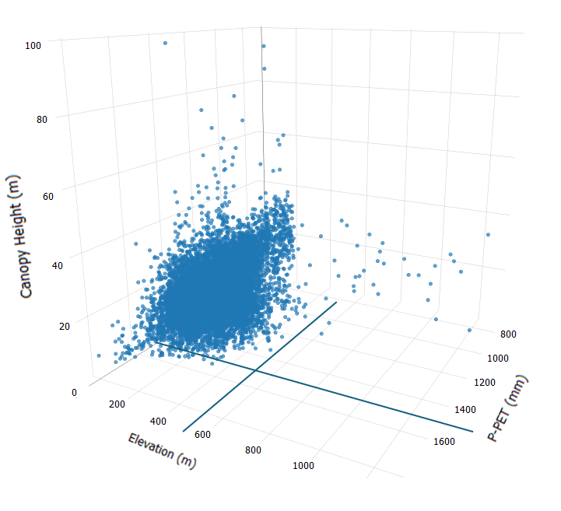
Supplementary Figure S1: The limited number of data points above the considered threshold and the multivariate relationship between canopy height of secondary forest aged 30-35 with, water availability, and elevation.
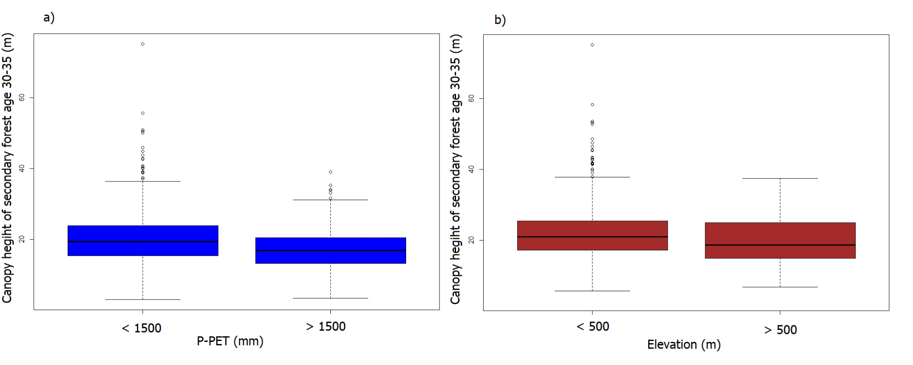
Supplementary Figure S2: a) Canopy height of forest age 30-35 years below and above considered water availability threshold (1500 mm). b) Canopy height of forest age 30-35 years below and above the considered elevation threshold (500 m). Data points above the thresholds are only 109 (1.3%) data points.

