Fig. S1. Comparison of alphabetical name Distribution between whole sample in current days and various samples in Meiji Era
Note: We conduct Chi-square tests for null hypothesis about proportion of each columns between “Whole sample in current days (with suffix 0)” vs “Sub-sample in Meiji era with suffix i” as follows:
H_{0 :}A_{i}=A₀, :Ka_{i}=Ka₀, Sa_{i}=Sa₀, Ta_{i}=Ta₀, Na_{i}=Na₀, Ha_{i}=Ha₀, Ma_{i}=Ma₀, Ya_{i}=Ya₀, Ra_{i}=Ra₀,
Wa_{i}=Wa₀,
${Chi}^{2}=\sum_{i=1}^{10}{\frac{{(X_{i}-X_{0})}^{2}}{X_{0}}}$ , Where X is Alphabetical Name.

Degree of freedom is 9 for all estimations below,
Chi² (Whole vs Civil)=0.72, Prob > chi2 = 0.99
Chi² (Whole vs Local)=0.71, Prob > chi2 = 0.99
Chi² (Whole vs Military)=0.77, Prob > chi2 = 0.99
Chi² (Whole vs U_Tokyo)=0.68, Prob > chi2 = 0.99
Chi² (Whole vs High Civil)=1.01, Prob > chi2 = 0.99

The null hypothesis has not been rejected for all estimations.

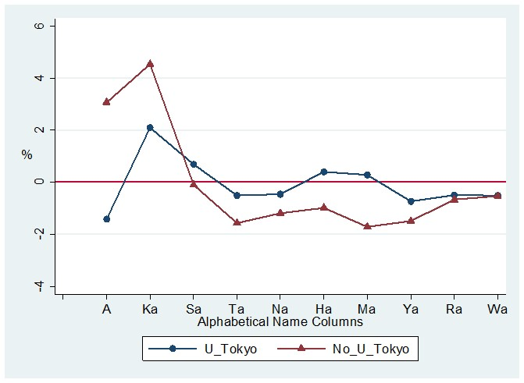

Fig. S2(a). The elite in the Meiji era (successful applicants of a higher civil service examination (1895–1913)): Difference of “Graduate from University Tokyo” and “Others” ratio from the general population by alphabetical columns
Note: Vertical line (0) is the reference group (general population)

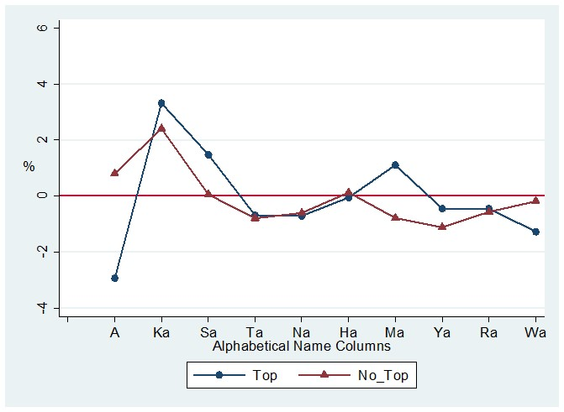
Fig. S2(b). The elite in the Meiji era (successful applicants of a higher civil service examination (1895–1913)): Difference of “Top” and “Others” ratio from the general population by alphabetical columns
Note: Vertical line (0) is the reference group (general population)

Fig. S3. The elite in the Meiji era before the introducing the higher civil service examination (1868–1894).
Bureaucrat in the civil service (“Elite”) vs. Local public servants (“No elite”)
Difference of “Elite” and “No elite” ratio from the general population by alphabetical columns
Note: Vertical line (0) is the reference group (general population)

