Supporting information to the paper
La Montagna, D. et al. Square-grid sampling to address the vegetation patterns of declined Mediterranean forest ecosystems. Community Ecology
Appendix S1. Additional results figures and tables

RESULTS
Table 1: Synoptic table of the species with the identified clusters
Number of relevés | 10 | 3 | 11 | 5 | 2 | 6
Char Cluster 1
Arum italicum | 70 | 0 | 9 | 40 | 0 | 0
Cardamine hirsuta | 70 | 0 | 9 | 0 | 0 | 0
Euphorbia peplus | 70 | 0 | 9 | 0 | 50 | 0
Erodium moschatum | 60 | 33 | 0 | 0 | 0 | 0
Euonymus europaeus | 60 | 0 | 0 | 20 | 0 | 0
Geranium columbinum | 50 | 0 | 9 | 0 | 0 | 0
Erodium malacoides | 40 | 0 | 0 | 0 | 0 | 0
Geranium rotundifolium | 40 | 0 | 0 | 0 | 0 | 0
Ornithopus compressus | 40 | 0 | 9 | 0 | 0 | 0
Sisymbrium officinale | 30 | 0 | 0 | 0 | 0 | 0
Trifolium scabrum | 30 | 0 | 0 | 0 | 0 | 0
Veronica cymbalaria subsp. cymbalaria | 30 | 0 | 0 | 0 | 0 | 0
Char Cluster 2
Erodium cicutarium | 0 | 100 | 0 | 0 | 0 | 0
Isoetes histrix | 0 | 100 | 0 | 0 | 50 | 17
Kickxia commutata subsp. commutata | 20 | 100 | 36 | 20 | 0 | 0
Kickxia elatine | 20 | 100 | 0 | 0 | 50 | 83
Muscari comosum | 50 | 100 | 0 | 0 | 0 | 0
Bellardia viscosa | 0 | 100 | 9 | 0 | 0 | 83
Trifolium resupinatum | 10 | 100 | 18 | 0 | 50 | 0
Festuca ligustica | 60 | 100 | 0 | 0 | 50 | 50
Alopecurus myosuroides | 30 | 67 | 0 | 0 | 0 | 0
Anisantha sterilis | 10 | 67 | 18 | 0 | 0 | 0
Calendula arvensis | 10 | 67 | 0 | 0 | 0 | 17
Trigonella smallii | 10 | 67 | 0 | 0 | 0 | 0
Potentilla reptans | 10 | 67 | 0 | 0 | 0 | 17
Trifolium nigrescens subsp. nigrescens | 30 | 67 | 0 | 0 | 0 | 0
Char Cluster 3
Lychnis flos-cuculi | 80 | 0 | 100 | 60 | 0 | 0
Holcus lanatus | 30 | 33 | 91 | 20 | 0 | 0
Juncus effusus | 10 | 0 | 91 | 20 | 0 | 17
Lythrum junceum | 30 | 0 | 91 | 20 | 0 | 17
Prunella vulgaris | 30 | 0 | 91 | 0 | 0 | 0
Rubus ulmifolius | 30 | 33 | 91 | 40 | 0 | 17
Cyclamen repandum | 40 | 0 | 82 | 60 | 0 | 0
Lythrum hyssopifolia | 20 | 0 | 82 | 0 | 0 | 0
Arbutus unedo | 10 | 0 | 73 | 20 | 0 | 0
Carex punctata | 0 | 0 | 73 | 0 | 0 | 0
Ranunculus ophioglossifolius | 10 | 0 | 73 | 0 | 0 | 33
Euphorbia amygdaloides | 50 | 0 | 64 | 20 | 0 | 0
Isolepis cernua | 0 | 0 | 64 | 0 | 0 | 0
Lythrum tribracteatum | 0 | 0 | 64 | 0 | 0 | 33
Pulicaria dysenterica | 10 | 0 | 64 | 20 | 0 | 0
Agrostis stolonifera | 0 | 0 | 55 | 0 | 0 | 33
Erica arborea | 0 | 0 | 55 | 20 | 0 | 0
Juncus conglomeratus | 0 | 0 | 55 | 0 | 0 | 0
Betonica officinalis | 0 | 0 | 36 | 0 | 0 | 0
Char Cluster 4
Crataegus monogyna | 80 | 0 | 45 | 100 | 0 | 33
Carex depauperata | 30 | 0 | 9 | 80 | 0 | 0
Char Cluster 5
Thinopyrum junceum | 0 | 0 | 0 | 0 | 100 | 0
Thinopyrum acutum | 0 | 0 | 0 | 0 | 100 | 0
Anthemis maritima | 0 | 0 | 0 | 0 | 100 | 0
Atriplex prostrata | 0 | 0 | 9 | 0 | 100 | 0
Crithmum maritimum | 0 | 0 | 0 | 0 | 100 | 0
Limbarda crithmoides | 0 | 0 | 0 | 0 | 100 | 0
Lathyrus ochrus | 0 | 0 | 0 | 0 | 100 | 50
Limonium narbonense | 0 | 0 | 0 | 0 | 100 | 0
Opuntia ficus-indica | 0 | 0 | 0 | 0 | 100 | 0
Parietaria judaica | 0 | 33 | 0 | 0 | 100 | 0
Phragmites australis | 0 | 0 | 55 | 0 | 100 | 0
Plantago macrorhiza | 0 | 0 | 0 | 0 | 100 | 0
Salsola tragus | 0 | 0 | 0 | 0 | 100 | 0
Char Cluster 6
Aira elegans | 30 | 67 | 9 | 0 | 50 | 100
Avena sterilis | 40 | 100 | 18 | 0 | 0 | 100
Centaurium pulchellum | 0 | 33 | 27 | 20 | 50 | 100
Cerinthe major | 50 | 0 | 0 | 0 | 100 | 100
Medicago murex | 10 | 33 | 0 | 20 | 0 | 100
Serapias vomeracea | 10 | 33 | 27 | 0 | 50 | 100
Silene gallica | 30 | 33 | 9 | 0 | 50 | 100
Ervum gracile | 40 | 33 | 9 | 20 | 0 | 100
Avena fatua | 20 | 67 | 18 | 0 | 0 | 83
Galium parisiense | 0 | 0 | 0 | 0 | 50 | 83
Ornithogalum narbonense | 10 | 67 | 0 | 0 | 0 | 83
Trifolium subterraneum | 20 | 0 | 0 | 0 | 0 | 83
Blackstonia perfoliata | 10 | 0 | 27 | 20 | 0 | 67
Euphorbia exigua | 0 | 0 | 0 | 0 | 0 | 67
Hypochoeris achyrophorus | 10 | 0 | 0 | 0 | 0 | 67
Lotus tenuis | 0 | 0 | 9 | 0 | 0 | 67
Pinus pinea | 10 | 0 | 27 | 0 | 0 | 67
Prunella laciniata | 20 | 0 | 0 | 20 | 0 | 67
Romulea rollii | 10 | 0 | 0 | 0 | 0 | 67
Centaurea solstitialis | 10 | 0 | 0 | 0 | 0 | 50
Linum trigynum | 10 | 0 | 9 | 0 | 0 | 50
Malope malacoides | 0 | 0 | 0 | 0 | 0 | 50
Phleum pratense | 0 | 0 | 9 | 0 | 0 | 50
Thymelaea passerina | 0 | 0 | 0 | 0 | 0 | 50
Tordylium apulum | 0 | 0 | 0 | 0 | 0 | 50
Bidens frondosa | 0 | 0 | 0 | 0 | 0 | 33
Bolboschoenus glaucus | 0 | 0 | 0 | 0 | 0 | 33
Lysimachia nummularia | 0 | 0 | 0 | 0 | 0 | 33
Parapholis pycnantha | 0 | 0 | 0 | 0 | 0 | 33
Festuca fasciculata | 0 | 0 | 0 | 0 | 0 | 33
Constant species
Helminthotheca echioides | 70 | 100 | 91 | 20 | 100 | 100
Geranium purpureum | 100 | 67 | 55 | 80 | 50 | 100
Trifolium campestre | 50 | 100 | 55 | 20 | 100 | 100
Sherardia arvensis | 80 | 100 | 18 | 20 | 100 | 100
Hypericum australe | 40 | 67 | 100 | 60 | 50 | 100
Phillyrea latifolia | 100 | 33 | 100 | 100 | 0 | 83
Dittrichia viscosa | 30 | 67 | 100 | 20 | 100 | 83
Laurus nobilis | 90 | 0 | 91 | 100 | 50 | 50
Ulmus minor | 100 | 33 | 55 | 60 | 50 | 83
Pistacia lentiscus | 70 | 0 | 91 | 80 | 50 | 83
Coleostephus myconis | 30 | 100 | 91 | 0 | 50 | 100
Ranunculus bulbosus subsp. aleae | 70 | 67 | 36 | 80 | 50 | 67
Daucus carota | 60 | 67 | 91 | 0 | 50 | 100
Prunus spinosa | 60 | 67 | 55 | 100 | 0 | 83
Rubia peregrina | 100 | 0 | 64 | 100 | 50 | 50
Quercus cerris | 80 | 67 | 100 | 80 | 0 | 33
Campanula rapunculus | 90 | 33 | 73 | 60 | 50 | 50
Mentha pulegium | 20 | 100 | 82 | 20 | 50 | 83
Smilax aspera | 90 | 0 | 82 | 100 | 50 | 33
Allium triquetrum | 80 | 0 | 91 | 100 | 50 | 33
Urospermum dalechampii | 40 | 100 | 9 | 0 | 100 | 100
Oenanthe pimpinelloides | 70 | 33 | 73 | 100 | 0 | 67
Quercus ilex | 70 | 33 | 91 | 80 | 0 | 67
Serapias lingua | 30 | 100 | 55 | 20 | 50 | 83
Cichorium intybus | 70 | 67 | 0 | 0 | 100 | 100
Linum bienne | 40 | 100 | 64 | 0 | 50 | 83
Ranunculus velutinus | 80 | 100 | 27 | 60 | 50 | 17
Jacobaea erratica | 80 | 33 | 91 | 80 | 0 | 50
Rosa sempervirens | 90 | 33 | 100 | 60 | 0 | 50
Asparagus acutifolius | 70 | 0 | 91 | 100 | 0 | 67
Viburnum tinus | 90 | 33 | 73 | 80 | 0 | 50
Carex flacca subsp. serrulata | 50 | 33 | 91 | 60 | 0 | 83
Convolvulus arvensis | 50 | 100 | 0 | 0 | 100 | 67
Dasypyrum villosum | 80 | 67 | 9 | 20 | 100 | 33
Dioscorea communis | 90 | 0 | 36 | 100 | 50 | 33
Ruscus aculeatus | 80 | 33 | 91 | 100 | 0 | 0
Plantago lanceolata | 80 | 33 | 18 | 20 | 50 | 100
Lysimachia arvensis | 60 | 100 | 55 | 0 | 0 | 83
Fraxinus angustifolia subsp. oxycarpa | 70 | 0 | 100 | 60 | 0 | 67
Medicago polymorpha | 70 | 67 | 9 | 0 | 100 | 50
Vicia segetalis | 60 | 100 | 36 | 0 | 50 | 50
Brachypodium sylvaticum | 80 | 0 | 82 | 100 | 0 | 33
Macrobriza maxima | 60 | 67 | 18 | 0 | 50 | 100
Bellis perennis | 60 | 67 | 18 | 80 | 0 | 67
Centaurium erythraea | 50 | 33 | 91 | 80 | 0 | 33
Ranunculus sardous | 30 | 100 | 73 | 0 | 0 | 83
Silene latifolia | 80 | 67 | 0 | 20 | 100 | 17
Lotus angustissimus | 20 | 67 | 91 | 20 | 0 | 83
Gaudinia fragilis | 60 | 100 | 36 | 0 | 0 | 83
Centaurea napifolia | 60 | 100 | 0 | 0 | 100 | 17
Raphanus raphanistrum | 60 | 100 | 0 | 0 | 100 | 17
Rumex sanguineus | 80 | 67 | 36 | 40 | 50 | 0
Briza minor | 40 | 67 | 82 | 0 | 50 | 33
Verbascum blattaria | 90 | 100 | 9 | 0 | 0 | 67
Picris hieracioides | 40 | 33 | 91 | 0 | 50 | 50
Poa trivialis | 70 | 100 | 0 | 60 | 0 | 33
Stachys ocymastrum | 60 | 67 | 0 | 0 | 50 | 83
Hypericum perforatum | 70 | 100 | 18 | 0 | 0 | 67
Melica minuta subsp. latifolia | 50 | 33 | 91 | 60 | 0 | 17
Chamaerops humilis | 30 | 0 | 9 | 60 | 100 | 50
Galium aparine | 80 | 33 | 9 | 60 | 50 | 17
Centaurium tenuiflorum | 0 | 67 | 27 | 20 | 50 | 83
Lathyrus aphaca | 90 | 33 | 45 | 60 | 0 | 17
Hedera helix | 60 | 0 | 18 | 80 | 50 | 33
Foeniculum vulgare | 70 | 33 | 0 | 0 | 50 | 83
Myrtus communis | 30 | 0 | 91 | 60 | 0 | 50
Dactylis glomerata | 80 | 0 | 82 | 0 | 50 | 17
Cynodon dactylon | 30 | 67 | 9 | 20 | 100 | 0
Lathyrus annuus | 50 | 0 | 18 | 20 | 50 | 83
Trifolium angustifolium | 60 | 0 | 73 | 20 | 0 | 67
Oloptum miliaceum | 70 | 33 | 36 | 80 | 0 | 0
Lotus ornithopodioides | 50 | 33 | 0 | 0 | 100 | 33
Geranium molle | 80 | 33 | 0 | 0 | 50 | 50
Hordeum bulbosum | 40 | 33 | 0 | 0 | 50 | 83
Malva punctata | 40 | 33 | 0 | 0 | 50 | 83
Euphorbia cuneifolia | 10 | 33 | 27 | 0 | 50 | 83
Crepis vesicaria | 40 | 0 | 9 | 20 | 50 | 83
Hyoseris radiata | 40 | 0 | 9 | 20 | 100 | 33
Sixalix atropurpurea | 50 | 0 | 18 | 0 | 50 | 83
Fumaria capreolata | 80 | 33 | 18 | 0 | 50 | 17
Valerianella eriocarpa | 30 | 0 | 0 | 0 | 100 | 67
Poa annua | 80 | 67 | 9 | 20 | 0 | 17
Scorpiurus muricatus | 30 | 0 | 27 | 0 | 50 | 83
Poterium sanguisorba | 30 | 67 | 9 | 0 | 0 | 83
Anisantha diandra | 80 | 67 | 18 | 20 | 0 | 0
Carex divulsa | 70 | 0 | 18 | 80 | 0 | 17
Trifolium pratense | 50 | 0 | 0 | 0 | 100 | 33
Carex otrubae | 20 | 0 | 73 | 0 | 50 | 33

Table 2 Values of the 'Dunn's post-hoc test showing the significant differences of each pairs of cluster

Figure 1 Shepard diagram with the two correlation-like statistics, explaining the goodness of fit of the observed dissimilarity against the ordination results from the NMDS.
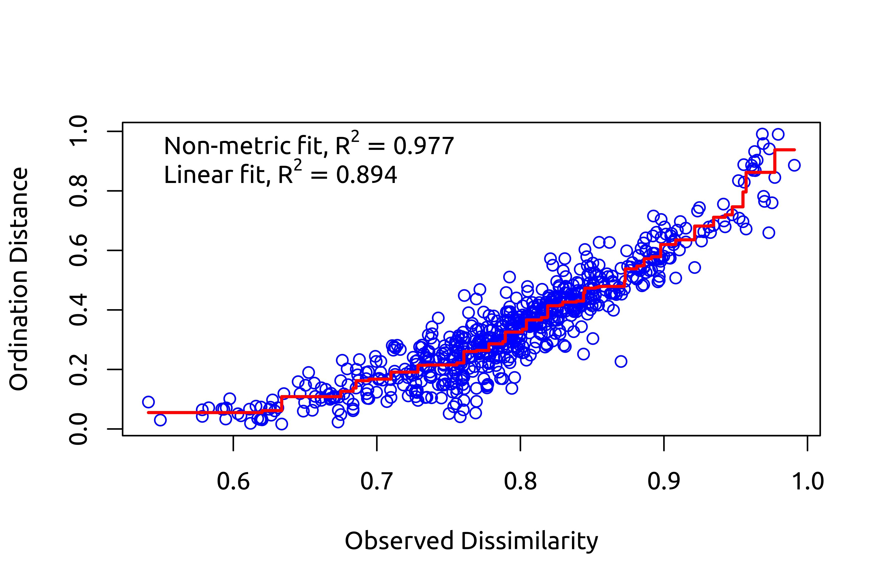

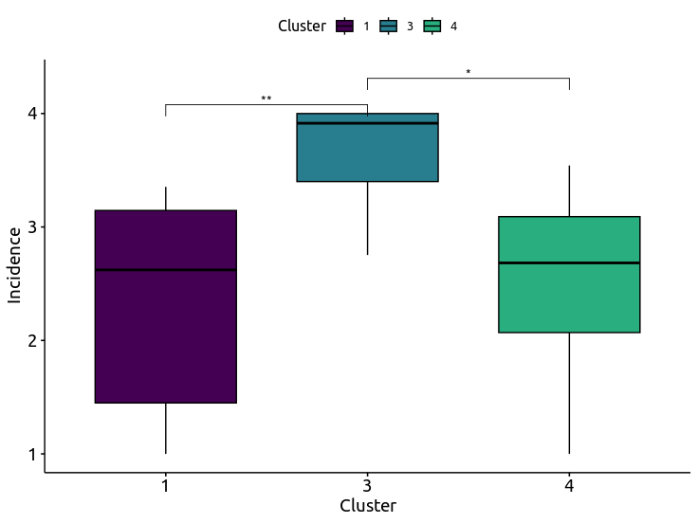
Figure 2 Boxplots showing the significative difference between the three forest-dominated cluster based on the dieback incidence values.

