Electronic Supplementary Material (ESM)

to Bányai et al.: Identification of Superior Spring Durum Wheat Genotypes under Irrigated and Rain-fed Conditions

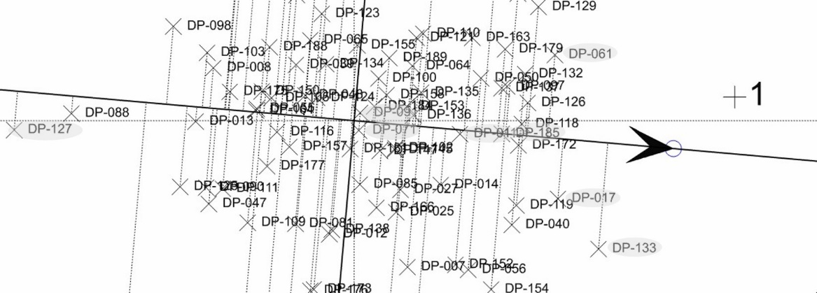
Figure S1. Ranking biplot method of rain-fed replications based on the mean performance and stability of the genotypes.

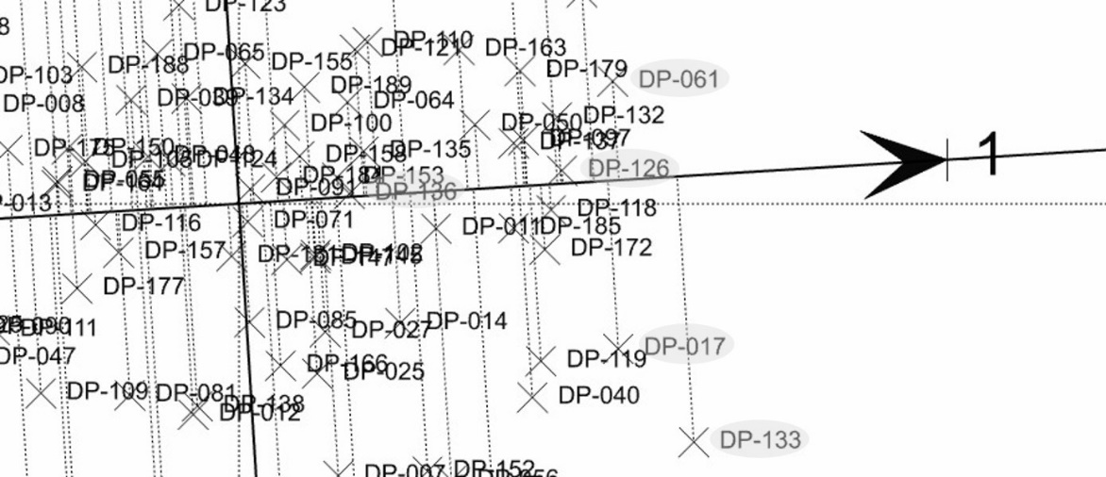
Figure S2. The order of the genotypes based on their yields in the rain-fed replications of 2011 with the ranking biplot method.

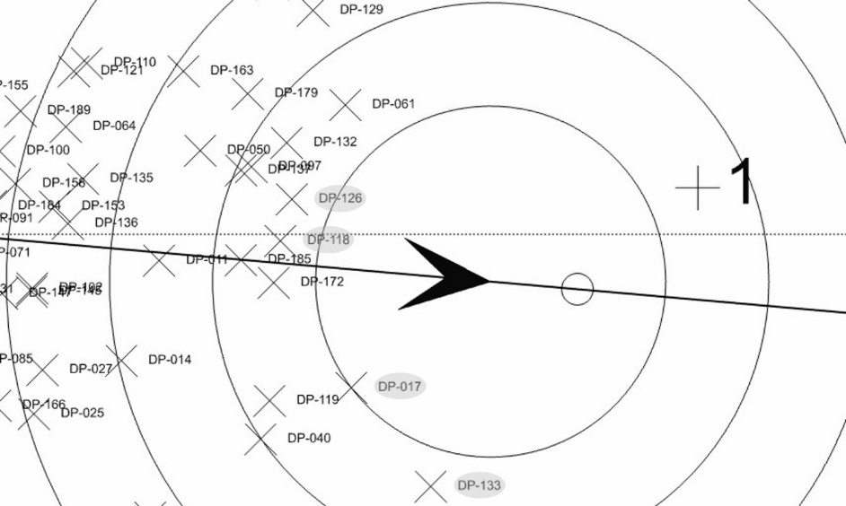
Figure S3. Comparison of genotypes with the ideal genotype.

