Supplementary Material

Nitrogen supplying capability of wool pellets as an alternative fertilizer depending on soil biological activity

Flórián Kovács^{1,2*}, Enikő Papdi¹, Ingrid Gyalai², Borbála Biró¹, Katalin Juhos¹

¹Department of Agro-Environmental Studies, Hungarian University of Agriculture and Life Sciences, Villányi str. 29-43, H-1118 Budapest, Hungary

²Institute of Plant Sciences and Environmental Protection, University of Szeged, Andrássy út 15, 6800 Hódmezővásárhely, Hungary

Table S1. Composition of the applied nutrient solutions in the experiment
Composition | Treatments
Composition | Control (CTRL) | Reference N-solution (RN) | Wool Pellets (WP)
NH₃NO₃ (2.5 mM) | − | + | −
K₂SO₄ (2 mM) | + | + | +
KH₂PO₄ (1 mM) | + | + | +
MgSO₄ (0.5 mM) | + | + | +
H₃BO₃ (25 μM) | + | + | +
CuSO₄ (0.5 μM) | + | + | +
ZnSO₄ (2 μM) | + | + | +
MnCl₂ (2 μM) | + | + | +
H₂MoO₄ (0.5 μM) | + | + | +
Fe-EDDHA (20 μM) | + | + | +

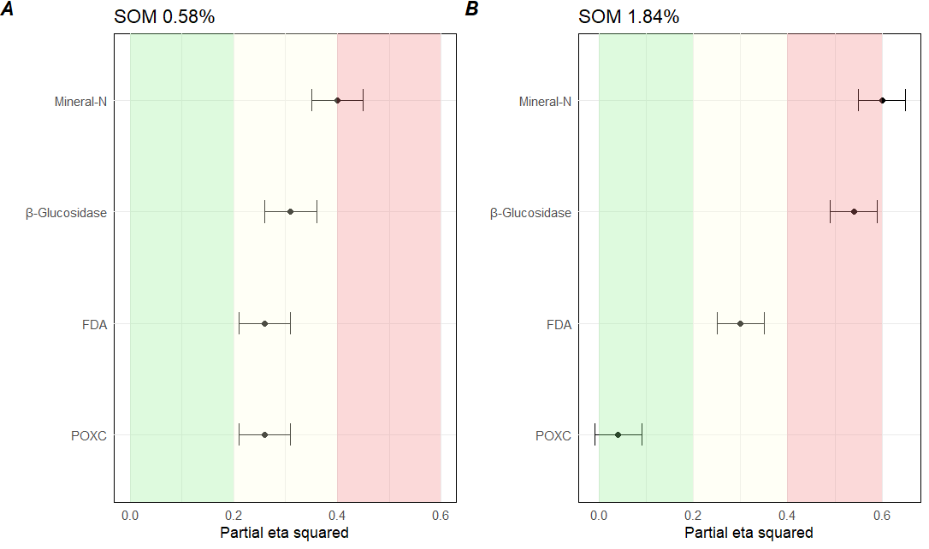
Fig S1. Effect of treatments on the partial η² value of the dependent variables (POXC – permanganate oxidizable organic carbon content, FDA – fluorescein diacetate activity, β-glucosidase activity, and the mineral nitrogen content – NH₄⁺ + NO₃⁻ −N of the soil) with their 90% confidence interval. Partial η² is classified and presented in green (low effect size), medium yellow (medium effect size) and red (large effect size).

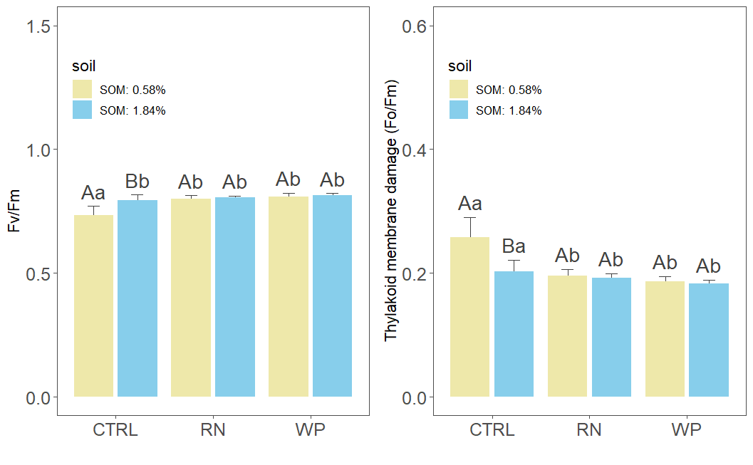
Fig S2. Effect of treatments on A) maximum quantum yield of PSII (Fv/Fm) and B) thylakoid membrane damage (Fo/Fm) in two types of soil. CTRL: control, RN: reference N-solution, WP: wool pellets. Different letters indicate significantly different groups. Capital letters indicate significant differences between soils (SOM: 0.58%; SOM: 1.84%) under the same treatment. Lowercase letters indicate comparisons of treatments with fixed soil organic matter content (Games-Howell post hoc test, P<0.05).

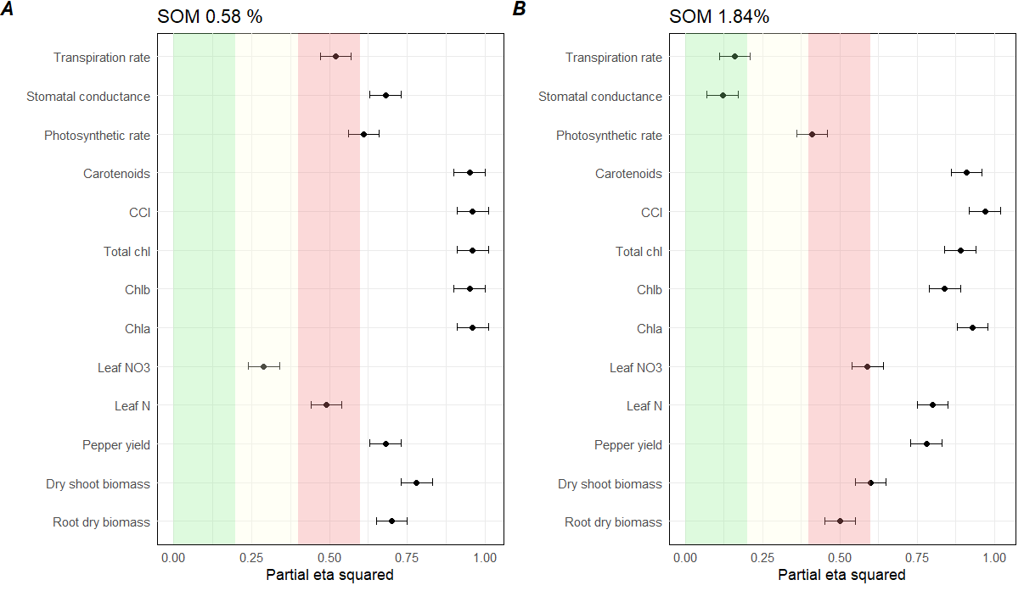
Fig S3. Effect of treatments on the partial η² value of the dependent variables with their 90 % confidence interval. Partial η² is classified and presented in green (low effect size), medium yellow (medium effect size) and red (large effect size).

