Title
The effect of physical activity on cardiorespiratory fitness and markers of cardiovascular disease risk during menopause: A systematic review and meta-analysis of randomised-controlled trials.
Journal
Journal of Science in Sport and Exercise
Author information
Amie Woodward¹ ORCID: 0000-0002-9579-4012. Corresponding author: a.woodward1@yorksj.ac.uk.
Amanda J. Mason-Jones³ ORCID: 0000-0002-4292-3183
Matthew Faires¹
Victoria Jones¹
Alexander Beaumont² ORCID: 0000-0002-5773-6356
¹ York St John University (Institute for Health and Care Improvement), York, England
² York St John University (School of Science, Technology, and Health), York, England
³ University of York (Department of Health Sciences), York, England

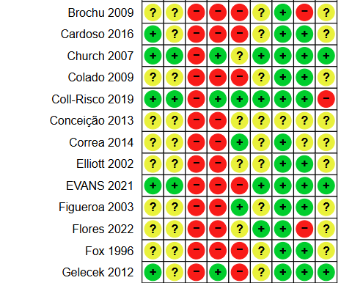
Online Resource 3. Risk of Bias Summary Graph Across Each Domain in all Studies