Title
The effect of physical activity on cardiorespiratory fitness and markers of cardiovascular disease risk during menopause: A systematic review and meta-analysis of randomised-controlled trials.
Journal
Journal of Science in Sport and Exercise
Author information
Amie Woodward¹ ORCID: 0000-0002-9579-4012. Corresponding author: a.woodward1@yorksj.ac.uk.
Amanda J. Mason-Jones³ ORCID: 0000-0002-4292-3183
Matthew Faires¹
Victoria Jones¹
Alexander Beaumont² ORCID: 0000-0002-5773-6356
¹ York St John University (Institute for Health and Care Improvement), York, England
² York St John University (School of Science, Technology, and Health), York, England
³ University of York (Department of Health Sciences), York, England

Online Resource 6. Forest plots for all meta-analyses in Exercise versus Control.
6.1 Forest plot for outcome: VO₂max/peak (mL/kg/min) in comparison: exercise versus control
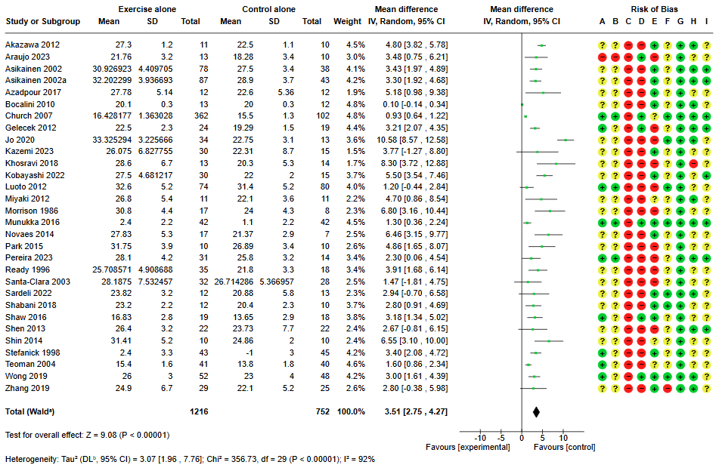
6.2 Forest plot for outcome: Total Cholesterol (mmol/L) in comparison: exercise versus control
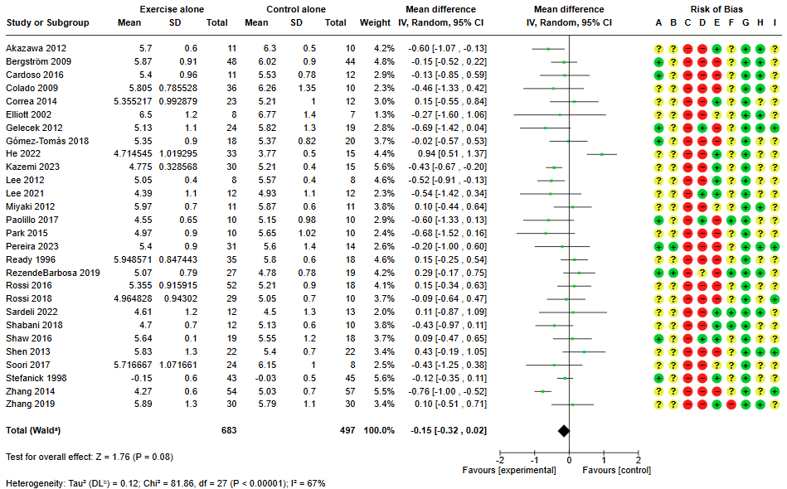

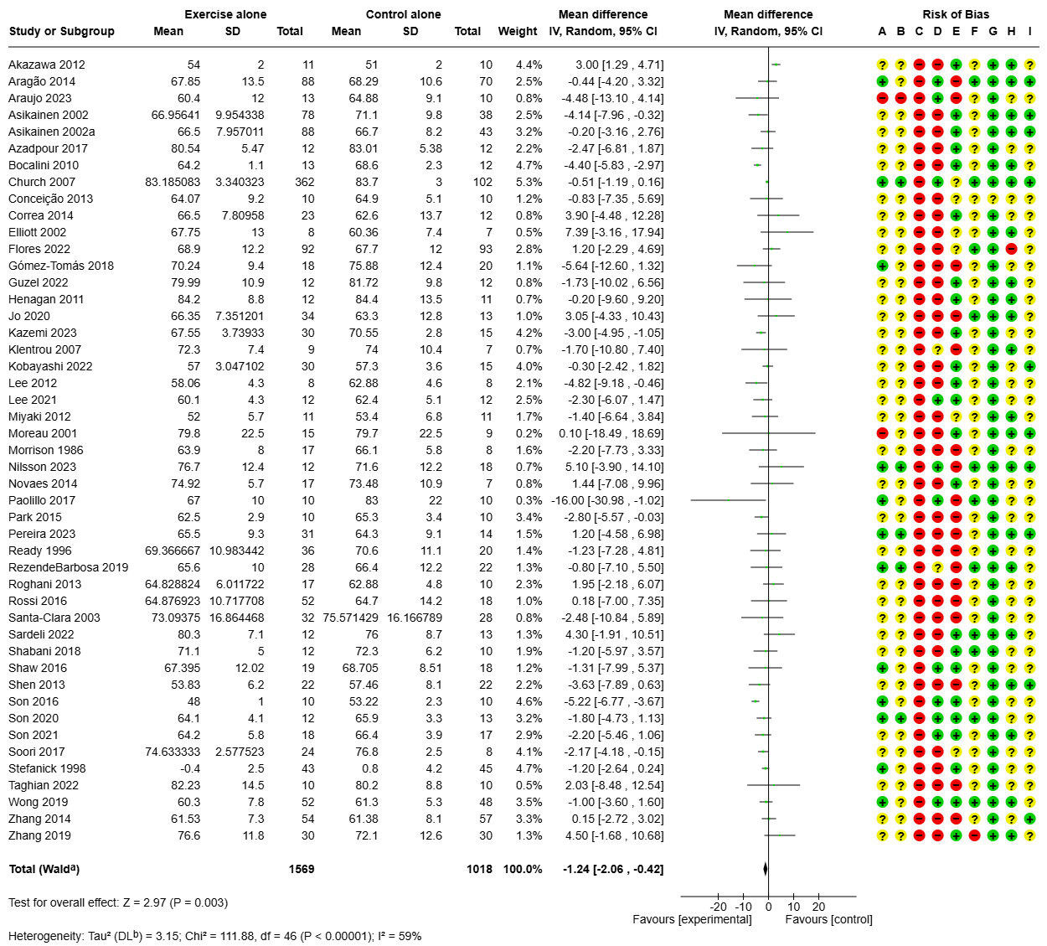
6.3 Forest plot for outcome: Body mass (kg) in comparison: exercise versus control

6.4 Forest plot for outcome: Systolic Blood Pressure (mmHg) in comparison: exercise versus control
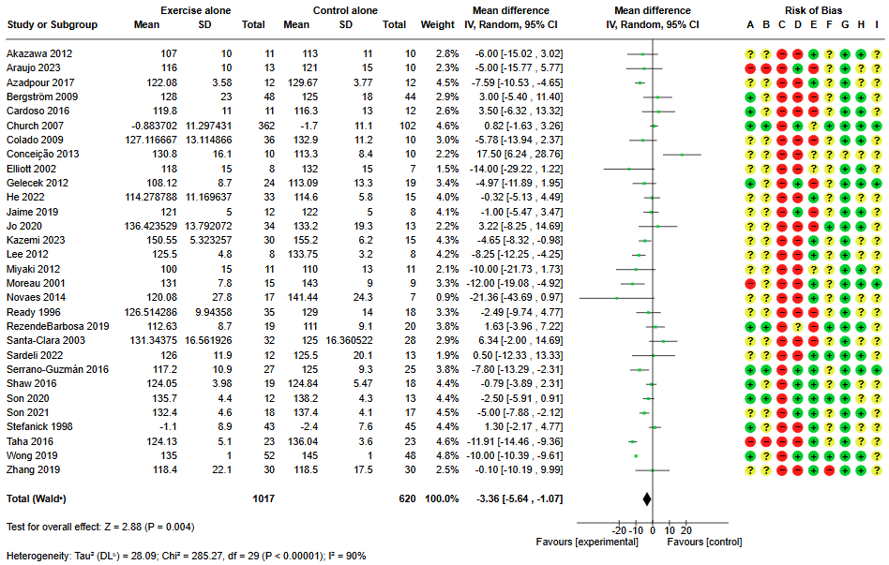
6.5. Forest plot for outcome: Diastolic Blood Pressure (mmHg) in comparison: exercise versus control
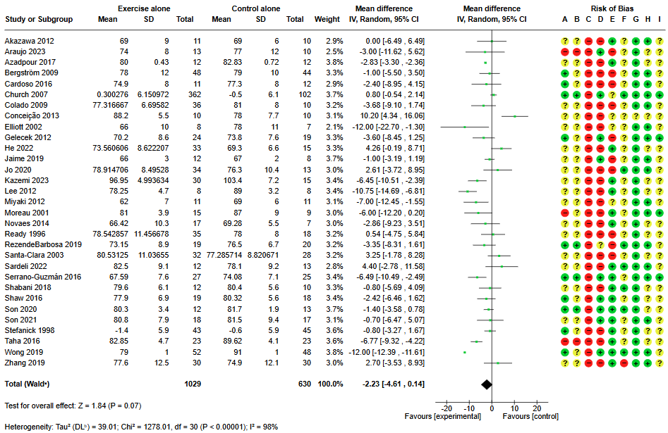
6.6. Forest plot for outcome: Body fat % in comparison: exercise versus control
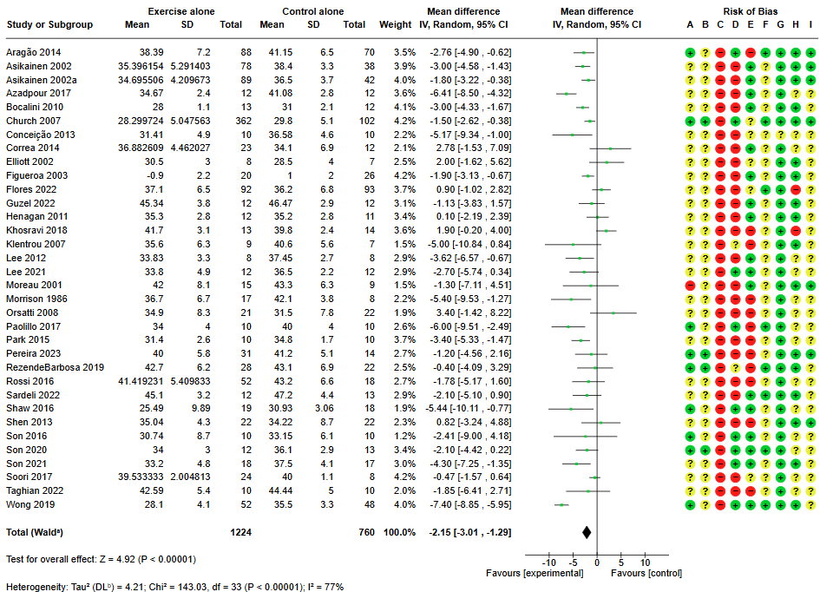
6.7 Forest plot for outcome: BMI in comparison: exercise versus control
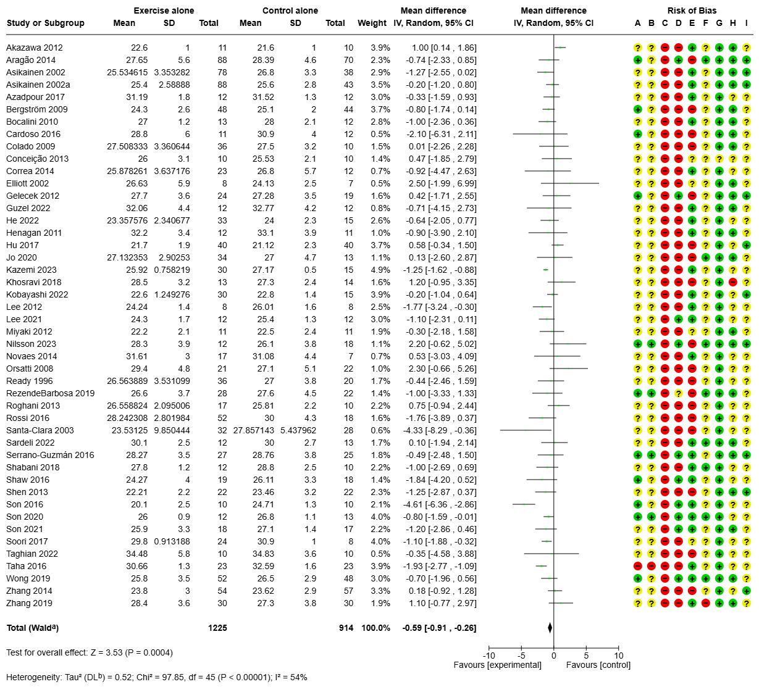
6.8 Forest plot for outcome: HDL (mmol/L) in comparison: exercise versus control
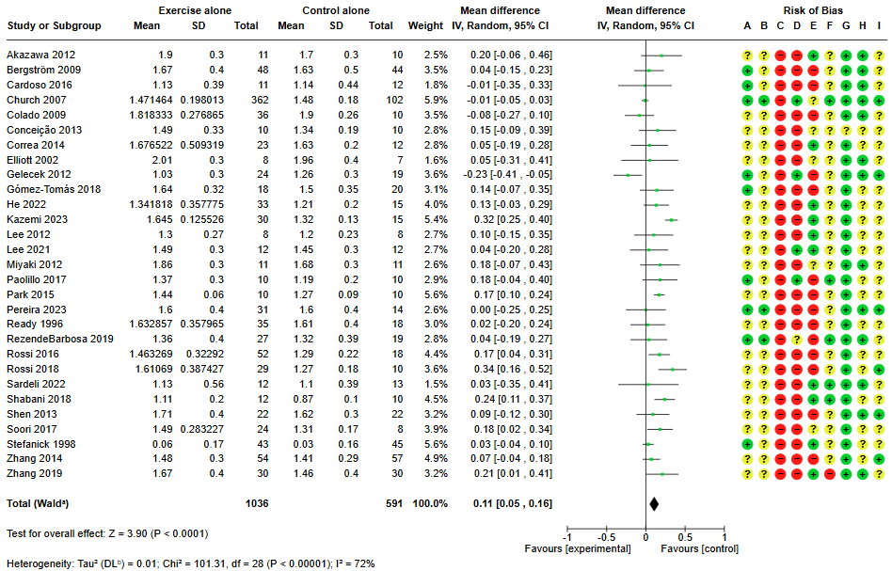
6.9 Forest plot for outcome: LDL (mmol/L) in comparison: exercise versus control
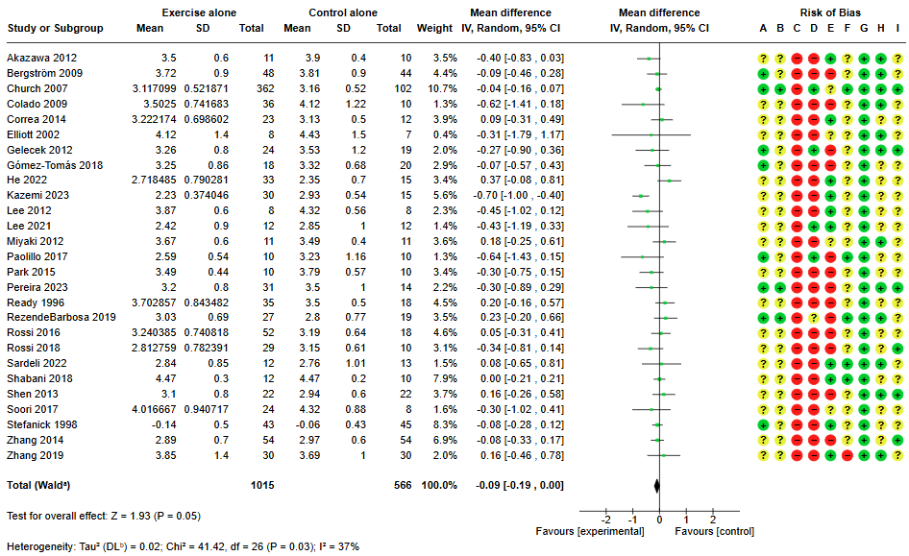
6.10 Forest plot for outcome: Triglycerides (mmol/L) in comparison: exercise versus control
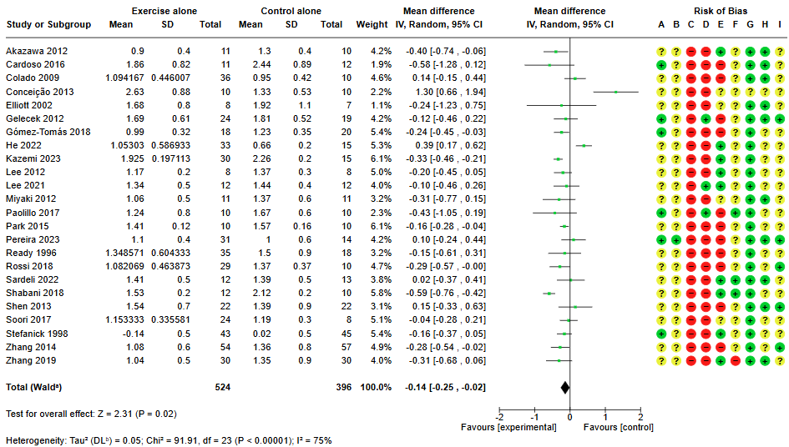

6.11 Forest plot for outcome: Waist circumference (cm) in comparison: exercise versus control
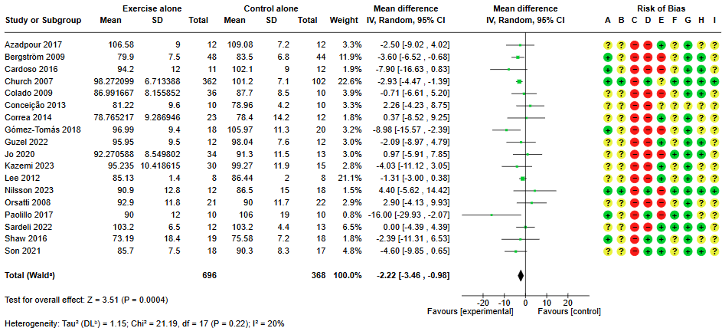

6.12 Forest plot for outcome: Hip circumference (cm) in comparison: exercise versus control
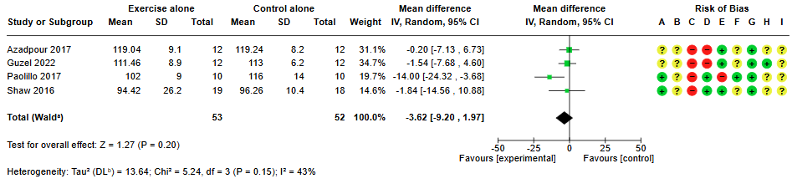

6.13 Forest plot for outcome: FMD (%) in comparison: exercise versus control
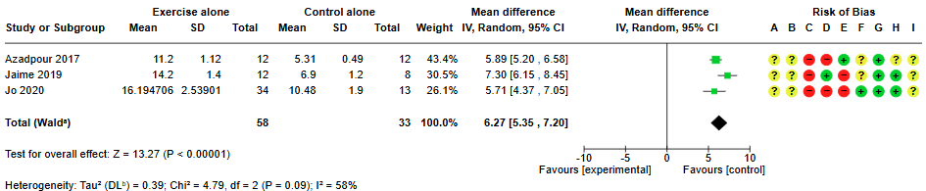

6.14 Forest plot for outcome: Waist-to-hip ratio in comparison: exercise versus control
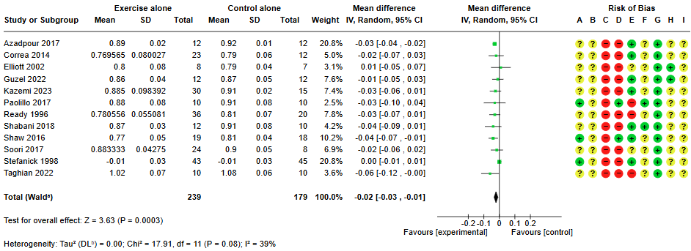

6.15 Forest plot for outcome: Fat Free Mass (kg) in comparison: exercise versus control
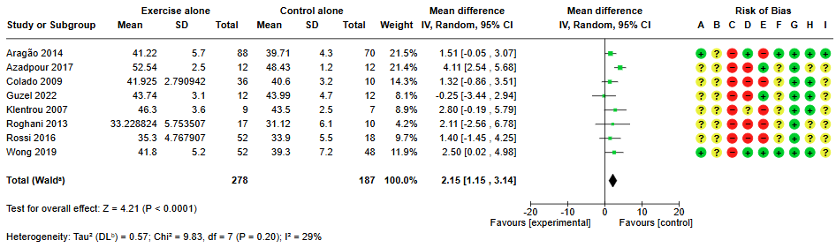

6.16 Forest plot for outcome: Fat Mass (kg) in comparison: exercise versus control
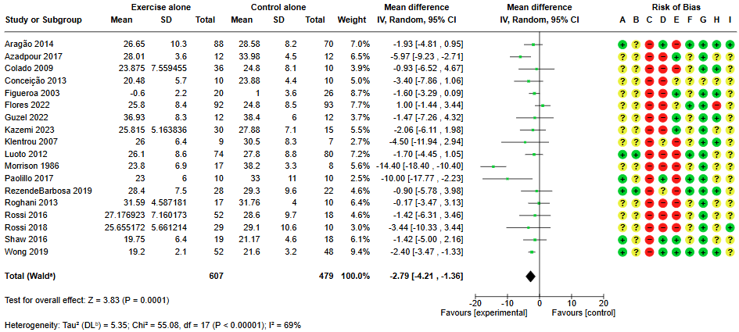

6.17 Forest plot for outcome: TC:HDL ratio in comparison: exercise versus control
