Fine-scale habitat selection of a small mammalian urban adapter; the West European hedgehog (Erinaceus europaeus)
Abigail Gazzard^{1*}, Richard W. Yarnell² & Philip J. Baker¹
¹ School of Biological Sciences, University of Reading, Whiteknights, Reading, Berkshire, RG6 6AH, UK
² School of Animal, Rural and Environmental Sciences, Brackenhurst Campus, Nottingham Trent University, Southwell, NG25 0QF, UK
*Correspondence: Abigail.Gazzard@pgr.reading.ac.uk

Supplementary Information

Missing GPS fixes

Introduction
Analysis of the hedgehog tracking data for those animals fitted with GPS tags indicated that a large proportion of the location fixes were not recorded because of a failure to connect with sufficient satellites. This limited “sky-view” is caused by e.g. dense canopy cover (Ironside et al., 2017) and / or, in the case of urban studies, proximity to (or even inside / underneath) buildings. Therefore, we assessed the patterns of missing GPS fixes to examine whether they were associated with abnormal movements or atypical habitats, which would indicate a potential bias in the data itself (i.e. missing fixes were associated with particular habitats).

Data analysis
The potential effect(s) of missing GPS fixes were investigated in five ways. First, we collated the frequency with which different numbers of consecutive fixes were or were not recorded to identify whether missing fixes tended to occur in large blocks or not. Second, we quantified the proportion of programmed fixes that were recorded versus not recorded, and how these varied throughout the tracking regimen (22:00-04.00). This would help identify whether missing fixes tended to occur at specific times of the night or not.

Third, locations from nights where animals were tracked using VHF tags (all 73 fixes were recorded every night for these animals) and the fixes from each full GPS tracking session that were recorded were used to construct 100% minimum convex polygons (nightly MCPs) in QGIS 3.4.4, representing nightly areas ranged by each hedgehog. If a hedgehog was tracked for >1 night, then the mean of their nightly MCPs was calculated. Differences in mean nightly MCP areas between sexes and tag types were tested using independent t-tests.

Fourth, the minimum straight-line distance moved between different blocks of consecutive fixes where the intervening locations were fully or partially recorded versus those where no intervening locations were recorded was quantified (see Supplementary Figure 1). For the latter, for example: the term “1 fix missing” refers to a block of three consecutive fixes where the first and third fixes were recorded but the intervening fix was missing; whereas the terms “2 fix missing” and “3 fix missing” refer to blocks of four and five consecutive fixes where the first and last fixes were recorded but the intervening two or three fixes were not recorded (Supplementary Figure 1a). Conversely, the term “1 fix not missing” refers to a block of three consecutive fixes where all three locations were recorded, whereas the terms “2 fix not missing” and “3 fix not missing” refer to blocks of four and five consecutive fixes where the first and last fixes were recorded but at least one of the intervening two or three fixes were also recorded (Supplementary Figure 1b). Differences in the median distance moved between pairs of blocks of the same length where the intervening fixes were not or were at least partially recorded were compared using a series of Mann-Whitney tests.
Last, the possible effect of hedgehogs moving into different habitats which may be particularly prone to fixes not being recorded was investigated by comparing the habitat composition of pooled home range areas (calculated as the minimum convex polygon, ‘MCP’, around all known fixes) against the habitat composition of pooled home ranges after a 100m buffer zone was added to the points immediately preceding and following a block (of any size) of missing fixes. We tested whether the proportions of each habitat type (see the main text) in MCPs based on known locations only versus MCPs based on known locations plus buffered locations were statistically different by calculating Wilks’ lambda.

Supplementary Figure 1. Schematic illustrating how distance travelled (m) was calculated for blocks of consecutive fixes where (a) all intervening fixes were missing (D_{M}) and (b) where at least some of the intervening fixes were also recoded (D_{R}). The former are referred to as “1 fix missing”, “2 fixes missing”, etc. to indicate the number of consecutive fixes where data were not recorded. The latter are referred to as “1 fix not missing”, “2 fixes not missing”, etc. to indicate that one or all of the intervening consecutive fixes were recorded. Consecutive blocks of cells shaded (a) red or (b) orange indicate the locations within the data record used to calculate D_{M} and D_{R}, respectively: in all cases, distances were calculated as the straight-line distance between the first and last recorded location in that block of cells.
(a) Instances where all intervening fixes were missing (D_{M})
Data record | 1 fix missing |  |  |  | 2 fixes  missing |  | 3 fixes  missing
Fix recorded
Fix recorded
Fix missed
Fix missed
Fix recorded
Fix missed
Fix missed
Fix missed
Fix recorded
Fix missed
Fix recorded
Fix recorded
Fix missed
Fix recorded
Fix missed
Fix missed
Fix recorded
Fix recorded
Fix recorded
Fix recorded
Fix recorded
Fix recorded
Fix recorded
Fix recorded
Fix missed
Fix recorded
Fix missed
Fix recorded
Fix missed
Fix missed
Fix missed
Fix recorded
Fix missed
Fix missed
Fix missed
Fix recorded

(b) Instances where one or more intervening fixes were also recorded (D_{R})
Data record | 1 fix not missing |  |  |  |  | 2 fixes not  missing |  |  |  |  |  |  |  | 3 fixes not  missing
Fix recorded
Fix recorded
Fix missed
Fix missed
Fix recorded
Fix missed
Fix missed
Fix missed
Fix recorded
Fix missed
Fix recorded
Fix recorded
Fix missed
Fix recorded
Fix missed
Fix missed
Fix recorded
Fix recorded
Fix recorded
Fix recorded
Fix recorded
Fix recorded
Fix recorded
Fix recorded
Fix missed
Fix recorded
Fix missed
Fix recorded
Fix missed
Fix missed
Fix missed
Fix recorded
Fix missed
Fix missed
Fix missed
Fix recorded

Results
Overall, nine hedgehogs were GPS tracked for a total of 71 nights (range: 6-10 nights each). Excluding instances where the animal’s tag was attached at the start and / or removed at the end of its tracking period (N = 448 fixes), tags were potentially able to record a total of 4,735 locations; of these, a total of 2496 fixes (57.1%) were recorded. The majority of missing fixes (N = 2239) were single locations (N = 488; 21.8%: Supplementary Figure 2). Cumulatively, 64.4% of missing fixes (N = 1442) occurred in blocks of 1-5 locations, 20.0% occurred in blocks of 6-10 fixes (N = 448) and 11.8% occurred in blocks of 11-20 fixes (N = 264). However, one block each of 22, 28 and 35 consecutively missed fixes were observed (N = 85, 3.8%: Supplementary Figure 2).

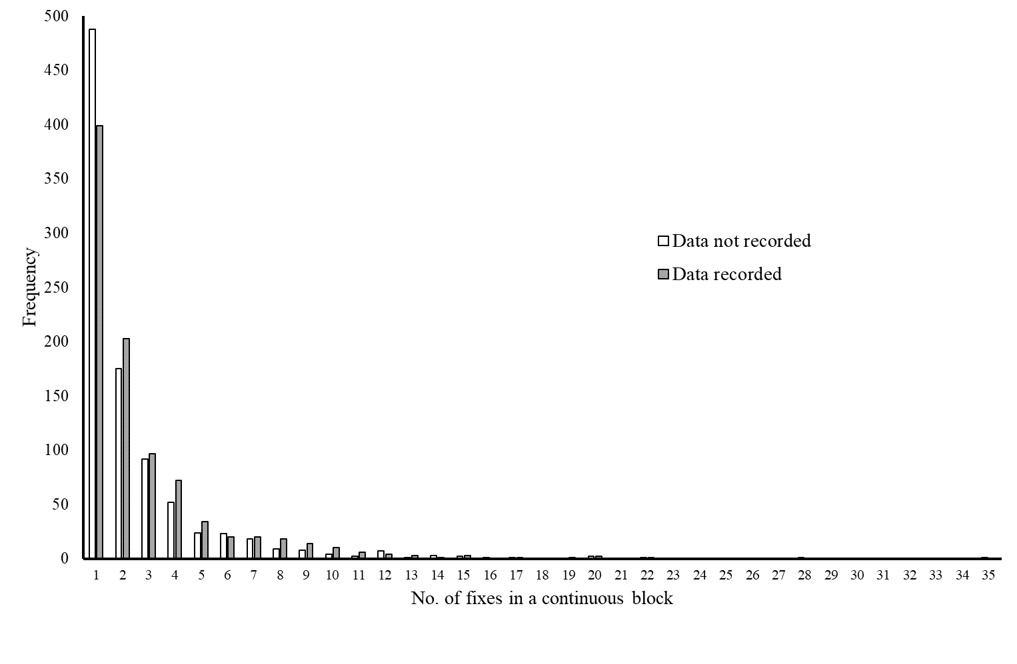
Supplementary Figure 2. Summary of the number of recorded versus missed locations documented for nine hedgehogs tracked for a total of 71 nights in 2016-2018 inclusive. Data were collated in the context of the length of continuous sequential blocks of recorded or missed fixes (see Supplementary Figure 1).

Fixes recorded in relation to time of night
In relation to time during the nightly tracking regimen, and excluding instances where tags were not attached, proportionally more fixes were recorded in the latter half of the night, although there was a lot of variation across all parts of the tracking period (Supplementary Figure 3).

Supplementary Figure 3. Summary of the percentage of location fixes recorded for GPS-tagged hedgehogs in relation to the time of night. Hedgehogs were tracked for a continuous 6-hour period from 22:00 (10pm) to 04:00 (4am) with fixes recorded every five minutes.

Difference between nightly range area in relation to tag type
Although the mean (± SD) nightly MCP area of males (3.54 ± 3.06ha) was significantly larger than that of females (0.71 ± 0.31ha: t₁₂ = 3.33, p < 0.01), nightly MCP area did not differ significantly between tag types for either sex (males: t₁₁ = -1.21, p = 0.25; females: t₁₃ = 1.69, p = 0.11).

Distance moved between blocks of missing and non-missing fixes
In general terms, the straight-line distances moved between blocks of consecutive fixes of different length were broadly similar for those instances where all intervening fixes were missing versus those instances where at least one intervening fix was recorded (Supplementary Table 1; Supplementary Figure 4). Where a significant difference was detected, hedgehogs had tended to move further where intervening data had been recorded versus those instances where intervening data were completely absent (Supplementary Table 1).

Supplementary Table 1. Summary of the analyses comparing median distance moved: (i) across blocks of consecutive missing fixes (e.g. “2 fix missing” indicates instances where two consecutive fixes were missing, but the positions before and after these two fixes were known); versus (ii) between any two fixes of a given time span where some of the intervening fixes were also known (e.g. “2 fix not missing” indicates a segment of four fixes where the first and last positions were known but where at least one of the intervening two fixes was also known). Data were analysed using a series of Mann-Whitney tests. Data are illustrated in Figure 3.
Length of  block of  fixes being  considered  (B)¹ | Max. no.  of missing  fixes within  block² | Median distance  (D_{M}) moved  where fixes were  missing (N)³ | Median distance  (D_{R}) moved  where fixes were  not missing (N)⁴ | Mann-Whitney test | Conclusion⁵
3 | 1 | 20.5 (448) | 23.5 (1076) | W = 322890.0, P = 0.017 | Recorded > Missed
4 | 2 | 22.6 (159) | 27.2 (1301) | W = 105826.0, P = 0.040 | Recorded > Missed
5 | 3 | 26.7 (85) | 31.9 1323) | W = 54336.5, P = 0.127 | NS
6 | 4 | 24.2 (45) | 35.5 (1362) | W = 26046.5, P = 0.036 | Recorded > Missed
7 | 5 | 27.6 (19) | 38.5 (1309) | W = 10810.0, P = 0.274 | NS
8 | 6 | 28.4 (17) | 40.5 (1320) | W = 10144.0, P = 0.437 | NS
9 | 7 | 25.6 (14) | 43.2 (1265) | W = 6172.0, P = 0.043 | Recorded > Missed
10 | 8 | 30.4 (7) | 46.2 (1248) | W = 3249.5, P = 0.231 | NS
11 | 9 | 18.9 (5) | 47.9 (1233) | W = 1771.0, P = 0.097 | NS
12 | 10 | 21.7 (4) | 51.1 (1188) | W = 1326.5, P = 0.123 | NS
13 | 11 | - (0) |  | - | -
14 | 12 | 30.2 (4) | 54.6 (1136) | W = 1515.0, P = 0.244 | NS
¹ B is the total number of consecutive fixes under consideration; the first and last fix within this block must be known, but the number of known fixes between these known locations can vary from 1 to (B-2). These data were used to calculate D_{R}. ² This is the maximum number of fixes in a column of length B that can be missing; these data were used to calculate D_{M}. ³ D_{M} is the median distance moved between a block of fixes of length B where the first and last fixes were known but all intervening locations were missing. N is total sample size. ⁴ D_{R} is the median distance moved between a block of fixes of length B where the first and last fixes were known and at least one intervening fix was also known. N is total sample size. ⁵ “Recorded > Missed” indicates that the median distance travelled across a set of consecutive fixes of length B where at least one intervening fix was recorded (D_{R}) was significantly greater than the median distance travelled across a set of consecutive fixes of length B where all intervening fixes were missing (D_{M}). NS indicates median distances travelled were not significantly different.

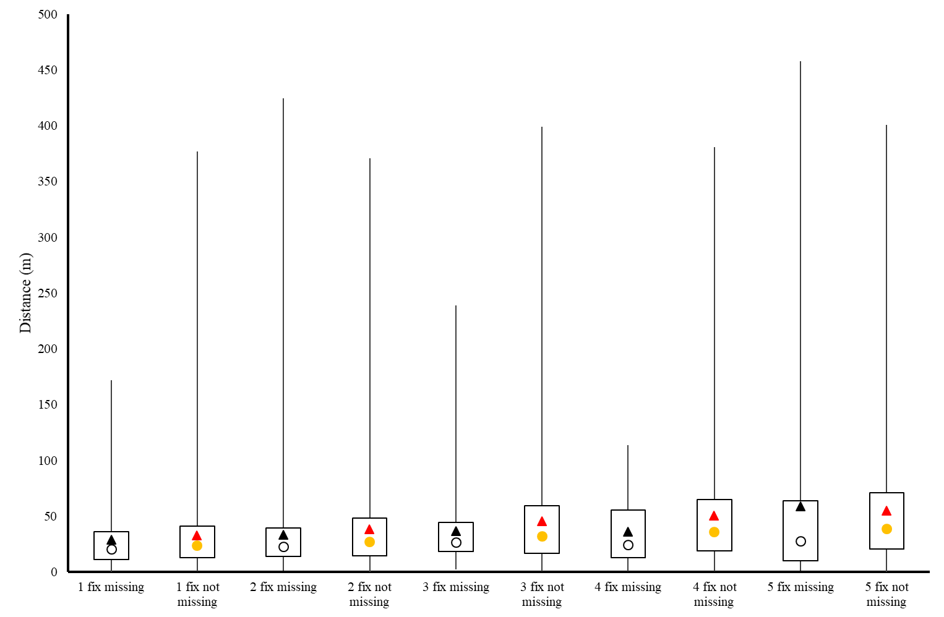
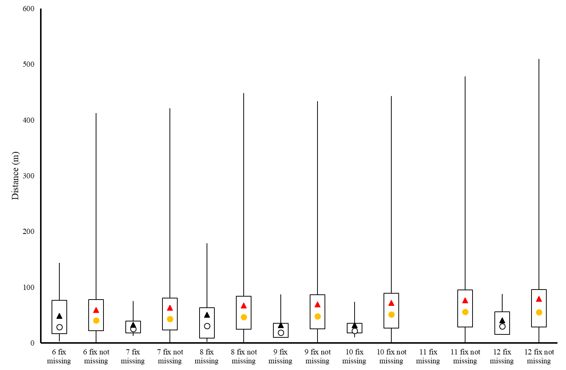
Supplementary Figure 4. Boxplots indicating distance moved (metres): (i) across blocks of consecutive missing fixes; versus (ii) between any two fixes of a given time span where some of the intervening fixes were also known (see Supplementary Figure 1). Triangle symbols indicate mean values; circles indicate median values. Vertical error bars indicate maximum and minimum values; boxes indicate inter-quartile ranges. Sample sizes are indicated in Supplementary Table 1.

Habitat composition
The proportion of habitats present in pooled MCPs of known locations did not significantly differ from the proportion of habitats present in pooled MCPs generated by the buffered GPS locations (Λ = 0.35, p = 0.78). As such, the observed habitat compositions in this study are not considered to have been markedly affected by missing GPS fixes.

Summary and conclusion
There was little evidence that missing GPS locations were associated with unusual movements nor atypical habitats: (i) the duration of blocks of missing fixes closely mirrored the pattern observed for recorded GPS locations; (ii) the distance moved across blocks of missing fixes was broadly similar to that observed for straight-line distances moved between know locations (and where significant pair-wise differences were recorded, the distance moved across missing fixes tended to be smaller); (iii) there was no significant difference in area ranged nightly based on VHF tagged animals (where all location fixes were recorded every night) versus GPS tagged animals; and (iv) the addition of a 100m buffer around all fixes preceding or following a block of missing fixes did not significantly affect the habitat composition of individual pooled ranges. However, the proportion of GPS locations that were recorded tended to be lower at the start of the night and higher at the end of the night, although there was a lot of variation in all time periods.

Although we do not have definitive data, this pattern of missing fixes would be consistent with GPS-tagged hedgehogs moving primarily within and between residential gardens but periodically being in proximity to structures that could potentially block their GPS signal, such as fences or buildings, but also perhaps underneath structures such as decking and sheds where they may be resting. In addition, hedgehogs are often fed by householders in covered feeding stations to protect the food from being stolen by cats and foxes. Given that hedgehogs are likely to be familiar with the location of supplementary feeding stations, and therefore likely competing with one another, it is plausible that they may tend to access this food source early in the night; as such, this pattern of foraging behaviour might also explain the increased tendency to miss fixes early in the night.

Overall, therefore, we do not believe that there are likely to be any significant biases in the habitat types nor individual gardens where the positions of GPS tagged hedgehogs were and were not recorded and that the results presented are valid. However, at the same time, we acknowledge that these assumptions do need to be verified. As a consequence, the results arising from this study should be considered a preliminary investigation of the factors affecting the use of individual gardens by urban hedgehogs in the UK.
Habitats
Supplementary Table 2. The quantity (hectares; ha) and proportion of habitats available within (a) the study area and (b) pooled hedgehog ranges, and (c) the quantity and proportion of location fixes recorded in habitats of pooled ranges. NB. In the analyses, buildings were excluded, and scrub, woodland, roads and other were combined into other.
(a) study area
Measure | Front gardens |  |  | Back gardens |  |  | Other |  |  |  |  |  | Total
Measure | Detached | Semi-detached | Terraced | Detached | Semi-detached | Terraced | Amenity grassland | Scrub | Woodland | Roads | Buildings | Other | Total
ha | 34.53 | 16.94 | 7.38 | 67.55 | 39.00 | 13.62 | 94.59 | 8.92 | 57.11 | 62.67 | 79.22 | 99.94 | 581.47
Proportion | 0.06 | 0.03 | 0.01 | 0.12 | 0.07 | 0.02 | 0.16 | 0.02 | 0.10 | 0.11 | 0.14 | 0.17 | 1.00

(b) habitats in pooled ranges. Habitat measurements are provided first in hectares, and then in proportions
ID | Sex | Measure | Front gardens |  |  | Back gardens |  |  | Other |  |  |  |  |  | Total
ID | Sex | Measure | Detached | Semi-detached | Terraced | Detached | Semi-detached | Terraced | Amenity grassland | Scrub | Woodland | Roads | Buildings | Other | Total
1 | M | ha | 0.30 | 0.20 | 0.11 | 0.38 | 0.49 | 0.32 | 0.34 | 0.04 | 0.03 | 1.08 | 1.04 | 0.69 | 5.03
2 | M | ha | 0.01 | 0.01 | 0.14 | 0.00 | 0.02 | 0.19 | 0.11 | 0.04 | 0.00 | 0.21 | 0.18 | 0.26 | 1.16
3 | M | ha | 0.37 | 0.02 | 0.25 | 0.44 | 0.07 | 0.48 | 0.08 | 0.02 | 0.00 | 0.85 | 1.15 | 0.54 | 4.26
4 | M | ha | 0.09 | 0.03 | 0.00 | 0.10 | 0.09 | 0.00 | 0.00 | 0.16 | 0.00 | 0.27 | 0.09 | 0.24 | 1.07
5 | M | ha | 0.04 | 0.02 | 0.02 | 0.04 | 0.05 | 0.07 | 0.03 | 0.00 | 0.00 | 0.01 | 0.12 | 0.09 | 0.49
6 | M | ha | 0.16 | 0.21 | 0.19 | 0.25 | 0.45 | 0.67 | 0.58 | 0.02 | 0.17 | 0.83 | 0.99 | 1.10 | 5.61
7 | M | ha | 0.03 | 0.13 | 0.00 | 0.09 | 0.25 | 0.00 | 0.00 | 0.00 | 0.00 | 0.10 | 0.19 | 0.05 | 0.83
8 | M | ha | 0.27 | 0.04 | 0.02 | 0.48 | 0.17 | 0.01 | 0.23 | 0.16 | 0.00 | 0.47 | 0.50 | 0.40 | 2.76
9 | M | ha | 0.89 | 0.17 | 0.83 | 1.08 | 0.26 | 1.46 | 0.97 | 0.02 | 0.14 | 2.15 | 2.77 | 2.18 | 12.92
10 | M | ha | 0.46 | 0.27 | 0.86 | 0.86 | 0.55 | 1.60 | 1.11 | 0.41 | 0.06 | 1.88 | 2.62 | 2.10 | 12.78
11 | M | ha | 2.68 | 1.12 | 0.00 | 6.57 | 2.82 | 0.00 | 0.00 | 0.02 | 0.00 | 1.93 | 3.14 | 2.68 | 20.98
12 | M | ha | 2.48 | 0.37 | 0.00 | 5.21 | 1.26 | 0.00 | 2.59 | 1.22 | 9.11 | 1.56 | 2.15 | 3.11 | 29.05
13 | M | ha | 0.20 | 0.02 | 0.67 | 0.13 | 0.03 | 0.95 | 0.17 | 0.11 | 0.00 | 0.39 | 1.26 | 1.48 | 5.42
14 | F | ha | 0.29 | 0.04 | 0.82 | 0.28 | 0.06 | 1.20 | 0.17 | 0.41 | 0.00 | 0.89 | 1.63 | 2.64 | 8.43
15 | F | ha | 0.13 | 0.25 | 0.16 | 0.34 | 0.33 | 0.45 | 2.74 | 0.12 | 0.00 | 0.38 | 0.69 | 0.94 | 6.52
16 | F | ha | 0.04 | 0.02 | 0.11 | 0.08 | 0.03 | 0.08 | 0.00 | 0.02 | 0.00 | 0.09 | 0.16 | 0.05 | 0.66
17 | F | ha | 0.00 | 0.08 | 0.00 | 0.01 | 0.15 | 0.00 | 0.00 | 0.00 | 0.00 | 0.05 | 0.12 | 0.03 | 0.44
18 | F | ha | 0.16 | 0.00 | 0.00 | 0.20 | 0.00 | 0.00 | 0.00 | 0.00 | 0.12 | 0.09 | 0.16 | 0.18 | 0.91
19 | F | ha | 0.00 | 0.00 | 0.00 | 0.05 | 0.00 | 0.00 | 1.14 | 0.01 | 0.00 | 0.00 | 0.01 | 0.00 | 1.21
20 | F | ha | 0.01 | 0.00 | 0.05 | 0.03 | 0.00 | 0.11 | 0.17 | 0.02 | 0.00 | 0.02 | 0.14 | 0.07 | 0.62
21 | F | ha | 0.17 | 0.05 | 0.00 | 0.48 | 0.15 | 0.00 | 0.00 | 0.00 | 0.64 | 0.32 | 0.33 | 0.24 | 2.37
22 | F | ha | 0.21 | 0.21 | 0.00 | 0.50 | 0.58 | 0.02 | 0.00 | 0.00 | 0.00 | 0.30 | 0.50 | 0.14 | 2.46
23 | F | ha | 0.07 | 0.04 | 0.04 | 0.09 | 0.07 | 0.06 | 0.16 | 0.00 | 0.00 | 0.08 | 0.24 | 0.10 | 0.96
24 | F | ha | 0.37 | 0.16 | 0.05 | 0.67 | 0.47 | 0.12 | 0.00 | 0.00 | 0.00 | 0.41 | 0.65 | 0.35 | 3.25
25 | F | ha | 0.46 | 0.18 | 0.09 | 1.06 | 0.25 | 0.27 | 3.53 | 0.37 | 0.00 | 0.39 | 0.74 | 2.03 | 9.35
26 | F | ha | 0.03 | 0.01 | 0.21 | 0.03 | 0.00 | 0.46 | 0.27 | 0.02 | 0.00 | 0.19 | 0.53 | 0.52 | 2.28
27 | F | ha | 0.09 | 0.01 | 0.51 | 0.04 | 0.02 | 0.73 | 0.27 | 0.28 | 0.00 | 0.43 | 0.77 | 1.70 | 4.85
28 | F | ha | 0.12 | 0.02 | 0.62 | 0.11 | 0.01 | 0.97 | 0.60 | 0.32 | 0.00 | 0.43 | 1.07 | 1.72 | 5.98
1 | M | Proportion | 0.06 | 0.04 | 0.02 | 0.08 | 0.10 | 0.06 | 0.07 | 0.01 | 0.01 | 0.21 | 0.21 | 0.14 | 1.00
2 | M | Proportion | 0.01 | 0.01 | 0.12 | 0.00 | 0.02 | 0.16 | 0.09 | 0.04 | 0.00 | 0.18 | 0.15 | 0.22 | 1.00
3 | M | Proportion | 0.09 | 0.00 | 0.06 | 0.10 | 0.02 | 0.11 | 0.02 | 0.00 | 0.00 | 0.20 | 0.27 | 0.13 | 1.00
4 | M | Proportion | 0.09 | 0.03 | 0.00 | 0.10 | 0.08 | 0.00 | 0.00 | 0.15 | 0.00 | 0.25 | 0.09 | 0.22 | 1.00
5 | M | Proportion | 0.08 | 0.05 | 0.03 | 0.09 | 0.10 | 0.14 | 0.05 | 0.00 | 0.00 | 0.02 | 0.25 | 0.19 | 1.00
6 | M | Proportion | 0.03 | 0.04 | 0.03 | 0.04 | 0.08 | 0.12 | 0.10 | 0.00 | 0.03 | 0.15 | 0.18 | 0.20 | 1.00
7 | M | Proportion | 0.04 | 0.16 | 0.00 | 0.10 | 0.30 | 0.00 | 0.00 | 0.00 | 0.00 | 0.12 | 0.23 | 0.06 | 1.00
8 | M | Proportion | 0.10 | 0.01 | 0.01 | 0.17 | 0.06 | 0.00 | 0.08 | 0.06 | 0.00 | 0.17 | 0.18 | 0.15 | 1.00
9 | M | Proportion | 0.07 | 0.01 | 0.06 | 0.08 | 0.02 | 0.11 | 0.08 | 0.00 | 0.01 | 0.17 | 0.21 | 0.17 | 1.00
10 | M | Proportion | 0.04 | 0.02 | 0.07 | 0.07 | 0.04 | 0.13 | 0.09 | 0.03 | 0.00 | 0.15 | 0.21 | 0.16 | 1.00
11 | M | Proportion | 0.13 | 0.05 | 0.00 | 0.31 | 0.13 | 0.00 | 0.00 | 0.00 | 0.00 | 0.09 | 0.15 | 0.13 | 1.00
12 | M | Proportion | 0.09 | 0.01 | 0.00 | 0.18 | 0.04 | 0.00 | 0.09 | 0.04 | 0.31 | 0.05 | 0.07 | 0.11 | 1.00
13 | M | Proportion | 0.04 | 0.00 | 0.12 | 0.02 | 0.01 | 0.18 | 0.03 | 0.02 | 0.00 | 0.07 | 0.23 | 0.27 | 1.00
14 | F | Proportion | 0.03 | 0.00 | 0.10 | 0.03 | 0.01 | 0.14 | 0.02 | 0.05 | 0.00 | 0.11 | 0.19 | 0.31 | 1.00
15 | F | Proportion | 0.02 | 0.04 | 0.02 | 0.05 | 0.05 | 0.07 | 0.42 | 0.02 | 0.00 | 0.06 | 0.11 | 0.14 | 1.00
16 | F | Proportion | 0.05 | 0.02 | 0.17 | 0.12 | 0.04 | 0.12 | 0.00 | 0.02 | 0.00 | 0.14 | 0.24 | 0.07 | 1.00
17 | F | Proportion | 0.00 | 0.17 | 0.00 | 0.03 | 0.33 | 0.00 | 0.00 | 0.00 | 0.00 | 0.12 | 0.28 | 0.07 | 1.00
18 | F | Proportion | 0.18 | 0.00 | 0.00 | 0.22 | 0.00 | 0.00 | 0.00 | 0.00 | 0.13 | 0.10 | 0.18 | 0.19 | 1.00
19 | F | Proportion | 0.00 | 0.00 | 0.00 | 0.04 | 0.00 | 0.00 | 0.94 | 0.01 | 0.00 | 0.00 | 0.01 | 0.00 | 1.00
20 | F | Proportion | 0.01 | 0.00 | 0.08 | 0.05 | 0.00 | 0.18 | 0.28 | 0.03 | 0.00 | 0.03 | 0.23 | 0.11 | 1.00
21 | F | Proportion | 0.07 | 0.02 | 0.00 | 0.20 | 0.06 | 0.00 | 0.00 | 0.00 | 0.27 | 0.13 | 0.14 | 0.10 | 1.00
22 | F | Proportion | 0.08 | 0.09 | 0.00 | 0.20 | 0.24 | 0.01 | 0.00 | 0.00 | 0.00 | 0.12 | 0.20 | 0.06 | 1.00
23 | F | Proportion | 0.07 | 0.04 | 0.04 | 0.09 | 0.08 | 0.06 | 0.17 | 0.00 | 0.00 | 0.09 | 0.25 | 0.11 | 1.00
24 | F | Proportion | 0.11 | 0.05 | 0.01 | 0.21 | 0.14 | 0.04 | 0.00 | 0.00 | 0.00 | 0.13 | 0.20 | 0.11 | 1.00
25 | F | Proportion | 0.05 | 0.02 | 0.01 | 0.11 | 0.03 | 0.03 | 0.38 | 0.04 | 0.00 | 0.04 | 0.08 | 0.22 | 1.00
26 | F | Proportion | 0.01 | 0.01 | 0.09 | 0.01 | 0.00 | 0.20 | 0.12 | 0.01 | 0.00 | 0.08 | 0.23 | 0.23 | 1.00
27 | F | Proportion | 0.02 | 0.00 | 0.10 | 0.01 | 0.00 | 0.15 | 0.06 | 0.06 | 0.00 | 0.09 | 0.16 | 0.35 | 1.00
28 | F | Proportion | 0.02 | 0.00 | 0.10 | 0.02 | 0.00 | 0.16 | 0.10 | 0.05 | 0.00 | 0.07 | 0.18 | 0.29 | 1.00

(c) location fixes in each habitat within pooled ranges. Measurements are first provided as the raw number of fixes, then proportion of all fixes
ID | Sex | Measure | Front gardens |  |  | Back gardens |  |  | Other |  |  |  |  |  | Total
ID | Sex | Measure | Detached | Semi-detached | Terraced | Detached | Semi-detached | Terraced | Amenity grassland | Scrub | Woodland | Roads | Buildings | Other | Total
1 | M | no. fixes | 19 | 0 | 0 | 31 | 1 | 2 | 0 | 4 | 0 | 8 | 0 | 8 | 73
2 | M | no. fixes | 0 | 0 | 2 | 0 | 5 | 52 | 3 | 1 | 0 | 6 | 0 | 5 | 73
3 | M | no. fixes | 0 | 0 | 7 | 18 | 0 | 29 | 15 | 0 | 0 | 3 | 0 | 1 | 73
4 | M | no. fixes | 33 | 3 | 0 | 21 | 0 | 0 | 0 | 0 | 0 | 0 | 15 | 0 | 73
5 | M | no. fixes | 21 | 6 | 0 | 12 | 8 | 10 | 9 | 6 | 0 | 0 | 0 | 1 | 73
6 | M | no. fixes | 0 | 8 | 5 | 16 | 4 | 7 | 3 | 0 | 5 | 5 | 8 | 12 | 73
7 | M | no. fixes | 2 | 18 | 0 | 52 | 60 | 0 | 0 | 0 | 0 | 6 | 8 | 0 | 146
8 | M | no. fixes | 33 | 2 | 0 | 81 | 24 | 0 | 0 | 33 | 0 | 5 | 24 | 17 | 219
9 | M | no. fixes | 31 | 4 | 3 | 50 | 9 | 74 | 14 | 0 | 0 | 31 | 58 | 17 | 292
10 | M | no. fixes | 22 | 3 | 20 | 14 | 32 | 48 | 17 | 11 | 0 | 13 | 46 | 20 | 245
11 | M | no. fixes | 12 | 5 | 0 | 124 | 62 | 0 | 0 | 0 | 0 | 15 | 15 | 12 | 244
12 | M | no. fixes | 15 | 3 | 0 | 168 | 22 | 0 | 8 | 4 | 6 | 14 | 42 | 19 | 300
13 | M | no. fixes | 32 | 0 | 18 | 21 | 3 | 35 | 33 | 18 | 0 | 16 | 54 | 49 | 280
14 | F | no. fixes | 8 | 1 | 49 | 1 | 12 | 69 | 13 | 8 | 0 | 38 | 42 | 18 | 257
15 | F | no. fixes | 1 | 9 | 4 | 2 | 11 | 4 | 5 | 1 | 0 | 9 | 13 | 13 | 73
16 | F | no. fixes | 11 | 0 | 22 | 18 | 0 | 16 | 0 | 0 | 0 | 4 | 1 | 1 | 73
17 | F | no. fixes | 0 | 9 | 0 | 18 | 45 | 0 | 0 | 0 | 0 | 0 | 0 | 1 | 73
18 | F | no. fixes | 25 | 0 | 0 | 22 | 6 | 0 | 0 | 10 | 2 | 0 | 6 | 3 | 73
19 | F | no. fixes | 0 | 0 | 0 | 65 | 0 | 0 | 75 | 4 | 0 | 0 | 2 | 0 | 146
20 | F | no. fixes | 16 | 0 | 14 | 43 | 0 | 105 | 17 | 0 | 0 | 1 | 22 | 0 | 219
21 | F | no. fixes | 15 | 2 | 0 | 74 | 0 | 0 | 0 | 0 | 98 | 0 | 9 | 23 | 219
22 | F | no. fixes | 49 | 29 | 0 | 124 | 87 | 0 | 0 | 0 | 0 | 3 | 0 | 0 | 292
23 | F | no. fixes | 93 | 6 | 2 | 134 | 20 | 0 | 13 | 0 | 0 | 2 | 6 | 15 | 292
24 | F | no. fixes | 28 | 1 | 0 | 194 | 47 | 14 | 0 | 0 | 0 | 8 | 0 | 0 | 292
25 | F | no. fixes | 12 | 18 | 3 | 30 | 19 | 11 | 15 | 44 | 0 | 3 | 24 | 29 | 208
26 | F | no. fixes | 7 | 0 | 37 | 4 | 0 | 46 | 99 | 5 | 0 | 11 | 26 | 8 | 243
27 | F | no. fixes | 5 | 5 | 24 | 0 | 6 | 96 | 51 | 3 | 0 | 22 | 17 | 21 | 249
28 | F | no. fixes | 2 | 0 | 29 | 1 | 0 | 66 | 8 | 4 | 0 | 26 | 58 | 33 | 226
1 | M | Proportion | 0.25 | 0.00 | 0.00 | 0.42 | 0.01 | 0.03 | 0.00 | 0.06 | 0.00 | 0.11 | 0.00 | 0.11 | 1.00
2 | M | Proportion | 0.00 | 0.00 | 0.03 | 0.00 | 0.06 | 0.71 | 0.04 | 0.01 | 0.00 | 0.08 | 0.00 | 0.06 | 1.00
3 | M | Proportion | 0.00 | 0.00 | 0.10 | 0.25 | 0.00 | 0.39 | 0.20 | 0.00 | 0.00 | 0.04 | 0.00 | 0.01 | 1.00
4 | M | Proportion | 0.46 | 0.04 | 0.00 | 0.29 | 0.00 | 0.00 | 0.00 | 0.00 | 0.00 | 0.00 | 0.21 | 0.00 | 1.00
5 | M | Proportion | 0.29 | 0.08 | 0.00 | 0.16 | 0.11 | 0.14 | 0.12 | 0.08 | 0.00 | 0.00 | 0.00 | 0.01 | 1.00
6 | M | Proportion | 0.00 | 0.11 | 0.06 | 0.22 | 0.05 | 0.09 | 0.04 | 0.00 | 0.07 | 0.06 | 0.12 | 0.17 | 1.00
7 | M | Proportion | 0.01 | 0.12 | 0.00 | 0.36 | 0.41 | 0.00 | 0.00 | 0.00 | 0.00 | 0.04 | 0.05 | 0.00 | 1.00
8 | M | Proportion | 0.15 | 0.01 | 0.00 | 0.37 | 0.11 | 0.00 | 0.00 | 0.15 | 0.00 | 0.02 | 0.11 | 0.08 | 1.00
9 | M | Proportion | 0.11 | 0.01 | 0.01 | 0.17 | 0.03 | 0.25 | 0.05 | 0.00 | 0.00 | 0.11 | 0.20 | 0.06 | 1.00
10 | M | Proportion | 0.09 | 0.01 | 0.08 | 0.06 | 0.13 | 0.19 | 0.07 | 0.05 | 0.00 | 0.05 | 0.19 | 0.08 | 1.00
11 | M | Proportion | 0.05 | 0.02 | 0.00 | 0.51 | 0.25 | 0.00 | 0.00 | 0.00 | 0.00 | 0.06 | 0.06 | 0.05 | 1.00
12 | M | Proportion | 0.05 | 0.01 | 0.00 | 0.56 | 0.07 | 0.00 | 0.03 | 0.01 | 0.02 | 0.05 | 0.14 | 0.06 | 1.00
13 | M | Proportion | 0.11 | 0.00 | 0.07 | 0.08 | 0.01 | 0.13 | 0.12 | 0.07 | 0.00 | 0.06 | 0.19 | 0.17 | 1.00
14 | F | Proportion | 0.03 | 0.00 | 0.19 | 0.00 | 0.05 | 0.27 | 0.05 | 0.03 | 0.00 | 0.15 | 0.16 | 0.07 | 1.00
15 | F | Proportion | 0.02 | 0.12 | 0.06 | 0.02 | 0.16 | 0.06 | 0.06 | 0.02 | 0.00 | 0.13 | 0.17 | 0.18 | 1.00
16 | F | Proportion | 0.15 | 0.00 | 0.30 | 0.25 | 0.00 | 0.22 | 0.00 | 0.00 | 0.00 | 0.05 | 0.01 | 0.01 | 1.00
17 | F | Proportion | 0.00 | 0.12 | 0.00 | 0.25 | 0.62 | 0.00 | 0.00 | 0.00 | 0.00 | 0.00 | 0.00 | 0.01 | 1.00
18 | F | Proportion | 0.34 | 0.00 | 0.00 | 0.30 | 0.08 | 0.00 | 0.00 | 0.13 | 0.03 | 0.00 | 0.08 | 0.04 | 1.00
19 | F | Proportion | 0.00 | 0.00 | 0.00 | 0.44 | 0.00 | 0.00 | 0.51 | 0.03 | 0.00 | 0.00 | 0.01 | 0.00 | 1.00
20 | F | Proportion | 0.07 | 0.00 | 0.06 | 0.20 | 0.00 | 0.48 | 0.08 | 0.00 | 0.00 | 0.00 | 0.10 | 0.00 | 1.00
21 | F | Proportion | 0.07 | 0.01 | 0.00 | 0.34 | 0.00 | 0.00 | 0.00 | 0.00 | 0.45 | 0.00 | 0.04 | 0.10 | 1.00
22 | F | Proportion | 0.17 | 0.10 | 0.00 | 0.42 | 0.30 | 0.00 | 0.00 | 0.00 | 0.00 | 0.01 | 0.00 | 0.00 | 1.00
23 | F | Proportion | 0.32 | 0.02 | 0.01 | 0.46 | 0.07 | 0.00 | 0.05 | 0.00 | 0.00 | 0.01 | 0.02 | 0.05 | 1.00
24 | F | Proportion | 0.10 | 0.00 | 0.00 | 0.66 | 0.16 | 0.05 | 0.00 | 0.00 | 0.00 | 0.03 | 0.00 | 0.00 | 1.00
25 | F | Proportion | 0.06 | 0.09 | 0.02 | 0.14 | 0.09 | 0.05 | 0.07 | 0.21 | 0.00 | 0.02 | 0.12 | 0.14 | 1.00
26 | F | Proportion | 0.03 | 0.00 | 0.15 | 0.02 | 0.00 | 0.19 | 0.41 | 0.02 | 0.00 | 0.05 | 0.11 | 0.03 | 1.00
27 | F | Proportion | 0.02 | 0.02 | 0.10 | 0.00 | 0.02 | 0.39 | 0.21 | 0.01 | 0.00 | 0.09 | 0.07 | 0.08 | 1.00
28 | F | Proportion | 0.01 | 0.00 | 0.13 | 0.00 | 0.00 | 0.29 | 0.04 | 0.02 | 0.00 | 0.11 | 0.26 | 0.15 | 1.00

