Supporting Information
Summer roost site selection of a declining bat species
Sarah C. Williams¹, Sarah K. Krueger², Gene A. Zirkle¹, Catherine G. Haase³
¹Environmental Division, US Army Fort Campbell, 4718 Polk Road, Fort Campbell, Kentucky 42223, USA
²Department of Biology, University of Washington, 3747 West Stevens Way NE, Seattle, USA 98195, USA
³Department of Biology, Austin Peay State University, 601 College Street, Clarksville, Tennessee 37044, USA

Supporting Table S1. Mean and standard deviations (SD) of habitat variables describing summer roost trees used by tricolored bats (Perimyotis subflavus) and random available trees in summers 2020 and 2021 on Fort Campbell, KY.
Habitat Variable | Roost Trees |  | Random Trees
Habitat Variable | Mean | SD | Mean | SD
Tree height (m) | 37.64 | 7.63 | 30.91 | 11.84
Diameter at breast height (cm) | 51.98 | 17.02 | 38.78 | 18.87
Average roosting height (m) | 16.29 | 5.23 | 14.84 | 11.39
Decay stage¹ (1-5) | 1.45 | - | 1.47 | -
Roost aspect¹ (°) | 191 | - | 207 | -
Degree of slope (°) | 5.78 | 5.35 | 4.99 | 4.28
Base canopy closure (%) | 88.53 | 6.63 | 87.89 | 9.3
Stand canopy closure (%) | 86.21 | 8.71 | 84.11 | 13
Distance to nearest overstory tree (m) | 2.75 | 1.7 | 3.11 | 2.26
Distance to nearest taller overstory tree (m) | 7.5 | 4.76 | 6.65 | 5.78
Height of nearest overstory tree (m) | 22.99 | 11.16 | 24.7 | 12.64
Height of nearest taller overstory tree (m) | 43 | 7.83 | 39.49 | 10.64
Percent snags (%) | 6.8 | 5.23 | 7.99 | 5.49
Percent conifers (%) | 6.49 | 12.47 | 7.03 | 15.13
Total understory trees in plot | 65.26 | 37.83 | 67.03 | 43.15
Total overstory trees in plot | 39 | 13.71 | 38.84 | 17.37
Understory diversity | 11.71 | 5.16 | 10.88 | 4.66
Overstory diversity | 10.53 | 3.2 | 10.48 | 3.42
Distance to water (m) | 256.97 | 221.96 | 271.49 | 229.75
Distance to road (m) | 119.65 | 77.07 | 126.3 | 81.59
Distance to edge (m) | 118.11 | 68.91 | 130.67 | 106.16
Percent deciduous forest (%) | 0.60 | 0.14 | 0.58 | 0.14
Percent mixed forest (%) | 0.07 | 0.04 | 0.08 | 0.04
Percent evergreen forest (%) | 0.07 | 0.06 | 0.07 | 0.06
Percent wetland (%) | 0.003 | 0.005 | 0.005 | 0.008
¹ Due to decay stage and roost aspect being discrete variables, median is reported with no standard deviation.

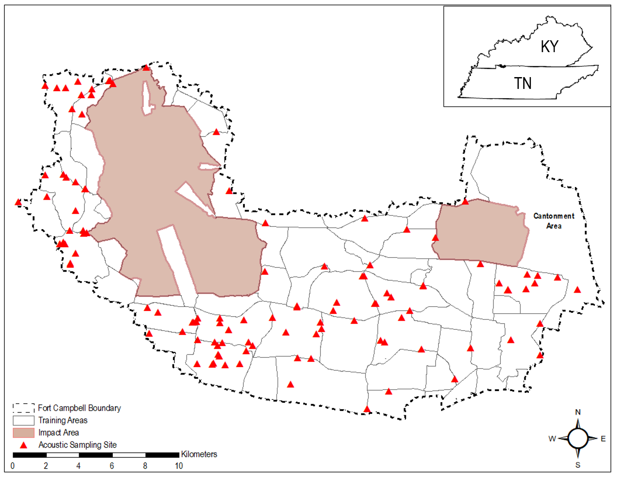

Supporting Figure S1. Site locations of Anabat Titley Scientific Express Passive Bat Detectors deployed across Fort Campbell, KY to assess tricolored bat (Perimyotis subflavus) occurrence from 2020-2021. Sampling was prohibited within the areas designated as Impact Areas due to safety concerns.

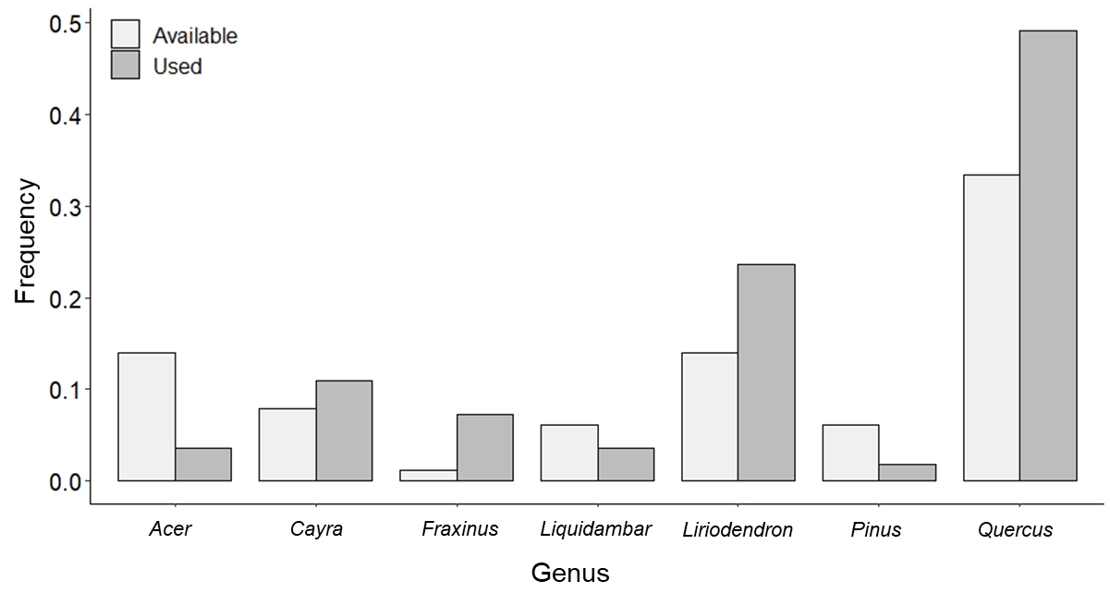
Supporting Figure S2. Frequency of tree genera selected as roost trees by tricolored bats (Perimyotis subflavus) and the frequencies of available trees sampled as a comparison on Fort Campbell, KY from 2020-2021.

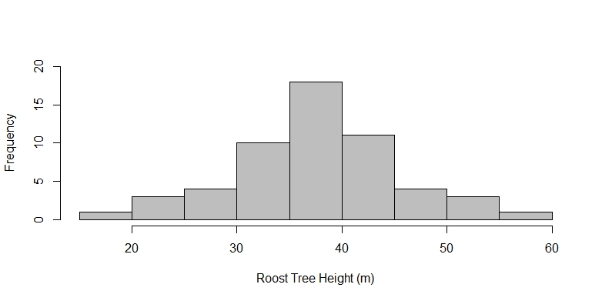
Supporting Figure S3. Frequency distribution of roost tree heights (m) selected by tricolored bats (Perimyotis subflavus) in Fort Campbell, KY from 2020-2021.

