A non-invasive genetics insight into population structure and recolonization dynamics of the Eurasian otter (Lutra lutra) at the boundary of its Italian core range

Greta Agostini¹, Anna Loy^{1,2,3}, Giulia Gentile², Simone Giovacchini^{2,3}, Cecilia De Sanctis², Enrico Mirone², Lorenzo Papaleo², Antonio Petrella⁴, Nicola D’Alessio⁵, Paolo Colangelo^{1,6}
¹ Research Institute on Terrestrial Ecosystems, National Research Council, 00015 Montelibretti, Rome, Italy
² Envix Lab, Department of Biosciences and Territory, University of Molise, 96090 Pesche, Isernia, Italy
³ IUCN SSC Otter Specialist Group, Gland, Switzerland
⁴ Istituto Zooprofilattico Sperimentale della Puglia e della Basilicata, Foggia, Italy
⁵ Dipartimento di Sanità Animale, Istituto Zooprofilattico Sperimentale del Mezzogiorno, Portici, Italy
⁶ NBFC-National Biodiversity Future Center, Palermo, Italy

Corresponding author: Greta Agostini (greta.agostini@iret.cnr.it)

ORCID: Greta Agostini (Orcid ID: 0009-0008-9872-5144); Paolo Colangelo (Orcid ID: 0000-0002-0283-3618); Simone Giovacchini (Orcid ID: 0009-0004-0290-7455); Anna Loy (Orcid ID: 0000-0002-8934-6694)
Supplementary material

ID | Sampling Site | Population ID | Longitude | Latitude | n | Specimen Type
Sin5 | Sinello river | Sinello | 14.46176 | 41.99764 | 1 | Spraint
For3 | Foro river | Foro-Aterno-Pescara | 14.27558 | 42.34975 | 1 | Spraint
Pes4 | Pescara river | Foro-Aterno-Pescara | 14.12956 | 42.37584 | 1 | Spraint
Pes18 | Pescara river | Foro-Aterno-Pescara | 14.01807 | 42.27066 | 1 | Spraint
Ate2 | Aterno river | Foro-Aterno-Pescara | 13.71376 | 42.17242 | 1 | Anal jelly
Ate3 | Aterno river | Foro-Aterno-Pescara | 13.60754 | 42.22162 | 2 | Spraints
Bis | Crossroads for Bisegna SS83 – SP17 | PNALM | 13.77754 | 41.85134 | 2 | Spraint
Opi1 | Opi (L’Aquila) | PNALM | 13.8395 | 41.78217 | 1 | Spraint
Opi2 | Opi (L’Aquila) | PNALM | 13.83371 | 41.78489 | 6 | Spraints
Opi3 | Opi (L’Aquila) | PNALM | 13.82639 | 41.78286 | 2 | Spraints
Fond | “Val Fondillo” | PNALM | 13.85608 | 41.77961 | 2 | Spraints
VB | Villetta Barrea (L’Aquila) | PNALM | 13.94395 | 41.77417 | 5 | Spraints
Bar | Barrea (L’Aquila) | PNALM | 13.97401 | 41.75851 | 7 | Spraint and anal jellies
Villa | Villa Scontrone (L’Aquila) | Sangro-Volturno | 14.06608 | 41.74921 | 3 | Spraints
Sng | Castel di Sangro (L’Aquila) | Sangro-Volturno | 14.09634 | 41.77492 | 2 | Spraints
Zit1 | “Pantano della Zittola” | Sangro-Volturno | 14.0812 | 41.70403 | 1 | Spraint
Zit2 | “Pantano della Zittola” | Sangro-Volturno | 14.09472 | 41.72057 | 1 | Spraint
Zit14 | “Pantano della Zittola” | Sangro-Volturno | 14.1056 | 41.7681 | 1 | Spraint
Vol5 | Volturno river | Sangro-Volturno | 14.145309 | 41.543372 | 1 | Spraint
Vol70 | Volturno river | Sangro-Volturno | 14.09831 | 41.60744 | 1 | Spraint
Vol96 | Volturno river | Sangro-Volturno | 14.0783 | 41.639 | 1 | Spraint
Lut98066 | Eboli (Salerno) | Sele | 15.0564332 | 40.6179234 | 1 | Tissue
Lut98619 | Altavilla Silentina (Salerno) | Sele | 15.1291027 | 40.5319728 | 1 | Tissue
Lut5805 | Foggia | Tavoliere | 15.5446302 | 41.4621984 | 1 | Tissue
Lut65 | Biccari (Foggia) | Tavoliere | 15.1980786 | 41.3984747 | 1 | Tissue
Lut273 | Zapponeta (Foggia) | Gulf of Manfredonia | 15.95854 | 41.4555757 | 1 | Tissue
Lut26661 | Margherita di Savoia (Barletta) | Gulf of Manfredonia | 16.14567 | 41.37693 | 2 | Tissues
Lut225 | Manfredonia (Foggia) | Gulf of Manfredonia | 15.9165105 | 41.6307347 | 5 | Tissues
Lut617 | Poggiorsini (Bari) | Murgia-Ionian Coast | 16.2549851 | 40.9183628 | 1 | Tissue
Lut3380 | Taranto | Murgia-Ionian Coast | 17.2470303 | 40.4643606 | 1 | Tissue
Lut75 | Montalbano Jonico (Matera) | Murgia-Ionian Coast | 16.5672561 | 40.2919911 | 1 | Tissue
Lut233 | Policoro (Matera) | Murgia-Ionian Coast | 16.6796558 | 40.2141054 | 1 | Tissue

Supplementary Table S1. ID is the identification code, Sampling Site is the collection site of specimens, belonging Population ID of each sampling site assigned on the basis of population structure analysis, longitude and latitude are the geographical coordinates of sites, n is the number of successfully genotyped specimens for each sampling site, Specimen type specifies if we used spraints, anal jellies or tissue for each sampling site.

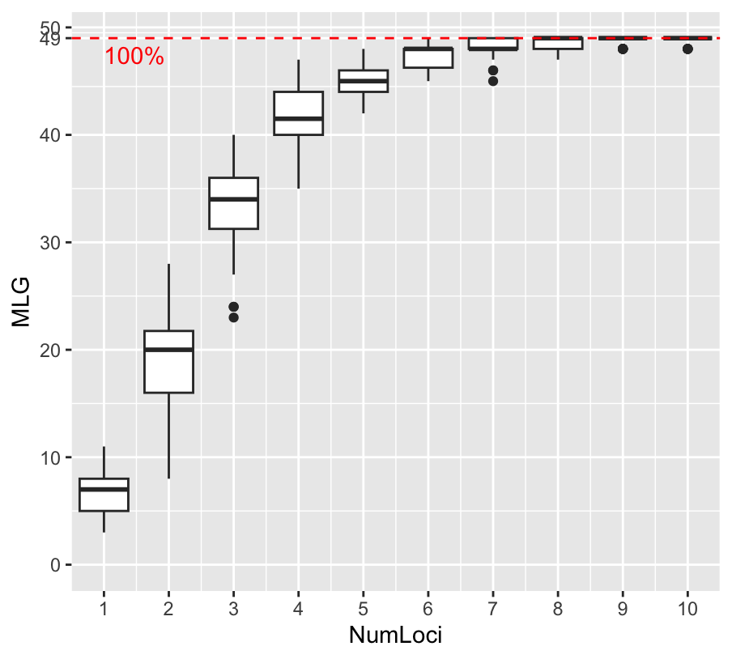
Supplementary Fig. S2. Genotype accumulation curve for the 50 genotyped spraints and anal jellies. Boxplots show the range of MultiLocus Genotypes (MLGs) estimated for each random Number of Loci (NumLoci).

 | n | Positive for cytb | Tested for primer mixes | Positive for ≥ 3 mixes
PNALM | 61 | 52 | 46 | 31
Sangro | 25 | 24 | 14 | 9
Volturno | 6 | 6 | 4 | 3
Aterno-Pescara | 9 | 9 | 7 | 5
Foro | 2 | 2 | 1 | 1
Sinello | 4 | 4 | 3 | 1
Salerno* | 2 | 2 | 2 | 2
Foggia* | 1 | 1 | 1 | 1
Biccari* | 1 | 1 | 1 | 1
Zapponeta* | 1 | 1 | 1 | 1
Margherita di Savoia* | 2 | 2 | 2 | 2
Manfredonia* | 5 | 5 | 5 | 5
Poggiorsini* | 1 | 1 | 1 | 1
Taranto* | 1 | 1 | 1 | 1
Montalbano Jonico* | 1 | 1 | 1 | 1
Policoro* | 1 | 1 | 1 | 1
Total | 123 | 113 | 91 | 66

Supplementary Table S3. Number of spraints and anal jellies analysed for each population. Muscle tissue specimens from Southern Italy are highlighted by an asterisk (*). n is the number of specimens collected and so tested for cytb; Positive for cytb are the specimens tested for the amplification of cytb and then resulted positive; Tested for primer mixes are those amplified for the five different mixes chosen among the specimens resulted positive to cytb; Positive for ≥ 3 mixes refers to the number of specimens resulted that showed successful amplification in PCR multiplex for three or more microsatellite primer mixes, and which were subsequently genotyped.

 | OT17 | Lut832 | OT19 | Lut701 | Lut833 | Lut604 | OT05 | OT07 | Lut902 | Lut717 | OT22
Observed frequency | 0.05 | 0.11 | 0.18 | -0.08 | -0.07 | 0.02 | 0.01 | 0.06 | 0.01 | -0.05 | -0.01
Median frequency | 0.04 | 0.10 | 0.18 | -0.08 | -0.08 | 0.02 | 0.00 | 0.06 | 0.00 | -0.05 | -0.01
2.5th percentile | -0.07 | 0.00 | 0.07 | -0.15 | -0.13 | -0.06 | -0.10 | -0.04 | -0.04 | -0.13 | -0.10
97.5th percentile | 0.18 | 0.23 | 0.30 | 0.01 | -0.02 | 0.11 | 0.11 | 0.18 | 0.07 | 0.05 | 0.07

Supplementary Table S4. Frequency of null alleles estimated from observed heterozygosity and homozygosity for each locus using Brookfield's method (1996).

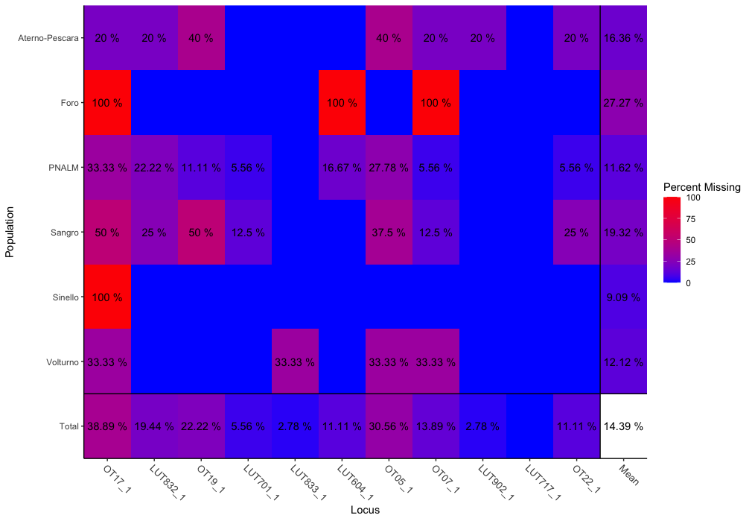
Supplementary Fig. S5. Percentage of missing data for each locus, for the total population and for each population. OT17 was the locus with the highest percentage of missing data (38.89%), thus indicating a greater difficulty in amplification and genotyping.

Sampling site | Number of males | Number of females
Sinello | 0 | 1
Foro | 1 | 0
Aterno-Pescara | 4 | 1
PNALM | 16 | 2
Sangro | 7 | 1
Volturno | 3 | 0
Foggia | 8 | 0
Bari | 1 | 0
Barletta | 1 | 1
Taranto | 0 | 1
Matera | 2 | 0
Salerno | 0 | 2

Supplementary Table S6. Number of males and females determined with molecular sexing for each population.

Importance of components:
 | PC1 | PC2
Standard deviation | 1.3136 | 0.5238
Proportion of Variance | 0.8628 | 0.1372
Cumulative Proportion | 0.8628 | 1.0000

Supplementary Table S7. PCA conducted on geographic coordinates (latitude and longitude) of each individual. PC1 explained 86.28% of the total variance, while PC2 the 13.72%.

(a)
 | Coef. Estimate | Std. Error | t Value | p(> | t | )
(Intercept) | -8.209e-16 | 5.639e-02 | 0.000 | 1
Geographic PC1 | 3.159e-01 | 4.335e-02 | 7.289 | 2.12e-09***

(b)
 | Coef. Estimate | Std. Error | t Value | p(> | t | )
(Intercept) | 2.404e-16 | 7.520e-02 | 0.000 | 1.000
Geographic PC1 | 1.187e-02 | 5.781e-02 | 0.205 | 0.838

Supplementary Table S8. Generalized linear model (GLM) with PC1 of geographic coordinates’ PCA and PC1 of sPCA (a), and PC1 of geographic coordinates’ PCA and PC2 of sPCA (b). For each GLM, effects coefficient (coef.) estimate, standard (std) error, t value, and significance (p) are reported. For genetic distance, the significance is relative to the first PC score of the sPCA against the geographic distance vector.

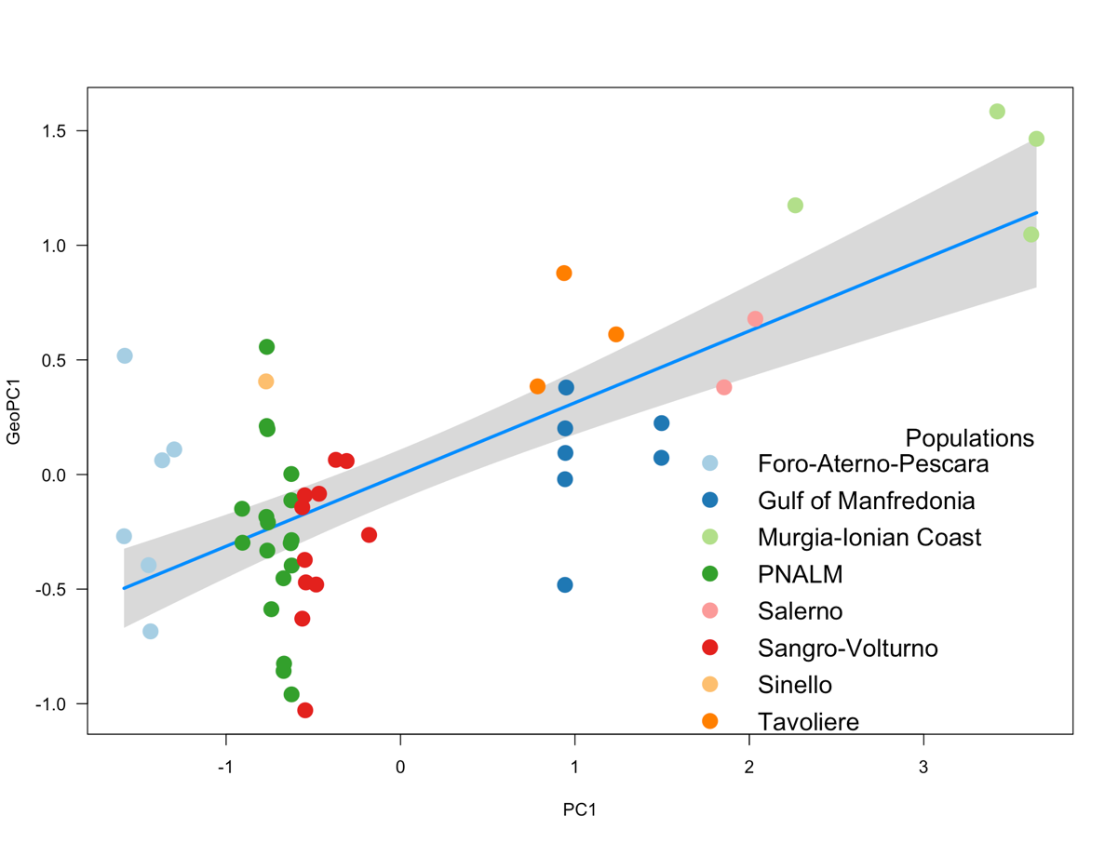

Supplementary Fig. S9. Isolation by distance (IBD): regression between the first PC of sPCA (PC1) and the vector of the geographic distance (GeoPC1). Each circle represents a unique individual, with colors indicating the population of origin. The legend for the population colors is provided in the bottom-right corner of the figure.

 | Foro-Aterno-Pescara
Locus | A | H_{o}/H_{e} | F_{IS} | p-value (HWE)
OT17 | 3 | 0.17/0.71 | 0.5714 | 0.4279
Lut832 | 5 | 0.50/0.83 | 0.2500 | 0.2648
OT19 | 4 | 0.33/0.79 | 0.3333 | 0.1990
Lut701 | 2 | 1.00/0.55 | -1.0000 | 1.0000
Lut833 | 3 | 0.83/0.62 | -0.3889 | 1.0000
Lut604 | 4 | 0.67/0.73 | -0.3333 | 1.0000
OT05 | 3 | 0.33/0.73 | 0.1429 | 0.6009
OT07 | 3 | 0.17/0.71 | 0.5714 | 0.4302
Lut902 | 3 | 0.17/0.44 | 0.0000 | 0.0000
Lut717 | 2 | 0.33/0.55 | 0.4118 | 0.6195
OT22 | 4 | 0.33/0.80 | 0.4839 | 0.0833

 | PNALM
Locus | A | H_{o}/H_{e} | F_{IS} | p-value (HWE)
OT17 | 3 | 0.28/0.67 | 0.1538 | 0.5287
Lut832 | 4 | 0.61/0.73 | -0.2711 | 0.9295
OT19 | 4 | 0.39/0.68 | 0.2881 | 0.1188
Lut701 | 3 | 0.61/0.53 | -0.3968 | 1.0000
Lut833 | 3 | 0.78/0.67 | -0.1695 | 0.8273
Lut604 | 3 | 0.39/0.56 | -0.1951 | 1.0000
OT05 | 3 | 0.44/0.67 | -0.2632 | 0.9469
OT07 | 3 | 0.50/0.62 | 0.0769 | 0.0686
Lut902 | 2 | 0.17/0.16 | -0.0625 | 1.0000
Lut717 | 2 | 0.72/0.47 | -0.5455 | 1.0000
OT22 | 3 | 0.61/0.64 | -0.0831 | 0.7790

 | Sangro-Volturno
Locus | A | H_{o}/H_{e} | F_{IS} | p-value (HWE)
OT17 | 3 | 0.27/0.67 | 0.0625 | 0.7566
Lut832 | 4 | 0.27/0.82 | 0.6087 | 0.0041
OT19 | 3 | 0.09/0.71 | 0.7600 | 0.0207
Lut701 | 4 | 0.55/0.66 | -0.0769 | 0.0500
Lut833 | 3 | 0.55/0.72 | 0.0345 | 0.5150
Lut604 | 4 | 0.73/0.71 | -0.0645 | 0.5618
OT05 | 3 | 0.09/0.64 | 0.6471 | 0.0725
OT07 | 3 | 0.18/0.55 | 0.4074 | 0.3435
Lut902 | 1 | 0.00/0.00 | 0.0000 | 0.0000
Lut717 | 2 | 0.64/0.45 | -0.2031 | 0.9135
OT22 | 3 | 0.64/0.67 | -0.5158 | 1.0000

 | Gulf of Manfredonia
Locus | A | H_{o}/H_{e} | F_{IS} | p-value (HWE)
OT17 | 3 | 0.38/0.51 | -0.2000 | 1.0000
Lut832 | 4 | 0.50/0.70 | 0.0769 | 0.4829
OT19 | 2 | 0.00/0.23 | 1.0000 | 0.0685
Lut701 | 3 | 0.50/0.49 | -0.0182 | 0.5947
Lut833 | 3 | 0.88/0.67 | -0.3425 | 0.9812
Lut604 | 3 | 0.13/0.64 | 0.7500 | 0.0821
OT05 | 3 | 0.38/0.51 | -0.2000 | 1.0000
OT07 | 3 | 0.50/0.68 | 0.0204 | 0.6700
Lut902 | 2 | 0.50/0.40 | -0.2727 | 1.0000
Lut717 | 2 | 0.63/0.46 | -0.4000 | 1.0000
OT22 | 3 | 0.50/0.63 | -0.0909 | 0.8531

 | Murgia-Ionian Coast
Locus | A | H_{o}/H_{e} | F_{IS} | p-value (HWE)
OT17 | 3 | 0.50/0.71 | -0.3333 | 0.4279
Lut832 | 2 | 0.25/0.54 | 0.5714 | 0.2648
OT19 | 4 | 0.75/0.82 | 0.000 | 0.1990
Lut701 | 3 | 0.75/0.71 | -0.0588 | 1.0000
Lut833 | 3 | 1.00/0.75 | -0.4118 | 1.0000
Lut604 | 3 | 0.75/0.75 | 0.0000 | 1.0000
OT05 | 2 | 0.75/0.54 | -0.5000 | 0.6009
OT07 | 2 | 0.50/0.57 | 0.1429 | 0.4302
Lut902 | 2 | 0.50/0.57 | 0.1429 | 0.0000
Lut717 | 1 | 0.00/0.00 | 0.0000 | 0.6195
OT22 | 2 | 0.25/0.25 | 0.0000 | 0.0833

Supplementary Table S10. Genetic diversity of Eurasian otter in each population of Abruzzo and Molise regions and Gulf of Manfredonia as estimated by eleven microsatellites. A number of alleles per locus, H_{o} observed heterozygosity, H_{e} expected heterozygosity F_{IS} inbreeding coefficient, p-value of Hardy-Weinberg equilibrium.

Locus | Population | Allele
OT17 | Murgia-Ionian Coast | 152
OT19 | Murgia-Ionian Coast | 231
OT19 | PNALM | 233
OT19 | PNALM | 237
Lut701 | Sangro-Volturno | 219
Lut701 | Gulf of Manfredonia | 201
Lut833 | PNALM | 166
Lut604 | Sangro-Volturno | 127
OT05 | Sangro-Volturno | 175
OT07 | PNALM | 209
OT07 | Gulf of Manfredonia | 217
OT22 | Foro-Aterno-Pescara | 151

Supplementary Table S11. Private alleles for each locus and each population.

Supplementary Fig. S12. Box-Whisker plot with mean values of estimated inbreeding coefficients (F) for each specimen. The lower and upper hinges of the box indicate the 25% and 75% quantiles, respectively, with the horizontal line in the box showing the median.

ID | Sex | First Capture | Last Capture | N. Captures/Recaptures | River Length Covered (km)
M_1 | Male | 3 June 2022 | 6 November 2022 | 2 | 20.4
M_2 | Male | 11 July 2022 | 8 October 2022 | 5 | 12.6
M_3 | Male | 28 September 2022 | 2 October 2022 | 2 | 9.6
F_1 | Female | 5 June 2022 | 8 November 2022 | 2 | 10.6

Supplementary Table S13. Details on capture/recapture of 3 males and one female sampled in the PNALM.

References
Brookfield JFY (1996) A simple new method for estimating null allele frequency from heterozygote deficiency. Molecular Ecology 5:453-455.

