Supplementary materials
Table S1: The grading criteria used to determine if a killer whale image was suitable for photo morphometric analysis. A score of over 12 points was deemed suitable for use.
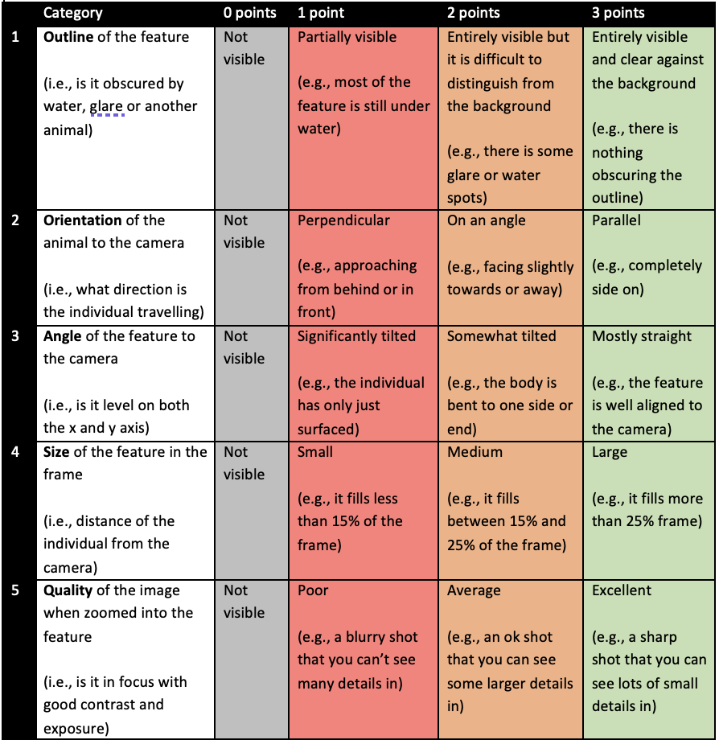
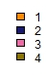
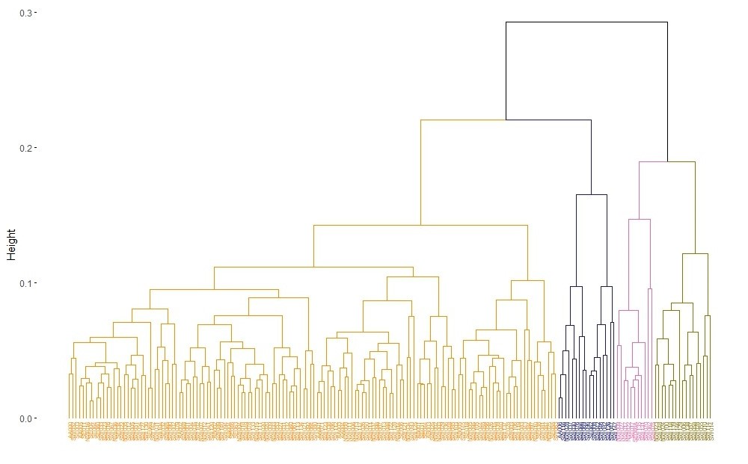
A
DC = 0.892
CC = 0.641
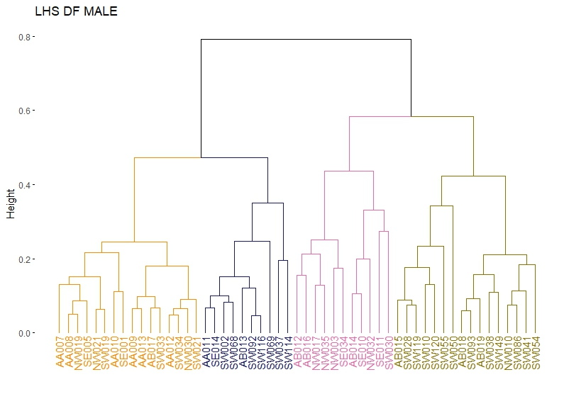
DC = 0.853
CC = 0.471
B
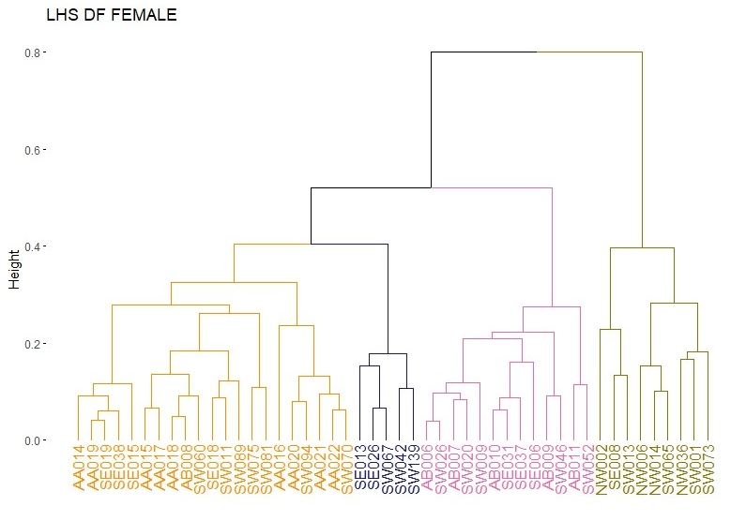
DC = 0.875
CC = 0.732
C
Fig. S1: Dendrograms for the eye patch (A), adult male (B) and female dorsal fin (C) suggest a high degree of individual variation amongst these features for killer whales in Australia and Antarctica. Divisive coefficients (DC) and cophenetic correlation (CC) values are provided. Height (y-axis) indicates the distance or dissimilarity between clusters or data points being merged. Higher heights indicate greater distance or dissimilarity between the individuals (x-axis), while lower heights indicate closer proximity or similarity. Please note there is no unit for height.

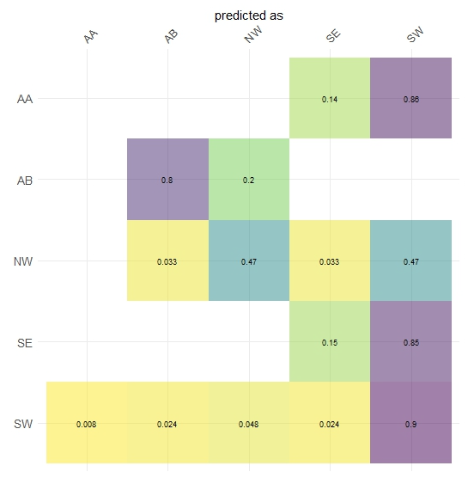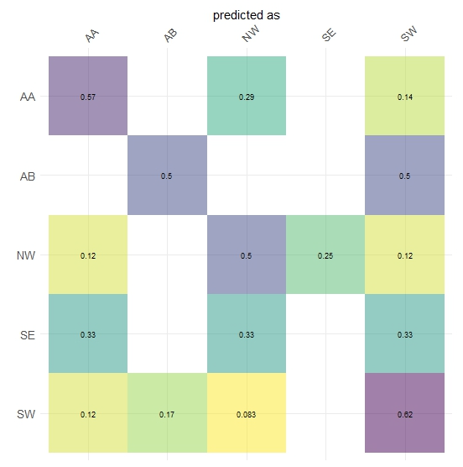
C
A
B
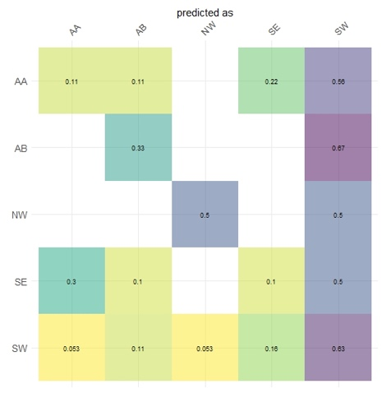
Fig. S2: Linear discriminant analysis for the eye patch (A), adult male dorsal fin (B) and female dorsal fin (C) suggest that individual killer whales cannot be classified into their respective study groups based on the EFA derived shape of their eye patches and dorsal fins alone. The numbers in each box note the proportion of assignments made between two particular study groups. Those on the diagonal therefore represent correct assignments. The lighter the colour the lower the proportion and the darker the colour the higher the proportion.

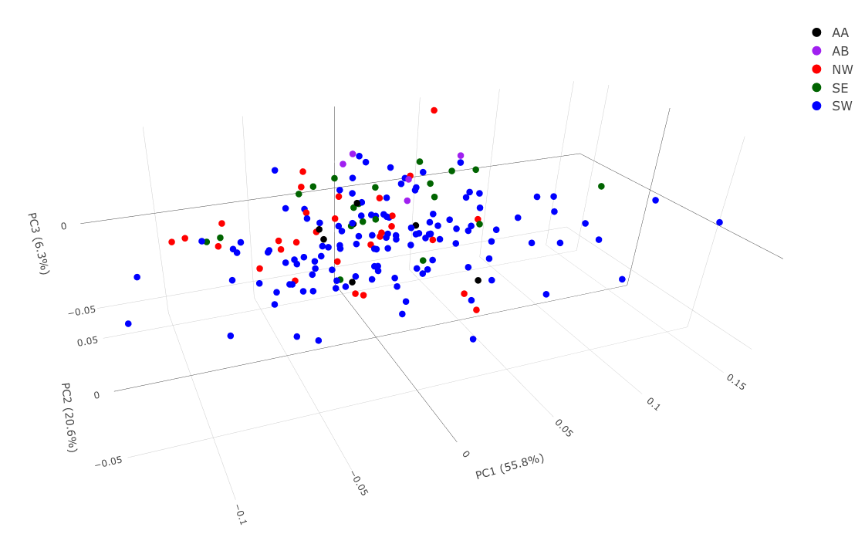
A

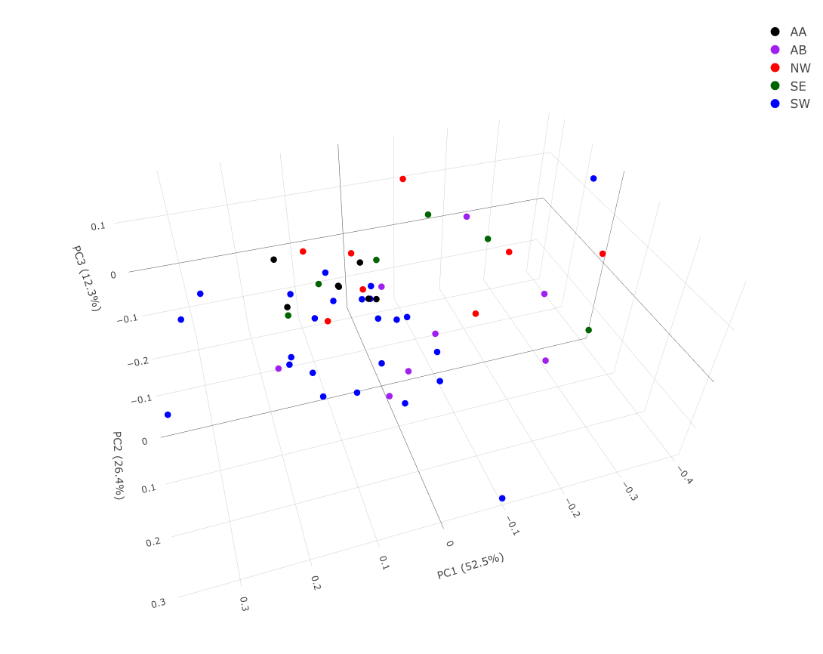
B
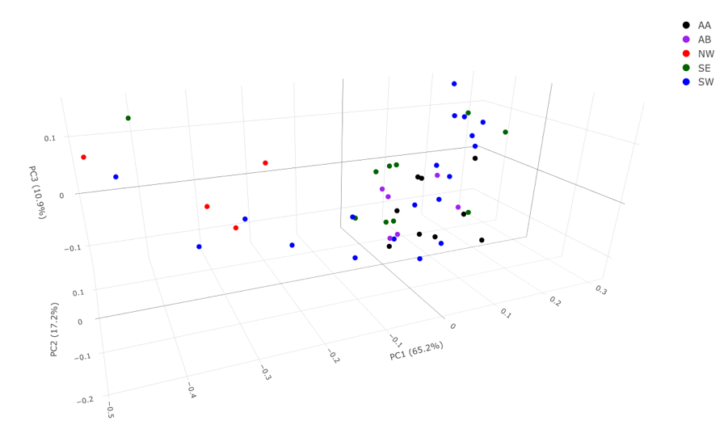
C
Fig. S3: 3D principal component analysis plots for the eye patch (A), adult male (B) and female dorsal fin (C) show morphological differences both within and between Australian and Antarctic killer whale populations. The percentage of variation explained for the first three principal components is noted alongside each axis.

