How to catch a ghost? Comparing two camera trap-based monitoring methods for elusive small mustelids in the Italian Alps

Supplementary Material

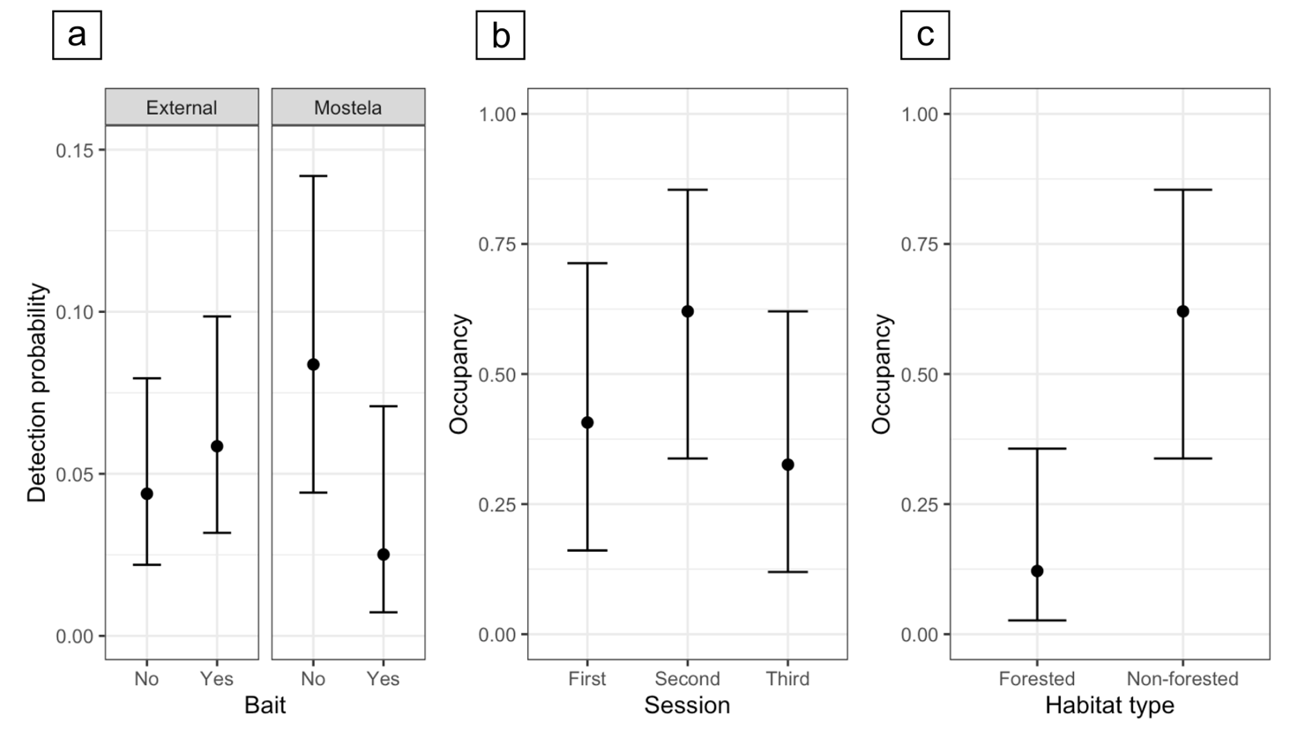
Fig. S1 Results of the occupancy model run without including cell identity as the random intercept. Plot (a) shows predicted stoat detection probabilities from the detection component of the model, comparing external cameras and Alpine Mostelas (enclosed camera traps), both with and without bait. Plots (b) and (c) show predicted stoat occupancy probabilities from the occupancy component of the model across sampling sessions and habitat types, respectively. Occupancy predictions were generated by holding other predictors constant and are presented here for non-forested habitats (b) and the second sampling session (c). Points represent the mean, and whiskers indicate the 95% credible intervals

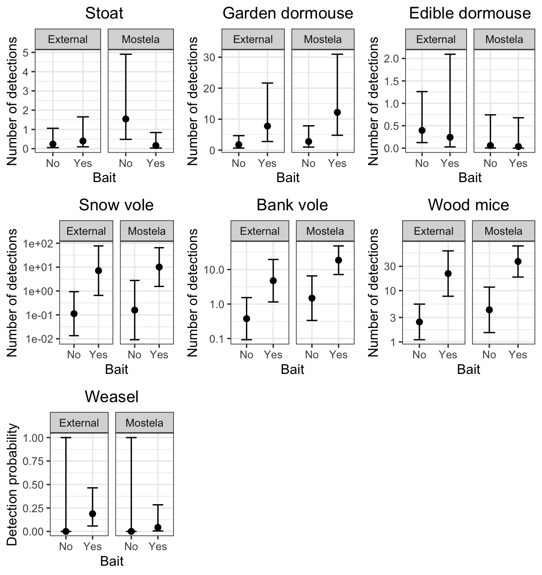
Fig. S2 Model predictions of generalized linear mixed models (GLMMs) comparing the number of detections recorded by external cameras and Alpine Mostelas (enclosed camera traps), both with and without bait, for small mustelids (stoat and weasel) and their most common prey in the study area (snow vole, bank vole, wood mice, garden dormouse, and edible dormouse), without including cell identity as the random intercept. For all species except the weasel, GLMMs with a Negative Binomial distribution and a log link function were used; for the weasel, a Binomial distribution with a logit link function was applied due to the low number of observations. Given the high numbers in some categories, the detections of voles and mice are presented on a log scale. Due to the low number of observations, the weasel model was limited to detection or non-detection of the species at the camera location. Points represent the mean, while whiskers show the 95% confidence intervals

