Supplementary material

Early surveillance of rice Bakanae disease using deep learning and hyperspectral imaging

Sishi Chen¹, Xuqi Lu¹, Hongda Fang², Anand Babu Perumal^{1, 3}, Ruyue Li⁴, Lei Feng¹, Mengcen Wang^{2, 5}, Yufei Liu^{1,*}
¹ College of Biosystems Engineering and Food Science, Zhejiang University, Hangzhou 310058, China
² State Key Laboratory of Rice Biology and Breeding, Zhejiang University, Hangzhou 310058, China
³ Computational Modeling and Nanoscale Processing Unit, National Institute of Food Technology, Entrepreneurship and Management - Thanjavur, Ministry of Food Processing Industries, Thanjavur, 613005, India
⁴ College of Environmental & Resource Sciences, Zhejiang University, Hangzhou 310058, China
⁵ Global Education Program for AgriScience Frontiers, Graduate School of Agriculture, Hokkaido University, Sapporo, 060-8589, Japan

Corresponding author： Yufei Liu; E-mail: yufeiliu@zju.edu.cn

Supplementary Tables
Table S1 5 and 10 characteristic wavelengths for each variety extracted by SPA and CARS.
Method | Variety | Wavelength number | Wavelengths
Method | Variety | Wavelength number | (nm)
SPA | ZZY-8 | 5 | 558, 664, 703, 1005, 1017
SPA | ZZY-8 | 10 | 553, 613, 698, 721, 817, 924, 958, 976, 994, 1017
SPA | HZY-9326 | 5 | 553, 672, 726, 1010, 1017
SPA | HZY-9326 | 10 | 533, 583, 659, 703, 724, 744, 963, 992, 1005, 1017
SPA | ZNY-1 | 5 | 555, 664, 724, 992, 1017
SPA | ZNY-1 | 10 | 495, 530, 553, 583, 657, 726, 744, 981, 1005,1017
CARS | ZZY-8 | 5 | 500, 611, 669, 762, 963
CARS | ZZY-8 | 10 | 451, 500, 611, 669, 687, 700, 716, 762, 835, 963
CARS | HZY-9326 | 5 | 558, 595, 669, 752, 788
CARS | HZY-9326 | 10 | 558, 575, 595, 669, 687, 700, 726, 731, 752, 788
CARS | ZNY-1 | 5 | 578, 611, 669, 760, 976
CARS | ZNY-1 | 10 | 578, 598, 611, 662, 669, 760, 895, 955, 971, 976

Table S2 Classification accuracy based on characteristic wavelengths
Day | Variety | Accuracy (%) |  |  | Average accuracy (%) | Parameters
Day | Variety | Cal | Val | Pre | Pre | Parameters
9 | ZZY-8 | 100 | 62.2 | 81.1 | 78.3 | 1500
9 | HZY-9326 | 98.6 | 65.2 | 65.2 | 78.3 | 1500
9 | ZNY-1 | 100 | 92.3 | 88.5 | 78.3 | 1500
15 | ZZY-8 | 100 | 65.0 | 80.0 | 88.1 | 1500
15 | HZY-9326 | 100 | 88.0 | 88.0 | 88.1 | 1500
15 | ZNY-1 | 100 | 76.9 | 96.2 | 88.1 | 1500
21 | ZZY-8 | 100 | 82.1 | 87.2 | 89.8 | 1500
21 | HZY-9326 | 92.4 | 90.9 | 86.4 | 89.8 | 1500
21 | ZNY-1 | 100 | 87.0 | 95.7 | 89.8 | 1500
Note: parameter for RBD-VGG model is epoch.

Table S3 Number of healthy and infected rice seedling samples
Name | Variety | The number of infected samples | The number of healthy samples (CK)
ZNY-1 | Japonica glutinous rice | 72 | 72
ZZY-8 | Indica rice | 144 | 144
HZY-9326 | Japonica rice | 72 | 72
JHY-5 | Japonica rice | 8 | 8
XS-121 | Japonica rice | 8 | 8

Supplementary Figures
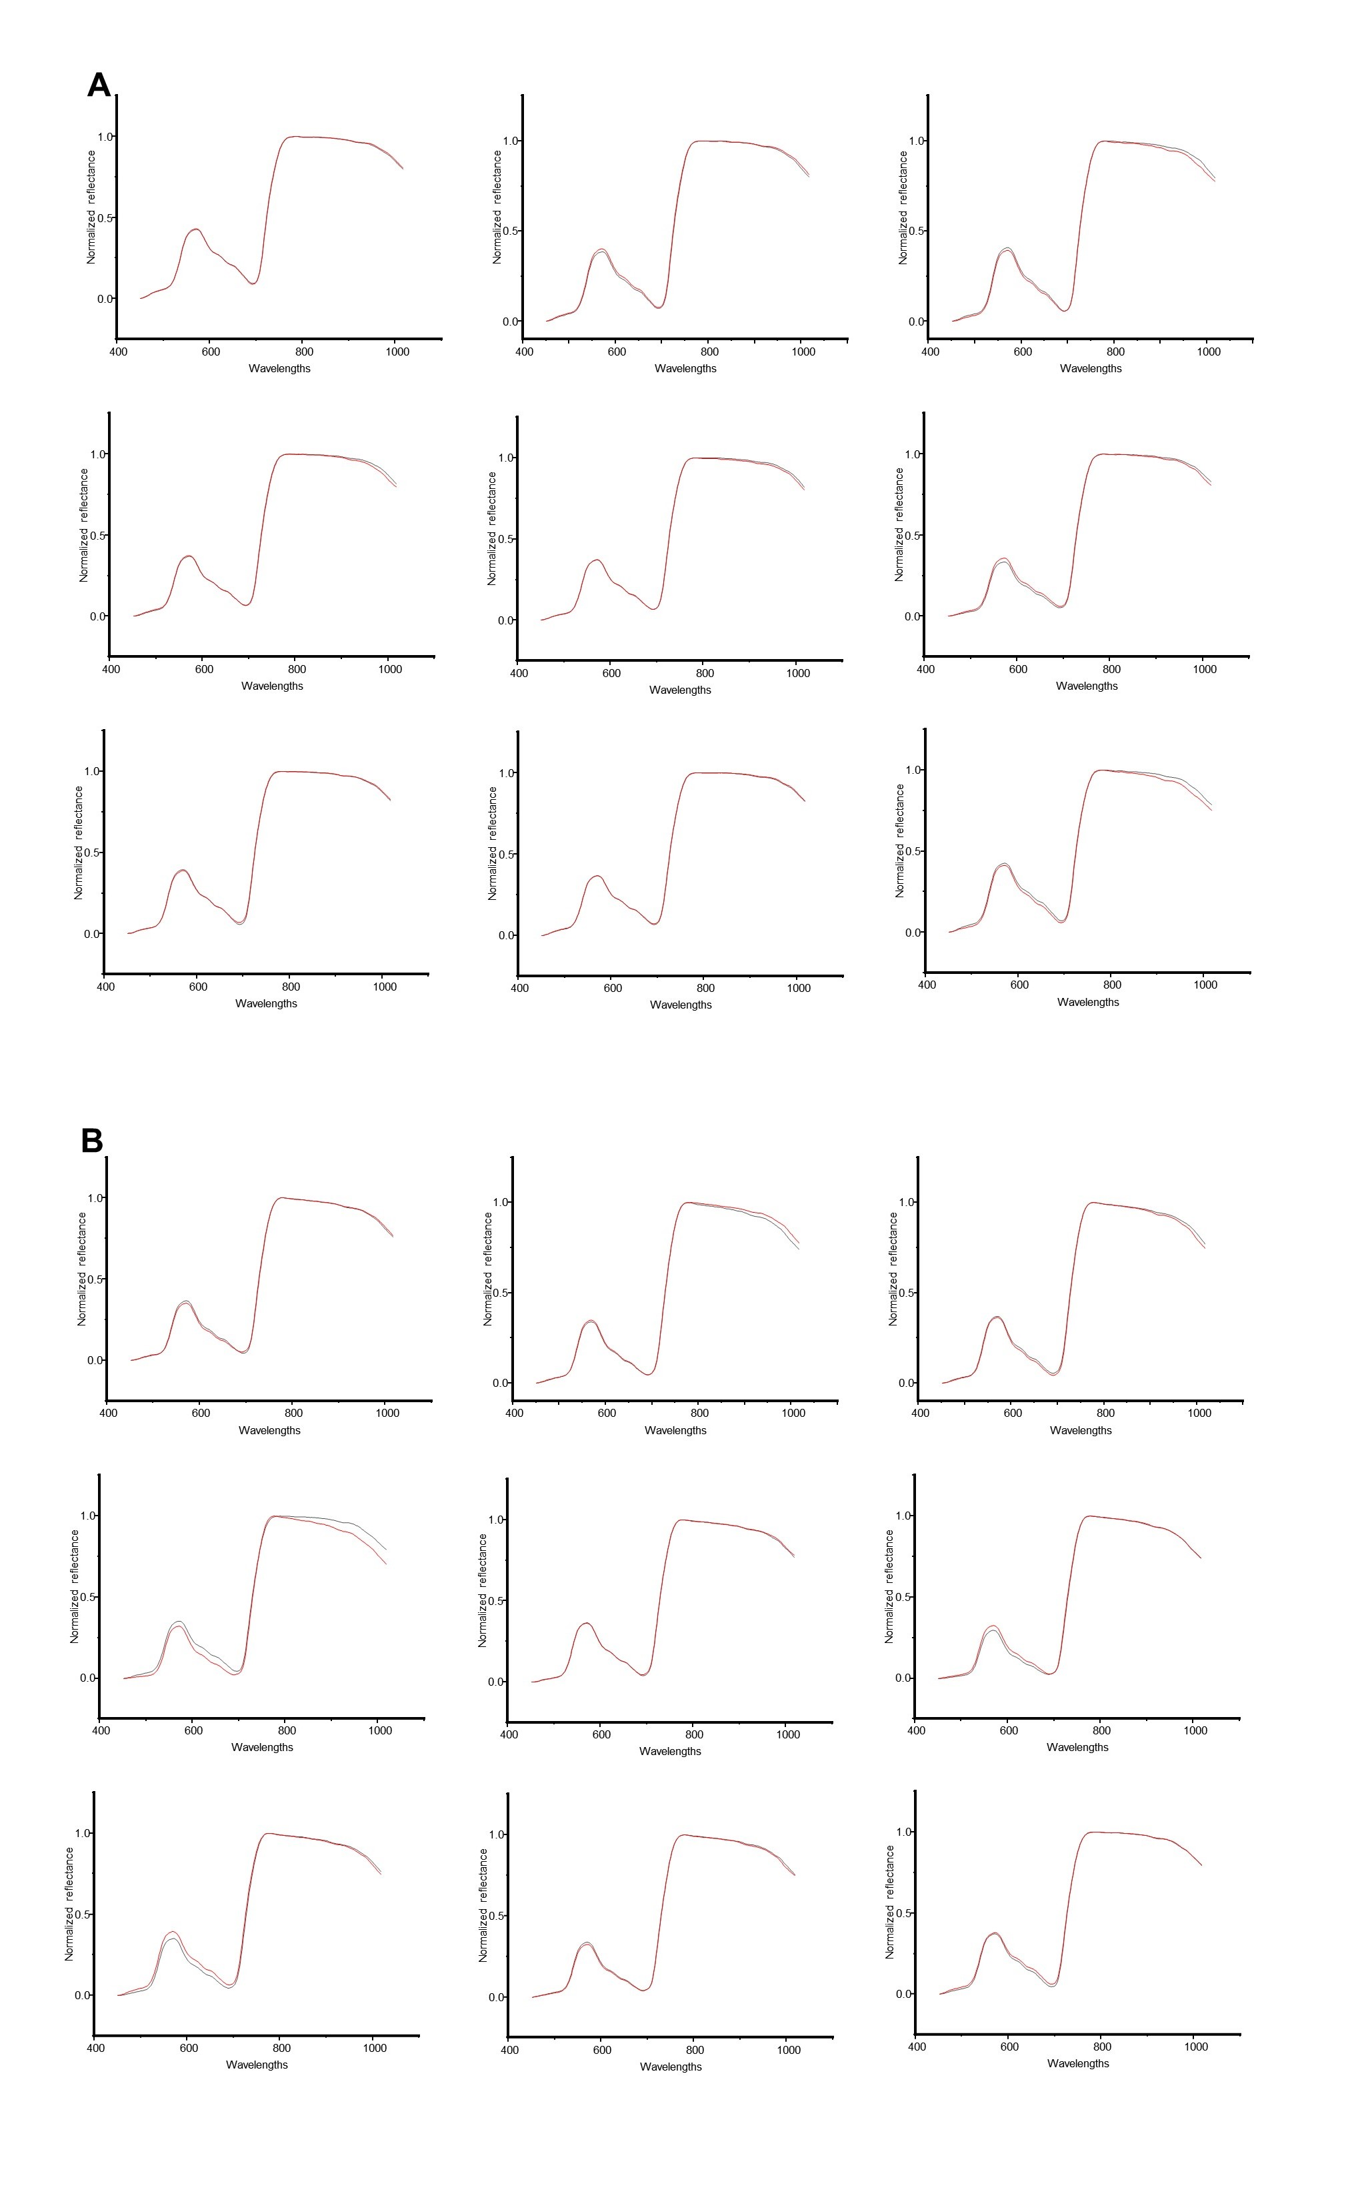
Fig. S1 Two hyperspectral data obtained by flipping the seedling pot: (a) CK samples; (b) infected samples.

