Epigenetically poised chromatin states regulate PRR and NLR genes in soybean

Linzhe Jin¹, Yihan Zhang¹, Jiayuan Guo¹, Xuexia Liu¹, Yanling Lai¹, Xinfang Huang¹, Yuhan Zou¹, Shichuan Yan¹, Xianzhe Dai¹, Zhenhui Zhong^{1*}

¹ Ministry of Education Key Laboratory for Bio-Resource and Eco-Environment, College of Life Sciences, State Key Laboratory of Hydraulics and Mountain River Engineering, Sichuan University, Chengdu 610064, China
* To whom correspondence may be addressed. E-mail: zhenhuizhong@scu.edu.cn

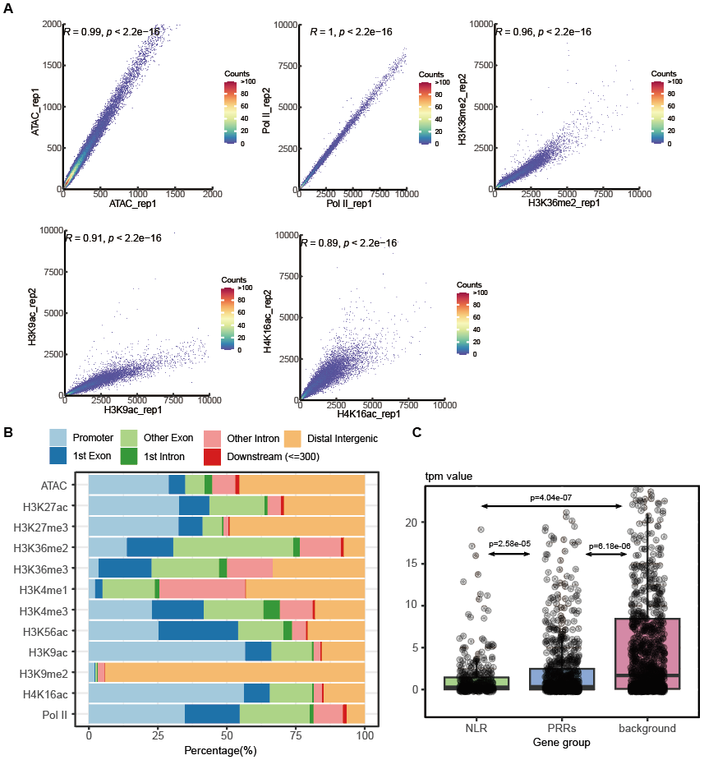
Supplementary Fig. S1 A Pearson correlation of two replicates of ATAC-seq and ChIP-seq (Pol II, H3K36me2, H3K9ac, and H4K16ac). B Peak annotation of different histone modifications, ATAC-seq, and Pol II peaks in soybean. C Expression level of PRRs and NLRs compared with random control

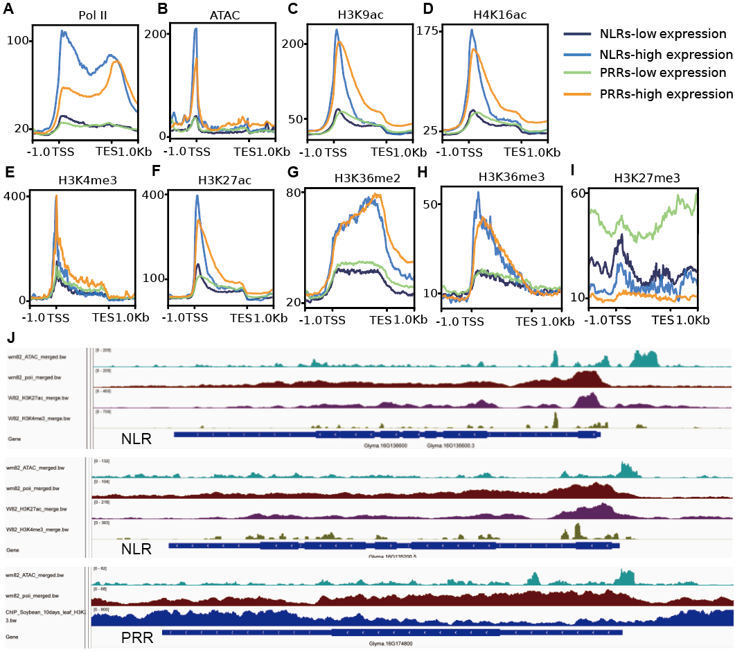
Supplementary Fig. S2 Pol II ChIP-seq (A), ATAC-seq (B), H3K9ac ChIP-seq (C), H4K16ac ChIP-seq (D), H3K4me3 ChIP-seq (E), H3K27ac ChIP-seq (F), H3K36me2 ChIP-seq (G), H3K36me3 ChIP-seq (H), H3K27me3 ChIP-seq (I) data over NLR and PRR genes. Both NLR and PRR have been divided into two groups according to their expression level. J Examples of H3K27me3 enriched at 5’ end of NLR and flanking regions of PRR

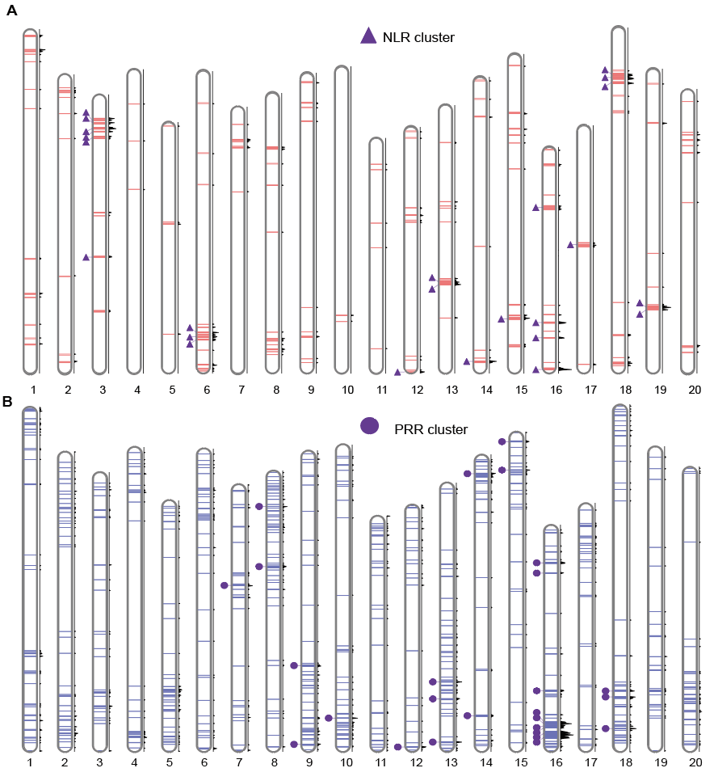
Supplementary Fig. S3 A Chromosomal distribution of NLRs in soybean Wm82 genome. The triangle stands for NLR clusters identified in this study. B Chromosomal distribution of PRRs in soybean Wm82 genome. The cycle stands for PRR clusters identified in this study

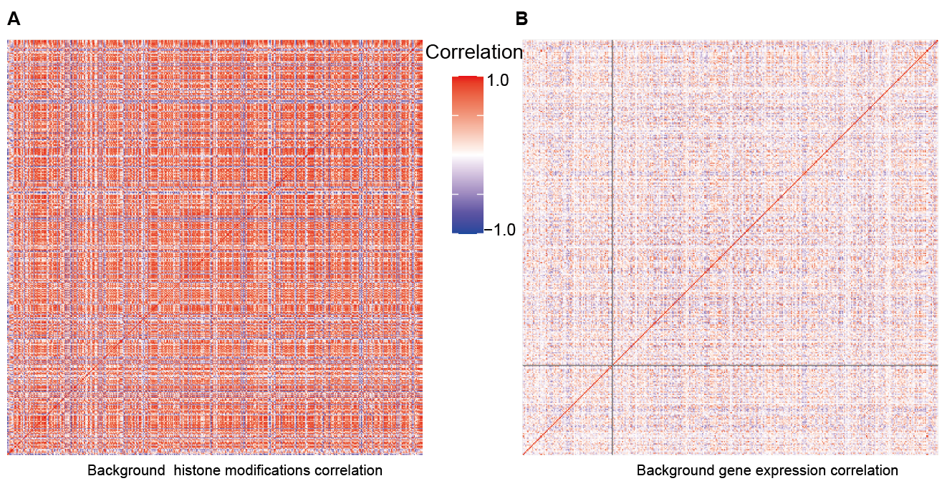 Supplementary Fig. S4 Pairwise Pearson correlation analysis of histone modifications (A) and gene expression levels (B) for random control

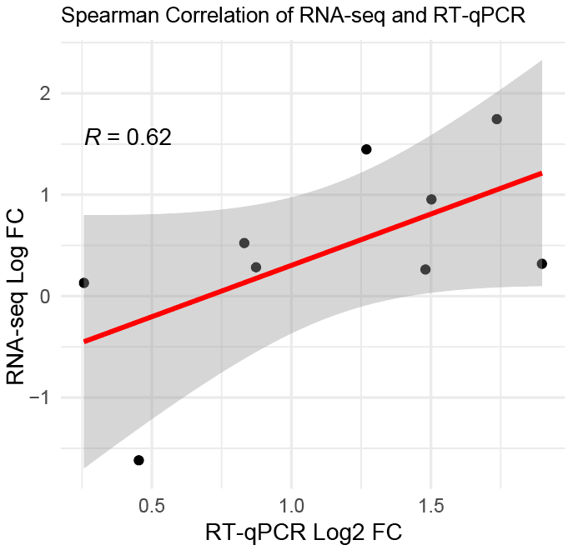
Supplementary Fig. S5 Pairwise Spearman correlation analysis of RNA-seq data and RT-qPCR validation. Log2 fold change of RNA-seq (RPKM) and relative expression level quantified by RT-qPCR results were plot on y and x axis, respectively. qRT-PCR primers used in this study are presented in the Supplementary Table 2.

