Decoupling of bacterial production and respiration in the surface water of the North Pacific Subtropical Gyre
Supplementary materials

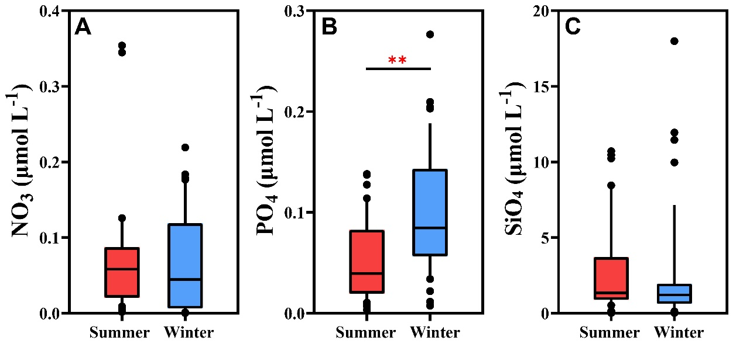
Fig. S1 The concentrations of nutrients between summer and winter include NO₃ (A), PO₄ (B), and SiO₄(C) (Wilcoxon test, ** p < 0.001)

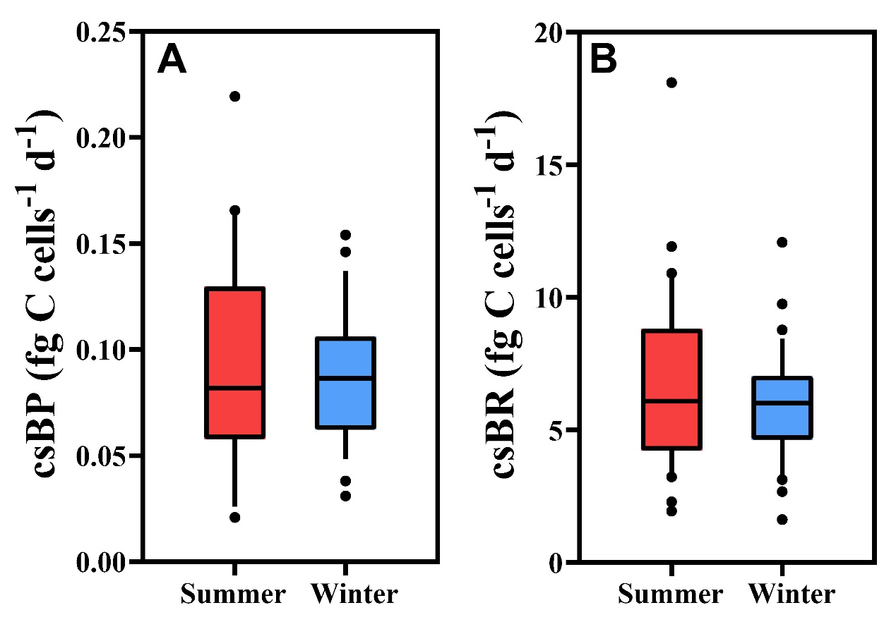
Fig. S2 The differences in bacterial metabolism between summer and winter include cell-specific bacterial production (csBP) (A) and cell-specific bacterial respiration (csBR) (B)

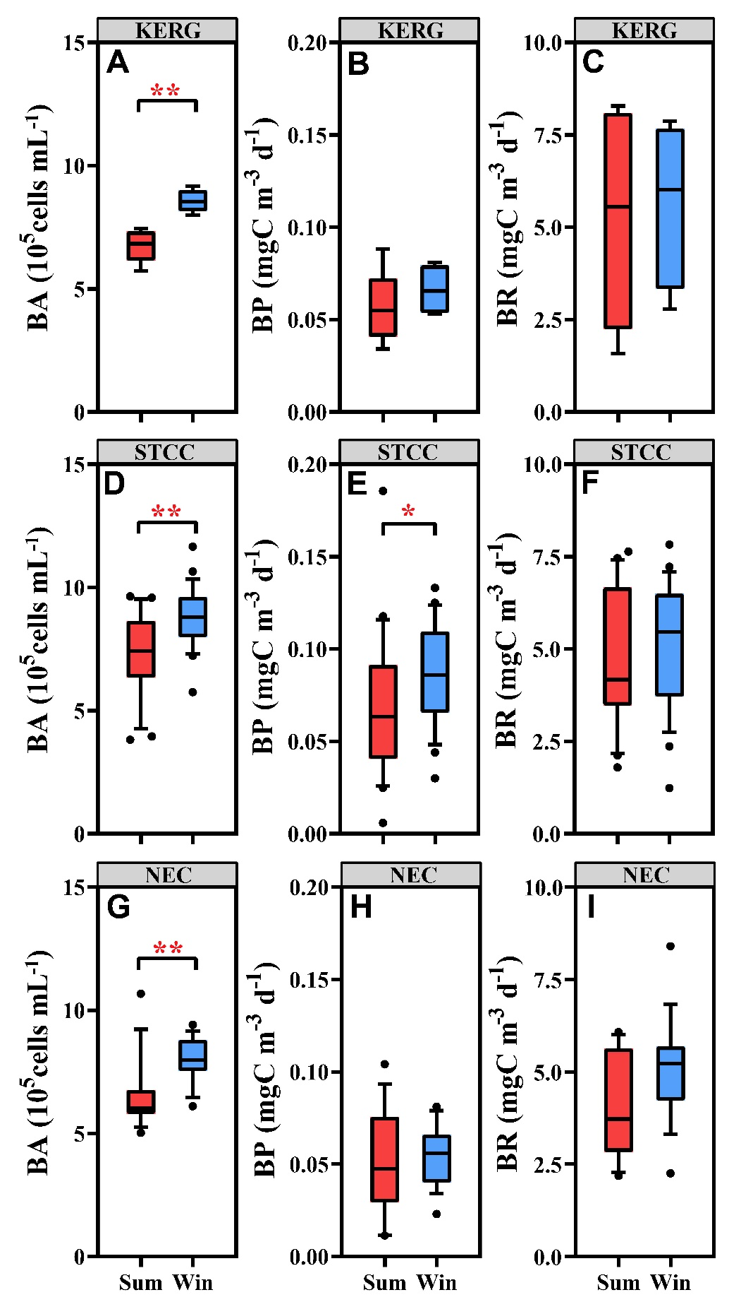
Fig. S3 The differences in bacterial metabolism between summer and winter among Kuroshio Extension region (KERG) (A-C), Subtropical Countercurrent (STCC) (D-F) and North Equatorial Current (NEC) (G-I) (Wilcoxon test, * p < 0.05, ** p < 0.001)

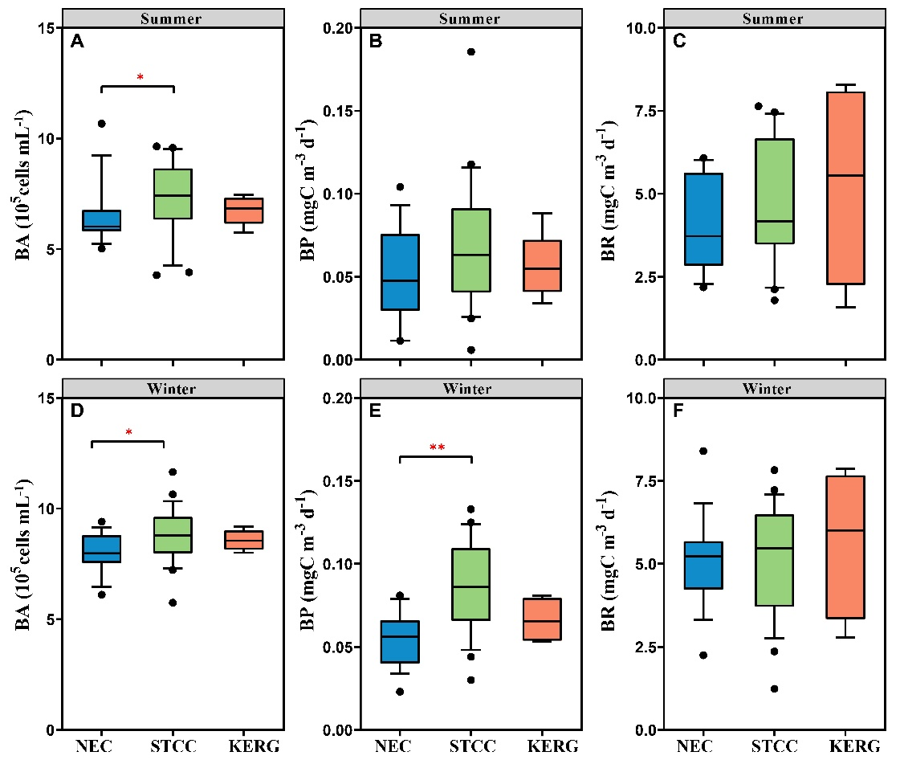
Fig. S4 The differences in bacterial metabolism among Kuroshio Extension region (KERG), Subtropical Countercurrent (STCC) and North Equatorial Current (NEC) between summer (A-C) and winter (D-F) (Wilcoxon test, * p < 0.05, ** p < 0.001)

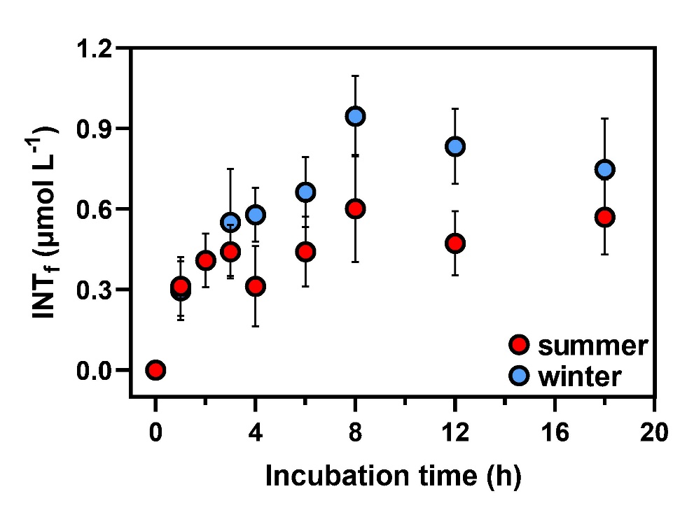
Fig. S5 The relationship between INT_{f} (formazan) reduction rates and incubation time at surface layers during summer and winter cruise in the NPSG

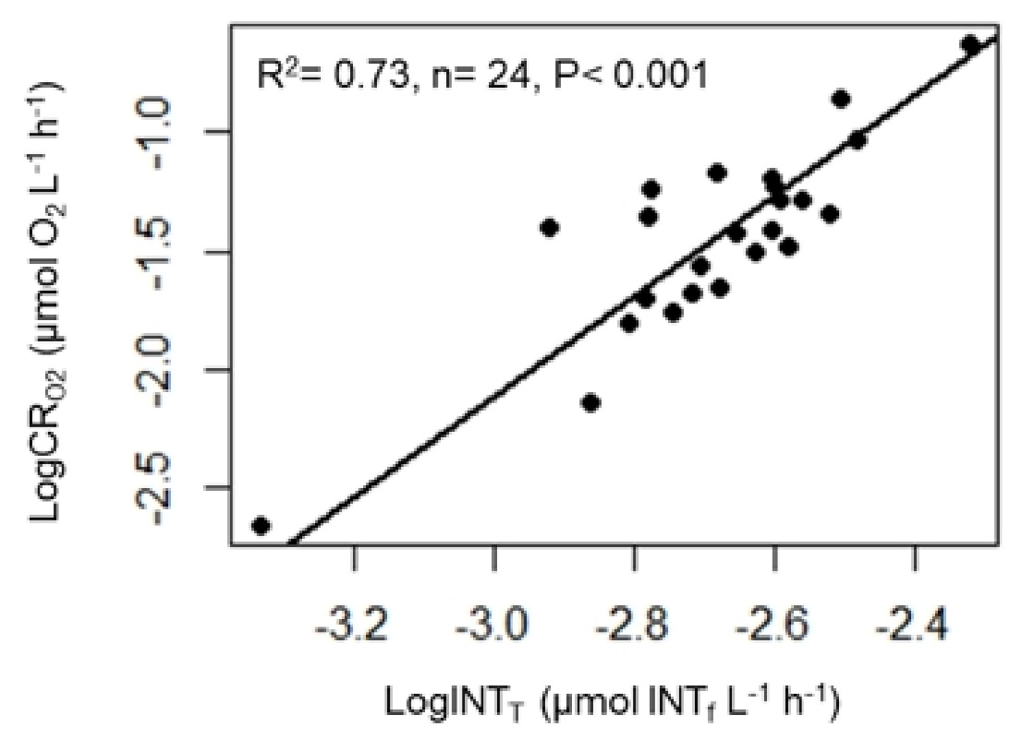
Fig. S6 Log-Log relationship between dissolved oxygen consumption (CR_{O2}) measured by Winkler titration and INT reduction rate (INT_{T}) measured by ETS method during summer and winter cruise in the NPSG

