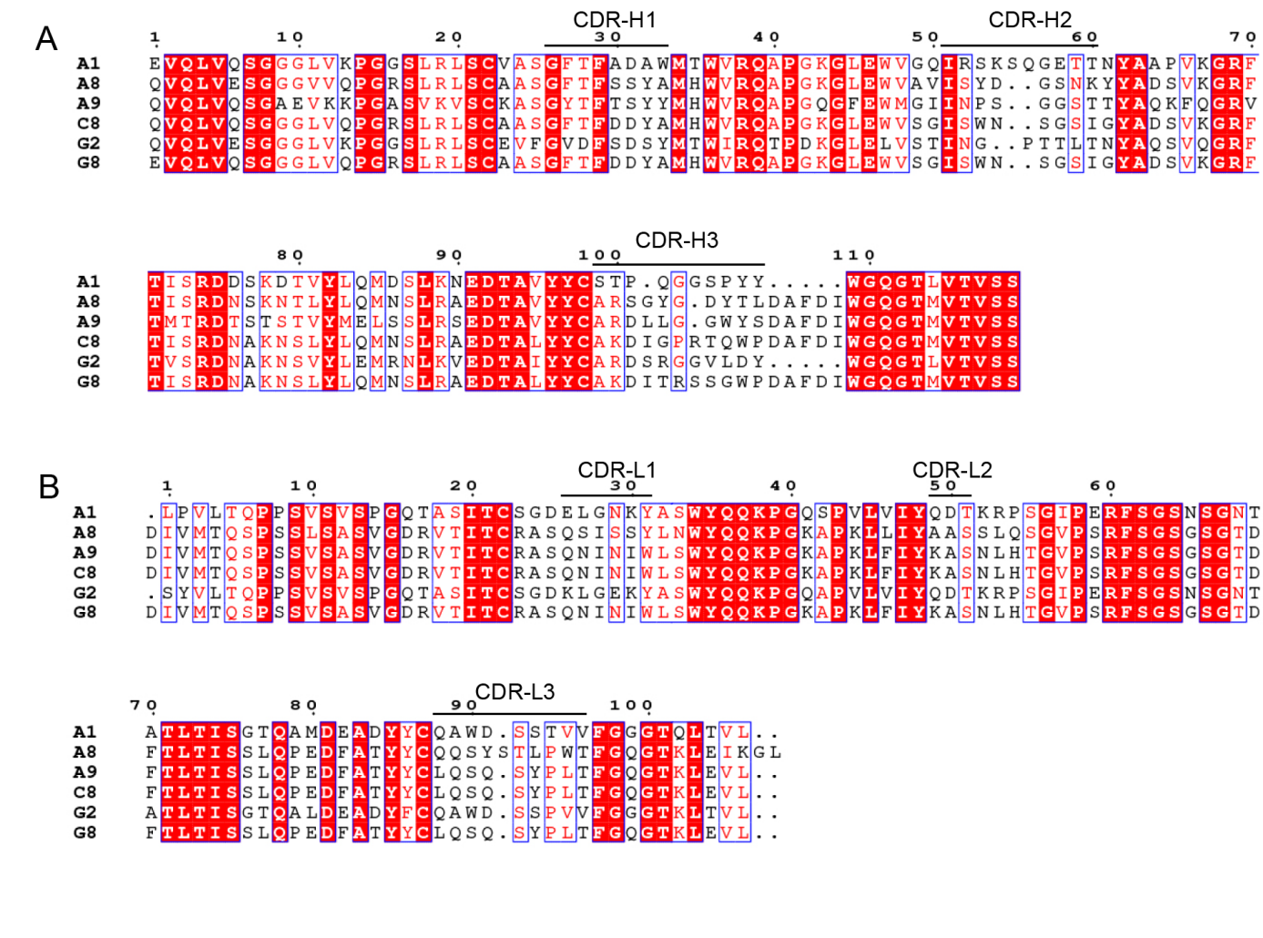
Supplementary Fig. 1 Sequence analysis of anti-OX40 scFv antibodies. A Sequence analysis of anti-OX40 scFv antibodies heavy chains. B Sequence analysis of anti-OX40 scFv antibodies light chains. Figures created by ENDscript/ESPript.
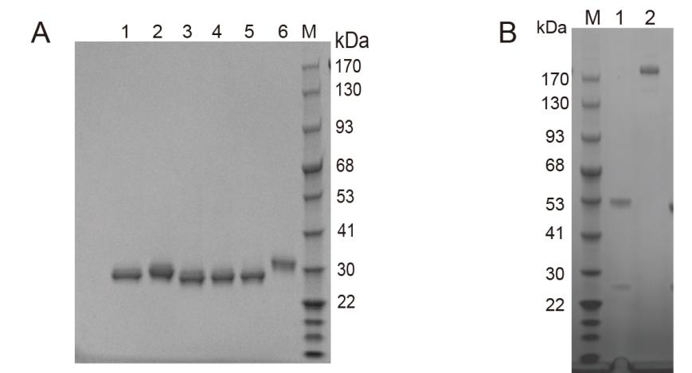
Supplementary Fig. 2 The results of antibody SDS-PAGE. A Results of scFv protein isolation and purification. line1: A1; line2: A8; line3: A9; line4: C8; line5: G2; line6: G8; line M: protein marker. B SDS-PAGE analysis of the expression and purification processes. line M: protein marker; line 1: reduced SDS; line 2: non-reduced SDS.
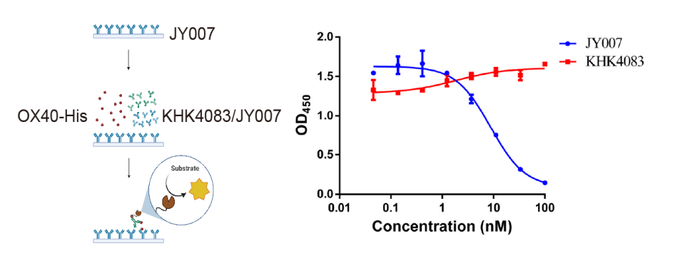
Supplementary Fig. 3 Competitive ELISA between OX40, JY007, and KHK4083. Gradient dilutions of KHK4083 were incubated with precoated JY007 and 0.2 μg/mL OX40-His. Anti-His antibody was used as the secondary antibody. JY007 was used as a control. Error bars represent standard deviation. Data are presented as mean ± SD, n = 6 in triplicate. Schematic illustration created by BioRender.
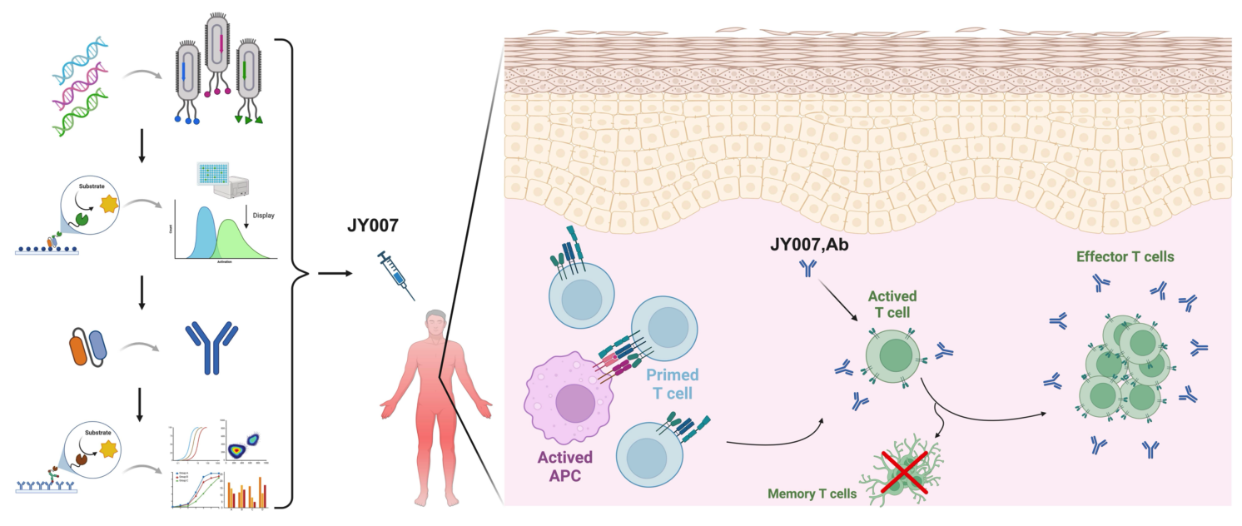Supplementary Fig. 4 Schematic illustration of the discovery and functional studies of antibody JY007. Figure created by BioRender.

Supplrmrntary Table 1 Amino acid sequence of OX40 wild-type and mutants
 | Mutation Position | Sequence
WT | NA | LHCVGDTYPSNDRCCHECRPGNGMVSRCSRSQNTVCRPCGPGFYNDVVSSKPCKPCTWCNLRSGSERKQLCTATQDTVCRCRAGTQPLDSYKPGVDCAPCPPGHFSPGDNQACKPWTNCTLAGKHTLQPASNSSDAIC
OX40-1 | H30A | LACVGDTYPSNDRCCHECRPGNGMVSRCSRSQNTVCRPCGPGFYNDVVSSKPCKPCTWCNLRSGSERKQLCTATQDTVCRCRAGTQPLDSYKPGVDCAPCPPGHFSPGDNQACKPWTNCTLAGKHTLQPASNSSDAICEDGSHHHHHH
OX40-2 | D34A | LHCVGATYPSNDRCCHECRPGNGMVSRCSRSQNTVCRPCGPGFYNDVVSSKPCKPCTWCNLRSGSERKQLCTATQDTVCRCRAGTQPLDSYKPGVDCAPCPPGHFSPGDNQACKPWTNCTLAGKHTLQPASNSSDAICEDGSHHHHHH
OX40-3 | T35A | LHCVGDAYPSNDRCCHECRPGNGMVSRCSRSQNTVCRPCGPGFYNDVVSSKPCKPCTWCNLRSGSERKQLCTATQDTVCRCRAGTQPLDSYKPGVDCAPCPPGHFSPGDNQACKPWTNCTLAGKHTLQPASNSSDAICEDGSHHHHHH
OX40-4 | Y36A | LHCVGDTAPSNDRCCHECRPGNGMVSRCSRSQNTVCRPCGPGFYNDVVSSKPCKPCTWCNLRSGSERKQLCTATQDTVCRCRAGTQPLDSYKPGVDCAPCPPGHFSPGDNQACKPWTNCTLAGKHTLQPASNSSDAICEDGSHHHHHH
OX40-5 | P37A | LHCVGDTYASNDRCCHECRPGNGMVSRCSRSQNTVCRPCGPGFYNDVVSSKPCKPCTWCNLRSGSERKQLCTATQDTVCRCRAGTQPLDSYKPGVDCAPCPPGHFSPGDNQACKPWTNCTLAGKHTLQPASNSSDAICEDGSHHHHHH
OX40-6 | E45A | LHCVGDTYPSNDRCCHACRPGNGMVSRCSRSQNTVCRPCGPGFYNDVVSSKPCKPCTWCNLRSGSERKQLCTATQDTVCRCRAGTQPLDSYKPGVDCAPCPPGHFSPGDNQACKPWTNCTLAGKHTLQPASNSSDAICEDGSHHHHHH
OX40-7 | R55A | LHCVGDTYPSNDRCCHECRPGNGMVSACSRSQNTVCRPCGPGFYNDVVSSKPCKPCTWCNLRSGSERKQLCTATQDTVCRCRAGTQPLDSYKPGVDCAPCPPGHFSPGDNQACKPWTNCTLAGKHTLQPASNSSDAICEDGSHHHHHH
OX40-8 | D74A | LHCVGDTYPSNDRCCHECRPGNGMVSRCSRSQNTVCRPCGPGFYNAVVSSKPCKPCTWCNLRSGSERKQLCTATQDTVCRCRAGTQPLDSYKPGVDCAPCPPGHFSPGDNQACKPWTNCTLAGKHTLQPASNSSDAICEDGSHHHHHH
OX40-9 | V75A | LHCVGDTYPSNDRCCHECRPGNGMVSRCSRSQNTVCRPCGPGFYNDAVSSKPCKPCTWCNLRSGSERKQLCTATQDTVCRCRAGTQPLDSYKPGVDCAPCPPGHFSPGDNQACKPWTNCTLAGKHTLQPASNSSDAICEDGSHHHHHH
OX40-10 | V76A | LHCVGDTYPSNDRCCHECRPGNGMVSRCSRSQNTVCRPCGPGFYNDVASSKPCKPCTWCNLRSGSERKQLCTATQDTVCRCRAGTQPLDSYKPGVDCAPCPPGHFSPGDNQACKPWTNCTLAGKHTLQPASNSSDAICEDGSHHHHHH
OX40-11 | S78A | LHCVGDTYPSNDRCCHECRPGNGMVSRCSRSQNTVCRPCGPGFYNDVVSAKPCKPCTWCNLRSGSERKQLCTATQDTVCRCRAGTQPLDSYKPGVDCAPCPPGHFSPGDNQACKPWTNCTLAGKHTLQPASNSSDAICEDGSHHHHHH
OX40-12 | K79A | LHCVGDTYPSNDRCCHECRPGNGMVSRCSRSQNTVCRPCGPGFYNDVVSSAPCKPCTWCNLRSGSERKQLCTATQDTVCRCRAGTQPLDSYKPGVDCAPCPPGHFSPGDNQACKPWTNCTLAGKHTLQPASNSSDAICEDGSHHHHHH
OX40-13 | K82A | LHCVGDTYPSNDRCCHECRPGNGMVSRCSRSQNTVCRPCGPGFYNDVVSSKPCAPCTWCNLRSGSERKQLCTATQDTVCRCRAGTQPLDSYKPGVDCAPCPPGHFSPGDNQACKPWTNCTLAGKHTLQPASNSSDAICEDGSHHHHHH
OX40-14 | D117A | LHCVGDTYPSNDRCCHECRPGNGMVSRCSRSQNTVCRPCGPGFYNDVVSSKPCKPCTWCNLRSGSERKQLCTATQDTVCRCRAGTQPLASYKPGVDCAPCPPGHFSPGDNQACKPWTNCTLAGKHTLQPASNSSDAICEDGSHHHHHH
OX40-15 | S118A | LHCVGDTYPSNDRCCHECRPGNGMVSRCSRSQNTVCRPCGPGFYNDVVSSKPCKPCTWCNLRSGSERKQLCTATQDTVCRCRAGTQPLDAYKPGVDCAPCPPGHFSPGDNQACKPWTNCTLAGKHTLQPASNSSDAICEDGSHHHHHH
OX40-16 | Y119A | LHCVGDTYPSNDRCCHECRPGNGMVSRCSRSQNTVCRPCGPGFYNDVVSSKPCKPCTWCNLRSGSERKQLCTATQDTVCRCRAGTQPLDSAKPGVDCAPCPPGHFSPGDNQACKPWTNCTLAGKHTLQPASNSSDAICEDGSHHHHHH
OX40-17 | K120A | LHCVGDTYPSNDRCCHECRPGNGMVSRCSRSQNTVCRPCGPGFYNDVVSSKPCKPCTWCNLRSGSERKQLCTATQDTVCRCRAGTQPLDSYAPGVDCAPCPPGHFSPGDNQACKPWTNCTLAGKHTLQPASNSSDAICEDGSHHHHHH
OX40-18 | S38A | LHCVGDTYPANDRCCHECRPGNGMVSRCSRSQNTVCRPCGPGFYNDVVSSKPCKPCTWCNLRSGSERKQLCTATQDTVCRCRAGTQPLDSYKPGVDCAPCPPGHFSPGDNQACKPWTNCTLAGKHTLQPASNSSDAICEDGSHHHHHH
OX40-19 | D40A | LHCVGDTYPSNARCCHECRPGNGMVSRCSRSQNTVCRPCGPGFYNDVVSSKPCKPCTWCNLRSGSERKQLCTATQDTVCRCRAGTQPLDSYKPGVDCAPCPPGHFSPGDNQACKPWTNCTLAGKHTLQPASNSSDAICEDGSHHHHHH

Supplementary Table 2 Fold decrease of KHK4083
Mutant | Fold decrease
WT | 1
OX40-1 | 2.99
OX40-2 | 0.75
OX40-3 | 0.5
OX40-4 | 1.54
OX40-5 | 2.94
OX40-6 | NA
OX40-7 | NA
OX40-8 | 12.21
OX40-9 | 0.2
OX40-10 | NA
OX40-11 | NA
OX40-12 | 0.08
OX40-13 | 14.81
OX40-14 | 27.53
OX40-15 | 6.29
OX40-16 | 21.23
OX40-17 | 16.3
OX40-18 | NA
OX40-19 | 1.99
Note: "NA": mutants have too high affinity to be calculated.

Supplementary Table 3 Fold decrease of JY007
Mutant | Fold decrease
WT | 1
OX40-1 | NA
OX40-2 | NA
OX40-3 | NA
OX40-4 | NA
OX40-5 | 10.58
OX40-6 | NA
OX40-7 | NA
OX40-8 | NA
OX40-9 | NA
OX40-10 | NA
OX40-11 | NA
OX40-12 | NA
OX40-13 | 3.19
OX40-14 | 5.27
OX40-15 | 3.49
OX40-16 | 1.81
OX40-17 | 2.21
OX40-18 | 12.24
OX40-19 | 12.33
Note: "NA": mutants have too high affinity to be calculated.

