Supporting information
MR2938 relieves DSS-induced colitis in mice through inhibiting NF-κB signaling and improving epithelial barrier

Ling Lv^{1,2}, Mireguli Maimaitiming^{1,2}, Shuli Xia^{1,2}, Jichen Yang^{1,2}, Tiantian Zhang¹, Yuming Wang¹, Xin Li^{1,2}, Iryna Pinchuk³, Pingyuan Wang^{1,2}, Chang-Yun Wang^{1,2}, Zhiqing Liu^{1,2*}

¹Key Laboratory of Marine Drugs and Key Laboratory of Evolution and Marine Biodiversity (Ministry of Education), School of Medicine and Pharmacy, Institute of Evolution & Marine Biodiversity, College of Food Science and Engineering, Ocean University of China, Qingdao 266003, China

²Laboratory for Marine Drugs and Bioproducts, Qingdao Marine Science and Technology Center, Qingdao 266237, China

³Division of Gastroenterology, Department of Medicine, Pennsylvania State Milton S. Hershey Medical Center, Hershey, Pennsylvania, 17033, USA

*Corresponding author: liuzhiqing@ouc.edu.cn.

Table of Contents

Table S1. PK profiles of MR2938 in rat after administrations
Table S2. Concentration of MR2938 in brain after its i.p. administration
Table S3. Primer sequences for qRT-PCR analysis.
Figure S1. The organ weight and liver function index in DSS-induced colitis.
Figure S2. MR2938 inhibited NF-κB activation in vitro.
Figure S3. Quantitative Western Blot analysis of p-p65/ p65 levels in Raw264.7 cells.
Figure S4. ¹H NMR spectra of MR2938.
Figure S5. ¹³C NMR spectra of MR2938
Figure S6. HPLC chromatograms of MR2938

Table S1. PK profiles of MR2938 in rat after administrations ª
PK parameter | T_{1/2} (h) | T_{max} (h) | C_{max} (ng/mL) | AUC_{last} (h·ng/mL) | AUC_{Inf} (h·ng/mL) | Cl (mL/min/kg) | F (%)
3 mg/kg i.v. | 2.25 | - | 1,026 | 1,059 | 1,071 | 47.2 | -
10 mg/kg p.o. | 2.87 | 0.667 | 592 | 2,075 | 2,107 | - | 59
ªExpressed as mean, n = 3. T_{1/2}, half-life; T_{max}, time for reaching C_{max}; C_{max}, maximum drug concentration; AUC, area under the curve; Cl, plasma clearance; F, bioavailability

Table S2. Concentration of MR2938 in brain after its i.p. administration (6.5 mg/kg)
Parameter | Value of MR2938 (n=3)
Concentration (ng/g) | 222.07
Amount (ng) | 236.7
i.p. administration (μg) | 145

Table S3. Primer sequences for qRT-PCR analysis.
Gene | Forward Primer Sequence | Reverse Primer Sequence
β-actin | GACGTTGACATCCGTAAAGAC | CCACCGATCCACACAGAGTA
IL-6 | TGGAGTCACAGAAGGAGTGGCTAAG | TCTGACCACAGTGAGGAATGTCCAC
IL-1β | AGACAACTGCACTACAGGCTC | GTGGGTGTGCCGTCTTTCAT
TNF-α | ACCACGCTCTTCTGTCTACT | GGCTACAGGCTTGTCACTC
NLRP3 | TCCCAGACACTCATGTTGCC | GTCCAGTTCAGTGAGGCTCC
caspase-1 | ACTGACTGGGACCCTCAAGT | GCAAGACGTGTACGAGTGGT
ZO-1 | GCAGACCCAGCAAAGGTGTA | GTATGACGGCTGCTCAAGGT
occludin | GGTTGATCCCCAGGAGGCTA | CCGATCCATCTTTCTTCGGGT
Claudin-1 | CAACCCGAGCCTTGATGGTA | ACTAATGTCGCCAGACCTGAAA

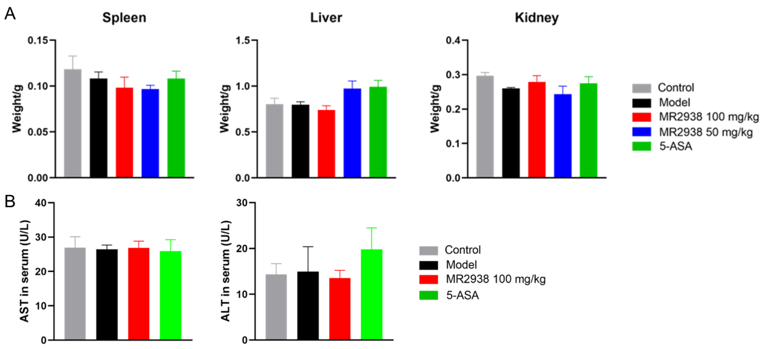
Figure S1. The organ weight and liver function index in DSS-induced colitis. (A) The weight of spleen, liver and kidney in different groups. (B) The AST and ALT activity in serum.

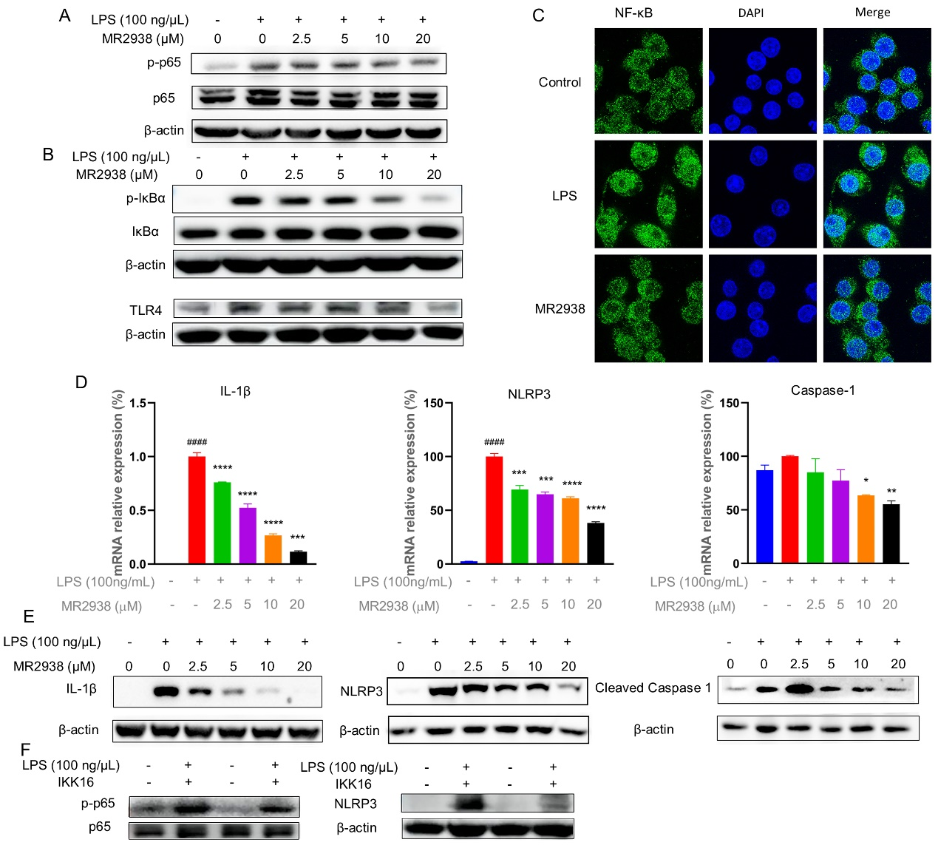 Figure S2. MR2938 inhibited NF-κB activation in vitro. Raw264.7 cells were treated with different concentration of MR2938 and stimulated by LPS. (A-B) The protein levels of p65, p-p65, IκB, p-IκB, and TLR4 analyzed by western blot in Raw264.7 cells. (C) Fluorescent microscopy image analysis of NF-κB in Raw264.7 cells with 10 μM of MR2938 pre-treatment after LPS activation. (D-E) Effects of IL-1β, NLRP3 and caspase-1 expression by (C) qPCR and (D) western blot (E). (F) The protein levels of p65, p-p65 and NLRP3 in Raw264.7 cells with IKK inhibitors to block the NF-κB pathway. ####p < 0.0001 compared with control group. *p < 0.05, **p < 0.01, ***p < 0.001 and ****p < 0.0001 compared with model group.

Figure S3. Quantitative Western Blot analysis of p-p65/ p65 levels in Raw264.7 cells.

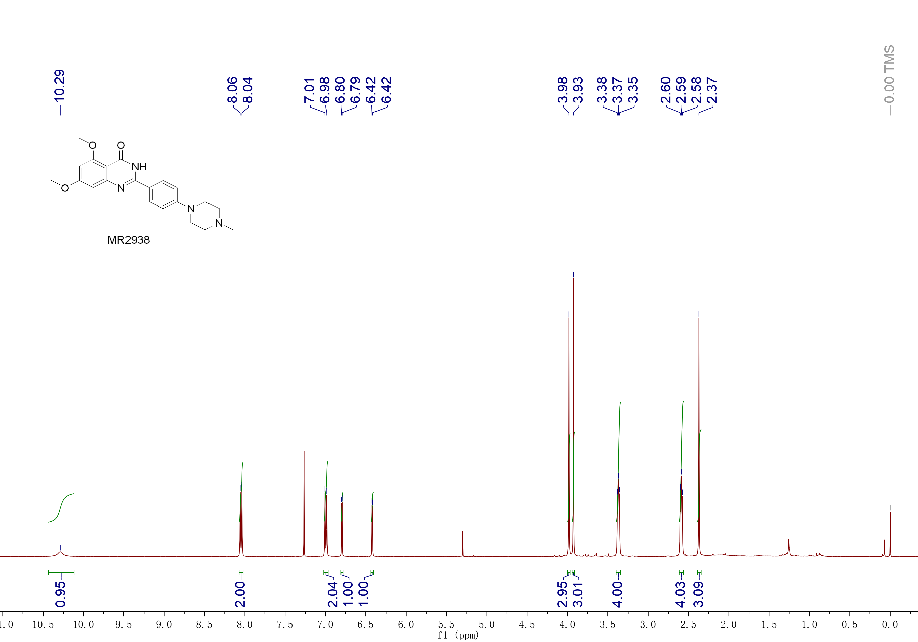
Figure S4. The copy of ¹H NMR spectrum (400 MHz, CDCl₃) of MR2938.

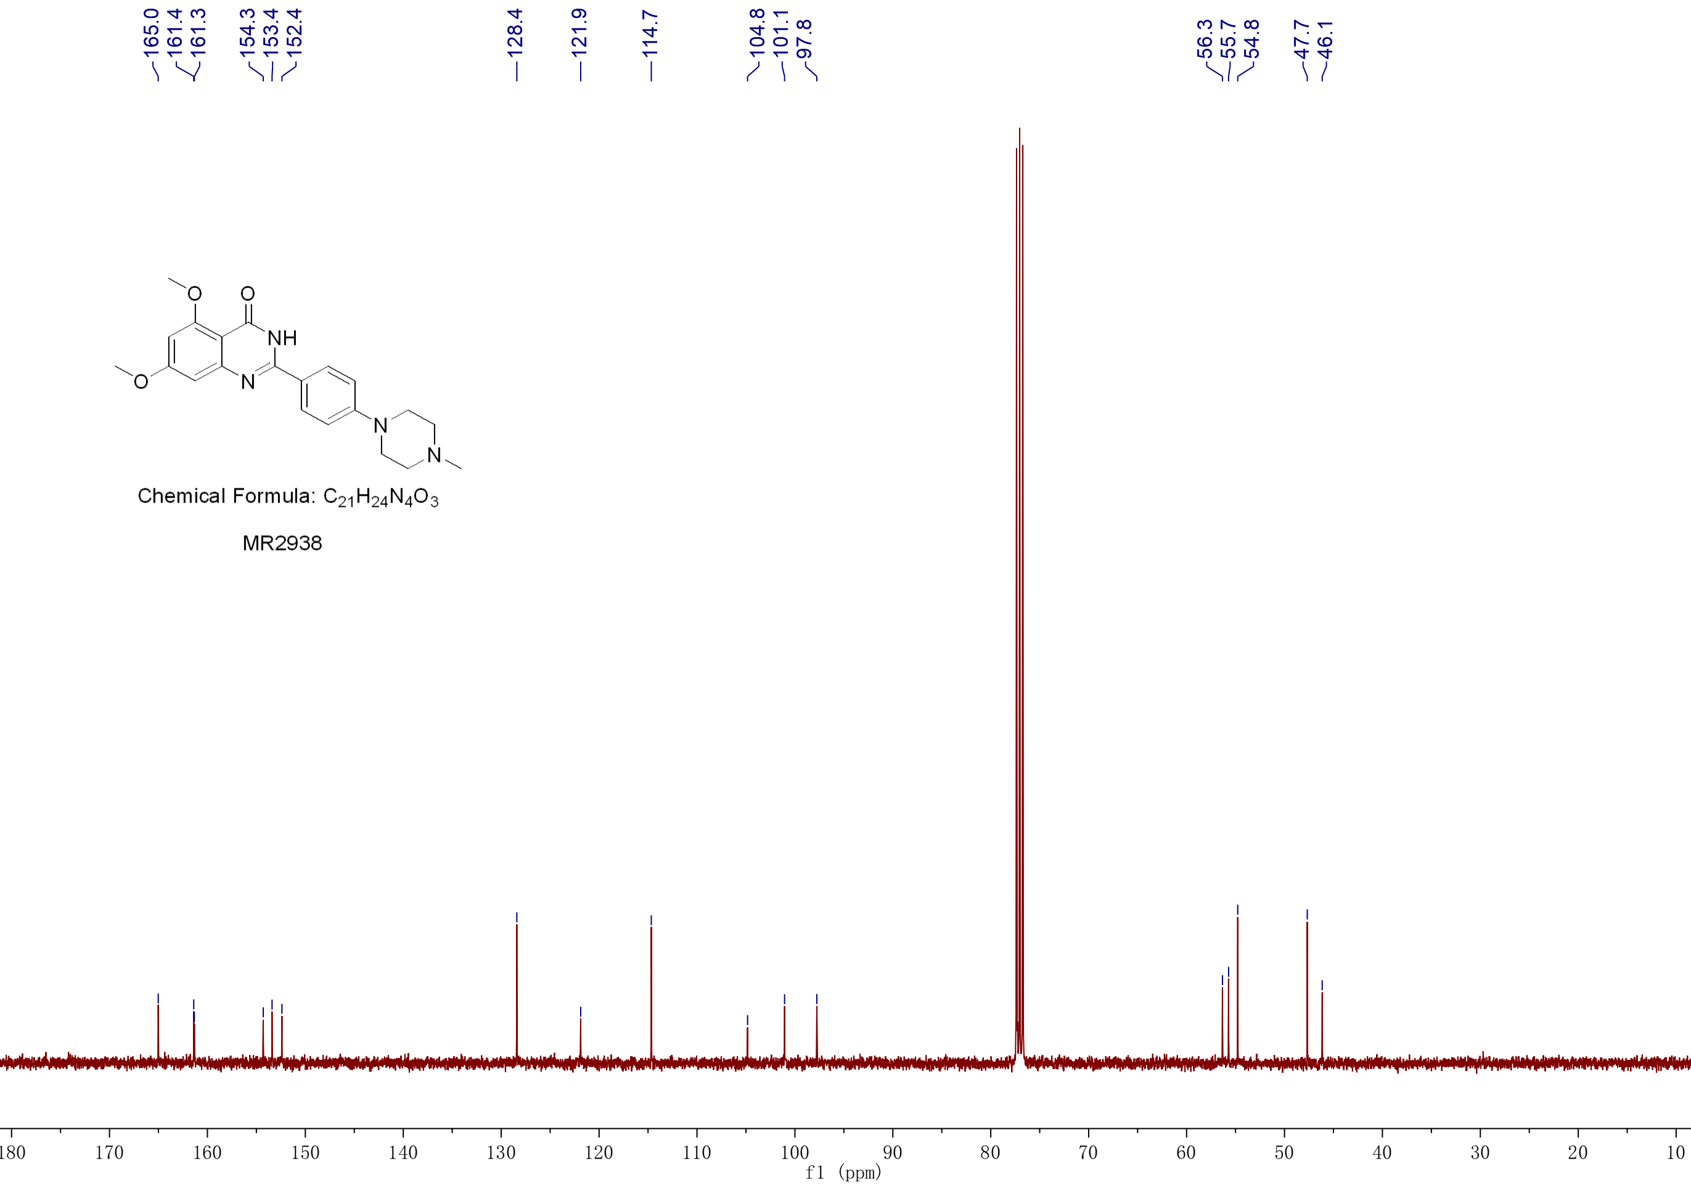
Figure S5. The copy of ¹³C NMR spectrum (100 MHz, CDCl₃) of MR2938

Peak | RT (min) | Peak area (AU*min) | % area
a | 2.836 | 357446 | 1.31
b | 2.918 | 684050 | 2.51
c | 3.530 | 26161661 | 96.17

Figure S6. HPLC profile of MR2938

