Supplementary figures
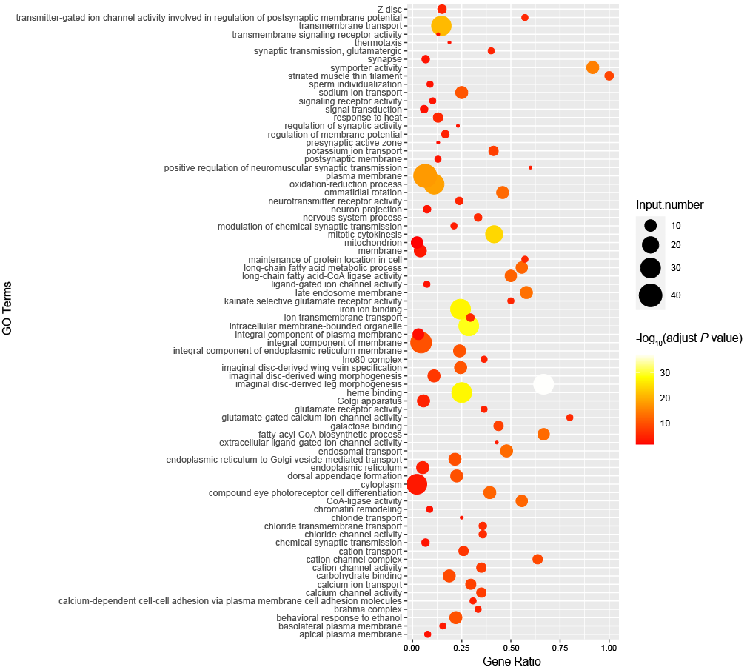
Fig. S1 The GO enrichment results of significantly expanded gene families in terrestrial talitrids compared with coastal talitrids.

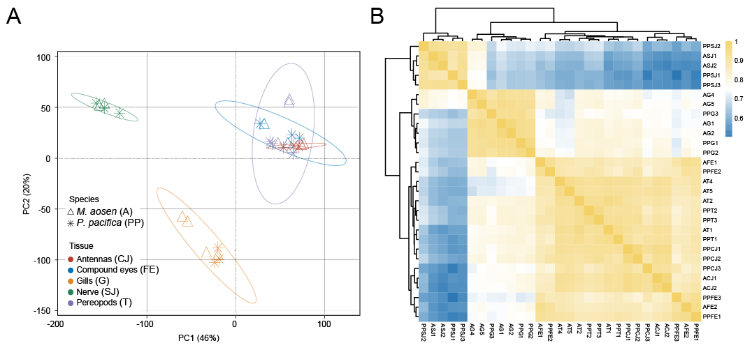
Fig. S2 Principal component analysis (A) and Symmetrical heat map of Spearman’s correlation coefficients (B) show that data for the gills are clearly separated from those of other tissues. Samples are represented with abbreviations of species+tissues+samples number. e.g., AG1: Morinoia aosen gills sample1.

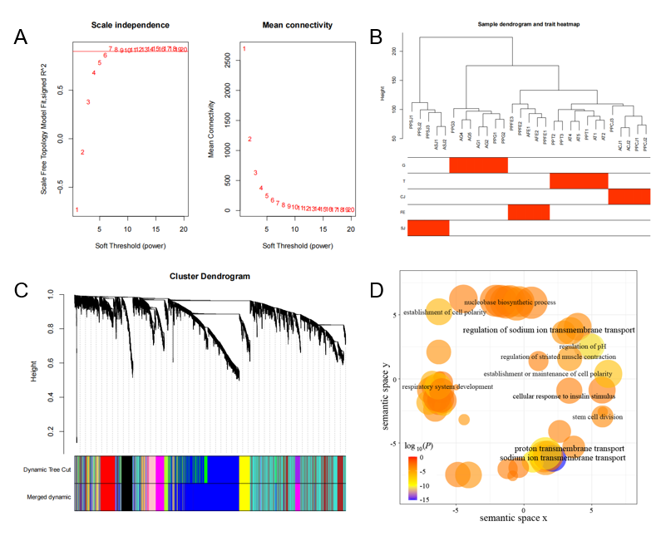
Fig. S3 The Weighted gene Co-expression analysis (WGCNA) for five tissues in Morinoia aosen and Platorchestia pacifica. A Analysis of soft-thresholding powers based on scale independence (left) and mean connectivity (right). Soft threshold of 6 was selected. B Sample cluster analysis. All the same tissues cluster together, indicating reasonable biological repetitions. C The cluster dendrogram of genes. Modules considered with high similarity were merged. D Enriched GO terms of the of magenta module associated with gill genes. Bubble size represents the number of annotations for a certain GO term, and color indicates the corrected enrichment P-value on a log₁₀ scale.

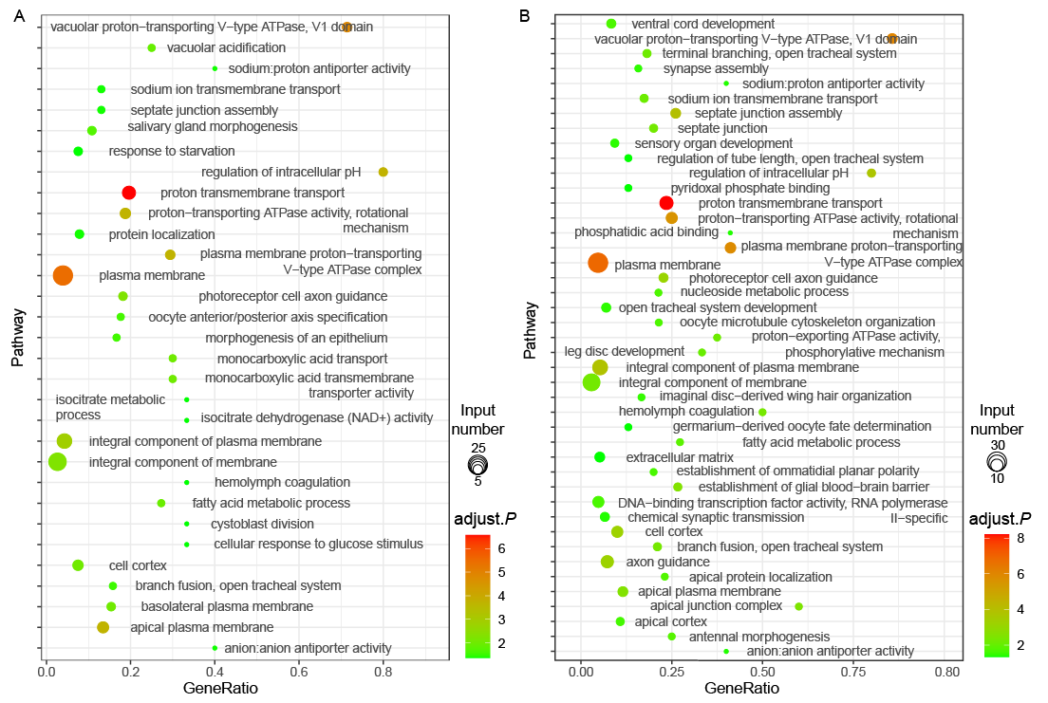
Fig. S4 GO enrichment of upregulated genes in gills relative to other tissues in Morinoia aosen and Platorchestia pacifica. A GO enrichment results of upregulated genes in M. aosen gills relative both to other tissues and to P. pacifica gills. B GO enrichment results of upregulated genes in P. pacifica gills relative both to other tissues and to M. aosen gills.

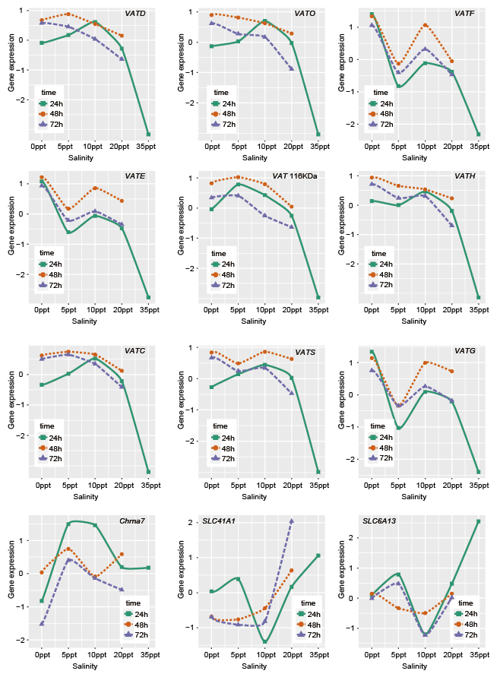
Fig. S5. The DEGs expression changes in Morinoia aosen under the gradient salinity acclimation validated by the RT-qPCR. M. aosen that were not treated were treated as a control.
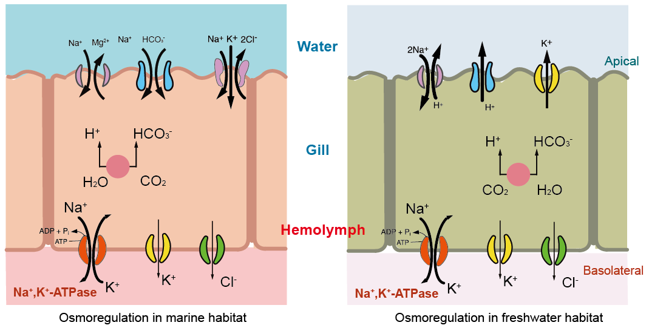
Fig. S6 Other possible models related to ion transport and pH regulation in talitrids based on several DEGs. In marine habitats, genes related to inorganic ion transport, i.e., NKCC (Na⁺, K⁺, Cl⁻), SLC4A5 (Na⁺, HCO₃⁻), and SLC41A1 (Mg²⁺, Na⁺), were upregulated. In freshwater habitats, V-type H⁺-ATPases and SLC9A2 (sodium/hydrogen exchanger) were upregulated, while KCNK1 (Potassium channel subfamily K member 1), which is related to the potassium channel and inorganic K⁺ transport, was downregulated. Na⁺/K⁺-ATPase, which transports Na⁺ from the cell into the hemolymph, shows similar expression between habitats but higher expression relative to other tissues. CO₂ hydration by cytosolic carbonic anhydrase generates H⁺ and HCO₃⁻, perhaps originally coupled to intracellular pH regulation.

Supplementary Tables
Table S1. BUSCO-based assessment (arthropoda_odb10) of genome coding sequence used in this study.
Type |  | Complete BUSCOs (C) | Complete and single-copy BUSCOs (S) | Complete and duplicated BUSCOs (D) | Fragmented BUSCOs (F) | Missing BUSCOs (M)
Morinoia aosen  (GCA_030386875.1) | Number | 957 | 873 | 84 | 16 | 40
Morinoia aosen  (GCA_030386875.1) | Rate（%） | 94.5 | 86.2 | 8.3 | 1.6 | 3.9
Platorchestia  hallaensis  (GCA_014220935.1) | Number | 743 | 730 | 13 | 132 | 138
Platorchestia  hallaensis  (GCA_014220935.1) | Rate（%） | 73.4 | 72.1 | 1.3 | 13.0 | 13.6
Platorchestia pacifica (This study) | Number | 905 | 800 | 105 | 53 | 55
Platorchestia pacifica (This study) | Rate（%） | 89.4 | 79.0 | 10.4 | 5.2 | 5.4
Ochestia grillus  (GCA_014899125.1) | Number | 630 | 624 | 6 | 203 | 180
Ochestia grillus  (GCA_014899125.1) | Rate（%） | 62.2 | 61.6 | 0.6 | 20 | 17.8
Trinorchestia longiramus  (GCA_006783055.1) | Number | 860 | 827 | 33 | 84 | 69
Trinorchestia longiramus  (GCA_006783055.1) | Rate（%） | 84.9 | 81.6 | 3.3 | 8.3 | 6.8
Parhyale  hawaiensis  (GCA_001587735.2) | Number | 970 | 953 | 17 | 20 | 23
Parhyale  hawaiensis  (GCA_001587735.2) | Rate（%） | 95.8 | 94.1 | 1.7 | 2.0 | 2.2
Hyalella azteca  (GCA_000764305.4) | Number | 955 | 865 | 90 | 27 | 31
Hyalella azteca  (GCA_000764305.4) | Rate（%） | 94.3 | 85.4 | 8.9 | 2.7 | 3.0

Table S2. Positively selected genes with P-values. Two terrestrial species (Morinoia aosen and Platorchestia hallaensis) were set as foreground branches.
GeneID | genename | lnL | lnL0 | P | FDR
gmmseq476G001290.2 | TUT4 | -6169.64 | -6234.38 | 5.32E-30 | 1.2291E-26
gmmseq204G001400.1 | TROP | -2976.12 | -3008.9 | 5.64E-16 | 6.51861E-13
gmmseq142G001080.1 | - | -5039.74 | -5067.96 | 5.77E-14 | 4.44799E-11
gmmseq385G000810.3 | RER1 | -1086.59 | -1112.26 | 7.79E-13 | 4.5055E-10
gmmseq503G000010.1 | MTX1 | -2377.78 | -2402.69 | 1.69E-12 | 7.83181E-10
gmmseq115G001700.1 | MYOB1 | -4146.23 | -4168.52 | 2.44E-11 | 9.40654E-09
gmmseq739G000100.1 | - | -4365.78 | -4386.9 | 8.07E-11 | 2.66577E-08
gmmseq207G000050.1 | FLOT1 | -2170.37 | -2189.86 | 4.27E-10 | 1.2337E-07
gmmseq598G000540.1 | STEA4 | -4910.02 | -4928.96 | 7.54E-10 | 1.93679E-07
gmmseq589G000740.1 | INCE | -8740.36 | -8757.37 | 5.43E-09 | 1.25644E-06
gmmseq792G000080.1 | FANCM | -15931 | -15947.3 | 1.19E-08 | 2.50618E-06
gmmseq602G000440.1 | - | -16193.1 | -16208.8 | 2.05E-08 | 3.94172E-06
gmmseq399G001060.1 | - | -4797.02 | -4812.31 | 3.23E-08 | 5.73698E-06
gmmseq396G000690.1 | PEG3 | -8646.48 | -8661.74 | 3.31E-08 | 5.47195E-06
gmmseq163G000350.1 | PKD1 | -18017.2 | -18032 | 5.69E-08 | 8.77168E-06
gmmseq402G000680.1 | RAB3GAP2 | -3925.55 | -3940.15 | 6.53E-08 | 9.43801E-06
gmmseq856G000020.1 | KHDC3 | -7737.53 | -7751.78 | 9.44E-08 | 1.28438E-05
gmmseq117G000640.1 | CENPE | -30916.4 | -30930.3 | 1.37E-07 | 1.75995E-05
gmmseq198G000300.1 | SYCP2 | -18491.1 | -18504.9 | 1.41E-07 | 1.71254E-05
gmmseq245G002290.1 | - | -4325.23 | -4338.9 | 1.71E-07 | 1.9792E-05
gmmseq19G000050.1 | YFL067W | -1288.44 | -1301.71 | 2.6E-07 | 2.86064E-05
gmmseq556G000200.2 | CDAN1 | -12520.4 | -12532.7 | 7.36E-07 | 7.7322E-05
gmmseq65G000430.1 | PRP2 | -20141.1 | -20152.8 | 1.28E-06 | 0.000128716
gmmseq740G000680.1 | ZN626 | -9144.81 | -9156.42 | 1.44E-06 | 0.000139105
gmmseq754G000210.1 | SMYD4 | -7986.04 | -7997.55 | 1.59E-06 | 0.000147367
gmmseq271G000260.1 | KIF4B | -6573.34 | -6584.06 | 3.65E-06 | 0.000324721
gmmseq509G000130.1 | REN3A | -8095.19 | -8105.9 | 3.7E-06 | 0.000316628
gmmseq129G001270.1 | - | -2908.47 | -2919.09 | 4.05E-06 | 0.000334129
gmmseq354G000920.2 | DIAP2 | -5955.12 | -5965.73 | 4.11E-06 | 0.000327655
gmmseq736G000120.1 | HPF1 | -2619.21 | -2629.69 | 4.73E-06 | 0.000364678
gmmseq733G000420.1 | IPPK | -10616.6 | -10627 | 5.05E-06 | 0.000376897
gmmseq497G000940.1 | MCAF1 | -8892.16 | -8902.56 | 5.14E-06 | 0.000371694
gmmseq791G000100.1 | FA5 | -11594.5 | -11604.7 | 6.51E-06 | 0.000456158
gmmseq564G000730.1 | - | -7799.55 | -7809.62 | 7.23E-06 | 0.000491827
gmmseq54G000190.1 | METL4 | -2835.89 | -2845.95 | 7.31E-06 | 0.000482711
gmmseq422G000480.1 | - | -8852.77 | -8862.75 | 7.87E-06 | 0.000505289
gmmseq22G000160.1 | PTH1R | -4157.2 | -4167.1 | 8.62E-06 | 0.000538903
gmmseq312G000190.1 | TRM13 | -5023.99 | -5033.77 | 9.69E-06 | 0.000589639
gmmseq69G000260.1 | ABHEB | -1546.28 | -1555.61 | 1.56E-05 | 0.000922268
gmmseq482G000510.1 | MOCOS | -6173.84 | -6183.02 | 1.82E-05 | 0.00105323
gmmseq204G000220.1 | - | -7766.76 | -7775.91 | 1.88E-05 | 0.001061745
gmmseq250G000160.1 | - | -1887.03 | -1895.96 | 2.38E-05 | 0.001311124
gmmseq22G000020.1 | - | -11443.7 | -11452.6 | 2.63E-05 | 0.001413488
gmmseq486G000260.1 | CCNY | -8204.35 | -8213.07 | 2.95E-05 | 0.001549621
gmmseq48G000240.1 | SDR9C7 | -5760.5 | -5769.07 | 3.5E-05 | 0.001796656
gmmseq476G001610.1 | OCRL | -2105.71 | -2114.13 | 4.06E-05 | 0.002042228
gmmseq574G000510.1 | FAR1 | -2449.09 | -2457.43 | 4.39E-05 | 0.002160295
gmmseq51G001220.1 | CTHB1 | -3301.29 | -3309.6 | 4.55E-05 | 0.002193087
gmmseq750G000150.1 | NO12B | -5250.58 | -5258.85 | 4.77E-05 | 0.002248523
gmmseq407G000170.1 | WHITE | -10212.5 | -10220.6 | 5.32E-05 | 0.002459448
gmmseq518G000080.1 | RPGRH | -9496.82 | -9504.99 | 5.33E-05 | 0.002414462
gmmseq585G001090.1 | PTGR1 | -2288.43 | -2296.54 | 5.63E-05 | 0.002501976
gmmseq466G000400.1 | NIPA | -5889.95 | -5898.06 | 5.63E-05 | 0.002455404
gmmseq539G000140.1 | HEM3 | -2274.39 | -2282.45 | 5.93E-05 | 0.002539304
gmmseq304G000100.1 | - | -12044 | -12052 | 5.94E-05 | 0.002495653
gmmseq508G000200.1 | - | -4251.96 | -4259.85 | 7.14E-05 | 0.002948249
gmmseq469G000750.1 | CFDP1 | -2323.99 | -2331.77 | 7.97E-05 | 0.003233095
gmmseq258G000170.1 | TAB1 | -2349.63 | -2357.38 | 8.27E-05 | 0.003296704
gmmseq593G000250.1 | C2CD5 | -5561.48 | -5569.19 | 8.56E-05 | 0.003353271
gmmseq252G000500.1 | CBPB | -8589.17 | -8596.88 | 8.64E-05 | 0.00332795
gmmseq68G000280.1 | XPO5 | -5086.7 | -5094.37 | 9.01E-05 | 0.00341366
gmmseq143G000360.1 | TMC7 | -1655.39 | -1663.01 | 9.4E-05 | 0.003506872
gmmseq132G001540.1 | KIF3B | -9893.92 | -9901.49 | 9.98E-05 | 0.003663652
gmmseq48G000260.1 | THUM3 | -3909.17 | -3916.72 | 0.000102 | 0.003672587
gmmseq497G001380.1 | FP1 | -10123.4 | -10130.9 | 0.000103 | 0.003661058
gmmseq91G000270.1 | ARRD3 | -2429.54 | -2436.92 | 0.000122 | 0.004286254
gmmseq68G000390.2 | DTX2 | -7725.51 | -7732.85 | 0.000126 | 0.004363029
gmmseq467G000440.1 | THADA | -12097.6 | -12104.9 | 0.000132 | 0.004472617
gmmseq274G001970.1 | PTPRC | -7232.08 | -7239.32 | 0.000142 | 0.004744282
gmmseq85G000080.1 | CLRN3 | -2993.61 | -3000.81 | 0.000148 | 0.004874586
gmmseq16G000180.1 | RESIL | -7696.07 | -7703.18 | 0.000162 | 0.005279997
gmmseq255G000870.1 | APLF | -5532.22 | -5539.28 | 0.000171 | 0.005483624
gmmseq85G000360.1 | NXN | -3999.95 | -4006.93 | 0.000186 | 0.005902277
gmmseq39G000200.1 | OCTL | -4264.67 | -4271.65 | 0.000187 | 0.005843087
gmmseq589G000660.1 | - | -1613.18 | -1620.11 | 0.000197 | 0.00608646
gmmseq134G000030.1 | BMAL1 | -4123.19 | -4129.95 | 0.000236 | 0.007166754
gmmseq736G000070.1 | PP12C | -9338.12 | -9344.87 | 0.000239 | 0.007178669
gmmseq736G000220.1 | - | -2522.15 | -2528.72 | 0.000289 | 0.008571072
gmmseq376G000250.1 | BMI1B | -6502.18 | -6508.71 | 0.0003 | 0.008772954
gmmseq385G001500.2 | ZN628 | -11106.4 | -11112.9 | 0.000306 | 0.008832882
gmmseq824G000040.1 | - | -12396.6 | -12403.1 | 0.000333 | 0.009495244
gmmseq644G000960.1 | ZN236 | -3253.87 | -3260.27 | 0.000348 | 0.009804966
gmmseq274G000830.1 | DNMBP | -8029.92 | -8036.31 | 0.000352 | 0.009816426
gmmseq68G000590.1 | GAGA | -6764.31 | -6770.63 | 0.000377 | 0.010376675
gmmseq101G000280.1 | LACH | -713 | -719.311 | 0.000381 | 0.010369444
gmmseq248G000320.1 | MIPT3 | -2694.25 | -2700.53 | 0.000394 | 0.01058392
gmmseq247G001190.2 | PDE | -4237.45 | -4243.66 | 0.000426 | 0.011323406
gmmseq206G000510.1 | - | -3855.53 | -3861.67 | 0.000454 | 0.011924704
gmmseq607G000160.1 | - | -1583.25 | -1589.38 | 0.000461 | 0.011978626
gmmseq93G000140.1 | RBM5A | -5110.33 | -5116.46 | 0.000463 | 0.011889526
gmmseq336G000220.1 | ESCA | -5293.24 | -5299.37 | 0.000464 | 0.011776075
gmmseq392G000170.1 | - | -1216.81 | -1222.93 | 0.00047 | 0.011822017
gmmseq607G000560.1 | ZFP26 | -5420.46 | -5426.55 | 0.000479 | 0.011901815
gmmseq855G000080.1 | - | -1038.57 | -1044.62 | 0.000502 | 0.012355498
gmmseq768G000170.1 | TOPRS | -7948.39 | -7954.43 | 0.000512 | 0.012464361
gmmseq250G000720.1 | U518 | -4355.53 | -4361.47 | 0.000565 | 0.013610744
gmmseq476G000940.1 | PLBLB | -3257.44 | -3263.36 | 0.000577 | 0.013749975
gmmseq206G000500.1 | - | -2558.42 | -2564.32 | 0.000596 | 0.014049495
gmmseq526G000650.1 | - | -898.629 | -904.428 | 0.00066 | 0.015411078
gmmseq410G000410.1 | CU27 | -4483.62 | -4489.41 | 0.000663 | 0.015335666
gmmseq569G000150.1 | GEMI5 | -14163.8 | -14169.6 | 0.000669 | 0.015303872
gmmseq274G000530.1 | - | -11389.6 | -11395.4 | 0.000679 | 0.015391509
gmmseq618G000210.1 | - | -738.407 | -744.144 | 0.000706 | 0.015842767
gmmseq385G000280.1 | - | -2379.84 | -2385.5 | 0.000766 | 0.017036077
gmmseq887G000020.1 | - | -9660.24 | -9665.88 | 0.000776 | 0.017094345
gmmseq274G000300.1 | RBMX2 | -2849.69 | -2855.28 | 0.000829 | 0.018078665
gmmseq735G000280.1 | - | -1873.35 | -1878.9 | 0.000864 | 0.018665879
gmmseq132G002120.1 | - | -830.479 | -836.026 | 0.000866 | 0.018547194
gmmseq115G000810.1 | - | -1033.61 | -1039.12 | 0.000901 | 0.019120161
gmmseq826G000490.1 | - | -515.532 | -521.004 | 0.000939 | 0.019732605
gmmseq206G001410.1 | MTH2 | -13707 | -13712.5 | 0.000955 | 0.019882193
gmmseq142G000860.1 | OPLA | -3435.02 | -3440.44 | 0.000987 | 0.020381716
gmmseq115G000890.2 | IQGA1 | -14910.7 | -14916.1 | 0.001012 | 0.020698604
gmmseq505G000370.1 | MACOI | -3214.67 | -3220.06 | 0.001034 | 0.020960371
gmmseq591G000650.1 | TM169 | -2210.46 | -2215.8 | 0.001078 | 0.021667631
gmmseq771G000280.1 | SANT | -1441.12 | -1446.47 | 0.001082 | 0.021562487
gmmseq794G000320.1 | TRFM | -2712.79 | -2718.12 | 0.001092 | 0.021575874
gmmseq21G000070.1 | CycB3 | -603.541 | -608.856 | 0.001112 | 0.021788601
gmmseq791G000050.1 | RESIL | -2119.11 | -2124.41 | 0.001133 | 0.022011877
gmmseq743G000290.1 | AASD1 | -2307.35 | -2312.64 | 0.001146 | 0.022072958
gmmseq577G000340.1 | - | -7441.53 | -7446.81 | 0.001158 | 0.022124333
gmmseq115G001150.1 | MTTF | -4080.41 | -4085.67 | 0.001176 | 0.022287419
gmmseq8G000110.1 | NFH | -1965.88 | -1971.09 | 0.001247 | 0.023444169
gmmseq735G000390.1 | FHOD3 | -5912.24 | -5917.43 | 0.001269 | 0.023651923
gmmseq67G000810.1 | EIF3A | -7591.9 | -7597.09 | 0.001281 | 0.023688259
gmmseq175G000240.1 | - | -4242.32 | -4247.5 | 0.001285 | 0.023570857
gmmseq458G000010.1 | RUSD2 | -1186.29 | -1191.45 | 0.001316 | 0.02395399
gmmseq181G000450.1 | TTN1 | -21068.1 | -21073.2 | 0.001331 | 0.024045098
gmmseq225G000090.1 | PPAF2 | -1475.92 | -1481.05 | 0.001357 | 0.024326542
gmmseq407G000360.1 | PCE | -1954.32 | -1959.42 | 0.001401 | 0.024917037
gmmseq793G000050.1 | - | -1263.5 | -1268.55 | 0.001489 | 0.026286278
gmmseq129G001770.1 | - | -5373.53 | -5378.54 | 0.001554 | 0.027222796
gmmseq183G000160.1 | - | -2651.35 | -2656.36 | 0.001559 | 0.027096977
gmmseq143G000420.1 | NLRC4 | -6571.98 | -6576.98 | 0.001569 | 0.027069876
gmmseq480G000580.1 | LIGO1 | -3982.04 | -3987.04 | 0.001569 | 0.026871168
gmmseq385G002180.1 | NDUBA | -958.088 | -963.084 | 0.001572 | 0.026718178
gmmseq733G000200.1 | CAD96 | -8183.3 | -8188.27 | 0.001605 | 0.02708168
gmmseq579G000450.1 | GLRA3 | -3754.19 | -3759.16 | 0.001627 | 0.027255454
gmmseq421G001860.1 | GCM2 | -3830.32 | -3835.28 | 0.001639 | 0.027261062
gmmseq345G001520.1 | - | -2739.3 | -2744.25 | 0.001648 | 0.027210377
gmmseq206G002080.1 | - | -3240.87 | -3245.82 | 0.00166 | 0.027211501
gmmseq604G000300.1 | DDX51 | -3331.29 | -3336.24 | 0.001666 | 0.027131992
gmmseq164G000740.1 | CELR2 | -6119.06 | -6123.99 | 0.001687 | 0.027276805
gmmseq3G000220.1 | NRG | -1380.31 | -1385.24 | 0.001689 | 0.02711042
gmmseq132G001910.1 | - | -3903 | -3907.92 | 0.001714 | 0.027326728
gmmseq452G000110.1 | COG8 | -1246.93 | -1251.82 | 0.001757 | 0.027826399
gmmseq405G000160.1 | NFH | -7376.19 | -7381.08 | 0.001767 | 0.027796798
gmmseq20G000200.1 | - | -14865.6 | -14870.5 | 0.001808 | 0.028237452
gmmseq203G000180.1 | AGK | -1721.12 | -1725.94 | 0.00191 | 0.029643318
gmmseq193G000060.1 | SAP | -2008.5 | -2013.31 | 0.001934 | 0.02980207
gmmseq644G000610.1 | HSP70 | -6100.8 | -6105.61 | 0.001934 | 0.029615056
gmmseq372G001270.1 | - | -5287.43 | -5292.18 | 0.002048 | 0.031149155
gmmseq564G000950.1 | UTP6 | -4651.91 | -4656.66 | 0.00207 | 0.031274907
gmmseq206G000120.1 | MTAP2 | -1199.33 | -1204.01 | 0.002203 | 0.033073285
gmmseq776G000270.1 | ZN678 | -14152 | -14156.7 | 0.002232 | 0.033293665
gmmseq447G000270.1 | EMC7 | -1034.04 | -1038.7 | 0.002284 | 0.033849255
gmmseq115G001870.1 | ZN367 | -9021.63 | -9026.25 | 0.002373 | 0.034946203
gmmseq123G000420.1 | - | -2998.15 | -3002.77 | 0.002377 | 0.034782838
gmmseq33G001170.2 | Ppp6r3 | -3036.24 | -3040.85 | 0.002382 | 0.034643151
gmmseq823G000130.1 | PRD10 | -2399.07 | -2403.68 | 0.002401 | 0.034691154
gmmseq198G000410.1 | RECQ4 | -14369.8 | -14374.4 | 0.002453 | 0.035226681
gmmseq370G000460.1 | - | -11231.2 | -11235.7 | 0.002564 | 0.036594161
gmmseq65G000160.2 | TGIF1 | -7168.69 | -7173.21 | 0.002646 | 0.037536474
gmmseq649G000180.1 | RAI14 | -6634.8 | -6639.29 | 0.002726 | 0.038429886
gmmseq492G000020.1 | ENTK | -7168.64 | -7173.09 | 0.002834 | 0.039716434
gmmseq229G000820.1 | - | -933.487 | -937.919 | 0.00291 | 0.040524575
gmmseq60G000330.1 | - | -3427.5 | -3431.93 | 0.002936 | 0.04064792
gmmseq274G000230.1 | YF1BB | -2379.53 | -2383.94 | 0.002973 | 0.040919946
gmmseq245G000380.1 | SETMR | -3216.5 | -3220.91 | 0.003004 | 0.041089415
gmmseq89G000400.1 | - | -7917.8 | -7922.2 | 0.003006 | 0.040876783
gmmseq750G000210.1 | CU1A | -1186.75 | -1191.12 | 0.003111 | 0.042067997
gmmseq138G000100.2 | DXO | -1689.48 | -1693.83 | 0.003169 | 0.042593755
gmmseq402G000250.1 | - | -1018.62 | -1022.97 | 0.003178 | 0.042472249
gmmseq900G000570.1 | THG1 | -10294.9 | -10299.2 | 0.003216 | 0.042734237
gmmseq175G000010.1 | - | -4858.93 | -4863.24 | 0.003326 | 0.043944
gmmseq115G001380.1 | RN123 | -1858.88 | -1863.19 | 0.003344 | 0.043929514
gmmseq426G001280.1 | DDX20 | -8702.37 | -8706.67 | 0.003345 | 0.0436985
gmmseq554G000100.2 | - | -3846.19 | -3850.48 | 0.003399 | 0.044149101
gmmseq498G000140.1 | CCNL1 | -1471.01 | -1475.24 | 0.00366 | 0.047270558
gmmseq110G000670.1 | IGB1B | -1754.14 | -1758.35 | 0.003699 | 0.047512498
gmmseq129G002410.1 | ARMC6 | -3873.36 | -3877.57 | 0.003715 | 0.047455587
gmmseq814G001110.1 | - | -1641.42 | -1645.63 | 0.003749 | 0.04762497
gmmseq362G000350.1 | - | -2632.08 | -2636.28 | 0.003757 | 0.047464153
gmmseq526G000380.1 | SUFU | -2314.53 | -2318.72 | 0.003792 | 0.047642435
gmmseq85G000390.1 | - | -2090 | -2094.19 | 0.003798 | 0.047465538
gmmseq373G000110.1 | SMYD4 | -4177.16 | -4181.32 | 0.003949 | 0.04908131
gmmseq509G000390.1 | RESIL | -2822.21 | -2826.36 | 0.003959 | 0.048952727
gmmseq229G000880.1 | GLCM | -4403.12 | -4407.26 | 0.004027 | 0.04952659

Table S3 The significant enriched pathways based on the identified specifically expressed gene in each tissue in Morinoia aosen.
GO items enriched in Antennae | ID | Generatio | Corrected P-Value
extracellular space | GO:0005615 | 0.011029 | 0.002994
innate immune response | GO:0045087 | 0.053571 | 0.002981
proteolysis | GO:0006508 | 0.008242 | 0.035866
endopeptidase inhibitor activity | GO:0004866 | 0.333333 | 0.002981
positive regulation of Wnt protein secretion | GO:0061357 | 0.285714 | 0.002981
extracellular exosome | GO:0070062 | 0.142857 | 0.00512
microtubule-based process | GO:0007017 | 0.095238 | 0.00894
extracellular matrix organization | GO:0030198 | 0.08 | 0.009973
structural constituent of cytoskeleton | GO:0005200 | 0.076923 | 0.009973
signaling receptor activity | GO:0038023 | 0.051282 | 0.016315
cilium | GO:0005929 | 0.051282 | 0.016315
positive regulation of canonical Wnt signaling pathway | GO:0090263 | 0.05 | 0.016315
microtubule | GO:0005874 | 0.046512 | 0.01715
ligand-gated ion channel activity | GO:0015276 | 0.036364 | 0.024199
endosome | GO:0005768 | 0.033898 | 0.024199
microtubule cytoskeleton organization | GO:0000226 | 0.033333 | 0.024199
metalloendopeptidase activity | GO:0004222 | 0.033333 | 0.024199
cilium assembly | GO:0060271 | 0.030303 | 0.02729
defense response to Gram-negative bacterium | GO:0050829 | 0.022472 | 0.034174
GTPase activity | GO:0003924 | 0.017241 | 0.035866
extracellular matrix | GO:0031012 | 0.017241 | 0.035866
mitotic cell cycle | GO:0000278 | 0.017094 | 0.035866
GTP binding | GO:0005525 | 0.016129 | 0.035866
GO items enriched in Compound eye | ID | Generatio | Corrected P-Value
integral component of plasma membrane | GO:0005887 | 0.121711 | 3.51E-25
rhabdomere | GO:0016028 | 0.444444 | 4.98E-13
homophilic cell adhesion via plasma membrane adhesion molecules | GO:0007156 | 0.333333 | 5.48E-12
neuron projection | GO:0043005 | 0.205882 | 8.42E-12
plasma membrane | GO:0005886 | 0.048589 | 7.04E-11
synapse | GO:0045202 | 0.16 | 4.90E-09
chemical synaptic transmission | GO:0007268 | 0.157895 | 4.90E-09
axon extension involved in axon guidance | GO:0048846 | 1 | 4.90E-08
cell-cell adhesion mediated by cadherin | GO:0044331 | 0.666667 | 2.30E-07
identical protein binding | GO:0042802 | 0.333333 | 3.93E-07
synapse organization | GO:0050808 | 0.173077 | 3.93E-07
deactivation of rhodopsin mediated signaling | GO:0016059 | 0.5 | 5.90E-07
calcium ion binding | GO:0005509 | 0.082803 | 5.90E-07
calcium-dependent cell-cell adhesion via plasma membrane cell adhesion molecules | GO:0016339 | 0.461538 | 7.33E-07
phototransduction | GO:0007602 | 0.2 | 7.33E-07
G protein-coupled receptor binding | GO:0001664 | 0.241379 | 1.75E-06
regulation of membrane potential | GO:0042391 | 0.233333 | 2.02E-06
cell-cell adhesion mediator activity | GO:0098632 | 0.555556 | 4.77E-06
neurotransmitter receptor activity | GO:0030594 | 0.285714 | 5.54E-06
neuron projection membrane | GO:0032589 | 0.285714 | 5.54E-06
cadherin binding | GO:0045296 | 0.5 | 6.08E-06
R7 cell development | GO:0045467 | 0.416667 | 1.13E-05
dendrite self-avoidance | GO:0070593 | 0.384615 | 1.48E-05
synaptic vesicle endocytosis | GO:0048488 | 0.214286 | 1.90E-05
neuropeptide signaling pathway | GO:0007218 | 0.148936 | 1.97E-05
nervous system process | GO:0050877 | 0.333333 | 2.35E-05
sensory perception of sound | GO:0007605 | 0.142857 | 2.35E-05
thermotaxis | GO:0043052 | 0.3125 | 2.84E-05
ion transmembrane transport | GO:0034220 | 0.294118 | 3.53E-05
integral component of membrane | GO:0016021 | 0.030263 | 5.28E-05
signaling receptor activity | GO:0038023 | 0.153846 | 8.22E-05
ommatidial rotation | GO:0016318 | 0.208333 | 0.000129
calcium-mediated signaling | GO:0019722 | 0.208333 | 0.000129
heterophilic cell-cell adhesion via plasma membrane cell adhesion molecules | GO:0007157 | 0.208333 | 0.000129
visual perception | GO:0007601 | 0.363636 | 0.000165
enzyme regulator activity | GO:0030234 | 0.192308 | 0.000172
neuropeptide hormone activity | GO:0005184 | 0.185185 | 0.000197
G protein-coupled receptor signaling pathway | GO:0007186 | 0.076923 | 0.000206
axon guidance | GO:0007411 | 0.065217 | 0.000206
rhabdomere development | GO:0042052 | 0.178571 | 0.000213
locomotor rhythm | GO:0045475 | 0.117647 | 0.000253
photoreceptor cell maintenance | GO:0045494 | 0.266667 | 0.000381
signal transduction | GO:0007165 | 0.082353 | 0.000419
axon | GO:0030424 | 0.066116 | 0.000499
motor neuron axon guidance | GO:0008045 | 0.1 | 0.000535
neuron cell-cell adhesion | GO:0007158 | 0.6 | 0.000535
circadian sleep/wake cycle | GO:0042745 | 0.6 | 0.000535
aminergic neurotransmitter loading into synaptic vesicle | GO:0015842 | 0.6 | 0.000535
presynaptic membrane assembly | GO:0097105 | 0.5 | 0.00075
G protein-coupled photoreceptor activity | GO:0008020 | 0.5 | 0.00075
striated muscle thin filament | GO:0005865 | 0.5 | 0.00075
acetylcholine-gated channel complex | GO:0005892 | 0.428571 | 0.001025
acetylcholine-gated cation-selective channel activity | GO:0022848 | 0.428571 | 0.001025
hormone activity | GO:0005179 | 0.173913 | 0.001266
inaD signaling complex | GO:0016027 | 0.375 | 0.001325
neurexin family protein binding | GO:0042043 | 0.375 | 0.001325
cation transport | GO:0006812 | 0.148148 | 0.002087
sensory perception of smell | GO:0007608 | 0.096154 | 0.00215
ion transport | GO:0006811 | 0.3 | 0.00215
ionotropic glutamate receptor complex | GO:0008328 | 0.272727 | 0.002629
phototransduction, visible light | GO:0007603 | 0.272727 | 0.002629
postsynaptic membrane | GO:0045211 | 0.129032 | 0.003099
dendrite | GO:0030425 | 0.065217 | 0.00344
long-term memory | GO:0007616 | 0.083333 | 0.003617
regulation of axonogenesis | GO:0050770 | 0.230769 | 0.003689
cellular response to light stimulus | GO:0071482 | 0.230769 | 0.003689
axonal fasciculation | GO:0007413 | 0.214286 | 0.004381
synaptic vesicle transport | GO:0048489 | 0.1875 | 0.006064
regulation of dendrite morphogenesis | GO:0048814 | 0.166667 | 0.008085
modulation of chemical synaptic transmission | GO:0050804 | 0.157895 | 0.009115
cell surface | GO:0009986 | 0.090909 | 0.009115
extracellular space | GO:0005615 | 0.025735 | 0.009652
sensory perception of chemical stimulus | GO:0007606 | 0.0625 | 0.010758
early endosome | GO:0005769 | 0.085106 | 0.010943
cell-cell junction | GO:0005911 | 0.142857 | 0.010943
cell-cell adhesion | GO:0098609 | 0.142857 | 0.010943
photoreceptor cell axon guidance | GO:0072499 | 0.136364 | 0.011674
protein binding | GO:0005515 | 0.023088 | 0.011674
foregut morphogenesis | GO:0007440 | 0.4 | 0.011674
Wnt-activated receptor activity | GO:0042813 | 0.4 | 0.011674
nephrocyte filtration | GO:0097206 | 0.4 | 0.011674
body fluid secretion | GO:0007589 | 0.4 | 0.011674
store-operated calcium channel activity | GO:0015279 | 0.4 | 0.011674
rhabdomere microvillus membrane | GO:0035997 | 0.4 | 0.011674
regulation of compound eye pigmentation | GO:0048076 | 0.4 | 0.011674
transmembrane signaling receptor activity | GO:0004888 | 0.130435 | 0.011986
adenylate cyclase-activating G protein-coupled receptor signaling pathway | GO:0007189 | 0.130435 | 0.011986
presynaptic active zone | GO:0048786 | 0.130435 | 0.011986
locomotion | GO:0040011 | 0.12 | 0.0143
potassium ion transmembrane transport | GO:0071805 | 0.12 | 0.0143
rhodopsin mediated signaling pathway | GO:0016056 | 0.333333 | 0.0143
regulation of cytosolic calcium ion concentration | GO:0051480 | 0.333333 | 0.0143
compound eye morphogenesis | GO:0001745 | 0.054348 | 0.015127
muscle cell cellular homeostasis | GO:0046716 | 0.115385 | 0.01544
negative regulation of transcription by RNA polymerase II | GO:0000122 | 0.037634 | 0.016333
dipeptidase activity | GO:0016805 | 0.285714 | 0.016333
synaptic signaling | GO:0099536 | 0.285714 | 0.016333
detection of light stimulus involved in visual perception | GO:0050908 | 0.285714 | 0.016333
regulation of myoblast fusion | GO:1901739 | 0.285714 | 0.016333
coreceptor activity | GO:0015026 | 0.285714 | 0.016333
extracellular ligand-gated ion channel activity | GO:0005230 | 0.285714 | 0.016333
synaptic transmission, cholinergic | GO:0007271 | 0.285714 | 0.016333
microtubule cytoskeleton organization | GO:0000226 | 0.066667 | 0.018049
protein homodimerization activity | GO:0042803 | 0.049505 | 0.019177
sensory perception of touch | GO:0050975 | 0.25 | 0.019177
cytoskeleton of presynaptic active zone | GO:0048788 | 0.25 | 0.019177
response to anesthetic | GO:0072347 | 0.25 | 0.019177
trunk segmentation | GO:0035290 | 0.25 | 0.019177
signaling receptor binding | GO:0005102 | 0.096774 | 0.020869
potassium channel activity | GO:0005267 | 0.222222 | 0.021893
entrainment of circadian clock by photoperiod | GO:0043153 | 0.222222 | 0.021893
cGMP biosynthetic process | GO:0006182 | 0.222222 | 0.021893
cGMP-mediated signaling | GO:0019934 | 0.222222 | 0.021893
axon target recognition | GO:0007412 | 0.222222 | 0.021893
instar larval or pupal development | GO:0002165 | 0.222222 | 0.021893
cell elongation involved in imaginal disc-derived wing morphogenesis | GO:0090254 | 0.2 | 0.024828
carbohydrate homeostasis | GO:0033500 | 0.2 | 0.024828
positive regulation of cell migration | GO:0030335 | 0.2 | 0.024828
potassium ion leak channel activity | GO:0022841 | 0.2 | 0.024828
guanylate cyclase activity | GO:0004383 | 0.2 | 0.024828
synaptic target inhibition | GO:0016201 | 0.2 | 0.024828
male courtship behavior | GO:0008049 | 0.083333 | 0.027516
retinal ganglion cell axon guidance | GO:0031290 | 0.181818 | 0.028012
cation channel complex | GO:0034703 | 0.181818 | 0.028012
neuron projection morphogenesis | GO:0048812 | 0.181818 | 0.028012
voltage-gated potassium channel activity | GO:0005249 | 0.181818 | 0.028012
cytoplasmic vesicle | GO:0031410 | 0.078947 | 0.030175
circadian rhythm | GO:0007623 | 0.078947 | 0.030175
membrane | GO:0016020 | 0.028571 | 0.031015
stabilization of membrane potential | GO:0030322 | 0.166667 | 0.031015
endocytic vesicle | GO:0030139 | 0.166667 | 0.031015
cell adhesion molecule binding | GO:0050839 | 0.166667 | 0.031015
cell adhesion | GO:0007155 | 0.076923 | 0.031067
heparin binding | GO:0008201 | 0.153846 | 0.035031
eye development | GO:0001654 | 0.142857 | 0.037829
small GTPase mediated signal transduction | GO:0007264 | 0.142857 | 0.037829
chloride transmembrane transport | GO:1902476 | 0.142857 | 0.037829
carbonate dehydratase activity | GO:0004089 | 0.142857 | 0.037829
positive regulation of circadian sleep/wake cycle, sleep | GO:0045938 | 0.142857 | 0.037829
chloride channel activity | GO:0005254 | 0.142857 | 0.037829
hormone-mediated signaling pathway | GO:0009755 | 0.142857 | 0.037829
peptidase activity | GO:0008233 | 0.133333 | 0.041156
ommochrome biosynthetic process | GO:0006727 | 0.133333 | 0.041156
canonical Wnt signaling pathway | GO:0060070 | 0.133333 | 0.041156
hydro-lyase activity | GO:0016836 | 0.133333 | 0.041156
Wnt-protein binding | GO:0017147 | 0.133333 | 0.041156
galactose binding | GO:0005534 | 0.125 | 0.045087
medium-term memory | GO:0072375 | 0.125 | 0.045087
response to light stimulus | GO:0009416 | 0.125 | 0.045087
potassium ion transport | GO:0006813 | 0.117647 | 0.049736
GO items enriched in Gill | ID | Generatio | Corrected P-Value
integral component of membrane | GO:0016021 | 0.011842 | 0.020553
integral component of plasma membrane | GO:0005887 | 0.023026 | 0.003697
plasma membrane | GO:0005886 | 0.010972 | 0.050551
RNA polymerase II transcription regulatory region sequence-specific DNA binding | GO:0000977 | 0.027027 | 0.040237
regulation of intracellular pH | GO:0051453 | 0.6 | 0.000289
open tracheal system development | GO:0007424 | 0.041667 | 0.04192
DNA-binding transcription activator activity, RNA polymerase II-specific | GO:0001228 | 0.034884 | 0.049418
G protein-coupled receptor signaling pathway | GO:0007186 | 0.028846 | 0.053488
DNA-binding transcription factor activity, RNA polymerase II-specific | GO:0000981 | 0.017964 | 0.11219
DNA-binding transcription factor activity | GO:0003700 | 0.014778 | 0.11219
regulation of transcription, DNA-templated | GO:0006355 | 0.012048 | 0.113045
regulation of transcription by RNA polymerase II | GO:0006357 | 0.011236 | 0.113045
sodium:proton antiporter activity | GO:0015385 | 0.4 | 0.012664
photoreceptor cell axon guidance | GO:0072499 | 0.090909 | 0.049418
potassium ion transmembrane transport | GO:0071805 | 0.08 | 0.050551
basolateral plasma membrane | GO:0016323 | 0.076923 | 0.050551
cell surface receptor signaling pathway | GO:0007166 | 0.071429 | 0.053488
neuropeptide receptor activity | GO:0008188 | 0.0625 | 0.053572
positive regulation of border follicle cell migration | GO:1903688 | 0.0625 | 0.053572
salivary gland morphogenesis | GO:0007435 | 0.054054 | 0.066406
wing disc dorsal/ventral pattern formation | GO:0048190 | 0.046512 | 0.083335
proton transmembrane transport | GO:1902600 | 0.039216 | 0.107665
apical plasma membrane | GO:0016324 | 0.038462 | 0.107665
ventral cord development | GO:0007419 | 0.033333 | 0.11219
G protein-coupled receptor activity | GO:0004930 | 0.030769 | 0.11219
structural constituent of chitin-based larval cuticle | GO:0008010 | 0.027778 | 0.11219
structural constituent of cuticle | GO:0042302 | 0.027397 | 0.11219
chitin-based extracellular matrix | GO:0062129 | 0.022222 | 0.11219
compound eye morphogenesis | GO:0001745 | 0.021739 | 0.11219
transcription regulatory region sequence-specific DNA binding | GO:0000976 | 0.021739 | 0.11219
GO items enriched in Nerve | ID | Generatio | Corrected P-Value
carbohydrate metabolic process | GO:0005975 | 0.274194 | 1.67E-11
plasma membrane | GO:0005886 | 0.061129 | 1.09E-07
apoptotic process | GO:0006915 | 0.289474 | 1.52E-07
transferase activity, transferring hexosyl groups | GO:0016758 | 0.275 | 2.16E-07
integral component of membrane | GO:0016021 | 0.055263 | 2.97E-07
UDP-glycosyltransferase activity | GO:0008194 | 0.3125 | 3.42E-07
sphingolipid metabolic process | GO:0006665 | 0.636364 | 1.47E-06
proteolysis | GO:0006508 | 0.071429 | 2.45E-06
xenobiotic metabolic process | GO:0006805 | 0.75 | 5.54E-06
scavenger receptor activity | GO:0005044 | 0.5 | 2.63E-05
protein tyrosine kinase activity | GO:0004713 | 0.375 | 8.35E-05
positive regulation of MAPK cascade | GO:0043410 | 0.625 | 8.35E-05
lysosome | GO:0005764 | 0.157895 | 0.000129
CoA-ligase activity | GO:0016405 | 0.333333 | 0.000131
intracellular membrane-bounded organelle | GO:0043231 | 0.104762 | 0.000352
cysteine-type endopeptidase activity involved in execution phase of apoptosis | GO:0097200 | 0.8 | 0.000352
positive regulation of phosphatidylinositol 3-kinase signaling | GO:0014068 | 0.8 | 0.000352
oxidation-reduction process | GO:0055114 | 0.065693 | 0.000352
cytosol | GO:0005829 | 0.04936 | 0.000431
cysteine-type endopeptidase activity involved in apoptotic process | GO:0097153 | 0.666667 | 0.000526
sterol transport | GO:0015918 | 0.666667 | 0.000526
apicolateral plasma membrane | GO:0016327 | 0.294118 | 0.000994
central nervous system development | GO:0007417 | 0.131148 | 0.000994
3-keto sterol reductase activity | GO:0000253 | 0.5 | 0.001087
transmembrane receptor protein tyrosine kinase activity | GO:0004714 | 0.277778 | 0.001093
positive regulation of kinase activity | GO:0033674 | 0.277778 | 0.001093
positive regulation of ERK1 and ERK2 cascade | GO:0070374 | 0.277778 | 0.001093
long-chain fatty acid metabolic process | GO:0001676 | 0.277778 | 0.001093
neuron cellular homeostasis | GO:0070050 | 0.263158 | 0.00133
long-chain fatty acid-CoA ligase activity | GO:0004467 | 0.25 | 0.001602
determination of adult lifespan | GO:0008340 | 0.080292 | 0.002241
memory | GO:0007613 | 0.227273 | 0.002265
nurse cell apoptotic process | GO:0045476 | 0.363636 | 0.002313
programmed cell death | GO:0012501 | 0.363636 | 0.002313
integral component of plasma membrane | GO:0005887 | 0.055921 | 0.00258
estradiol 17-beta-dehydrogenase activity | GO:0004303 | 0.333333 | 0.002924
amino acid transmembrane transporter activity | GO:0015171 | 0.208333 | 0.002934
multicellular organism development | GO:0007275 | 0.15 | 0.00325
transmembrane transport | GO:0055085 | 0.065657 | 0.00325
receptor complex | GO:0043235 | 0.2 | 0.003286
cellular response to unfolded protein | GO:0034620 | 0.307692 | 0.003447
cell cortex | GO:0005938 | 0.1 | 0.003804
anatomical structure development | GO:0048856 | 0.285714 | 0.004142
transmembrane receptor protein tyrosine kinase signaling pathway | GO:0007169 | 0.185185 | 0.004142
Wnt-protein binding | GO:0017147 | 0.266667 | 0.004867
fatty-acyl-CoA biosynthetic process | GO:0046949 | 0.266667 | 0.004867
metallopeptidase activity | GO:0008237 | 0.25 | 0.005903
oxidoreductase activity | GO:0016491 | 0.090909 | 0.006061
programmed cell death involved in cell development | GO:0010623 | 0.5 | 0.006083
membrane | GO:0016020 | 0.053571 | 0.007079
dipeptidase activity | GO:0016805 | 0.428571 | 0.007889
actin filament-based movement | GO:0030048 | 0.428571 | 0.007889
vacuole | GO:0005773 | 0.428571 | 0.007889
ceramide biosynthetic process | GO:0046513 | 0.428571 | 0.007889
neuron remodeling | GO:0016322 | 0.138889 | 0.011087
triglyceride metabolic process | GO:0006641 | 0.333333 | 0.0135
transmembrane transporter activity | GO:0022857 | 0.08642 | 0.01514
phototransduction | GO:0007602 | 0.125 | 0.016126
dorsal closure | GO:0007391 | 0.084337 | 0.01682
cysteine-type endopeptidase activity | GO:0004197 | 0.166667 | 0.018048
basal part of cell | GO:0045178 | 0.25 | 0.024835
amino acid transmembrane transport | GO:0003333 | 0.142857 | 0.027172
hydrolase activity | GO:0016787 | 0.142857 | 0.027172
chitinase activity | GO:0004568 | 0.230769 | 0.027172
male germ-line stem cell population maintenance | GO:0036098 | 0.230769 | 0.027172
N-glycan processing | GO:0006491 | 0.230769 | 0.027172
contractile ring | GO:0070938 | 0.230769 | 0.027172
cytoplasmic transport, nurse cell to oocyte | GO:0007303 | 0.230769 | 0.027172
extracellular space | GO:0005615 | 0.038603 | 0.027172
heme binding | GO:0020037 | 0.066667 | 0.027532
chitin-based embryonic cuticle biosynthetic process | GO:0008362 | 0.214286 | 0.031236
chitin catabolic process | GO:0006032 | 0.214286 | 0.031236
peptidase activity | GO:0008233 | 0.2 | 0.036206
rhodopsin biosynthetic process | GO:0016063 | 0.2 | 0.036206
calcium ion binding | GO:0005509 | 0.057325 | 0.038401
negative regulation of synaptic growth at neuromuscular junction | GO:0045886 | 0.121212 | 0.04074
regulation of protein localization | GO:0032880 | 0.1875 | 0.04074
metallocarboxypeptidase activity | GO:0004181 | 0.1875 | 0.04074
nervous system development | GO:0007399 | 0.076923 | 0.041876
glucose homeostasis | GO:0042593 | 0.117647 | 0.043688
peptidoglycan binding | GO:0042834 | 0.176471 | 0.045915
immune response | GO:0006955 | 0.114286 | 0.047058
foregut morphogenesis | GO:0007440 | 0.4 | 0.04744
serine-type carboxypeptidase activity | GO:0004185 | 0.4 | 0.04744
long-chain fatty acid biosynthetic process | GO:0042759 | 0.4 | 0.04744
extrinsic component of plasma membrane | GO:0019897 | 0.4 | 0.04744
glycosphingolipid biosynthetic process | GO:0006688 | 0.4 | 0.04744
myosin light chain binding | GO:0032027 | 0.4 | 0.04744
nuclear inner membrane | GO:0005637 | 0.4 | 0.04744
hydrolase activity, hydrolyzing O-glycosyl compounds | GO:0004553 | 0.4 | 0.04744
positive regulation of insulin secretion | GO:0032024 | 0.4 | 0.04744
ecdysis, chitin-based cuticle | GO:0018990 | 0.166667 | 0.04744
regulation of growth | GO:0040008 | 0.166667 | 0.04744
GO items enriched in Legs | ID | Generatio | Corrected P-Value
chitin-based cuticle development | GO:0040003 | 0.129032 | 3.27E-14
extracellular matrix | GO:0031012 | 0.112069 | 7.32E-11
chitin-based extracellular matrix | GO:0062129 | 0.111111 | 2.89E-08
structural constituent of chitin-based larval cuticle | GO:0008010 | 0.125 | 6.02E-08
structural constituent of cuticle | GO:0042302 | 0.123288 | 6.02E-08
structural constituent of chitin-based cuticle | GO:0005214 | 0.1875 | 3.64E-06
chitin binding | GO:0008061 | 0.076923 | 1.12E-05
chitin metabolic process | GO:0006030 | 0.085366 | 2.93E-05
oxidation-reduction process | GO:0055114 | 0.036496 | 0.000185
ecdysteroid metabolic process | GO:0045455 | 0.3 | 0.001454
extracellular region | GO:0005576 | 0.02681 | 0.001957
oxidoreductase activity, acting on CH-OH group of donors | GO:0016614 | 0.230769 | 0.002342
sulfotransferase activity | GO:0008146 | 0.25 | 0.031307
oxidoreductase activity | GO:0016491 | 0.045455 | 0.040312

Table S4. The 19 hub genes with weight parameter > 0.3 according to the node cytoscape results in talitrids.
fromNode | toNode | weight | direction
VATG | RENR | 0.300615 | undirected
VATS | VATA | 0.30951 | undirected
DACH1 | VATA | 0.307511 | undirected
RENR | VATA | 0.307062 | undirected
VATC | VATA | 0.306954 | undirected
ZNT1 | VATA | 0.301879 | undirected
VATG | VATA | 0.301239 | undirected
VATF | VATA | 0.300489 | undirected
VATA | VATB | 0.308393 | undirected
RENR | VATE | 0.308833 | undirected
VATC | VATE | 0.306213 | undirected
VATB | VATE | 0.305282 | undirected
ZNT1 | VATE | 0.304683 | undirected
VATS | VATE | 0.304055 | undirected
VATF | VATE | 0.301704 | undirected
VATA | VATE | 0.301124 | undirected
VATG | VATE | 0.300765 | undirected
SLC39A1 | VATE | 0.300511 | undirected
DACH1 | VATE | 0.300191 | undirected
CKAP5 | VATE | 0.30006 | undirected
VATB | VAT116kDa | 0.30645 | undirected
VATA | VAT116kDa | 0.305565 | undirected
VATC | VAT116kDa | 0.304904 | undirected
VATS | VAT116kDa | 0.30458 | undirected
VATG | VAT116kDa | 0.304389 | undirected
VATF | VAT116kDa | 0.304161 | undirected
VATE | VAT116kDa | 0.303178 | undirected
RENR | VAT116kDa | 0.301609 | undirected
EHD1 | VAT116kDa | 0.301367 | undirected
DACH1 | VAT116kDa | 0.30054 | undirected
VATE | VATO | 0.306776 | undirected
VATA | VATO | 0.306294 | undirected
VAT116kDa | VATO | 0.302475 | undirected
VATS | VATH | 0.309528 | undirected
DACH1 | VATH | 0.307767 | undirected
VATB | VATH | 0.306949 | undirected
VATA | VATH | 0.306142 | undirected
VAT116kDa | VATH | 0.305132 | undirected
VATO | VATH | 0.304653 | undirected
VATC | VATH | 0.304609 | undirected
RENR | VATH | 0.302689 | undirected
EHD1 | VATH | 0.30121 | undirected
VATH | GBRB3 | 0.308394 | undirected
VATA | GBRB3 | 0.305234 | undirected
VATH | KAD1 | 0.314422 | undirected
VATA | KAD1 | 0.313569 | undirected
VAT116kDa | KAD1 | 0.307497 | undirected
VATE | KAD1 | 0.306253 | undirected
VATB | KAD1 | 0.305175 | undirected
VATG | KAD1 | 0.302514 | undirected
KAD1 | VATD | 0.304618 | undirected
RENR | VATD | 0.304596 | undirected
VAT116kDa | VATD | 0.303726 | undirected
VATC | VATD | 0.302805 | undirected
VATB | VATD | 0.302479 | undirected
VATO | VATD | 0.302381 | undirected
VATE | VATD | 0.301526 | undirected
VATA | VATD | 0.301384 | undirected
ZNT1 | VATD | 0.300737 | undirected
VATF | VATD | 0.300018 | undirected
VATA | VATD | 0.306261 | undirected
VATH | VATD | 0.300801 | undirected
VATE | VATD | 0.300722 | undirected
BALAT | VATD | 0.300249 | undirected

Table S5 The significant enriched KEGG pathways based on upregulated genes in Platorchestia pacifica gills.
KEGG Terms | ID | Gene Ratio | P-Value
Valine, leucine and isoleucine degradation | dme00280 | 0.09091 | 0.001021
Histidine metabolism | dme00340 | 0.25000 | 0.001319
ECM-receptor interaction | dme04512 | 0.16667 | 0.00263
Metabolic pathways | dme01100 | 0.01170 | 0.008792
beta-Alanine metabolism | dme00410 | 0.07692 | 0.010388
Glycine, serine and threonine metabolism | dme00260 | 0.07143 | 0.011869
Pyrimidine metabolism | dme00240 | 0.05000 | 0.02251
Arginine and proline metabolism | dme00330 | 0.03774 | 0.037076
Hippo signaling pathway - fly | dme04391 | 0.03279 | 0.047404

Table S6. The DEGs in the gills relative to other tissues and between M. aosen and P. pacifica. The full name of group could be found in Fig. 4A in the main text.

GeneID | Gene_name | Group | Foldchange  Gill_others | Foldchange  AG_PPG
gmmseq306G000130.1 | KKCC | PPG_down | -3.784420461 | 2.820049421
gmmseq129G001110.1 | NRARP | PPG_down | -3.00587962 | 2.944389282
gmmseq791G000430.1 | T23O | PPG_down | -3.312077891 | 3.741612165
gmmseq134G000420.1 | SLC22A5 | PPG_down | -6.498803098 | 4.997466002
gmmseq206G002270.1 | TBD2B | PPG_down | -1.665881621 | 1.094004523
gmmseq485G000610.1 | RB87F | PPG_down | -1.534089249 | 1.190359924
gmmseq85G000360.1 | NXN | PPG_down | -6.812560409 | 7.154812835
gmmseq206G000980.1 | - | PPG_down | -2.235313301 | 2.740879049
gmmseq483G000190.1 | PLD2 | PPG_down | -1.917373939 | 1.456935793
gmmseq438G000010.1 | DX39B | PPG_down | -1.893835187 | 1.21924475
gmmseq137G000800.1 | DXO | PPG_down | -3.859614937 | 3.250572731
gmmseq386G000460.1 | OTUL | PPG_down | -4.539973674 | 1.824343954
gmmseq428G000200.1 | - | PPG_down | -4.648774899 | 3.191472089
gmmseq129G000870.1 | HAOX1 | PPG_down | -5.495585736 | 3.809940258
gmmseq394G000080.1 | CBS | AOSG_down | -2.730300612 | -1.564970001
gmmseq467G001410.1 | PAHX | AOSG_down | -2.473838508 | -1.313398104
gmmseq256G001060.1 | SLC6A13 | AOSG_down | -2.67579867 | -3.931812099
gmmseq81G000300.1 | RFT2 | AOSG_down | -4.708331973 | -4.103634745
gmmseq771G000070.1 | TECR | AOSG_down | -1.603479113 | -1.235280903
gmmseq476G002150.1 | CO6A6 | AOSG_down | -3.817166467 | -2.998045357
gmmseq591G000480.1 | SLC36A4 | AOSG_down | -4.709167364 | -3.317597927
gmmseq112G000660.1 | RGN | AOSG_down | -4.761240611 | -3.378223751
gmmseq89G000440.1 | F169B | AOSG_down | -1.598308655 | -1.018233344
gmmseq164G000260.1 | - | AOSG_down | -3.448504932 | -2.474086719
gmmseq142G000570.1 | ABCB1 | AOSG_down | -6.553191611 | -3.323342918
gmmseq79G000170.1 | PLPHP | AOSG_down | -2.054153178 | -1.733495375
gmmseq476G002010.1 | DL | AOSG_down | -4.037843848 | -2.152103554
gmmseq59G000740.1 | UGT2 | AOSG_down | -7.49981684 | -5.449713337
gmmseq260G000090.1 | KCNK1 | AOSG_down | -5.872590455 | -7.741590033
gmmseq94G000140.1 | MEX3B | AOSG_down | -2.83777863 | -2.880644872
gmmseq115G000790.1 | FAH | AOSG_down | -2.510979937 | -1.264767849
gmmseq115G000380.2 | CP2L1 | AOSG_down | -1.899609091 | -1.174818016
gmmseq421G000020.1 | - | PPG_up | 4.856803432 | -11.27213999
gmmseq132G001620.1 | GUTR1 | PPG_up | 2.988037077 | -1.682033693
gmmseq112G000210.1 | - | PPG_up | 4.195339976 | -3.910362266
gmmseq259G000060.1 | CTCF | PPG_up | 4.6422011 | -4.722060243
gmmseq829G000260.1 | SCRB2 | PPG_up | 2.49717976 | -1.091798362
gmmseq368G000030.1 | TINC | PPG_up | 3.076295016 | -1.962079883
gmmseq129G001950.1 | - | PPG_up | 2.73084903 | -1.235984355
gmmseq593G000530.1 | PHC2 | PPG_up | 2.969928809 | -1.289371992
gmmseq388G000680.1 | UMPS | PPG_up | 1.568077712 | -1.037230583
gmmseq1367G000060.1 | PCCB | PPG_up | 2.043933394 | -13.79244132
gmmseq740G000160.1 | TTD14 | PPG_up | 3.318731752 | -1.129462382
gmmseq521G000170.1 | TGMH | PPG_up | 2.854423638 | -1.414998501
gmmseq117G000590.1 | UPP | PPG_up | 1.869181238 | -2.39283423
gmmseq117G000270.1 | RGS12 | PPG_up | 2.352147241 | -1.225120327
gmmseq206G001420.1 | - | PPG_up | 3.736579612 | -2.308387974
gmmseq89G000750.1 | VAT1L | PPG_up | 2.580334712 | -2.013580407
gmmseq1555G000290.1 | CISYC | PPG_up | 6.689361143 | -6.995618608
gmmseq591G000620.2 | TTKB | PPG_up | 2.24926107 | -1.264762367
gmmseq793G000090.1 | PCCA | PPG_up | 1.865497769 | -2.658001523
gmmseq551G000060.1 | SSR2 | PPG_up | 4.573941112 | -3.521385472
gmmseq363G000150.1 | ARH | PPG_up | 4.907152873 | -2.260387342
gmmseq1767G001320.1 | SODF | PPG_up | 7.796979222 | -8.101605503
gmmseq112G000190.1 | Chrna7 | PPG_up | 4.236606451 | -1.502211335
gmmseq814G000850.1 | POPD1 | PPG_up | 5.07670563 | -2.694620006
gmmseq133G000040.1 | FABD | PPG_up | 2.711386557 | -2.708306855
gmmseq247G000970.1 | ODC | PPG_up | 1.905061116 | -1.516857562
gmmseq1497G000120.1 | CNDP1 | PPG_up | 6.99415759 | -7.299508976
gmmseq573G000270.1 | TOLL6 | PPG_up | 2.240507332 | -4.232737893
gmmseq255G001400.1 | SLC41A1 | PPG_up | 1.671229651 | -1.660696403
gmmseq476G002430.1 | Slc22a22 | PPG_up | 3.177156302 | -1.277223474
gmmseq379G000600.1 | PREP | PPG_up | 1.205910482 | -1.035809915
gmmseq198G000180.1 | ATL5 | PPG_up | 3.278341934 | -1.219008383
gmmseq36G000760.1 | - | PPG_up | 5.757128078 | -7.456913477
gmmseq379G001230.1 | CIN | PPG_up | 2.217116904 | -1.57677761
gmmseq307G000340.1 | NKCL | PPG_up | 5.676103482 | -3.514979791
gmmseq312G000310.1 | EGAL1 | PPG_up | 1.748315989 | -1.063656815
gmmseq421G001510.1 | APKC | PPG_up | 1.977850193 | -1.120099607
gmmseq606G000410.1 | STUB | PPG_up | 4.165911109 | -2.269927709
gmmseq159G000210.1 | - | PPG_up | 3.198414732 | -1.480161306
gmmseq480G000660.1 | SLC34A1 | PPG_up | 3.221969695 | -2.764635272
gmmseq132G002330.1 | - | AG_up | 1.613660931 | 1.992676942
gmmseq1G000260.1 | FUCTC | AG_up | 3.961634687 | 7.064366358
gmmseq606G000340.1 | GLUCL | AG_up | 5.56706769 | 9.67337717
gmmseq630G000910.1 | - | AG_up | 4.776263979 | 2.561420922
gmmseq250G000740.1 | - | AG_up | 4.088431167 | 2.668307323
gmmseq115G001990.1 | NPY2R | AG_up | 5.022833219 | 3.614039839
gmmseq247G000390.1 | PCKGM | AG_up | 2.297078056 | 2.480543147
gmmseq376G000300.1 | CP315 | AG_up | 4.701695299 | 4.160142828
gmmseq582G000210.1 | CHHB | AG_up | 3.330582413 | 2.275854588
gmmseq345G000340.1 | - | AG_up | 4.699813242 | 2.446208258
gmmseq509G000240.1 | TRET1 | AG_up | 5.801100373 | 3.980355073
gmmseq206G001570.1 | - | AG_up | 1.463427782 | 2.382596724
gmmseq247G000380.1 | PCKGM | AG_up | 5.183075208 | 1.877638984
gmmseq247G001280.1 | PTGS2 | AG_up | 2.531442443 | 1.646874816
gmmseq65G000200.1 | MMP21 | AG_up | 6.388133521 | 6.528565261
gmmseq68G000760.1 | 4CLL7 | AG_up | 3.360399033 | 2.329070557
gmmseq8G000010.1 | - | AG_up | 4.597555756 | 1.598946524
gmmseq115G001550.1 | SH24B | AG_up | 2.001672218 | 1.102964548
gmmseq466G000110.1 | RHOM1 | AG_up | 2.20559232 | 1.320364343
gmmseq379G000080.1 | DOXA1 | AG_up | 3.05487252 | 2.121180941
gmmseq754G000110.1 | WEE1 | AG_up | 2.627957011 | 2.890423504
gmmseq247G001290.2 | PA24A | AG_up | 2.273082862 | 1.842003724
gmmseq606G000330.1 | ENTK | AG_up | 5.969532778 | 8.728254179
gmmseq447G000680.1 | - | AG_up | 4.647806277 | 2.652559436
gmmseq336G000110.1 | CYGB2 | AG_up | 3.132886992 | 2.182904336
gmmseq736G000100.1 | Moe | AG_up | 1.925537642 | 1.092654407

