Supplementary Table
Table S1. Sequences of the primers used in this study
Name and brief Description | Primer sequence (5’-3’)
CRISPR/Cas9  P1(zglp-1 F)  P2(zglp-1 R)  P3(sf-1 F)  P4(sf-1 R)  Real-time PCR | TCCATCCACAGGGAAATCTTGTGACATCACTTCCTGTCT  GAACCTCCTCAGTGGAGTATGAATGCGTCTACACCACCT  AAACACAACGGCTTATGGAAATACA  AGTATGCAACATAAATAAACAACTAGACA
P5（actin F） | CGAGCAGGAGATGGGAACC
P6（actin R） | CAACGGAAACGCTCATTGC
P7(zglp-1 F) | CCGACTGCTCATCACCTCCAAC
P8(zglp-1 R) | GGTGCGGCAAGATGCACAGAT
P9(cyp19a1a F) | CCTGTTGTCTCCTACTGTCGGTTCA
P10(cyp19a1a R) | GACCCAGTTTACTTCCAAAGCGTGA
P11(amh F) | CTGTGATGCTCCTGTTCAGTGTCAA
P12(amh R) | AAGGTGAATGTGGCCATGACTCCAT
P13（dmrt1 F） | ATGGCAGAGCAGAACGATTTACTG
P14（dmrt1 R） | TAGTCCCACAACAGCATGGAGAT
P15（foxl2a F） | CTACGAGAAGAACAAGAAGGGATGG
P16（foxl2a R） | CTGACAGGAGGTATATGACATGGG
P17（cdc25 F） | TCTCCCCACCACCCACCAAT
P18（cdc25 R） | CCCTCCAGAAAGCCATCATCGT
P19（cdca9 F） | TGTTGGCGAGGTGACGATGG
P20（cdca9 R） | TTTTGGCATTGATGGTTGAGGC
P21（vasa F） | TAGGAAGAACTGGACGCTGTGGG
P22（vasa R） | GCTCGGGGCAGATGTTTGTGAT
P23（tp53 F） | CGCAGGCCCATCCTCACAAT
P24（tp53 R） | TTGCTCCCCTCAGGTCGTAATGTA
P25(sycp3 F) | ATGGCCGCTGCAGGCAGAAA
P26(sycp3 R) | TCAGAACAGCATGGACTGAAGAG
In Situ Hybridization  P27 (zglp-1 F)  P28 (zglp-1 R) | ATGCTGGGCTGGATTGTCC  CTACCAGCCGCCGCTCTT
Luciferase assay
P29(zglp-1-ZnF F) | tagtccagtgtggtggaattcCAGCCCCGTCCTGCACGC
P30(zglp-1-ZnF R) | aacgggccctctagactcgagCTACCAGCCGCCGCTCTT
P31(zglp-1-N F) | tagtccagtgtggtggaattcATGCTGGGCTGGATTGTCC
P32(zglp-1-N R) | aacgggccctctagactcgagCTTCCTCCGGCGGCACAC
Subcellular co-location
P33(Zglp-1-Egfp F) | tagtccagtgtggtggaattcATGCTGGGCTGGATTGTCC
P34(Zglp-1-eGFP R) | aacgggccctctagactcgagCTACCAGCCGCCGCTCTT
P35(Sf-1-mCherry F) | tagtccagtgtggtggaattcATGGACTACAGTTATGATGCGGAC
P36(Sf-1-mCherry R) | aacgggccctctagactcgagTCAGATGCAGGTTCTCTTGGC
Co-IP
P37(pCMV-HA-zglp-1 F) | tagtccagtgtggtggaattcATGCTGGGCTGGATTGTCC
P38(pCMV-HA- zglp-1 R) | aacgggccctctagactcgagCTACCAGCCGCCGCTCTT
P39(pCMV-Myc-sf-1 F) | tagtccagtgtggtggaattcATGGACTACAGTTATGATGCGGAC
P40(pCMV-Myc-sf-1 R) | aacgggccctctagactcgagTCAGATGCAGGTTCTCTTGGC
P41(pCMV-HA- zglp-1-ZnF F) | tccaagcttctgcaggaattcCAGCCCCGTCCTGCACGCAGC
P42(pCMV-HA- zglp-1-ZnF R) | accgggcccactagttctagaCTACCAGCCGCCGCTCTTCAT
P43(pCMV-HA- zglp-1-N F) | tccaagcttctgcaggaattcATGCTGGGCTGGATTGTCCGT
P44(pCMV-HA- zglp-1-N R) | accgggcccactagttctagaCTTCCTCCGGCGGCACACAC
P45(pCMV-Myc-sf-1-ZnF F) | tccaagcttctgcaggaattc ATGGACTACAGTTATGATGCGGACC
P46(pCMV-Myc-sf-1-ZnF R) | accgggcccactagttctagaGCGTTCGTAATCGGTGGGTGCCACA
P47(pCMV-Myc-sf-1-C F) | tccaagcttctgcaggaattcAGCCTCTACGCATCCAGCTCCCT
P48(pCMV-Myc-sf-1-C R) | accgggcccactagttctagaTCAGATGCAGGTTCTCTTGGCATGC

Supplementary Figures
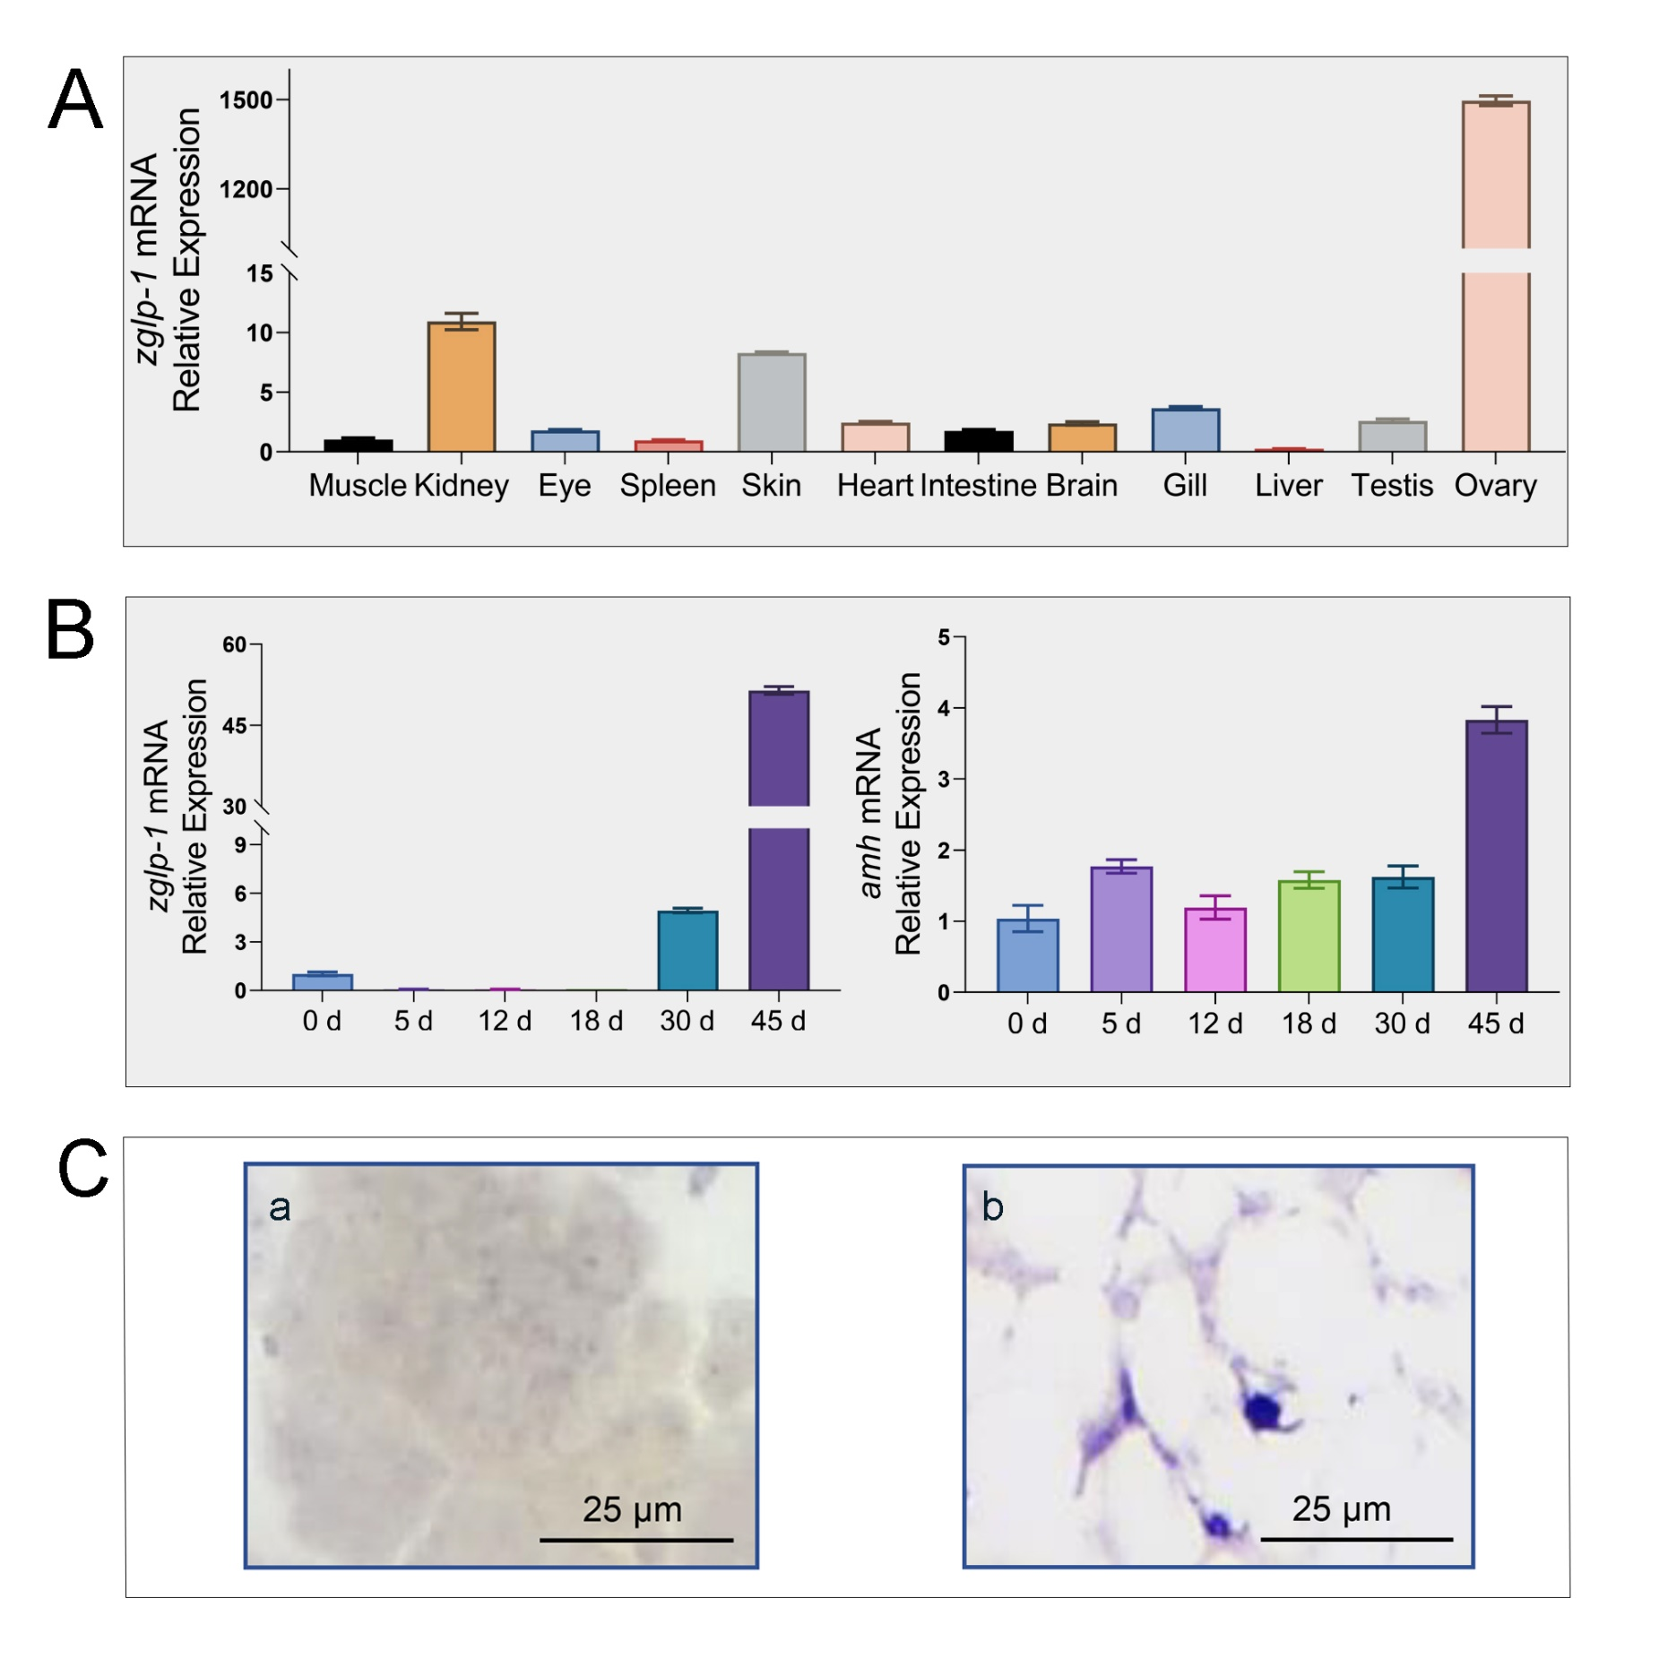
Fig. S1 zglp-1 is highly expressed in the zebrafish ovary. (A) The expression of zglp-1 in different tissues in zebrafish detected by quantitative RT-PCR technology. zglp-1 was highly expressed in the adult ovary. (B) Expression of zebrafish zglp-1 and amh genes in different developmental stages. (C) Section ISH of zebrafish zglp-1. a: testis; b: ovary. The β-actin was used as loading control. Data are presented as mean ± SD.

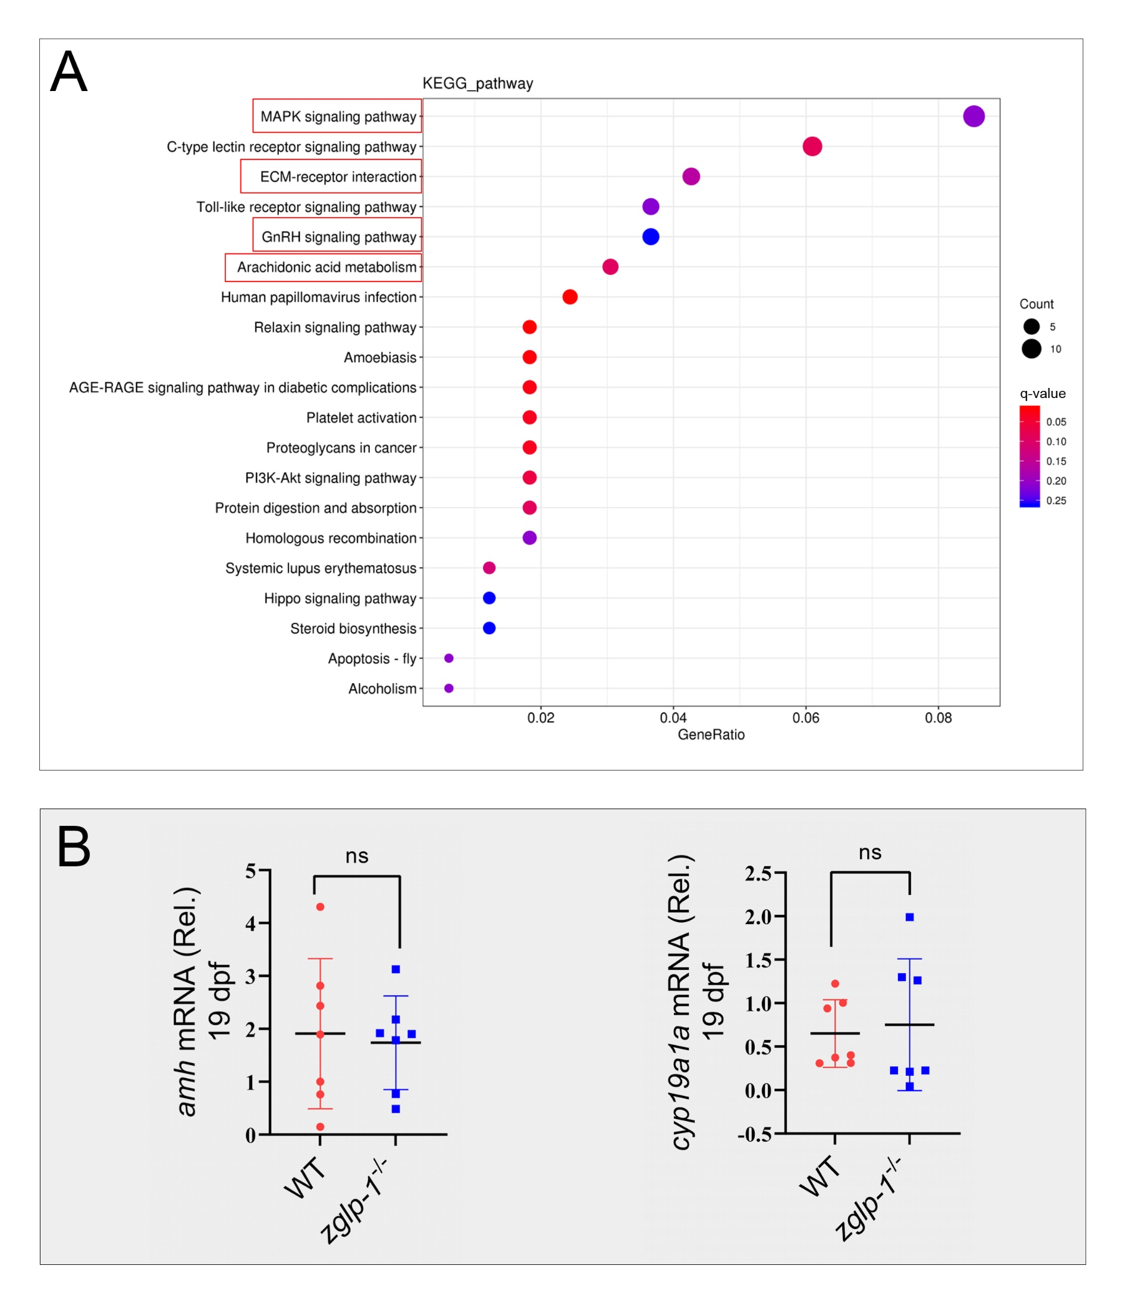
Fig. S2 Comparison of the expression of genes in wild type zebrafish and zglp-1 homozygous mutant zebrafish at 19 dpf. (A) KEGG analysis of differentially expressed genes in wild type zebrafish and zglp-1^{-/- +2} zebrafish at 19 dpf. The size and color of dots show the number of differentially expressed genes and q-value, respectively. The path represented by the graph near the upper right corner is of significant reference value. (B) The expression of amh and cyp19a1a of wild type and zglp-1 homozygous mutant zebrafish at 19 dpf detected by Real-time PCR. β-actin was used as the loading control. Data are presented as mean ± SD. Data were analyzed by One-way ANOVA (ns not significant).

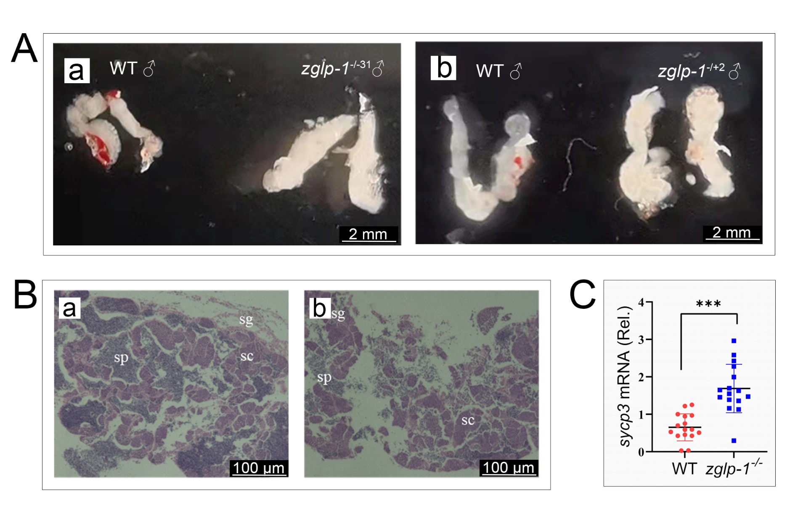
Fig. S3 Zglp-1 deficiency leads to a hypertrophy testis. (A) Comparison of testis between wild type and zglp-1 homozygous mutant male zebrafish. (B) HE staining of testis section of wild type (a) and zglp-1 homozygous mutants (b). sg: spermatogonia, sc: spermatocytes, sp: sperm. (C) The sycp3 gene was detected in testis of wild type and zglp-1 homozygous mutants by Real-time PCR. β-actin was used as the control. Data are presented as mean ± SD. Data were analyzed by One-way ANOVA. *** P <0.001.

