Supplementary Information
Investigating byssus self-assembly of Mytilus coruscus: synergy of biological regulations and spatial heterogeneity in mussel foot
Ruoxuan Zhao, Shuimei Li, Kaijie Wu, Haozhe Chai, Shuangyue Li, Qing Fang, Zibo Zhu, Liya Li, Yanan Di*
Ocean College, Zhejiang University, Zhoushan 316000, China
* Corresponding author:
Dr. Yanan Di
Department of Marine Science
Ocean College, Zhejiang University
Zhoushan, 316000, P. R. China
Tel. (Fax): 0086-(0)580-2092891
E-mail address: diyanan@zju.edu.cn (Y. Di)
This supplementary information file contains 14 pages, 8 supplementary tables, 7 supplementary figures, and a reference.
Table S1. Sequences of the primer pairs used in this study
Gene |  | Primer sequence (5′-3′) |  | Ta (°C) | Ref/GenBank
I | Mfp1 | F | TGGCTACAATTCAAGAACTG | 50 | JQ794825 (Zhao et al. 2017)
I | Mfp1 | R | AGAGAAGGATGAGAACGAAT | 50 | JQ794825 (Zhao et al. 2017)
I | Mfp2 | F | CGGTCACAGAAGCATCAT | 50 | KP876473.1 (Zhao et al. 2017)
I | Mfp2 | R | CATCCTCATCGTCGTCATAT | 50 | KP876473.1 (Zhao et al. 2017)
I | Mfp3 | F | TTTGCTGGCTTTAGTCCTT | 50 | GQ281052.1 (Zhao et al. 2017)
I | Mfp3 | R | ACCGCTATTCCATCCCTTA | 50 | GQ281052.1 (Zhao et al. 2017)
I | Mfp4 | F | AGACATATTCACAGCCACCAAG | 50 | DQ351535.1
I | Mfp4 | R | TCAAGACATTCCTGCCAAAGAG | 50 | DQ351535.1
I | Mfp5 | F | TTGGTGCTCGTTCTTGTAA | 50 | GQ281053.2 (Zhao et al. 2017)
I | Mfp5 | R | TGCTACTGCCTCCATAATG | 50 | GQ281053.2 (Zhao et al. 2017)
I | PTMP | F | TGCTGTAGTAACCTTTGCTGAC | 50 | AF414454.1
I | PTMP | R | TCCTCCGCCATTCCTATTCG | 50 | AF414454.1
I | COL | F | GTGGTCAGTGTATCTCCAACTC | 50 | KJ946425.1
I | COL | R | CTGGTCTCCGTCACTTCCTT | 50 | KJ946425.1
I | pC-D | F | ACCAAGAGGAGATAGAGGAG | 60 | EU120661.1 (Zhao et al. 2017)
I | pC-D | R | GGCTGTTCTGAGGTCTTC | 60 | EU120661.1 (Zhao et al. 2017)
I | pC-NG | F | ACAAGGACCACAAGGAGAA | 60 | EU120662.1 (Zhao et al. 2017)
I | pC-NG | R | ACACCACCAACACCAGTT | 60 | EU120662.1 (Zhao et al. 2017)
I | Mfp6 | F | CGGTGATTATGATTACAGAGG | 55 | GU321214.1 (Zhao et al. 2017)
I | Mfp6 | R | GAAGACAGCATCCAGCAT | 55 | GU321214.1 (Zhao et al. 2017)
I | TY2 | F | GCCTGTGGACGACTCTGTAA | 55 | KX268645.1
I | TY2 | R | GGTGTGAACTTGCCATAGAACT | 55 | KX268645.1
II | ATP | F | GCCAGCAGCACTCACTATTG | 55 | CAC5407096.1
II | ATP | R | GCATATCCAAGCCATCTTCTGT | 55 | CAC5407096.1
III | CNN | F | TGATTGGAGAAGACATCGGAGA | 55 | KP757799.1
III | CNN | R | AAGGCAATTCGCTTGGTGAT | 55 | KP757799.1
III | Actin | F | CTCTTGATTTCGAGCAGGAAA | 52 | XM_063568620.1
III | Actin | R | AGGATGGTTGGAATAGTGATT | 52 | XM_063568620.1
III | Tub | F | TTGCAACCATCAAGACCAAG | 52 | HM537081
III | Tub | R | TGCAGACGGCTCTCTGT | 52 | HM537081
III | Scamp | F | TGTCCTGTTGGTCCCTGTTT | 52 | CACVKT020007048.1
III | Scamp | R | TCCTCCATCACCATCCACAAT | 52 | CACVKT020007048.1
III | Sec13 | F | GATGTTGTTTGGCACCTCAGT | 52 | CACVKT020008734.1
III | Sec13 | R | TTATCCGTCACTTGTCCTTGTC | 52 | CACVKT020008734.1
III | P115 | F | GCAGGATGGTCAGCACAGA | 52 | CACVKT020003487.1
III | P115 | R | GAACGCCACTTGCCATAAGAA | 52 | CACVKT020003487.1
III | Ift43 | F | AATCCACCAGATGCTCCTGAT | 52 | CACVKT020002619.1
III | Ift43 | R | TCCTTCACCAAGTTTCCGACT | 52 | CACVKT020002619.1
IV | Hsp70 | F | TCACTACTTACTCCGACAACCA | 52 | KF322135.2
IV | Hsp70 | R | GATACCGTTGGCATCAATGTCA | 52 | KF322135.2
Note: Ta, annealing temperature; I, mussel byssus protein; II, energy metabolism; III, cytoskeleton-based protein secretion; IV, stress handling; F, forward primer; R, reverse primer. The listed primers were all synthesized by Saiheng Biotechnology, China.
Table S2. Accumulated number of byssi from individual mussel in the control group during the 7-day experiment
Individual mussel in the control group | D1 | D2 | D3 | D4 | D5 | D6 | D7
C1 | 1 | 1 | 5 | 17 | 27 | 33 | 39
C2 | 0 | 0 | 2 | 4 | 7 | 9 | 14
C3 | 0 | 0 | 0 | 0 | 2 | 10 | 11
C4 | 0 | 0 | 5 | 5 | 8 | 17 | 24
Note: C1–C4 are the code names of the four individual mussels in the control group.
Table S3. Determination of byssal morphological and mechanical parameters
Mussel NO. | Byssus NO. | Thread diameter (μm) | Plaque diameter  (mm) | Thread length  (cm) | Tensile force (N) | Deformation length  (mm)
C1 | 1 | 108.8 | 1.08 | 3.12 | 0.46 | 6.43
C1 | 2 | 122.2 | 0.998 | 2.6 | 0.44 | 5.77
C1 | 3 | 97.3 | 0.92 | 3.47 | 0.58 | 4.77
C1 | 4 | 103.2 | 1.05 | 2.17 | 0.85 | 4.08
C1 | 5 | 95.5 | 1.03 | 2.29 | 0.24 | 0.79
C2 | 1 | 191.6 | 1 | 2.8 | 0.48 | 4.6
C2 | 2 | 192.8 | 1.8 | 3.57 | 0.63 | 5.1
C2 | 3 | 154.9 | 1.6 | 3.55 | 0.99 | 8.92
C2 | 4 | 141.3 | 1.8 | 3.95 | 0.55 | 7.09
C2 | 5 | 164.3 | 1.9 | 3.15 | 1.23 | 14.47
C3 | 1 | 86.2 | 0.984 | 1.99 | 0.3 | 6.93
C3 | 2 | 118.5 | 1.5 | 2.05 | 0.77 | 6.42
C3 | 3 | 76.9 | 0.865 | 2.05 | 0.47 | 4.85
C3 | 4 | 94.2 | 0.923 | 2.6 | 0.53 | 6.98
C3 | 5 | 150.8 | 0.97 | 1.85 | 0.23 | 2.6
C4 | 1 | 98.2 | 1.16 | 1.96 | 0.46 | 3.68
C4 | 2 | 167.1 | 1.09 | 2.35 | 1.09 | 4.29
C4 | 3 | 149.5 | 1.07 | 1.79 | 0.61 | 1.91
C4 | 4 | 112 | 1.18 | 2 | 0.55 | 2.01
C4 | 5 | 132.5 | 1.04 | 1.69 | 0.73 | 3.38
Note: C1–C4 are the code names of the four individual mussels in the control group.
Table S4. Summary of the RNA sequencing clean data and quality control indices
Sample ID | Total Reads | Total Bases (bp) | Q20 Bases (bp) | Q30 Bases (bp) | Q20 Rate (%) | Q30 Rate (%) | GC Content
C1_A | 58,206,122 | 8,572,812,579 | 8,525,020,488 | 8,388,521,106 | 99.4425 | 97.8503 | 37.8915
C2_A | 69,788,272 | 10,256,224,095 | 10,197,538,805 | 10,031,781,713 | 99.4278 | 97.8116 | 38.3144
C3_A | 65,263,794 | 9,627,510,513 | 9,575,085,010 | 9,426,344,933 | 99.4555 | 97.9105 | 36.8379
Ca1_A | 66,852,120 | 9,835,220,266 | 9,779,946,383 | 9,624,379,263 | 99.438 | 97.8563 | 39.6241
Ca2_A | 71,190,170 | 10,482,865,228 | 10,422,458,909 | 10,250,185,816 | 99.4238 | 97.7804 | 38.1613
Ca3_A | 61,283,910 | 8,982,335,297 | 8,929,299,289 | 8,782,606,931 | 99.4096 | 97.7764 | 41.5503

Table S5. Summary of assembly of the clean reads
Type | Total sequence number | Total sequence base (bp) | GC percent (%) | Largest (bp) | Smallest (bp) | Average (bp) | N50 | N90
Unigene | 159,337 | 105,558,761 | 33.5 | 16741 | 201 | 662.49 | 995 | 274
Transcripts | 237,550 | 207,114,050 | 33.12 | 16741 | 177 | 871.88 | 1573 | 329

Table S6. Summary of the annotation of transcripts/unigene from public databases
Database | Transcripts number | Transcripts percentage (%) | Unigene number | Unigene percentage (%)
Annotated in all databases | 172 | 0.07% | 127 | 0.08%
Annotated in at least one database | 43534 | 18.33% | 26845 | 16.85%
Annotated in GO | 7732 | 3.25% | 4303 | 2.70%
Annotated in KEGG | 11079 | 4.66% | 6359 | 3.99%
Annotated in Nr | 43266 | 18.21% | 26665 | 16.73%
Annotated in Pfam | 15640 | 6.58% | 8279 | 5.20%
Annotated in STRING | 861 | 0.36% | 691 | 0.43%
Annotated in Swiss-Prot | 7864 | 3.31% | 4370 | 2.74%

GO, Gene Ontology; KEGG, Kyoto Encyclopedia of Genes and Genomes; Nr, Non-redundant; Pfam, Protein family; STRING, Search Tool for the Retrieval of Interacting Genes; Swiss-Prot, Swiss-Prot protein
Table S7. Typical genes relevant to byssus fabrication that were identified from transcriptomic annotation
Process | GO number | GO term | Unigene | Gene | Gene description
energy metabolism | GO:0003878 | ATP citrate synthase activity | TRINITY_DN5048_c0_g1 | ACLY | ATP Citrate Lyase
energy metabolism | GO:0016887 | ATPase activity | TRINITY_DN98221_c0_g1 | ATP13A3 | Cation-Transporting ATPase 13A3
energy metabolism | GO:0000220 | vacuolar proton-transporting V-type ATPase, V0 domain | TRINITY_DN2706_c0_g1 | ATP6V1A | V-type H⁺-transporting ATPase subunit A
protein synthesis | GO:0006418  /GO:0043038 | tRNA aminoacylation for protein translation  /amino acid activation | TRINITY_DN4479_c0_g1 | AARS1 | Alanyl-tRNA synthetase
protein synthesis | GO:0006418  /GO:0043038 |  | TRINITY_DN9898_c0_g1 | IARS | Isoleucyl-TRNA Synthetase 1
protein synthesis | GO:0098553 | luminal side of the endoplasmic reticulum membrane | TRINITY_DN52586_c0_g1 | SPPL3 | Signal Peptide Peptidase Like 3
protein synthesis | GO:0006467 | protein disulfide isomerase activity | TRINITY_DN1401_c1_g1  TRINITY_DN32162_c0_g1  TRINITY_DN6821_c1_g1 | PDIA5  PDIA3  PDIA1 | Protein Disulfide Isomerase Family A Member 5  Protein Disulfide Isomerase Family A Member 3  Protein Disulfide Isomerase Family A Member 1
protein transport | GO:0008104 | protein localization | TRINITY_DN1528_c0_g2 | RAB11A | RAB11A, Member RAS Oncogene Family
protein transport | GO:0008104 | protein localization | TRINITY_DN1539_c0_g1 | ZDHHC9 | Zinc Finger DHHC-Type Palmitoyltransferase 9
protein transport | GO:0008104 | protein localization | TRINITY_DN1604_c0_g1 | RAB21 | RAB21, Member RAS Oncogene Family
protein transport | GO:0008104 | protein localization | TRINITY_DN21770_c0_g1 | TIM50 | Translocase of the Inner Mitochondrial Membrane 50
protein transport | GO:0008104 | protein localization | TRINITY_DN2335_c0_g1 | RAB32 | RAB32, Member RAS Oncogene Family
protein transport | GO:0008104 | protein localization | TRINITY_DN2491_c0_g1 | TOMM7 | Translocase of the Outer Mitochondrial Membrane 7
protein transport | GO:0008104 | protein localization | TRINITY_DN28795_c0_g1 | MOV10L1 | Mov10 Like RNA Helicase 1
protein transport | GO:0008104 | protein localization | TRINITY_DN3266_c0_g1 | ACTR3 | Actin-Related Protein 3
protein transport | GO:0008104 | protein localization | TRINITY_DN39553_c0_g1 | AIP3 | Atrophin-1 interacting protein 3
protein transport | GO:0008104 | protein localization | TRINITY_DN4059_c1_g1 | CDC42 | Cell Division Cycle 42
protein transport | GO:0008104 | protein localization | TRINITY_DN436_c0_g1 | CHMP5 | Charged Multivesicular Body Protein 5
protein transport | GO:0008104 | protein localization | TRINITY_DN6498_c0_g1 | CTNNB1 | Catenin Beta 1
protein transport | GO:0006605 | protein targeting | TRINITY_DN1539_c0_g1 | ZDHHC9 | Zinc Finger DHHC-Type Palmitoyltransferase 9
protein transport | GO:0006605 | protein targeting | TRINITY_DN21770_c0_g1 | TIM50 | Translocase of the Inner Mitochondrial Membrane 50
protein transport | GO:0006605 | protein targeting | TRINITY_DN2491_c0_g1 | TOMM7 | Translocase of the Outer Mitochondrial Membrane 7
secretory process | GO:0030141 | secretory granule | TRINITY_DN1528_c0_g2 | RAB11A | RAB11A, Member RAS Oncogene Family
secretory process | GO:0030141 | secretory granule | TRINITY_DN2335_c0_g1 | RAB32 | RAB32, Member RAS Oncogene Family
secretory process | GO:0044420 | extracellular matrix component | TRINITY_DN12021_c1_g1 | vWA | von Willebrand factor type A domain
secretory process | GO:0006888 | endoplasmic reticulum to Golgi vesicle-mediated transport | TRINITY_DN2409_c1_g1 | P115 | General vesicular transport factor p115
secretory process | GO:0090114 | COPII-coated vesicle budding | TRINITY_DN7939_c0_g1 | SEC13 | Protein Transport Protein Sec13, Nuclear Pore and COPII Coat Complex Component
secretory process | GO:0005576 | extracellular region | TRINITY_DN25110_c0_g1 | CRISP | Cysteine-rich secretory protein
cytoskeleton | GO:0031532  /GO:0030027 | actin cytoskeleton reorganization/lamellipodium | TRINITY_DN3266_c0_g1 | ACTR3 | Actin-Related Protein 3
cytoskeleton | GO:0031532  /GO:0030027 | actin cytoskeleton reorganization/lamellipodium | TRINITY_DN4059_c1_g1 | CDC42 | Cell Division Cycle 42
cytoskeleton | GO:0060271 | cilium assembly | TRINITY_DN4052_c0_g1 | IFT43 | Intraflagellar Transport 43
cytoskeleton | GO:0042073 | intraciliary transport | TRINITY_DN5979_c0_g1 | IFT46 | Intraflagellar Transport 46
cytoskeleton | GO:0061512 | protein localization to the cilium | TRINITY_DN65659_c0_g1 | IFT122 | Intraflagellar Transport 122
cytoskeleton | GO:0005856 | cytoskeleton | TRINITY_DN10589_c0_g2 | Actin | Actin
cytoskeleton | GO:0007017 | microtubule-based process | TRINITY_DN13563_c0_g6 | TUBA | Tubulin Alpha
cytoskeleton | GO:0005509 | calcium ion binding | TRINITY_DN129186_c0_g1 | CNN | calponin-like protein
stress | GO:0010606 | positive regulation of stress-activated protein kinase signaling cascade | TRINITY_DN5110_c0_g1 | PAN2 | Poly(A) Specific Ribonuclease Subunit PAN2
stress | GO:0006986 | response to unfolded protein | TRINITY_DN11338_c0_g2 | HSP70 | Heat Shock Protein Family A (Hsp70)
Table S8. List of annotated genes involved in protein folding, accessory molecules, and mechanosensing in byssus fabrication, with relative expression levels compared between the Ca exposure and control groups
Category | Unigene | log₂(Fold Change) (Ca/C) | Regulation | p-value | Gene | Gene description
Protein disulfide isomerase | TRINITY_DN6821_c1_g1 | -1.7642 | down | 0.0000 | PDIA1 | protein disulfide-isomerase A1
Protein disulfide isomerase | TRINITY_DN1401_c1_g1 | -3.6307 | down | 0.0013 | PDIA5 | protein disulfide-isomerase A5
Protein disulfide isomerase | TRINITY_DN32162_c0_g1 | -11.8732 | down | 0.0000 | PDIA3 | protein disulfide-isomerase A3
5-HT Receptor | TRINITY_DN26013_c0_g1 | 0.1140 | up | 0.5184 | 5HTR1D | 5-hydroxytryptamine receptor 1D
2-AG-mediated signaling pathway | TRINITY_DN7722_c0_g3 | 0.5376 | up | 0.0689 | PLCB | phospholipase C beta
2-AG-mediated signaling pathway | TRINITY_DN3376_c0_g1 | -2.1381 | down | 0.2931 | NAPE-PLD | N-acyl-phosphatidylethanolamine-hydrolyzing phospholipase D-like isoform X3
2-AG-mediated signaling pathway | TRINITY_DN4435_c0_g3 | 0.5367 | up | 0.2230 | FAAH | fatty acid amide hydrolase
2-AG-mediated signaling pathway | TRINITY_DN37569_c0_g1 | -0.1082 | down | 0.9877 | VGCC | voltage-dependent calcium channel
2-AG-mediated signaling pathway | TRINITY_DN1475_c0_g1 | 1.0048 | up | 1.0000 | NOS | nitric oxide synthase
Transient receptor potential channel | TRINITY_DN1056_c0_g1 | -1.1995 | down | 0.4587 | TRP4 | transient receptor potential channel 4
Transient receptor potential channel | TRINITY_DN2367_c0_g1 | -2.7939 | down | 0.0357 | TRPM1 | transient receptor potential cation channel subfamily M member 1
Transient receptor potential channel | TRINITY_DN24147_c0_g2 | -0.3265 | down | 0.8196 | TRPC4 | transient receptor potential cation channel subfamily C member 4
Transient receptor potential channel | TRINITY_DN25342_c0_g1 | 2.2329 | up | 0.3523 | TRPM2 | transient receptor potential cation channel subfamily M member 2
Transient receptor potential channel | TRINITY_DN2752_c0_g1 | -0.5768 | down | 1.0000 | TRPM8 | transient receptor potential cation channel subfamily M member 8
Note: 5-HT, 5-Hydroxytryptamine; 2-AG, 2-arachidonoylglycerol
Supporting Figures
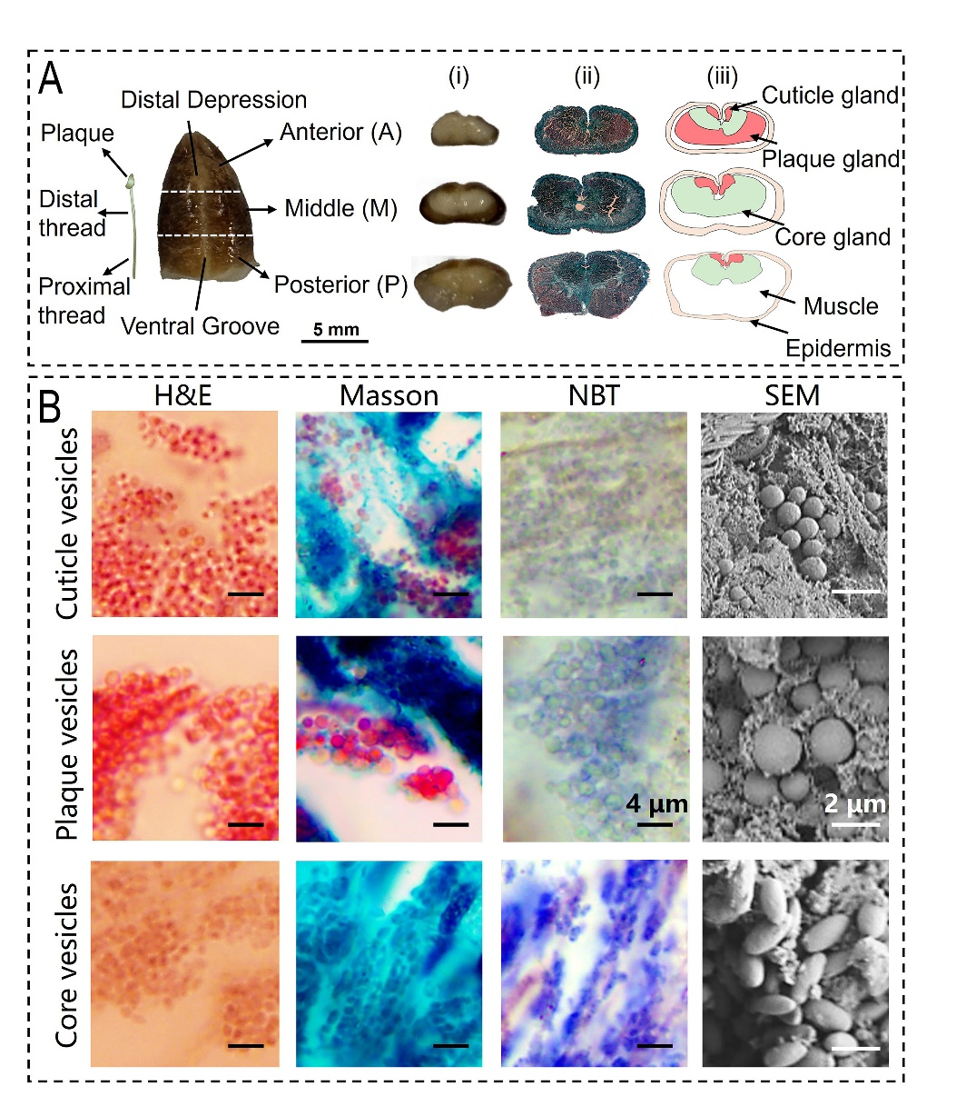
Fig. S1 Foot structures and secretory vesicles of mussels. A Illustrated byssus and actual mussel foot sample with three sections separated by white dashed lines into anterior (A), middle (M), and posterior (P). (i) Cross sections of three sections of actual mussel foot samples, (ii) histological slices of the three foot sections stained with Masson’s trichrome, and (iii) diagrams of three sections of foot plotted based on the staining results, showing different internal structures with distinct secretory glands. B Morphology of three byssal secretory vesicles using different staining approaches (hematoxylin and eosin, Masson’s trichrome, and NBT-glycinate staining) observed by optical microscope, and their morphology under scanning electron microscopy (SEM). Scale bars in black = 4 μm, and those in white = 2 μm.

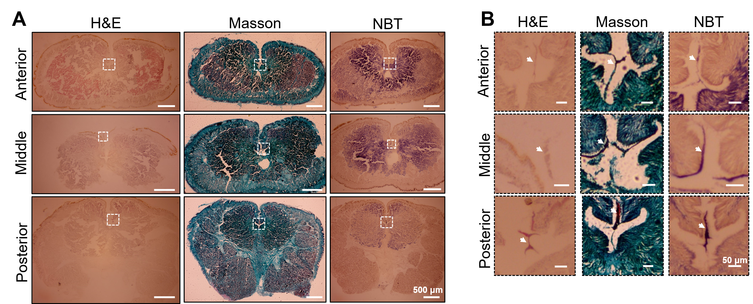
Fig. S2 Histological investigations of the mussel in the control group. A Slices of the anterior, middle, and posterior sections of mussel foot from the control group stained with hematoxylin and eosin (H&E), Masson’s trichrome, and NBT-glycinate. Scale bars = 500 μm. B Byssal precursors in the ventral groove from slices of the three sections of the mussel foot are indicated by white arrows. These figures were correspondingly enlarged views of the dashed-line squares in (A). Byssal precursors appeared pink, green/red, and purple with H&E, Masson’s trichrome, and NBT-glycinate staining, respectively. Scale bars = 50 μm.
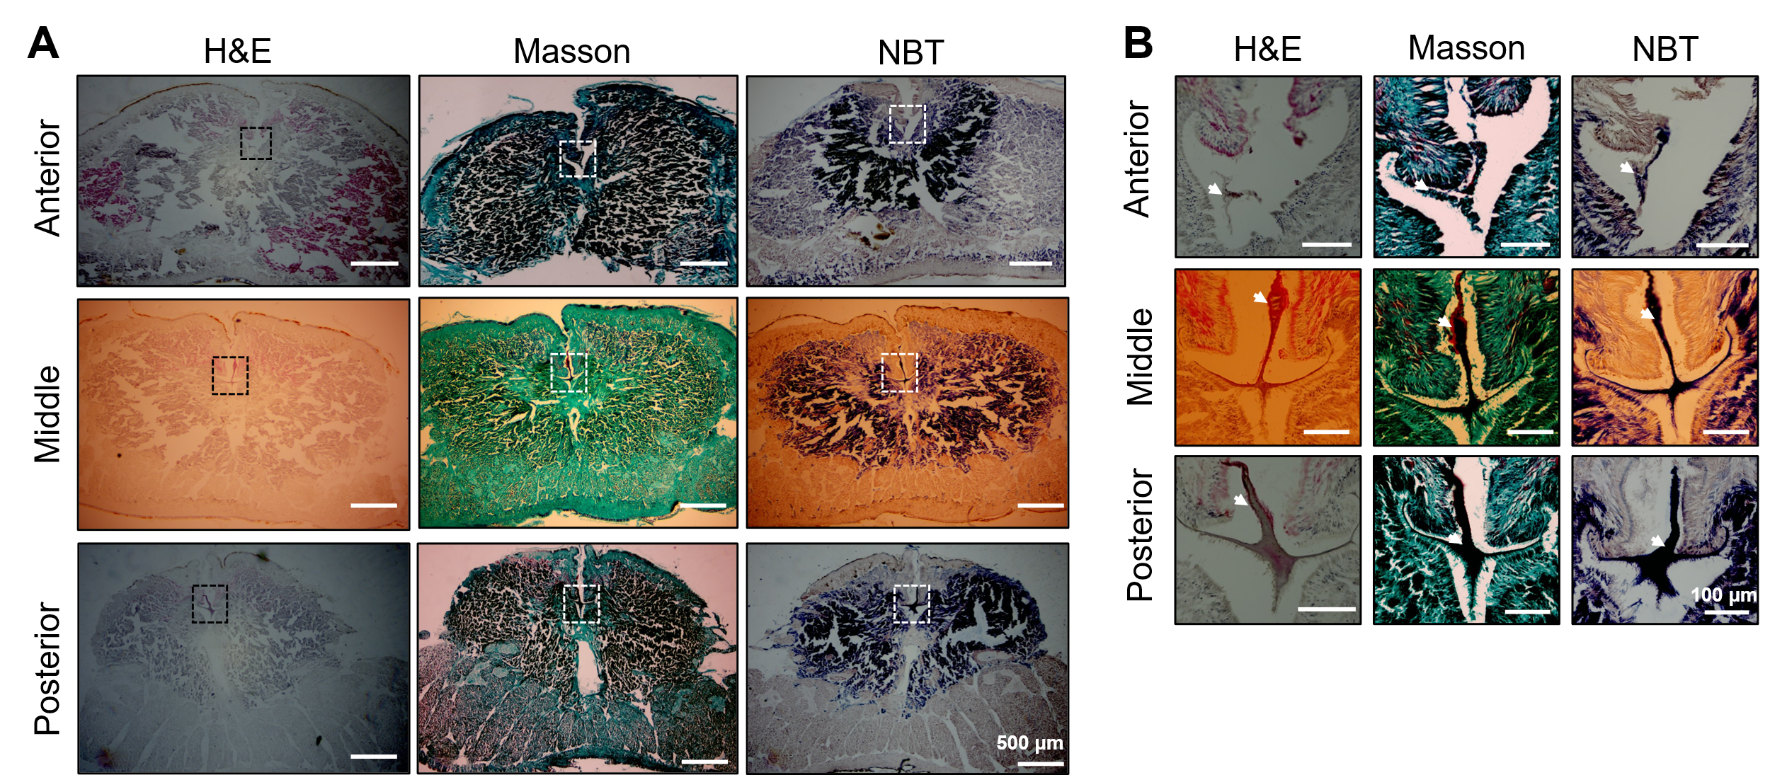
Fig. S3 Histological investigations of the mussel in the exposure group. A Slices of the anterior, middle, and posterior sections of the mussel foot from the exposure group were stained with hematoxylin and eosin (H&E), Masson’s trichrome, and NBT-glycinate. Scale bars = 500 μm. B Byssal precursors in the ventral groove from slices of the three sections of the mussel foot are indicated by white arrows. These figures were correspondingly enlarged views of the dashed-line squares in (A). Byssal precursors appeared pink, green/red, and purple with H&E, Masson’s trichrome, and NBT-glycinate staining, respectively. Scale bars = 50 μm.
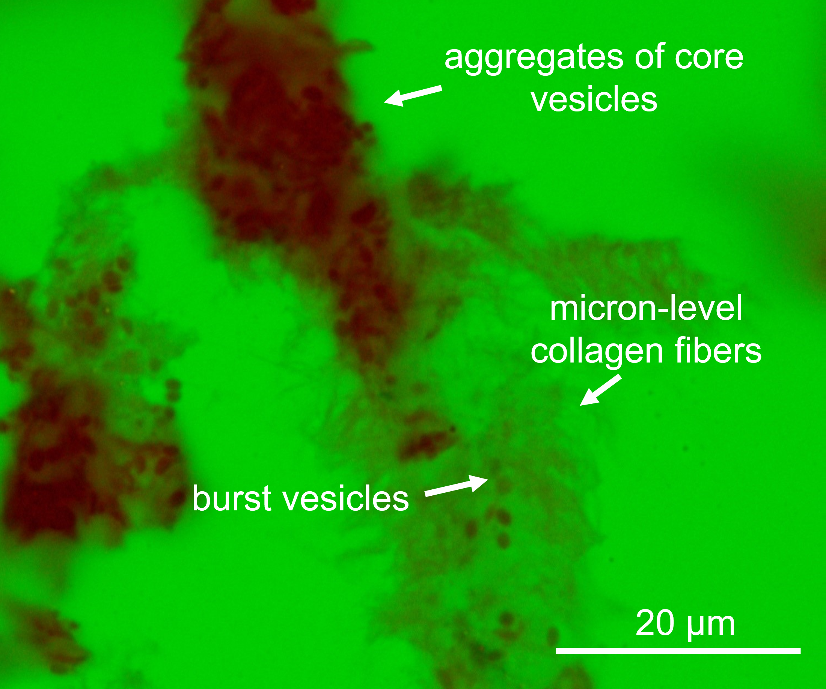
Fig. S4 Collagen proteins released from burst core vesicles self-assemble into micron-scale collagen fibers in the ventral groove. The green background is the result of adjusting the white balance of the image to more clearly show the core vesicles and fibers.
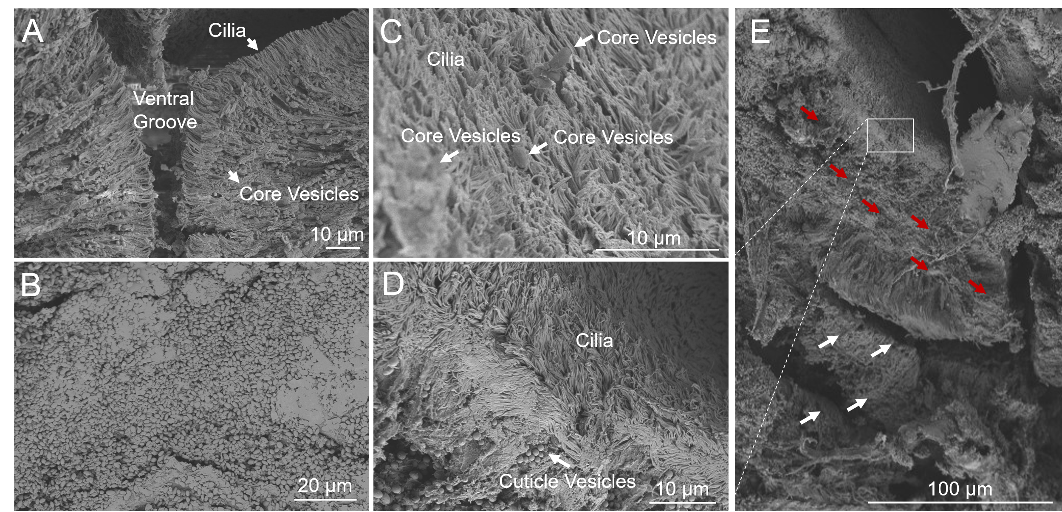
Fig. S5 Foot structure observed by scanning electron microscopy. A Cross section of the anterior/middle interface of the mussel foot from the control group. B High density of core vesicles at the anterior/middle interface of the mussel foot from the Ca exposure group. C Cilium and secreted core vesicles on the surface of the ventral groove at the medium/posterior interface of the mussel foot from the Ca exposure group. D Secreting cuticle vesicles near the ventral groove at the medium/posterior interface of the mussel foot from the Ca exposure group. E Ventral groove at the medium/posterior interface of the mussel foot from the Ca exposure group. The red arrows indicate the secreting direction of the cuticle vesicles, and the white arrows indicate that of the core vesicles into the ventral groove.
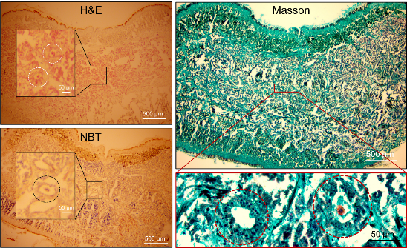
Fig. S6 Longitudinal ducts (indicated by dashed-line circles) in the anterior section of the mussel foot sections from the Ca exposure group
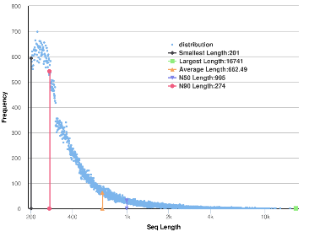
Fig. S7 Sequence length distribution of the assembled unigenes
Reference
Zhao XG, Guo C, Han Y, Che ZM, Wang YC, Wang XY, Chai XL, Wu HX, Liu GX (2017) Ocean acidification decreases mussel byssal attachment strength and induces molecular byssal responses. Mar Ecol Prog Ser 565:67-77

