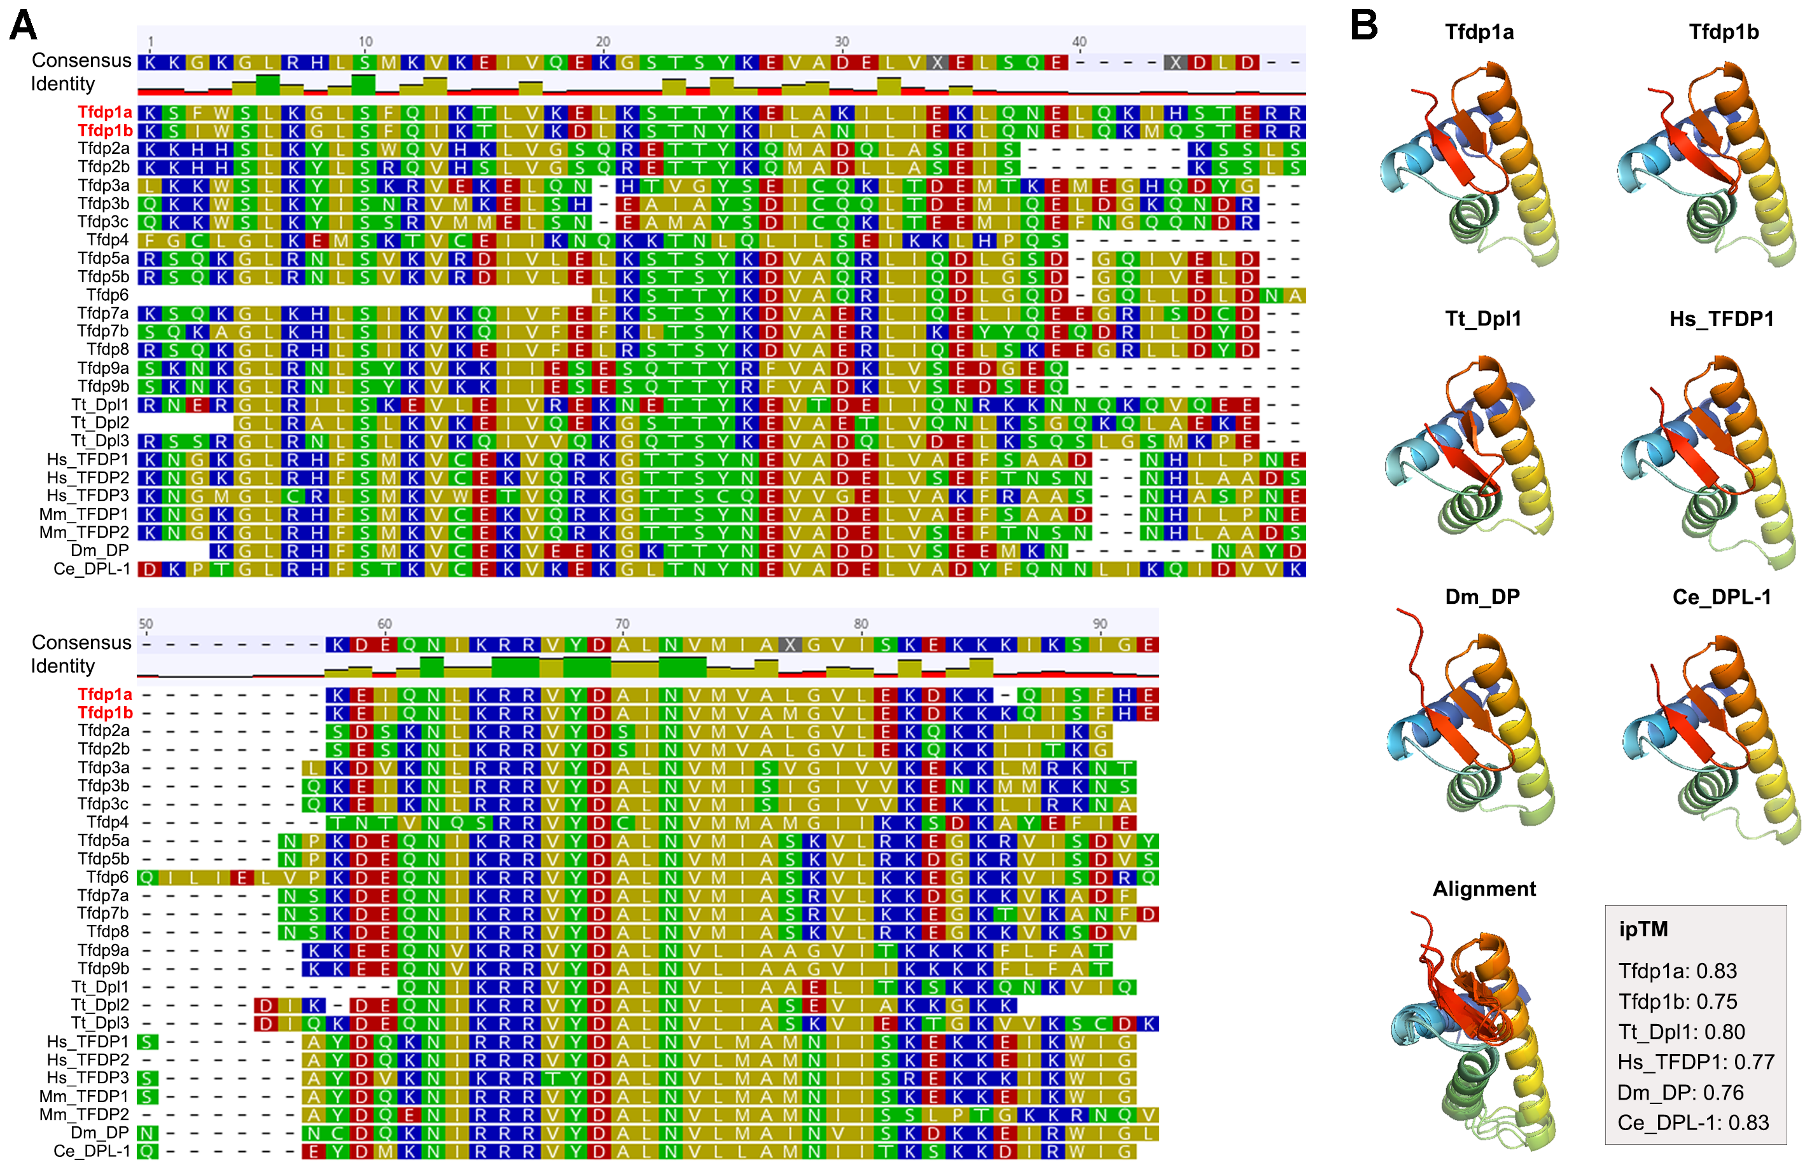
Fig. S1 Sequence alignment (A) and protein structure prediction (B) of E2F/DP family winged-helix DNA-binding domains. Hs: Homo sapiens; Mm: Mus musculus; Dm: Drosophila melanogaster; Ce: Caenorhabditis elegans; Tt: Tetrahymena thermophila.

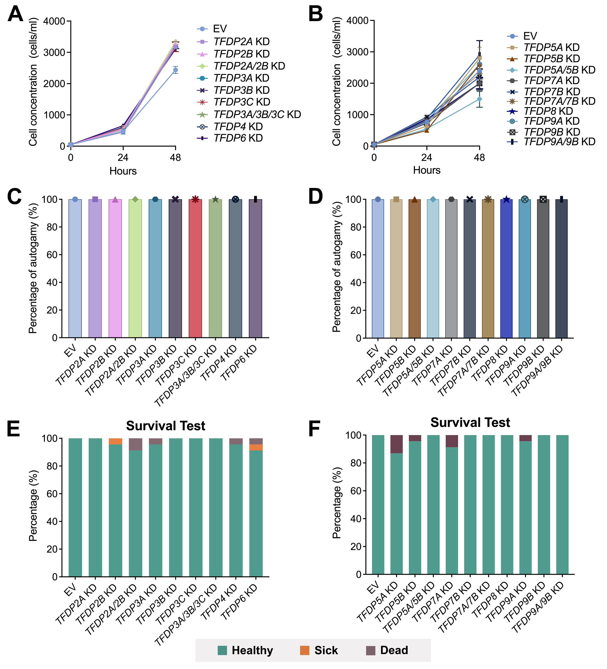
Fig. S2 Influences of TFDP2-9 knockdowns on vegetative growth and sexual reproduction in Paramecium tetraurelia. (A, B) Vegetative growth curve of P. tetraurelia following TFDP2-9 knockdowns, starting from an initial concentration of 50 cells/ml. (C, D) Percentage of P. tetraurelia undergoing autogamy following TFDP2-9 knockdown. Results are from cells in A and B after 72 hours growth. (E, F) Survival test of P. tetraurelia recovering from autogamy to vegetative growth after TFDP2-9 knockdowns. Green: healthy; Orange: sick; Brown: dead.
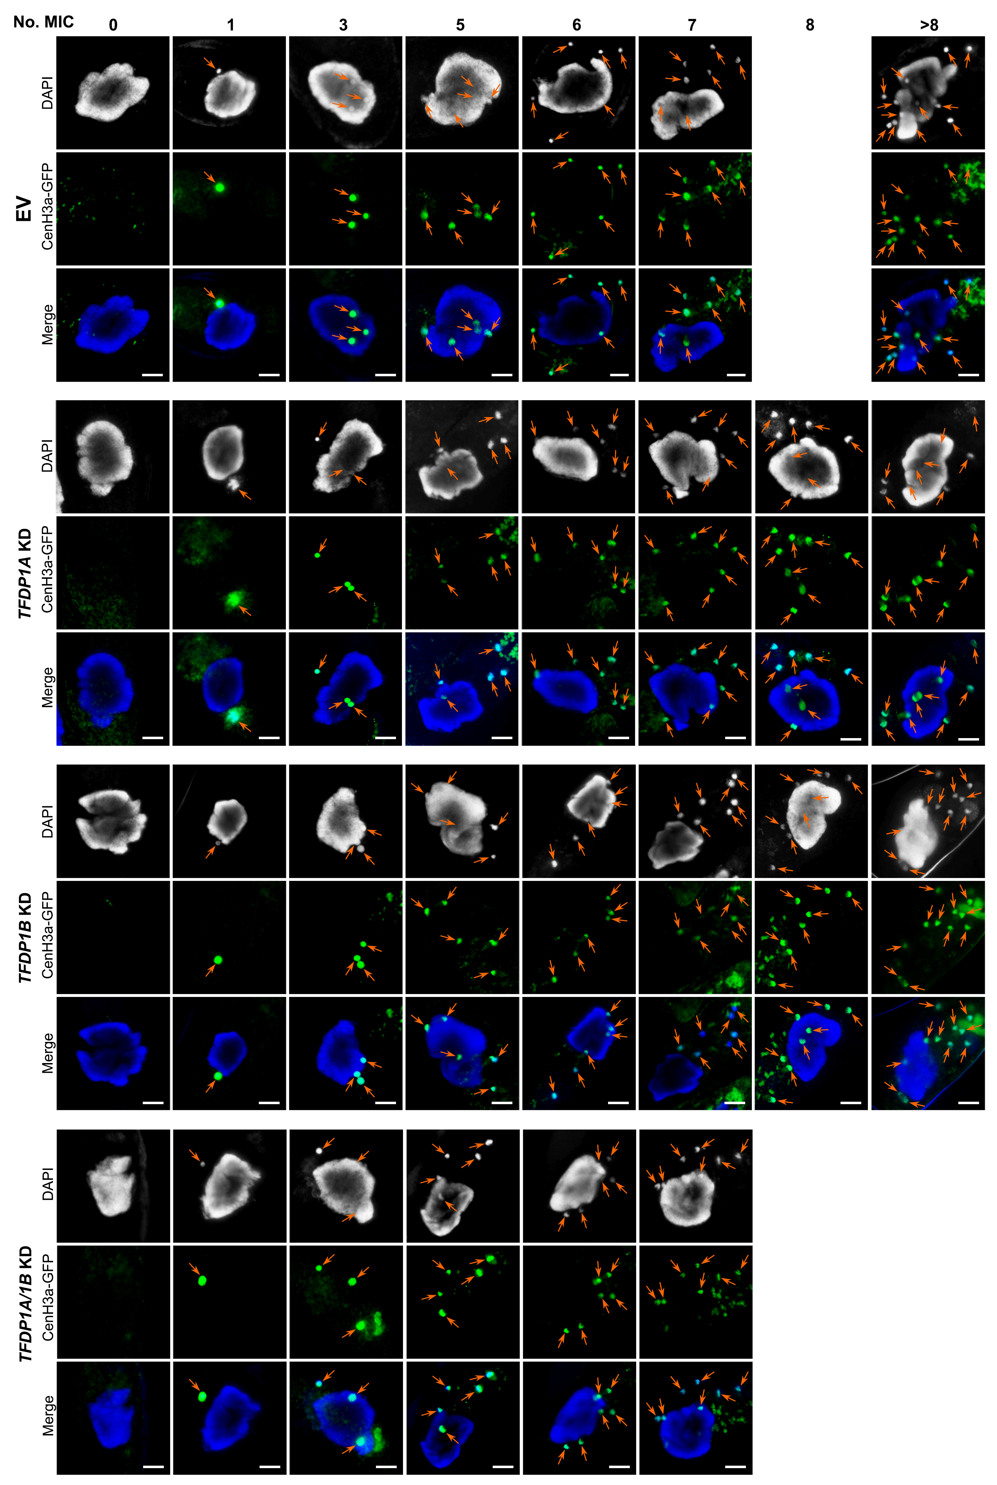
Fig. S3 Photographs of cells with atypical numbers of MICs. MICs are indicated with orange arrows. Scale bar: 10 μm.
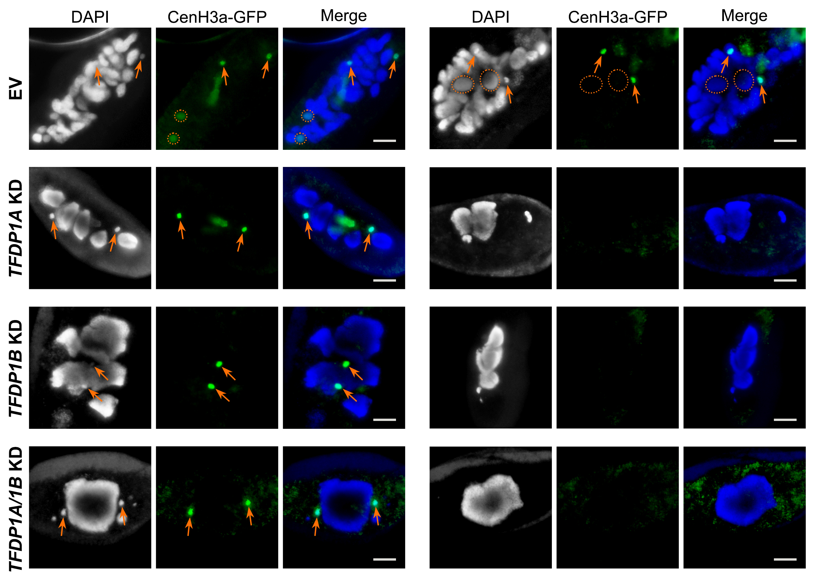
Fig. S4 State of MICs at the late stage of autogamy in EV control, TFDP1A, TFDP1B and TFDP1A/1B KD. MICs are indicated with orange arrows. The new macronuclei are indicated with orange dashed circles. Scale bar: 10 μm.

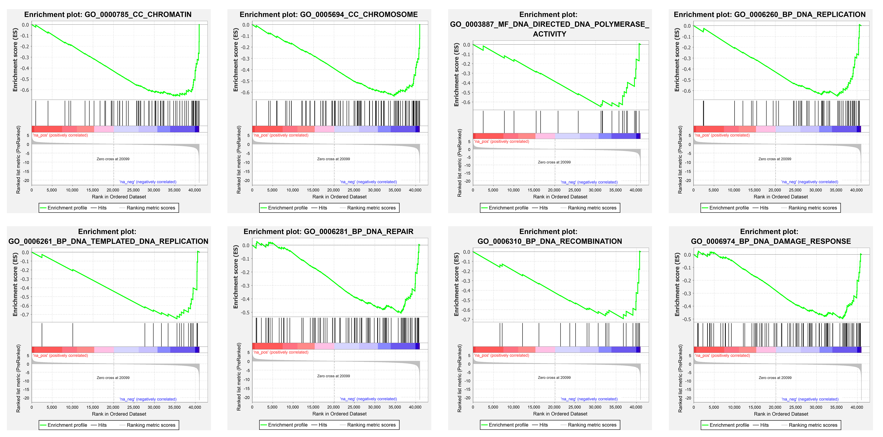
Fig. S5 Gene Set Enrichment Analysis of the TFDP1A/1B KD transcriptome.

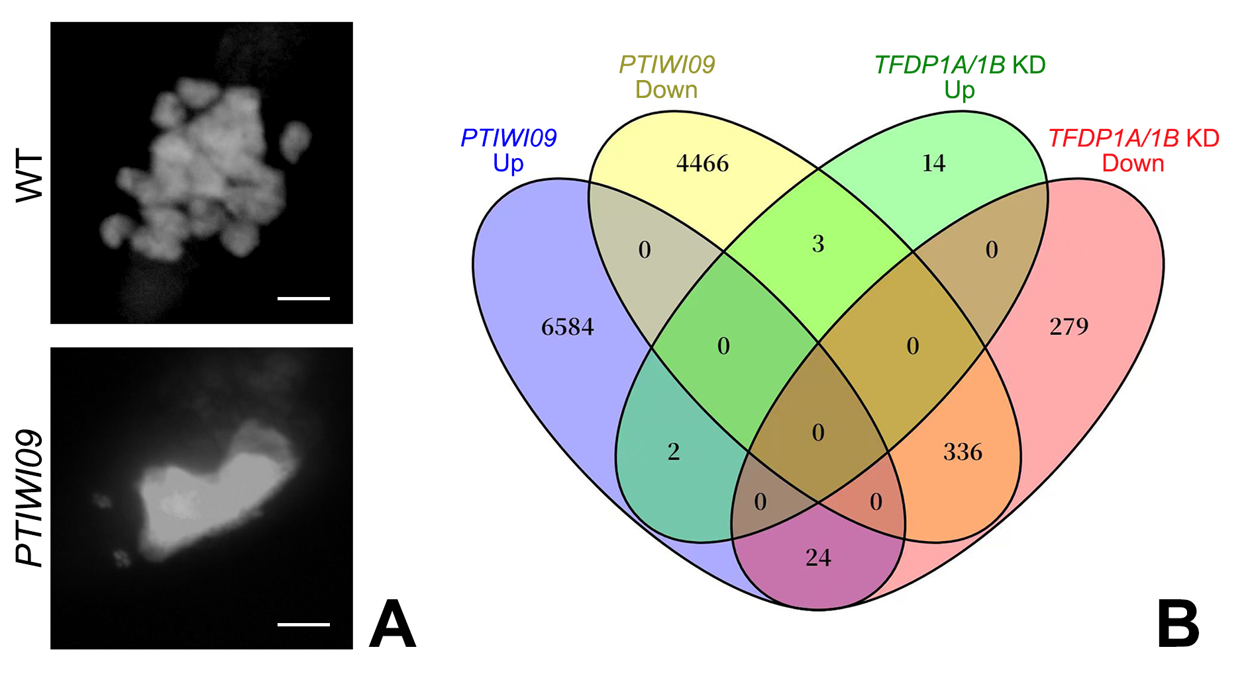
Fig. S6 Differentially expressed genes shared between PTIWI09 overexpression and TFDP1A/1B Knockdown. (A) DAPI staining to show the old MAC in wild type (WT) and PTIWI09 overexpressed cells. Scale bar: 10 μm. (B) Venn diagram of the differentially expressed genes in PTIWI09 overexpression and TFDP1A/1B Knockdown. Up, upregulated genes; Down, downregulated genes.

Table S1. Primers and Flag-HA sequence used to make the silencing and Flag-HA tagged constructs of TFDPs.
 | Genes | Primers | Sequences
Silencing constructs | TFDP1A | TFDP1A-sil-Fwd | ATGAAAAGAACTTATAAGCAGTTTTCAA
Silencing constructs | TFDP1A | TFDP1A-sil-Rev | TCAATTTAGTATCTTTTATAATACTTCTAATTCT
Silencing constructs | TFDP1B | TFDP1B-sil-Fwd | ATGATAATGAAAAGATCTTAGAGAAGGT
Silencing constructs | TFDP1B | TFDP1B-sil-Rev | TCATTTTAGTTATAGCTTTTGTAAGACTTC
Silencing constructs | TFDP2A | TFDP2A-sil-Fwd | TATAAGAGCGCCATCGATGCAAT
Silencing constructs | TFDP2A | TFDP2A-sil-Rev | ATTCAACATAGGTCCAGGAAGATTTT
Silencing constructs | TFDP2B | TFDP2B-sil-Fwd | TGCATTAGACAATTGTTCATTCCACA
Silencing constructs | TFDP2B | TFDP2B-sil-Rev | AGACCTAAGATTTCCCTTCTGTA
Silencing constructs | TFDP3A | TFDP3A-sil-Fwd | ACAGGGTAATTCAGACTTGATGA
Silencing constructs | TFDP3A | TFDP3A-sil-Rev | AGGCAATACCCAGGATTCCAAAA
Silencing constructs | TFDP3B | TFDP3B-sil-Fwd | ATGGATTTCACAGGACAATTCAGA
Silencing constructs | TFDP3B | TFDP3B-sil-Rev | GTACTACAGTTAGATCTAGCTGGA
Silencing constructs | TFDP3C | TFDP3C-sil-Fwd | TCACAGGGTAATTCAGATTGGAC
Silencing constructs | TFDP3C | TFDP3C-sil-Rev | ATACCATGTGTTCACTTTGAAATAGC
Silencing constructs | TFDP4 | TFDP4-sil-Fwd | GATGTTTTTGTTTACTAGCGATTGCT
Silencing constructs | TFDP4 | TFDP4-sil-Rev | TCAACTCAATTATCACGTCTAAGTC
Silencing constructs | TFDP5A | TFDP5A-sil-Fwd | GAATCATCTCCTCTGAACCTTC
Silencing constructs | TFDP5A | TFDP5A-sil-Rev | TCATTGATTTACACTATTTCTACTAGACTT
Silencing constructs | TFDP5B | TFDP5B-sil-Fwd | TGAACTGGAATCCTCTCCTCTAA
Silencing constructs | TFDP5B | TFDP5B-sil-Rev | ATCAATTCAGGAGCAGAGATCATTTA
Silencing constructs | TFDP6 | TFDP6-sil-Fwd | GTAATTGAGTGTTAGTAAGATATATAGTTAT
Silencing constructs | TFDP6 | TFDP6-sil-Rev | TGAGGTTTGCTTAATCATTTCAATTAGTT
Silencing constructs | TFDP7A | TFDP7A-sil-Fwd | TGCTTCATGAGTCCTAGTTCGTT
Silencing constructs | TFDP7A | TFDP7A-sil-Rev | TCTCGCATTCATCTATTAGGTACTT
Silencing constructs | TFDP7B | TFDP7B-sil-Fwd | CCTTCATAAATGCTTCACGAGTC
Silencing constructs | TFDP7B | TFDP7B-sil-Rev | ATTCATCCAACAAGTACTTTGAGTCT
Silencing constructs | TFDP8 | TFDP8-sil-Fwd | TAAGTGATTATGAATTCCCTTTTGATCC
Silencing constructs | TFDP8 | TFDP8-sil-Rev | CAACAGTTTCACTAAGATAAATTCATAAATGA
Silencing constructs | TFDP9A | TFDP9A-sil-Fwd | CGACGGAGAAGCTAGTCAG
Silencing constructs | TFDP9A | TFDP9A-sil-Rev | TGTTGCGCATCCTAGAGTAATTC
Silencing constructs | TFDP9B | TFDP9B-sil-Fwd | CGATGGAGAGGCTAGTCAGT
Silencing constructs | TFDP9B | TFDP9B-sil-Rev | TCTACTTCAGACATAAAAGAGCAGAA
Flag-HA tagged  constructs | TFDP1A | TFDP1A-FlagHA-F | TTATTTACTTTTTTTAAATAATATTCATATTTAGATTG
Flag-HA tagged  constructs | TFDP1A | TFDP1A-FlagHA-R | TTGAATTAATACCTATAAATAAATATTTTACCAAT
Flag-HA tagged  constructs | TFDP1B | TFDP1B-FlagHA-F | CTAAACATCTTTCCCTACATGAAAG
Flag-HA tagged  constructs | TFDP1B | TFDP1B-FlagHA-R | TTACTAATTTACAAAACATTTATCAATGAATAC
Flag-HA sequence
GATTATAAAGATCATGATGGAGACTACAAGGACCACGACATTGATTATAAAGATGATGATGATAAATATCCATACGATGTTCCAGATTATGCTCAT

Table S2. Primers for qPCR.

Genes | Gene ID | Primers | Sequences
Cdc20 | PTET.51.1.G1180088 | Cdc20-Fwd | ACCGCTCAAATTACTGGATGCT
Cdc20 | PTET.51.1.G1180088 | Cdc20-Rev | TGCGTGCGAACAAATTCTCTTT
Cks | PTET.51.1.G1550066 | Cks-Fwd | GGGCAAGGAATCGGTCAAACTC
Cks | PTET.51.1.G1550066 | Cks-Rev | TGCAACCATCCTCGACTCTACT
CycB | PTET.51.1.G0450154 | CycB-Fwd | CCTGAAGCAGACAGATTGGAGC
CycB | PTET.51.1.G0450154 | CycB-Rev | ATATAGTATCTCCTTCTCCATGTCA
CycE | PTET.51.1.G0050383 | CycE-Fwd | TGATTGGTTGGTTGATGTCGCA
CycE | PTET.51.1.G0050383 | CycE-Rev | TATGAATAAGGCAGCTACTGCA
Dna2 | PTET.51.1.G1180088 | Dna2-Fwd | ACAACTTTCAGAATGCATGGCT
Dna2 | PTET.51.1.G1180088 | Dna2-Rev | CTCCAAACCAATGGCGTAATCA
Ku80c | PTET.51.1.G1140146 | Ku80c-Fwd | GCTCTGGCTGCTCTAGTCATTG
Ku80c | PTET.51.1.G1140146 | Ku80c-Rev | TGTCTTCAGTTGTAGGCAAGGA
Lig1 | PTET.51.1.G1670070 | Lig1-Fwd | CTCGGACTGGTAACTCATTAAAC
Lig1 | PTET.51.1.G1670070 | Lig1-Rev | CAAATGGCTCATCCAACAAAGG
ORC1 | PTET.51.1.G1560044 | ORC1-Fwd | ACAGTGCTGCACAGAAACCTCA
ORC1 | PTET.51.1.G1560044 | ORC1-Rev | TCCTGTTCCCGGTTACCCTGTT
PARG | PTET.51.1.G0140103 | PARG-Fwd | GGCAGAGTTGGCGTTGAAGG
PARG | PTET.51.1.G0140103 | PARG-Rev | TCCTTCTCCCTTTCCTCTCTGA
PARP | PTET.51.1.G1030161 | PARP-Fwd | ACCACAGAGATCAGACCAGACG
PARP | PTET.51.1.G1030161 | PARP-Rev | TGCTGATGGTAACTGCCAGAGT
Pol λ | PTET.51.1.G0210235 | Pol λ-Fwd | TGGCTCTGATGCAACAGTAGAA
Pol λ | PTET.51.1.G0210235 | Pol λ-Rev | ACTTCCTCTAAGACTGGCTGGA
Smc1 | PTET.51.1.G0590135 | Smc1-Fwd | GTGATGTCAGGTGGTCCAGAAC
Smc1 | PTET.51.1.G0590135 | Smc1-Rev | CCATTTCCTCATCCGACAAGGT
Ycs4 | PTET.51.1.G0430205 | Ycs4-Fwd | AGGCAGTTGAGAGATTGAAGGA
Ycs4 | PTET.51.1.G0430205 | Ycs4-Rev | TCTCCAACTCCAACAACTTCCT
Act1-1 | PTET.51.1.G0430205 | Ycs4-Fwd | GACTGAAGCTCCAATGAATCCAAAGGC
Act1-1 | PTET.51.1.G0430205 | Ycs4-Rev | GTTCTTCCTGAAGCATAGAGTGAGAGC

Table S3. Amino acid sequence alignment of E2F/DP family winged-helix DNA-binding domain.
(%) | Tfdp1a | Tfdp1b | Tfdp2a | Tfdp2b | Tfdp3a | Tfdp3b | Tfdp3c | Tfdp4 | Tfdp5a | Tfdp5b | Tfdp6 | Tfdp7a | Tfdp7b | Tfdp8 | Tfdp9a | Tfdp9b | Tt_Dpl1 | Tt_Dpl2 | Tt_Dpl3 | Hs_  TFDP1 | Hs_  TFDP2 | Hs_  TFDP3 | Mm_  TFDP1 | Mm_  TFDP2 | Dm_  DP | Ce_  DPL-1
Tfdp1a |  | 97.62 | 68.29 | 68.29 | 66.67 | 67.86 | 66.67 | 54.22 | 73.26 | 74.42 | 69.86 | 71.76 | 70.93 | 72.94 | 66.27 | 67.47 | 71.08 | 74.03 | 68.97 | 68.24 | 69.05 | 68.24 | 68.24 | 64.71 | 65.06 | 63.53
Tfdp1b | 97.62 |  | 67.07 | 67.07 | 67.86 | 65.48 | 65.48 | 56.63 | 73.26 | 74.42 | 69.86 | 72.94 | 69.77 | 72.94 | 67.47 | 68.67 | 72.29 | 74.03 | 67.82 | 67.06 | 67.86 | 68.24 | 67.06 | 62.35 | 65.06 | 63.53
Tfdp2a | 68.29 | 67.07 |  | 94.67 | 68.67 | 68.67 | 68.67 | 59.74 | 69.88 | 69.88 | 64.29 | 66.67 | 64.29 | 67.86 | 73.08 | 73.08 | 68.29 | 66.23 | 65.88 | 69.51 | 72.84 | 64.63 | 69.51 | 69.14 | 76.32 | 66.67
Tfdp2b | 68.29 | 67.07 | 94.67 |  | 67.47 | 67.47 | 67.47 | 59.74 | 67.47 | 67.47 | 61.43 | 65.48 | 63.10 | 66.67 | 67.95 | 67.95 | 68.29 | 66.23 | 64.71 | 68.29 | 71.60 | 63.41 | 68.29 | 67.90 | 75.00 | 65.48
Tfdp3a | 66.67 | 67.86 | 68.67 | 67.47 |  | 91.36 | 90.12 | 58.54 | 63.86 | 63.86 | 55.56 | 66.27 | 68.67 | 69.88 | 67.90 | 69.14 | 67.07 | 65.33 | 61.90 | 68.24 | 72.62 | 61.18 | 68.24 | 69.05 | 65.85 | 68.24
Tfdp3b | 67.86 | 65.48 | 68.67 | 67.47 | 91.36 |  | 98.77 | 54.88 | 63.86 | 63.86 | 56.94 | 69.88 | 69.88 | 67.47 | 67.90 | 67.90 | 71.95 | 69.33 | 66.67 | 67.06 | 71.43 | 63.53 | 67.06 | 67.86 | 69.51 | 72.94
Tfdp3c | 66.67 | 65.48 | 68.67 | 67.47 | 90.12 | 98.77 |  | 51.22 | 63.86 | 63.86 | 56.94 | 69.88 | 68.67 | 67.47 | 67.90 | 67.90 | 67.07 | 66.67 | 65.48 | 65.88 | 70.24 | 62.35 | 65.88 | 65.48 | 68.29 | 71.76
Tfdp4 | 54.22 | 56.63 | 59.74 | 59.74 | 58.54 | 54.88 | 51.22 |  | 52.44 | 52.44 | 45.07 | 53.01 | 54.22 | 53.01 | 63.01 | 63.01 | 61.73 | 52.00 | 55.95 | 57.83 | 59.76 | 57.83 | 57.83 | 53.66 | 65.79 | 57.65
Tfdp5a | 73.26 | 73.26 | 69.88 | 67.47 | 63.86 | 63.86 | 63.86 | 52.44 |  | 98.80 | 84.72 | 92.77 | 88.10 | 95.18 | 72.84 | 72.84 | 71.08 | 80.00 | 80.00 | 67.44 | 68.24 | 59.30 | 67.44 | 62.79 | 63.86 | 60.47
Tfdp5b | 74.42 | 74.42 | 69.88 | 67.47 | 63.86 | 63.86 | 63.86 | 52.44 | 98.80 |  | 86.11 | 92.77 | 89.29 | 95.18 | 72.84 | 72.84 | 71.08 | 80.00 | 80.00 | 67.44 | 68.24 | 59.30 | 67.44 | 62.79 | 62.65 | 60.47
Tfdp6 | 69.86 | 69.86 | 64.29 | 61.43 | 55.56 | 56.94 | 56.94 | 45.07 | 84.72 | 86.11 |  | 77.78 | 76.00 | 81.94 | 62.86 | 62.86 | 63.89 | 70.15 | 68.00 | 61.11 | 62.50 | 54.17 | 61.11 | 56.00 | 55.41 | 58.33
Tfdp7a | 71.76 | 72.94 | 66.67 | 65.48 | 66.27 | 69.88 | 69.88 | 53.01 | 92.77 | 92.77 | 77.78 |  | 91.57 | 96.39 | 70.73 | 70.73 | 74.70 | 81.33 | 83.33 | 67.44 | 71.76 | 61.63 | 67.44 | 67.06 | 67.47 | 66.28
Tfdp7b | 70.93 | 69.77 | 64.29 | 63.10 | 68.67 | 69.88 | 68.67 | 54.22 | 88.10 | 89.29 | 76.00 | 91.57 |  | 92.77 | 70.73 | 70.73 | 72.29 | 78.67 | 78.26 | 63.95 | 65.88 | 58.14 | 63.95 | 61.36 | 62.79 | 67.44
Tfdp8 | 72.94 | 72.94 | 67.86 | 66.67 | 69.88 | 67.47 | 67.47 | 53.01 | 95.18 | 95.18 | 81.94 | 96.39 | 92.77 |  | 71.95 | 71.95 | 74.70 | 78.67 | 83.33 | 69.77 | 72.94 | 61.63 | 69.77 | 68.24 | 66.27 | 62.79
Tfdp9a | 66.27 | 67.47 | 73.08 | 67.95 | 67.90 | 67.90 | 67.90 | 63.01 | 72.84 | 72.84 | 62.86 | 70.73 | 70.73 | 71.95 |  | 98.63 | 69.14 | 73.33 | 73.49 | 69.51 | 71.60 | 62.20 | 69.51 | 66.67 | 80.00 | 66.67
Tfdp9b | 67.47 | 68.67 | 73.08 | 67.95 | 69.14 | 67.90 | 67.90 | 63.01 | 72.84 | 72.84 | 62.86 | 70.73 | 70.73 | 71.95 | 98.63 |  | 67.90 | 72.00 | 73.49 | 68.29 | 71.60 | 60.98 | 68.29 | 66.67 | 78.67 | 65.48
Tt_Dpl1 | 71.08 | 72.29 | 68.29 | 68.29 | 67.07 | 71.95 | 67.07 | 61.73 | 71.08 | 71.08 | 63.89 | 74.70 | 72.29 | 74.70 | 69.14 | 67.90 |  | 81.08 | 76.19 | 68.24 | 71.43 | 65.88 | 68.24 | 66.67 | 71.95 | 69.41
Tt_Dpl2 | 74.03 | 74.03 | 66.23 | 66.23 | 65.33 | 69.33 | 66.67 | 52.00 | 80.00 | 80.00 | 70.15 | 81.33 | 78.67 | 78.67 | 73.33 | 72.00 | 81.08 |  | 82.67 | 73.08 | 74.03 | 69.23 | 73.08 | 68.83 | 70.51 | 69.23
Tt_Dpl3 | 68.97 | 67.82 | 65.88 | 64.71 | 61.90 | 66.67 | 65.48 | 55.95 | 80.00 | 80.00 | 68.00 | 83.33 | 78.26 | 83.33 | 73.49 | 73.49 | 76.19 | 82.67 |  | 71.26 | 73.26 | 66.67 | 71.26 | 69.66 | 65.52 | 65.52
Hs_TFDP1 | 68.24 | 67.06 | 69.51 | 68.29 | 68.24 | 67.06 | 65.88 | 57.83 | 67.44 | 67.44 | 61.11 | 67.44 | 63.95 | 69.77 | 69.51 | 68.29 | 68.24 | 73.08 | 71.26 |  | 95.18 | 87.95 | 100.00 | 84.34 | 82.50 | 84.71
Hs_TFDP2 | 69.05 | 67.86 | 72.84 | 71.60 | 72.62 | 71.43 | 70.24 | 59.76 | 68.24 | 68.24 | 62.50 | 71.76 | 65.88 | 72.94 | 71.60 | 71.60 | 71.43 | 74.03 | 73.26 | 95.18 |  | 85.54 | 95.18 | 89.02 | 85.00 | 85.88
Hs_TFDP3 | 68.24 | 68.24 | 64.63 | 63.41 | 61.18 | 63.53 | 62.35 | 57.83 | 59.30 | 59.30 | 54.17 | 61.63 | 58.14 | 61.63 | 62.20 | 60.98 | 65.88 | 69.23 | 66.67 | 87.95 | 85.54 |  | 87.95 | 74.70 | 75.00 | 78.82
Mm_TFDP1 | 68.24 | 67.06 | 69.51 | 68.29 | 68.24 | 67.06 | 65.88 | 57.83 | 67.44 | 67.44 | 61.11 | 67.44 | 63.95 | 69.77 | 69.51 | 68.29 | 68.24 | 73.08 | 71.26 | 100.00 | 95.18 | 87.95 |  | 84.34 | 82.50 | 84.71
Mm_TFDP2 | 64.71 | 62.35 | 69.14 | 67.90 | 69.05 | 67.86 | 65.48 | 53.66 | 62.79 | 62.79 | 56.00 | 67.06 | 61.36 | 68.24 | 66.67 | 66.67 | 66.67 | 68.83 | 69.66 | 84.34 | 89.02 | 74.70 | 84.34 |  | 72.29 | 75.29
Dm_DP | 65.06 | 65.06 | 76.32 | 75.00 | 65.85 | 69.51 | 68.29 | 65.79 | 63.86 | 62.65 | 55.41 | 67.47 | 62.79 | 66.27 | 80.00 | 78.67 | 71.95 | 70.51 | 65.52 | 82.50 | 85.00 | 75.00 | 82.50 | 72.29 |  | 85.37
Ce_DPL-1 | 63.53 | 63.53 | 66.67 | 65.48 | 68.24 | 72.94 | 71.76 | 57.65 | 60.47 | 60.47 | 58.33 | 66.28 | 67.44 | 62.79 | 66.67 | 65.48 | 69.41 | 69.23 | 65.52 | 84.71 | 85.88 | 78.82 | 84.71 | 75.29 | 85.37
Numbers in the table are the identity between sequences. Hs: Homo sapiens; Mm: Mus musculus; Dm: Drosophila melanogaster; Ce: Caenorhabditis elegans; Tt: Tetrahymena thermophila

Table S4. Expression levels of TFDP1A and TFDP1B in TFDP1A, TFDP1B and TFDP1A/1B KD compared with EV control.
Samples |  | TFDP1A | TFDP1B
TFDP1A KD | Fold change (FC) | 0.05 | 0.25
TFDP1A KD | Log₂ FC | -4.43 | -1.98
TFDP1A KD | Adjusted p-value | 1.66E-06 | 0.23
TFDP1B KD | Fold change | 0.23 | 0.05
TFDP1B KD | Log₂ FC | -2.09 | -4.47
TFDP1B KD | Adjusted p-value | 0.26 | 7.19E-07
TFDP1A/1B KD | Fold change | 0.07 | 0.11
TFDP1A/1B KD | Log₂ FC | -3.83 | -3.21
TFDP1A/1B KD | Adjusted p-value | 5.41E-07 | 8.70E-05

Table S5. Differentially expressed genes shared between PTIWI09 overexpression and TFDP1A/1B KD.
Gene ID
PTET.51.1.G0010132 | PTET.51.1.G0360158 | PTET.51.1.G0510115 | PTET.51.1.G1380095 | PTET.51.1.G0710063 | PTET.51.1.G1560044
PTET.51.1.G0100220 | PTET.51.1.G0380149 | PTET.51.1.G0520024 | PTET.51.1.G1390106 | PTET.51.1.G0740138 | PTET.51.1.G1650093
PTET.51.1.G1000119 | PTET.51.1.G0420052 | PTET.51.1.G0520030 | PTET.51.1.G1400043 | PTET.51.1.G0770131 | PTET.51.1.G0170202
PTET.51.1.G1010094 | PTET.51.1.G0430101 | PTET.51.1.G0580013 | PTET.51.1.G1410034 | PTET.51.1.G0080423 | PTET.51.1.G1820002
PTET.51.1.G0110407 | PTET.51.1.G0450280 | PTET.51.1.G0580213 | PTET.51.1.G1410056 | PTET.51.1.G0860052 | PTET.51.1.G0190159
PTET.51.1.G1160096 | PTET.51.1.G0460088 | PTET.51.1.G0630042 | PTET.51.1.G1460035 | PTET.51.1.G0090128 | PTET.51.1.G0220209
PTET.51.1.G1180088 | PTET.51.1.G4610001 | PTET.51.1.G0690077 | PTET.51.1.G1480052 | PTET.51.1.G0970111 | PTET.51.1.G0030257
PTET.51.1.G1180107 | PTET.51.1.G0050104 | PTET.51.1.G0070284 | PTET.51.1.G1510123 | PTET.51.1.G0190346 | PTET.51.1.G0310033
PTET.51.1.G1210130 | PTET.51.1.G0050383 | PTET.51.1.G0070391 | PTET.51.1.G1520057 | PTET.51.1.G0330302 | PTET.51.1.G0320165
PTET.51.1.G1330058 | PTET.51.1.G0500130 | PTET.51.1.G0710038 | PTET.51.1.G1520058 | PTET.51.1.G4610002 | PTET.51.1.G0330152
PTET.51.1.G0010408 | PTET.51.1.G1080038 | PTET.51.1.G1190008 | PTET.51.1.G1290041 | PTET.51.1.G0140272 | PTET.51.1.G1560014
PTET.51.1.G0100167 | PTET.51.1.G1080062 | PTET.51.1.G1190058 | PTET.51.1.G0130193 | PTET.51.1.G1400136 | PTET.51.1.G1560117
PTET.51.1.G1000144 | PTET.51.1.G0110239 | PTET.51.1.G0120071 | PTET.51.1.G0130237 | PTET.51.1.G1440089 | PTET.51.1.G1580022
PTET.51.1.G1020035 | PTET.51.1.G1130040 | PTET.51.1.G0120094 | PTET.51.1.G0130395 | PTET.51.1.G1450044 | PTET.51.1.G1590017
PTET.51.1.G1020165 | PTET.51.1.G1150089 | PTET.51.1.G0120140 | PTET.51.1.G1320107 | PTET.51.1.G1450059 | PTET.51.1.G1590024
PTET.51.1.G1030019 | PTET.51.1.G1150123 | PTET.51.1.G0120149 | PTET.51.1.G1380122 | PTET.51.1.G1480009 | PTET.51.1.G0160206
PTET.51.1.G1030062 | PTET.51.1.G1150128 | PTET.51.1.G0120198 | PTET.51.1.G1390018 | PTET.51.1.G0150223 | PTET.51.1.G0160234
PTET.51.1.G1030161 | PTET.51.1.G1170092 | PTET.51.1.G0120377 | PTET.51.1.G0140103 | PTET.51.1.G1500066 | PTET.51.1.G1600120
PTET.51.1.G1060046 | PTET.51.1.G1170112 | PTET.51.1.G1230079 | PTET.51.1.G0140179 | PTET.51.1.G1520043 | PTET.51.1.G1600121
PTET.51.1.G1070131 | PTET.51.1.G1180067 | PTET.51.1.G1260050 | PTET.51.1.G0140243 | PTET.51.1.G1550066 | PTET.51.1.G1660029
PTET.51.1.G1660090 | PTET.51.1.G0180198 | PTET.51.1.G0210213 | PTET.51.1.G0250204 | PTET.51.1.G0280180 | PTET.51.1.G0330182
PTET.51.1.G1670111 | PTET.51.1.G0180257 | PTET.51.1.G0210235 | PTET.51.1.G0250252 | PTET.51.1.G2860001 | PTET.51.1.G0330303
PTET.51.1.G1690069 | PTET.51.1.G1830010 | PTET.51.1.G0220076 | PTET.51.1.G0260153 | PTET.51.1.G0030055 | PTET.51.1.G0340175
PTET.51.1.G1710047 | PTET.51.1.G0190347 | PTET.51.1.G0220149 | PTET.51.1.G0260165 | PTET.51.1.G0030203 | PTET.51.1.G0350154
PTET.51.1.G1720081 | PTET.51.1.G0020155 | PTET.51.1.G0230221 | PTET.51.1.G0260213 | PTET.51.1.G0030254 | PTET.51.1.G0350183
PTET.51.1.G1740026 | PTET.51.1.G0020267 | PTET.51.1.G0230268 | PTET.51.1.G0260286 | PTET.51.1.G0030402 | PTET.51.1.G0350202
PTET.51.1.G1740041 | PTET.51.1.G0200051 | PTET.51.1.G0230328 | PTET.51.1.G0270067 | PTET.51.1.G0310084 | PTET.51.1.G0370037
PTET.51.1.G1770039 | PTET.51.1.G0200107 | PTET.51.1.G0240072 | PTET.51.1.G0270166 | PTET.51.1.G0320152 | PTET.51.1.G0370120
PTET.51.1.G0180112 | PTET.51.1.G0200133 | PTET.51.1.G0240142 | PTET.51.1.G0270194 | PTET.51.1.G0320259 | PTET.51.1.G0370246
PTET.51.1.G0180124 | PTET.51.1.G0210152 | PTET.51.1.G0240243 | PTET.51.1.G0280156 | PTET.51.1.G3290002 | PTET.51.1.G0380056
PTET.51.1.G0380169 | PTET.51.1.G0440186 | PTET.51.1.G5560025 | PTET.51.1.G0630129 | PTET.51.1.G0710115 | PTET.51.1.G0080258
PTET.51.1.G0040036 | PTET.51.1.G0440197 | PTET.51.1.G0560087 | PTET.51.1.G0630147 | PTET.51.1.G0710159 | PTET.51.1.G0800195
PTET.51.1.G0400119 | PTET.51.1.G0440203 | PTET.51.1.G0570054 | PTET.51.1.G0650023 | PTET.51.1.G0730049 | PTET.51.1.G0800198
PTET.51.1.G0400181 | PTET.51.1.G0450154 | PTET.51.1.G0580166 | PTET.51.1.G0650036 | PTET.51.1.G0730130 | PTET.51.1.G0810122
PTET.51.1.G0400276 | PTET.51.1.G0470133 | PTET.51.1.G0580178 | PTET.51.1.G0650165 | PTET.51.1.G0750138 | PTET.51.1.G0810201
PTET.51.1.G0400281 | PTET.51.1.G0490221 | PTET.51.1.G0060015 | PTET.51.1.G0660068 | PTET.51.1.G0760009 | PTET.51.1.G0840065
PTET.51.1.G0420102 | PTET.51.1.G0050297 | PTET.51.1.G0060096 | PTET.51.1.G0070099 | PTET.51.1.G0760010 | PTET.51.1.G0840117
PTET.51.1.G0420179 | PTET.51.1.G0500162 | PTET.51.1.G0060232 | PTET.51.1.G0070139 | PTET.51.1.G0770014 | PTET.51.1.G0840124
PTET.51.1.G0430205 | PTET.51.1.G0530201 | PTET.51.1.G0610198 | PTET.51.1.G0070387 | PTET.51.1.G0790188 | PTET.51.1.G0840125
PTET.51.1.G0430206 | PTET.51.1.G0550004 | PTET.51.1.G0620217 | PTET.51.1.G0070416 | PTET.51.1.G0790198 | PTET.51.1.G0840130
PTET.51.1.G0860013 | PTET.51.1.G0990005 | PTET.51.1.G0970093 | PTET.51.1.G0970003 | PTET.51.1.G0930081 | PTET.51.1.G0910133
PTET.51.1.G0090187 | PTET.51.1.G0670249 | PTET.51.1.G0980124 | PTET.51.1.G0970059 | PTET.51.1.G0930179 | PTET.51.1.G0920152
PTET.51.1.G0900199 | PTET.51.1.G0830111 | PTET.51.1.G0980174 | PTET.51.1.G0970065 | PTET.51.1.G0950081
PTET.51.1.G0130368 | PTET.51.1.G0710099 | PTET.51.1.G0650095 | PTET.51.1.G0040252 | PTET.51.1.G0260051 | PTET.51.1.G0850141
PTET.51.1.G1360024 | PTET.51.1.G0730131 | PTET.51.1.G0660136 | PTET.51.1.G0480221 | PTET.51.1.G0350167
PTET.51.1.G0150274 | PTET.51.1.G0760223 | PTET.51.1.G0670204 | PTET.51.1.G0630130 | PTET.51.1.G0040241
PTET.51.1.G0200144 | PTET.51.1.G1630040 | PTET.51.1.G0390026 | PTET.51.1.G0980037 | PTET.51.1.G0030307 | PTET.51.1.G1250168
PTET.51.1.G1000114 | PTET.51.1.G1640096 | PTET.51.1.G0410263 | PTET.51.1.G0070425 | PTET.51.1.G0310095 | PTET.51.1.G1260135
PTET.51.1.G1050041 | PTET.51.1.G1680042 | PTET.51.1.G0480049 | PTET.51.1.G0870187 | PTET.51.1.G0230122 | PTET.51.1.G1620052
PTET.51.1.G1190017 | PTET.51.1.G1770034 | PTET.51.1.G0530107 | PTET.51.1.G0600216 | PTET.51.1.G0260097 | PTET.51.1.G0940146
PTET.51.1.G1250036 | PTET.51.1.G0210154 | PTET.51.1.G0060181 | PTET.51.1.G0620120 | PTET.51.1.G0310124 | PTET.51.1.G1460102
PTET.51.1.G1520093
PTET.51.1.G1400010 | PTET.51.1.G0150240 | PTET.51.1.G1590023 | PTET.51.1.G1790049 | PTET.51.1.G0590066
The expression pattern of genes with green background is Early peak. Yellow is Intermediate peak. Blue is Late induction. Gray is Late repression and Purple is None.

