Marine Life Science & Technology
A new contribution to the subclass Cyrtophoria (Protista, Ciliophora): a brief revision of Chilodonellidae, including reports of three species and one new genus

Junqi Guo^{1*}, Gongaote Zhang^{2*}, Lukáš Pecina³, Jiamei Jiang¹, Hongbo Pan¹

¹Shanghai Universities Key Laboratory of Marine Animal Taxonomy and Evolution, Shanghai Ocean University, Shanghai 201306, China
²Institute of Evolution & Marine Biodiversity and MOE Key Laboratory of Evolution & Marine Biodiversity, Ocean University of China, Qingdao 266003, China
³Department of Zoology, Faculty of Natural Sciences, Comenius University in Bratislava, Ilkovičova 6, 842 15 Bratislava, Slovakia

* Both authors contributed equally to this work
Corresponding author, Hongbo Pan, email: hbpan@shou.edu.cn

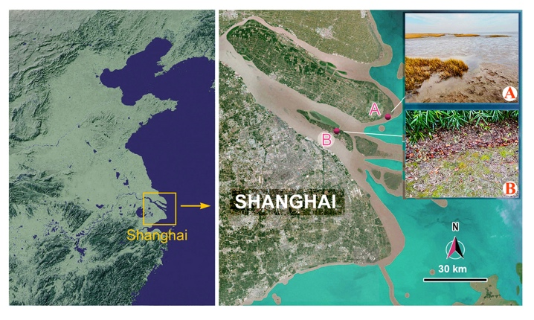
Supplementary Fig. S1 Sample locations and habitats. A Tidal flat on Chongming Island, where Monochilodonella sinica gen. et sp. nov. and Chlamydonella foissneri sp. nov. were collected. B Moss habitat on Changxing Island, where Gastronauta derouxi was collected.

Supplementary Fig. S2 Predicted secondary structure of the nuclear SSU rRNA molecule of Monochilodonella sinica gen. et sp. nov. Numbering of helices follows Petrov et al. (2014). The secondary structure map of the S. cerevisiae SSU rRNA molecule (lower right panel) is from http://apollo.chemistry.gatech.edu/RibosomeGallery (Petrov et al., 2014).

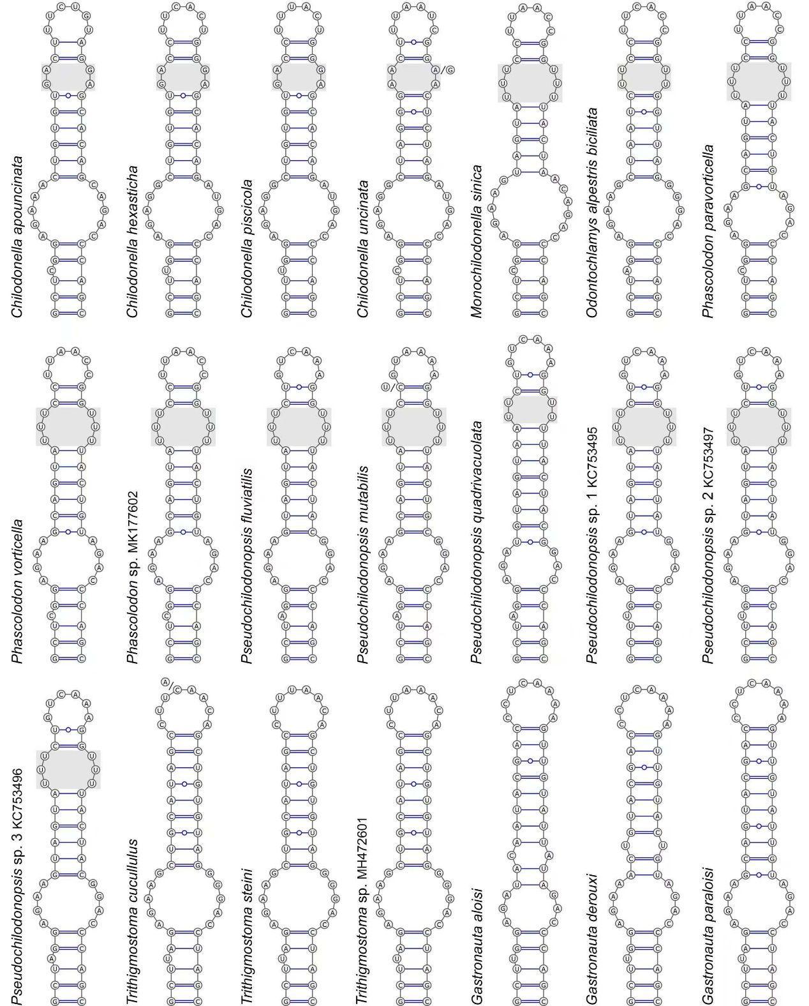 Supplementary Fig. S3 Putative secondary structures of helix 21es6b of the nuclear SSU rRNA molecule of selected chilodonellids and gastronautids. Gray squares highlight the symmetrical internal loop near the terminal loop of helix 21es6b in the genera Chilodonella, Monochilodonella gen. nov., Odontochlamys, Phascolodon and Pseudochilodonopsis.

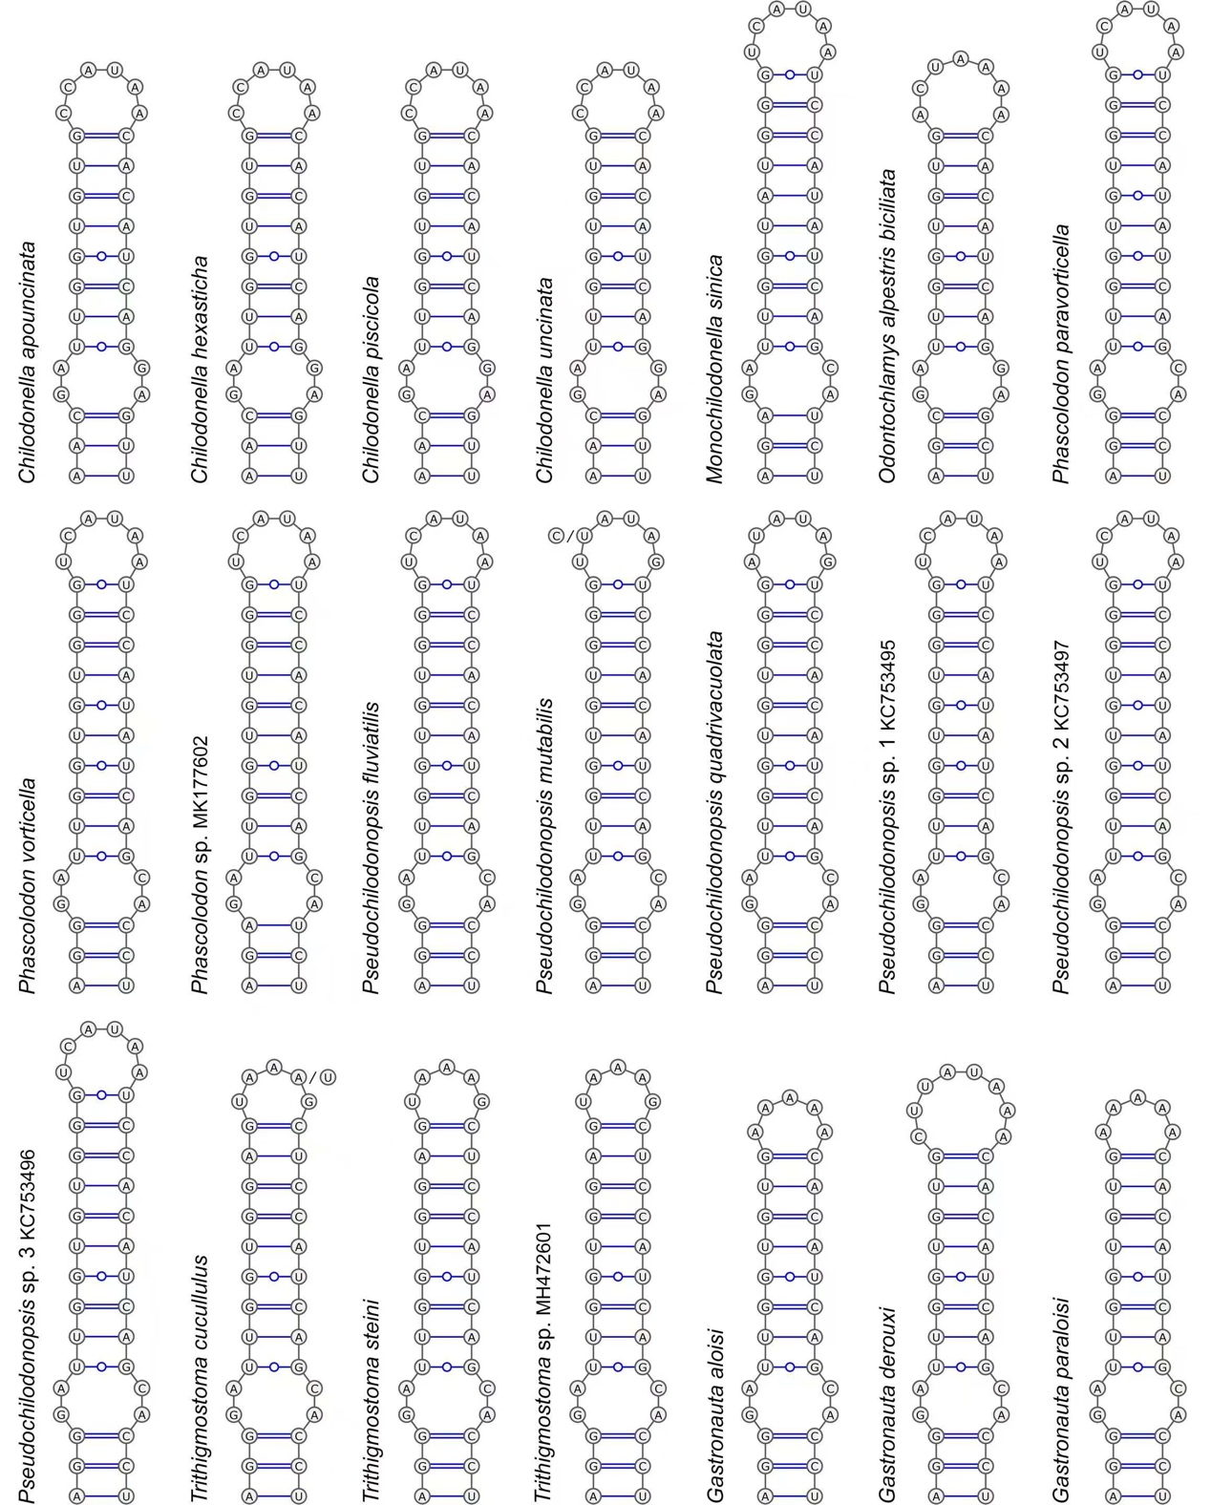 Supplementary Fig. S4 Putative secondary structures of helix 26 of the nuclear SSU rRNA molecule of selected chilodonellids and gastronautids.

Supplementary Table S1. Results of AU tests calculated based on SSU rRNA gene sequences.
Hypothesis | P-value | Conclusion
Monophyly of the family Chilodonellidae | 0.960 | Not rejected
Monophyly of Chlamydonella | 0.559 | Not rejected
Monochilodonella gen. nov. clusters with Odontochlamys | 0.067 | Not rejected

References for the data used in Fig. 7:
Abdel-Baki A-AS, Al-Quraishy S (2014) First record of Chilodonella spp.(Ciliophora: Chilodonellidae) in cultured Nile tilapia (Oreochromis niloticus) in the central region of Saudi Arabia. Pak J Zool 46:657–660
André Em (1912) Les Chilodontes parasites des Cyprinides. Rev Suisse Zool 20:207–212
Ashburner L, Ehl A (1973) Chilodonella cyprini (Moroff), a parasite of freshwater fish and its treatment. Bull Aust Soc Limnol 5:3–4
Augustin H, Unterweger A, Wiener W (1987) Die Organismenvielfalt in einem natürlich-mäandrierenden und in einem regulierten Abschnitt der Oichten. Jahrbuch des Haus der Natur Salzburg 10:72–80
Basson L (1982) Ektoparasitiese protozoa van die Cyprinidae en Cichlidae van Suid-Afrika en Israel. University of Johannesburg, South Africa 1–172
Becares E, Foissner W (1994) Redescription of Chilodonatella minuta DRAGESCO 1966 (Protozoa, Ciliophora). Linzer Biol Beitr 26:515–530
Bereczky MC (1975) Die ökologische Charakterisierung einiger Ciliaten-Organismen des ungarischen Donauabschnittes. Ann Univ Sci Budap Rolando Eötvös 17:123–136
Bhatia BL (1922) Notes on fresh-water ciliate protozoa of India.-II. J R Microsc Soc 42:27–36
Blatterer H, Foissner W (1990) Beiträge zur Ciliatenfauna (Protozoa: Ciliophora) der Amper (Bayern, Bundesrepublik Deutschland). Arch Protistenkd 138:93–115
Blatterer H, Foissner W (1992) Morphology and infraciliature of some cyrtophorid ciliates (Protozoa, Ciliophora) from freshwater and soil. Arch Protistenkd 142:101–118
Bu X, Wang R, Gomes GB, Ban S, Li W, Wu S, Zou H, Li M, Wang G (2021) First record of facultative parasitism of Chilodonella uncinata based on goldfish (Carassius auratus) infection model. Aquaculture 538:736535
Bu X, Zhao W, Li W, Zou H, Li M, Wang G (2023) Comparative transcriptomics of Chilodonella hexasticha and C. uncinata provide new insights into adaptations to a parasitic lifestyle and Mdivi-1 as a potential agent for chilodonellosis control. Int J Mol Sci 24:13058
Bütschli O, Schwager C (1889) Protozoa. Abt. III. Infusoria und System der Radiolaria. In: H. G. Bronn (ed) Klassen und Ordnung des Thiers-Reichs, edn. C. F. Winter, Leipzig, pp 1098–2035
Certes AA (1891) Note sur deux infusoires nouveaux des environs de Paris vol 4. Mém Soc Zool Fr 4:536–541
Chen X, Li L, Al-Farraj SA, Ma H, Pan H (2018) Taxonomic studies on Aegyria apoliva sp. nov. and Trithigmostoma cucullulus (Müller, 1786) Jankowski, 1967 (Ciliophora, Cyrtophoria) with phylogenetic analyses. Eur J Protistol 62:122–134
Choi JM, Jung J-H, Kang J-H, Kim Y-O (2020) New record of four ciliates (Protozoa, Ciliophora) collected from rocky intertidal pools of South Korea. J Species Res 9:455–461
Claudia GI, Oana MI, Constanţa T (2018) Studies of Chilodonella cyprini Sin. (Piscicola) infection (Chilodonellidae, Chilodonella) in the Preajba Valley River Basin (Romania). Int J Environ Pollut Environ Model 1:39–43
Das BP (2003) Chilodonella uncinata–a protozoa pathogenic to mosquito larvae. Curr Sci 85:483–489
Deng Q, Guo Q, Zhai Y, Wang Z, Gu Z (2015) First record of Chilodonella piscicola (Ciliophora: Chilodonellidae) from two endangered fishes, Schizothorax o’connori and Oxygymnocypris stewartii in Tibet. Parasitol Res 114:3097–3103
Deroux G (1974) Les dispositifs adhésifs ciliaires chez les Cyrtophorida et la famille des Hypocomidae. Protistologica 10:379–396
Dobrzańska J (1958) Investigations on ciliates living in lamellibranchiates of small water bodies. Bull Pol Acad Sci Ser Sci Biol 6:113–118
Dragesco J (1960) Ciliés mésopsammiques littoraux. Systématique, morphologie, écologie. Trav Stat Biol Roscoff 12:1–356
Dragesco J, Dragesco-Kernéis A (1986) Ciliés libres de l'Afrique intertropicale vol 26. Faune Tropicale.
Dragesco J, Njiné T (1971) Compléments à la connaissance des ciliés libres du Cameroun. Ann Fac Sci Univ Féd Cameroun 7–8:97–140
Ehrenberg CG (1838) Die Infusionsthierchen als vollkommene Organismen. Ein Blick in das tiefere organische Leben der Natur. Verlag von Leopold Voss, Leipzig 548
Fan X, Ma R, Al-Farraj SA, Gu F (2014) Morphological and molecular characterization of Parafurgasonia zhangi spec. nov. and Chilodonella acuta Kahl, 1931 (Protozoa, Ciliophora), from a soil habitat of Saudi Arabia. Int J Syst Evol Microbiol 64:2385–2394
Foissner W (1979a) Ökologische und Systematische Studien zum Neuston alpiner Kleingewässer: Unter besonderer Berücksichtigung der Ciliaten. Int Rev Ges Hydrobiol Hydrogr 64:99–140
Foissner W (1979b) Taxonomische Studien über die Ciliaten des Großglocknergebietes (Hohe Tauern, Österreich). Familien Microthoracidae, Chilodonellidae und Furgasoniidae. Sber Akad Wiss Wien 188:27–43
Foissner W (1981) Morphologie und Taxonomie einiger neuer und wenig bekannter Kinetofragminophorer Ciliaten (Protozoa: Ciliophora) aus alpinen Böden. Zool Jahrb Abt Syst Ökol Geogr Tiere 108:264–297
Foissner W (1988) Taxonomie und Ökologie einiger Ciliaten (Protozoa, Ciliophora) des Saprobiensystems. II. Familie Chilodonellidae. Hydrobiologia 162:21–45
Foissner W (1997) Faunistic and taxonomic studies on ciliates (Protozoa, Ciliophora) from clean rivers in Bavaria (Germany), with descriptions of new species and ecological notes. Limnologica 27:179–238
Foissner W, Agatha S, Berger H (2002) Soil ciliates (Protozoa, Ciliophora) from Namibia (Southwest Africa), with emphasis on two contrasting environments, the Etosha region and the Namib Desert vol 5. Biologiezentrum der Oberösterreichischen Landesmuseums Austria, Austria
Foissner W, Blatterer H, Berger H, Kohmann F (1991) Taxonomische und Ökologische revision der Ciliaten des Saprobiensystems - Band I: Cyrtophorida, Oligotrichia, Hypotrichia, Colpodea. Informationsberichte des Bayerischen Landesamtes für Wasserwirtschaft:471
Foissner W, Didier P (1981) Morphologie und Infraciliatur einiger Kinetofragminophorer und hypotricher Ciliaten aus Fließgewässern von Besse-en-Chandesse (Frankreich). Ann Stat Limnol Besse 15:254–275
Gelei J (1954) Über die Lebensgemeinschaft einiger temporärer Tümpel auf einer Bergwiese im Börzsönygebirge (Oberungarn). Akadémiai Kiadó
Gomes GB, Miller TL, Vaughan DB, Jerry DR, McCowan C, Bradley TL, Hutson KS (2017) Evidence of multiple species of Chilodonella (Protozoa, Ciliophora) infecting Australian farmed freshwater fishes. Vet Parasitol 237:8–16
Hoffman GL, Kazubski S, Mitchell AJ, Smith C (1979) Chilodonella hexasticha (Kiernik, 1909) (Protozoa, Ciliata) from North American warmwater fish. J Fish Dis 2:153–157
Hofmann AH (1988) Stomatogenesis in cyrtophorid ciliates: II. Chilodonella cyprini (Moroff, 1902): The kinetofragment as an anlagen-complex. Eur J Protistol 23:165–184
Hofmann AH, Bardele CF (1987) Stomatogenesis in cyrtophorid ciliates: I. Trithigmostoma steini (Blochmann, 1895): from somatic kineties to oral kineties. Eur J Protistol 23:2–17
Hu Y (2012) Ciliate ectoparasites (Ciliophora: Trichodinidae/Chilodonellidae) on gills of Carassius auratus from the Yangtze River, China, with the description of Trichodina luzhoues sp. n.. Parasitol Res 111:433–439
Imai S, Hatai K, Ogawa M (1985) Chilodonella hexasticha (Kiernik, 1909) found from the gills of a discus, Symphysodon discus Heckel, 1940. Jpn J Vet Sci 47:305–308
Jankowski AW (2007) Phylum Ciliophora Doflein, 1901. Protista. Part 2, Handbook on Zoology. Russian Academy of Sciences, Zoological Institute, St. Petersburg
Ji B-Y, Kim K-H, Park S-I (1996) Chilodonella hexasticha (Protozoa, Ciliata) from Korean freshwater fish. J Fish Pathol 9:113–118
Kahl A (1928) Die Infusorien (Ciliata) der Oldesloer Salzwasserstellen. Arch Hydrobiol 19:50–246
Kahl A (1931) Urtiere oder Protozoa. I. Wimpertiere oder Ciliata (Infusoria). 2. Holotricha. Tierwelt Adria Meerest 21:181–398
Katz LA, DeBerardinis J, Hall MS, Kovner AM, Dunthorn M, Muse SV (2011) Heterogeneous rates of molecular evolution among cryptic species of the ciliate morphospecies Chilodonella uncinata. J Mol Evol 73:266–272
Kazubski S, Migala K (1974) Studies on the distinctness of Chilodonella cyprini (Moroff) and Ch. hexasticha (Kiernik) (Chlamydodontidae, Gymnostomatida), ciliate parasites of fishes. Acta Protozool 13:9–40
Kidder GW, Summers FM (1935) Taxonomic and cytological studies on the ciliates associated with the amphipod family orchestiidæ from the woods hole district: I. The stomatous holotrichous ectocommensals. Biol Bull 68:51–68
Kiernik E (1909) Chilodon hexastichus sp. nov. ein auf süsswasserfischen parasitierendes infusorium, nebst bemearkungen über vakuolenhautbildung und zellteilung. Spółka Wydawnicza Polska
Kim JH, Jung J-H (2017) Brief descriptions of 12 ciliate species previously unrecorded (Protozoa: Ciliophora) in Korea. J Species Res 6:15–25
Kim K-S, Min G-S (2018) New records of nine ciliates (Protozoa: Ciliophora) from Korea: Brief descriptions and remarks. J Species Res 7:315–322
Krascheninnikow S (1953) The silver‐line system of Chilodonella cyprini (Moroff). J Morphol 92:79–113
Langdon J, Gudkovs N, Humphrey J, Saxon E (1985) Deaths in Australian freshwater fishes associated with Chilodonella hexasticha infection. Aust Vet J 62:409–413
Li M, Wang R, Bastos Gomes G, Zou H, Li W, Wu S, Wang G, Ponce-Gordo F (2018) Epidemiology and identification of two species of Chilodonella affecting farmed fishes in China. Vet Parasitol 264:8–17
Liu W, Gong J, Lin X, Shen Z, Li J, Zhu M, Wang M, Song W (2008) Redescriptions of two cyrtophorid ciliates, Dysteria procera Kahl, 1931 and Pseudochilodonopsis marina Song, 1991 (Protozoa, Ciliophora). Acta Hydrobiol Sin 32:84–89
Mitra AK, Haldar D (2004) First record of Chilodonella hexasticha (Kiernik, 1909) Kahl, 1931 (Ciliophora: Chilodonellidae) infesting a freshwater fish Nandus nandus (Hamilton) from Gangetic West Bengal, India. Anim Biol 54:111–118
Moon JH, Park M-H, Jung J-H (2017) New records of terrestrial and freshwater ciliates (Protozoa: Ciliophora) from Korea: brief descriptions with notes. J Species Res 6:1–7
Moroff T (1902) Chilodon cyprini nov. spec.. Zool Anz 26:5–8
Nie D, Ho Y (1943) Notes on some epizoic infusoria from the freshwater shrimp, Palaemon nipponensis. Sinensia 14:143–149
Nikolić V, Simonović P, Marić S (2006) Occurrence of Chilodonella hexasticha (Ciliophora, Protista) on farmed rainbow trout (Oncorhynchus mykiss) throughout the season. Acta Vet 56:55–61
Packroff G, Wilbert N (1991) Taxonomische Studien über die Ciliatenfauna (Protozoa, Ciliophora) der Eifelmaare. Arch Protistenkd 140:121–139
Pádua SB, Martins ML, Carrijo-Mauad JR, Ishikawa MM, Jerônimo GT, Dias-Neto J, Pilarski F (2013) First record of Chilodonella hexasticha (Ciliophora: Chilodonellidae) in Brazilian cultured fish: A morphological and pathological assessment. Vet Parasitol 191:154–160
Pan H, Wang L, Jiang J, Stoeck T (2016) Morphology of four cyrtophorian ciliates (Protozoa, Ciliophora) from Yangtze Delta, China, with notes on the phylogeny of the genus Phascolodon. Eur J Protistol 56:134–146
Paperna I, Van As J (1983) The pathology of Chilodonella hexasticha (Kiernik). Infections in cichlid fishes. J Fish Biol 23:441–450
Pätsch B (1974) Die Aufwuchsciliaten des Naturlehrparks Haus Wildenrath: monographische Bearbeitung der Morphologie und Ökologie. Arb Inst landw Zool Bienenkd 1:1–82
Penard E (1922) Etudes sur les infusoires d'eau douce. Georg, Geneve
Perty M (1852) Zur Kenntniss kleinster Lebensformen nach Bau, Funktion, Systematik, mit Specialverzeichniss der in der Schweiz beobachteten. Jent & Reinert, Bern
Petz W, Foissner W (1997) Morphology and infraciliature of some soil ciliates (Protozoa, Ciliophora) from continental Antarctica, with notes on the morphogenesis of Sterkiella histriomuscorum. Polar Rec 33:307–326
Plehn M (1924) Praktikum der Fischkrankheiten. Schweizerbart (E. Nägele) g.m.b.h, Stuttgart
Qu Z, Pan H, Al-Rasheid KAS, Hu X, Gao S (2015a) Morphological and phylogenetic studies on three members of the genus Pseudochilodonopsis (Ciliophora, Cyrtophoria) isolated from brackish waters in China, including a novel species, Pseudochilodonopsis quadrivacuolata sp. nov.. Int J Syst Evol Microbiol 65:4323–4334
Qu Z, Pan H, Hu X, Li J, Al‐Farraj SA, Al‐Rasheid KAS, Yi Z (2015b) Morphology and molecular phylogeny of three cyrtophorid ciliates (Protozoa, Ciliophora) from China, including two new species, Chilodonella parauncinata sp. n. and Chlamydonella irregularis sp. n.. J Eukaryot Microbiol 62:267-279
Qu Z, Pan H, Wang C, Ma H, Hu X (2021) Gastronautidae Deroux, 1994 and Trithigmostoma Jankowski, 1967: evolutionary links among cyrtophorian ciliates (Protista, Ciliophora, and Phyllopharyngea). Front Mar Sci 8:625644
Radzikowski S (1966) Study on morphology, division and postconjugation morphogenesis in Chilodonella cucullulus (O.F. Müller). Acta Protozool 4:1–35
Radzikowski S, Golembiewska M (1977) Chilodonella steini morphology and culture method. Protistologica 3:381–389
Rintamäki P, Torpström H, Bloigu A (1994) Chilodonella spp. at four fish farms in northern Finland. J Eukaryot Microbiol 41:602–607
Rydlo M, Foissner W (1987) Beitrag zur Taxonomie und Therapie von Chilodonella cyprini und C. hexasticha. Deutsche Veterinaermedizinische Gesellschaft eV DVG, Tagungsberichte 173–184
Shariff M (1984) Occurrence of Chilodonella hexasticha (Kiernik, 1909) (Protozoa, Ciliata) on big head carp Aristichthys nobilis (Richardson) in Malaysia. Trop Biomed 1:69–75
Shen YF (1983) Protozoa of the Tibetan Plateau. Aquatic Invertebrates of the Tibetan Plateau. Science Press, Beijing, China
Song W, Wilbert N (1989) Taxonomische untersuchungen an aufwuchsciliaten (Protozoa, Ciliophora) im poppelsdorfer Weiher, Bonn. Lauterbornia 3:2–221
Song W (1991) Morphologie und Infraciliatur von Pseudochilodonopsis marina nov. spec.(Protozoa: Ciliophora), einem marinen Ciliaten aus Qingdao (VR China). Zool Jahrb Abt Syst Ökol Geogr Tiere 118:79–86
Song W (1997) Stomatogenesis and cell ontogeny in Chilodorella uncinata Ehrenberg, 1838 (Protozoa, Ciliophora). Acta Zool Sin 43:90–95
Song W, Warren A, Hu XZ (2009) Free-Living Ciliates in the Bohai and Yellow Seas, China. Science Press, Beijing, China
Šrámek-Hušek R (1952) O dvou pozoruhodných nálevnicich rodu Chilodonella z Čech (Über zwei bemerkenswerte Ciliaten der Gattung Chilodonella aus Böhmen). Česk Biol 1:137–140
Šrámek-Hušek R (1957) K poznáni nálevniků ostravského kraje (Zur Kenntnis der Ciliaten des Ostrauer-Gebietes [Tschechoslovakei]). Věst Čes Slov Zool Spol 21:1–24
Stein F (1859) Wissenschaftliche Mittheilungen. Charakteristik neuer Infusorien-Gattungen. Lotos 9:2–5
Stokes AC (1885) Notes on some apparently undescribed forms of fresh-water infusoria. No. 2. Am J Sci 29:313-328
Stokes AC (1887) Notices of new fresh-water infusoria. Proc Am Philos Soc 24:244–255
Stokes AC (1891) Notes of new infusoria from the fresh waters of the United States. J R Microsc Soc 11:697–704
Švec F (1897) Beiträge zur Kenntnis der Infusorien Böhmens. I. Die ciliaten Infusorien des Unterpočernitzer Teiches. Bull Int Acad Tch Sci 4:29–47
Tucker JB (1972) Microtubule-arms and propulsion of food particles inside a large feeding organelle in the ciliate Phascolodon vorticella. J Cell Sci 10:883–903
Urawa S, Yamao S (1992) Scanning electron microscopy and pathogenicity of Chilodonella piscicola (Ciliophora) on juvenile salmonids. J Aquat Anim Health 4:188–197
Wang CC (1925) Study of the protozoa of Nanking vol 1. Contemporary Biology Laboratory, Science Society. China
Wang CC (1974) Protozoa in the Mount Everest Region. Scientific Investigation Report on Mount Everest Region (Biology and Alpine Physiology). Science Press, Beijing, China
Wang Z, Zhou T, Yang H, Gu Z (2019) First diagnosis of ectoparasitic ciliates (Trichodina and Chilodonella) on farmed juvenile yellow catfish, Tachysurus fulvidraco in China. Aquac Res 50:3275–3285
Wenzel F (1952) Die Ciliaten der Moosrasen trockner Standorte. Arch Protistenkd 99:70–141
Wiles M, Cone DK, Odense PH (1985) Studies on Chilodonella cyprini and C. hexasticha (Protozoa, Ciliata) by scanning electron microscopy. Can J Zool 63:2483–2487
Xiao W, Li L (1995) Studies on the morphology and morphogenesis of Chilodonella cyprini Moroff. Acta Hydrobiol Sin 19:269–274
Ning Y, Liu H, Li N, Sun H, Zhang C, Duan H, Wang H, Ma Z (2009) One new species and five new records of soil ciliates (Protozoa, Ciliophora) in China. Acta Zootaxon Sin 34:699–708
Zhang G, Wang C, Niu J, Cao X, Wang Y, Al-Farraj SA, Warren A, Pan H (2024) Four freshwater cyrtophorids from the Lake Weishan wetland, China (Protozoa, Ciliophora): taxonomy, phylogeny, and description of a new species. Syst Biodivers 22:2379860
Ziemann H (1970) Zur Gültigkeit des Saprobienssystems in versalzten Binnengewässern. Limnologica (Berlin) 7:279–293

