Supplementary Figure legends
Supplementary Figure 1. - Study workflow diagram
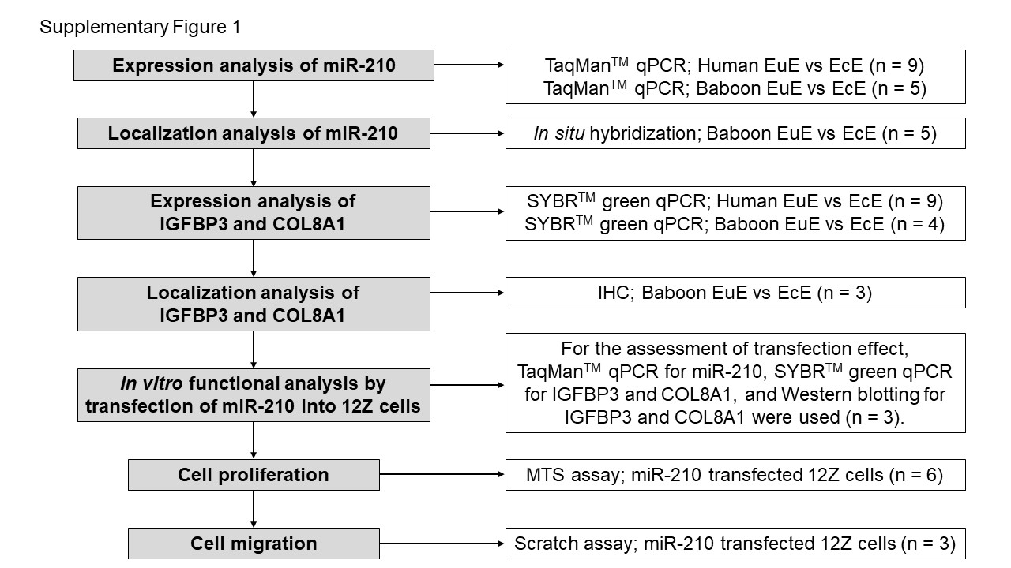

Supplementary Figure 2. - Expression profile of HIF1A and menstrual fluctuation of miR-210
RT-qPCR analysis showed that the expression of HIF1A significantly decreased in ectopic endometrium (EcE) compared with eutopic endometrium (EuE) in the baboons (n = 5, biological replicate) 15 months (15M) after endometriosis (Eosis) induction. (B) Expression of miR-210 is significantly higher in the mid-secretory phase than in the proliferative phase in baboons (n = 5, biological replicate) 15M after Eosis induction. Mean (SD) is shown. Student’s t-test. *P < 0.05; **P < 0.01. RT-qPCR, quantitative reverse transcript polymerase chain reaction; SD, standard deviation.
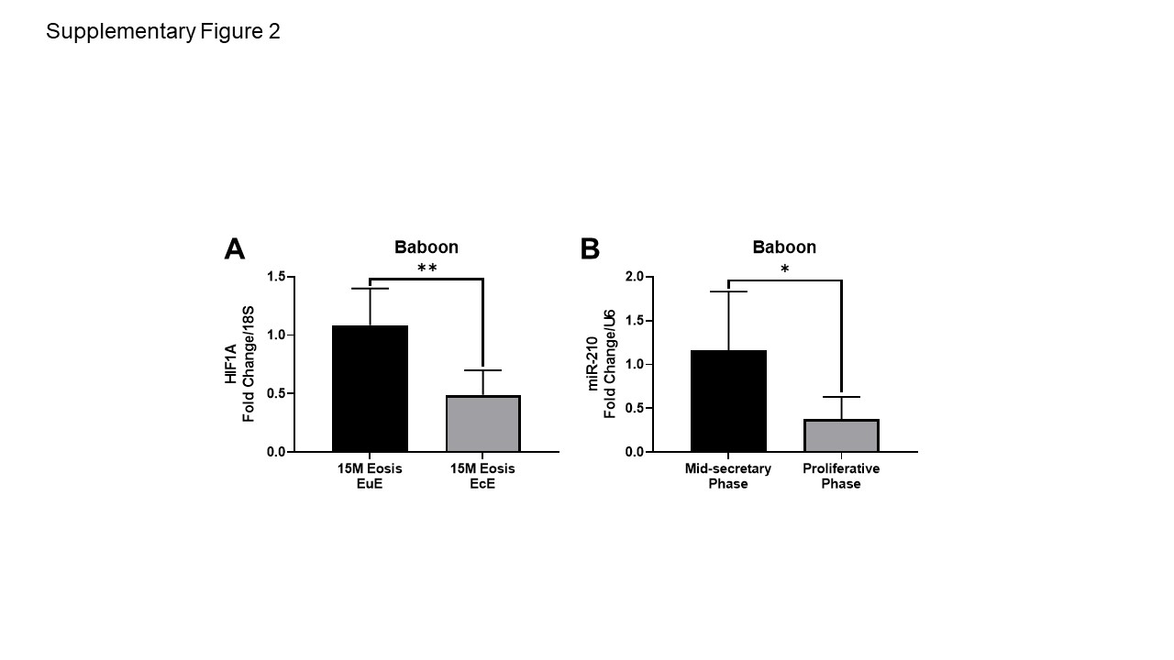

Supplementary Figure 3.- In silico analysis of miR-210 family targets
