Successful Live Birth Outcome in A Patient with Empty Follicle Syndrome：
A Case Report and Literature Review

Figure 1
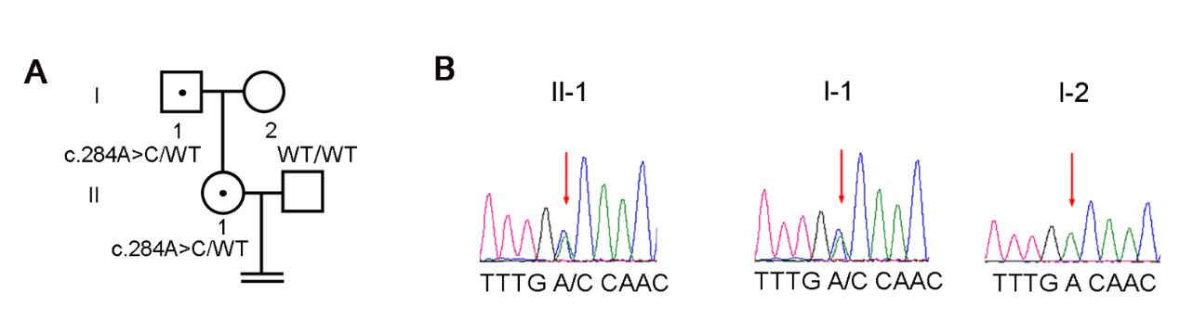
Figure 1 Mutation and sequence analysis of LHCGR. (A) Pedigrees of this family ,WT indicates a normal allele , black spot indicates carrier. (B)Sanger sequencing chromatograms are shown near the pedigrees. The patient had a single heterozygous missense mutation in the LHCGR gene, inherited from the father.

Figure 2-7 Cycle1-6
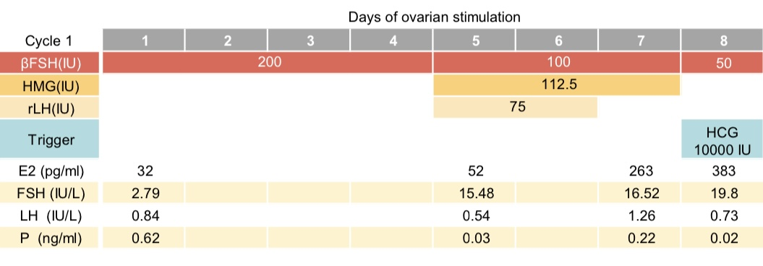
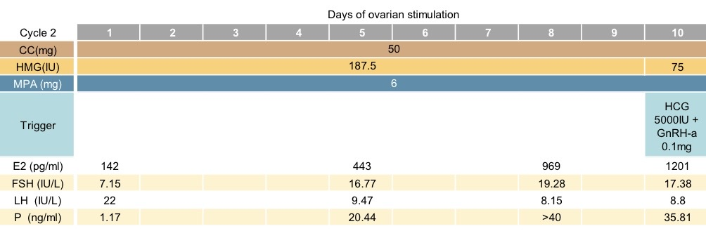
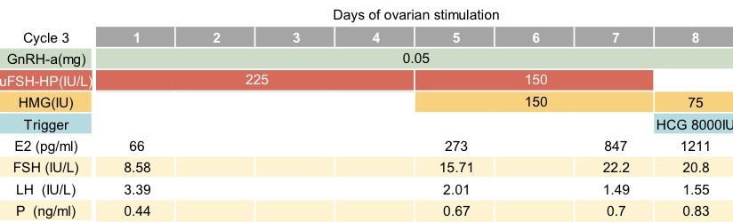
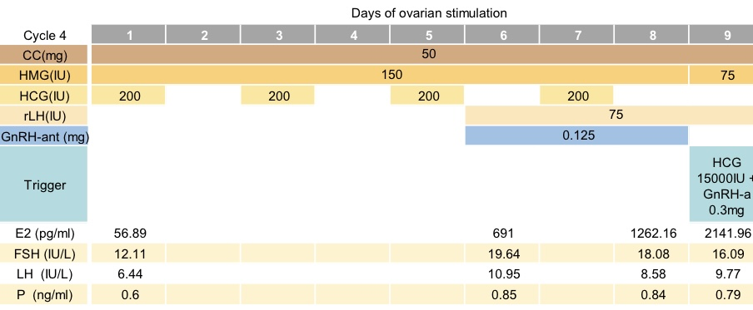
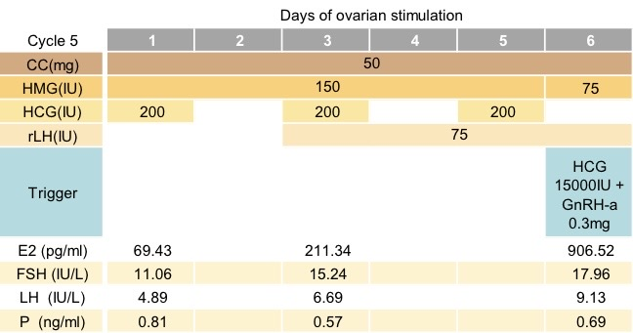
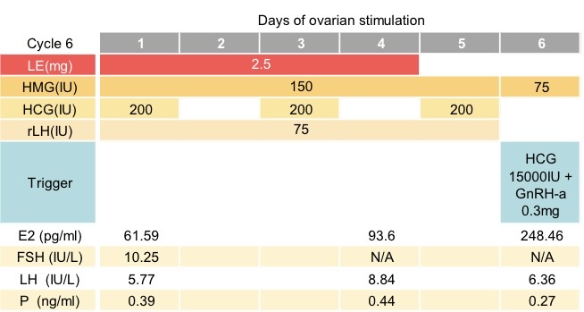

Figure 2-7 Diagram of ovarian hyperstimulation cycles. βFSH = recombinant follicle-stimulating hormone β; HMG = human menopausal gonadotropin; uFSH-HP=urofollitropin follicle-stimulating hormone, highly purified；rLH= recombinant luteinizing hormone ;GnRH-ant= Gonadotropin-releasinghormone antagonist; GnRH-a=Gonadotropin-releasing hormone agonist; LE=Letrozole; hCG = human chorionic gonadotropin; MPA =medroxyprogesterone acetate; E2=estradiol; FSH=follicle stimulatinghormone; LH=luteinizing hormone; P=Progesterone;

Table 1 Case reports and series of empty follicle syndrome
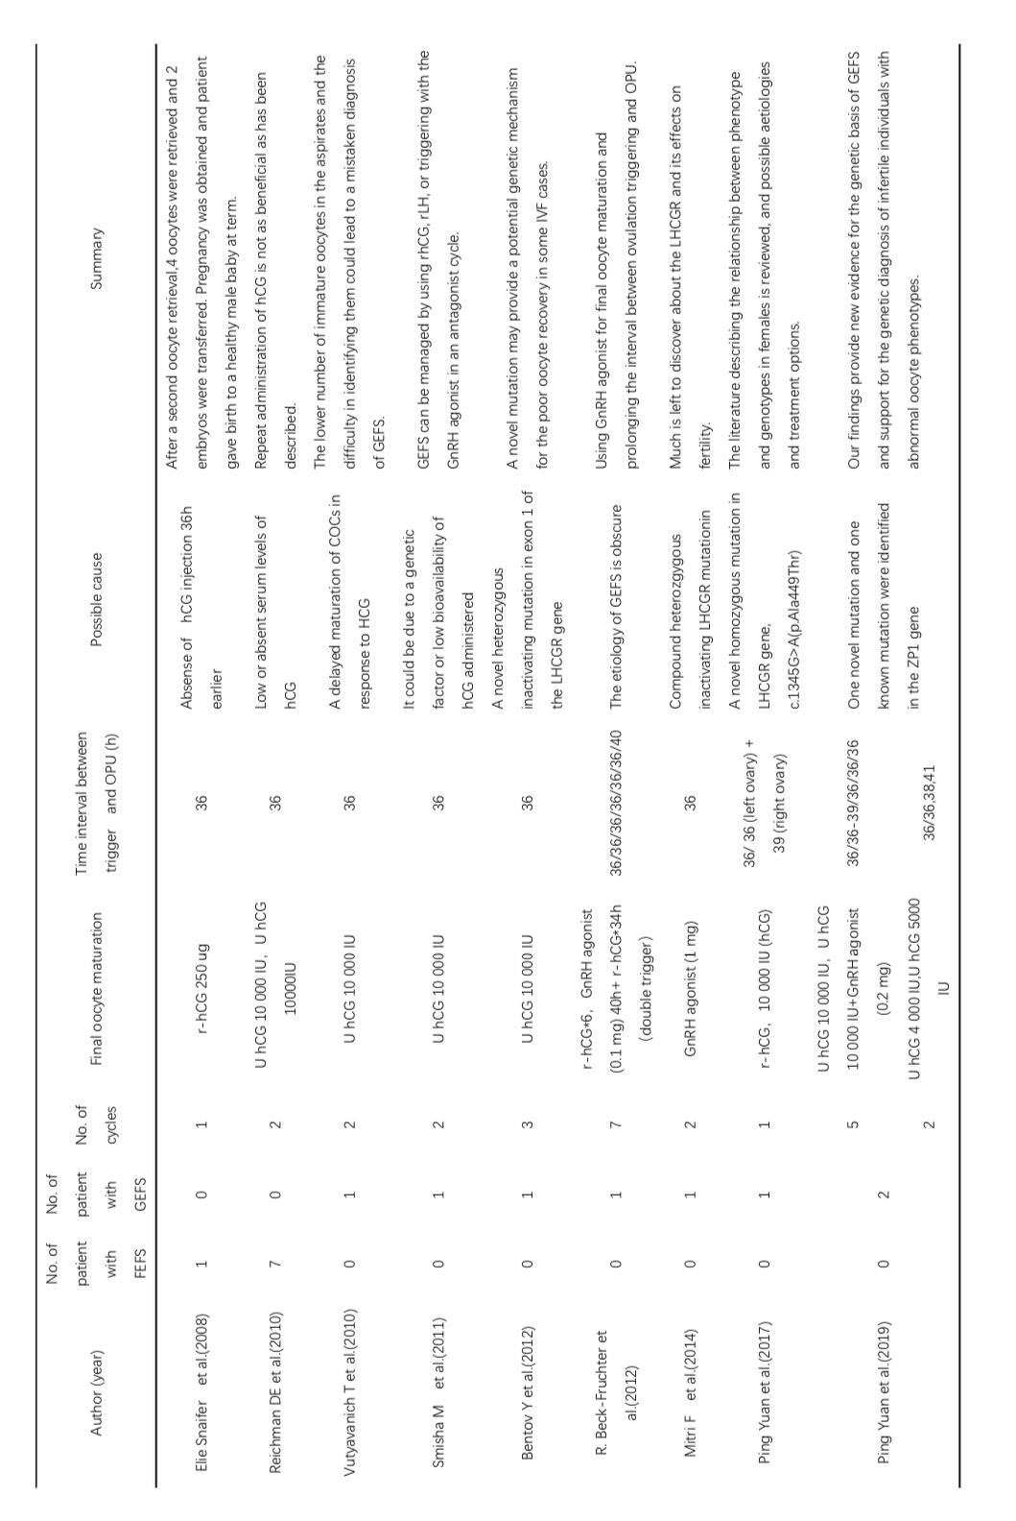
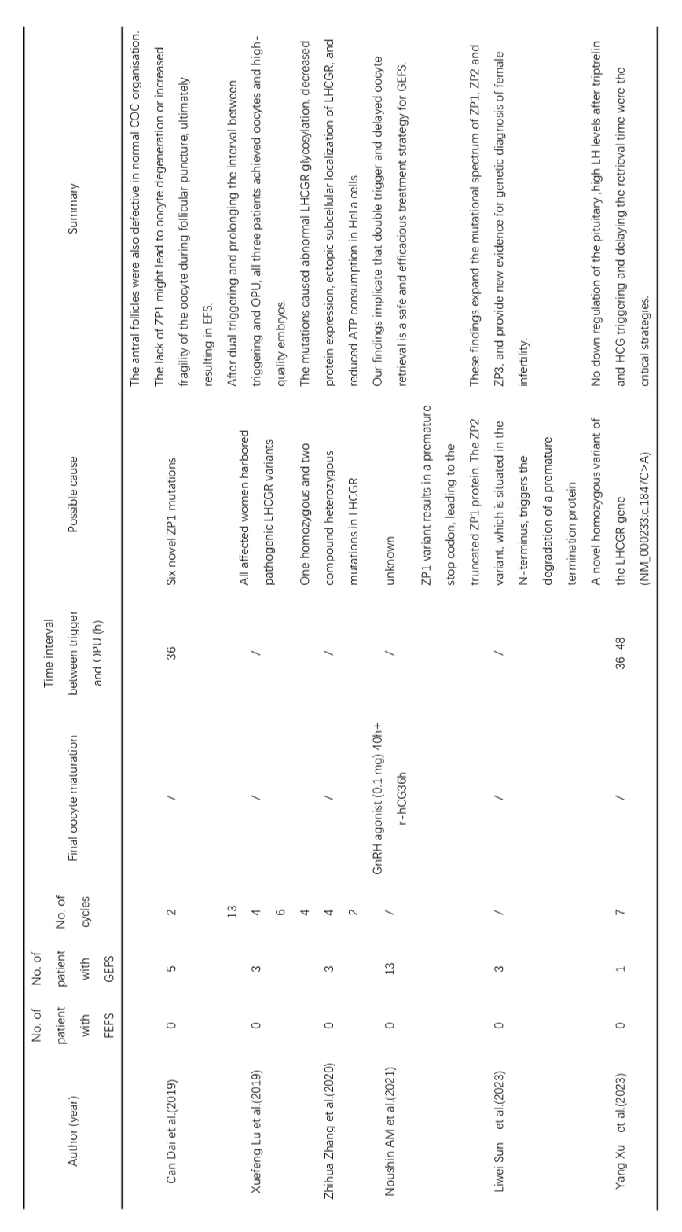
OPU：ovum pick up

Table 2 Details of the stimulation cycles
Cycle | protocol |  | FSH | rLH | HCG | Gn days | Trigger drug | Time from trigger to egg retrieval | Number of eggs obtained
 | GnRH agonist | 1437.5 |  | 150 | 0 | 7 | HCG10000IU | 36 | 0
 | Luteal-phase | 1687.5 |  | 0 | 0 | 9 | HCG5000IU+  GnRHa0.1mg | 36 | 0
 | GnRH agonist | 1800 |  | 0 | 0 | 7 | HCG8000IU | 36 | 1
 | Microstimulation | 1200 |  | 300 | 800 | 8 | HCG15000IU+GnRHa0.3mg | 40 | 4
 | Microstimulation | 750 |  | 300 | 600 | 5 | HCG15000IU+  GnRHa0.3mg | 42 | 3
 | Microstimulation | 750 |  | 375 | 600 | 5 | HCG15000IU+  GnRHa0.3mg | 42 | 1
FSH= follicle-stimulating hormone ；rLH= recombinant luteinizing hormone ；HCG = human chorionic gonadotropin

