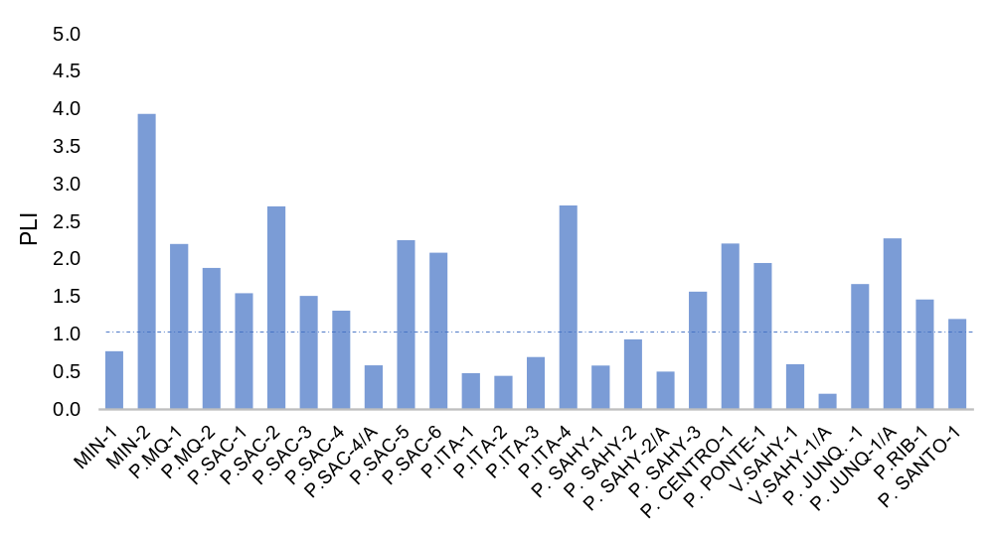A
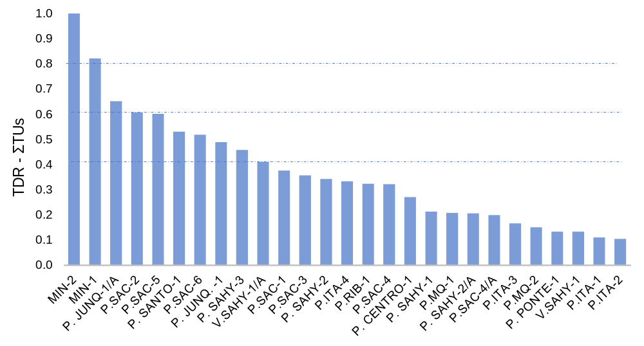B
Figure S1. A. PLI and B. TDR-ΣTUs values in the studied sites (see the map in Fig. 12; and location in Table 1).

