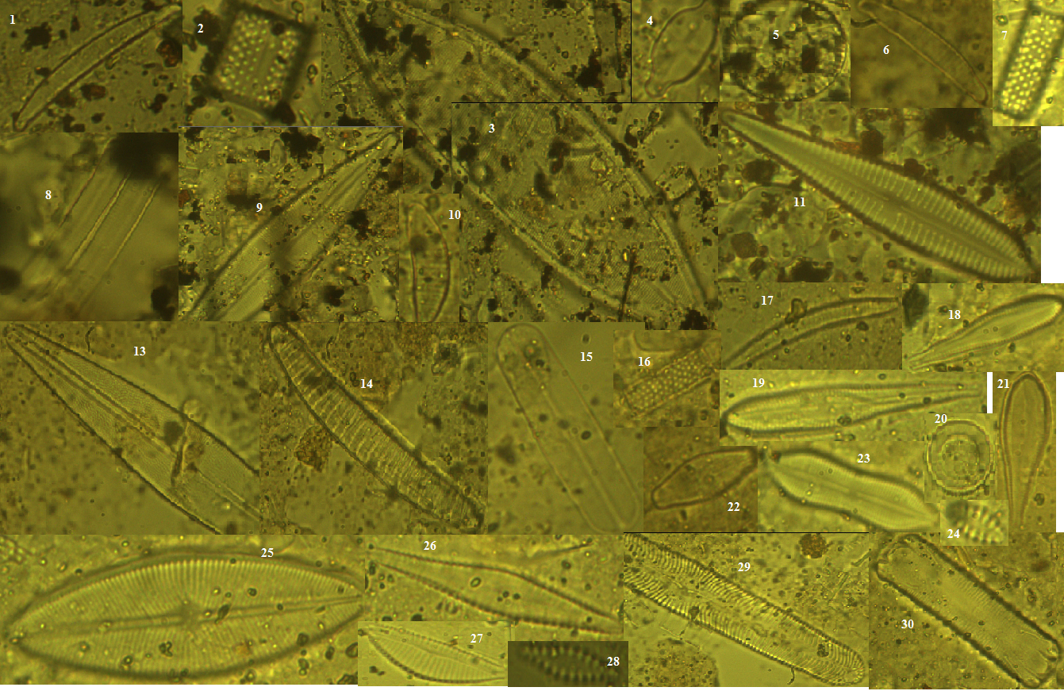

Appendix 1. Photomicrographs of dominant diatom taxa from Lakes Ossa, Simbock, and Ngaoundaba: 1, 6. Eunotia incisa; 2, 16, 7. Aulacoseira granulata ; 3. Neidium iridis; 4. Navicula humerosa; 5, 20. Aulacoseira ambigua ; 8. Fragilaria virescens ; 9. Stauroneis phoenicenteron ; 10. Eunotia minor; 11. Gomphonema augur var. turris ; 13. Frustulia rhomboides; 14. Eunotia glacialis; 15. Navicula americana; 17. Eunotia arcus; 18, 19. Gomphonema parvulum; 22. Cymbella tumida ; 23. Navicula seminuloides ;
24, 28. Fragilaria pinnata ; 25. Navicula amphicola ; 26. Gomphonema gracile var. naviculiformis ; 27. Cymbella pusilla Grunow ; 29. Pinnularia gibba ; 30. Eunotia tenella

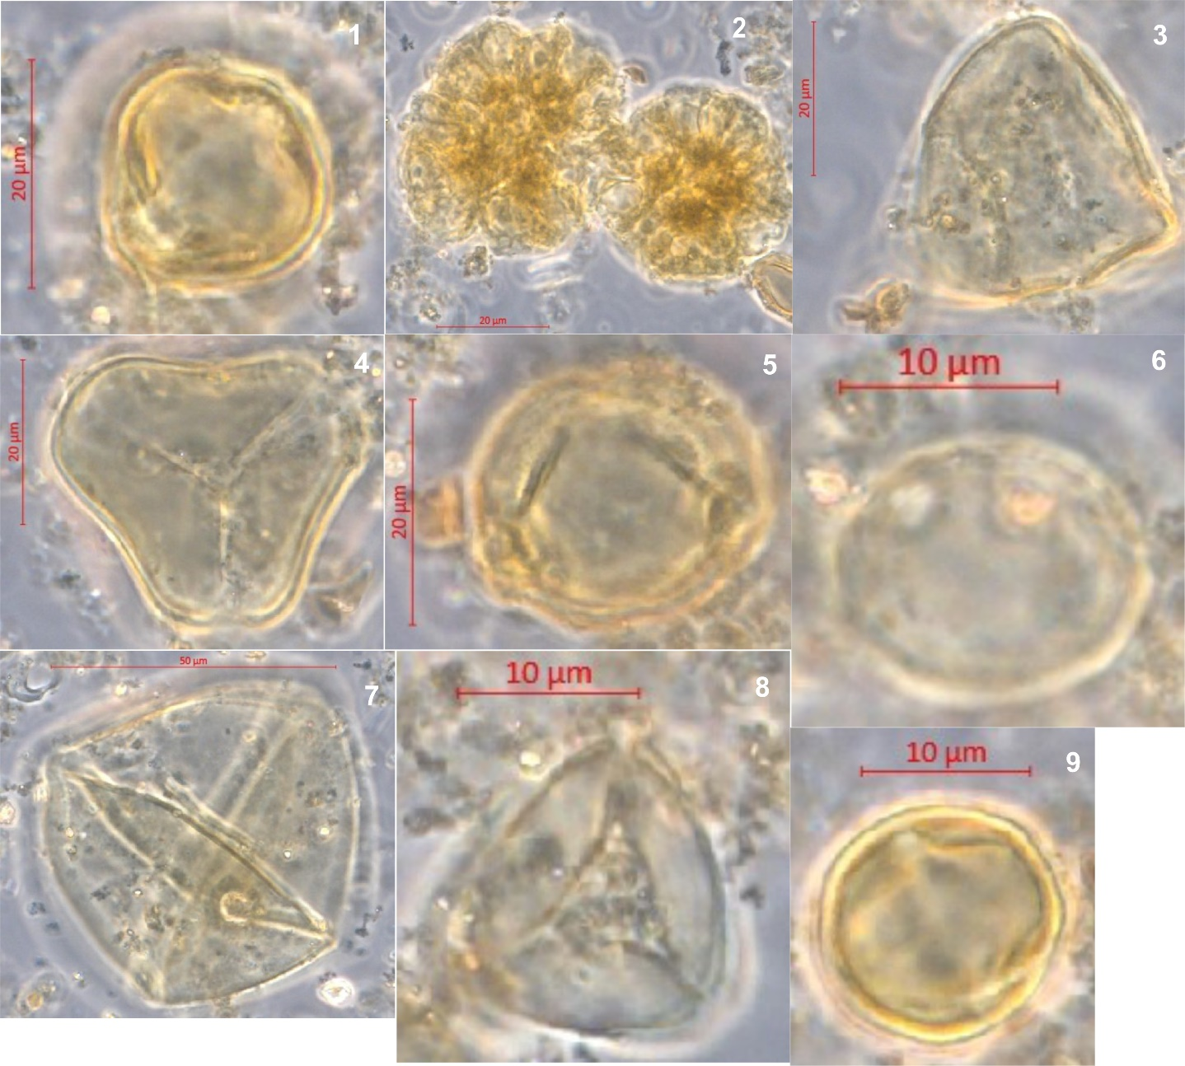
Appendix 2. 1) Alchornea; 2) Botryococcus; 3) Cyperaceae; 4) Elaeis guineensis; 5) Macaranga; 6) Martretia; 7) Musanga; 8) Poaceae and 9) Syzygium

