Appendix
Figure A1 Current Account Balance in % GDP. 1975-2020
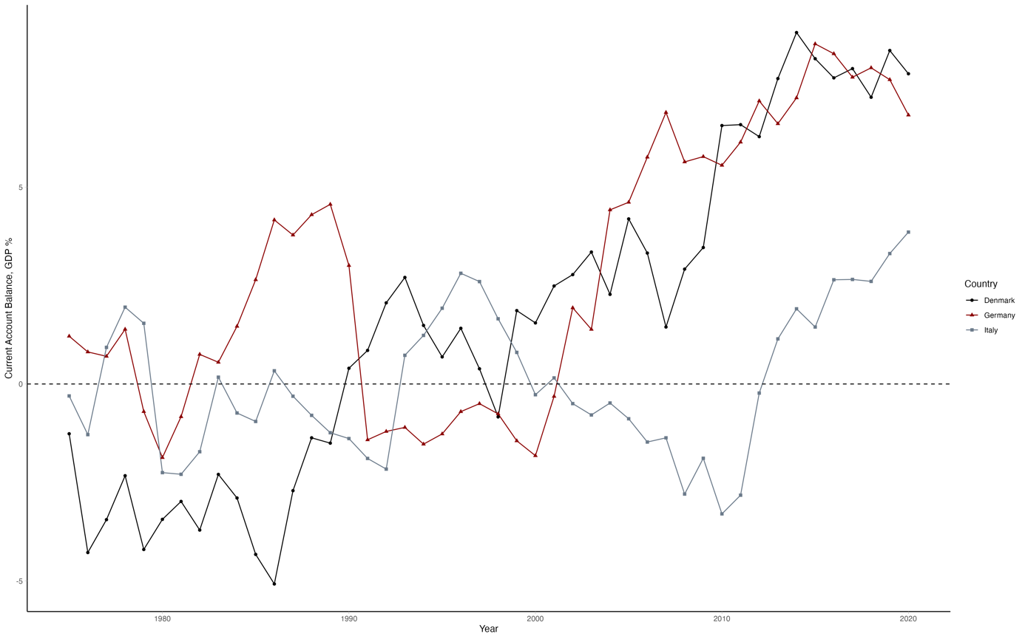Source: Own elaboration based on OECD data.

Figure A2 Export of Goods in % GDP. 1975-2020
Source: Own elaboration based on UNCTAD data.

Figure A3 REER (CPI-based) of Denmark, Italy and Germany against 65 trading partners, 1960-2020
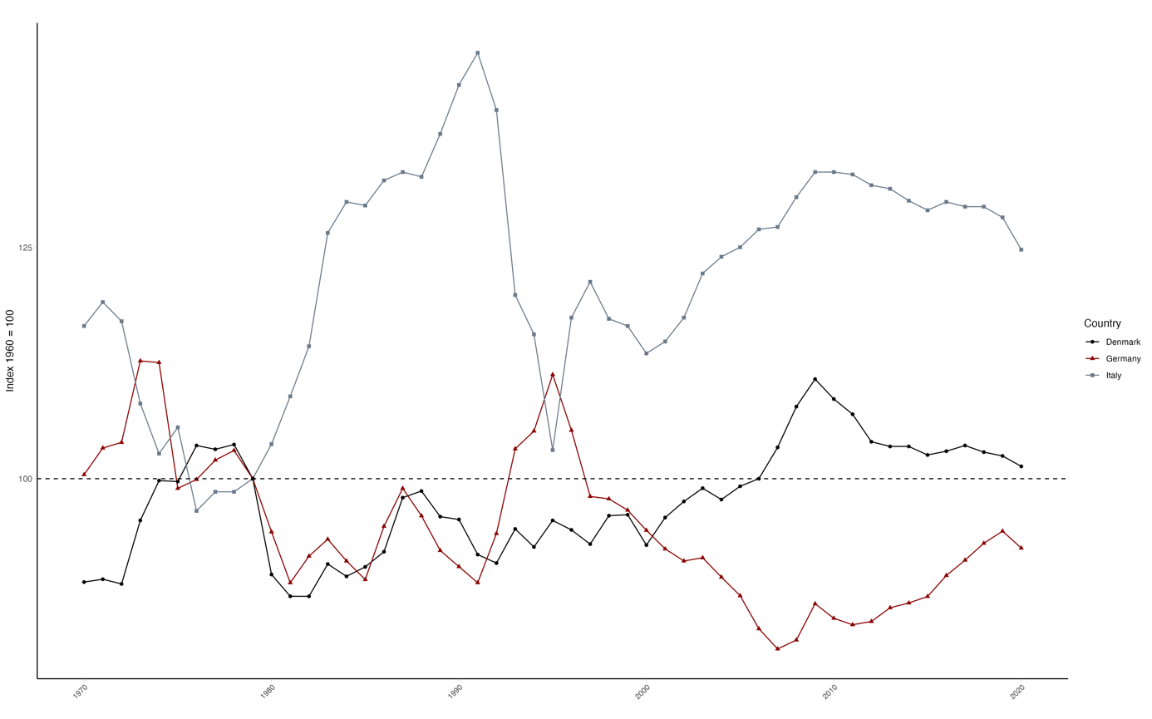
Source: Own calculations based on Bruegel (Darvas, 2012).

Figure A4 REER of Denmark, Italy and Germany against EU-15, 1979-2002
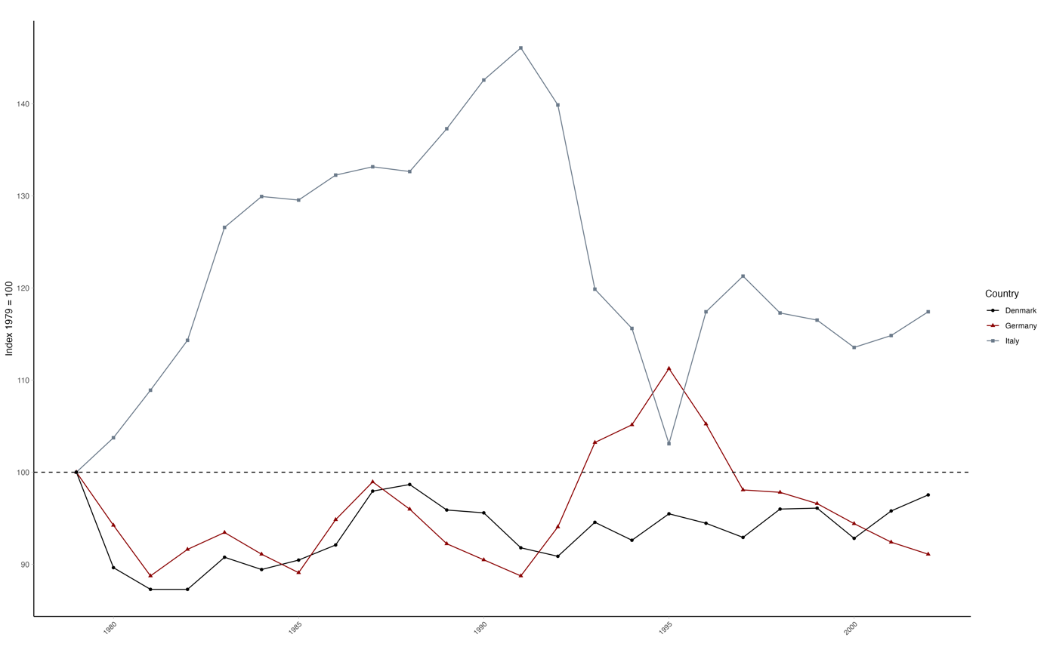
Source: Own calculations based on Ameco.

Figure A5 REER Rate (CPI-based) of Germany and the United States against 65 trading partners, 1960-2020
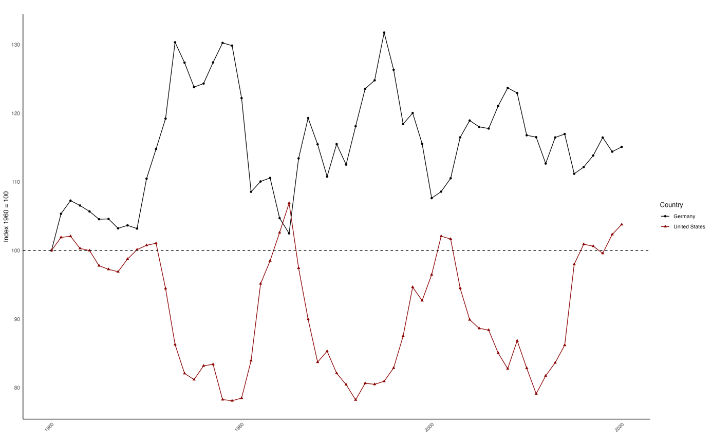Source: Own calculations based on Bruegel (Darvas, 2012).

Table A1: Average Growth Contributions, 1979-2003
Period | Country | Exports | Domestic Consumption |  | Total Growth | Share of Total Growth
 |  |  | Household | Public |  | Exports | Household | Public
1979-1984 | Germany | 0.52% | 0.64% | 0.38% | 1.53% | 34% | 42% | 25%
1979-1984 | Italy | -0.19% | 1.62% | 0.58% | 2.01% | -9% | 80% | 29%
1979-1984 | Denmark | 0.98% | 0.36% | 0.59% | 1.93% | 51% | 19% | 30%
1985-1989 | Germany | 0.11% | 1.67% | 0.13% | 1.92% | 6% | 87% | 7%
1985-1989 | Italy | -0.36% | 2.16% | 0.66% | 2.46% | -15% | 88% | 27%
1985-1989 | Denmark | 0.24% | 0.82% | 0.14% | 1.20% | 20% | 68% | 12%
1990-1993 | Germany | 0.21% | 1.62% | 0.51% | 2.34% | 9% | 69% | 22%
1990-1993 | Italy | 0.55% | 0.48% | 0.30% | 1.33% | 42% | 36% | 22%
1990-1993 | Denmark | 0.81% | 0.50% | 0.30% | 1.61% | 50% | 31% | 19%
1994-1998 | Germany | 0.14% | 0.78% | 0.43% | 1.35% | 11% | 57% | 32%
1994-1998 | Italy | -0.02% | 1.29% | -0.09% | 1.17% | -2% | 110% | -8%
1994-1998 | Denmark | -0.42% | 1.57% | 0.52% | 1.67% | -25% | 94% | 31%
1999-2002 | Germany | 0.81% | 0.58% | 0.22% | 1.60% | 50% | 36% | 14%
1999-2002 | Italy | -0.39% | 0.91% | 0.52% | 1.04% | -38% | 88% | 50%
1999-2002 | Denmark | 1.10% | 0.22% | 0.61% | 1.93% | 57% | 11% | 31%
Note: Table summarizes average growth contributions of Germany, Italy and Denmark in the early post-Fordist era. The analysis focuses on the period of initial turmoil under the EMS (1979-1984), the system’s relative stabilization (1985-1989) and subsequent three stages accompanying the foundation of the EMU (1990-1993; 1994-1998; 1999-2002) as laid out in the Delors report. Until 1991, Germany represents former territory of West Germany (Federal Republic of Germany). Exports encompass net exports (exports minus imports), domestic consumption is divided into private (household) final consumption expenditure and public (government) final consumption expenditure and the total growth rates are sums of net export and domestic consumption contributions to the growth. Gross capital formation contributions are omitted from this analysis. The average annual growths calculated over five periods. The values for 1979-1984, for instance, are the averages of 1979-1980, 1980-1981, 1981-1982, 1982-1983, 1983-1984.
Source: Ameco Database.

Table A2. Selected macroeconomic variables, 1980s-2000s
Period | Country | GDP growth | Unemployment | Inflation | Interest rates | Primary balance  (% of GDP) |  | ULC growth | Labour productivity
1980s | Germany | 1,96 | 6,17 | 2,90 | 7,65 | - | 2,37 |  | 1,05
1980s | Italy | 2,55 | 8,12 | 11,20 | 14,82 | -3,75 | 10,86 |  | 1,99
1980s | Denmark | 1,91 | 7,01 | 6,91 | 14,31 | 1,01 | 5,91 |  | 1,48
1990s | Germany | 2,17 | 7,84 | 2,56 | 6,62 | -0,85 | 2,18 |  | 1,68
1990s | Italy | 1,51 | 10,22 | 4,16 | 9,99 | 2,35 | 3,33 |  | 1,36
1990s | Denmark | 2,45 | 7,36 | 2,11 | 7,56 | 1,38 | 1,24 |  | 2,07
2000s | Germany | 0,77 | 8,96 | 1,59 | 4,15 | 0,12 | 0,40 |  | 0,46
2000s | Italy | 0,54 | 7,96 | 2,27 | 4,54 | 1,60 | 2,94 |  | -0,42
2000s | Denmark | 0,98 | 4,97 | 2,11 | 4,38 | 3,64 | 2,96 |  | 0,44
Source: Own elaboration based on OECD data.

Table A3: Value added share in total economy across main industries, 1985-2018
 |  |  |  | Value added share (total economy)
Period | Country | Agriculture | Manufacturing |  | Construction | FIIRE | Public | Total services
1985-1990 | Germany | - | - |  | - | - | - | -
1985-1990 | Denmark | 1.00 | 16.38 |  | 6.87 | 17.94 | 25.57 | 69.49
1985-1990 | Italy | 2.31 | 17.98 |  | 7.57 | - | 19.61 | 68.10
1991-2000 | Germany | 1.03 | 21.70 |  | 7.70 | 19.37 | 18.92 | 66.98
1991-2000 | Denmark | 1.25 | 15.30 |  | 5.36 | 17.21 | 23.28 | 70.34
1991-2000 | Italy | 2.35 | 17.91 |  | 6.57 | 20.61 | 18.48 | 69.00
2001-2008 | Germany | 0.85 | 21.77 |  | 5.16 | 19.86 | 18.23 | 69.73
2001-2008 | Denmark | 1.20 | 14.45 |  | 5.15 | 18.46 | 21.60 | 72.00
2001-2008 | Italy | 2.12 | 17.06 |  | 6.55 | 20.79 | 17.02 | 70.66
2009-2018 | Germany | 0.80 | 22.22 |  | 4.63 | 19.95 | 18.29 | 69.37
2009-2018 | Denmark | 1.07 | 14.30 |  | 4.81 | 20.98 | 22.09 | 75.37
2009-2018 | Italy | 2.21 | 15.91 |  | 4.93 | 22.70 | 16.95 | 73.81
Note: FIIRE comprises financial and insurance activities (K). information and communication (J) and real estate (L) using ISIC Rev. 4 classification. The reported values represent period averages using yearly shares.
Source: Own elaboration based on OECD STAN structural indicators (2022 ed.).

Table A4: Employment share in total economy across main industries, 1985-2018
 |  |  |  | Employment share (total economy)
Period | Country | Agriculture | Manufacturing |  | Construction | FIIRE | Public | Total services
1985-1990 | Germany | - | - |  | - | - | - | -
1985-1990 | Denmark | 5.81 | 17.50 |  | 6.78 | 6.61 | 29.05 | 68.83
1985-1990 | Italy | 8.43 | 22.77 |  | 6.75 | 4.70 | 19.38 | 60.71
1991-2000 | Germany | 2.31 | 21.64 |  | 8.01 | 6.74 | 22.29 | 66.09
1991-2000 | Denmark | 4.12 | 15.90 |  | 6.11 | 6.87 | 30.55 | 72.77
1991-2000 | Italy | 5.69 | 20.95 |  | 6.57 | 5.45 | 20.13 | 65.51
2001-2008 | Germany | 1.74 | 18.72 |  | 6.02 | 7.25 | 23.38 | 72.06
2001-2008 | Denmark | 2.83 | 13.15 |  | 6.67 | 7.56 | 30.50 | 76.44
2001-2008 | Italy | 4.13 | 18.68 |  | 7.33 | 5.82 | 19.29 | 68.61
2009-2018 | Germany | 1.49 | 17.45 |  | 5.65 | 6.74 | 24.20 | 74.05
2009-2018 | Denmark | 2.49 | 10.20 |  | 6.10 | 7.94 | 31.40 | 80.28
2009-2018 | Italy | 3.74 | 16.15 |  | 6.80 | 5.81 | 18.98 | 72.03
Note: FIIRE comprises financial and insurance activities (K). information and communication (J) and real estate (L) using ISIC Rev. 4 classification. The reported values represent period averages using yearly shares.
Source: Own elaboration based on OECD STAN structural indicators (2022 ed.).

Table A5: Exports of Manufactured Goods by Degree of Manufacturing, 1995-2018
 |  |  | Capital-intensive
Period | Country | Labour-intensive | Low-skill | Medium-skill | High-skill
1995-2000 | Germany | 10.82 | 8.65 | 48.82 | 31.71
1995-2000 | Denmark | 20.91 | 10.57 | 35.46 | 33.05
1995-2000 | Italy | 28.99 | 10.47 | 39.46 | 21.08
2001-2008 | Germany | 9.02 | 8.93 | 49.16 | 32.89
2001-2008 | Denmark | 17.78 | 10.90 | 36.85 | 34.47
2001-2008 | Italy | 25.18 | 12.40 | 40.60 | 21.82
2009-2018 | Germany | 8.30 | 8.87 | 49.32 | 33.51
2009-2018 | Denmark | 14.88 | 11.04 | 37.53 | 36.56
2009-2018 | Italy | 22.01 | 12.63 | 41.42 | 23.94
Source: Own elaboration based on UNCTAD data.

Table A6. Chronology of the European Joint Float
Year | Date | Country | Action
1972 | 24 April | Belgium, France, Germany, Italy, Luxembourg and the Netherlands partake | Basle Agreement enters into force
1972 | 1 May | The United Kingdom and Denmark | Join
1972 | 23 May | Norway | Joins
1972 | 23 June | The United Kingdom | Withdraws
1972 | 27 June | Denmark | Withdraws
1972 | 10 October | Denmark | Returns
1973 | 13 February | Italy | Withdraws
1973 | 19 March | All  Sweden  Germany | Withdraws  Transition to the joint float, interventions to maintain fixed margins against the dollar (Smithsonian tunnel) are discontinued  Joins  Revaluation by 3 per cent
1973 | 29 June | Germany | Revaluation by 5.5 per cent
1973 | 17 September | The Netherlands | Revaluation by 5 per cent
1973 | 16 November | Norway | Revaluation by 5 per cent
1974 | 19 January | France | Withdraws
1975 | 10 July | France | Returns
1976 | 15 March | France | Withdraws again
1976 | 17 October¹ | Denmark  The Netherlands  Belgium  Norway  Sweden | Devaluation by 6 per cent  Devaluation by 2 per cent  Devaluation by 2 per cent  Devaluation by 3 per cent  Devaluation by 3 per cent
1977 | 1 April | Sweden  Denmark  Norway | Devaluation by 6 per cent  Devaluation by 3 per cent  Devaluation by 3 per cent
1977 | 28 August | Sweden  Denmark  Norway | Withdraws  Devaluation by 5 per cent  Devaluation by 5 per cent
1978 | 13 February | Norway | Devaluation 8 per cent
1978 | 17 October | Germany  The Netherlands  Belgium | Revaluation by 4 per cent  Revaluation by 2 per cent  Revaluation by 2 per cent
1978 | 12 December | Norway | Withdraws
^{1 “}Frankfurt realignment”
Source: Own elaboration based on European Commission (2005).

Table A7: Currency Realignments within the EMS, 1979-1993
 | BF | DK | FF | DM | DG | IP | IL | LF | PE | SP | ECU
24/09/1979 |  | -3.0 |  | +2.0
30/11/1979 |  | -5.0
22/03/1981 |  |  |  |  |  |  | -6.0 |  |  |  | +2.54
4/10/1981 |  |  | -3.0 | +5.5 | +5.5 |  | -3.0
21/02/1982 | -8.5 | -3.0 |  |  |  |  |  | -8.5
12/06/1982 |  |  | -5.75 | +4.25 | +4.25 |  | -2.75
21/03/1983 | +1.5 | +2.5 | -2.5 | +5.5 | +3.5 | -3.5 | -2.5 | +1.5
17/05/1983 |  |  |  |  |  |  |  |  |  |  | +1.2
20/07/1985 | +2.0 | +2.0 | +2.0 | +2.0 | +2.0 | +2.0 | -6.0 | +2.0
6/04/1986 | +1.0 | +1.0 | -3.0 | +3.0 | +3.0 |  |  | +1.0
2/08/1986 |  |  |  |  |  | -8.0
12/01/1987 | +2.0 |  |  | +3.0 | +3.0 |  |  | +2.0
8/01/1990 |  |  |  |  |  |  | -3.7
14/09/1992 | +3.5 | +3.5 | +3.5 | +3.5 | +3.5 | +3.5 | -3.5 | +3.5 | +3.5 | +3.5
17/09/1992 |  |  |  |  |  |  |  |  |  | -5.0
22 /11/1992 |  |  |  |  |  |  |  |  | -6.0 | -6.0
30 /01/1993 |  |  |  |  |  | -10.0
14/05/1993 |  |  |  |  |  |  |  |  | -6.5 | -8.0
07/03/1995 |  |  |  |  |  |  |  |  | -3.6 | -7.0
∑ Cumulative | +1.5 | -2 | -8.75 | 28.75 | 24.75 | -16 | -27.45 | 1.5 | -12.6 | -22.5 | 3.74
Description: Realignments in %. ECU: realignments against all the EMS currencies; BF: Belgian franc, DK: Danish krone, FF: French franc, DM: German mark, DG: Dutch guilder, IP: Irish pound, IL: Italian lira, LF: Luxembourg franc; PE: Portuguese escudo and SP: Spanish peseta.
Source: Own elaboration based on European Commission (2005).

Table A8. Member States’ participation in various stages of the EMS since 1979
Member State’s Currency | VSTF/STMS | ERM | ECU basket
Belgian franc | Yes | ±2.25% margins* | Yes
Danish krone | Yes | ±2.25% margins* | Yes
Deutsche mark | Yes | ±2.25% margins** | Yes
Greek drachma | Yes (since 1/1986) | No | Yes (since 1/1984)
Spanish peseta | Yes (since 5/1987) | ±6% margins (since 6/1989) * | Yes (since 6/1989)
French franc | Yes | ±2.25% margins* | Yes
Irish pound | Yes | ±2.25% margins* | Yes
Italian Lira | Yes | ±6% margins (until 1/1990)  ±2.25% margins (until 1/1990)  No from 9/1992 to 11/1996  ±15% margins (since 11/1996) | Yes
Luxembourg franc | Yes | ±2.25% margins* | Yes
Dutch guilder | Yes | ±2.25% margins** | Yes
Austrian shilling | Yes (since 1/1995) | ±15% margins (since 1/1995) | No***
Portugal escudo | Yes (since 11/1997) | ±6% margins (since 4/1992) * | Yes (since 6/1989)
Finnish markka | Yes (since 2/1995) | ±15% margins (since 10/1995) | No***
Swedish krona | Yes (since 4/1995) | No | No
Pound sterling | Yes | ±6% margins (between 10/1990 and 9/1992) | Yes
* Since 2 August 1993, the bilateral margins widened to ± 15%.
** Since 2 August 1993, the bilateral margins widened to ± 15%, with the exception of the Deutsche mark/Dutch guilder exchange rate, which retained the narrow margins.
***These currencies have a weight of zero for calculation of the threshold of maximum divergence.
Source: Own elaboration based on European Commission (2005).

Table A9: Composition of the ECU basket at the outset (13 March 1979)
Currency | Weight for the ECU basket | Quantity of each currency | ECU central rate on 13.03.1979 | Weight on 13.03.1979 (%ECU)
Deutsche mark | 27.3 | 0.828 | 2.51064 | 32.89
French franc | 19.5 | 1.15 | 5.79831 | 19.83
Pound sterling | 17.5 | 0.0885 | 0.663247 | 13.34
Italian lira | 14.0 | 109.0 | 1148.15 | 9.5
Dutch guilder | 9.0 | 0.286 | 2.72077 | 10.51
Belgian franc | 7.9 | 3.66 | 39.4582 | 9.28
Danish krone | 3.0 | 0.217 | 7.08592 | 3.6
Irish punt | 1.5 | 0.00759 | 0.662638 | 1.15
Luxembourg franc | 0.3 | 0.14 | 399.4582 | 0.35
Source: Own elaboration based on European Commission (2005).

Table A10: Revisions of the Composition of the ECU basket in 1984 and 1989
Currency | Composition of the ECU basket after 17 September 1984 | 1984 weight  (% ECU) | Composition of the ECU basket after 21 September 1989 | 1989 weight  (% ECU)
Deutsche mark | 0.719 | 32.0 | 0.6242 | 30.1
French franc | 1.31 | 19.0 | 1.332 | 19.0
Pound sterling | 0.0878 | 15.0 | 0.08784 | 13.0
Italian lira | 140.0 | 10.2 | 151.8 | 10.15
Dutch guilder | 0.256 | 10.1 | 0.2198 | 9.4
Belgian franc | 3.71 | 8.2 | 3.301 | 7.6
Danish krone | 0.219 | 2.7 | 0.1976 | 2.45
Irish pound | 0.00871 | 1.2 | 0.00855 | 1.1
Luxembourg franc | 0.14 | 0.3 | 0.130 | 0.3
Greek drachma | 1.15 | 1.3 | 1.440 | 0.8
Spanish peseta | - | - | 6.885 | 5.3
Portugal escudo | - | - | 1.393 | 0.8
Source: Own elaboration based on European Commission (2005).

