Supplemental Figure S1. Direct comparison of percent change in coronal angle by rod material over ≥24 months
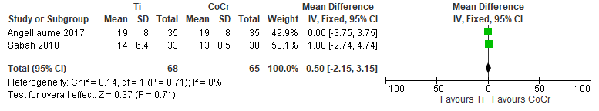

Supplemental Figure S2. Indirect comparison of percent change in coronal Cobb angle by rod material
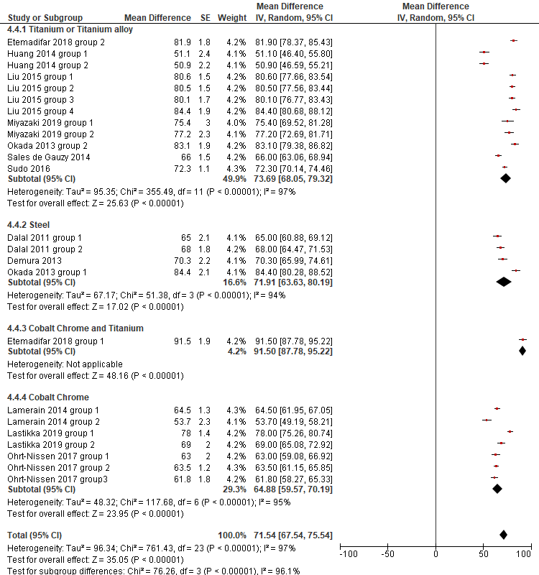

Supplemental Figure S3. Direct comparison of proximal junctional kyphosis by rod material
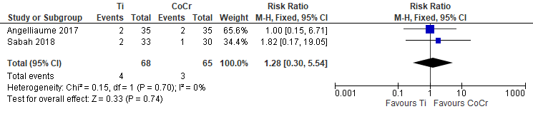

Supplemental Figure S4. Indirect comparison of proximal junction kyphosis by rod material. 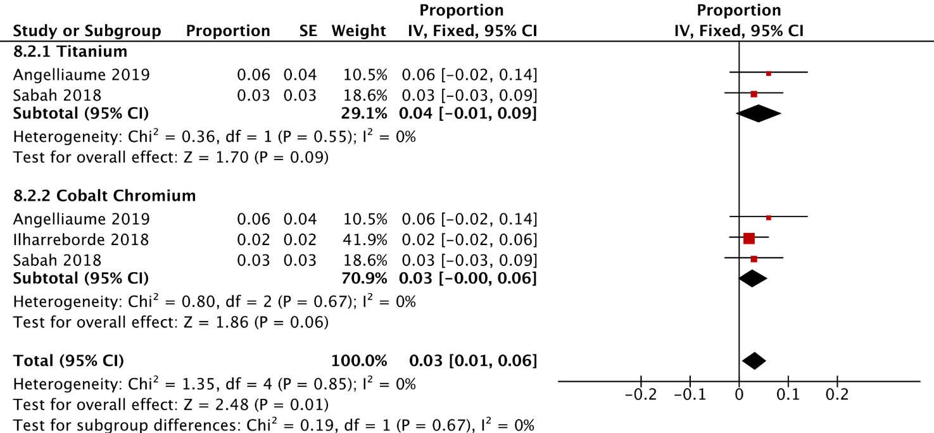

Supplemental Figure S5. Indirect comparison of revision surgery by rod material
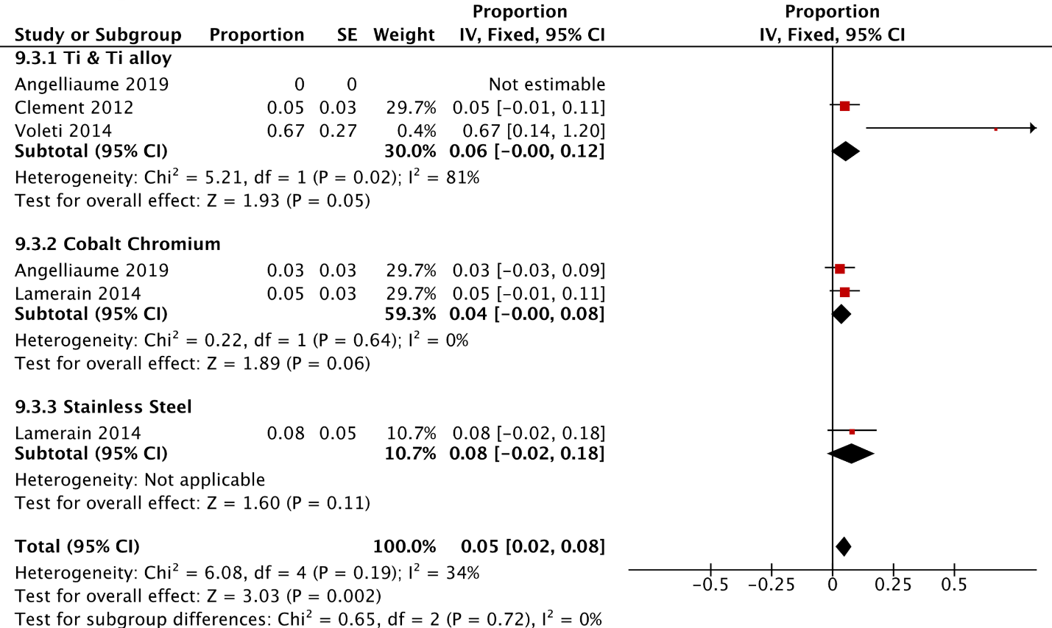

Supplemental Figure S6. Indirect comparison of reoperation by rod material
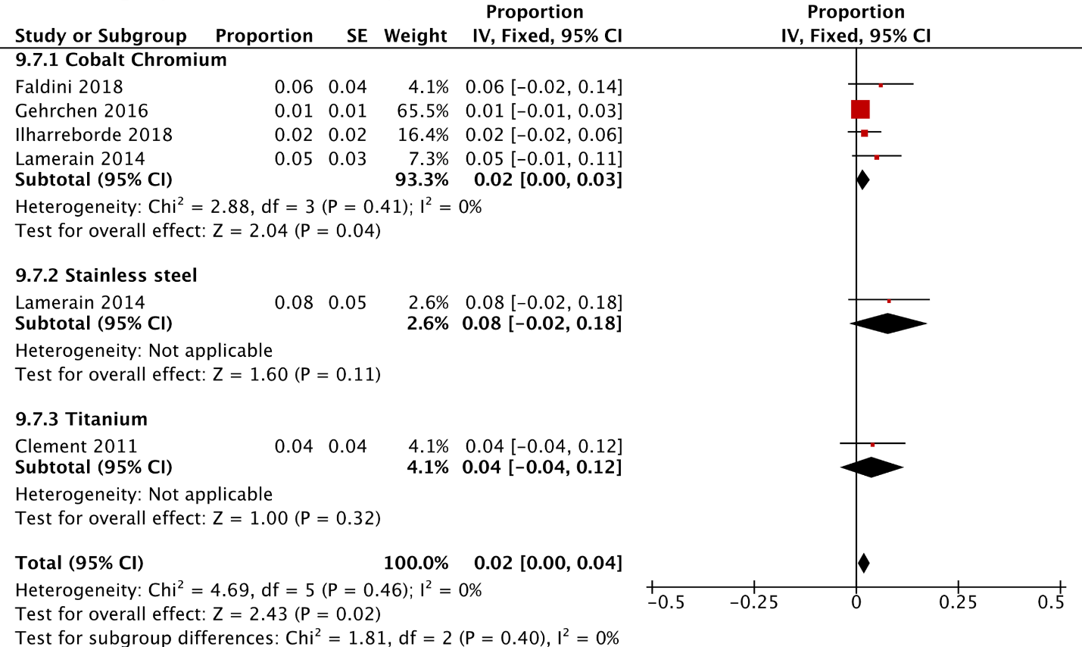

Supplemental Figure S7. Indirect comparison of infection by rod material
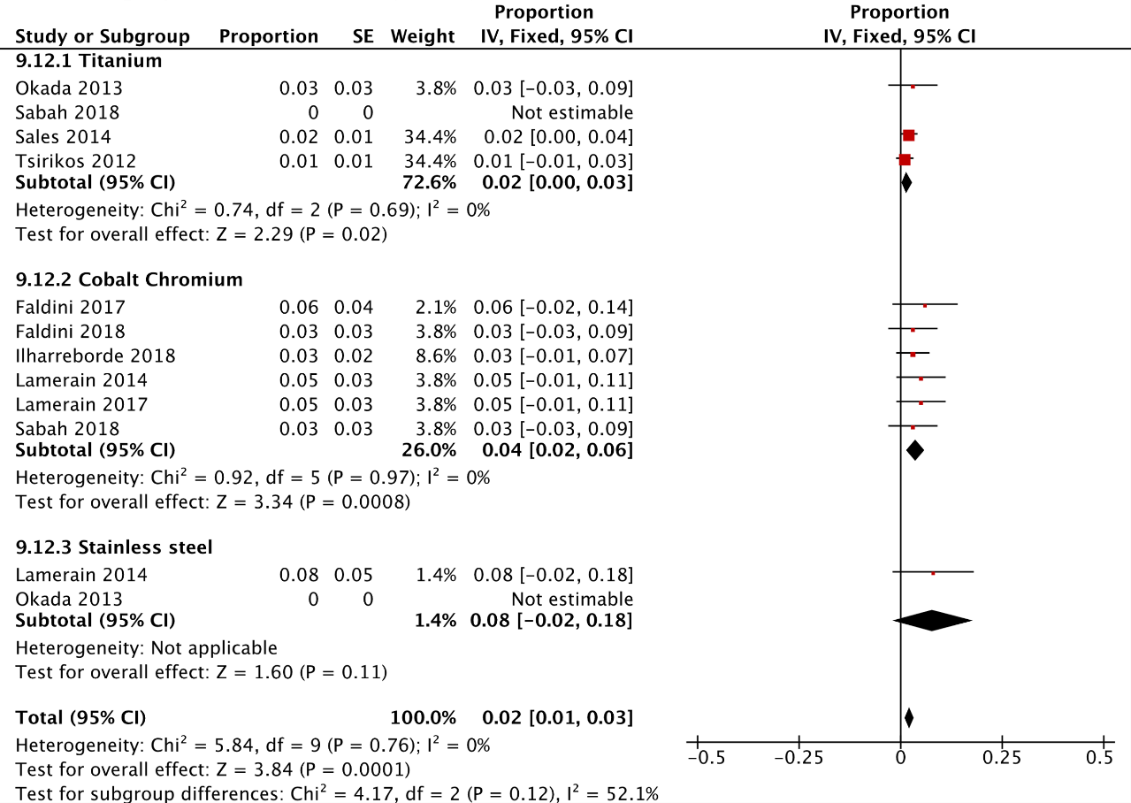

Supplemental Figure S8. Indirect comparison of kyphosis angle correction by rod diameter
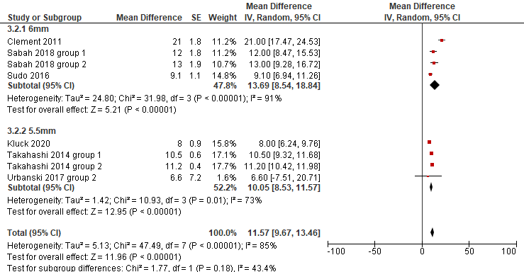

Supplemental Figure S9. Indirect comparison of percent change in coronal Cobb angle by rod diameter
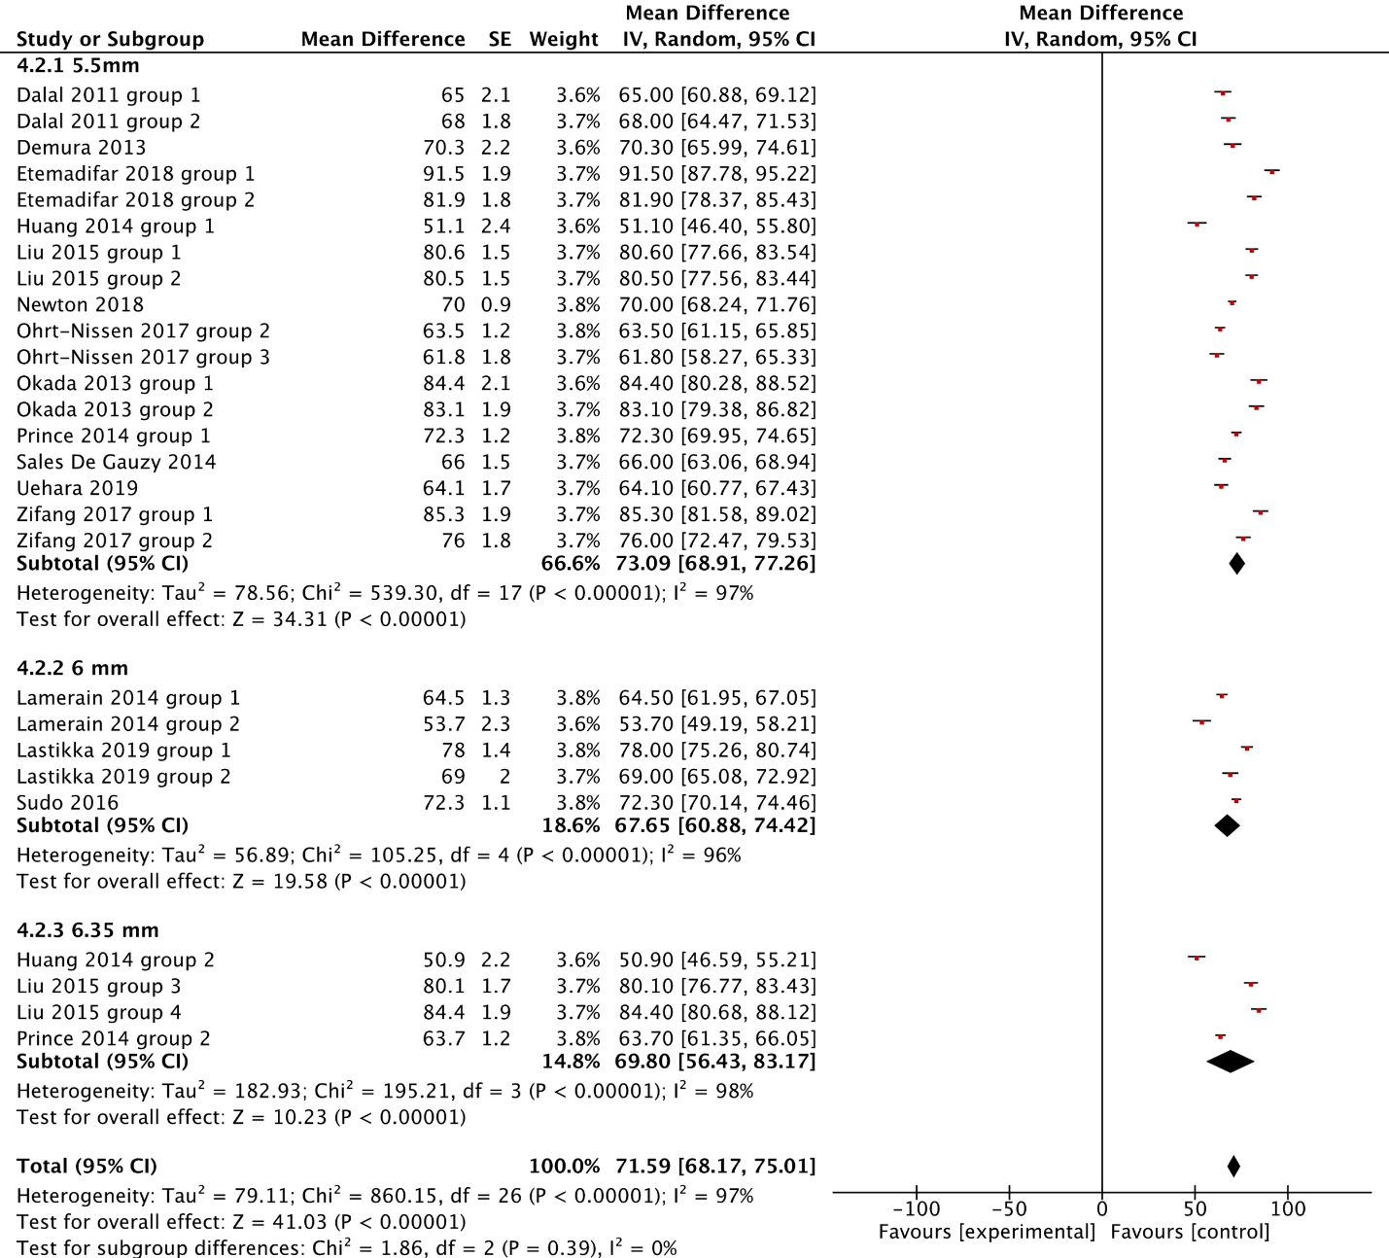

Supplemental Figure S10. Direct comparison of coronal angle correction by rod diameter
≥6 to 12 months
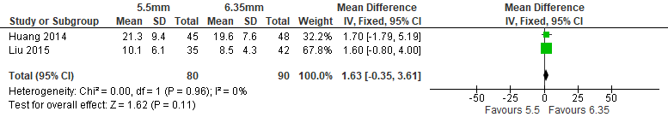
6 to 12 months
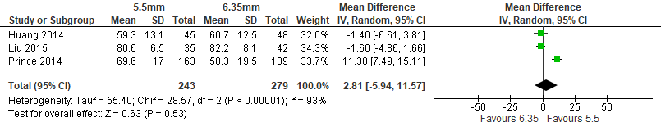

Supplemental Figure S11. Indirect comparison of change in lumbar lordosis by rod diameter
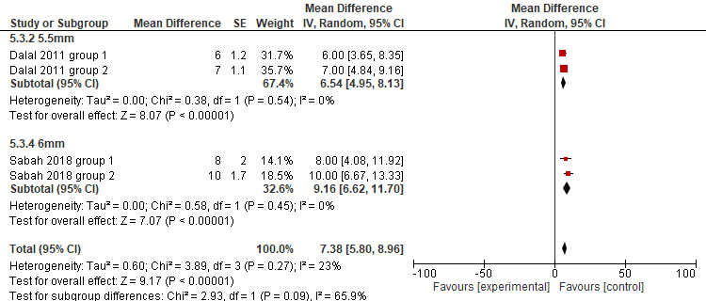

Supplemental Figure S12. Indirect comparison of revision surgery by rod diameter
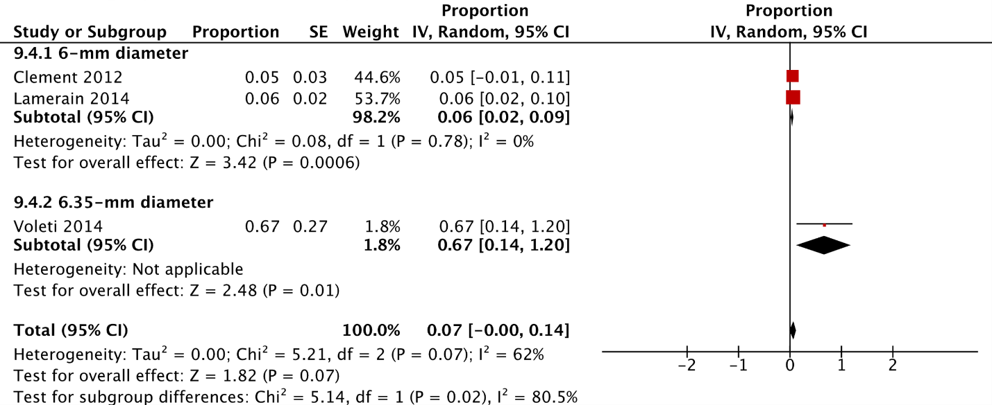

Supplemental Figure S13. Indirect comparison of infection by rod diameter
