Supplementary Table 1. Prisma Search strategy
Database | Search terms | No of studies
PubMed | scoliosis OR "spinal deformity" OR kyphoscoliosis OR "neuromuscular scoliosis")  AND  ("spinal fusion" OR "spine surgery" OR instrumentation OR arthrodesis)  AND  (pediatric OR paediatric OR child OR children OR adolescent)  AND  (mortality OR death OR complication OR "postoperative complication" OR "respiratory failure" OR pneumonia OR sepsis)  AND  ("risk factor" OR predictor OR association OR regression)  NOT  (adult) | 1114
Embase | (scoliosis OR spinal deformity OR kyphoscoliosis OR neuromuscular scoliosis)  AND  (spinal fusion OR spine surgery OR instrumentation OR arthrodesis)  AND  (pediatric OR paediatric OR child OR children OR adolescent)  AND  (mortality OR death OR complication OR postoperative complication OR respiratory failure OR pneumonia OR sepsis)  AND  (risk factor OR predictor OR association OR regression)  NOT  (adult) | 1537
Scopus | (scoliosis OR "spinal deformity" OR kyphoscoliosis OR "neuromuscular scoliosis")  AND  ("spinal fusion" OR "spine surgery" OR instrumentation OR arthrodesis)  AND  (pediatric OR paediatric OR child OR children OR adolescent)  AND  (mortality OR death OR complication OR "postoperative complication" OR "respiratory failure" OR pneumonia OR sepsis)  AND  ("risk factor" OR predictor OR regression)  AND NOT  (adult) | 2121
Web of Science | (scoliosis OR "spinal deformity" OR kyphoscoliosis OR "neuromuscular scoliosis")  AND  ("spinal fusion" OR "spine surgery" OR instrumentation OR arthrodesis)  AND  (pediatric OR paediatric OR child OR children OR adolescent)  AND  (mortality OR death OR complication OR "postoperative complication" OR "respiratory failure" OR pneumonia OR sepsis)  AND  ("risk factor" OR predictor OR regression)  NOT  (adult) | 358

Supplementary Table 2. Inclusion and Exclusion Criteria of Studies.

Inclusion criteria | Exclusion criteria
- Pediatric patients (typically ≤18 years) undergoing scoliosis corrective surgery (posterior fusion/instrumentation ± anterior approach; deformity correction)  - Any scoliosis etiology (idiopathic, neuromuscular, congenital, syndromic, early-onset, mixed), provided scoliosis surgery population is clear  - Studies assessing risk factors/predictors for postoperative outcomes (demographics, comorbidities, anthropometrics, etiology, surgical/technical factors, pre-op status)  - Reporting 30-day postoperative complications (any complication, medical complications, SSI, pulmonary/cardiac complications)  - Provides adjusted effect estimates (aOR/OR/RR/HR) with 95% CI  - Observational analytic studies: retrospective/prospective cohorts, registry/administrative database studies, case–control  - Any publication year (from database inception to search end date)  - English (or languages you can reliably extract/translate, if applicable)  - Any country/health system | - Adults only; mixed adult/pediatric cohorts without separable pediatric data; non-scoliosis spinal surgery only  - Non-scoliosis deformities only (e.g., kyphosis-only) unless scoliosis data separable  - Studies reporting outcomes without evaluating predictors (descriptive series only), unless raw 2×2 data allow effect estimation  - Outcomes not within 30 days (e.g., 90-day, 1-year) without separable 30-day data; purely radiographic outcomes (curve correction only), PROMs only  - No comparator and no computable effect size (e.g., complication rate only in one subgroup with no reference group); duplicate reporting of the same cohort without unique data  - Case reports, small case series without comparisons (e.g., <10 patients), editorials, narrative reviews, conference abstracts without full data  - Non-English if full-text data cannot be extracted

Outcome | Study design | Risk of bias | Inconsistency | Indirectness | Imprecision | Publication bias | Overall certainty
Cardiopulmonary disease (asthma, CHD, cardiomyopathy, HF, pre-op pulmonary risk) | Observational (registry / cohort) | Serious | Moderate-high | No | Serious | Undetected | ⨁◯◯◯ Very Low
Anthropometric | Observational | Moderate | Low | No | Not Serious | Undetected | ⨁⨁◯◯ Low
Sex (Male) | Observational | Low | Low | No | Not Serious | Undetected | ⨁⨁◯◯ Low
Neuromuscular disorders | Observational | Low | Moderate | No | Not Serious | Undetected | ⨁◯◯◯ Very Low
Hematologic disorders | Observational | Moderate | Low | No | Not Serious | Undetected | ⨁⨁◯◯ Low
Developmental delay | Observational | Moderate | Moderate | No | Serious | Undetected | ⨁◯◯◯ Very Low
Metabolic disorders (DM, HTN) | Observational | Considerable | High | No | Serious | Undetected | ⨁◯◯◯ Very Low
Pelvic fixation | Observational | Low | Moderate | No | Not Serious | Undetected | ⨁◯◯◯ Very Low
Osteotomy | Observational | Low | Moderate | No | Not Serious | Undetected | ⨁◯◯◯ Very Low
Supplementary Table 3. GRADE assessment of certainty of evidence for associations between evaluated risk factors and 30-day postoperative complications following pediatric scoliosis surgery. All included studies were observational. Certainty ratings were determined using the GRADE framework and reflect downgrades for risk of bias (assessed with ROBINS-I), inconsistency, and imprecision. Indirectness and publication bias were not identified across outcomes.

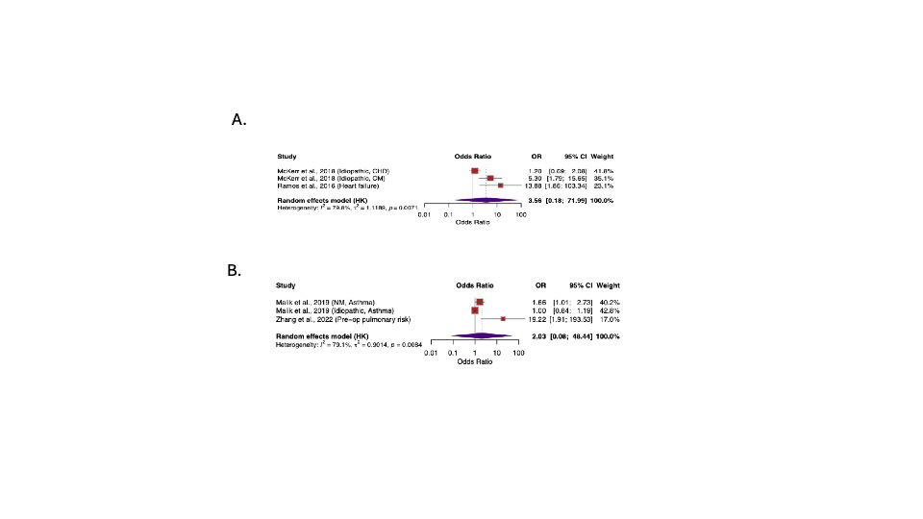

Supplementary Figure 1. Forest plots showing the association between cardio-pulmonary comorbidities and 30-day postoperative complications following pediatric scoliosis surgery. (A) Cardiac comorbidity subgroup, including congenital heart disease (CHD), cardiomyopathy (CM), and heart failure. (B) Pulmonary risk subgroup, including asthma and composite preoperative pulmonary risk. Pooled odds ratios (ORs) with 95% confidence intervals (CIs) were calculated using random-effects models with Hartung–Knapp adjustment. Between-study heterogeneity is reported using the I² statistic.

Supplementary Figure 2. Risk of Bias assessment using the ROBINS-I tool.
