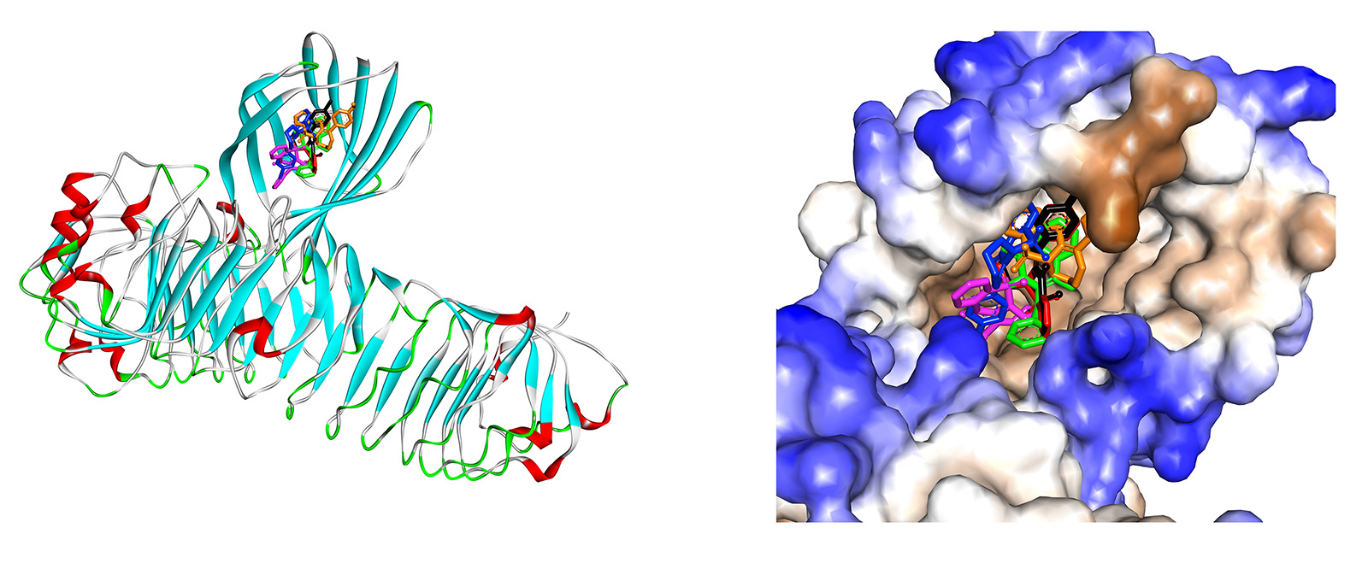
Figure 1S. The docked pose of TP1 (green), TP5 (red), TP6 (blue), TP7 (black), TP9 (orange), TP10 (pink)into pocket site of TLR4/MD-2 complex.
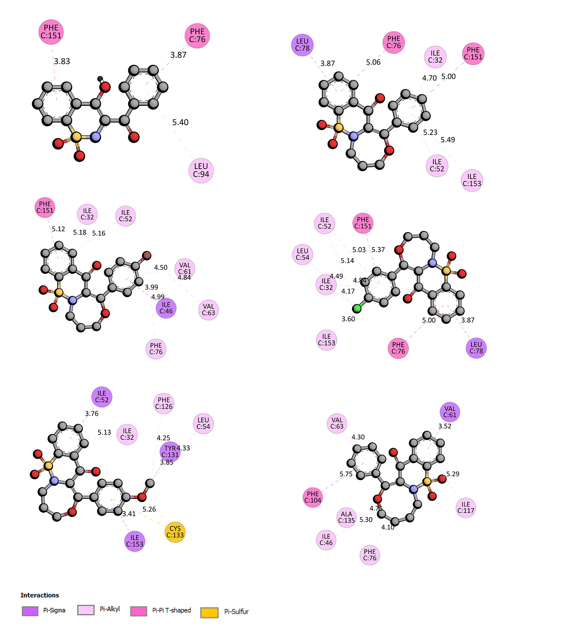
Figure 2S. The 2D plot of interaction TP1, TP5, TP6, TP7, TP9, and TP10 with TLR4/MD-2 complex.

