Fig. S1. The effect of a four-day administration of scopolamine (0.3 mg/kg; ip) on the eEF2, TrkB, mTOR, and PSD95 protein levels determined by Western blot analysis in the synaptosome-enriched fraction of the prefrontal cortex (PFC). Raw, unprocessed Western blot images. GAPDH – reference protein.
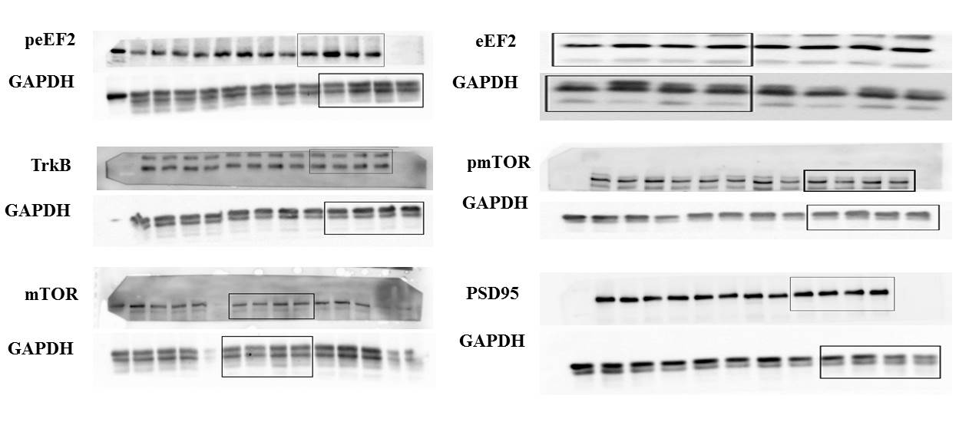
Fig. S2. The effect of a four-day administration of scopolamine (0.3 mg/kg; ip) on the eEF2, TrkB, mTOR, and PSD95 protein levels determined by Western blot analysis in the synaptosome-enriched fraction of the hippocampus. Raw, unprocessed Western blot images. GAPDH – reference protein.
