Supplementary information

Supplementary data 1: Original western-blot images corresponding to figures 1 D and 3 D, E.

Original blot for figure 1, D (only upper half, corresponding to GLS2 and COXIV):

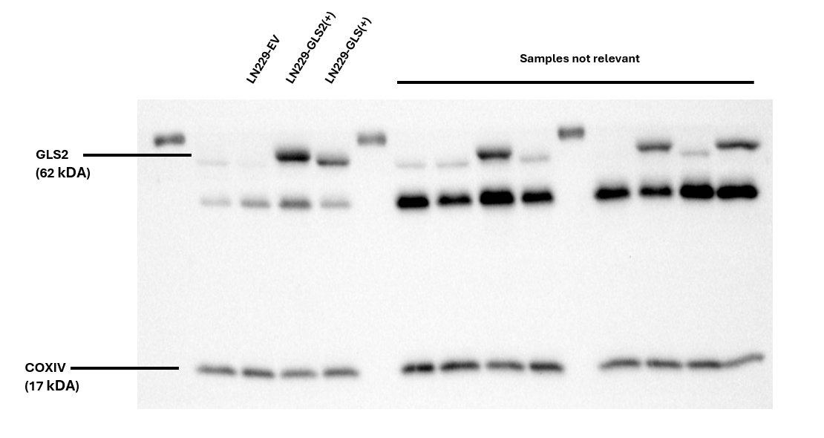The membrane in the left corresponds to figure 1, D (top half of the figure, for GLS2 (bands on top of the image) and COXIV (bands on the bottom of the image). Membranes were cut, incubated separately and analyzed together. The rest of the image is irrelevant for the current study. The original image of the molecular weight ladder is shown next:
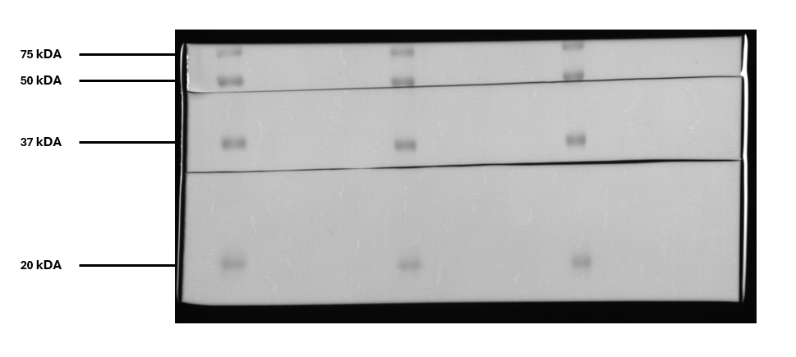

Supplementary data 2: Original blot for figure 1, D (only bottom half, corresponding to GLS (GAC) and COXIV):
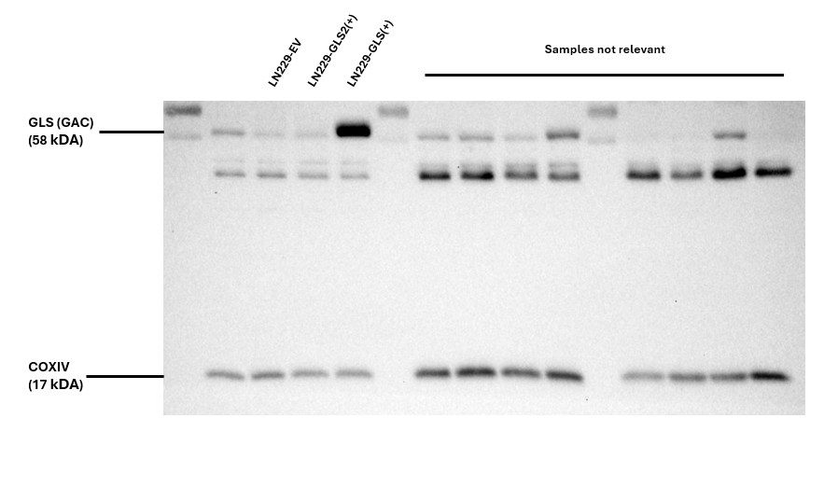The membrane in the left corresponds to figure 1, D (bottom half of the figure, for GLS (bands on top of the image) and COXIV (bands on the bottom of the image). Membranes were cut, incubated separately and analyzed together. The rest of the image is irrelevant for the current study. The original image of the molecular weight ladder is shown next:
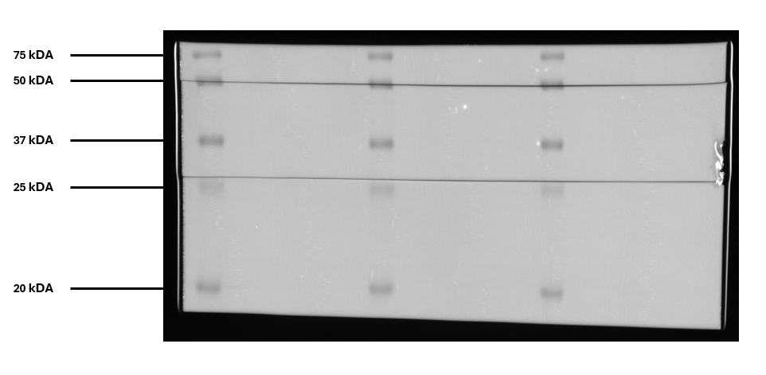

Supplementary data 3: Original blot for figure 3, D and E:

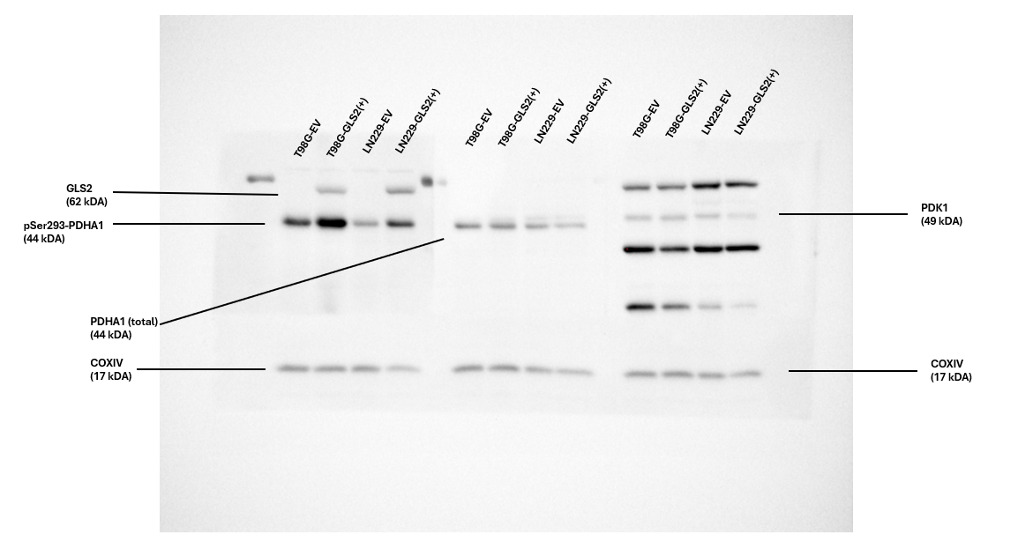Corresponds to figure 3, D and E. The membrane in the left corresponds to Figure 3, D. Center membrane corresponds to Figure 3, E (top half); The membrane in the right part corresponds to Figure 3, E (bottom half). Membranes were cut, incubated separately and analyzed together. Bottom band corresponds to COXIV in all cases. Several unspecific bands appeared when using the antibody against PDK1 (membrane in the right), PDK1 was identified by molecular weight comparison. The original image of the molecular weight ladder is shown next:
