Supplementary materials
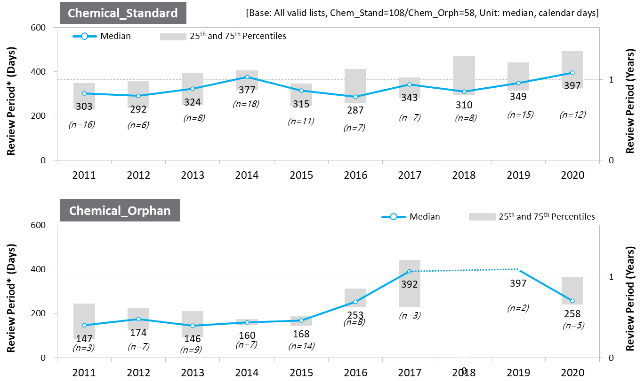
Supplementary figure 1. [Chemical] Standard/Orphan NDA Review Period

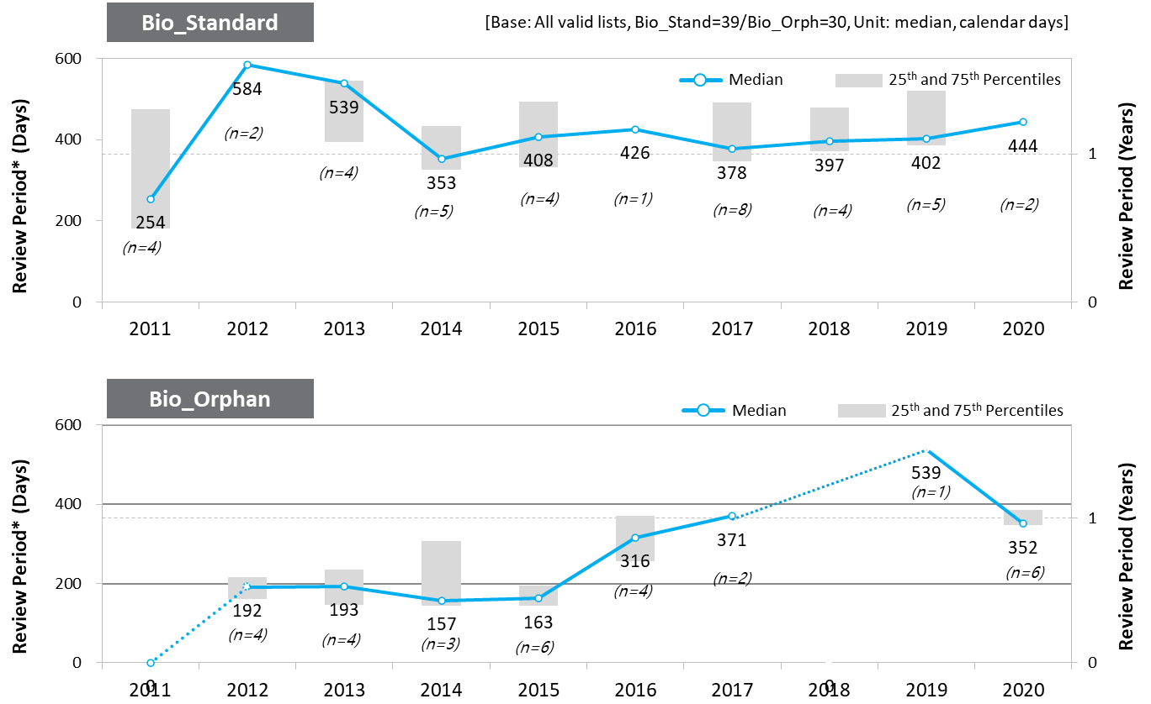
Supplementary figure 2. [Bio] Standard/Orphan NASs Review Period

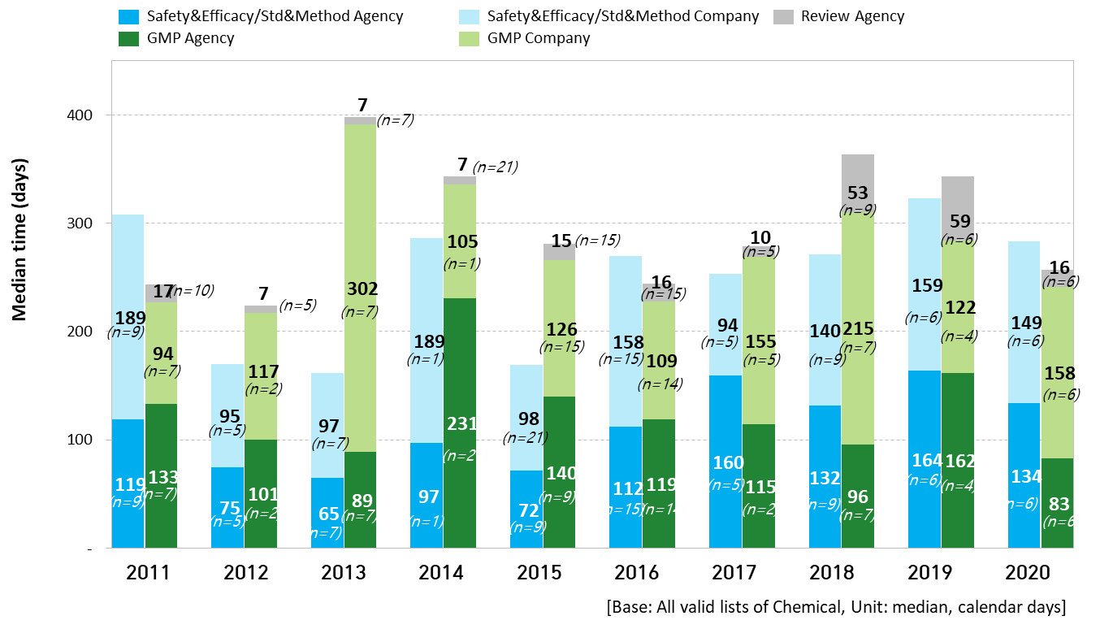
Supplementary figure 3. [Chemical] Safety-Efficacy review/Standard and Method review/GMP review period

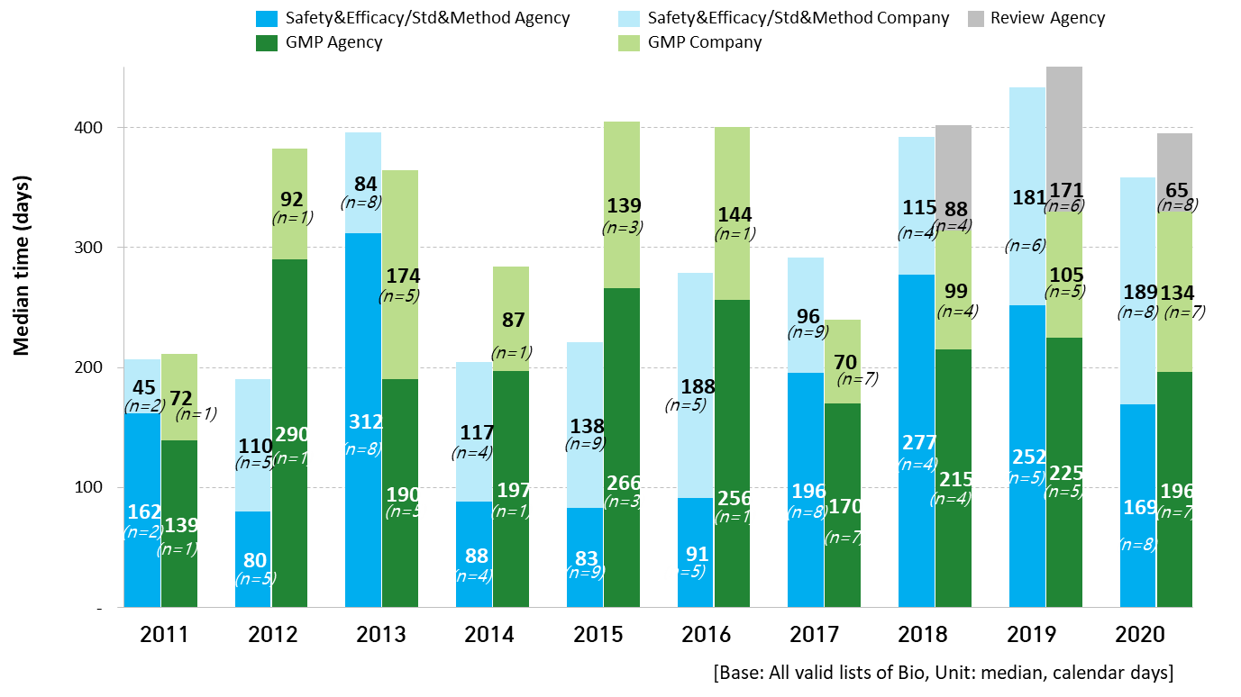
Supplementary figure 4. [Bio] Safety-Efficacy review/Standard and Method review/GMP review period

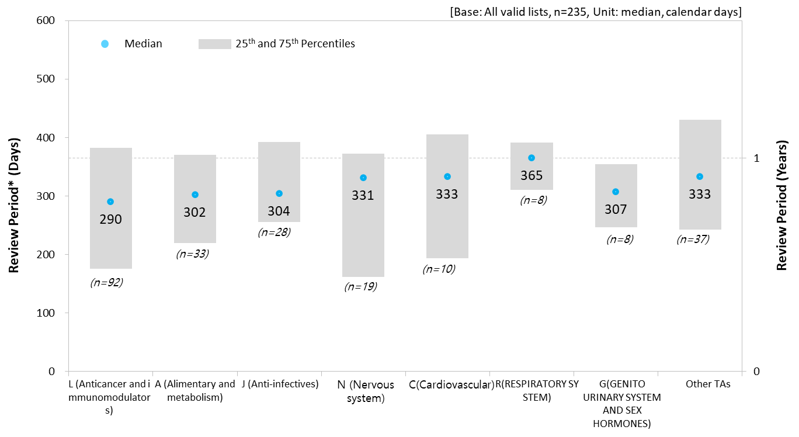 Supplementary figure 5. NDA Review Period by TA

