Supplementary Material
- Supplementary Tables
Supplementary Table 1. List of all sources investigated.
EU Member State | Competent agency | Reference name
Austria | Austrian Agency for Health and Food Safety (AGES) | Email communication
Austria | Austrian Federal Office for Safety in Health Care (BASG) | Email communication
Austria | Austrian Federal Office for Safety in Health Care (BASG) | Arzneispezialitätenregister [1]
Austria | Gesundheit Österreich | Email communication
Austria | Österreichische Sozailversicherung | Erstattungskodex [2]
Belgium | Federal agency for medicines and health products (FAMHP) | Email communication
Belgium | Federal agency for medicines and health products (FAMHP) | PharmaStatus [3]
Belgium | Rijksinstituut voor ziekte- en invaliditeitsverzekering (RIZIV) | Vergoedbare geneesmiddelen en radio-farmaceutische producten [4]
Bulgaria | Bulgarian Drug Agency | Email communication
Bulgaria | Bulgarian Drug Agency | Register of pharmaceutical products [5]
Bulgaria | National Council on Prices and Reimbursement of Medicinal Products (NCPR) | Registers of National Council on Prices and Reimbursement of Medicinal Products [6]
Bulgaria | National Health Insurance Fund | Списъци с лекарствени продукти [7]
Croatia | Croatian Agency for Medicinal Products and Medical Devices (HALMED) | Email communication
Croatia |  | Baza lijekova/Medicinal Product Database [8]
Croatia | Croatian Health Insurance Fund | Osnovna lista lijekova [9]
Cyprus | Pharmaceutical Services Ministry of Health | Email communication
Cyprus | Pharmaceutical Services Ministry of Health | Price list [10]
Cyprus | Pharmaceutical Services Ministry of Health | Product search [11]
Czech Republic | State Institute for Drug Control (SÚKL) | Email communication
Czech Republic | State Institute for Drug Control (SÚKL) | Opatření obecné povahy [12]
Czech Republic | State Institute for Drug Control (SÚKL) | Přehled správních řízení [13]
Czech Republic | State Institute for Drug Control (SÚKL) | Otevřená data: REG-13; DIS-13; LEK-13; Dodávky léčivých přípravků [14]
Denmark | Danish Medicine Agency | Email communication
Denmark | Danish Medicine Agency | Medicinpriser.dk [15]
Denmark | Danish Medicines Council | Medicinrådet: Anbefalinger og vejledninger [16]
Estonia | State Agency of Medicines (SAM) | Email communication
Estonia | State Agency of Medicines (SAM) | Register of Medicinal Products [17]
Estonia | Tervisekassa – Health Insurance Fund | Soodusravimid [18]
Finland | Fimea – Finnish Medicines Agency | Email communication
Finland | Fimea – Finnish Medicines Agency | FimeaWeb [19]
Finland | Kela | Medicinal Products Database [20]
France | French National Agency for Medicines and Health Products Safety (ANSM) | Email communication
France |  | Répertoire des Spécialités Pharmaceutiques [21]
France | French National Authority for Health (HAS) | Avis et décisions sur les medicaments [22]
France | Ministry of Health | Référentiel des indications des spécialités pharmaceutiques inscrites sur la liste en sus [23]
Germany | Gemeinsamet Bundesausschuss (G-BA) | Nutzenbewertung von Arzneimitteln [24]
Germany | Paul-Ehrlich-Institute | Email communication
Germany | CGM Lauer | Lauer-Taxe [25]
Greece | Ministry of Health | Φάρμακα Υψηλού Κόστους – καταλόγων για τη θεραπεία σοβαρών ασθενειών [26]
Greece | National Organization for Medicines | Email communication
Greece | National Organization for Medicines | Search human product [27]
Hungary | National Center for Public Health and Pharmacy | Email communication
Hungary | National Center for Public Health and Pharmacy | Gyógyszer-adatbázis [28]
Hungary | National Health Insurance Fund of Hungary (NEAK) | Publikus Gyógyszertörzs (PUPHA) – Végleges [29]
Ireland | Health Products Regulatory Authority (HPRA) | Email communication
Ireland | Health Products Regulatory Authority (HPRA) | Find a medicine [30]
Ireland | Health Service Executive | Reimbursable Items [31]
Ireland | National Centre for Pharmacoeconomics (NCPE) | Assessments of National Centre for Pharmacoeconomics [32]
Italy | Italian Medicines Agency (AIFA) | List of Class H medicinal products [33]
Italy | Italian Medicines Agency (AIFA) | Innovative drug list [34]
Italy | Italian Medicines Agency (AIFA) | List of Class C(nn) medicinal products [35]
Italy | Farmadati Italia | Email communication
Latvia | National Health Service | Assessment of applications for inclusion of new medicinal products in the list of reimbursable medicinal products [36]
Latvia | National Health Service | Lists of reimbursed medicines [37]
Latvia | State Agency of Medicines Republic of Latvia | Email communication
Latvia | State Agency of Medicines Republic of Latvia | Medicinal product register of Latvia [38]
Lithuania | State Medicines Control Agency of Lithuania | Email communication
Lithuania | State Medicines Control Agency of Lithuania | Parduotų vaistinėms ir ASPĮ vaistinių preparatų pakuočių kiekis [39]
Lithuania | National Health Insurance Fund under the Ministry of Health | Kompensuojamieji vaistai ir medicinos pagalbos priemonės [40]
Lithuania | National Health Insurance Fund under the Ministry of Health | Vaistų ir medicinos pagalbos priemonių kainų paieška [41]
Luxembourg | Ministère de la Santé et de la Sécurité sociale, Division de la pharmacie et des médicaments | Email communication
Luxembourg | CNS | Liste des médicaments commercialisés [42]
Malta | Malta Medicines Authority | Email communication
Malta | Malta Medicines Authority | Medicines Authority Advanced Search [43]
Malta | Directorate for Pharmaceutical Affairs | Government Formulary List [44]
Netherlands | Zorginstituut Nederland | Email communication
Netherlands | Zorginstituut Nederland | Horizonscan geneesmiddelen [45]
Netherlands | Zorginstituut Nederland | Medicijnkosten.nl > Zoeken [46]
Netherlands | Zorginstituut Nederland | Overzicht geneesmiddelen in de sluis [47]
Netherlands | Medicines Evaluation Board | Email communication
Netherlands | Medicines Evaluation Board | Medicines Information Bank [48]
Poland | Chief Pharmaceutical Inspectorate | Email communication
Poland | Chief Pharmaceutical Inspectorate | Zintegrowany System Monitorowania Obrotu Produktami Leczniczymi [49]
Poland | Ktomalek.pl | KtoMaLek.pl [50]
Poland | Ministry of Health | Leki refundowane [51]
Poland | Ministry of Health | Rejestr Produktów Leczniczych [52]
Poland | Office For Registration of Medicinal Products,  Medical Devices and Biocidal Products | Email communication
Portugal | Infarmed | Email communication
Portugal | Infarmed | INFOMED Base de dados de medicamentos de uso humano [53]
Portugal | Infarmed | Relatórios de avaliação de financiamento público [54]
Romania | Casa Națională de Asigurări de Sănătate | Lista interactivă a medicamentelor [55]
Romania | Ministry of Health | Catalogul Public național al prețurilor maximale ale medicamentelor de uz uman [56]
Romania | National Agency for Medicines and Medical Devices in Romania (ANMDMR) | Email communication
Romania |  | Lista medicamentelor din NOMENCLATOR [57]
Slovakia | Ministry of Health | Zoznam kategorizovaných liekov [58]
Slovakia | Ministry of Health | Zoznam liekov s úradne určenou cenou [59]
Slovakia | National Health Information Centre | Datasety spotreby humánnych liekov v Slovenskej Republike [60]
Slovakia | State Institute for Drug Control | Email communication
Slovakia | State Institute for Drug Control | Oznámenie o prvom uvedení, prerušení, obnovení alebo zrušení dodávok humánneho lieku [61]
Slovenia | Agency for Medicinal Products and Medical Devices of the Republic of Slovenia (JAZMP) | Advanced medicinal products (ATMP) / Medicinal products authorized in Europe by now [62]
Slovenia |  | Email communication
Slovenia |  | List of regulated prices [63]
Slovenia | Zavod za zdravstveno zavarovanje Slovenije (ZZZS) | Podatki o porabi zdravil [64]
Slovenia | JAZMP + ZZZS + Ministry of Health + National Institute of Health (NIJZ) | Centralna baza zdravil [65]
Spain | Ministry of Health | BIFIMED: Buscador de la Información sobre la situación de financiación de los medicamentos [66]
Spain | Spanish Agency of Medicines and Medical Devices (AEMPS) | Email communication
Spain | Spanish Agency of Medicines and Medical Devices (AEMPS) | CIMA - Centro de información de medicamentos [67]
Sweden | E-hälsomyndigheten | Email communication
Sweden | E-hälsomyndigheten | VARA [68]
Sweden | Läkemedelsindustriföreningens Service AB | FASS Allmänhet [69]
Sweden | Swedish Medical Products Agency | Email communication
Sweden | Tandvårds- och läkemedelsförmånsverket (TVL) | Sök priser och beslut i database [70]
EU | European Medicines Agency | AskEMA

Supplementary Table 2. List of sources and indicators of market availability for EU Member States.
EU Member State | Reference name | Indicator of availability | Verified by NCA
Austria¹ | NA | NA | Y
Belgium | PharmaStatus [3] | available in the database | Y
Bulgaria | email communication (Bulgarian Drug Agency) |  | Y
Croatia | Baza lijekova (Medicinal Product Database) [8] | available in the database with Marketing status: “stavljeno u promet” | Y
Cyprus | Pharmaceutical Services Ministry of Health – product search [11] | available in the database | N
Czech Republic | DIS-13; LEK-13; Dodávky léčivých přípravků [14] | available at least in one of the files | Y
Denmark | Medicinpriser.dk [15] | available in the database | N
Estonia | Register of Medicinal Products [17] | available in the database with the date of last import | Y
Finland | FimeaWeb [19] | Marketed status: "Marketed" | N
France | Répertoire des Spécialités Pharmaceutiques [21] | Commercialisation: "Commercialisée" | Y
Germany² | Lauer-Taxe [25] | not available if filed "KENNZ." contains "AV", "RW", "VP", "nw", "N", "Z" | N
Greece | Search human product [27] | available in the database with price | N
Hungary³ | Publikus Gyógyszertörzs (PUPHA) – Végleges [29] | table GYOGYSZ, the "FORGALOMBA" field is "1" | N
Ireland⁴ | NA | NA | Y
Italy | email communication (Farmadati Itali) |  | Y
Latvia | Medicinal product register of Latvia [38] | available in the database | Y
Lithuania | Parduotų vaistinėms ir ASPĮ vaistinių preparatų pakuočių kiekis [39] | available at least in one of the files | Y
Luxembourg | Liste des médicaments commercialisés [42] | available in the file | Y
Malta⁵ | Medicines Authority Advanced Search [43] | available in the database | N
Netherlands | Medicijnkosten.nl > Zoeken [46] | available in the database | Y
Poland | email communication (Chief Pharmaceutical Inspectorate) |  | Y
Portugal | INFOMED Base de dados de medicamentos de uso humano [53] | Comercialização: "Existe, pelo menos, uma apresentação comercializada." | Y
Romania⁶ | Lista medicamentelor din NOMENCLATOR [57] | available in the database | Y
Slovakia | Datasety spotreby humánnych liekov v Slovenskej Republike [60] | available at least in one of the files | Y
Slovenia | Centralna baza zdravil [65] | available in the database with price information | Y
Spain | CIMA - Centro de información de medicamentos [67] | available in the database with status "COMERCIALIZADO" | Y
Sweden | FASS Allmänhet [69] | information about the package is not strikethrough and the "Tillhandahålls ej" is not in the description | Y

Abbreviations: ATMP, advanced therapy medicinal product; NA, not available; NCA, national competent authority; N, no; Y, yes

Notes:
¹ Austrian Agency for Health and Food Safety (AGES) and Austrian Federal Office for Safety in Health Care (BASG) do not have information about the commercialisation status of centrally authorised products.
² Paul-Ehrlich-Institut does not have information about the commercialisation status of centrally authorised products. The commercial source was used.
³ No ATMP was found. Findings were not verified by NCA.
⁴ Health Products Regulatory Authority (HPRA) does not have information about the commercialisation status of centrally authorised products.
⁵ No ATMP was found. Findings were not verified by NCA.
⁶ Alongside email communication. The database includes medicinal products for which marketing authorisation holder notifies the intention to market in Romania (Carvykti – not marketed yet).

Supplementary Table 3. The number and ratio of ATMPs availability (market launched to authorised ATMPs) in EU Member States (MS) as of March 5, 2024.
EU Member State | Number of ATMPs available | Availability ratio (%)
Austria | NA | NA
Belgium | 9 | 50
Bulgaria | 2 | 11
Croatia | 4 | 22
Cyprus | 2 | 11
Czech Republic | 6 | 33
Denmark | 7 | 39
Estonia | 0 | 0
Finland | 7 | 39
France | 11 | 61
Germany | 16 | 89
Greece | 6 | 33
Hungary | NC | NC
Ireland | NA | NA
Italy | 11 | 61
Latvia | 0 | 0
Lithuania | 2 | 11
Luxembourg | 8 | 44
Malta | NC | NC
Netherlands | 9 | 50
Poland | 3 | 17
Portugal | 6 | 33
Romania | 4 | 22
Slovakia | 4 | 22
Slovenia | 3 | 17
Spain | 6 | 33
Sweden | 7 | 39
EU average¹ | 4.8 | 26

Abbreviations: ATMP, advanced therapy medicinal product; MS, Member State; NA, not available; NC, not confirmed

Notes:
¹ Average calculated for investigated EU MS.

Supplementary Table 4. ATMPs market availability in EU Member States (MS) as of March 5, 2024 according to the indicators defined in Supplementary Table 2 (green – ATMP available; grey – MS was excluded from the study).
EU Member State | Abecma | Alofisel | Breyanzi | Carvykti | Ebvallo | Hemgenix | Holoclar | Imlygic | Kymriah | Libmeldy | Luxturna | Roctavian | Spherox | Strimvelis | Tecartus | Upstaza | Yescarta | Zolgensma
Austria
Belgium
Bulgaria
Croatia
Cyprus
Czech Republic
Denmark
Estonia
Finland
France
Germany
Greece
Hungary
Ireland
Italy
Latvia
Lithuania
Luxembourg
Malta
Netherlands
Poland
Portugal
Romania
Slovakia
Slovenia
Spain
Sweden

Abbreviations: ATMP, advanced therapy medicinal product; MS, Member State.

- Supplementary Figures
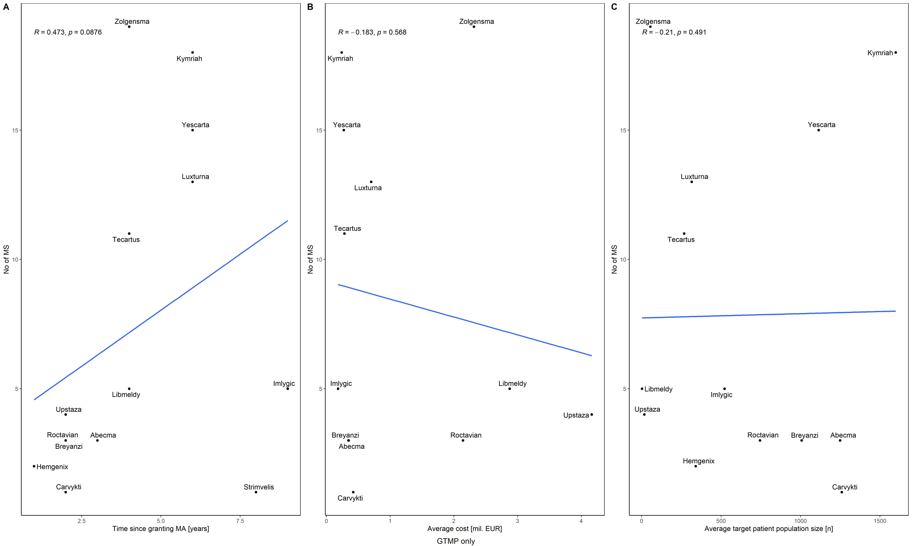
Supplementary Figure 1. Relation between gene therapy medicinal products (GTMP) availability in EU Member States and (A) time since granting marketing authorisation, (B) cost, (C) size of the target patient population.
Abbreviations: GTMP, gene therapy medicinal products; MA, marketing authorisation; MS, Member States
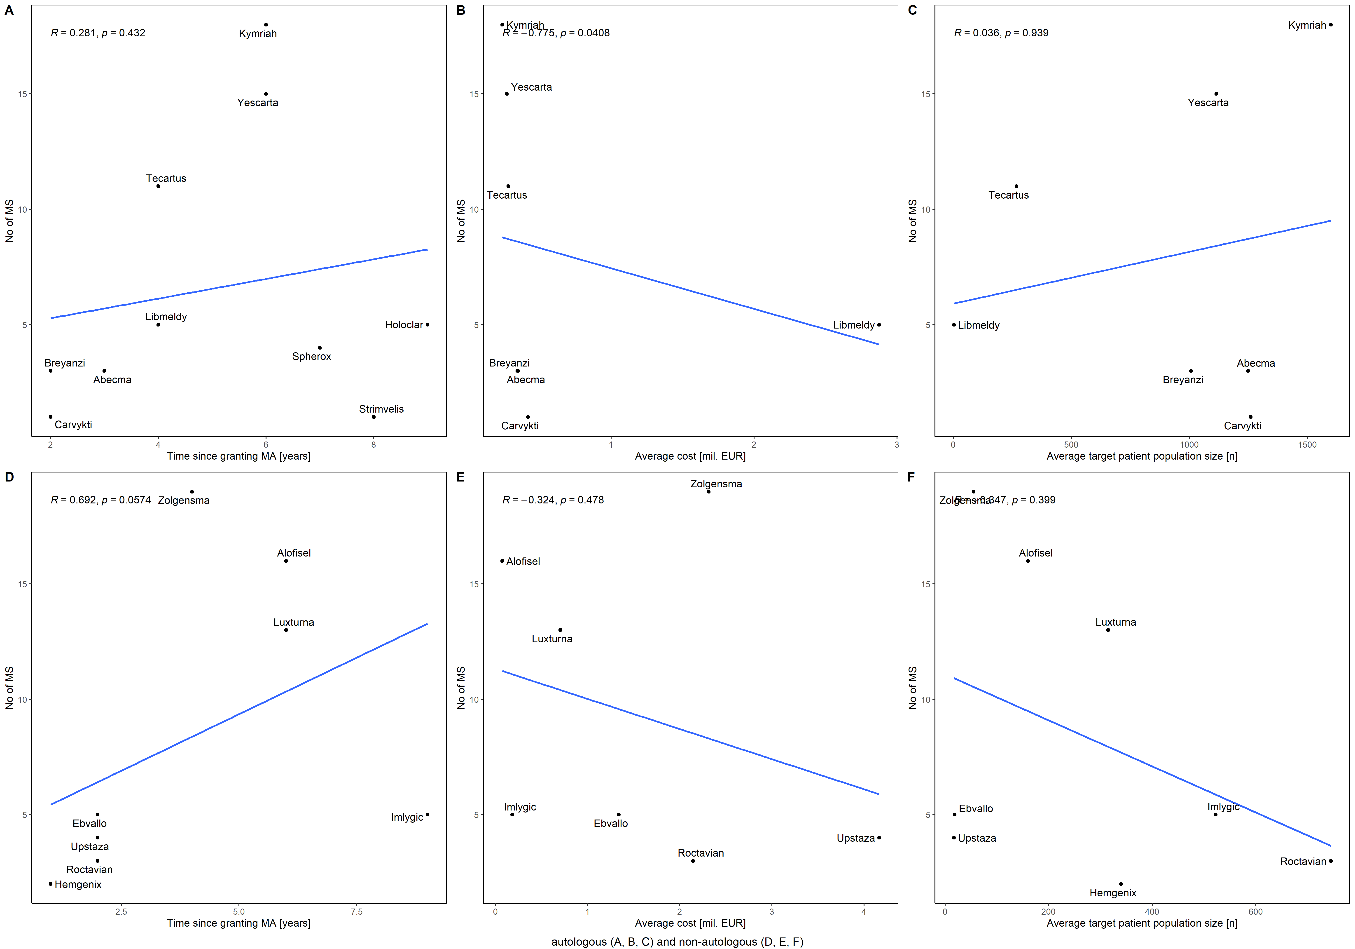
Supplementary Figure 2. Relation between ATMP availability in the Member States and (A) time since granting marketing authorisation, (B) cost, (C) size of the target patient population for autologous products; (D) time since granting marketing authorisation, (E) cost, (F) size of the target patient population for non-autologous products.
Abbreviations: ATMP, advanced therapy medicinal products; MA, marketing authorisation; MS, Member States
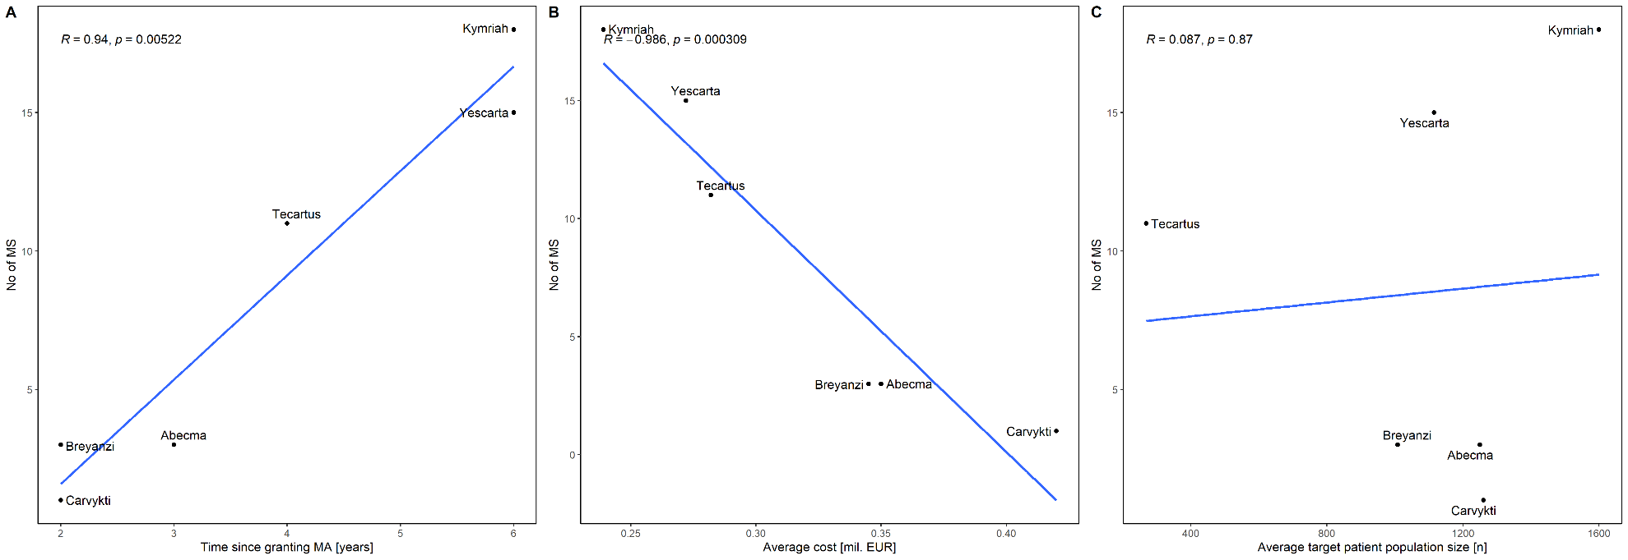
Supplementary Figure 3. Relation between CAR T-cell therapies availability in the Member States and (A) time since marketing granting authorisation, (B) cost, (C) size of the target patient population.
Abbreviations: CAR, chimeric antigenic receptor; MA, marketing authorisation; MS, Member States

- Supplementary References
- Bundesamt für Sicherheit im Gesundheitswesen. Arzneispezialitätenregister. https://aspregister.basg.gv.at/aspregister/faces/aspregister.jspx. Accessed 5 March 2024.
- Österreichische Sozailversicherung. Der Erstattungskodex (pdf). https://www.sozialversicherung.at/cdscontent/?contentid=10007.844497&portal=svportal. Accessed 20 February 2024.
- PharmaStatus. The online application on the availability of medicines. https://pharmastatus.be/. Accessed 5 March 2024.
- Rijksinstituut voor ziekte- en invaliditeitsverzekering. Zoekmodules SSP - bijgewerkt op. https://webappsa.riziv-inami.fgov.be/ssp/ProductSearch. Accessed 20 February 2024.
- Bulgarian Drug Agency. Register of pharmaceutical products. https://www.bda.bg/en/registers/register-of-pharmaceutical-products. Accessed 20 February 2024.
- National Council on Prices and Reimbursement of Medicinal Products. Registers of National Council on Prices and Reimbursement of Medicinal Products. https://portal.ncpr.bg/registers/pages/register/list-medicament.xhtml. Accessed 20 February 2024.
- National Health Insurance Fund. 2024 – Списъци с лекарствени продукти. https://www.nhif.bg/bg/medicine_food/medical-list/2024. Accessed 20 February 2024.
- HALMED. Medicinal Products Database. https://www.halmed.hr/en/Lijekovi/Baza-lijekova/. Accessed 5 March 2024.
- HZZO. Objavljene liste lijekova. https://hzzo.hr/zdravstvena-zastita/objavljene-liste-lijekova. Accessed 21 February 2024.
- Pharmaceutical Services. Price list of Medicinal Products. https://www.moh.gov.cy/Moh/phs/phs.nsf/pricelist_en/pricelist_en?opendocument. Accessed 21 February 2024.
- Pharmaceutical Services. Product search. https://www.phs.moh.gov.cy/human-search/home.xhtml. Accessed 5 March 2024.
- Státní ústav pro kontrolu léčiv. Opatření obecné povahy. https://sukl.gov.cz/prumysl/leciva/ceny-a-uhrady/opatreni-obecne-povahy/zverejnena-oop/. Accessed 5 March 2024.
- Státní ústav pro kontrolu léčiv. Přehled správních řízení. https://sukl.gov.cz/modules/procedures/. Accessed 5 March 2024.
- Státní ústav pro kontrolu léčiv. Otevřená data. https://opendata.sukl.cz/?q=katalog-otevrenych-dat. Accessed 5 March 2024.
- Danish Medicine Agency. Forside – www.medicinpriser.dk. https://www.medicinpriser.dk/. Accessed 5 March 2024.
- Medicinrådet. Anbefalinger – nye lægemidler og indikations-udvidelser. https://medicinraadet.dk/anbefalinger-og-vejledninger/laegemidler-og-indikationsudvidelser. Accessed 5 March 2024.
- Republic of Estonia, Agency of Medicines. Register of Medicinal Products. https://www.ravimiregister.ee/en/default.aspx?pv=HumRavimid.Otsing. Accessed 5 March 2024.
- Tervisekassa. Soodusravimid. https://www.tervisekassa.ee/partnerile/ravimitest/soodusravimid. Accessed 21 February 2024.
- Fimea. FimeaWeb. https://fimea.fi/en/databases_and_registers/fimeaweb. Accessed 5 March 2024.
- Kela. Medicinal Products Database. https://asiointi.kela.fi/laakekys_app/LaakekysApplication?kieli=en. Accessed 21 February 2024.
- ANSM. Répertoire des Spécialités Pharmaceutiques. https://agence-prd.ansm.sante.fr/php/ecodex/index.php. Accessed 5 March 2024.
- Haute Autorité de Santé. Avis et décisions sur les medicaments. https://www.has-sante.fr/jcms/p_3281266/fr/avis-et-decisions-sur-les-medicaments. Accessed 22 February 2024.
- Ministére du Travail, de la Santé, des Solidarités et des Familles. Référentiel des indications des spécialités pharmaceutiques inscrites sur la liste en sus. https://sante.gouv.fr/soins-et-maladies/medicaments/professionnels-de-sante/autorisation-de-mise-sur-le-marche/la-liste-en-sus/article/referentiel-des-indications-des-specialites-pharmaceutiques-inscrites-sur-la. Accessed 22 February 2024.
- Gemeinsamer Bundesausschuss. Nutzenbewertung von Arzneimitteln. https://www.g-ba.de/bewertungsverfahren/nutzenbewertung/. Accessed 22 February 2024.
- CGM Lauer. Lauer-Taxe Onlinde 4.0. https://portal.cgmlauer.cgm.com/LF/default.aspx?p=12000. Accessed 5 March 2024.
- Υπουργείου Υγείας. Φάρμακα Υψηλού Κόστους – καταλόγων για τη θεραπεία σοβαρών ασθενειών. https://www.moh.gov.gr/articles/times-farmakwn/farmaka-ypshloy-kostoys. Accessed 22 February 2024.
- National Organization for Medicines. Product search. https://services.eof.gr/human-search/home.xhtml?lang=en. Accessed 5 March 2024.
- Nemzeti Népegészségügyi és Gyógyszerészeti Központ. Gyógyszer-adatbázis. https://ogyei.gov.hu/gyogyszeradatbazis/. Accessed 5 March 2024.
- Nemzeti Egészségbiztosítási Alapkezelő. Publikus Gyógyszertörzs (PUPHA) – Végleges. https://www.neak.gov.hu/felso_menu/szakmai_oldalak/gyogyszer_segedeszkoz_gyogyfurdo_tamogatas/egeszsegugyi_vallalkozasoknak/pupha/Vegleges_PUPHA. Accessed 5 March 2024.
- Health Products Regulatory Authority. Find a medicine. https://www.hpra.ie/homepage/medicines/medicines-information/find-a-medicine. Accessed 22 February 2024.
- HSE - PCRS. Search Reimbursable Items. https://www.sspcrs.ie/druglist/pub. Accessed 22 February 2024.
- National Centre for Pharmacoeconomics. Drugs. https://www.ncpe.ie/category/drugs/. Accessed 22 February 2024.
- Italian Medicines Agency. List of Class A and Class H medicinal products. https://www.aifa.gov.it/en-US/web/guest/liste-farmaci-a-h. Accessed 23 February 2024.
- Italian Medicines Agency. Innovative medicinal products. https://www.aifa.gov.it/en/farmaci-innovativi. Accessed 23 February 2024.
- Italian Medicines Agency. Legge 189-2012. https://www.aifa.gov.it/en/legge-189-2012. Accessed 23 February 2024.
- Nacionālais veselības dienests. Iesniegtie pieteikumi medikamentu iekļaušanai KZS. https://www.vmnvd.gov.lv/lv/iesniegtie-pieteikumi-medikamentu-ieklausanai-kzs. Accessed 23 February 2024.
- Nacionālais veselības dienests. Kompensējamo zāļu saraksti. https://www.vmnvd.gov.lv/lv/kompensejamo-zalu-saraksti. Accessed 23 February 2024.
- State Agency of Medicines Republic of Latvia. Medicinal Product Register of Latvia. https://dati.zva.gov.lv/zalu-registrs/en. Accessed 5 March 2024.
- Valstybinė vaistų kontrolės tarnyba prie LR Sveikatos Apsaugos Ministerijos. Parduotų vaistinėms ir ASPĮ vaistinių preparatų pakuočių kiekis. https://vvkt.lrv.lt/lt/svarbi-informacija/parduotu-vaistiniu-preparatu-pakuociu-kiekiai-ir-ju-atsargos/parduotu-vaistinems-ir-aspi-vaistiniu-preparatu-pakuociu-kiekis/. Accessed 5 March 2024.
- Valstybinė ligonių kasa prie Sveikatos apsaugos ministerijos. Kompensuojamieji vaistai ir medicinos pagalbos priemonės. https://ligoniukasa.lrv.lt/lt/veiklos-sritys/informacija-gyventojams/vaistai-ir-medicinos-pagalbos-priemones-mpp/. Accessed 23 February 2024.
- Vaistų ir medicinos pagalbos priemonių kainų paieška. https://kainynas.vlk.lt/webapp/index.html. Accessed 23 February 2024.
- CNS. Liste des médicaments commercialisés – Triée par denomination. https://cns.public.lu/fr/assure/publications/legislations/textes-coordonnes/liste-med-comm-tridenom.html. Accessed 5 March 2024.
- Medicines Authority. Advanced Search. https://medicinesauthority.gov.mt/advanced-search. Accessed 5 March 2024.
- Directorate for Pharmaceutical Affairs. The Government Formulary List. https://pharmaceuticalaffairs.gov.mt/en/resources/the-government-formulary-list/. Accessed 5 March 2024.
- Zorginstituut Nederland. Horizonscan geneesmiddelen. https://www.horizonscangeneesmiddelen.nl/?lang=en. Accessed 23 February 2024.
- Medicijnkosten.nl. Zoeken. https://www.medicijnkosten.nl/zoeken. Accessed 5 March 2024.
- Zorginstituut Nederland. Overzicht geneesmiddelen in de sluis. https://www.zorginstituutnederland.nl/over-ons/programmas-en-samenwerkingsverbanden/horizonscan-geneesmiddelen/sluis-voor-dure-geneesmiddelen/overzicht-geneesmiddelen-in-de-sluis. Accessed 23 February 2024.
- Medicines Evaluation Board. Home | Medicines Information Bank. https://www.geneesmiddeleninformatiebank.nl/ords/f?p=111:1:0:::1:P0_DOMAIN,P0_LANG:H,EN. Accessed 23 February 2024.
- Centrum e-Zdrowia. Zintegrowany System Monitorowania Obrotu Produktami Leczniczymi. https://ezdrowie.gov.pl/portal/home/systemy-it/zintegrowany-system-monitorowania-obrotu-produktami-leczniczymi. Accessed 24 February 2024.
- KtoMaLek.pl. Wskaz leki. https://ktomalek.pl/. Accessed 24 February 2024.
- Ministerstwo Zdrowia. Leki refundowane. https://www.gov.pl/web/zdrowie/leki-refundowane. Accessed 5 March 2024.
- Rejestry e-Zdrowia. RPL. https://rejestry.ezdrowie.gov.pl/rpl/search/public. Accessed 24 February 2024.
- Infomed. Human medicinal products database. https://extranet.infarmed.pt/INFOMED-fo/pesquisa-avancada.xhtml. Accessed 5March 2024.
- INFARMED, IP. Relatórios de avaliação de financiamento público. https://www.infarmed.pt/web/infarmed/relatorios-de-avaliacao-de-financiamento-publico. Accessed 24 February 2024.
- Casa Națională de Asigurări de Sănătate. Lista interactivă a medicamentelor. https://cnas.ro/lista-medicamente/. Accessed 25 February 2024.
- Ministerul Sănătăţii. Catalogul Public național al prețurilor maximale ale medicamentelor de uz uman. https://www.ms.ro/en/ministry/structure/directia-politica-medicamentului-si-a-dispozitivelor-medicale/preturi-medicamente/catalogul-public-national-al-preturilor-maximale-ale-medicamentelor-de-uz-uman/. Accessed 25 February 2024.
- ANMDMR - Nomenclatorul medicamentelor pentru uz uman. Lista medicamentelor din NOMENCLATOR. https://nomenclator.anm.ro/medicamente. Accessed 5 March 2024.
- Ministerstvo zdravotníctva Slovenskej republiky. Zoznam kategorizovaných liekov. https://www.health.gov.sk/?zoznam-kategorizovanych-liekov. Accessed 25 February 2024.
- Ministerstvo zdravotníctva Slovenskej republiky. Zoznam liekov s úradne určenou cenou 1.3.2024 – 31.3.2024. https://www.health.gov.sk/Clanok?zuuc-202403-lieky. Accessed 25 February 2024.
- Národné centrum zdravotníckych informácií. Datasety spotreby humánnych liekov v Slovenskej republike. https://www.nczisk.sk/Statisticke_vystupy/Tematicke_statisticke_vystupy/TOP-50-liekov/Spotreba_humannych_liekov_zdravotnickych_pomocok_dietetickych_potravin_SR/Pages/Datasety-spotreby-humannych-liekov-v-Slovenskej-republike.aspx. Accessed 5 March 2024.
- Štátny ústav pre kontrolu liečiv. Hlásenie o prerušení. https://portal.sukl.sk/PreruseniePublic/?act=PrerusenieOznList&mId=2. Accessed 5 March 2024.
- JAZMP. Medicinal products authorized in Europe by now. https://www.jazmp.si/en/human-medicines/advanced-medicinal-products-atmp/medicinal-products-authorized-in-europe-by-now/. Accessed 26 February 2024.
- JAZMP. List of regulated prices. https://www.jazmp.si/en/human-medicines/pricing-of-medicinal-products/list-of-regulated-prices/. Accessed 26 February 2024.
- Portal za izvajalce. Podatki o porabi zdravil. https://partner.zzzs.si/zdravila-in-zivila-za-posebne-zdravstvene-namene/podatki-o-porabi-zdravil/. Accessed 26 February 2024.
- Centralna baza zdravil 2. Iskanje. http://www.cbz.si/cbz/bazazdr2.nsf/Search/$searchForm?SearchView. Accessed 5 March 2024.
- Ministerio de Sanidad – Profesionales de la Salud. Buscador situación financiación medicamentos. https://www.sanidad.gob.es/profesionales/medicamentos.do. Accessed 26 February 2024.
- CIMA. Centro de información de medicamentos. https://cima.aemps.es/cima/publico/home.html. Accessed 5 March 2024.
- VARA. Sök läkemedel. https://vara.ehalsomyndigheten.se/vara-web/. Accessed 26 February 2024.
- FASS PATIENT. Startsida → För dig som är patient eller närstående. https://www.fass.se/LIF/startpage?userType=2. Accessed 5 March 2024.
- Tandvårds- och läkemedelsförmånsverket TLV. Sök priser och beslut i database. https://www.tlv.se/beslut/sok-priser-och-beslut-i-databasen.html. Accessed 26 February 2024.

