Supplementary material for:
Bartosz Mikoda, Anna Potysz, Harry Kucha, Ewa Kmiecik. Vanadium removal from spent sulfuric acid plant catalyst using citric acid and Acidithiobacillus thiooxidans.

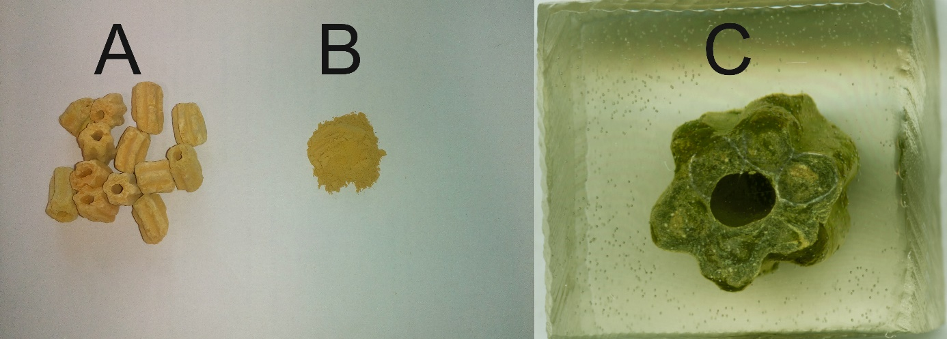
Figure S1. Spent desulfurization catalyst sample derived from the copper smelter sulfuric acid plant: A) as-received, B) crushed and sieved through 250 µm sieve, C) polished section embedded in resin (for microscopic observations)

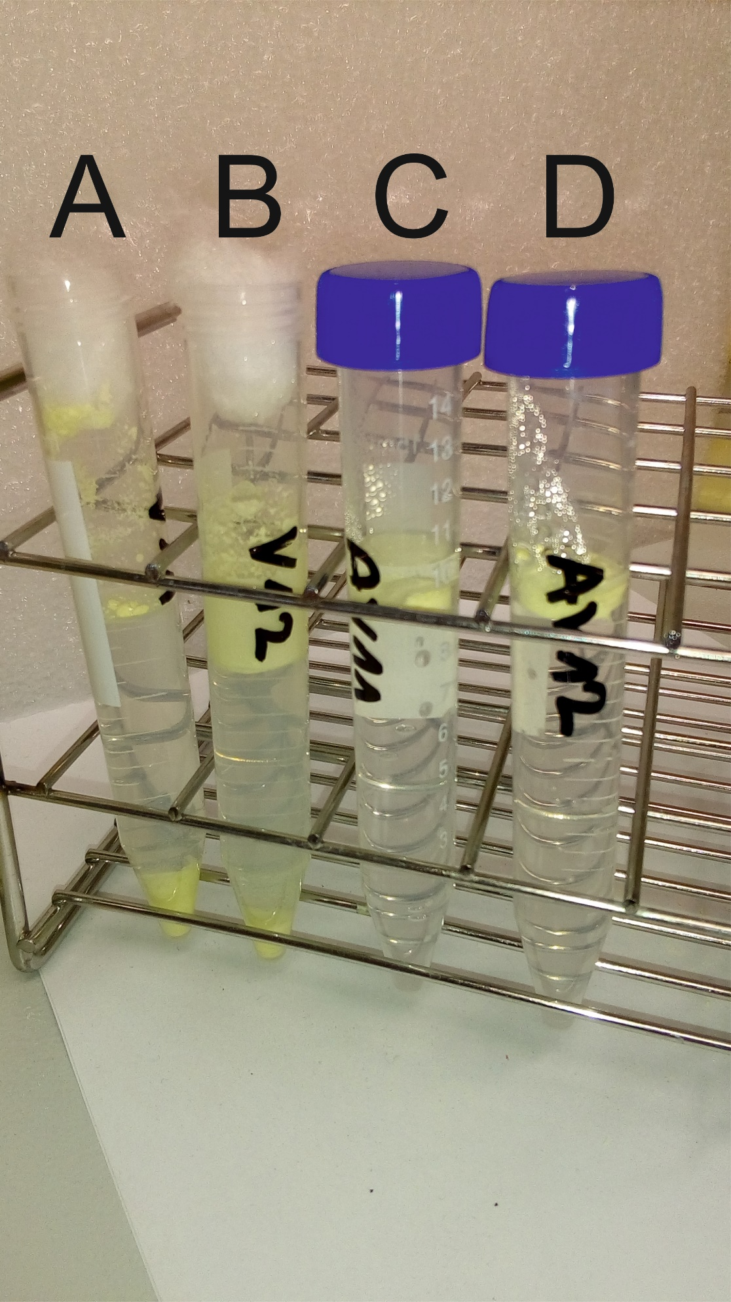
Figure S2. Activity test for Acidithiobacillus thiooxidans experiment (A and B) and abiotic control experiment (C and D)
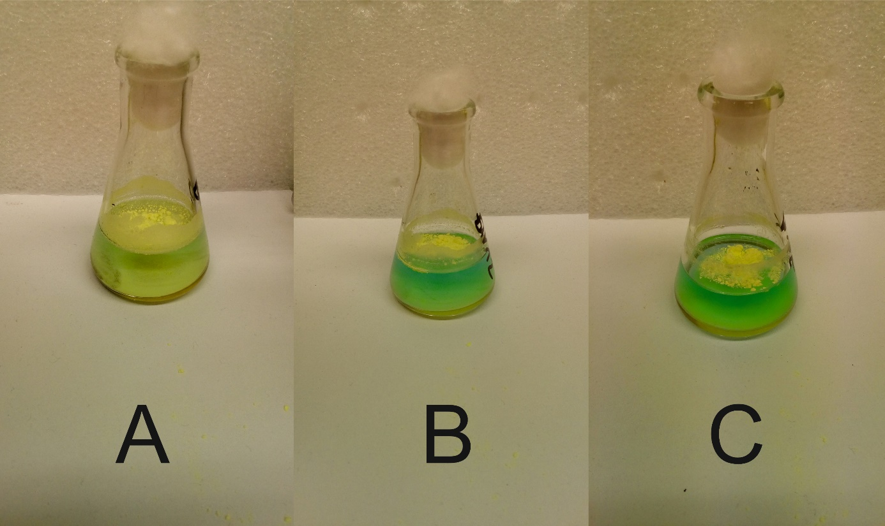Figure S3. Change of solution color in reactors during bioleaching with Acidithiobacillus thiooxidans after 7 days (A), 14 days (B) and 21 days (C)

