Supplementary Information
Microstructural evolution and mechanical properties of rotary friction welded AISI-8630 low-alloy steel
Amborish Banerjee^{a,*}, Michail Ntovasª, Laurie Da Silvaª, Salah Rahimiª, Brad Wynne^{a, b}
ª Advanced Forming Research Centre (AFRC), University of Strathclyde, 85 Inchinnan Drive, Inchinnan, Renfrewshire, PA 4 9LJ, UK
^{b} Department of Mechanical and Aerospace Engineering University of Strathclyde James Weir Building, 75 Montrose Street, Glasgow, G1 1XJ
* Corresponding author. Tel.: +447594660185; Email address: amborish.banerjee@strath.ac.uk, amborishbanerjee1205@gmail.com

The engineering stress-strain curve for the base metal (BM) tested at the 0.1 /s strain rate is shown in Fig. 1a. The corresponding yield strength and ultimate tensile strength of the BM were calculated around 588 MPa and 751 MPa respectively. Moreover, as observed in Fig. 1a, no double yielding phenomenon was observed in the BM. The strain hardening exponent derived from the the plastic regime of the true stress-strain curve as per the Hollomon equation is presented in Fig. 1b. The ln σ-ln ε plot of the BM exhibited a bi-linearity slope, thus demonstrating the lower regime (or first stage) and upper regime (second stage) of the strain hardening behaviour.
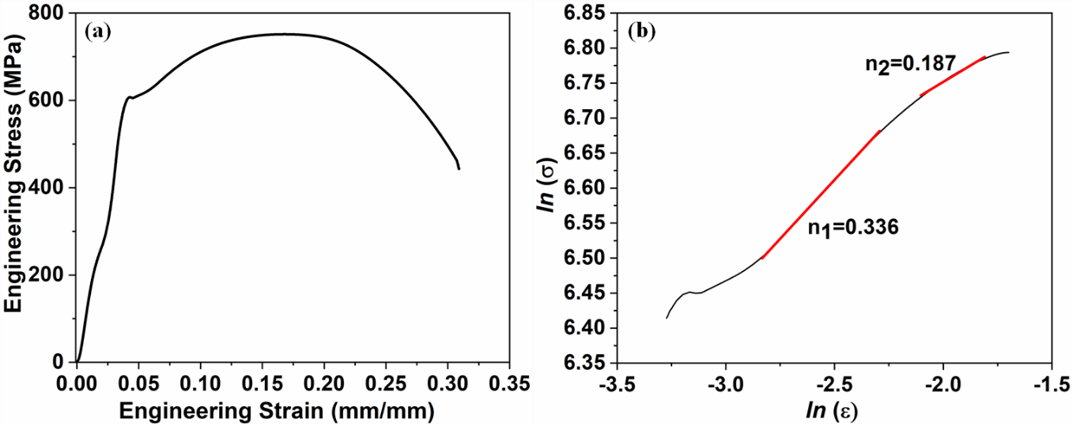
Fig. 1. (a) Engineering stress-strain curve and (b) strain hardening behaviour of the BM.

