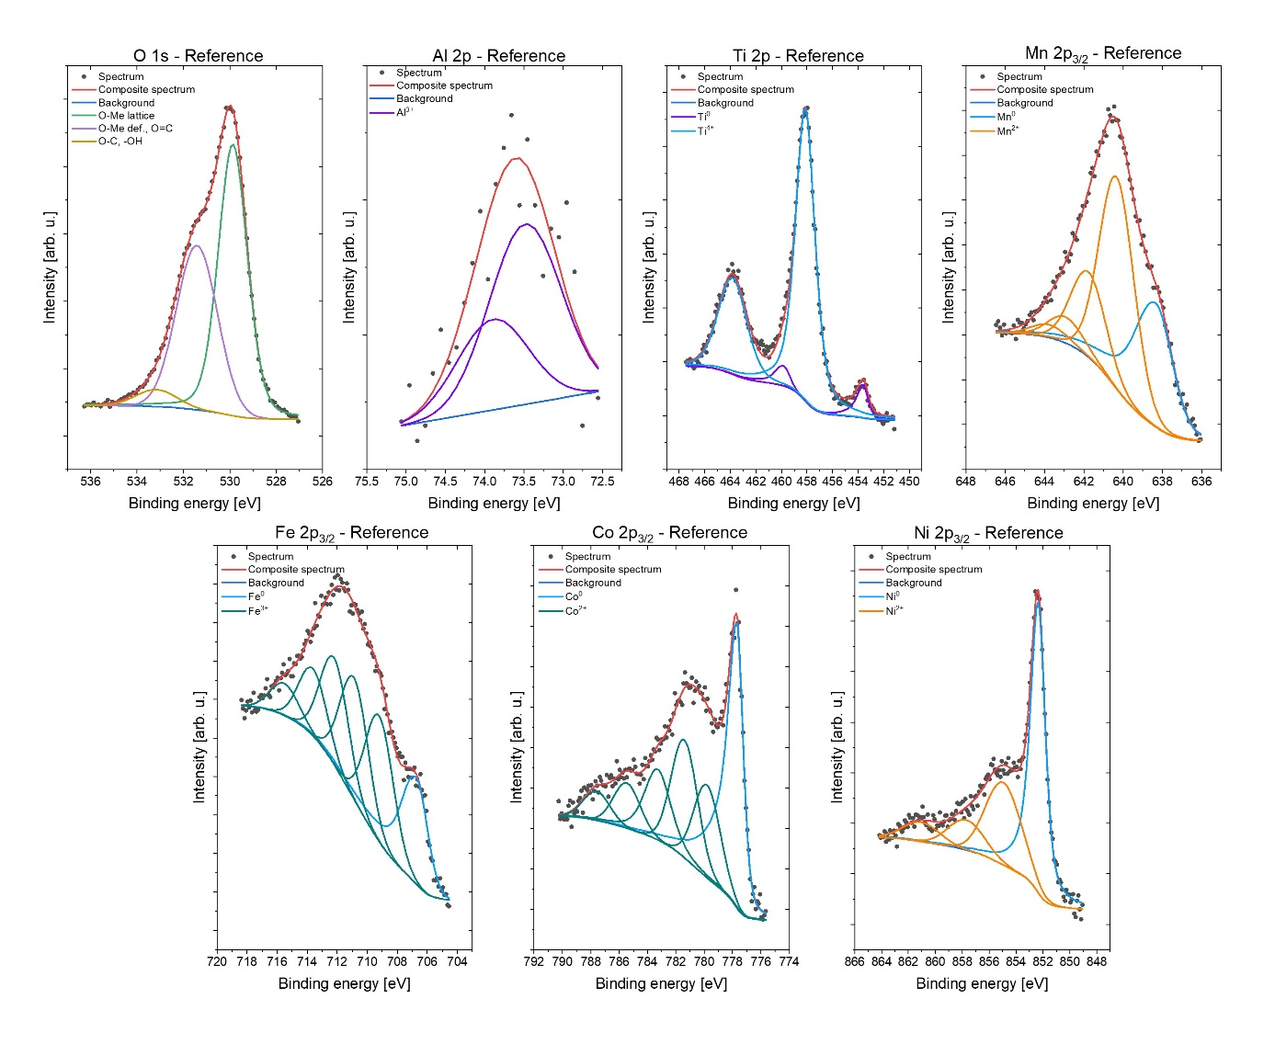
Figure S1. High-resolution spectra for the reference sample.
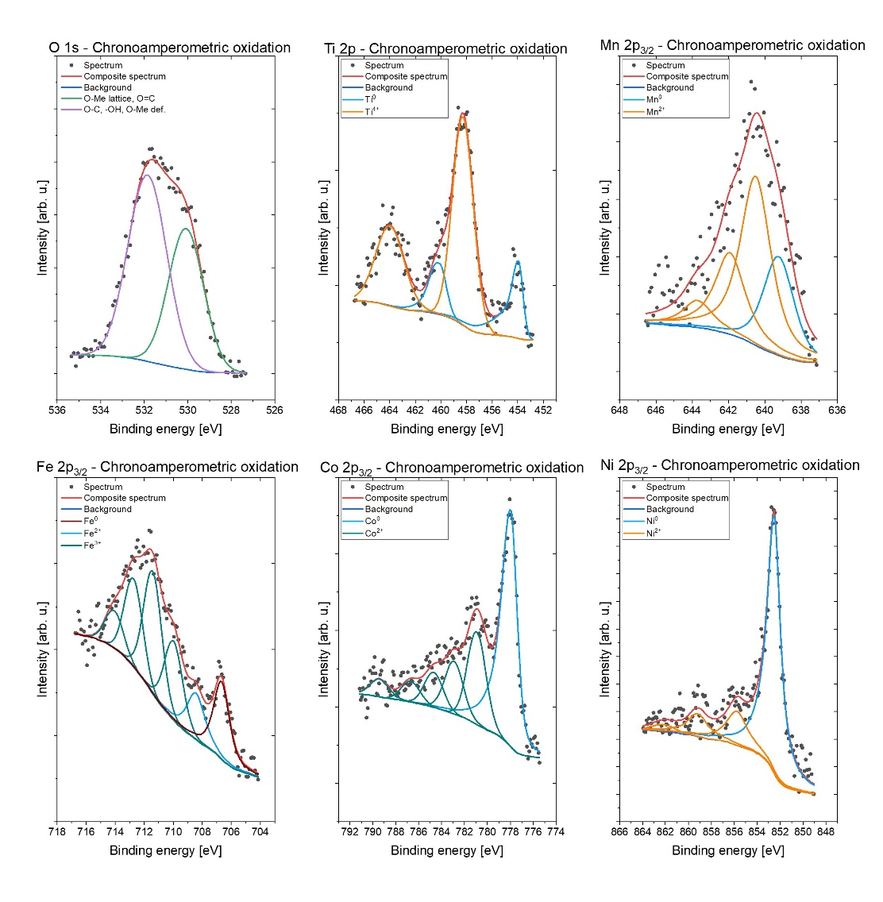
Figure S2. High-resolution spectra for the sample after chronoamperometric oxidation.

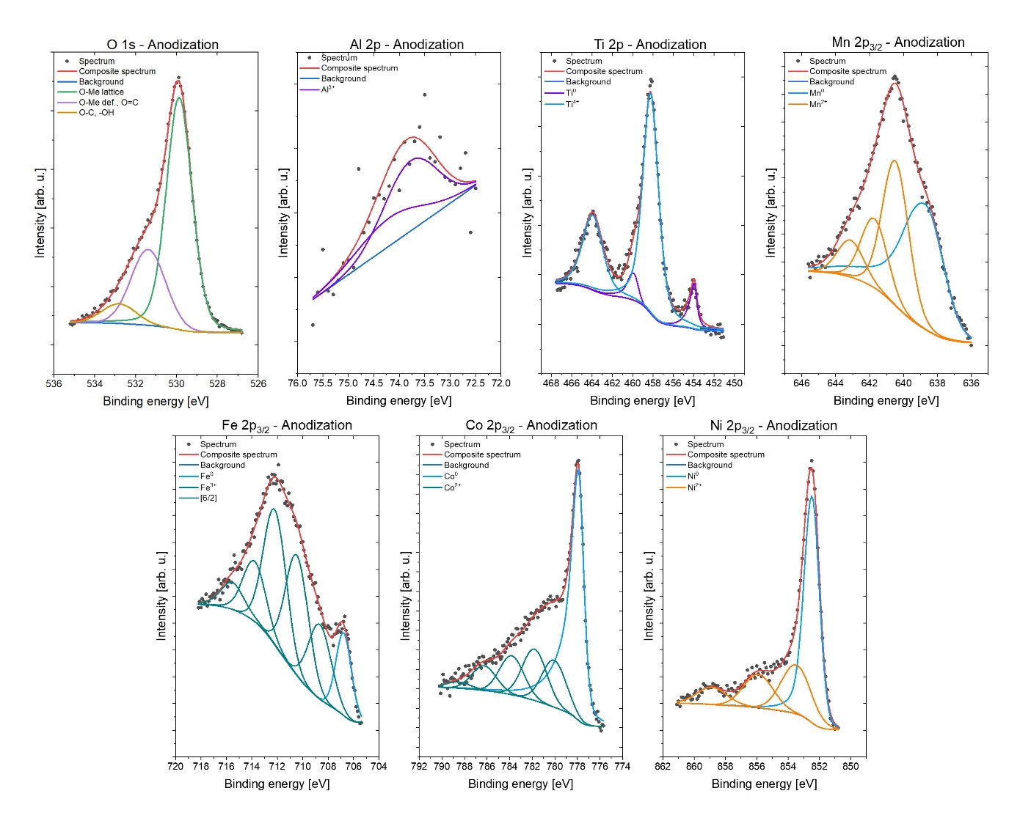
Figure S3. High-resolution spectra for the sample after anodization.
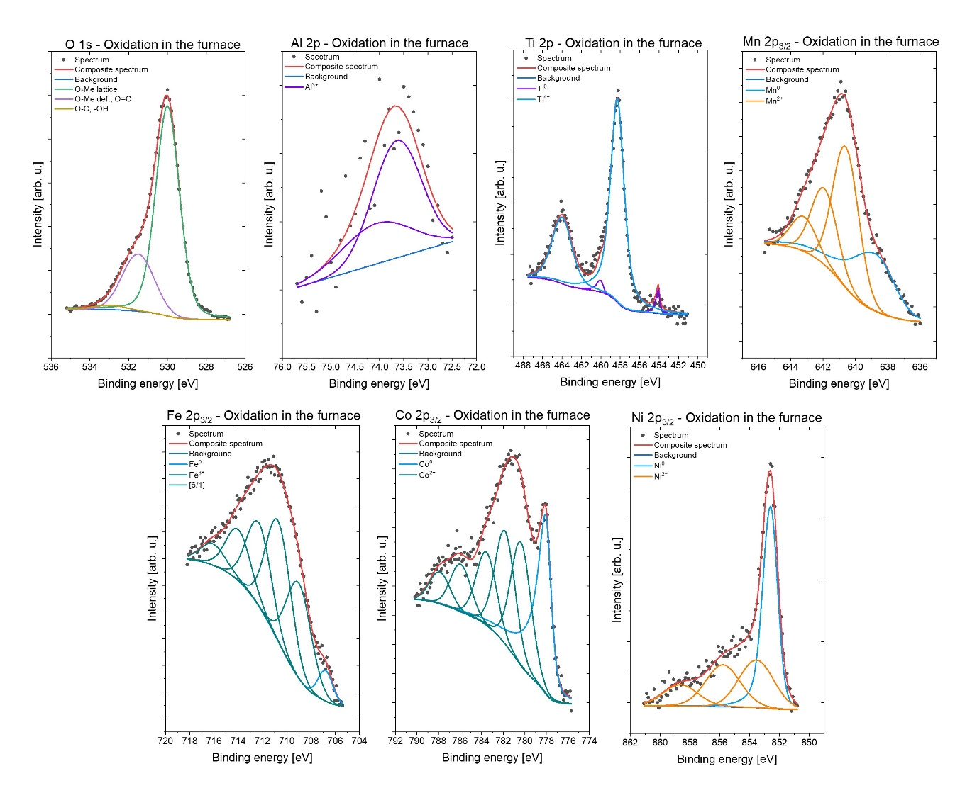
Figure S4. High-resolution spectra for the sample after oxidation in the furnace.

