Supplementary: Mechanochemical-Calcination of Mixed Layer and Pure Kaolinite/Illite Clays for Use as Supplementary Cementitious Materials: Reactivity and Strength

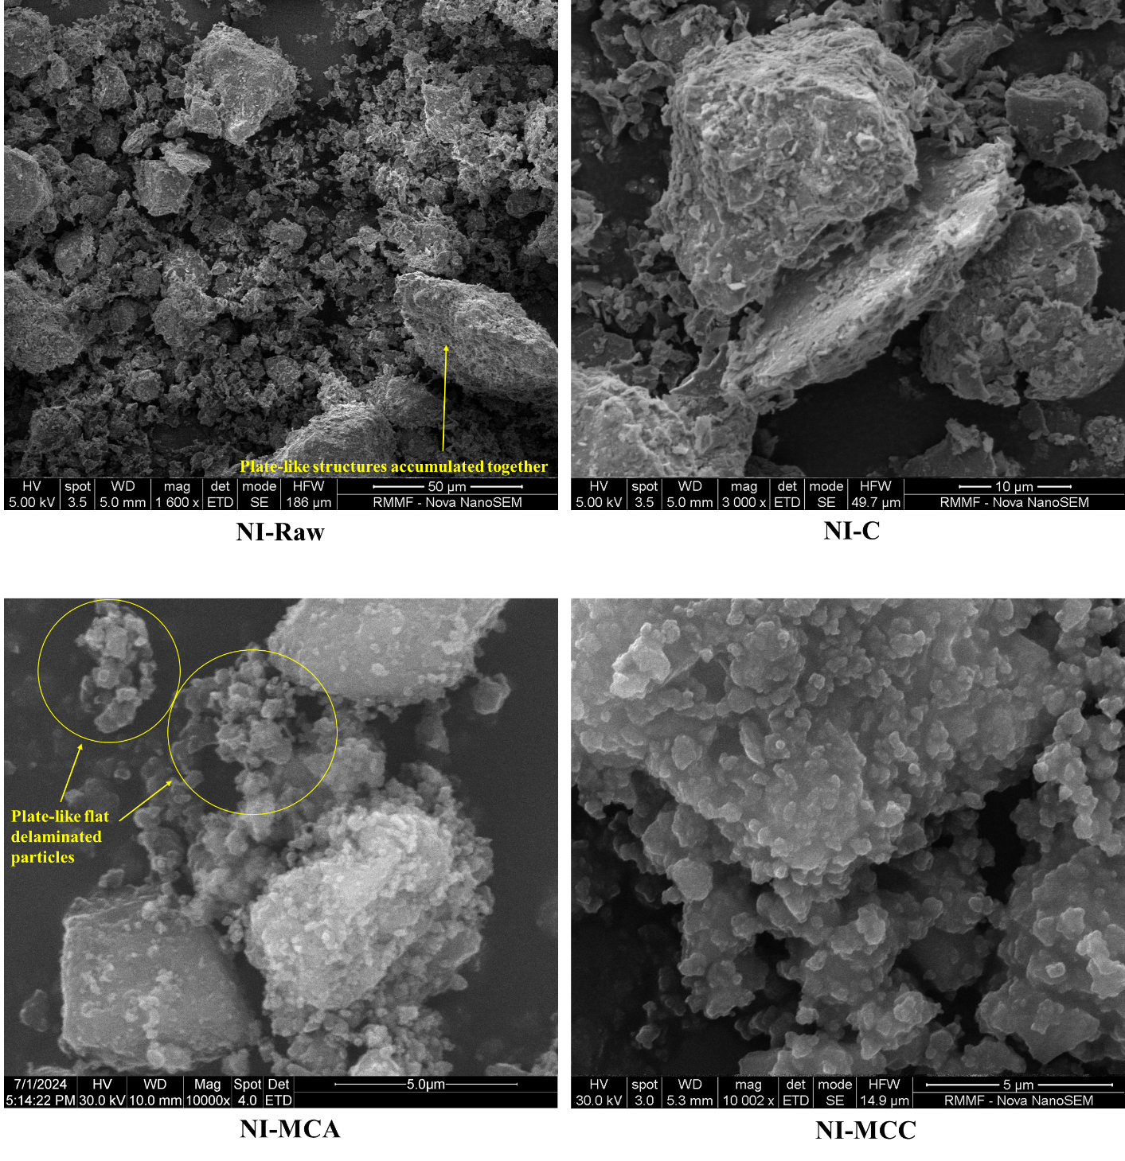
Fig.S1: SEM images for raw and activated NI clays
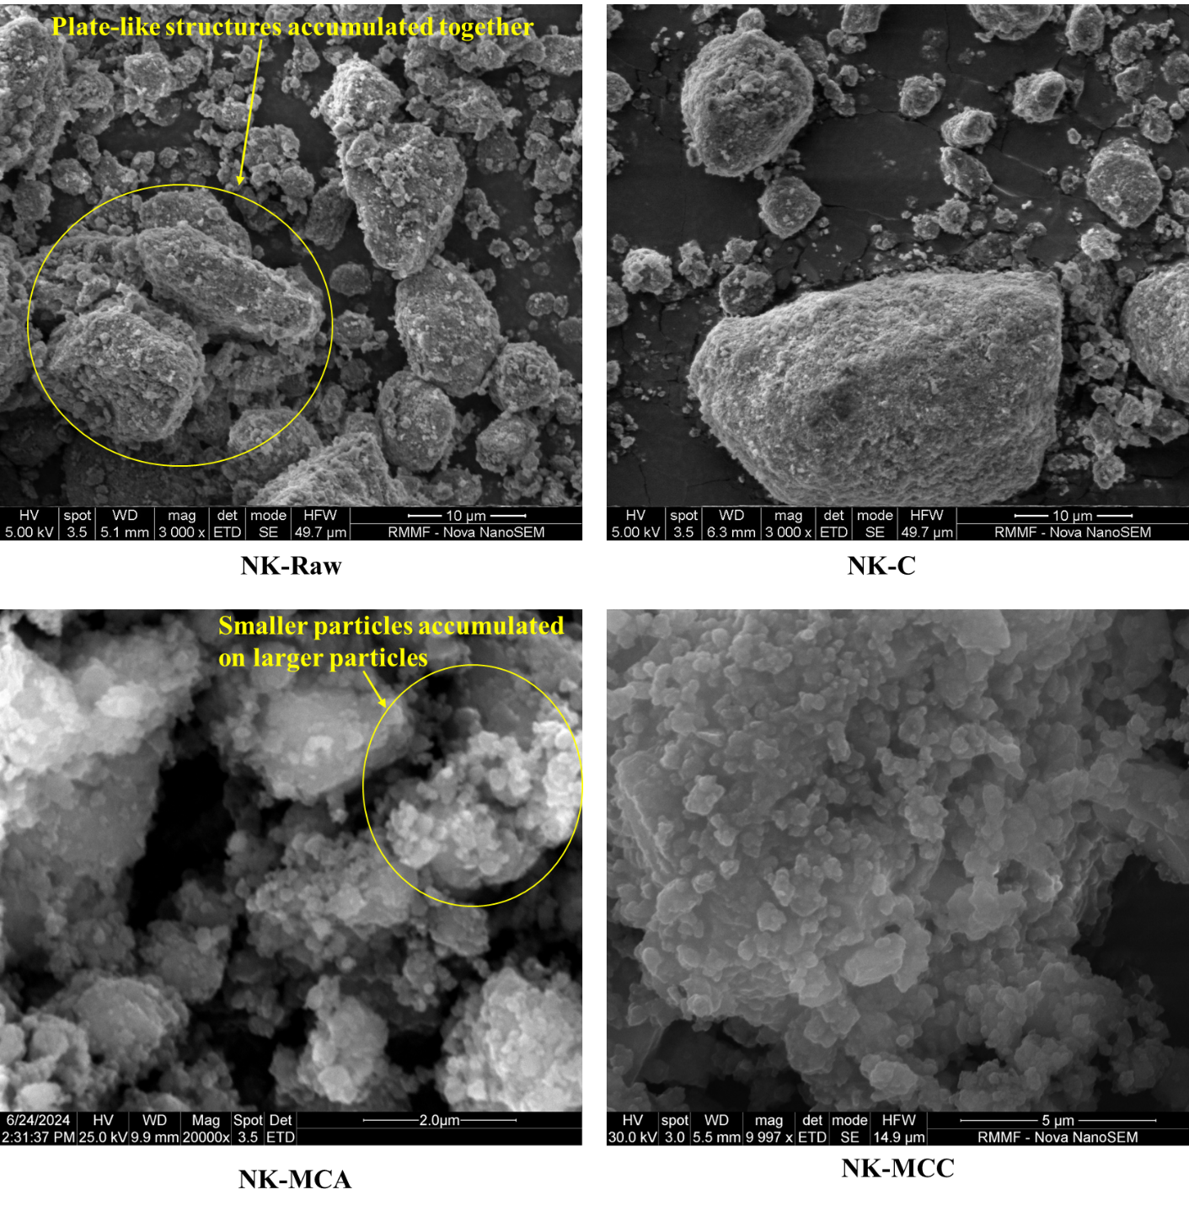
Fig.S2: SEM images for raw and activated NK clay

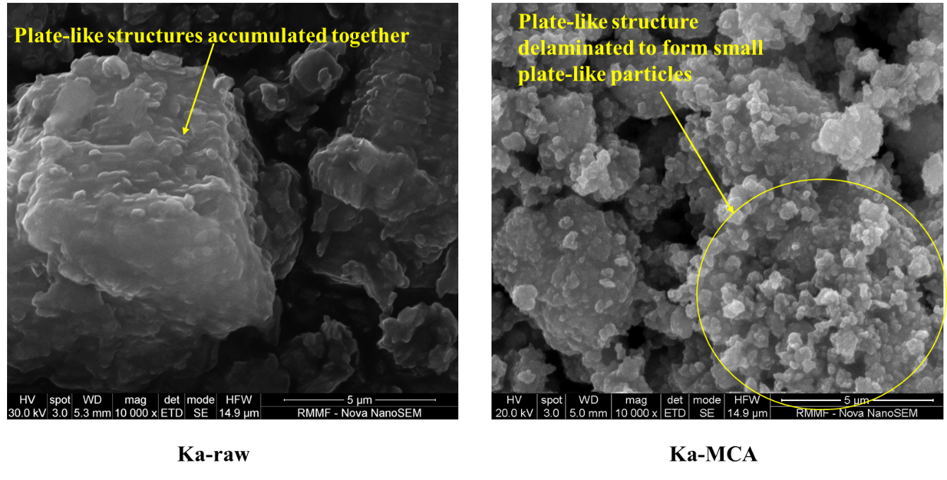
Fig.S3: SEM images for raw and activated Ka clay

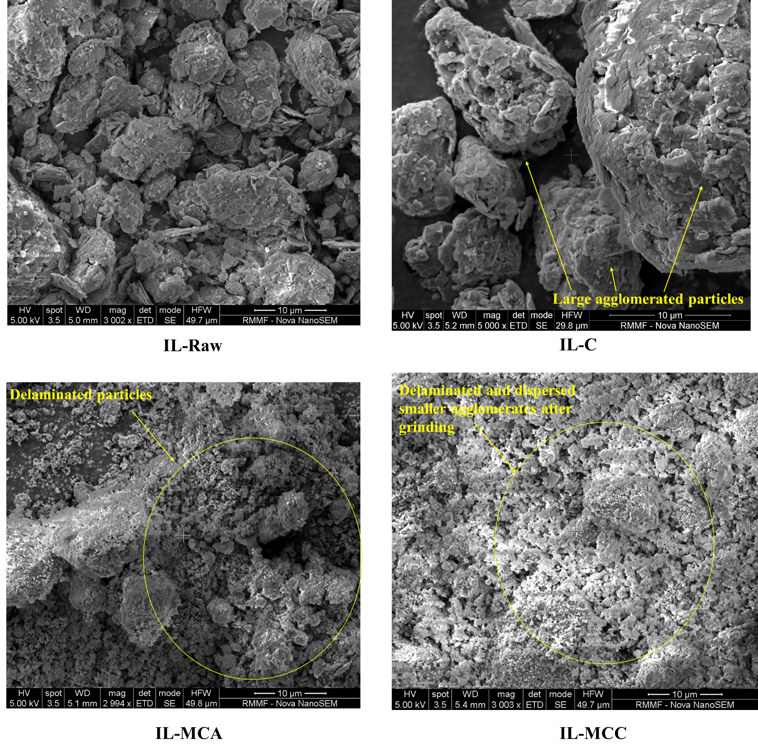
Fig.S4: SEM images for raw and activated IL clay

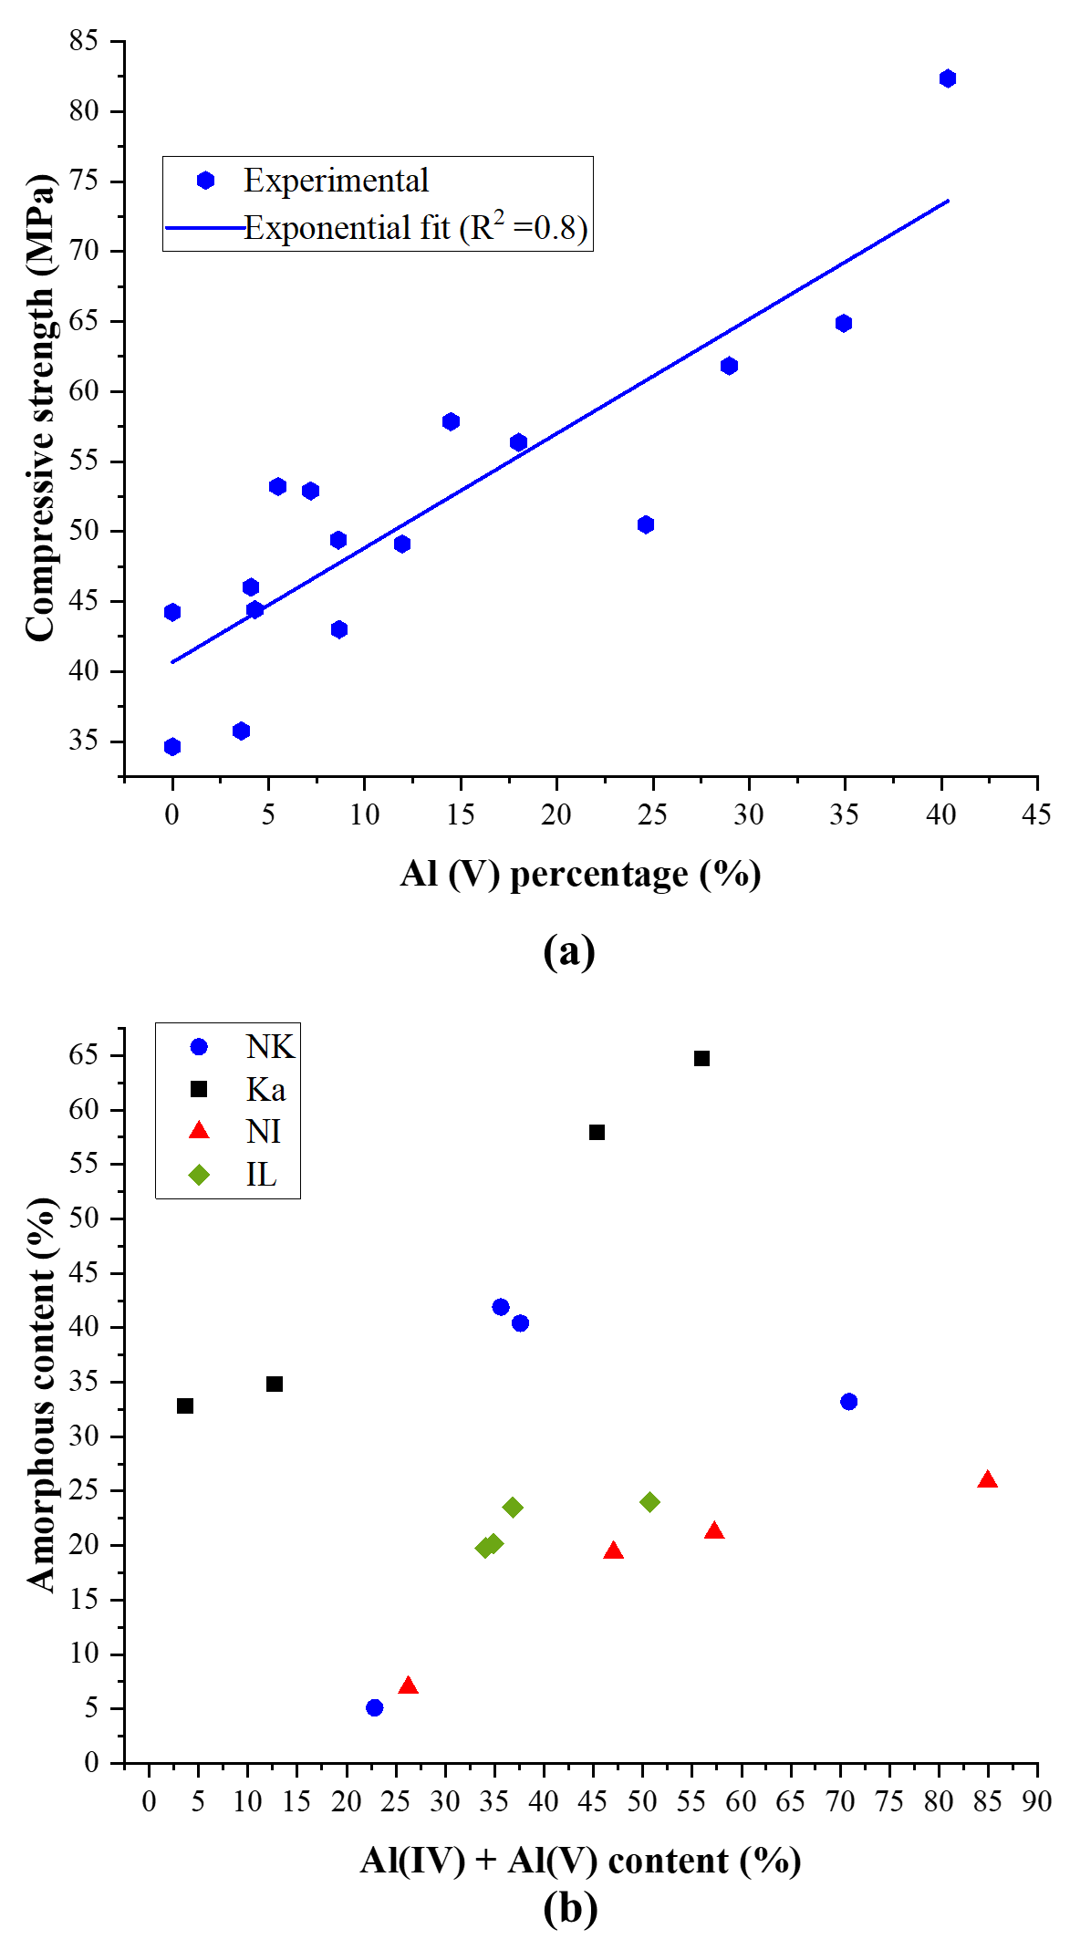
Fig. S5 : (a) Relationship between 28-day compressive strength and Al(V) percentage (b) Variation of amorphous content with total Al(IV)+Al(V) content
Fig. S6 : Pore diameter distribution

