Figure 1
Excerpt from a Sample District Feedback Report: District averages for each of implementation leadership, climate, and citizenship behaviors.
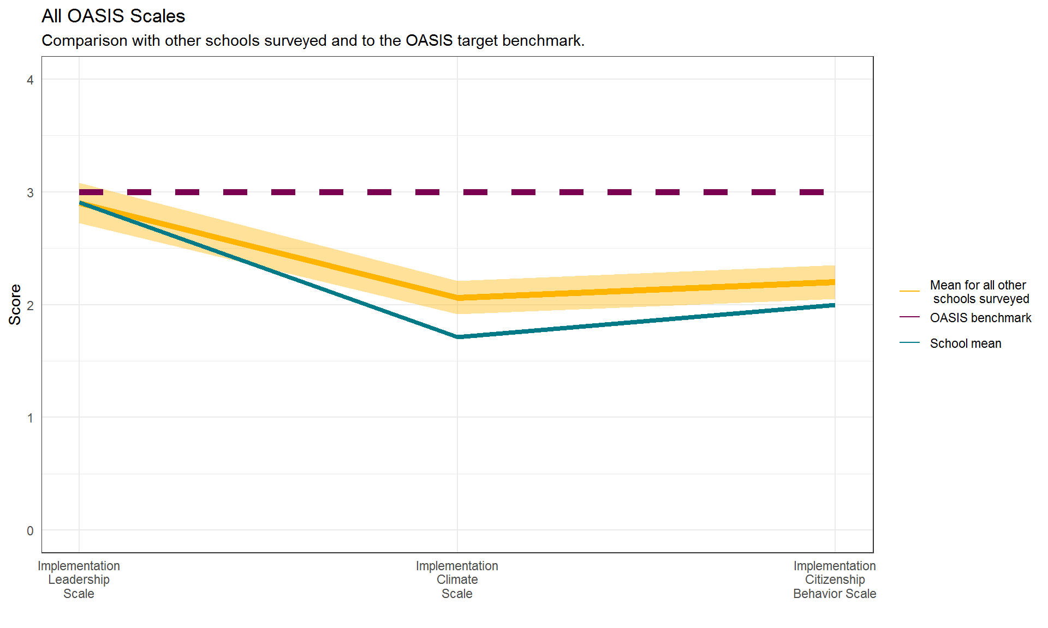
Note: OASIS = the acronym for the parent study
Figure 2
Excerpt from a Sample District Feedback Report: Averages for implementation leadership for each within the district.

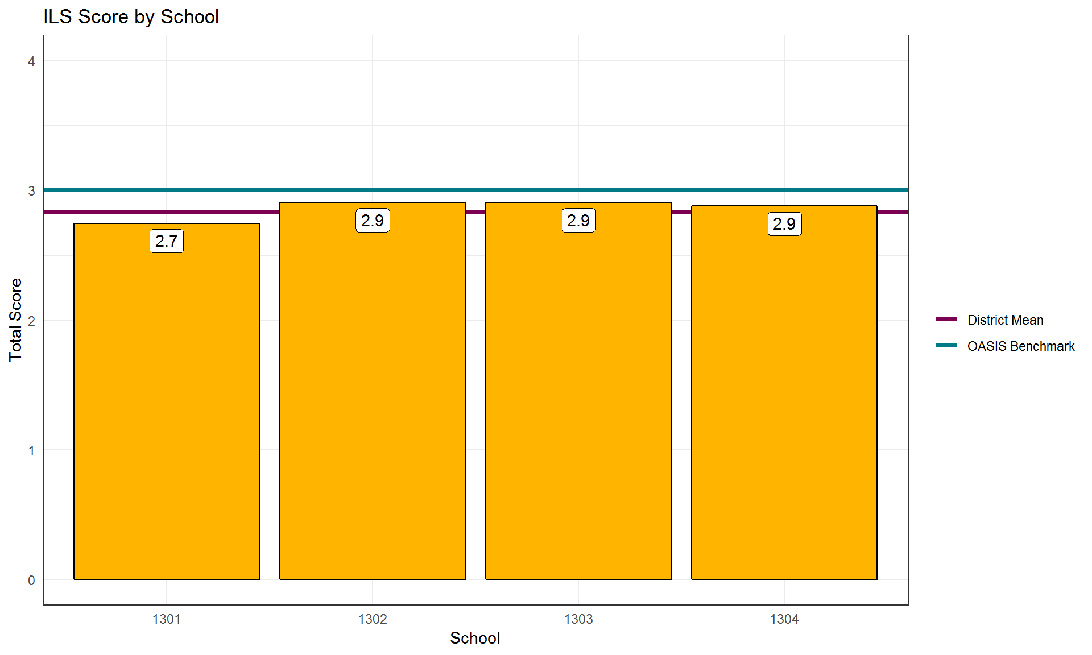
Note: ILS = implementation leadership scale

Figure 3
Excerpt from a Sample District Feedback Report: District averages for each of the implementation leadership subscales.

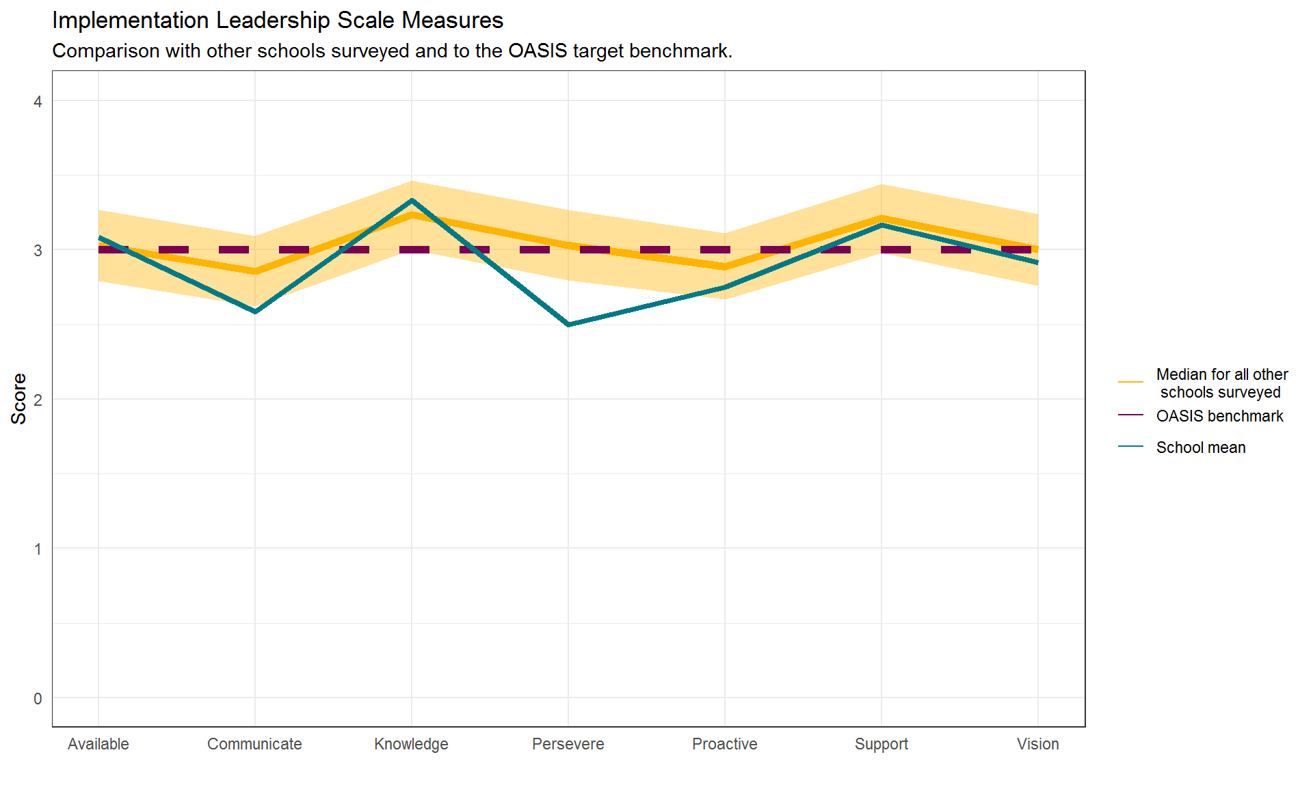 Note: OASIS = the acronym for the parent study
Figure 4
Excerpt from a Sample District Feedback Report: Average responses for an item from one implementation leadership subscale (the report includes all items for each subscale).
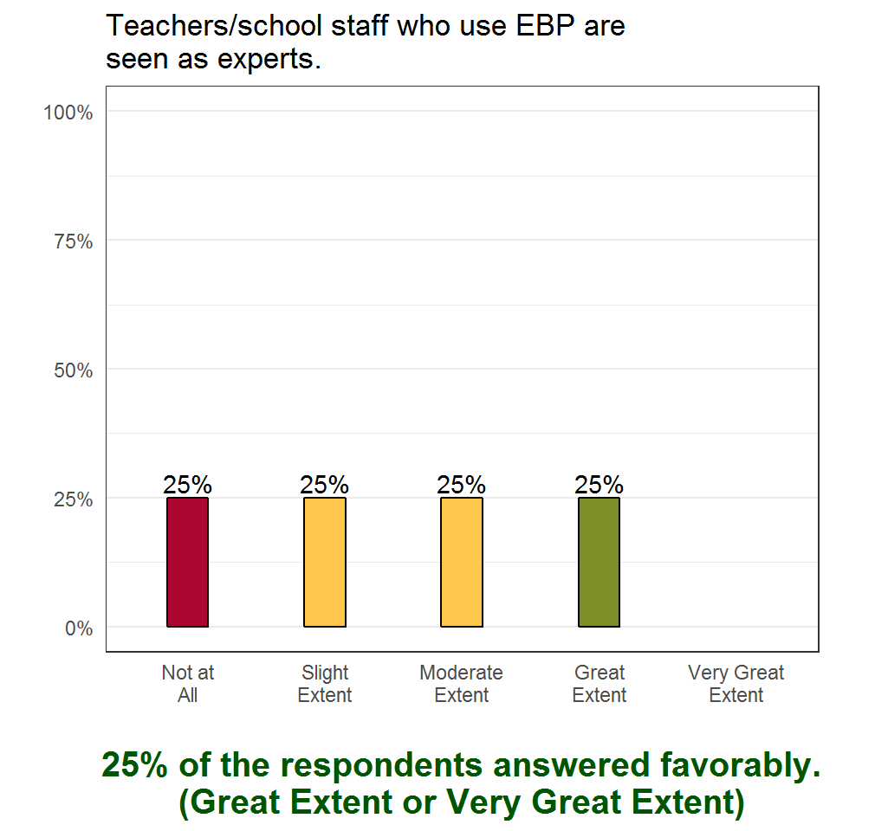
Note: EBP = evidence-based practice.

