SUPPLEMENTARY MATERIALS

TABLE OF CONTENTS

CONTENT | Page
APPENDIX 1. Survey and interview questions used in phase 1 | 2
APPENDIX 2. Survey and Interview questions used in phase 3 | 3
APPENDIX 3. ExAMPLE OF CENTER-SPECIFIC and COHORT REPORT | 3
APPENDIX 4. questions used in phase 4 | 4
APPENDIX 5. Questions used to improve PROACTIVE dissemination TOOLS | 4
APPENDIX 6. CHARACTERISTICS OF Latin American and Spain PROACTIVE centers | 5
APPENDIX 7. phase 1 RESULTS | 6
Appendix 8. PROACTIVE Domains and Subdomains | 7
Appendix 9. Impact and Effort Matrix for prioritization of regional QI initiative | 8
Appendix 10. Phase 3 results | 9
Appendix 11. Phase 4 results | 10
Appendix 12. Examples of dissemination TOOLS for PROACTIVE RESULTS | 11-12

Appendix 1. Survey and interview questions used in phase 1.

Aim: Improve the Spanish language medical terminology, content, and structure of Spanish-PROACTIVE
Date: May-June 2023
Questions (translated to English):
- Were the PROACTIVE components (assessment questions, site-specific report, and QI workshop materials) clear and appropriate in terms of content? Language?
- Was there any information you believe should have been included but was missing from the PROACTIVE assessment tool and report?
- Did you encounter any terms or wording that were unclear or confusing?
- Do you have any suggestions to improve the Spanish-PROACTIVE assessment tool, facility report, or QI materials? Consider aspects such as clarity of language, accuracy of terminology and overall organization.

Appendix 2. Survey and Interview questions used in phase 3 to identify barriers and facilitators for dissemination.

Aim: Identify the barriers and facilitators in dissemination of PROACTIVE results
Date: July to September 2023
Questions (translated to English):
- Do you believe that disseminating your PROACTIVE results is important?
- Do you feel confident in your ability to effectively share or disseminate your results within your institution? Please explain.
- Since receiving your PROACTIVE results, which of the following actions have you or your team taken? (Check all that apply): a) Held meeting(s) with your team to review the results; b) Participated in the virtual QI workshop; c) Held meeting(s) with hospital leadership to present your results; d) Held meeting(s) with your team or leadership to prioritize potential quality improvement projects based on your results; e) Identified a workgroup to plan QI projects.
- What specific activities have been most effective in sharing your PROACTIVE results and initiate improvement interventions? Please describe any formal dissemination efforts.
- How do you and your team plan to use your PROACTIVE results over the next 6 months? (e.g., initiative QI projects, advocate for resources, inform training)
- If applicable, what strategies or processes have worked well – or not – when sharing your facility’s results? What would you do differently?
- What challenges have you encountered in disseminating your PROACTIVE results at your institution? Based on your experience, what suggestions would you offer to help other teams?
Appendix 3. Spanish-PROACTIVE site-specific report example.
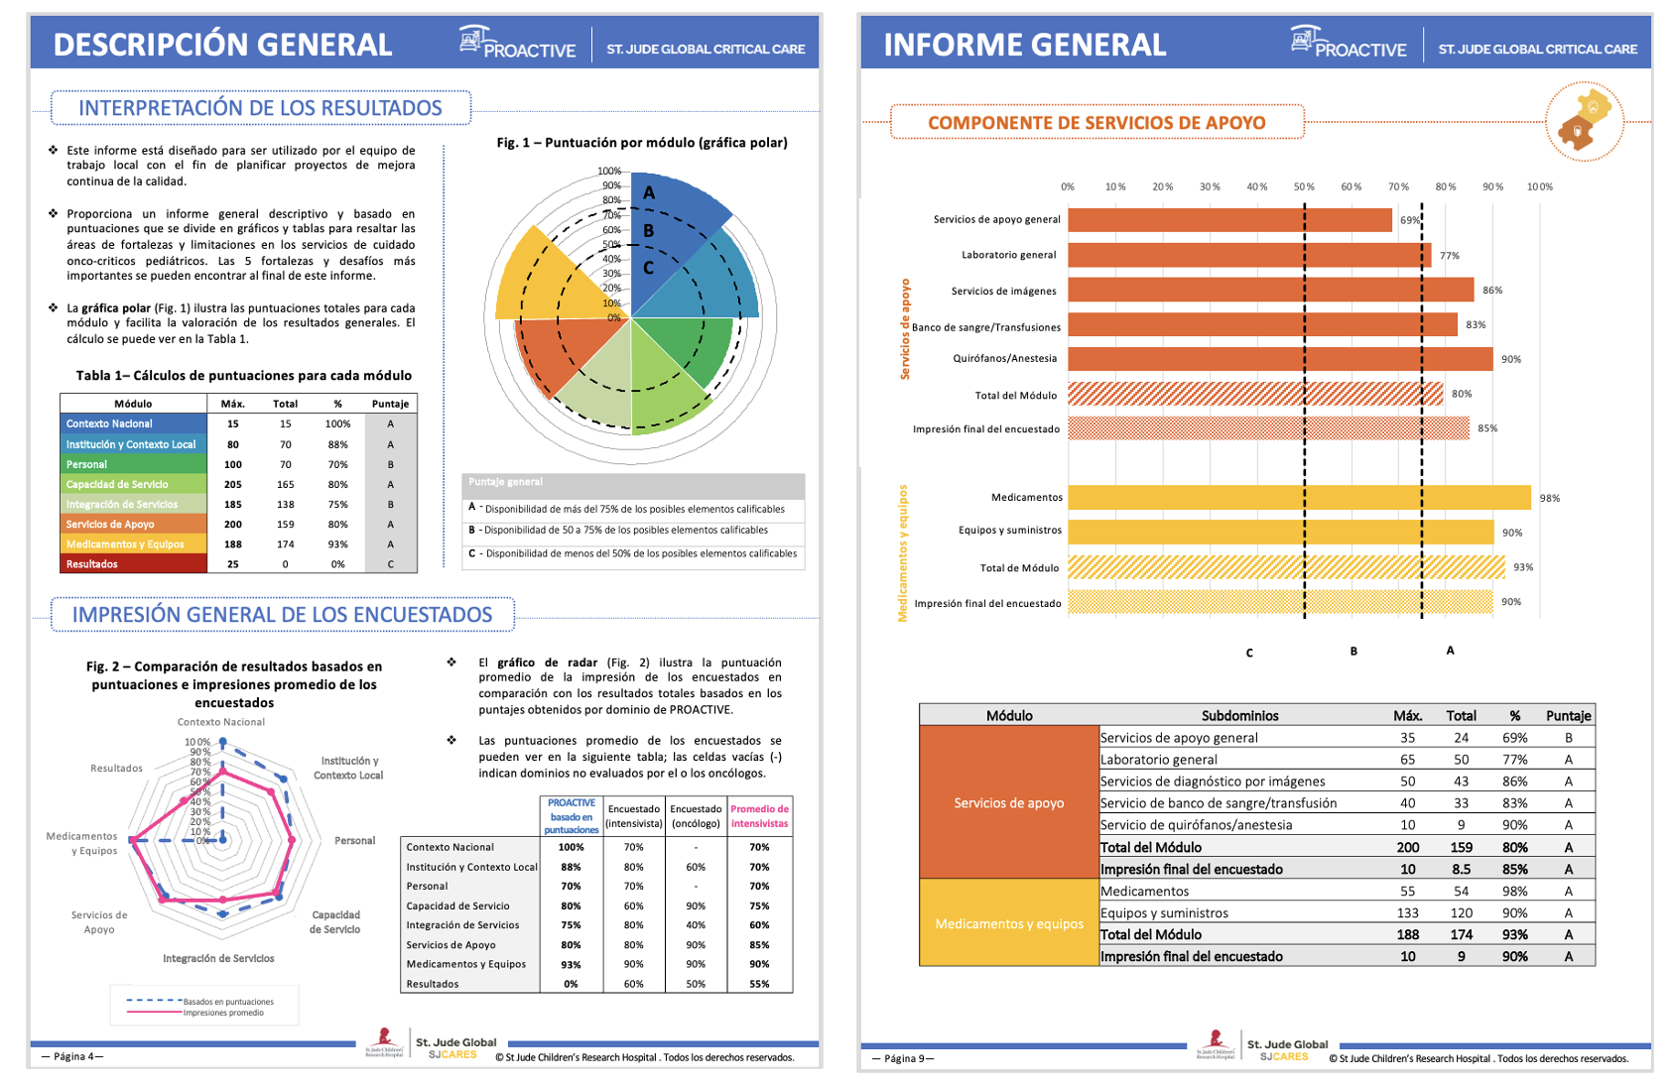
Appendix 4. Questions used in phase 4 to identify and develop dissemination materials.

Aim: Development of dissemination materials
Date: November 2023 – March 2024

Questions (translated to English):
- What motivates your team to disseminate PROACTIVE results? Consider internal drivers like improving care, external requirements, or institutional priorities.
- At what point during the PROACTIVE process did your team begin planning dissemination-related activities?
- As part of dissemination, who do you believe should be informed about the PROACTIVE findings? who within your institution is most likely to be influenced by them?
- What methods or strategies does your team typically use to share findings or data from quality improvement or research projects?
- Of the methods mentioned, which do you believe are both impactful and feasible for sharing your PROACTIVE results in your facility?

Appendix 5. Questions used to improve PROACTIVE dissemination tools.
Aim: Improvement of dissemination materials
Date: March 2024

Questions (translated to English):
- Is there any important information missing from the presentation or pamphlet that you believe should be included? If yes, what type of information or data should be added? Please explain.
- Do you think the information in the presentation and pamphlet is useful for disseminating the results at your center?
- If not, what additional content or changes would make to the presentation and pamphlet more useful or impactful for your center?
- If you have already used these materials to present findings at your center, is there anything you would add or modify (e.g., additional data, messaging)? Share any suggestions based on your experience.

Appendix 6. Characteristics of Latin American and Spain PROACTIVE centers

Center Location | Country Income Level † | Hospital Type | Funding Structure | ICU Type | Number of PICU beds | Average annual PHO admissions
- Argentina – Córdoba | UMIC | Children’s | Public | PICU | 26 | 480
- Argentina – Pilar | UMIC | General (adult and pediatric) | Private | PICU | 12 | 80
- Argentina – Santiago del Estero | UMIC | Children’s | Public | PICU | 12 | 45
- Chile – Santiago | HIC | Children’s | Public | PICU | 7 | 548
- Colombia – Bogotá | UMIC | Children’s | Private | PICU | 56 | 750
- Colombia – Bogotá | UMIC | General (adult and pediatric) | Private | PICU | 9 | 28
- Colombia – Bogotá | UMIC | Oncology (adult and pediatric) | Public | PICU | 6 | 300
- Colombia – Bucaramanga | UMIC | General (adult and pediatric) | Private | PICU | 5 | 145
- Colombia – Cali | UMIC | General (adult and pediatric) | Private | PICU | 10 | 1301
- Colombia – Cali | UMIC | General (adult and pediatric) | Private | PICU | 40 | 799
- Colombia – Medellín | UMIC | General (adult and pediatric) | Private | PICU | 14 | 120
- Ecuador – Guayaquil | UMIC | Oncology (adult and pediatric) | Private | PICU | 3 | 3500
- El Salvador – San Salvador | LMIC | Children’s | Public | PICU | 22 | 1100
- Guatemala – Guatemala City | UMIC | Pediatric Oncology | Public | PICU | 9 | 2099
- Haití – Puerto Príncipe | LMIC | Women’s and Children’s | Private | PICU | 10 | 197
- Honduras – Tegucigalpa | LMIC | General (adult and pediatric) | Public | PICU | 7 | 277
- México – Toluca | UMIC | Women’s and Children’s | Public | PICU | 15 | 360
- México – Toluca | UMIC | Children’s | Public | PICU | 8 | 900
- México – León, Guanajuato | UMIC | General (adult and pediatric) | Public | PICU | 4 | 510
- Perú – Lima | UMIC | Children’s | Public | PICU | 15 | 381
- Spain – Madrid | HIC | General (adult and pediatric) | Public | PICU | 18 | 956
- Venezuela – Maracaibo | N/A | Children’s | Public | PICU | 3 | 100

Abbreviations: UMIC - Upper Middle-Income Country; HIC – High-Income Country; LMIC – Low- to Middle-Income Country; ICU-Intensive Care Unit; PHO – Pediatric Hematology-Oncology.
† Based on the World Bank classification (2023 fiscal year)

Appendix 7. Results from the survey and focus group meetings in phase 1

Results (Changes)
- Total number of words/terms changed | 5 words were changed to be more representative of the Spanish-medical language of the region, this resulted in 17 questions being improved in the tool and report; these changes did not change the content of the questions or information being gathered (e.g., “consultores” was changed to “medicos consultantes/interconsultantes”)
- Total number of definitions improved | 2 new clarifications of definitions used in the tool were added to clarify the meaning of “closed unit” and “healthcare workers.”
- Total number of terms changed to improve content | 1 term was improved to clarify that the “primary cause of death was due to sepsis” (primary added). This change resulted in 1 question improvement.

Appendix 8. PROACTIVE Domains and Subdomains

Domains | Sub-domains
- National Context | - National Profile & Training Programs
- Facility and Local Context | - Configuration of Services and Facility Utilities
- Personnel | - Core Team
- Personnel | - Core Consultants
- Personnel | - Staffing
- Personnel | - Education, Research, and Quality Improvement
- Service Capacity | - Service Organization
- Service Capacity | - Acute Management of Critically Ill Pediatric Hematology Oncology Patients
- Service Capacity | - Pediatric Outreach Team
- Service Capacity | - Standard Precautions and Infection Prevention
- Service Capacity | - Guidelines and Protocols
- Service Integration | - Communication and Multidisciplinary Care
- Service Integration | - Parent Involvement
- Service Integration | - Quality Indicators
- Supportive Services | - General Supportive Services
- Supportive Services | - General Laboratory
- Supportive Services | - Imaging Services
- Supportive Services | - Blood Bank/Transfusion Services
- Supportive Services | - Operating Rooms/Anesthesia
- Medication and Equipment | - Medications
- Medication and Equipment | - Equipment and Supplies
- Outcomes | - Diagnosis & Outcomes

Appendix 9. Impact and Effort Matrix for prioritization of regional QI initiative – Activity done in Spanish.
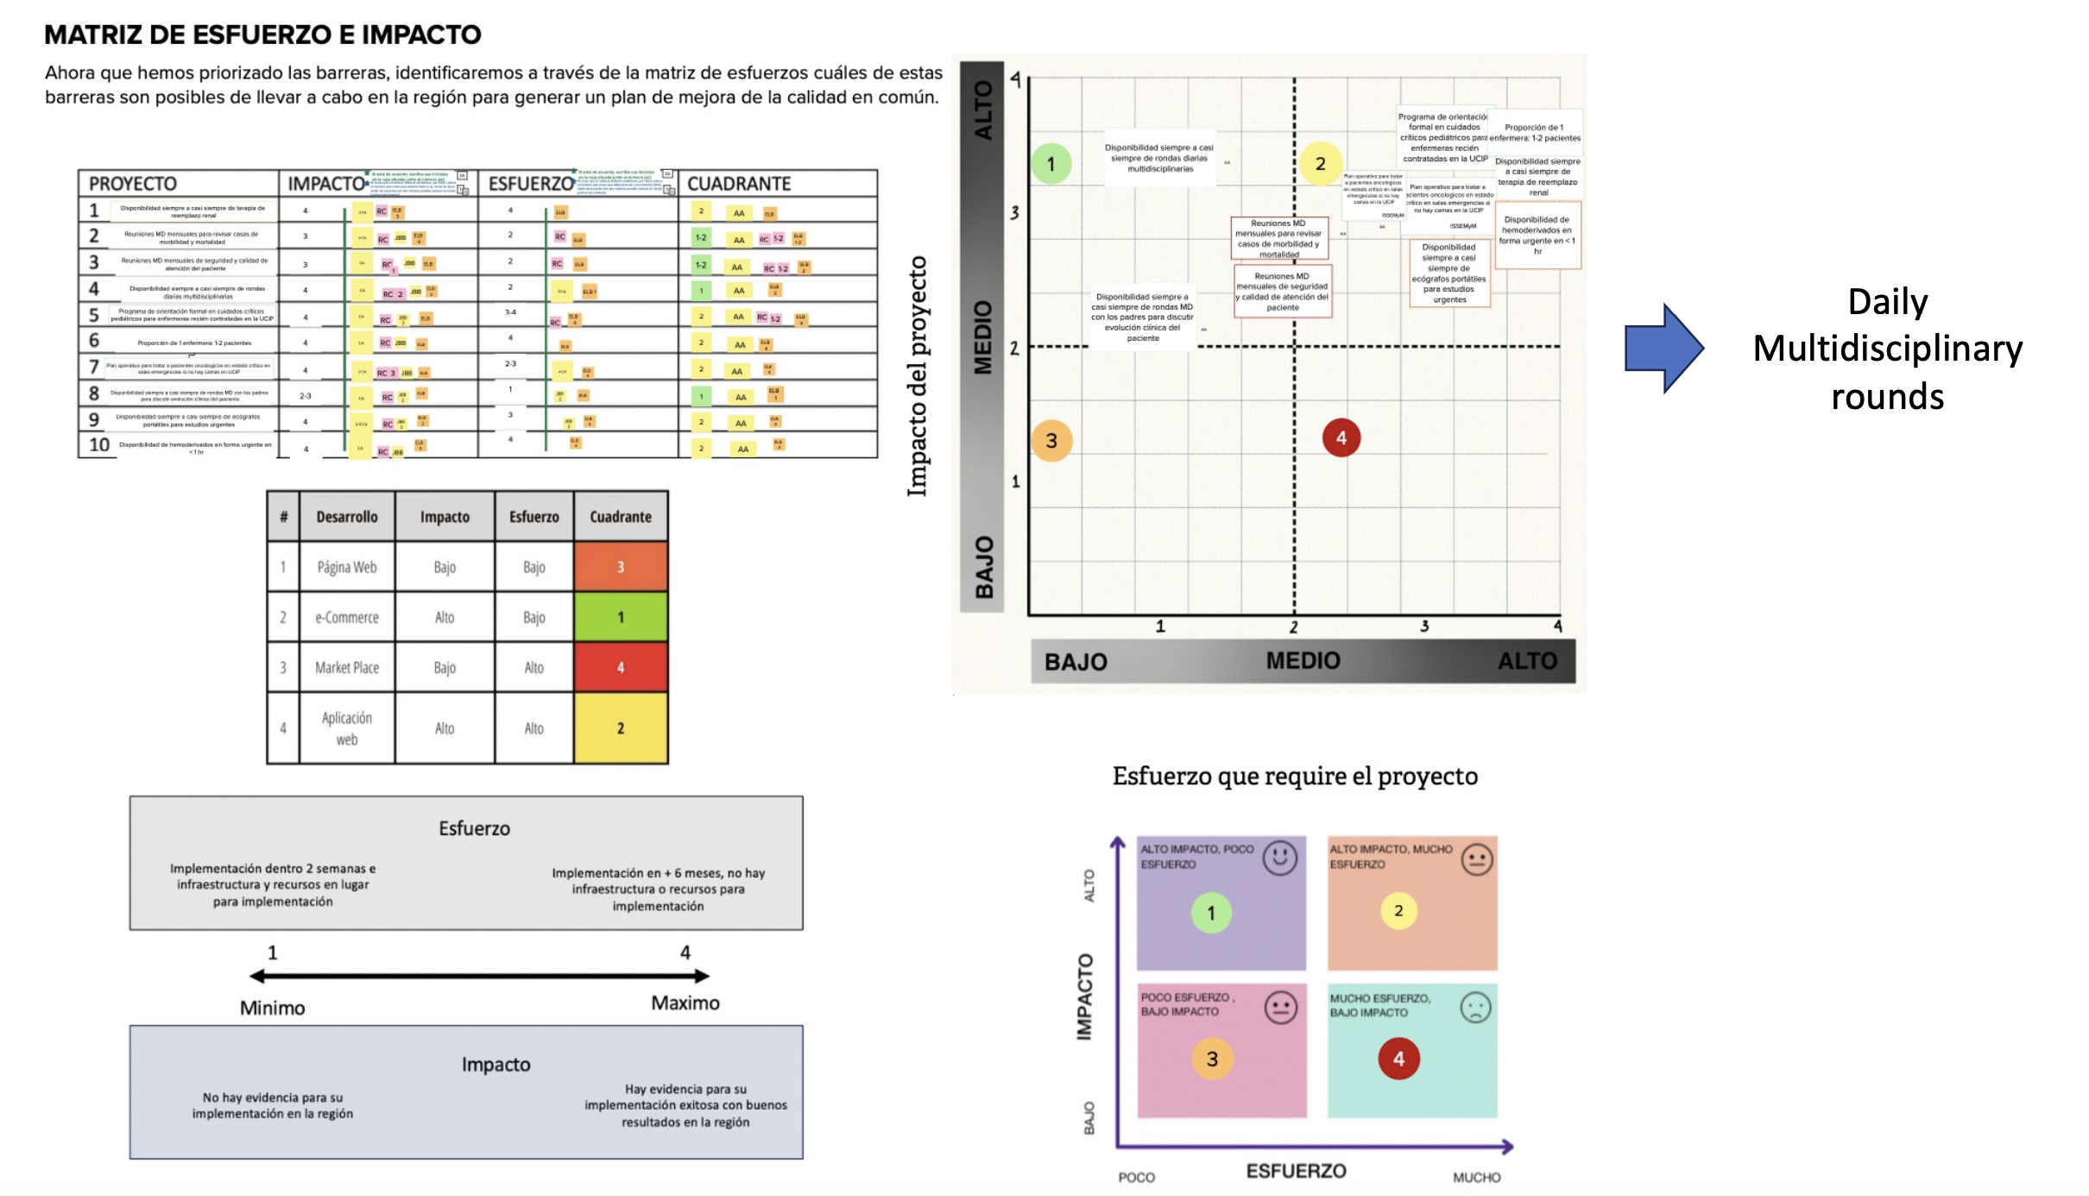
Appendix 10. Phase 3 results from survey and focus groups (N=24)*

Domains | Categories | Key Themes | Example Quotes (translated from Spanish)
Facilitators | Methods | - Accessibility (language – access to PROACTIVE in Spanish) | “Having the tool in Spanish has been extremely helpful, we have been able to gain a better understanding of our services and include other team members for discussion that we were not able to before”
Facilitators | Benefits | - Knowledge-transfer (ability to share information via reports) | “The results in the report allowed us to graphically visualize how we are doing in our clinical services and to share the data with hospital leaders.” “The results provide us with a way to benchmark, influence practices and for quality control.”
Facilitators | Benefits | - Collaboration (teamwork) | “The process has improved our teamwork and communication by sharing our results with other teams”
Facilitators | Benefits | - Leadership buy-in | “Having the hospital leadership and unit leaders involved from the beginning was extremely important not only to have access to reliable data but to have the space to share our results”
Facilitators | Benefits | - Capacity building (acting on results and becoming QI experts) | “I believe that once we start developing QI activities based on our results, our team will continue to ‘grow’ as leaders in QI at our institution”
Barriers | System-level | - Time constraints (competing responsibilities) | “I do believe that the more people who are involved in the project the better, however lack of time and competing responsibilities are significant barriers for discussing results as a group”
Barriers | System-level | - Workforce engagement | “Nurses are essential for the success of QI project and dissemination of results. Unfortunately, our nurses are often unable to participate in projects like PROACTIVE because clinical duties take priority, and there is no protected time for QI activities”
Barriers | System-level | - Inadequate support/resources for dissemination | “Given our hospital context, making meaningful changes is going to require external support and guidance – tools to present our results effectively in our hospital”
Barriers | Education | - Lack of knowledge on how to communicate results | “it’s been difficult to explain to our hospital authorities our PROACTIVE results and what our measurements mean, how do we effectively communicate our results?”
Barriers | Education | - Lack of skills on how to use results and establish priorities | “I would like to have more guidance for our team on how to prioritize and find solutions to our problems, it would be really beneficial to have a separate session to work on this”
Barriers | Education | - Lack of mentorship to disseminate results | “It would be helpful for teams that had similar problems and created solutions for disseminating their results to mentor us and show us which strategies worked”

* Survey completion=19/24; Interview participation=20/24; Overall engagement rate=100% (completed survey, interview, or both)

Appendix 11. Phase 4 results from focus group meetings (N=29)*
- Most Impactful and feasible dissemination tool | Presentation of PROACTIVE results to hospital leaders  Pamphlets with PROACTIVE results
- Target audiences | PROACTIVE team  Hospital personnel  Hospital authorities
- Content for tools | PROACTIVE goals and aims – brief overview of the purpose, scope, and intended impact  Summary of PROACTIVE findings – site- specific results  Identification of gaps for hospital-level improvement – clear presentation of most critical gaps
*>80% agreement among knowledge-users

Appendix 12. Examples of the dissemination tools for PROACTIVE results (translated to English)
