APPENDIX

For situation 3, the table below identifies the conditions for the 4 cases to prevail:

CASE | Conditions for effectiveness | Conditions for distance | Results
Case 1: Real progress  Effectiveness progress  Absolute progress | $$\frac{E_{t_{2}}^{NT}-E_{t_{2}}^{T}}{E_{t_{1}}^{NT}-E_{t_{1}}^{T}}>\frac{E_{t_{2}}^{NT}-E_{t_{2}}^{O}}{E_{t_{1}}^{NT}-E_{t_{1}}^{O}}$$ | $$E_{t_{2}}^{T}-E_{t_{2}}^{O}<E_{t_{1}}^{T}-E_{t_{1}}^{O}$$ | $$∆S>0$$  $$∆d<0$$
Case 2: Partial progress  Effectiveness failure  Absolute progress | $$\frac{E_{t_{2}}^{NT}-E_{t_{2}}^{T}}{E_{t_{1}}^{NT}-E_{t_{1}}^{T}}<\frac{E_{t_{2}}^{NT}-E_{t_{2}}^{O}}{E_{t_{1}}^{NT}-E_{t_{1}}^{O}}$$ | $$E_{t_{2}}^{T}-E_{t_{2}}^{O}<E_{t_{1}}^{T}-E_{t_{1}}^{O}$$ | $∆S<0$  $∆d<0$
Case 3 Partial progress  Effectiveness progress  Absolute failure | $$\frac{E_{t_{2}}^{NT}-E_{t_{2}}^{T}}{E_{t_{1}}^{NT}-E_{t_{1}}^{T}}>\frac{E_{t_{2}}^{NT}-E_{t_{2}}^{O}}{E_{t_{1}}^{NT}-E_{t_{1}}^{O}}$$ | $$E_{t_{2}}^{T}-E_{t_{2}}^{O}>E_{t_{1}}^{T}-E_{t_{1}}^{O}$$ | $$∆S>0$$  $$∆d>0$$
Case 4: Real failure  Effectiveness failure  Absolute failure | $$\frac{E_{t_{2}}^{NT}-E_{t_{2}}^{T}}{E_{t_{1}}^{NT}-E_{t_{1}}^{T}}<\frac{E_{t_{2}}^{NT}-E_{t_{2}}^{O}}{E_{t_{1}}^{NT}-E_{t_{1}}^{O}}$$ | $$E_{t_{2}}^{T}-E_{t_{2}}^{O}>E_{t_{1}}^{T}-E_{t_{1}}^{O}$$ | $∆S<0$  $∆d>0$

Examples of the four cases:

Case 1
 | 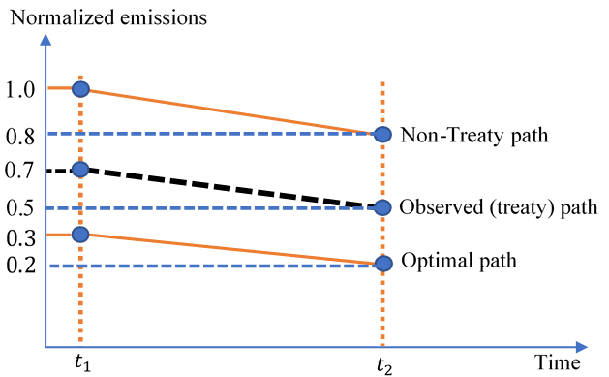
   | 2020 ($t_{1})$ | 2030 ($t_{2})$
  $$E_{t}^{NT}$$ | 1 | 0.8
  $$E_{t}^{T}$$ | 0.7 | 0.5
  $$E_{t}^{O}$$ | 0.3 | 0.2
  $$S_{t}$$ | 0.43 | 0.50
  $$d_{t}$$ | 0.4 | 0.3
$\frac{E_{t_{2}}^{NT}-E_{2}^{T}}{E_{t_{1}}^{NT}-E_{t_{1}}^{T}}=\frac{0.8-0.5}{1-0.7}=\frac{0.3}{0.3}=1.00, \frac{E_{t_{2}}^{NT}-E_{t_{2}}^{O}}{E_{t_{1}}^{NT}-E_{1}^{O}}=\frac{0.8-0.2}{1-0.3}=\frac{0.6}{0.7}=0.$86, $\frac{E_{t_{2}}^{NT}-E_{2}^{T}}{E_{t_{1}}^{NT}-E_{t_{1}}^{T}}>\frac{E_{t_{2}}^{NT}-E_{t_{2}}^{O}}{E_{t_{1}}^{NT}-E_{1}^{O}}=>∆S↑$
$E_{t_{2}}^{T}-E_{t_{2}}^{O}=0.5-0.2=0.3, E_{t_{1}}^{T}-E_{t_{1}}^{O}=0.7-0.3=0.4$, $E_{t_{2}}^{T}-E_{t_{2}}^{O}<E_{t_{1}}^{T}-E_{t_{1}}^{O}=>∆d↓$

Case 2
 | 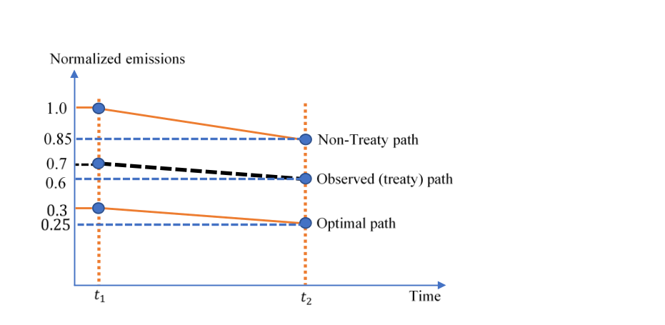
   | 2020 ($t_{1})$ | 2030 ($t_{2})$
  $$E_{t}^{NT}$$ | 1 | 0.85
  $$E_{t}^{T}$$ | 0.7 | 0.6
  $$E_{t}^{O}$$ | 0.3 | 0.25
  $$S_{t}$$ | 0.43 | 0.42
  $$d_{t}$$ | 0.4 | 0.35
$\frac{E_{t_{2}}^{NT}-E_{2}^{T}}{E_{t_{1}}^{NT}-E_{t_{1}}^{T}}=\frac{0.85-0.6}{1-0.7}=\frac{0.25}{0.3}=0.83, \frac{E_{t_{2}}^{NT}-E_{t_{2}}^{O}}{E_{t_{1}}^{NT}-E_{1}^{O}}=\frac{0.85-0.25}{1-0.3}=\frac{0.6}{0.7}=0.86$, $\frac{E_{t_{2}}^{NT}-E_{2}^{T}}{E_{t_{1}}^{NT}-E_{t_{1}}^{T}}>\frac{E_{t_{2}}^{NT}-E_{t_{2}}^{O}}{E_{t_{1}}^{NT}-E_{1}^{O}}=>∆S↓$
$E_{t_{2}}^{T}-E_{t_{2}}^{O}=0.6-0.25=0.35, E_{t_{1}}^{T}-E_{t_{1}}^{O}=0.7-0.3=0.4$, $E_{t_{2}}^{T}-E_{t_{2}}^{O}<E_{t_{1}}^{T}-E_{t_{1}}^{O}=>∆d↓$

Case 3
 | 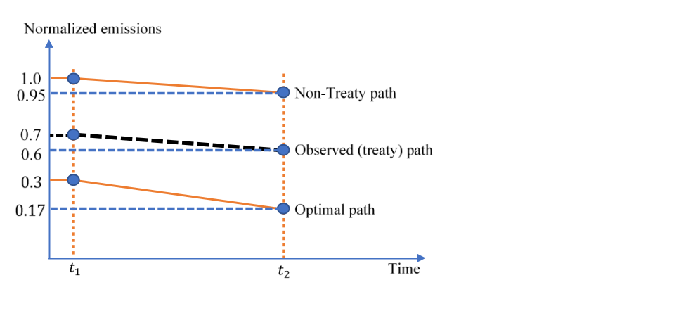
   | 2020 ($t_{1})$ | 2030 ($t_{2})$
  $$E_{t}^{NT}$$ | 1 | 0.95
  $$E_{t}^{T}$$ | 0.7 | 0.6
  $$E_{t}^{O}$$ | 0.3 | 0.17
  $$S_{t}$$ | 0.43 | 0.45
  $$d_{t}$$ | 0.4 | 0.43
$\frac{E_{t_{2}}^{NT}-E_{t_{2}}^{T}}{E_{t_{1}}^{NT}-E_{t_{1}}^{T}}=\frac{0.95-0.6}{1-0.7}=\frac{0.35}{0.3}=1.17, \frac{E_{t_{2}}^{NT}-E_{t_{2}}^{O}}{E_{t_{1}}^{NT}-E_{t_{1}}^{O}}=\frac{0.95-0.17}{1-0.3}=\frac{0.78}{0.7}=1.11$, $\frac{E_{t_{2}}^{NT}-E_{t_{2}}^{T}}{E_{t_{1}}^{NT}-E_{t_{1}}^{T}}>\frac{E_{t_{2}}^{NT}-E_{t_{2}}^{O}}{E_{t_{1}}^{NT}-E_{t_{1}}^{O}}=>∆S↑$
$E_{t_{2}}^{T}-E_{t_{2}}^{O}=0.6-0.17=0.43, E_{t_{1}}^{T}-E_{t_{1}}^{O}=0.7-0.3=0.4$, $E_{t_{2}}^{T}-E_{t_{2}}^{O}>E_{t_{1}}^{T}-E_{t_{1}}^{O}=>∆d↑$

Case 4
 | 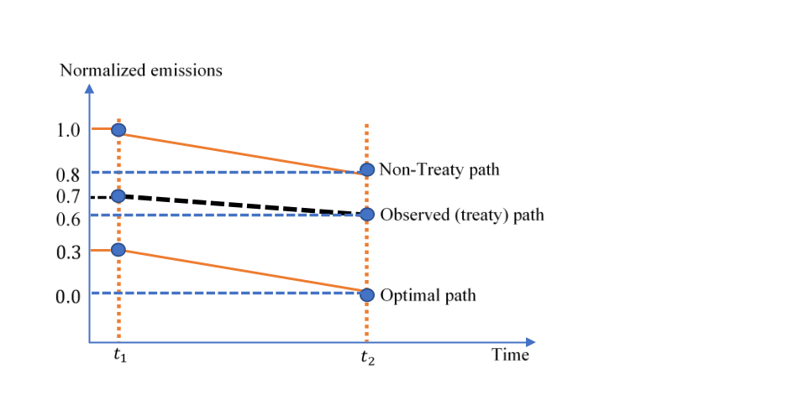
   | 2020 ($t_{1})$ | 2030 ($t_{2})$
  $$E_{t}^{NT}$$ | 1 | 0.8
  $$E_{t}^{T}$$ | 0.7 | 0.6
  $$E_{t}^{O}$$ | 0.3 | 0
  $$S_{t}$$ | 0.43 | 0.25
  $$d_{t}$$ | 0.4 | 0.6
$\frac{E_{t_{2}}^{NT}-E_{t_{2}}^{T}}{E_{t_{1}}^{NT}-E_{t_{1}}^{T}}=\frac{0.8-0.6}{1-0.7}=\frac{0.2}{0.3}=0.67, \frac{E_{t_{2}}^{NT}-E_{t_{2}}^{O}}{E_{t_{1}}^{NT}-E_{t_{1}}^{O}}=\frac{0.8-0.25}{1-0.3}=\frac{0.55}{0.7}=0.78$, $\frac{E_{t_{2}}^{NT}-E_{t_{2}}^{T}}{E_{t_{1}}^{NT}-E_{t_{1}}^{T}}<\frac{E_{t_{2}}^{NT}-E_{t_{2}}^{O}}{E_{t_{1}}^{NT}-E_{t_{1}}^{O}}=>∆S↓$
$E_{t_{2}}^{T}-E_{t_{2}}^{O}=0.6-0.0=0.6, E_{t_{1}}^{T}-E_{t_{1}}^{O}=0.7-0.3=0.4$, $E_{t_{2}}^{T}-E_{t_{2}}^{O}>E_{t_{1}}^{T}-E_{t_{1}}^{O}=>∆d↑$

