Annex

Annex 1: Overview of principles
Impact magnitude
- Principle 1: A positive company impact of an economic activity is significant if it leads to a social or environmental outcome that meets or exceeds a well-established (e.g., science-based or international standards-based) threshold. Regarding the IMP classification, this applies to B and C impacts.
- Principle 2: If thresholds are not available or if IMP’s “A” classification applies, the significance of company impacts should be defined based on relative performance measures. A company has significant positive impact if it leads to an improvement in a social or environmental outcome by a pre-defined percentage value on average compared to the previous years or if the change of the social or environmental outcome caused by the company belongs to the best-performing percentile of its peer group (sector/industry).
- Principle 3: Impact-aligned and impact-generating investments should only refer to significant company impacts and aggregate them on a portfolio level.
- Principle 4: If economic activities have no viable option to transition away from significantly harmful social or environmental outcomes, no significant positive company impact can be generated.

Impact life cycle
- Principle 5: A positive company impact is significant as long as the resulting social or environmental outcomes continue to meet their thresholds over time. For the IMP classification, this applies to “B” and “C” impacts.
- Principle 6: In cases when thresholds are not available or where IMP’s “A” classification applies, a positive company impact is significant as long as the pre-defined relative improvement rates or industry-specific percentile values are consistently met over time.
- Principle 7: For the capital allocation mechanism, a positive investor contribution lasts as long as the positive company impact lasts and the investor remains invested.
- Principle 8: The positive investor contribution of stewardship lasts as long as the investor provides ongoing evidence that the continuous improvements in company impact can be traced back to their engagement activities.
- Principle 9: Company impact is generally transferable between investors.
- Principle 10: Investor contribution is generally not transferable between investors.
- Principle 11: During the pre-investment phase, investors shall determine and report their company impact goals and, for impact-generating investments additionally, specify their intended investor contribution goals at the investee and portfolio levels.
- Principle 12: During the post-investment phase, investors shall annually measure and report progress in achieving company impact goals and, for impact-generating investments additionally, realized investor contribution goals at the investee and portfolio levels.

Impact tradeoffs
- Principle 13: Investors should conduct a context-based materiality assessment to select a company’s most relevant positive and negative environmental and social impacts for impact management.
- Principle 14: Investors should conduct a thorough analysis of the potential negative impacts that stem from tradeoffs between different impact categories. Such negative impacts should be measured, monitored, reported, and mitigated over time.
- Principle 15: Impact-aligned and impact-generating investments should only aggregate company impacts within established impact categories (e.g., as defined in life cycle assessments) and should not aggregate impacts across different impact categories.
- Principle 16: Monetizing impacts at the portfolio level across different impact categories is not a useful approach for impact-aligned or impact-generating investments.

Annex 2: IMP’s ABC classification
Fig. 2 IMP’s ABC classification in relation to a threshold (IMP 2023g)
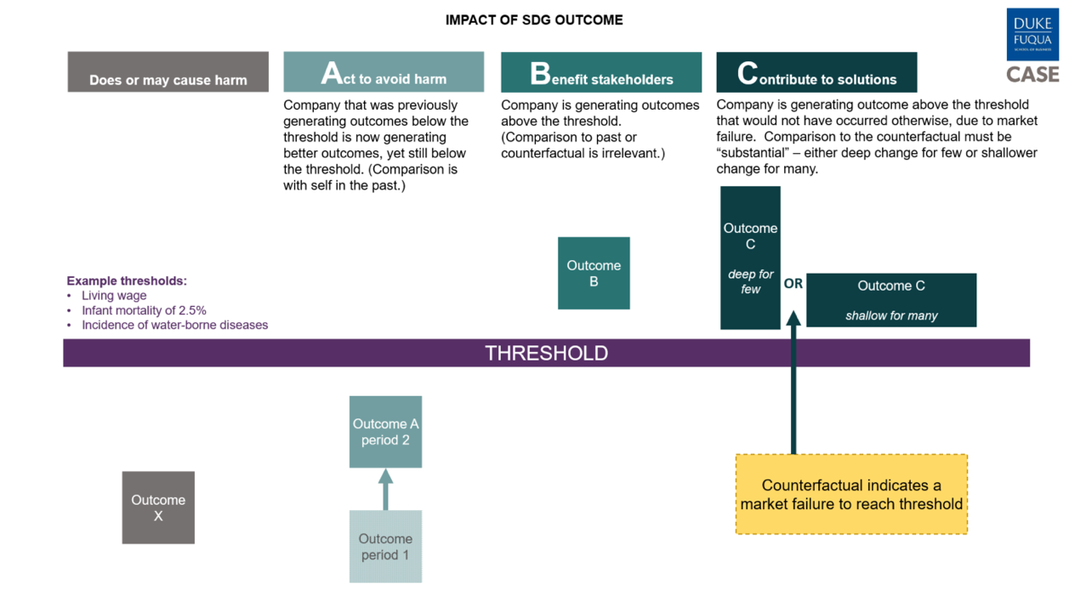
Fig. 3 IMP’s ABC classification description (IMP 2023g)
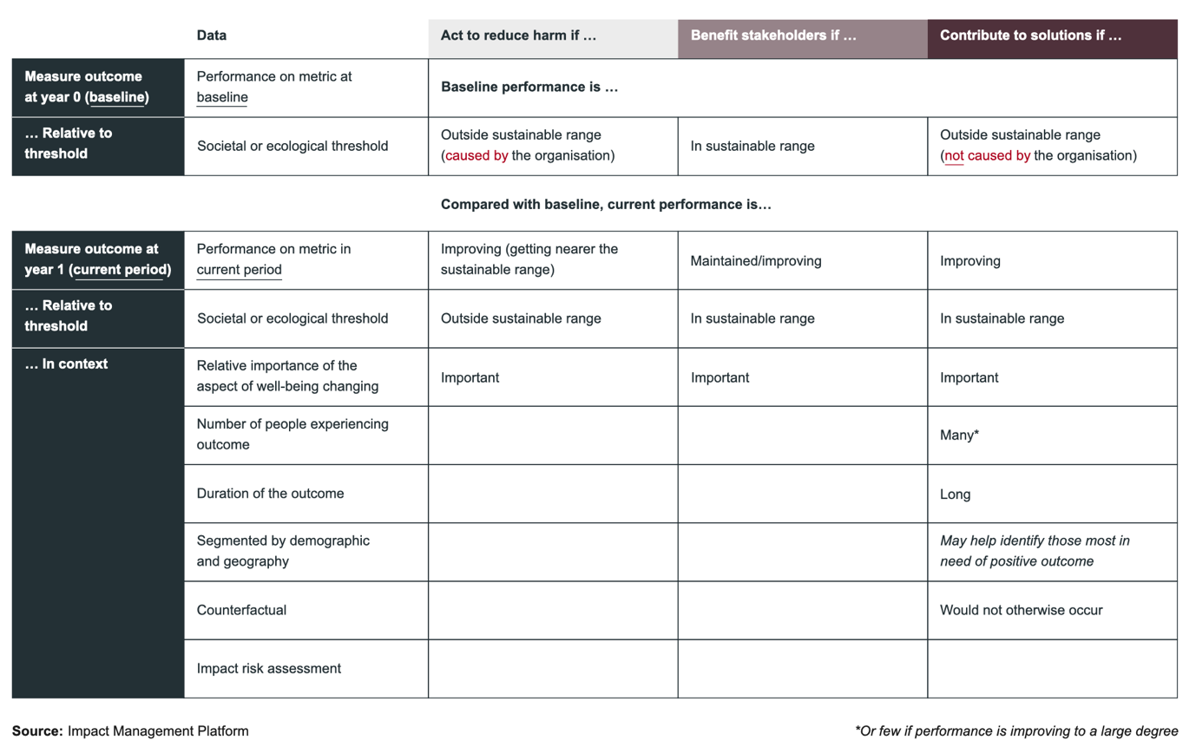

Annex 3: Aggregating ABC impacts at the portfolio level
Fig. 4 Aggregating ABC impacts at the portfolio level (IMP 2023d)
