Appendix
Fig. 1: Density graph for the propensity score.
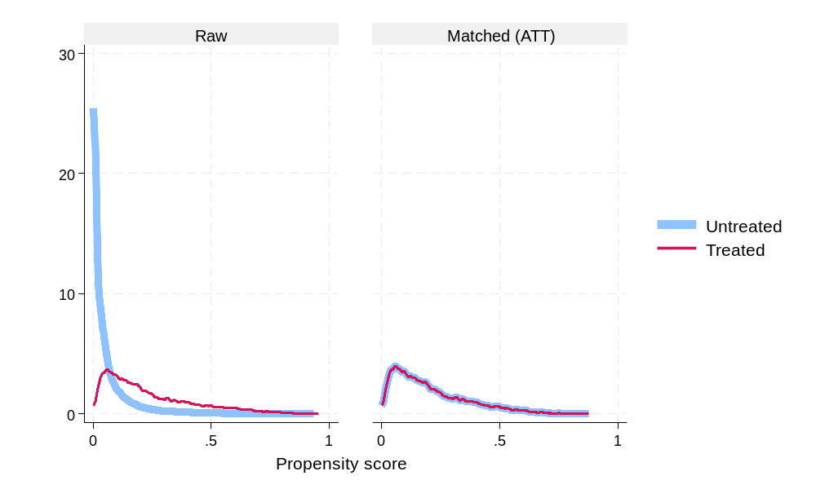

Fig. 2: Cumulative graph for the propensity score.
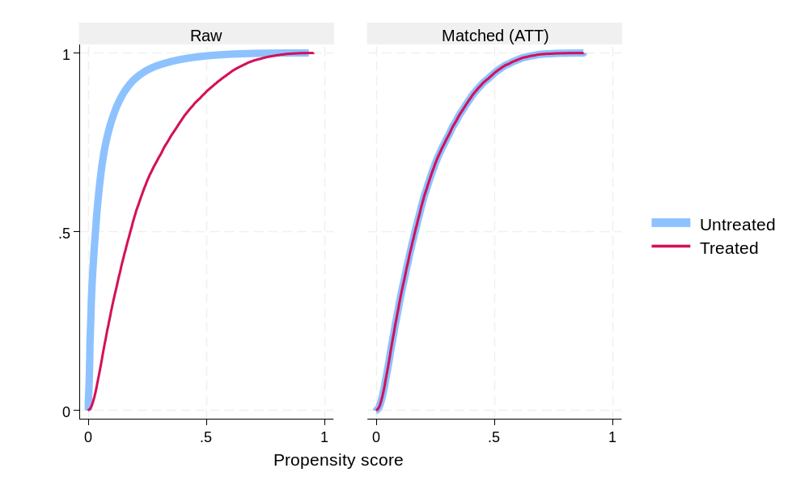

Fig. 3: Boxplot for the propensity score.

