Supplementary materials

Annex I – EuroVoc classes considered for building the directives sample
Table 7 – EV classes considered for building the directives sample
EV_I | EV_II | EV_III | NT/EV_IV | Considered in the sample
Environment | environmental policy | waste management |  | yes
Environment | environmental policy | pollution control measures |  | yes
Environment | environmental policy | environmental policy |  | yes
Environment | environmental policy | environmental protection |  | yes
Environment | environmental policy | climate change policy |  | yes
Environment | environmental policy | water policy |  | yes
Environment | natural environment | geophysical environment |  | yes
Environment | natural environment | Wildlife |  | yes
Environment | natural environment | natural resources |  | yes
Environment | natural environment | Climate |  | yes
Environment | natural environment | physical environment |  | yes
Environment | deterioration of the environment | nuisance |  | yes
Environment | deterioration of the environment | pollution |  | yes
Environment | deterioration of the environment | Waste |  | yes
Environment | deterioration of the environment | degradation of the environment |  | yes
Energy | energy policy | energy policy |  | yes
Energy | energy policy | energy industry |  | yes
Energy | coal and mining industries | mining industry
Energy | coal and mining industries | mining product
Energy | coal and mining industries | coal industry
Energy | oil industry | hydrocarbon
Energy | oil industry | oil industry
Energy | oil industry | petrochemicals
Energy | electrical and nuclear industries | nuclear industry
Energy | electrical and nuclear industries | electrical industry
Energy | electrical and nuclear industries | nuclear power station
Energy | electrical and nuclear industries | nuclear energy
Energy | soft energy | soft energy
Industry | industrial structures and policy | industrial policy |  | yes
Industry | industrial structures and policy | industrial production |  | yes
Industry | industrial structures and policy | technical profession
Industry | industrial structures and policy | industrial structures
Industry | chemistry | chemical industry
Industry | chemistry | special chemicals
Industry | chemistry | chemical element
Industry | chemistry | chemical compound
Industry | iron, steel, and other metal industries | iron and steel industry |  | yes
Industry | iron, steel, and other metal industries | metals
Industry | iron, steel, and other metal industries | metallurgical industry
Industry | mechanical engineering | mechanical engineering
Industry | mechanical engineering | machinery
Industry | mechanical engineering | mechanical equipment
Industry | mechanical engineering | precision engineering
Industry | mechanical engineering | pressure equipment
Industry | mechanical engineering | thermal equipment
Industry | electronics and electrical engineering | electronics industry
Industry | electronics and electrical engineering | electrical engineering
Industry | building and public works | building industry |  | yes
Industry | building and public works | building services |  | yes
Industry | building and public works | public works
Industry | wood industry | wood industry |  | yes
Industry | leather and textile industries | leather industry
Industry | leather and textile industries | textile industry
Industry | miscellaneous industries | refrigeration industry
Industry | miscellaneous industries | vacuum industry
Industry | miscellaneous industries | miscellaneous industries |  | yes
Industry | miscellaneous industries | ceramics |  | yes
Economics | economic policy | economic policy | circular economy | yes
Production, Technology and research | technology and technical regulations | technology | recycling technology | yes

Annex II – Detailed list of Circular Economy and Climate Mitigation policy objectives considered for the in-depth directive analysis
Table 8 – List of CE policy objectives
Policy objective | Detailed policy objectives
A. A SUSTAINABLE PRODUCT POLICY FRAMEWORK
CE 1. Designing sustainable products | CE 1.1. Improving product durability, reusability, upgradability, and reparability
CE 1. Designing sustainable products | CE 1.2 Addressing the presence of hazardous chemicals in products.
CE 1. Designing sustainable products | CE 1.3 Increasing product's energy efficiency.
CE 1. Designing sustainable products | CE 1.4 Increasing product's resource efficiency
CE 1. Designing sustainable products | CE 1.5 Increasing recycled content in products.
CE 1. Designing sustainable products | CE 1.6 Enabling remanufacturing and high-quality recycling.
CE 1. Designing sustainable products | CE 1.7 Reducing environmental footprints (not including carbon)
CE 1. Designing sustainable products | CE 1.8 Reducing the carbon footprint.
CE 1. Designing sustainable products | CE 1.9 Restricting single-use and countering premature obsolescence.
CE 1. Designing sustainable products | CE 1.10 Introducing a ban on the destruction of unsold durable goods.
CE 1. Designing sustainable products | CE 1.11 Incentivising product-as-a-service or other models where producers keep the ownership of the product or the responsibility for its performance throughout its lifecycle
CE 1. Designing sustainable products | CE 1.12 Mobilising the potential of digitalisation of product information, including solutions such as digital passports, tagging, and watermarks.
CE 1. Designing sustainable products | CE 1.13 Rewarding products based on their different sustainability performance, including by linking high-performance levels to incentives
CE 2. Empowering consumers and public buyers | CE 2.1 Ensure that consumers receive trustworthy and relevant information on products at the point of sale, including on their lifespan and the availability of repair services, spare parts, and repair manuals.
CE 2. Empowering consumers and public buyers | CE 2.2 Strengthening consumer protection against greenwashing, premature obsolescence, and setting minimum requirements for sustainability labels/logos and information tools.
CE 2. Empowering consumers and public buyers | CE 2.3 Right to repair: availability of spare parts or access to repair
CE 2. Empowering consumers and public buyers | CE 2.4 Minimum mandatory green public procurement (GPP) criteria and targets in sectoral legislation and phase in compulsory reporting to monitor the uptake of GPP
CE 3. Circularity in production processes | CE 3.1 Promoting circularity in industrial processes in the context of the review  of the Industrial Emissions Directive, including the integration of circular economy practices in upcoming Best Available Techniques
CE 3. Circularity in production processes | CE 3.2 Facilitating industrial symbiosis by developing an industry-led reporting and certification system.
CE 3. Circularity in production processes | CE 3.3 Supporting the sustainable and circular bio-based sector through the implementation of the Bioeconomy Action Plan.
CE 3. Circularity in production processes | CE 3.4. Promoting the use of digital technologies for tracking, tracing, and mapping resources
CE 3. Circularity in production processes | CE 3.5 Promoting the uptake of green technologies through a system of solid verification by registering the EU Environmental Technology Verification scheme as an EU certification mark
B. KEY PRODUCT VALUE CHAINS
CE 4. Focus on the sectors that use most resources and where the potential for circularity is high | CE 4.1 Electronics and ICT
 | CE 4.2 Batteries and vehicles
 | CE 4.3 Packaging
 | CE 4.4 Plastics
 | CE 4.5 Construction and buildings
C. LESS WASTE, MORE VALUE
CE 5. Less waste, more value | CE 5.1 Enhanced waste policy in support of waste prevention and circularity
CE 5. Less waste, more value | CE 5.2 Enhancing circularity in a toxic-free environment.
CE 5. Less waste, more value | CE 5.3 Creating a well-functioning EU market for secondary raw materials.
CE 5. Less waste, more value | CE 5.4 Addressing waste exports from the EU
D. MAKING CIRCULARITY WORK FOR PEOPLE, REGIONS AND CITIES
CE 6. Making circularity work for people, regions, and cities | CE 6.1 Making circularity work for people, regions, and cities
E. CROSSCUTTING ACTIONS
CE 7. Crosscutting actions | CE 7.1 Circularity as a prerequisite for climate neutrality
CE 7. Crosscutting actions | CE 7.2 Getting the economics right.
CE 7. Crosscutting actions | CE 7.3 Driving the transition through research, innovation, and digitalisation.
F. LEADING EFFORTS AT THE GLOBAL LEVEL
CE 8. Leading efforts at the global level | CE 8.1 Leading efforts at the global level

Table 9 – List of CM policy objectives
Policy objective | Description of the detailed policy objective
CM 1. Energy efficiency | CM 1.1 Energy efficiency for the decarbonisation of industrial processes
CM 1. Energy efficiency | CM 1.2 Significant reductions in overall energy use in buildings
CM 2. Deployment of renewables | CM 2.1 Increasing the share of renewables, thereby improving the security of supply and reducing dependence on imports.
CM 2. Deployment of renewables | CM 2.2 Increase electricity production from renewables  And promote a decentralised, smart, and flexible power system
CM 2. Deployment of renewables | CM 2.3 Fostering domestic jobs
CM 3. Clean, safe, and connected mobility | CM 3.1 Low or zero-emission vehicles with efficient alternative powertrains
CM 3. Clean, safe, and connected mobility | CM 3.2 Making heavy-duty vehicles, rail, aviation, and shipping climate-neutral
CM 3. Clean, safe, and connected mobility | CM 3.3 Having an efficient organization and infrastructure of the mobility system.
CM 4. Competitive industry and circular economy | CM 4.1 Promoting a more resource-efficient industrial production (such as steel, glass, and plastics)
CM 4. Competitive industry and circular economy | CM 4.2 Promoting a less emission-intensive industrial production (such as steel, glass, and plastics)
CM 4. Competitive industry and circular economy | CM 4.3 Raw material recovery and recycling to ensure sustainable and secure supply chains
CM 4. Competitive industry and circular economy | CM 4.4 Innovation and modernisation of industrial processes, new technologies
CM 4. Competitive industry and circular economy | CM 4.5 Information on carbon and environmental footprints of products and services should be more transparent so that consumers may make informed decisions.
CM 5. Infrastructure and interconnections | CM 5.1 Completion of the Trans-European Transport and Energy Networks
CM 5. Infrastructure and interconnections | CM 5.2 Smart charging and refueling stations allowing for cross-border services (among others)
CM 5. Infrastructure and interconnections | CM 5.3 Retrofitting of existing infrastructure can ensure continuous use, while replacing old infrastructure can be compatible with decarbonization objectives.
CM 6. Bioeconomy and natural carbon sinks | CM 6.1 Agricultural production for bioenergy using efficient and sustainable production methods
CM 6. Bioeconomy and natural carbon sinks | CM 6.2 Afforestation and restoration of degraded forest lands and similar ecosystems
CM 7. Tackling remaining emissions with carbon capture and storage | CM 7.1 More research, innovation, and demonstration to ensure the successful deployment of CCS

Annex III – Classification of directives in the Sample according to EuroVoc Level and publication date
Table 10 - No. directives classified in each EuroVoc level I per publication date
Publication date | No. Directives | EuroVoc Level 1
Publication date | No. Directives | Environment | Energy | Industry
<2000 | 52 | 44 | 6 | 4
2000-2009 | 75 | 69 | 7 | 6
2010-2019 | 65 | 59 | 7 | 9
>2019 | 5 | 4 | 1 | 2
Total | 197 | 176 | 21 | 21

Table 11 - No. directives classified in each EuroVoc level II per publication date
Eurovoc Level II /Publication date | <2000 | 2000-2009 | 2010-2019 | >2019 | Total
environmental policy | 24 | 50 | 36 | 3 | 113
natural environment | 6 | 0 | 4 | 2 | 12
deterioration of the environment | 14 | 16 | 19 | 0 | 49
energy policy | 4 | 5 | 4 | 0 | 13
industrial structures and policy | 1 | 1 | 1 | 0 | 3
iron, steel and other metal industries
building and public works | 1 | 0 | 1 | 0 | 2
wood industry | 0 | 1 | 0 | 0 | 1
miscellaneous industries | 2 | 2 | 0 | 0 | 4
economic policy
technology and technical regulations
Total | 52 | 75 | 65 | 5 | 197

Table 12 - No. directives classified in each EuroVoc level III per publication date
EuroVoc Level III / Publication Date | <2000 | 2000-2009 | 2010-2019 | >2019 | Total
waste management | 1 | 1 | 2 | 0 | 4
pollution control measures | 5 | 6 | 3 | 0 | 14
environmental policy | 9 | 14 | 9 | 1 | 33
environmental protection | 8 | 23 | 12 | 1 | 44
climate change policy | 1 | 5 | 9 | 1 | 16
water policy | 0 | 1 | 1 | 0 | 2
geophysical environment | 2 | 0 | 0 | 1 | 3
Wildlife | 1 | 0 | 4 | 0 | 5
natural resources
Climate | 3 | 0 | 0 | 0 | 3
physical environment | 0 | 0 | 0 | 1 | 1
Nuisance | 13 | 14 | 19 | 0 | 46
Pollution | 0 | 1 | 0 | 0 | 1
Waste | 0 | 1 | 0 | 0 | 1
degradation of the environment | 1 | 0 | 0 | 0 | 1
energy policy | 3 | 3 | 3 | 0 | 9
energy industry | 1 | 2 | 1 | 0 | 4
industrial policy | 1 | 1 | 0 | 0 | 2
industrial production | 0 | 0 | 1 | 0 | 1
iron and steel industry
building industry | 1 | 0 | 0 | 0 | 1
building services | 0 | 0 | 1 | 0 | 1
wood industry | 0 | 1 | 0 | 0 | 1
miscellaneous industries | 1 | 2 | 0 | 0 | 3
Ceramics | 1 | 0 | 0 | 0 | 1
economic policy (circular economy)
technology (recycling technology)
Total | 52 | 75 | 65 | 5 | 197

Annex IV - Detailed analysis of synergies and antagonisms per policy objective

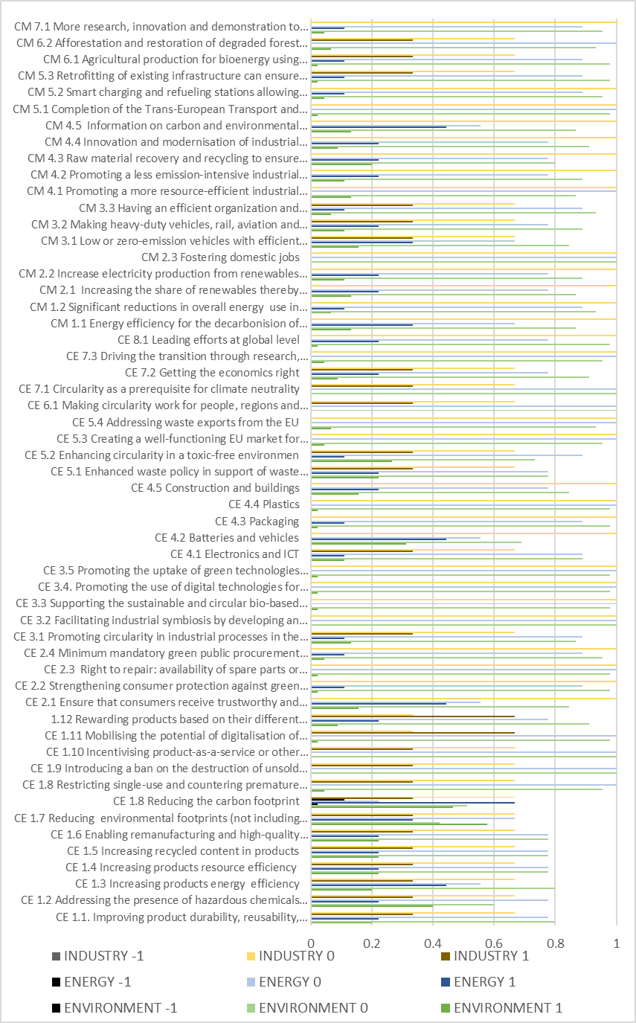
Figure 6 – Detailed analysis of synergies (values of “1”), antagonisms (values of “-1) and no interaction (values of “0”) per CM and CE policy objective for EU Directives of Industry, Energy and Environment policy domains. The values in the xx axis refer to the share of the total key sample of 47 directives that score -1, 1 or 0 with each policy objective

Table 13 - Directives distributed by value chain phase
Transportation | Manufacturing | Raw materials | Energy | Buildings | Waste
32018L0844 | 32011L0092 | 31992L0043 | 32018L0844 | 31987L0217 | 32010L0031
32012L0027 | 32000L0060 | 32004L0035 | 32000L0060 | 32018L0844 | 32008L0028
32003L0096 | 32015L2193 | 32008L0050 | 32009L0119 | 32010L0031 | 31994L0062
32003L0087 | 32008L0112 | 32011L0092 | 32014L0094 | 32018L2001 | 32012L0019
32010L0075 | 31992L0042 | 32000L0060 | 32009L0031 |  | 32011L0065
31999L0094 | 32016L2284 | 32003L0087 | 32015L2193 |  | 32019L0904
32006L0040 | 32012L0027 | 32010L0075 | 32016L2284 |  | 32009L0125
32007L0034 | 32003L0096 |  | 32012L0027 |  | 32006L0066
32009L0033 | 32014L0027 |  | 32003L0096 |  | 32005L0064
32022L0362 | 32008L0028 |  | 32003L0087 |  | 32018L0849
32009L0030 | 31994L0062 |  | 32010L0075 |  | 32000L0053
32009L0126 | 32012L0019 |  | 32018L2001 |  | 32008L0098
32018L2001 | 32011L0065 |  | 32015L1513 |  | 31999L0031
32015L1513 | 32019L0904 |  | 32016L0802
32016L0802 | 32009L0125 |  | 32006L0066
32006L0066 | 32003L0087
32005L0064 | 32010L0075
32018L0849
32000L0053

Figure 7 - % of synergies across 197 Directive sample and policy objectives - Raw materials extraction

Figure 8 – % of synergies across 197 Directive sample and policy objectives - Manufacturing of construction materials

Figure 9 – % of synergies across 197 Directive sample and policy objectives - Transportation

Figure 10-% of synergies across 197 Directive sample and policy objectives - Buildings construction and use

Figure 11 – % of synergies across 197 Directive sample and policy objectives - Renewable offshore energy construction and use

Figure 12 – % of synergies across 197 Directive sample and policy objectives - Waste management

