SUPPLEMENTARY MATERIAL
S1 – IMPORTANT INFORMATION FOR THE DEVELOPMENT OF THE TECHNICAL BLOCK
Tabla S1. DEWATS with secondary treatment level present in the train library
Code | DEWATS with secondary treatment level
Code | Primary treatment | Secondary treatment
TPS1 | Septic Tank | UAF
TPS2 | FAFA | NR
TPS3 | Septic Tank | Vertical Flow Constructed Wetlands
TPS4 | Septic Tank | Horizontal Flow Constructed Wetlands
TPS5 | Primary Sedimentation | Extended aeration
TPS6 | Imhoff Tank | UAF
TPS7 | Imhoff Tank | Facultative Pond
TPS8 | ABR | Horizontal Flow Constructed Wetlands
TPS9 | ABR | Vertical Flow Constructed Wetlands
TPS10 | Primary Sedimentation | UAF
TPS11 | SBR | NR
TPS12 | Imhoff Tank | Horizontal Flow Constructed Wetlands
TPS13 | Imhoff Tank | Vertical Flow Constructed Wetlands
TPS14 | Primary Sedimentation | CBR
TPS15 | Primary Sedimentation | Trickling filter
TPS16 | ABR | FAFA
TPS17 | UASB Reactor | NR
TPS18 | UASB Reactor | FAFA
TPS19 | UASB Reactor | Trickling filter
TPS20 | UASB Reactor | CBR
TPS21 | Anaerobic Pond | Horizontal Flow Constructed Wetlands
TPS22 | Anaerobic Pond | Facultative Pond
TPS23 | UASB Reactor | Facultative Pond
Note: NR = Not required
Table S2. DEWATS with tertiary treatment level present in the train library
Code | DEWATS with tertiary treatment level
Code | Primary treatment | Secondary treatment | Tertiary treatment
TPST1 | Septic Tank | UAF | Horizontal Flow Constructed Wetlands
TPST2 | Septic Tank | UAF | Vertical Flow Constructed Wetlands
TPST3 | Septic Tank | UAF | Maturation Pond
TPST4 | ABR | UAF | Chlorination
TPST5 | Septic Tank | Horizontal Flow Constructed Wetlands | Chlorination
TPST6 | Septic Tank | Vertical Flow Constructed Wetlands | Chlorination
TPST7 | Imhoff Tank | UAF | Horizontal Flow Constructed Wetlands
TPST8 | SBR | NR | Maturation Pond
TPST9 | SBR | NR | Chlorination
TPST10 | ABR | Horizontal Flow Constructed Wetlands | Chlorination
TPST11 | Primary Sedimentation | UAF | Horizontal Flow Constructed Wetlands
TPST12 | Primary Sedimentation | UAF | Vertical Flow Constructed Wetlands
TPST13 | ABR | UAF | Chlorination
TPST14 | Primary Sedimentation | Trickling filter | Laguna de maduración
TPST15 | Primary Sedimentation | Trickling filter | Horizontal Flow Constructed Wetlands
TPST16 | UASB reactor | NR | Chlorination
TPST17 | Sedimentador primario | CBR | Chlorination
TPST18 | UASB reactor | UAF | Chlorination
TPST19 | UASB reactor | Trickling filter | Chlorination
TPST20 | UASB reactor | CBR | Chlorination
TPST21 | Laguna anaerobia | Facultative Pond | Maturation Pond
TPST22 | UASB reactor |  | Maturation Pond
TPST23 | Anaerobic Pond | Facultative Pond | Maturation Pond
TPST24 | Anaerobic Pond | Horizontal Flow Constructed Wetlands | Maturation Pond
TPST25 | Anaerobic Pond | Vertical Flow Constructed Wetlands | Maturation Pond
Note: NR = Not required

Tabla S3. DEWATS Suggested by Settlement Typology
Settlement type | DEWATS applicable
Small settlements | TPS1, TPS2, TPS3, TPS4, TPS6, TPS7, TPS8, TPS9, TPS10, TPS11, TPS16, TPST1, TPST2, TPST3, TPST4, TPST5, TPST6, TPST7, TPST8, TPST9, TPST10, TPST11, TPST12, TPST13
Medium settlements | TPS1, TPS2, TPS3, TPS4, TPS6, TPS7, TPS8, TPS9, TPS10, TPS11, TPS12, TPS13, TPS14, TPS15, TPS16, TPS17, TPS18, TPS19, TPS20, TPS21, TPS22, TPST1, TPST2, TPST3, TPST4, TPST5, TPST6, TPST7, TPST8, TPST9, TPST10, TPST11, TPST12, TPST13, TPST14, TPST15, TPST16
Large settlements | TPS1, TPS2, TPS3, TPS4, TPS5, TPS6, TPS7, TPS8, TPS9, TPS10, TPS11, TPS12, TPS13, TPS14, TPS15, TPS16, TPS17, TPS18, TPS19, TPS20, TPS21, TPS22, TPS23, TPST1, TPST2, TPST3, TPST4, TPST5, TPST6, TPST7, TPST8, TPST9, TPST10, TPST11, TPST12, TPST13, TPST14, TPST15, TPST16, TPST17, TPST18, TPST19, TPST20, TPST21, TPST22, TPST23, TPST24, TPST25

Table S4. Extensive and intensive DEWATS with application potential based on the area available.
Type of treatment | DEWATS applicable
Intensive treatment | TPS1, TPS2, TPS6, TPS7, TPS11, TPS12, TPS15, TPS16, TPS17, TPS18, TPS19, TPS20, TPS21, TPST4, TPST9, TPST13, TPST16, TPST17, TPST18, TPST19, TPST20
Extensive treatment | TPS3, TPS4, TPS5, TPS8, TPS9, TPS10, TPS13, TPS14, TPS22, TPS23, TPS24, TPST1, TPST2, TPST3, TPST5, TPST6, TPST7, TPST8, TPST9, TPST11, TPST12, TPST14, TPST15, TPST21, TPST22, TPST23, TPST24, TPST25

Table S5. DEWATS with and without electrical power requirements
Electrical power requirement | DEWATS
Yes | TPS6, TPS12, TPS15, TPS16, TPS20, TPS21, TPST9, TPST10, TPST16, TPST18, TPST20, TPST21
No | TPS1, TPS2, TPS3, TPS4, TPS5, TPS7, TPS13, TPS14, TPS8, TPS9, TPS10, TPS11, TPS17, TPS18, TPS19, TPS22, TPS23, TPS24, TPST1, TPST2, TPST3, TPST4, TPST5, TPST6, TPST7, TPST8, TPST11, TPST12, TPST13, TPST14, TPST15, TPST17, TPST19, TPST22, TPST23, TPST24, TPST25, TPST26, TPST27, TPST28

Table S6. Criteria and sub-criteria considered for the selection of a DEWATS in informal settlements
Subcriteria | Description | Objective of the criteria | Type of measurement | Scale of measurement* | Diffuse weight (%) | Weight (%)
Technical |  |  |  |  | [28.1-33.8-41.1] | 33.9
SCT1. Technical complexity of the DEWATS | Refers to the level of sophistication and functional diversity of a treatment alternative that may require specialized personnel to manage. In this context, the most desirable alternative should have low complexity while ensuring efficiency and effectiveness. | Minimize (less is more) | Ordinal qualitative | The rating is given as follows:  - [1,1,2] if the system does not require specialized personnel and mechanical equipment (low)  - 1,2,3] if the system requires technical or technological personnel and mechanical equipment (medium)  - 3,4,5] if the system requires specialized personnel and mechanical equipment (high) | [33.0-40.0-47.0] | 39.7
SCT2. Energy consumption | Limitations in electrical power supply may limit the applicability of DEWATS. Therefore, the most desirable alternative is the one that requires less energy. | Minimize (less is more) | Quantitative* | Range of energy consumption of the treatment system measured in [kWh/inhabitant-year] | [27.0-31.0-37.0] | 31.5
SCT2. Efficiency of the removal of pollutants | It refers to the percentage removal of organic matter and nutrients such as total nitrogen (TN) and total phosphorus (TP), as well as the inactivation of pathogens. | Maximize | Quantitative* | Range of removal efficiencies of pollutant indicator parameters for each treatment system | [24.0-29.0-34.0] | 28.9
Environmental |  |  |  |  | [31.1-38.8-47.8] | 38.7
SCA1. Environmental impact index with direct repercussions for inhabitants | Refers to the visual, odor and noise impact of DEWATS. The ideal alternative will be the one that produces the lowest annoyance index. | Minimize (less is more) | Cualitativa nominal | The rating is given as follows:  - [1,1,2] if the treatment system does not generate impacts of this type  - 1,2,3] if the treatment system generates impacts of this type (medium)  - 3,4,5] if the system generates strong impacts (high) | [16.0-20.0-27.0] | 20.5
SCA2. Biosolids Reuse Potential | This refers to the potential for utilizing the sludge produced during wastewater treatment. The best alternative will be the one that allows to valorize the generated sludge with as many by-products as possible. | Maximize | Ordinal qualitative | The rating is given as follows:  - [3,4,5] if the treatment system produces sludge with stabilized organic matter (high)  - 1,2,3] if the treatment system produces sludge with partially stabilized organic matter (medium)  - 1,1,2] if the treatment system produces sludge with slightly stabilized organic matter (low) | [22.0-29.0-36.0] | 28.5
SCA3. Energy Recovery Potential | This refers to the potential for energy recovery in the form of methane (CH₄), which can be used for purposes within the treatment system or, depending on the amount produced, to supply grid or off-grid areas. Therefore, it is desirable that the treatment alternative be capable of producing renewable energy, so the best qualified will be the one with the highest potential for energy recovery. | Maximize | Quantitative | The rating is given as follows:  - [1,1,2] if the treatment train does not produce energy that can be used by the plant itself or by the community (zero)  - 1,2,3] if the treatment line produces energy with the potential to be used by the plant itself or by the community (medium) | [18.0-24.0-30.0] | 23.7
SCA4. Wastewater Reuse Potential | Refers to the ability to use treated effluent for purposes other than discharge to a water body. Therefore, the best alternative is the one that allows a use other than discharge without restrictions. | Maximize | Ordinal qualitative | The rating is given as follows:  - [3,4,5] if the treatment train allows the use of treated effluent without restrictions (high)  - 1,2,3] if the treatment system allows the use of treated effluent with restrictions (medium)  - 1,1,2] if the treatment system only allows discharge to a receiving body (low) | [21.0-27.0-35.0] | 27.3
Economical |  |  |  |  | [22.6-27.4-33.4] | 27.4
SCE1. Capital Expenditures (CAPEX) | This refers to the monetary investment in the acquisition of equipment, machinery, infrastructure, technology, and any other assets necessary to start up the treatment system. CAPEX should be as low as possible; therefore, the optimal treatment alternative is the one with the lowest value for this subcriterion. | Minimize (less is more) | Quantitative | Range of estimated cost per year of analysis measured in [USD/inhabitant] | [35.1-41.8-50.2] | 41.9
SCE2. Operational expenditures (OPEX) | Correspond to the daily operating expenses of the treatment system, including labor costs, supplies, maintenance, services and other recurring expenses. | Minimize (less is more) | Quantitative | Range of estimated costs per year of analysis measured in [USD/inhabitant per year] | [48.5-58.2-69.4] | 58.1

Table S7. Treatment alternatives according to terrain slope
Slope (%) | DEWATS
Less than or equal to 5 | TPS1, TPS2, TPS3, TPS4, TPS5, TPS6, TPS7, TPS8, TPS9, TPS10, TPS11, TPS12, TPS13, TPS14, TPS15, TPS16, TPS17, TPS18, TPS19, TPS20, TPS21, TPS22, TPS23, TPST1, TPST2, TPST15.
Greater than 5 | TPS1, TPS2, TPS5, TPS11, TPS14, TPS15, TPS17, TPS19, TPST1, TPST2, TPST3, TPST4, TPST5, TPST6, TPST7, TPST8, TPST9, TPST10, TPST11, TPST12, TPST13, TPST14, TPST15, TPST16, TPST17, TPST18, TPST19, TPST20, TPST21, TPST22, TPST23, TPST24, TPST25, TPST26.
Source: Adapted from IDEAM-UTP-CINARA (2005)

Table S8. Factors determining Willingness To Pay (WTP)
Variable | Name | Codification
Position in the household | Head | Head of the household=1  Other=0
Sex | Sex | Male= 1 Female = 0
Age | Age | Value
Education | Y_osfedu | Years
Marital Status | Married | Married=1  Other=0
Employment status | Works | Works=1  Other=0
Occupation | Employee | Employee=1  Other=0
Number of persons in the household | pershouse | Value
Presence of children under 5 years old in the household | Children | Children = 1  No Children = 0
Own housing | ownership | Own house=1  Other=0
Income (midpoint of income range in thousands of pesos) | income2 | Value
Household's monthly expenditure on utilities | expenses_s | Value
Time living in the settlement | viveloca | Year
Opinion on the current condition of the water source passing through the settlement | xcontam | Contaminated =1  Other=0
Do you feel affected by the conditions of the water source to carry out household activities | AfectHouse | Yes=1  No=0
Opinion on the most appropriate operator for the management of the DEWATS | operator | Operator Services provider company= =1  Community =0
Price offered to the household | Price | Value in Colombian $

Table S9. Values used for the application of Fuzzy TOPSIS
Subcriteria | Complexity (ST1) |  |  | Energy consumption (ST2) |  |  | TSS removal efficiency (ST3) |  |  | COD removal efficiency (ST4) |  |  | BOD5 removal efficiency (ST5) |  |  | NT removal efficiency (ST6) |  |  | PT removal efficiency (ST7) |  |  | Pathogens removal efficiency (ST8)
Objective of the sub-criterion | Min |  |  | Min |  |  | Max |  |  | Max |  |  | Max |  |  | Max |  |  | Max |  |  | Max
Weight of the sub-criterion | 0,33 | 0,40 | 0,47 | 0,27 | 0,31 | 0,37 | 0,04 | 0,05 | 0,06 | 0,04 | 0,05 | 0,06 | 0,04 | 0,05 | 0,06 | 0,04 | 0,05 | 0,06 | 0,04 | 0,05 | 0,06 | 0,04 | 0,05 | 0,06
Alternative
Septic Tank + UAF | 1 | 2 | 3 | 0 | 0 | 0 | 80 | 85 | 90 | 70 | 75 | 80 | 80 | 82,5 | 85 | 1 | 30,5 | 60 | 1 | 18 | 35 | 1 | 1,5 | 2
UAF | 1 | 2 | 3 | 0 | 0 | 0 | 60 | 70 | 80 | 55 | 67,5 | 80 | 60 | 70 | 80 | 1 | 15,5 | 30 | 1 | 10,5 | 20 | 1 | 1,5 | 2
Imhoff Tank + UAF | 1 | 2 | 3 | 0 | 0 | 0 | 50 | 70 | 90 | 40 | 60 | 80 | 50 | 70 | 90 | 1 | 25,5 | 50 | 1 | 15,5 | 30 | 1 | 1,5 | 2
SBR | 3 | 4 | 5 | 20 | 27,5 | 35 | 80 | 85 | 90 | 80 | 86,5 | 93 | 85 | 89 | 93 | 1 | 30,5 | 60 | 1 | 18 | 35 | 1 | 1,5 | 2
Primary Sedimentation + TF | 3 | 4 | 5 | 14 | 17 | 20 | 85 | 90 | 95 | 70 | 75 | 80 | 80 | 85 | 90 | 1 | 30,5 | 60 | 1 | 18 | 35 | 1 | 1,5 | 2
ABR + UAF | 1 | 2 | 3 | 0 | 0 | 0 | 80 | 85 | 90 | 70 | 75 | 80 | 80 | 82,5 | 85 | 1 | 30,5 | 60 | 1 | 18 | 35 | 1 | 1,5 | 2
UASB | 1 | 2 | 3 | 0 | 0 | 0 | 65 | 72,5 | 80 | 55 | 62,5 | 70 | 60 | 67,5 | 75 | 1 | 30,5 | 60 | 1 | 18 | 35 | 1 | 1,5 | 2
UASB + UAF | 1 | 2 | 3 | 0 | 0 | 0 | 80 | 85 | 90 | 70 | 75 | 80 | 75 | 81 | 87 | 1 | 30,5 | 60 | 1 | 18 | 35 | 1 | 1,5 | 2
UASB + TF | 3 | 4 | 5 | 18 | 21,5 | 25 | 87 | 90 | 93 | 70 | 79 | 88 | 80 | 86,5 | 93 | 1 | 30,5 | 60 | 1 | 18 | 35 | 1 | 1,5 | 2
UASB + CBR | 3 | 4 | 5 | 20 | 27,5 | 35 | 80 | 85 | 90 | 70 | 77,5 | 85 | 80 | 85 | 90 | 1 | 30,5 | 60 | 1 | 15,5 | 30 | 1 | 1,5 | 2
ABR + UASB + Chlorination | 1 | 2 | 3 | 0 | 0 | 0 | 80 | 85 | 90 | 70 | 75 | 80 | 80 | 85 | 90 | 1 | 30,5 | 60 | 1 | 18 | 35 | 3 | 4 | 5
UASB+ Chlorination | 1 | 2 | 3 | 0 | 0 | 0 | 65 | 72,5 | 80 | 55 | 62,5 | 70 | 60 | 67,5 | 75 | 1 | 30,5 | 60 | 1 | 18 | 35 | 3 | 4 | 5
UASB + UAF + Chlorination | 1 | 2 | 3 | 0 | 0 | 0 | 80 | 85 | 90 | 70 | 75 | 80 | 75 | 81 | 87 | 1 | 30,5 | 60 | 1 | 18 | 35 | 3 | 4 | 5
UASB + TF + Chlorination | 3 | 4 | 5 | 18 | 21,5 | 25 | 87 | 90 | 93 | 70 | 79 | 88 | 80 | 86,5 | 93 | 1 | 30,5 | 60 | 1 | 18 | 35 | 3 | 4 | 5
UASB + CBR + Chlorination | 3 | 4 | 5 | 0 | 0 | 0 | 80 | 85 | 90 | 70 | 77,5 | 85 | 80 | 85 | 90 | 1 | 30,5 | 60 | 1 | 15,5 | 30 | 1 | 1,5 | 2

Table S10. $ICO\&M$ index for DEWATS and implementation feasibility
DEWATS | Alternative |  | $OM\&E$ Index | $$I\&M$$  Index | GR Index | $ICO\&M$ Index
TPST16 | UASB+ Chlorination |  | 5 | 3 | 5 | 0.86
TPS17 | UASB |  | 5 | 5 | 5 | 1.00
TPS18 | UASB + UAF |  | 5 | 3 | 5 | 0.86
TPST18 | UASB + UAF + Chlorination |  | 5 | 3 | 5 | 0.86
TPS19 | UASB + TF |  | 5 | 3 | 5 | 0.86

Tabla S11. Output Final Model through Logit regression for Miradores de la UIS
Variable | B | S.E. | Wald | df | Sig. | Exp(B)
Sex | -0,897 | 0,553 | 2,631 | 1 | 0,105 | 0,408
Community organization | 0,078 | 0,052 | 2,291 | 1 | 0,130 | 1,082
Wastewater management | 1,463 | 0,520 | 7,926 | 1 | 0,005 | 4,318
WTPmax | 0,001 | 0,000 | 41,929 | 1 | 0,000 | 1,001
Constant | -1,697 | 0,604 | 7,908 | 1 | 0,005 | 0,183

Table S12. Final Model Output via Logit regression for El Porvenir-Los Cuadros
Variable | B | S.E. | Wald | gl | Sig. | Exp(B)
Persons in the household | 2,080 | 5870,478 | 0,000 | 1 | 1,000 | 8,007
Monthly Average monthly income | 0,000 | 0,027 | 0,000 | 1 | 1,000 | 1,000
Average monthly expenditure | 0,000 | 0,050 | 0,000 | 1 | 1,000 | 1,000
WTP max | 0,006 | 3,974 | 0,000 | 1 | 0,999 | 1,006
Constant | -2,520 | 49536,838 | 0,000 | 1 | 1,000 | 0,000
Note: B is the coefficient, gl is the degrees of freedom.
Table S13. Final Model Output through Logit regression for Los Santos Bajo
Variable | B | S.E. | Wald | df | Sig. | Exp(B)
Sex | -0,897 | 0,553 | 2,631 | 1 | 0,105 | 0,408
Community organization | 0,078 | 0,052 | 2,291 | 1 | 0,130 | 1,082
Wastewater management | 1,463 | 0,520 | 7,926 | 1 | 0,005 | 4,318
WTPmax | 0,001 | 0,000 | 41,929 | 1 | 0,000 | 1,001
Constant | -1,697 | 0,604 | 7,908 | 1 | 0,005 | 0,183
Note: B is the coefficient, gl is the degrees of freedom.
S2 - METHODOLOGY FOR THE SELECTION OF A POTENTIAL DEWATS IMPLEMENTATION SITE AND ITS APPLICATION TO THE CASE STUDY
The proposed methodology aims to systematize the site selection process for the implementation of a DEWATS, integrating the guiding principles established in the Colombian regulations (Resolución 631 de 2015 y Resolución 799 de 2021). For this purpose, a protocol consisting of 5 steps has been proposed for the initial approach of the area, its adaptation to the local conditions and the site selection. For this last process, the application of multi-criteria spatial analysis was proposed for the estimation of a suitability index. This was done taking as reference documents that applied this tool in other contexts, such as those carried out by [3], [4].

Figure S1 shows the proposed methodology for selecting a site to implement a STDAR. Each stage of this process is described in more detail below.
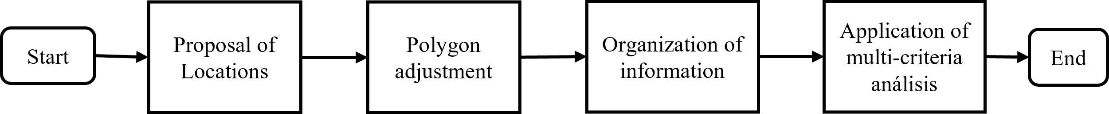
Figura S1. Site selection methodology for STDAR implementation
S2.1. Proposal of Initial Locations
To start the site selection process, it is proposed that the decision maker, based on his knowledge of the local context and conditions of the area, proposes different points where he considers the implementation of a STDAR feasible. These points will then be the centers of polygons generated using GIS tools. It is recommended that the polygons have approximately 15 m2/inhabitant, as this area is sufficient for the implementation of extensive technologies. However, it is also recommended to avoid overlapping the proposed area with population centers.
S2.2. Polygon adjustment
Once the initial polygons have been drawn, they are adjusted according to the boundary conditions of the area. Figure S2 shows the flowchart for the adjustment of the polygons, during the execution of this process, a sequential evaluation is made using GIS of the different conditions that exist in the areas where the polygons were drawn, it is determined whether it is necessary to make the adjustment, and they are adjusted if deemed necessary. For the adjustment of the polygons, the guidelines established in Resolución 330 de 2017 and la Resolución 799 de 2021 are used as a reference. These documents contain the information to be taken into account for the selection of sites for wastewater treatment facilities. Thus, it is recommended to evaluate criteria such as (i) existing infrastructure, (ii) isolation distances, (iii) zones of influence for odor generation, (iv) land use including cadastre, (v) special habitats, (vi) altitude, (viii) terrain slopes, (ix) vulnerability to flooding, (x) vulnerability to torrential flooding, and (xi) vulnerability to mass movements. However, it is important to emphasize that decision makers can include or exclude criteria according to their perception of the context
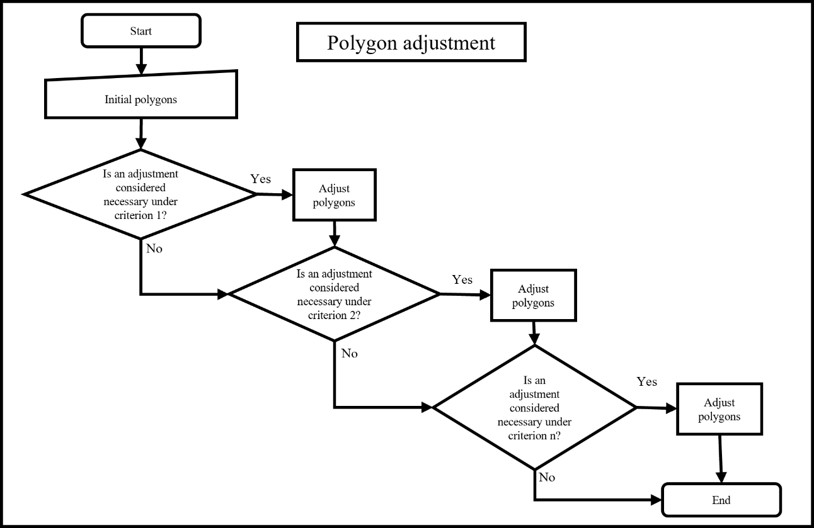
Figure S2. Protocol for the adjustment of polygons for the selection of sites for decentralized wastewater treatment systems
S2.3. Organization and analysis of information
Once the polygons that define the area where a DEWATS system can potentially be implemented have been adjusted, the information organization phase begins. In this phase, the information that defines the various siting alternatives is processed and systematized to facilitate its presentation and analysis, producing inputs such as maps, graphs, and tables. Additional characteristics such as pumping requirements and special hydraulic infrastructure are also identified. This information from the study area will be useful for the implementation of the next phase.
S2.4. Application of multi-criteria análisis
La última fase para la selección de la selección de localización del SDTAR corresponde a la evaluación de las diferentes alternativas utilizando métodos de análisis espacial multicriterio. La
The final phase of the DEWATS site selection corresponds to the evaluation of the different alternatives using multi-criteria spatial analysis methods. Figure S3 shows the site selection process. The evaluation criteria are (i) land use, (ii) proximity to population centers, (iii) proximity to roads, (iv) proximity to water bodies, (v) slope, (vi) altitude, (vii) susceptibility to landslide events, (viii) susceptibility to flooding, (ix) susceptibility to torrential flooding, (x) need for special hydraulic structures, and (xi) need for pumping. The different siting alternatives are qualitatively evaluated with respect to the criteria using the Likert scale as a reference, assigning scores from 1 to 5, with 1 being the least favorable condition and 5 being the most favorable condition. For this purpose, the previously organized maps are rasterized to generate images in which each generated pixel stores information about the performance of the circumscribed area with respect to a specific criterion. The evaluation criteria are prioritized using the weighted sum method, integrating the information stored in each pixel of the generated raster. In this way, a suitability index is obtained that allows the list of proposed sites to be ranked. The equation used for this procedure is presented below:
$$I_{j}=\sum_{i=1}^{m}{W_{i}*C_{ij}}$$
Where:
$I_{j}=$ Suitability index for alternative j
$W_{i}=$ Weighted weight of criterion i
$C_{i}=$ Performance value assigned to alternative j with respect to criterion i

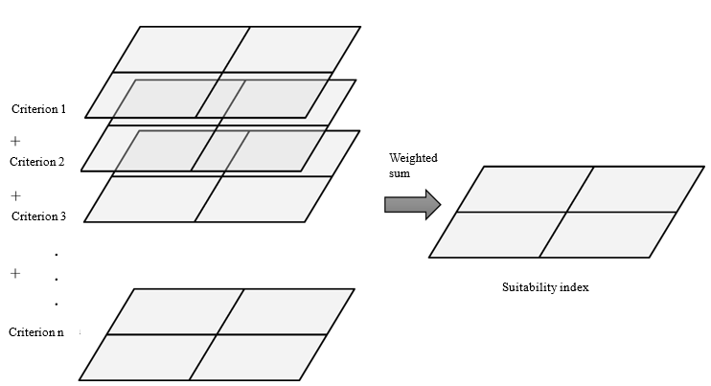
Figure S3. Methodology for the calculation of the suitability index.

S3 – METHODOLOGY FOR THE PARTICIPATIVE SELECTION OF TREATMENT SYSTEMS
The participative approach block is an essential component of the DEWATS methodology and is developed in parallel with the first phase of the technical block. For its implementation, the executing institution must encourage community participation and form a driving group of 5 to 10 people who will remain active throughout the process. This block is organized into three levels: participative learning, community and institutional forum, and decision dissemination, as shown in the participatory workshop flowchart in Figure S4.
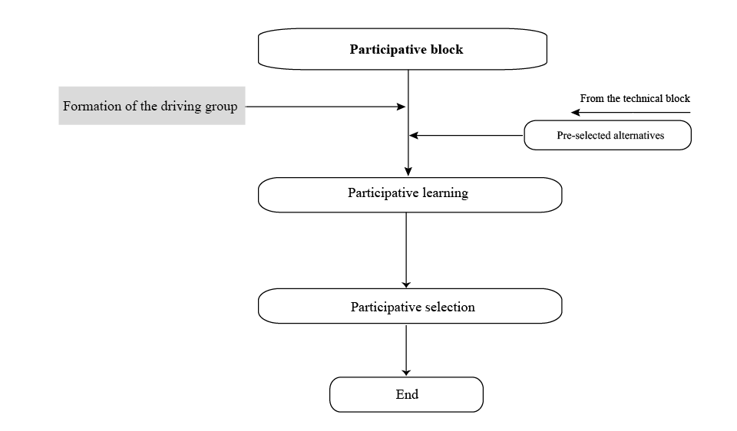
Figure S4. Participative block workflow for DEWATS selection

S3.1. PHASE I - Participative learning
The participative learning level seeks to strengthen the community by training and acquiring skills that enable its members to make informed decisions and act autonomously. In this process, the driving group gets familiar with key concepts related to supply, sanitation, wastewater, sewage, DEWATS applicable to the settlement, by-products, environmental impacts and costs. To this end, three training workshops are being developed using pedagogical methodologies based on participative action, using visual tools such as diagrams, three-dimensional digital resources, pedagogical cards, discussion forums and other resources to facilitate understanding. These workshops, led by members of the technical and social team, will allow the group of drivers to acquire the necessary knowledge to make informed DEWATS decisions with potential applicability in their community and are described in more detail below.

S3.1.1. Educational Workshop I: Decentralized Wastewater Treatment Systems

This training process is presented as a tool to strengthen and train the driving group on basic urban sanitation issues, allowing them to select the most appropriate technologies for their context. It is important to begin by reminding the participants of the purpose of the second phase of the project, the workshops to be held, and the general objectives of the initiative. Also, the fundamental concepts related to DEWATS should be clarified and the use of the participative decision tool for selecting treatment systems should be socialized. The main objective of this workshop is to introduce participants to key concepts such as wastewater, wastewater treatment and decentralized treatment.

S3.1.2. Educational Workshop II: Socialization of technologies with potential application in the settlement
In order to select technologies that are adapted to the conditions of the territory, it is essential that the community involved understands the basic functioning of the technological options that have the potential to be applied in their settlement. Therefore, this second training workshop focuses on presenting the general functioning of the technologies identified as viable after their analysis according to the criteria defined in the Technical Block Phase. During the workshop, participants will acquire basic knowledge about DEWATS systems, including their objectives and treatment levels. In addition, they will learn about the technologies applicable to the case study, taking into account operation and maintenance aspects, and will recognize the local conditions of the territory that influence the selection of treatment technologies.
S3.1.3. Educational Workshop III: Socialization of the operation and maintenance processes of technologies with potential application in the settlement
The third and final training workshop focuses on explaining to the driving group the operation and maintenance processes of the DEWATS trains shortlisted in Phase III of the participative tool, with potential for application in the unplanned peri-urban settlement. Upon completion, participants will have acquired basic knowledge that will enable them to strengthen their understanding of the technologies applicable to the case study, learn about the operation and maintenance processes and requirements of each treatment train, and understand the costs associated with their operation and maintenance in similar contexts.
S3.2. PHASE II - Participative selection of DEWATS for the implementing community
The second phase of the participative block is developed jointly by the driving group and the project's technical team, with the objective of fostering an informed debate that will lead to a consensual decision on the most appropriate technological train for the context, based on the acquired knowledge, perceptions and opinions of the community. The lessons learned from the previous workshops provide the community with a solid basis for making informed decisions, contributing to the sustainability and success of the technology train implementation. This phase includes a community workshop, the development of which is detailed below.
S.3.2.1. Participative selection workshop of the treatment system for the community of application
The workshop starts with the presentation of the selection criteria to evaluate and compare the DEWATS in order to reach a consensual and objective decision. The group of drivers then makes an individual assessment using a pairwise comparison questionnaire, prioritising the criteria using the Analytical Hierarchical Process (AHP). This method, based on pairwise comparisons and a simplified version of Saaty's scale ([6], allows each participant to assess the relative importance of one criterion to another, ranking them according to the relevance assigned by the community. The result is a list of criteria organised in order of priority.
Using the prioritised criteria, the Driving Group, together with the Institutional Panel, participates in a forum to discuss the benefits and potential impacts of each DEWATS alternative. Each member then makes a preliminary assessment by assigning a score to the performance of the technology options against the established criteria using the selection card. The individual results are processed in an Excel spreadsheet, generating an initial prioritisation of the alternatives and familiarising the group with the evaluation dynamics.
In the next step, the driving group is divided into sub-groups to carry out a collective evaluation of the technological alternatives according to the criteria. Each subgroup uses a discussion card, guided by a moderator from the institutional panel, who facilitates the discussion and the elaboration of the selection card. The results of the subgroups are processed in Excel to obtain a prioritisation of the alternatives by subgroup.
Finally, the results of each subgroup are presented as a whole and each subgroup presents its prioritisation. In a final discussion room, the subgroups agree on the most appropriate treatment system for the community.
REFERENCIAS
[1] Ministerio De Ambiente Y Desarrollo Sostenible, Resolución 631 De 2015. 2015.
[2] Ministerio de Vivienda, Ciudad y Territorio, Resolución 799 de 2021. 2021.
[3] M. Awawdeh, Z. Al-Rousan, and K. Alkaraki, “Wastewater treatment plant site selection using GIS and multicriteria decision analysis,” Arab Gulf J. Sci. Res., vol. ahead-of-print, no. ahead-of-print, Jan. 2023, doi: 10.1108/AGJSR-09-2023-0412.
[4] W. Issaoui, A. Aydi, M. Mahmoudi, M. U. Cilek, and T. Abichou, “GIS-based multi-criteria evaluation for olive mill wastewater disposal site selection,” J. Mater. Cycles Waste Manag., vol. 23, no. 4, pp. 1490–1502, Jul. 2021, doi: 10.1007/s10163-021-01231-6.
[5] Ministerio de Ambiente, Vivienda y Desarrollo Territorial, Resolución 330 de 2017. 2017.
[6] T. L. Saaty, “A scaling method for priorities in hierarchical structures,” J. Math. Psychol., vol. 15, no. 3, Art. no. 3, Jun. 1977, doi: 10.1016/0022-2496(77)90033-5.

S4- APPLICATION OF THE SITE SELECTION METHODOLOGY FOR THE IMPLEMENTATION OF A DECENTRALIZED WASTEWATER SYSTEM
The methodology was applied to site selection for the 3 communities studied. For this purpose, information sources were obtained from local institutions. This information was processed using the geographic information management software QGIS. As a result of the application of the tool, a ranking of the proposed alternatives was obtained in terms of the estimated suitability index.
S4.1. Initial location proposal
Three options were evaluated to study the location of the STDARs: the first, to the northeast near the community of Los Santos Bajos, with access via two roads; the second, next to the Bosconia WTP; and the third, on the upper part of the hillside, on the other side of the Suratá River. The sites are shown in Figure S5.

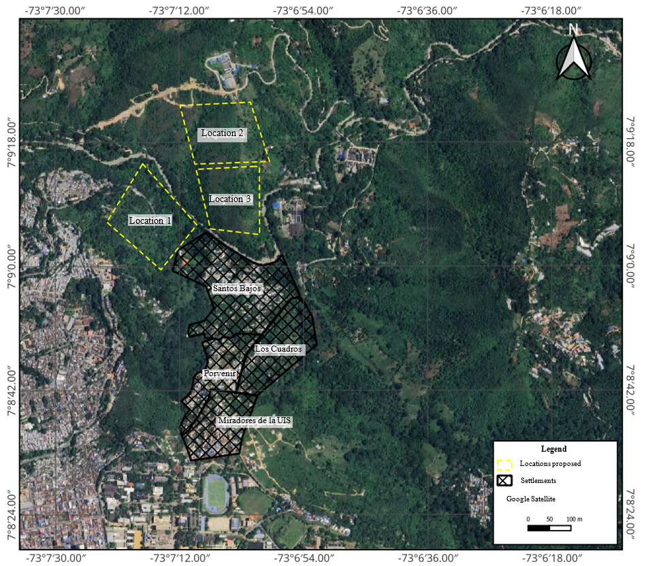
Figura S5. Initial areas proposed for the location of a decentralized wastewater system in the study area.
S4.2. Adjustment of polygons
Aspects such as land use, protected areas, topography, odors, and vulnerability were analyzed to adjust the proposed zones and delineate viable polygons for the STDAR. Table S14 summarizes the information on the proposed STDAR sites. Location 1 faces the greatest constraints, such as land use conflicts and additional costs for mitigation measures, although it does not require crossing the Suratá River or pumping water. Location 2 and Location 3, although less critical, have higher initial and operating costs due to the river crossing and pumping requirements.

Table S14. Characteristics of the different locations proposed for the implementation of a decentralized wastewater system
Feature | Location 1 | Location 2 | Location 3
Land use | Conservation | Agroforestry | Agroforestry
Area [ha] | 1.12 | 2.40 | 1.43
Altitude [m.a.s.l.] | 700 | 800 | 760
Number of affected properties | 3 | 1 | 1
Critical ecosystems | SINAP- DMRI | None | None
Approximate distance to settlements [m] | 160 | 213 | 360
Distance to the point of discharge [m] | 52 | 150 | 250
Terrain slope [%] | 0 - 1 | 0-1 | 20-50
Vulnerability to landslides | Medium | Low | Low
Vulnerability to flooding | Alto | Low | Low
Note: The most critical conditions for each parameter are underlined
S4.4. Application of spatial multi-criteria analysis
The last part of the protocol establishes the application of the multi-criteria spatial analysis, for this purpose the collected maps were rasterized and normalized for processing, Table S15 shows the criteria used for the normalization of the different criteria to be evaluated.
Table S15. Values used for raster reclassification for site selection using Spatial Multi-Criteria Analysis
CRITERION | VALUES ASSIGNED IN THE NORMALIZATION
Vulnerability to flooding | High=1  Medium=3  Low=5
Vulnerability to landslides | High=1  Medium=3  Low=5
Vulnerability to torrential flooding | High=1  Medium=3  Low=5
Land use | Agriculture=3  Agroforestry=3  Livestock=5  Forestry=3  Conservation=1  Settlement=1  Infrastructure=1  Mining=3  Landfills=1  Natural Water Bodies=1
Proximity to the Suratá River | Less than 50 meters = 1  More than 50 meters = 5
Proximity to populated areas | Less than 200 meters = 1  More than 200 meters = 5
Proximity to railroads | Less than 20 meters = 1  More than 20 meters = 5
Slope | Level, 0-1% (a) =5  Slightly flat, 1-3% (a)=4.5  Slightly sloping, 3-7%=4  Moderately sloped, 7-12%=3.5  Steeply sloping, 12-25%=3  Slightly steep or steep, 25-50% =2.5  Moderately steep or steep, 50-75% =2  Very steep or steep, 75-100% =1.5  Completely steep, >100% =1
Altitude | 500 m.a.s.l. - 720 m.a.s.l. = 5  720 m.a.s.l. - 740 m.a.s.l. = 4  740 m.a.s.l. = 4 - 760 m.a.s.l. = 3  760 m.a.s.l. = 3 - 780 m.a.s.l. = 2  780 m a.s.l. = 2 - 1800 m.a.s.l. = 1

The maps generated with the presented information were rasterized and reclassified. These maps were the basis for the classification of the different proposed sites using multi-criteria spatial analysis with the weighted sum method. The result of this process was a map with a suitability index calculated for the different locations. The generated map is shown in Figure S13.
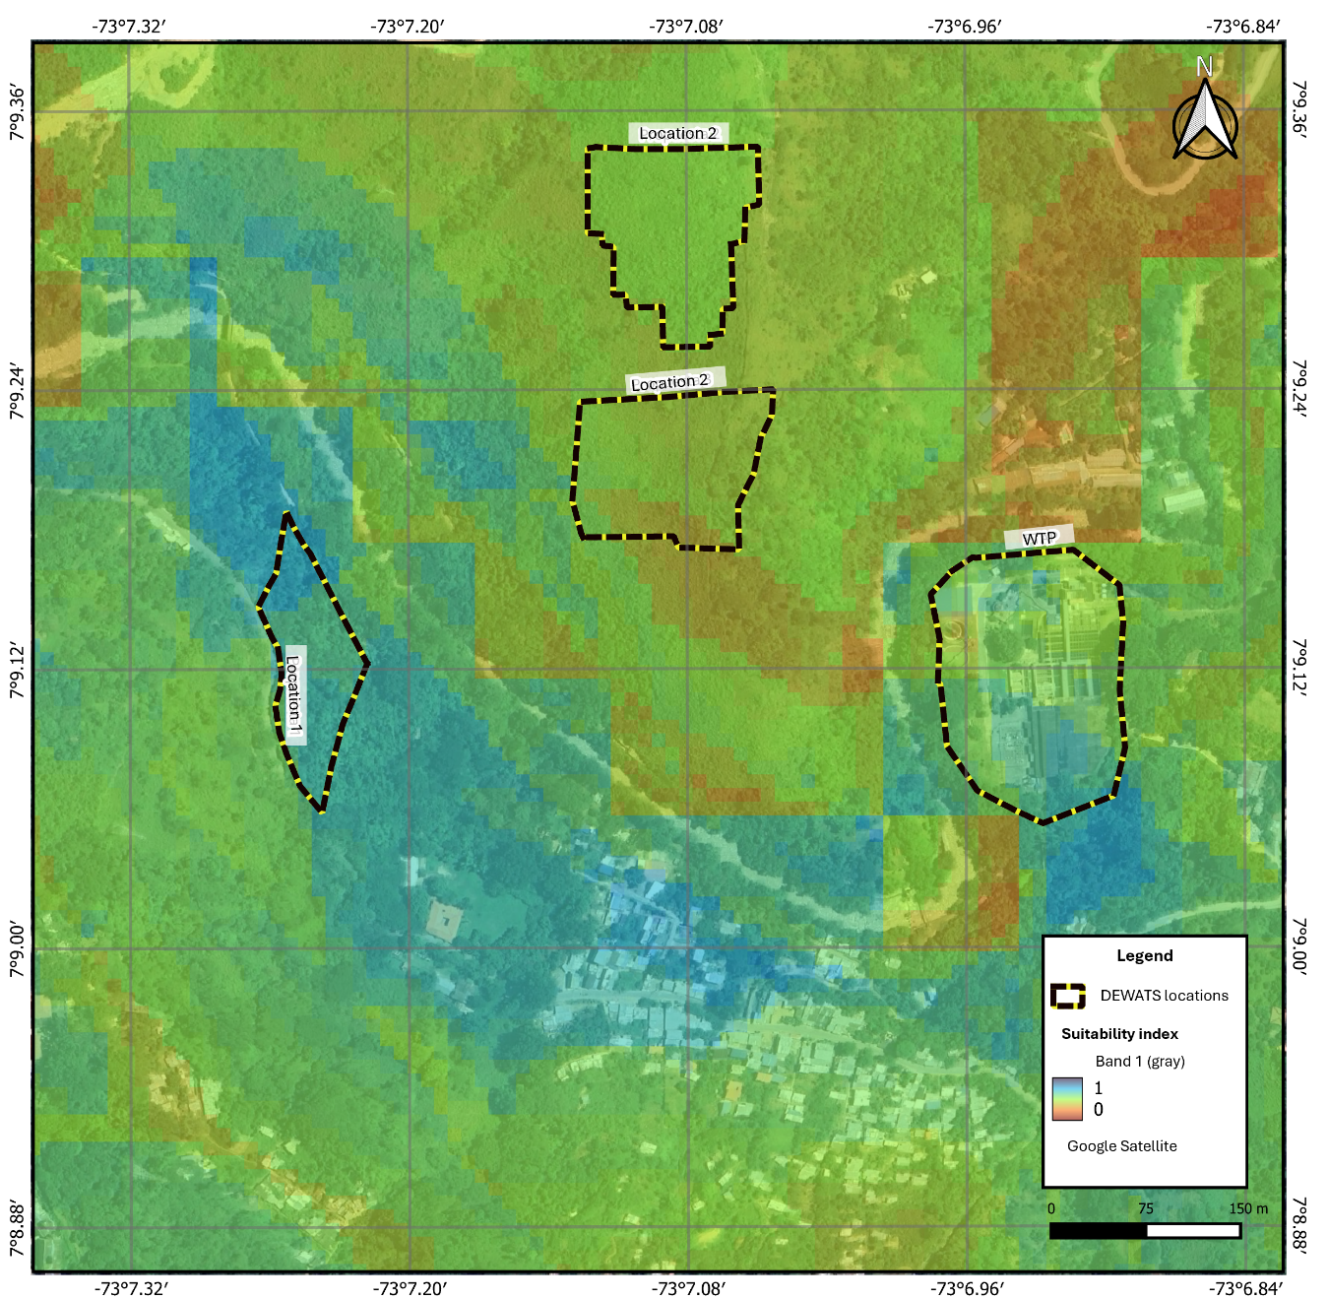
Figure S13. Suitability index calculated for different proposed locations for the implementation of a decentralized wastewater treatment system
The suitability index ranked the proposals with values of 0.63 for Location 1, 0.50 for Location 2 and 0.46 for Location 3. Despite the disadvantages of Location 1 in terms of vulnerability and land use, its height, slope, and lack of pumping or hydraulic works compensate for these weaknesses. Therefore, it was selected as the best option to implement the STDAR and proceed with the Prefeasibility Study.

