Supplementary Information

System Dynamics Analysis of Circular Economy Strategies for Plastic Waste Management in Shopping Malls

Pavinee Pongpunpurt ^{a, b, c, d}, Pascal Guiraud ^{b}, Ligia Tiruta-Barna ^{b}, Nattawin Chawaloesphonsiya ^{c, d, e}, Pisut Painmanakul ^{a, c, d*}

ª Department of Environmental and Sustainable Engineering, Chulalongkorn University, Bangkok 10330, Thailand (E-mail: ppongpunpurt@gmail.com; pisut.p@chula.ac.th)
^{b} TBI, Université de Toulouse, CNRS, INRAE, INSA, Toulouse 31077, France (E-mail: lbarna@insa-toulouse.fr; pascal.guiraud@insa-toulouse.fr)
^{c} Carbon Institute for Sustainability, Bangkok 10330, Thailand (E-mail: nattawin_ch@hotmail.com)
^{d} Center of Excellence on Treatment Technology and Management of Petroleum Contaminants and Environmental Pollution, Chulalongkorn University, Bangkok 10330, Thailand
^{e} Innovative Engineering for Sustainability, Faculty of Engineering, Chulalongkorn University, Bangkok 10330, Thailand

*Corresponding author:
Email: pisut.p@chula.ac.th
Address: Department of Environmental and Sustainable Engineering, Chulalongkorn University, Bangkok 10330, Thailand
ORCID IDs
Pavinee Pongpunpurt: https://orcid.org/0009-0008-3250-8761
Pascal Guiraud: https://orcid.org/0000-0002-3277-7709
Ligia Tiruta-Barna: https://orcid.org/0000-0003-1266-8051
Nattawin Chawaloesphonsiya: https://orcid.org/0009-0005-1026-5840
Pisut Painmanakul: https://orcid.org/0009-0009-7019-0798
Authorship contributions
Conceptualization: All authors; Data curation: Pavinee Pongpunpurt, Pascal Guiraud, Ligia Tiruta-Barna; Formal analysis and investigation: All authors; Funding acquisition: Pisut Painmanakul, Ligia Tiruta-Barna; Investigation: Pavinee Pongpunpurt; Methodology: All authors; Project administration: All authors; Resources: Pascal Guiraud, Ligia Tiruta-Barna, Pisut Painmanakul; Software: Pavinee Pongpunpurt, Pascal Guiraud, Ligia Tiruta-Barna; Supervision: Pascal Guiraud, Ligia Tiruta-Barna, Nattawin Chawaloesphonsiya, Pisut Painmanakul; Validation: All authors; Visualization: Pavinee Pongpunpurt, Pascal Guiraud, Ligia Tiruta-Barna, Nattawin Chawaloesphonsiya; Writing – original draft preparation: Pavinee Pongpunpurt, Pascal Guiraud, Ligia Tiruta-Barna, Nattawin Chawaloesphonsiya; Writing – review and editing: All authors.
Table of Contents

Pages

Information and Assumptions for the Simulation Model 1
System Dynamic Model (SDM) Testing and Validation 3
Behavioral Intervention Scenario Details 14
Causal Dynamics of Parameters in Scenario Simulations 15
Environmental Impacts Assessment Data 23
Economic Impact Assessment Data 34
Shopping Mall Typology and Scenario Applicability Framework 38

Information and Assumptions for the Simulation Model
Table SI1. Structured questionnaire for stakeholders involved in mall waste management (operational staff, waste contractors, transportation operators, and recyclers).
Stakeholder Group | Structured Questionnaire Topics / Questions
Waste Management Operational Staff | Generation:  - What types of waste are generated in the mall (general, food, plastic, paper, cardboard, glass, aluminum)?  - How much waste is generated daily on average, and how does it vary seasonally?  - Are there specific periods when large-event waste is excluded or handled differently?  Collection and storage:  - How frequently is each waste type collected?  - What is the storage capacity (m² and m³) for each type of waste (wet, dry, recycling)?  - How long is waste typically held before transfer to junk shops or processing facilities?  - What procedures are followed if storage exceeds capacity?  - How is waste separated by type (combustible, recyclable, RDF, hazardous)?
Waste Management Contractors | Collection and storage:  - Which types of waste are you responsible for collecting?  - What is the schedule and frequency for waste collection?  - How are deviations or unexpected volumes managed?  - How are holding times for combustible and recyclable waste ensured before transfer?
Transportation Operators | Transportation:  - What types of trucks and capacities are used for transporting waste to transfer stations, junk shops, or recycling facilities?  - What are the transportation routes and distances for each waste type?  - How frequently are trips scheduled, and how are additional trips arranged if volume exceeds truck capacity?  - How are spills, delays, or incidents managed?  - How is documentation and record-keeping performed during transport?
Recyclers / Recycling Facility Representatives | Processing:  - What types of recyclable waste are received from the mall?  - How are materials sorted, cleaned, and prepared for recycling or upcycling?  - Which processing methods or facilities are used (e.g., co-processing for RDF, composting food waste, landfill disposal)?  - How frequently are materials processed and returned to the supply chain or recycling platforms?  - How are contamination issues or unexpected volumes managed?

Table SI2. Assumptions and parameters used in system dynamics model by waste management stage
Waste stages | Information | Assumption
Generation | - Waste in shopping malls is primarily generated by customers and tenants; with simulation parameters derived from historical data collected during 2022–2023.  - Total daily waste generation is held constant at 15 tonnes/day (annual mean, 2022–2023). Large-event waste is excluded from the mall system under an external mall regulation (confirmed via management interviews). Seasonal dynamics are captured through monthly waste composition ratios for each waste type, parameterized via time-indexed Vensim lookup tables. The resulting daily recycling waste composition ratio has a CV of 6.85–10.59% across scenarios. | - All waste entering the recycling hub is assumed to originate externally, brought in by customers from their homes.  - Any waste diversion activities caused by strategies are assumed to affect only the general waste streams.
Collection and storage | - The wet waste storage area consists of two rooms, each with an area of 62 m² with capacity of 124 m³.  - The dry waste storage area consists of two rooms, each with an area of 31 m² with capacity of 62 m³.  - Holding time to transfer combustible waste to junk shop A is 30 days.  - Holding time to transfer recyclable waste to junk shop B is 15 days.  - The dry waste collection room receives both combustible and recyclable materials. If the volume of recyclable waste exceeds the room’s storage capacity, an additional vehicle is dispatched to transport the excess to junk shop B. | - All generated waste is assumed to be fully collected and transported to the designated collection room.
Transportation | - Truck capacity to the transfer station is 10.53 m³.  - Truck capacity to the junk shop A is 45 m³.  - Truck capacity to the junk shop B is 33.6 m³.  - Trucks assigned for wet waste collection are scheduled to collect all wet waste generated daily, regardless of volume. In cases where waste volume exceeds truck capacity, additional trips are made to ensure complete collection. | - If the loaded waste on a truck exceeds 50% of the vehicle’s capacity, the required number of trucks is rounded up to the nearest whole number.
Processing | - All waste transferred to junk shop A is undergoes co-processing for heat recovery.  - Recyclable waste is handled through junk shop B, which facilitates direct export to recycling facilities.  - Waste destined for disposal is transported to sanitary landfill sites.  - Sorted food waste is composted on-site using facilities provided by the local authority.

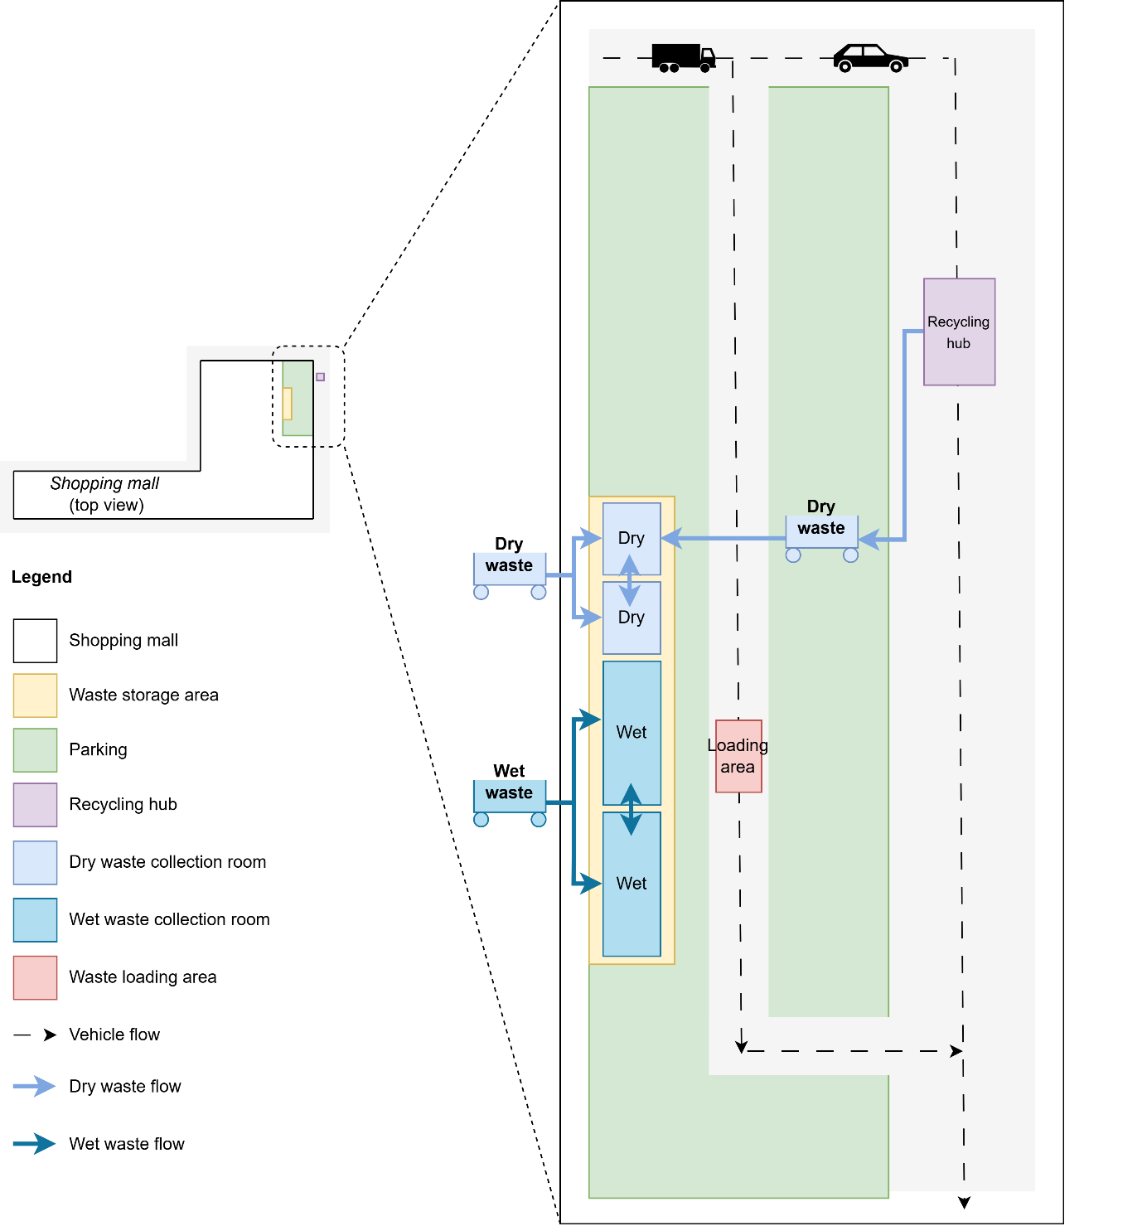

Fig. SI1. Layout of the shopping mall waste management system. The main diagram (right) shows the waste collection and processing area, including segregated dry and wet waste within the waste storage area, the loading area for transfer, and the recycling hub. Vehicle circulation is indicated with dashed arrows, while solid arrows show internal movement of waste from bins to the waste collection room. The inset (left) provides a top-down view of the shopping mall and zoomed waste collection and sorting area for spatial context. Color coding highlights functional zones: waste storage (yellow), parking (green), dry waste collection rooms (light-blue), wet waste collection room (dark-blue), and recycling hub (purple).

System Dynamic Model (SDM) Testing and Validation
The model undergoes validation through multiple strategies, including sensitivity analysis and stress testing. All mass and volume balances across units were thoroughly verified.

Sensitivity analysis
The sensitivity analysis was conducted to identify the most influential variables affecting the performance of the waste management system particularly in relation to storage capacity (Fig. SI2, Fig. SI3., and Fig. SI4.), waste transfer (Fig. SI5, Fig. SI6., and Fig. SI7.), and transportation frequency (Fig. SI8, Fig. SI9., and Fig. SI10.). The results are organized and summarized below by parameter category:
Temporal parameters
  - Waste holding time: Identified as the most critical factor, extended holding durations cause bottlenecks and disrupt waste flow efficiency. Reducing holding time improves responsiveness and helps prevent congestion in storage areas.
Quantity and composition Parameters
  - Waste generation rate: Higher waste generation significantly increases the number of required transport trips, especially to junk shop B and the transfer station.
  - Waste type and composition: Plastic waste (e.g., PET, PE, PS) and paper/cardboard are highly sensitive to changes in density and volume, directly impacting system performance.
Physical properties
  - Waste density: Heavily influences how much material can be stored or transported per trip. Low-density materials such as plastic create high-volume loads, requiring more frequent transportation.
  - Truck capacity: Limited vehicle capacity amplifies the logistical burden of bulky waste, increasing the number of trips required.
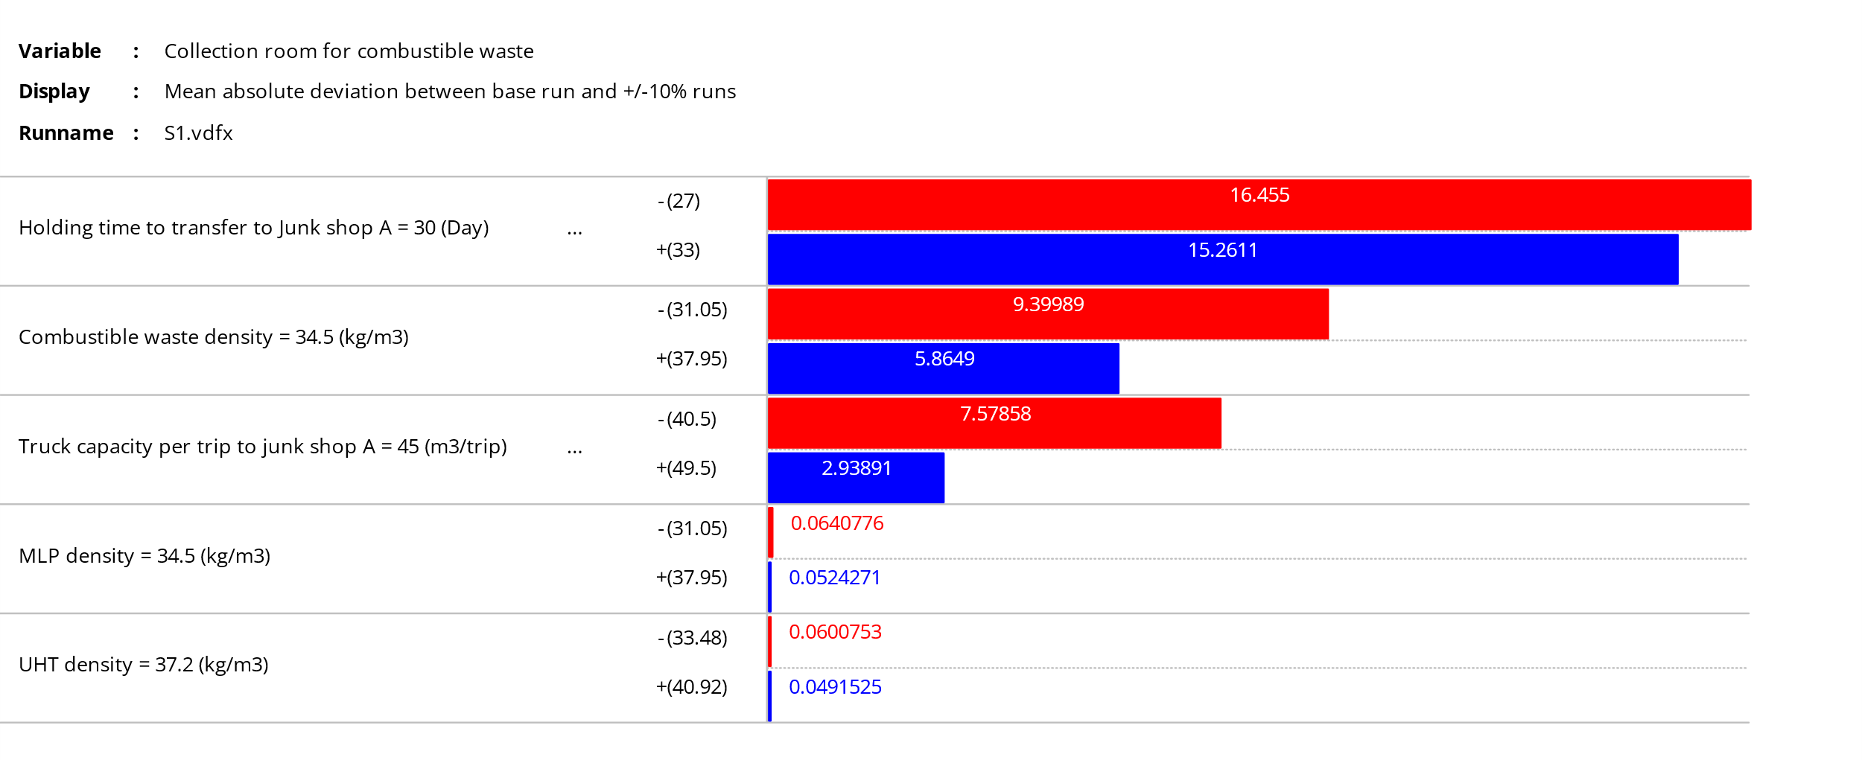
Fig. SI2. Sensitivity of combustible waste collection room to changes in constant parameters
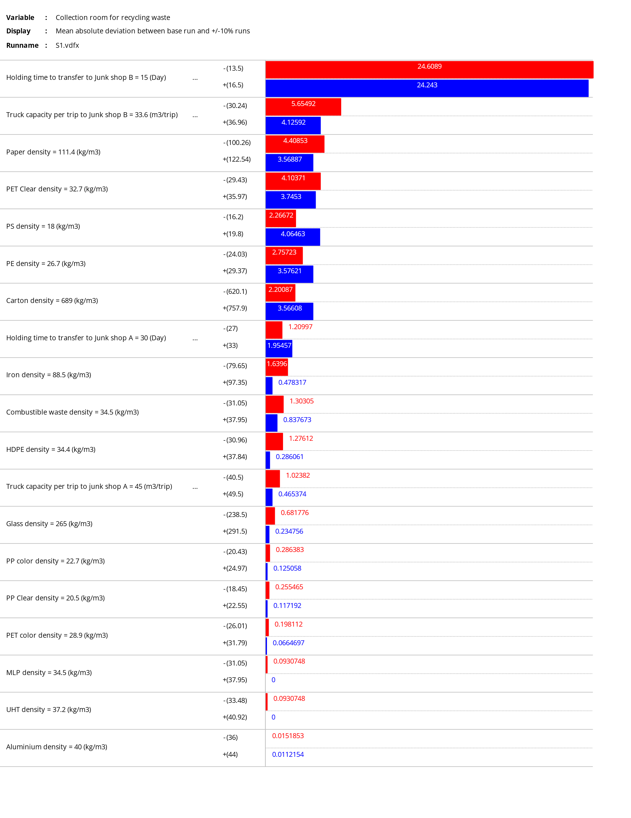
Fig. SI3. Sensitivity of recycling waste collection room to changes in constant parameters
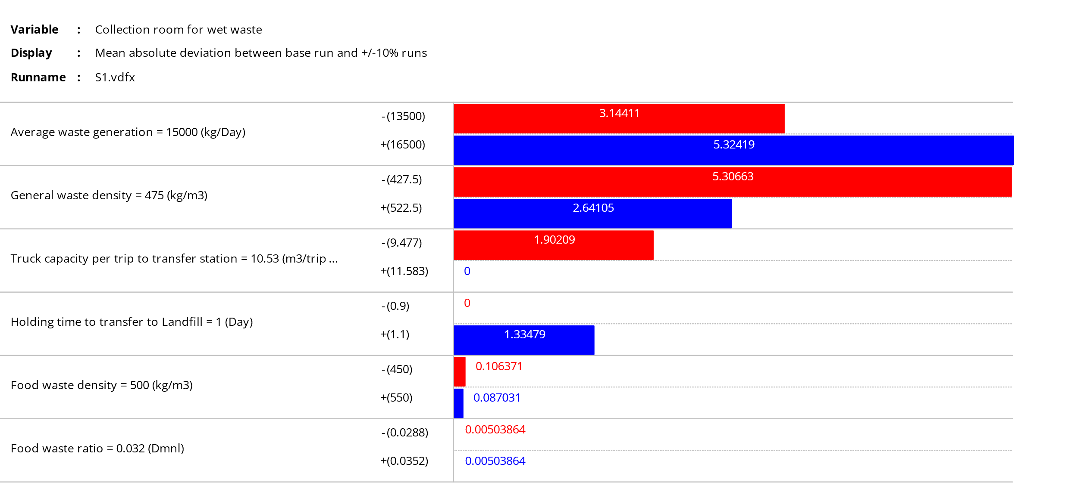
Fig. SI4. Sensitivity of wet waste collection room to changes in constant parameters
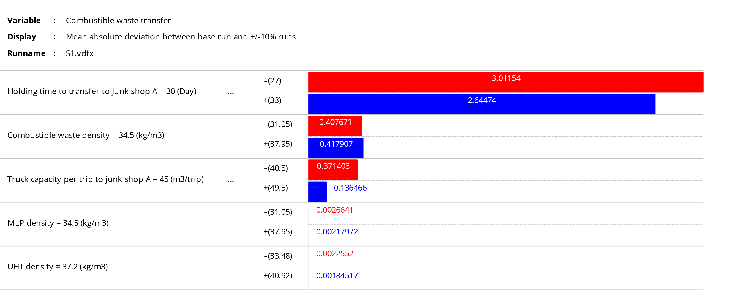
Fig. SI5. Sensitivity of combustible waste transfer to changes in constant parameters
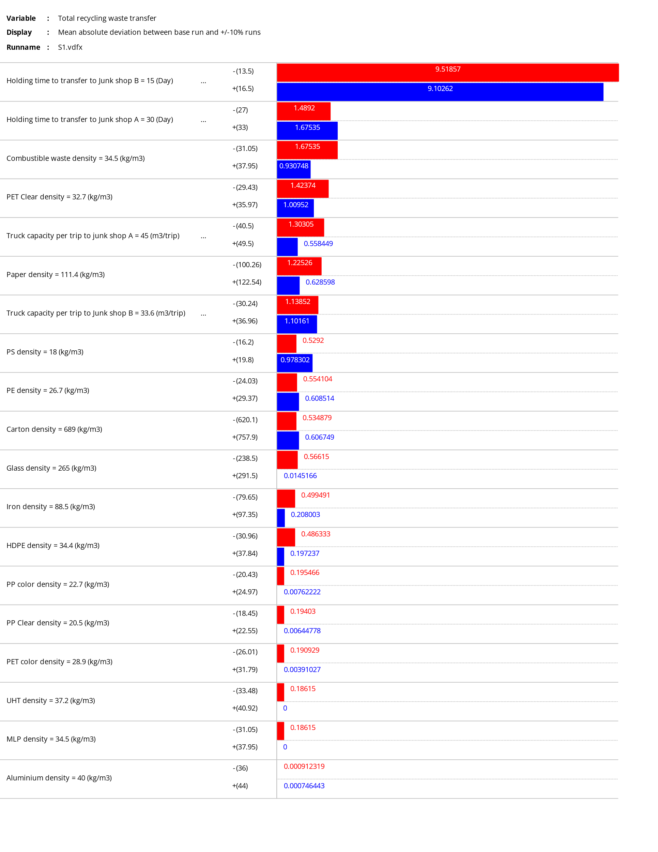
Fig. SI6. Sensitivity of recycling waste transfer to changes in constant parameters
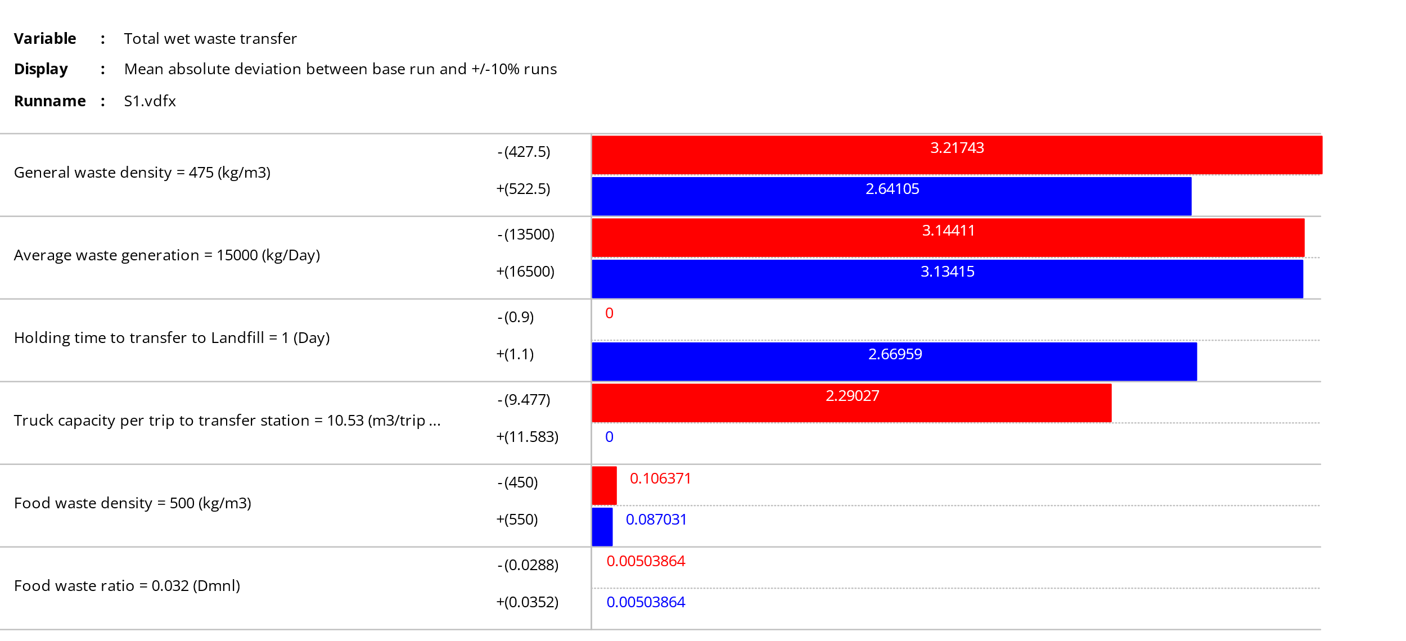
Fig. SI7. Sensitivity of wet waste transfer to changes in constant parameters

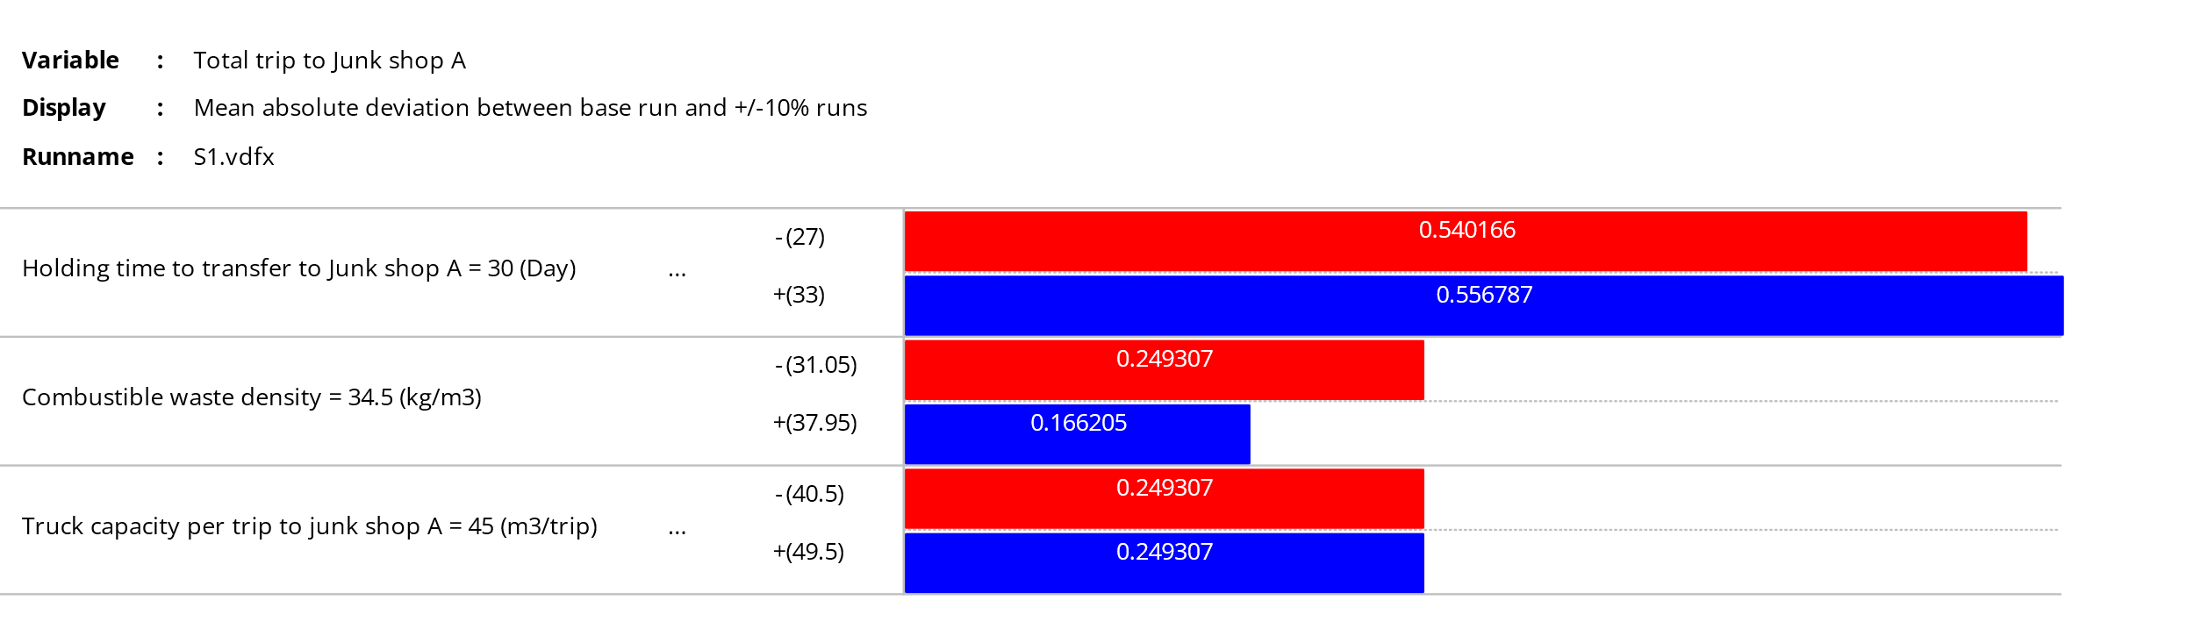
Fig. SI8. Sensitivity of total trip for combustible waste transfer to changes in constant parameters
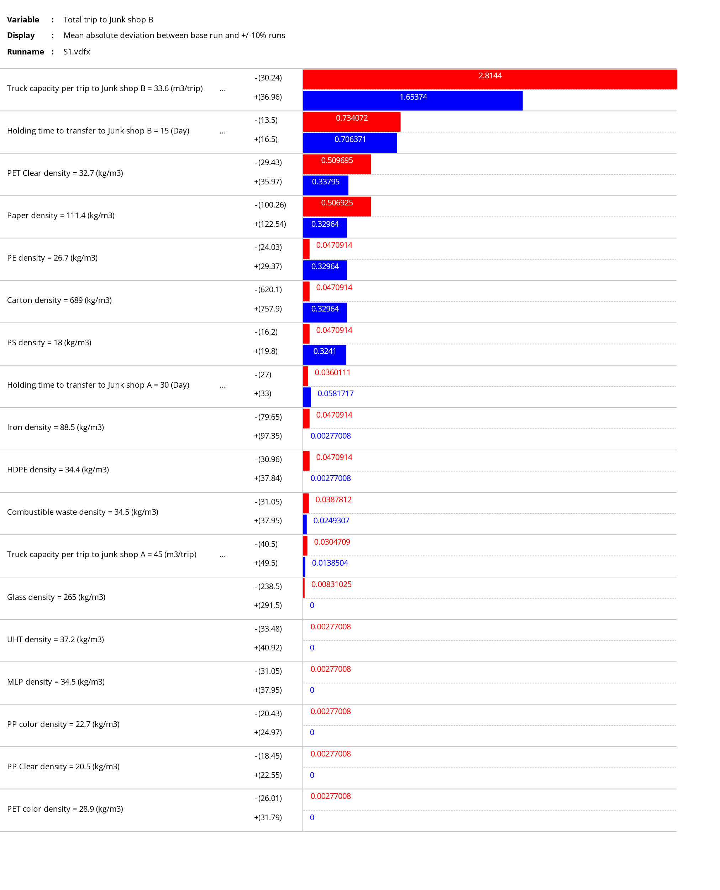
Fig. SI9. Sensitivity of total trip for recycling waste transfer to changes in constant parameters
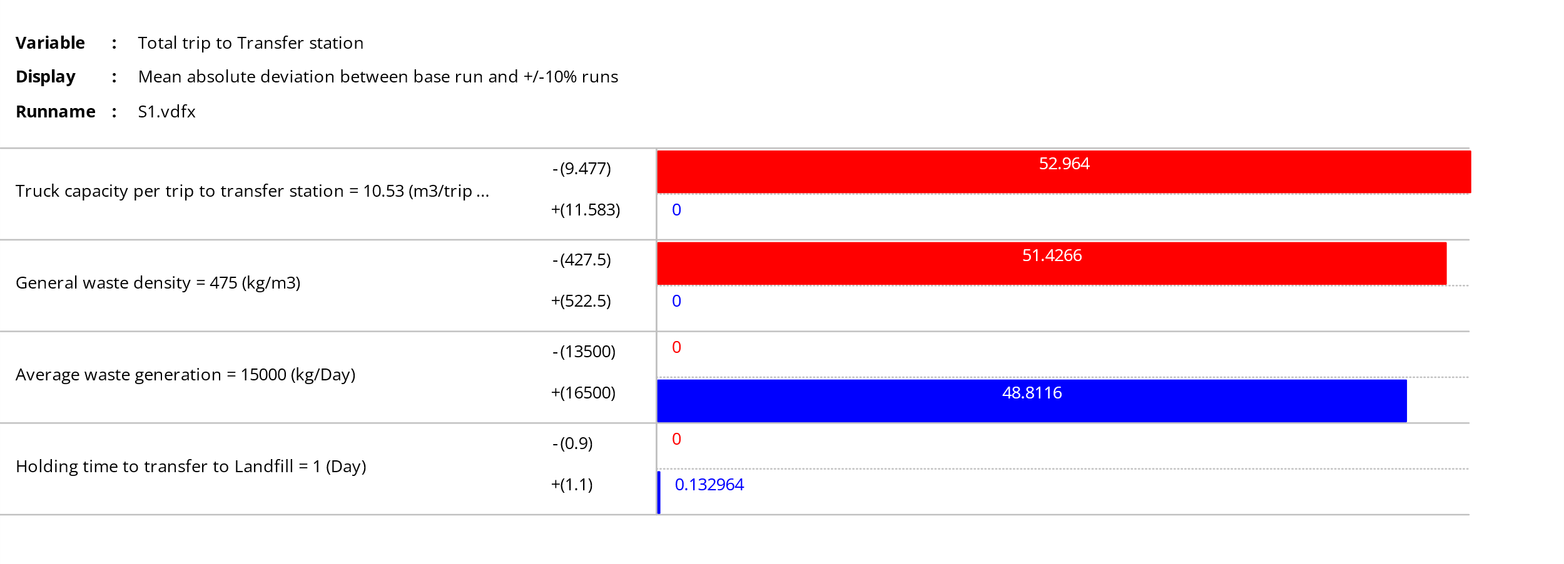
Fig. SI10. Sensitivity of total trip for wet waste transfer to changes in constant parameters
Given the inherent uncertainty in various parameters influencing the waste management system, a Monte Carlo sensitivity analysis was applied to model the effects of these uncertainties. The results, shown in Fig. SI11 illustrate the variation in the number of trips to junk shop A, junk shop B, and the Transfer station under different conditions, as outlined in Table SI3. The analysis reveals that key parameters, such as waste generation and density, significantly impact the number of transportation trips needed.

Table SI3. Sensitivity of parameters in waste system under Monte Carlo Simulation
Parameters | MIN | MAX | AVG | Variation (%)
Average waste generation (kg/day) | 13,500 | 16,500 | 15,000 | 10
Truck capacity per trip to transfer station (m³) | 8 | 13 | 10.53 | 20
Truck capacity per trip to junk shop B (m³) | 27 | 40 | 33.6 | 20
Truck capacity per trip to junk shop A (m³) | 36 | 54 | 45 | 20
Holding time to transfer to junk shop B (days) | 11 | 20 | 15 | 30
Holding time to transfer to junk shop A (days) | 21 | 39 | 30 | 30
General waste density (kg/m³) | 380 | 570 | 475 | 20
Combustible waste density (kg/m³) | 31 | 38 | 34.5 | 10
Carton density (kg/m³) | 620 | 758 | 689 | 10
Paper density (kg/m³) | 100 | 123 | 111.4 | 10
PET Clear density (kg/m³) | 29 | 36 | 32.7 | 10
PS density (kg/m³) | 16 | 20 | 18 | 10
PE density (kg/m³) | 24 | 29 | 26.7 | 10
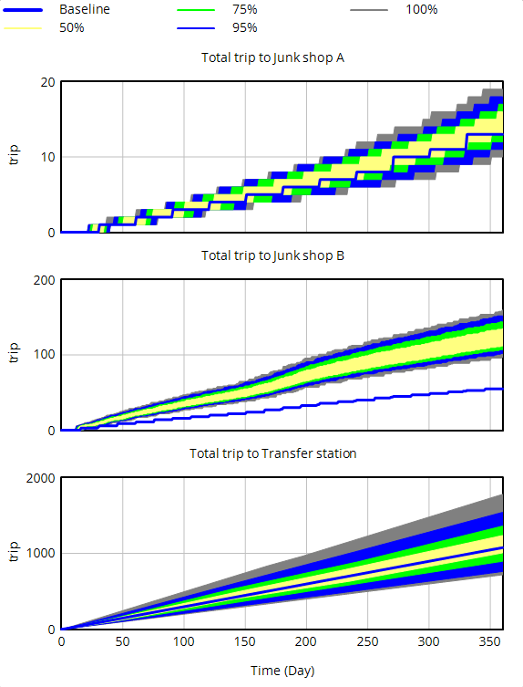
Fig. SI11. Monte Carlo simulation of transportation trips analysis over time
As waste generation increases, particularly under scenarios represented by the 100% and 95% curves, the number of trips to junk shop B and the Transfer station increases substantially. In contrast, trips to junk shop A exhibit a more gradual rise, with the baseline scenario consistently requiring fewer trips compared to scenarios with higher waste generation. This indicates that higher waste volumes lead to a larger transportation burden, highlighting the critical need for better logistical planning and optimized system design. The variation in waste density and generation emphasizes the importance of accommodating fluctuations in waste characteristics to ensure efficient waste management operations.

Stress testing
The model was also tested through a series of stress tests that simulated extreme conditions to assess the robustness and real-world applicability of the waste management system (Table SI4). These tests focused on different aspects of the system, such as truck availability, storage capacity, transportation efficiency, and waste generation rates. These strategies ensure that the model is both precise in representing the system and adaptable and realistic in addressing various real-world scenarios.
Table SI4. Model validation using stress testing
Case | Definition | Key variables change
C1 | Complete truck unavailability | Deactivate wet waste transfer
C2 | Extended storage capacity | Increase transfer station’s holding to 9 days
C3 | Reduced transportation capacity | Reduce the truck's capacity to junk shop B for recycling by 50%
C4 | Increased combustible waste | Fivefold of combustible waste generation
C5 | High waste generation | Increase the total amount of waste by 50%
C6 | Baseline | Model with data collected for 2022 and 2023

Fig. SI12 illustrates the impact on the wet waste storage facility. The absence of trucks for wet waste transfer resulted in prolonged waste accumulation in the collection room, reaching its maximum capacity of 248 m³ by the eighth day. This activated the protocol for emergency waste transfer, underscoring the crucial urgency of retaining logistics to prevent system failure. Extending the holding time for wet waste from 1 to 9 days (Case 2) resulted in the volume exceeded the room's capacity, triggering an overflow of excess wet waste. The emergency transfer protocol, permitting a single truck trip per day, was triggered on day 9 for both Case 1 and Case 2, as indicated by the change in the slope of the graph. This situation underscores the necessity for prompt waste transportation to prevent overflow, highlighting the significance of efficient waste management scheduling.
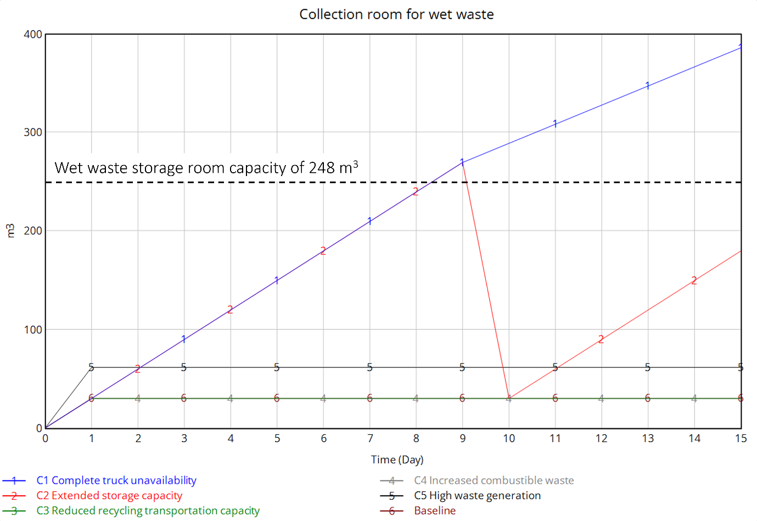
Fig. SI12. Waste volume in the wet waste collection room in the shopping mall
Both fewer trucks capacity for recycling (Case 3) and more combustible waste generated (Case 4) did not affect the wet waste collection room. However, they had a significant impact on the number of trips needed for the recycling and combustion processes (Fig. SI13) The rise in combustible waste has led to an increase in overall waste, affecting both combustible and recycling waste streams. The overflow necessitated extra trips to junk shop B for recycling due to the shared storage capacity for combustible and recyclable goods. The research underscores how an increase in combustible waste can disturb the equilibrium and impact the overall waste management system. Case C5 (50% total waste generation increase) additionally serves as a conservative upper-bound surrogate for peak waste generation conditions such as major shopping events or festive seasons. The doubling of daily truck trips to landfill (from 3 to 6) under C5 identifies transportation scheduling as the primary operational bottleneck under surge conditions. Given that the study site excludes large-event waste under an external mall regulation (confirmed via management interviews), actual seasonal surges experienced by the mall waste system are substantially smaller than the C5 scenario, and the system remains well within operational limits under realistic seasonal composition variation.

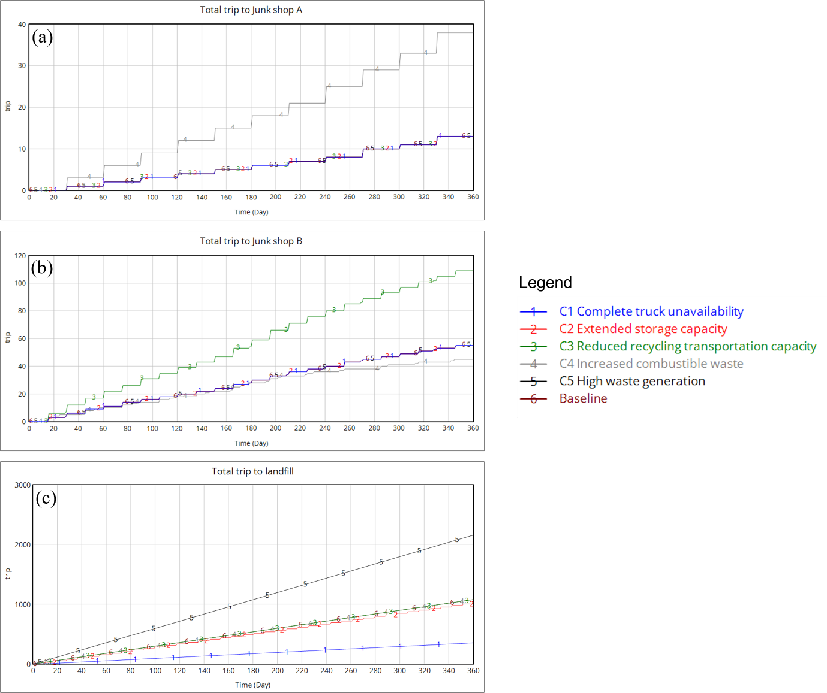

Fig. SI13. Total trip to (a) combustion process (b) recycling process, and (c) landfilling for one year

Behavioral Intervention Scenario Details
The intervention was tested for two months, and baseline data was gathered during a month of observation. The input parameters for the behavioral intervention (S3) are summarized in Table SI5, which details the separation rates for various types of plastics sorted inside the shopping mall, including Polyethylene (PE), Polyethylene Terephthalate (PET), Polystyrene (PS), and Polypropylene (PP).

Table SI5. Inputs parameters for behavioral intervention scenario (S3)
Type of plastic (sorted inside the shopping mall) | Separation Rate (kg/day)
Polyethylene (PE) | 138
Polyethylene Terephthalate (PET) – Clear | 252
Polystyrene (PS) | 16
Polypropylene (PP) – Clear | 14

Causal Dynamics of Parameters in Scenario Simulations
This section describes the interrelationships and feedback mechanisms within the shopping mall's waste management system, focusing on how changes in key parameters influence waste flow behavior. Causal strips and time-series graphs are used to illustrate how variations in waste generation rates, transportation logistics, and waste density affect storage utilization and transportation demand. The stock-and-flow diagrams highlight waste accumulation and transfer within the collection rooms, providing insights into how different strategies (e.g., waste compaction, source separation) impact system dynamics.

Dry waste
For combustible waste and recycling waste, the causal strip diagram (Fig. SI14) and time-series analysis of truck trips to junk shop A (Fig. SI15) reveal how fluctuations in waste generation and logistical parameters affect collection and transfer schedules. Increased waste volumes, due to higher generation rates, lead to more frequent trips to junk shop A (for heat recovery), thereby escalating transportation demand. Additionally, recycling waste dynamics are illustrated through the collection room storage (Fig. SI16) and transportation demand (Fig. SI17), showing how efficient recycling practices and improved source separation influence waste flow.
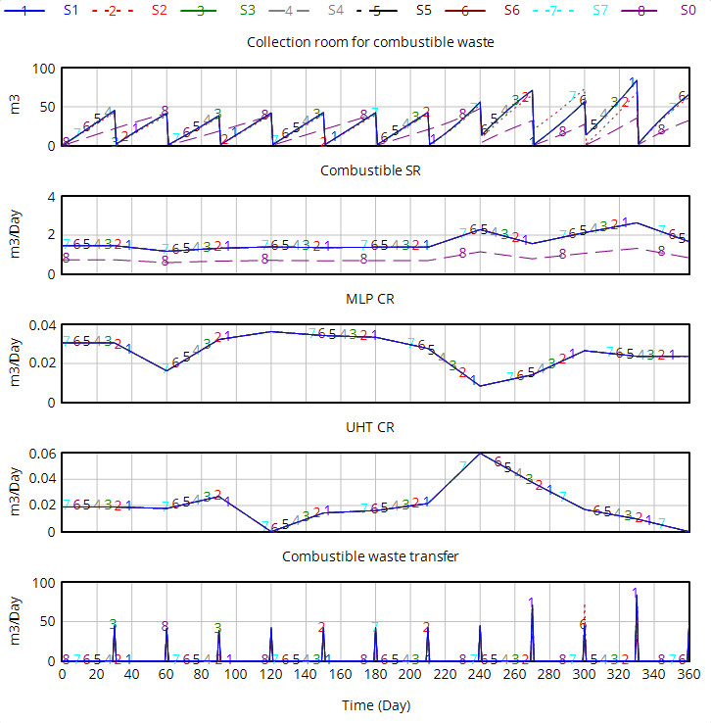
Fig. SI14. Causal strip diagram of collection room for combustible waste under different scenarios.
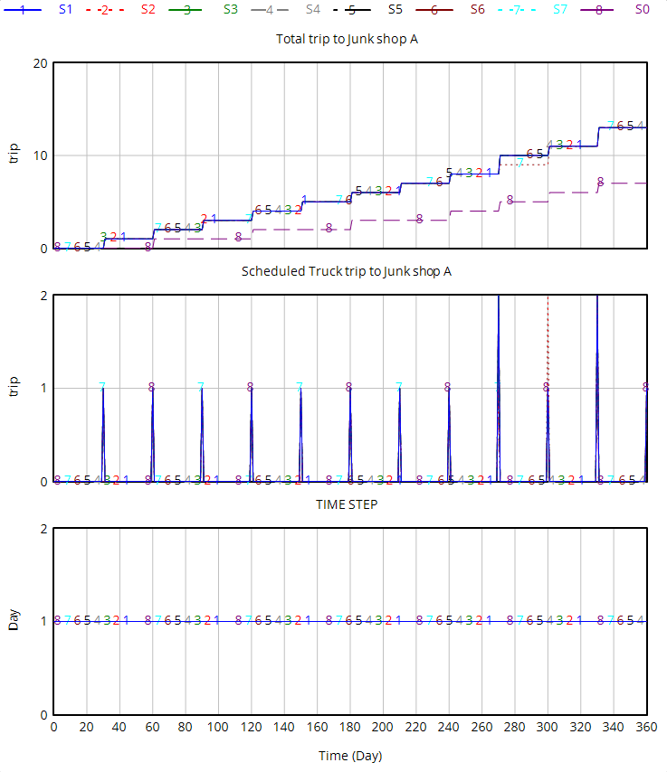
Fig. SI15. Time-series analysis of truck trips to junk shop A under various waste management scenarios
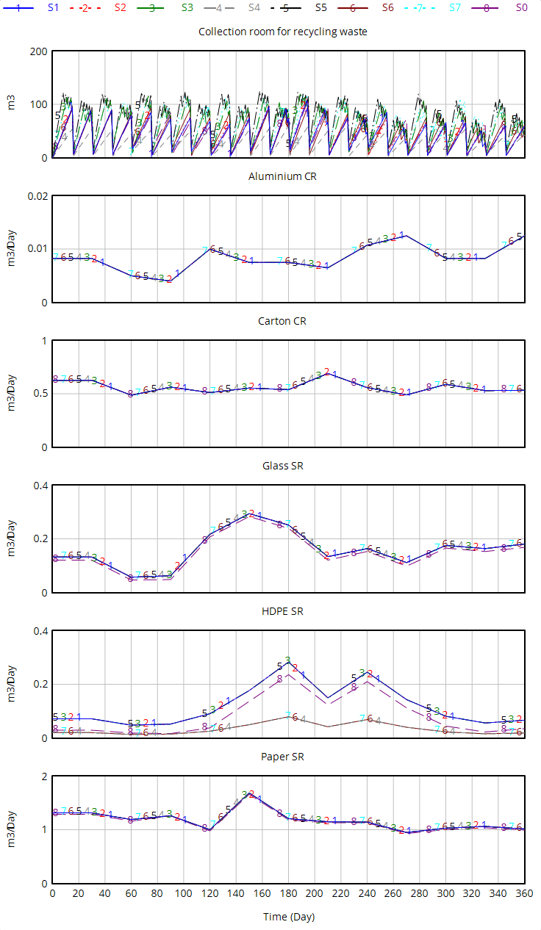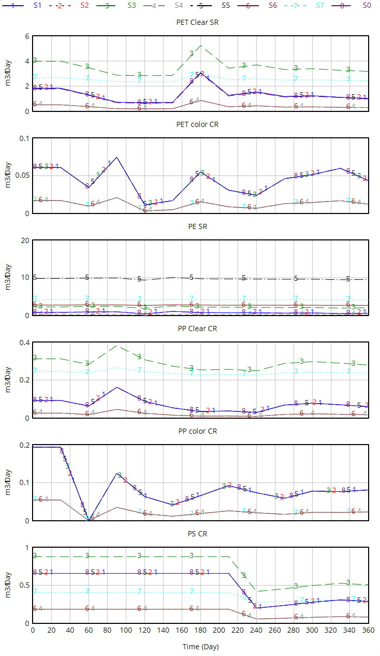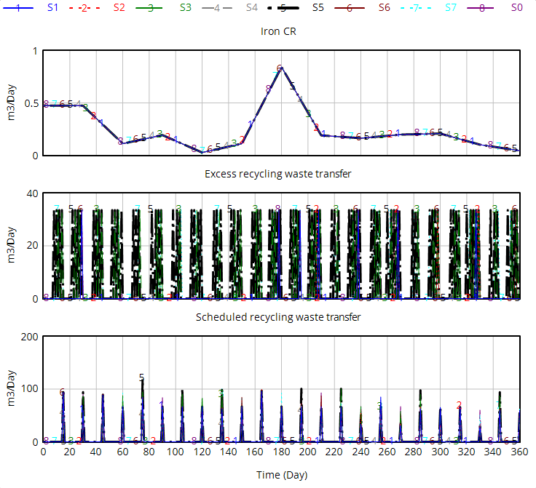
Fig. SI16. Causal strip diagram of collection room for recycling waste under different scenarios.

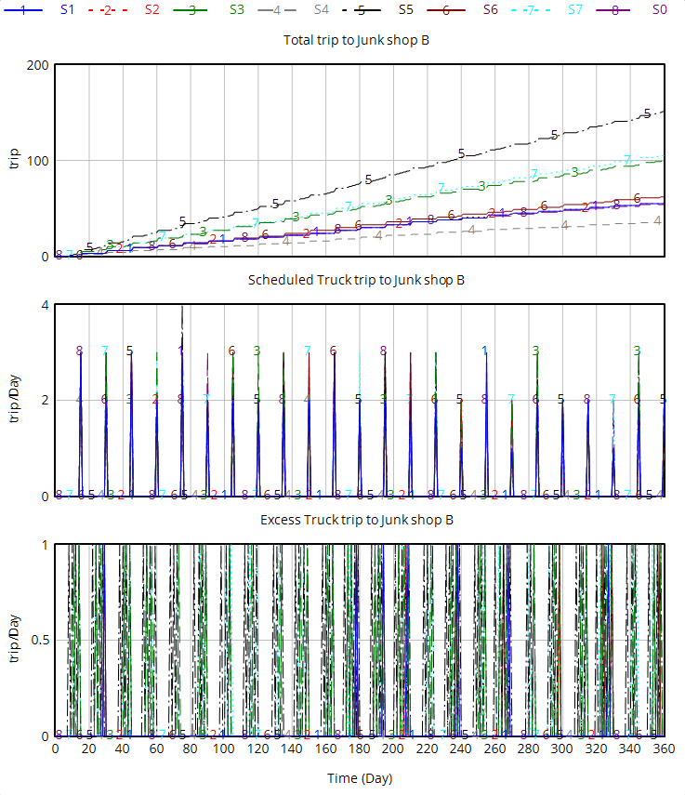
Fig. SI17. Time-series analysis of truck trips to junk shop B under various waste management scenarios

Wet waste
The management of wet waste showed minimal variation across scenarios, with consistent storage and transfer behaviors observed for all interventions (Figs. SI18–SI19). The results suggest that wet waste handling is less sensitive to the variations in waste generation rates and system interventions compared to other waste streams.
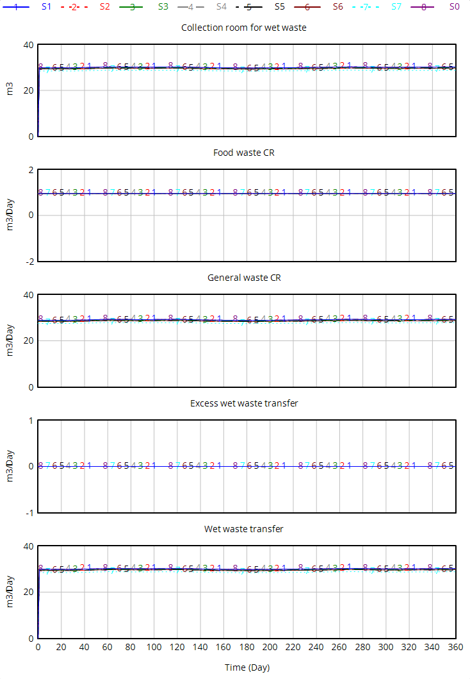
Fig. SI18. Causal strip diagram of collection room for wet waste under different scenarios.

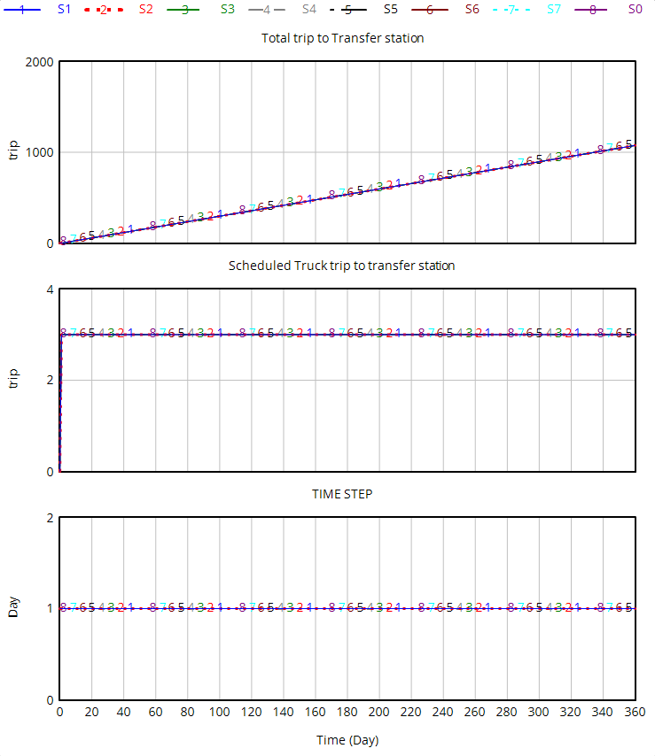
Fig. SI19. Time-series analysis of total trips to transfer station under various waste management scenarios

Environmental Impacts Assessment Data
Table SI6. The ReCiPe Midpoint (H) V1.13 Methodology – Abbreviations and units used.
Impact category | Abbreviation | Unit
Agricultural land occupation | ALOP | m²a
Climate change | GWP100 | kg CO₂-eq
Fossil depletion | FDP | kg oil-eq
Freshwater ecotoxicity | FETPinf | kg 1,4-DCB-eq
Freshwater eutrophication | FEP | kg P-eq
Human toxicity | HTPinf | kg 1,4-DCB-eq
Ionising radiation | IRP_HE | kg U235-eq
Marine ecotoxicity | METPinf | kg 1,4-DB-eq
Marine eutrophication | MEP | kg N-eq
Metal depletion | MDP | kg Fe-eq
Natural land transformation | NLTP | m²
Ozone depletion | ODPinf | kg CFC-11-eq
Particulate matter formation | PMFP | kg PM10-eq
Photochemical oxidant formation | POFP | kg NMVOC-eq
Terrestrial acidification | TAP100 | kg SO₂-eq
Terrestrial ecotoxicity | TETPinf | kg 1,4-DCB-eq
Urban land occupation | ULOP | m²a
Water depletion | WDP | m³ water-eq

Table SI7. Inventory table for environmental impacts assessment
Process | unit | S0 | S1 | S2 | S3 | S4 | S5 | S6 | S7 | Ecoinvent database 3.8 or Data source
Collection and Sorting Center (CSC) |  |  |  |  |  |  |  |  |  | Self defined
Combustible waste | kg | 10,188 | 10,188 | 10,188 | 10,188 | 10,188 | 10,188 | 10,188 | 10,188 | Exported data from Vensim
Metal scrap | kg | 7,680 | 7,680 | 7,680 | 7,680 | 7,680 | 7,680 | 7,680 | 7,680 | Exported data from Vensim
Glass waste | kg | 14,167 | 14,167 | 14,167 | 14,167 | 14,167 | 14,167 | 14,167 | 14,167 | Exported data from Vensim
Paper waste | kg | 46,533 | 46,533 | 46,533 | 46,533 | 46,533 | 46,533 | 46,533 | 46,533 | Exported data from Vensim
Paperboard waste | kg | 139,009 | 139,009 | 139,009 | 139,009 | 139,009 | 139,009 | 139,009 | 139,009 | Exported data from Vensim
PE waste | kg | 6,719 | 6,719 | 6,719 | 20,621 | 6,719 | 93,119 | 93,119 | 107,021 | Exported data from Vensim
HDPE waste | kg | 1,052 | 1,052 | 1,052 | 1,052 | 1,052 | 1,052 | 1,052 | 1,052 | Exported data from Vensim
PET Clear waste | kg | 15,275 | 15,275 | 15,275 | 40,693 | 15,275 | 15,275 | 15,275 | 40,693 | Exported data from Vensim
PET Color waste | kg | 449 | 449 | 591 | 449 | 449 | 449 | 449 | 591 | Exported data from Vensim
PP Clear waste | kg | 525 | 525 | 1,181 | 2,149 | 525 | 525 | 525 | 2,805 | Exported data from Vensim
PP Color waste | kg | 687 | 687 | 1,038 | 687 | 687 | 687 | 687 | 1,038 | Exported data from Vensim
PS waste | kg | 3,299 | 3,299 | 3,299 | 4,725 | 3,299 | 3,299 | 3,299 | 4,725 | Exported data from Vensim
Biowaste | kg | 172,320 | 172,320 | 172,320 | 172,320 | 172,320 | 172,320 | 172,320 | 172,320 | Exported data from Vensim
Municipal solid waste | kg | 4,959,094 | 4,959,094 | 4,959,094 | 4,916,842 | 4,959,094 | 4,872,934 | 4,872,934 | 4,830,682 | Exported data from Vensim
Mixed waste | kg | 5,400,000 | 5,400,000 | 5,400,000 | 5,400,000 | 5,400,000 | 5,400,000 | 5,400,000 | 5,400,000 | Exported data from Vensim
Recycling Collection Center (RCC) |  |  |  |  |  |  |  |  |  | Self defined
Combustible waste | kg | - | 10,188 | 7,488 | 10,188 | 10,188 | 10,188 | 10,188 | 7,488 | Exported data from Vensim
Aluminium scrap | kg | - | 119 | 119 | 119 | 119 | 119 | 119 | 119 | Exported data from Vensim
Glass waste | kg | - | 1,109 | 1,109 | 1,109 | 1,109 | 1,109 | 1,109 | 1,109 | Exported data from Vensim
Paper waste | kg | - | 867 | 867 | 867 | 867 | 867 | 867 | 867 | Exported data from Vensim
HDPE waste | kg | - | 463 | 463 | 463 | 463 | 463 | 463 | 463 | Exported data from Vensim
PE waste | kg | - | 335 | 335 | 335 | 335 | 335 | 335 | 335 | Exported data from Vensim
PET Clear waste | kg | - | 527 | 527 | 527 | 527 | 527 | 527 | 527 | Exported data from Vensim
Plastic waste mixture (MLP) | kg | - | 323 | 323 | 323 | 323 | 323 | 323 | 323 | Exported data from Vensim
Plastic waste mixture (UHT) | kg | - | 278 | 278 | 278 | 278 | 278 | 278 | 278 | Exported data from Vensim
Utilizing waste | kg | - | 14,210 | 14,210 | 14,210 | 14,210 | 14,210 | 14,210 | 14,210 | Exported data from Vensim
Collection room for wet waste |  |  |  |  |  |  |  |  |  | Self defined
Biowaste | kg | 172,320 | 172,320 | 172,320 | 172,320 | 172,320 | 172,320 | 172,320 | 172,320 | Exported data from Vensim
Municipal solid waste | kg | 4,959,094 | 4,959,094 | 4,959,094 | 4,916,842 | 4,959,094 | 4,872,934 | 4,872,934 | 4,830,682 | Exported data from Vensim
Collection room for recycling waste |  |  |  |  |  |  |  |  |  | Self defined
Metal scrap | kg | 7,680 | 7,680 | 7,680 | 7,680 | 7,680 | 7,680 | 7,680 | 7,680 | Exported data from Vensim
Aluminium scrap | kg | - | 119 | 119 | 119 | 119 | 119 | 119 | 119 | Exported data from Vensim
Glass waste | kg | 15,276 | 15,276 | 15,276 | 15,276 | 15,276 | 15,276 | 15,276 | 15,276 | Exported data from Vensim
Paper waste | kg | 47,400 | 47,400 | 47,400 | 47,400 | 47,400 | 47,400 | 47,400 | 47,400 | Exported data from Vensim
Paperboard waste | kg | 139,009 | 139,009 | 139,009 | 139,009 | 139,009 | 139,009 | 139,009 | 139,009 | Exported data from Vensim
PE waste | kg | 6,719 | 7,055 | 7,055 | 20,956 | 7,055 | 93,455 | 93,455 | 107,356 | Exported data from Vensim
HDPE waste | kg | 1,052 | 1,515 | 1,515 | 1,515 | 1,515 | 1,515 | 1,515 | 1,515 | Exported data from Vensim
PET Clear waste | kg | 15,275 | 15,802 | 15,802 | 41,220 | 15,802 | 15,802 | 15,802 | 41,220 | Exported data from Vensim
PET Color waste | kg | 449 | 449 | 591 | 449 | 449 | 449 | 449 | 591 | Exported data from Vensim
PP Clear waste | kg | 525 | 525 | 1,181 | 2,149 | 525 | 525 | 525 | 2,805 | Exported data from Vensim
PP Color waste | kg | 687 | 687 | 1,038 | 687 | 687 | 687 | 687 | 1,038 | Exported data from Vensim
PS waste | kg | 3,299 | 3,299 | 3,299 | 4,725 | 3,299 | 3,299 | 3,299 | 4,725 | Exported data from Vensim
Plastic waste mixture (MLP) | kg | - | 323 | 323 | 323 | 323 | 323 | 323 | 323 | Exported data from Vensim
Plastic waste mixture (UHT) | kg | - | 278 | 278 | 278 | 278 | 278 | 278 | 278 | Exported data from Vensim
Transportation to Transfer station | tkm | 108,421,166 | 108,421,166 | 108,421,166 | 107,497,412 | 108,421,166 | 106,537,442 | 106,537,442 | 105,613,687 | Self defined
Total landfilling waste transfer | kg | 4,959,094 | 4,959,094 | 4,959,094 | 4,916,842 | 4,959,094 | 4,872,934 | 4,872,934 | 4,830,682 | Exported data from Vensim
Distance | km | 20.3 | 20.3 | 20.3 | 20.3 | 20.3 | 20.3 | 20.3 | 20.3 | Self defined
Transportation trip | trip | 1,077 | 1,077 | 1,077 | 1,077 | 1,077 | 1,077 | 1,077 | 1,077 | Exported data from Vensim
Transportation to junk shop B | tkm | 646,032 | 663,665 | 666,850 | 1,420,205 | 422,332 | 2,479,600 | 1,018,114 | 1,358,861 | Transport, freight, lorry 16-32 metric ton, EURO5 [RoW]
Total recycling waste transfer | kg | 237,372 | 239,417 | 240,567 | 281,787 | 239,417 | 325,817 | 325,817 | 369,336 | Exported data from Vensim
Distance | km | 50 | 50 | 50 | 50 | 50 | 50 | 50 | 50 | Self defined
Transportation trip | trip | 54 | 55 | 55 | 100 | 35 | 151 | 62 | 73 | Exported data from Vensim
Transportation to junk shop A | tkm | 2,567 | 9,536 | 8,272 | 9,536 | 9,536 | 9,536 | 9,536 | 8,272 | Transport, freight, lorry 16-32 metric ton, EURO5 [RoW]
Combustible waste | kg | 10,188 | 20,377 | 17,676 | 20,377 | 20,377 | 20,377 | 20,377 | 17,676 | Exported data from Vensim
Distance | km | 36 | 36 | 36 | 36 | 36 | 36 | 36 | 36 | Self defined
Transportation trip | trip | 7 | 13 | 13 | 13 | 13 | 13 | 13 | 13 | Exported data from Vensim
Transportation to Co-processing | tkm | 7,916 | 29,403 | 25,507 | 29,403 | 29,403 | 29,403 | 29,403 | 25,507 | Transport, freight, lorry 16-32 metric ton, EURO5 [RoW]
Combustible waste | kg | 10,188 | 20,377 | 17,676 | 20,377 | 20,377 | 20,377 | 20,377 | 17,676 | Exported data from Vensim
Distance | km | 111 | 111 | 111 | 111 | 111 | 111 | 111 | 111 | Self defined
Transportation trip | trip | 7 | 13 | 13 | 13 | 13 | 13 | 13 | 13 | Exported data from Vensim
Treatment of biowaste, industrial composting |  |  |  |  |  |  |  |  |  | Treatment of biowaste, industrial composting [RoW]
Biowaste | kg | 172,320 | 172,320 | 172,320 | 172,320 | 172,320 | 172,320 | 172,320 | 172,320 | Exported data from Vensim

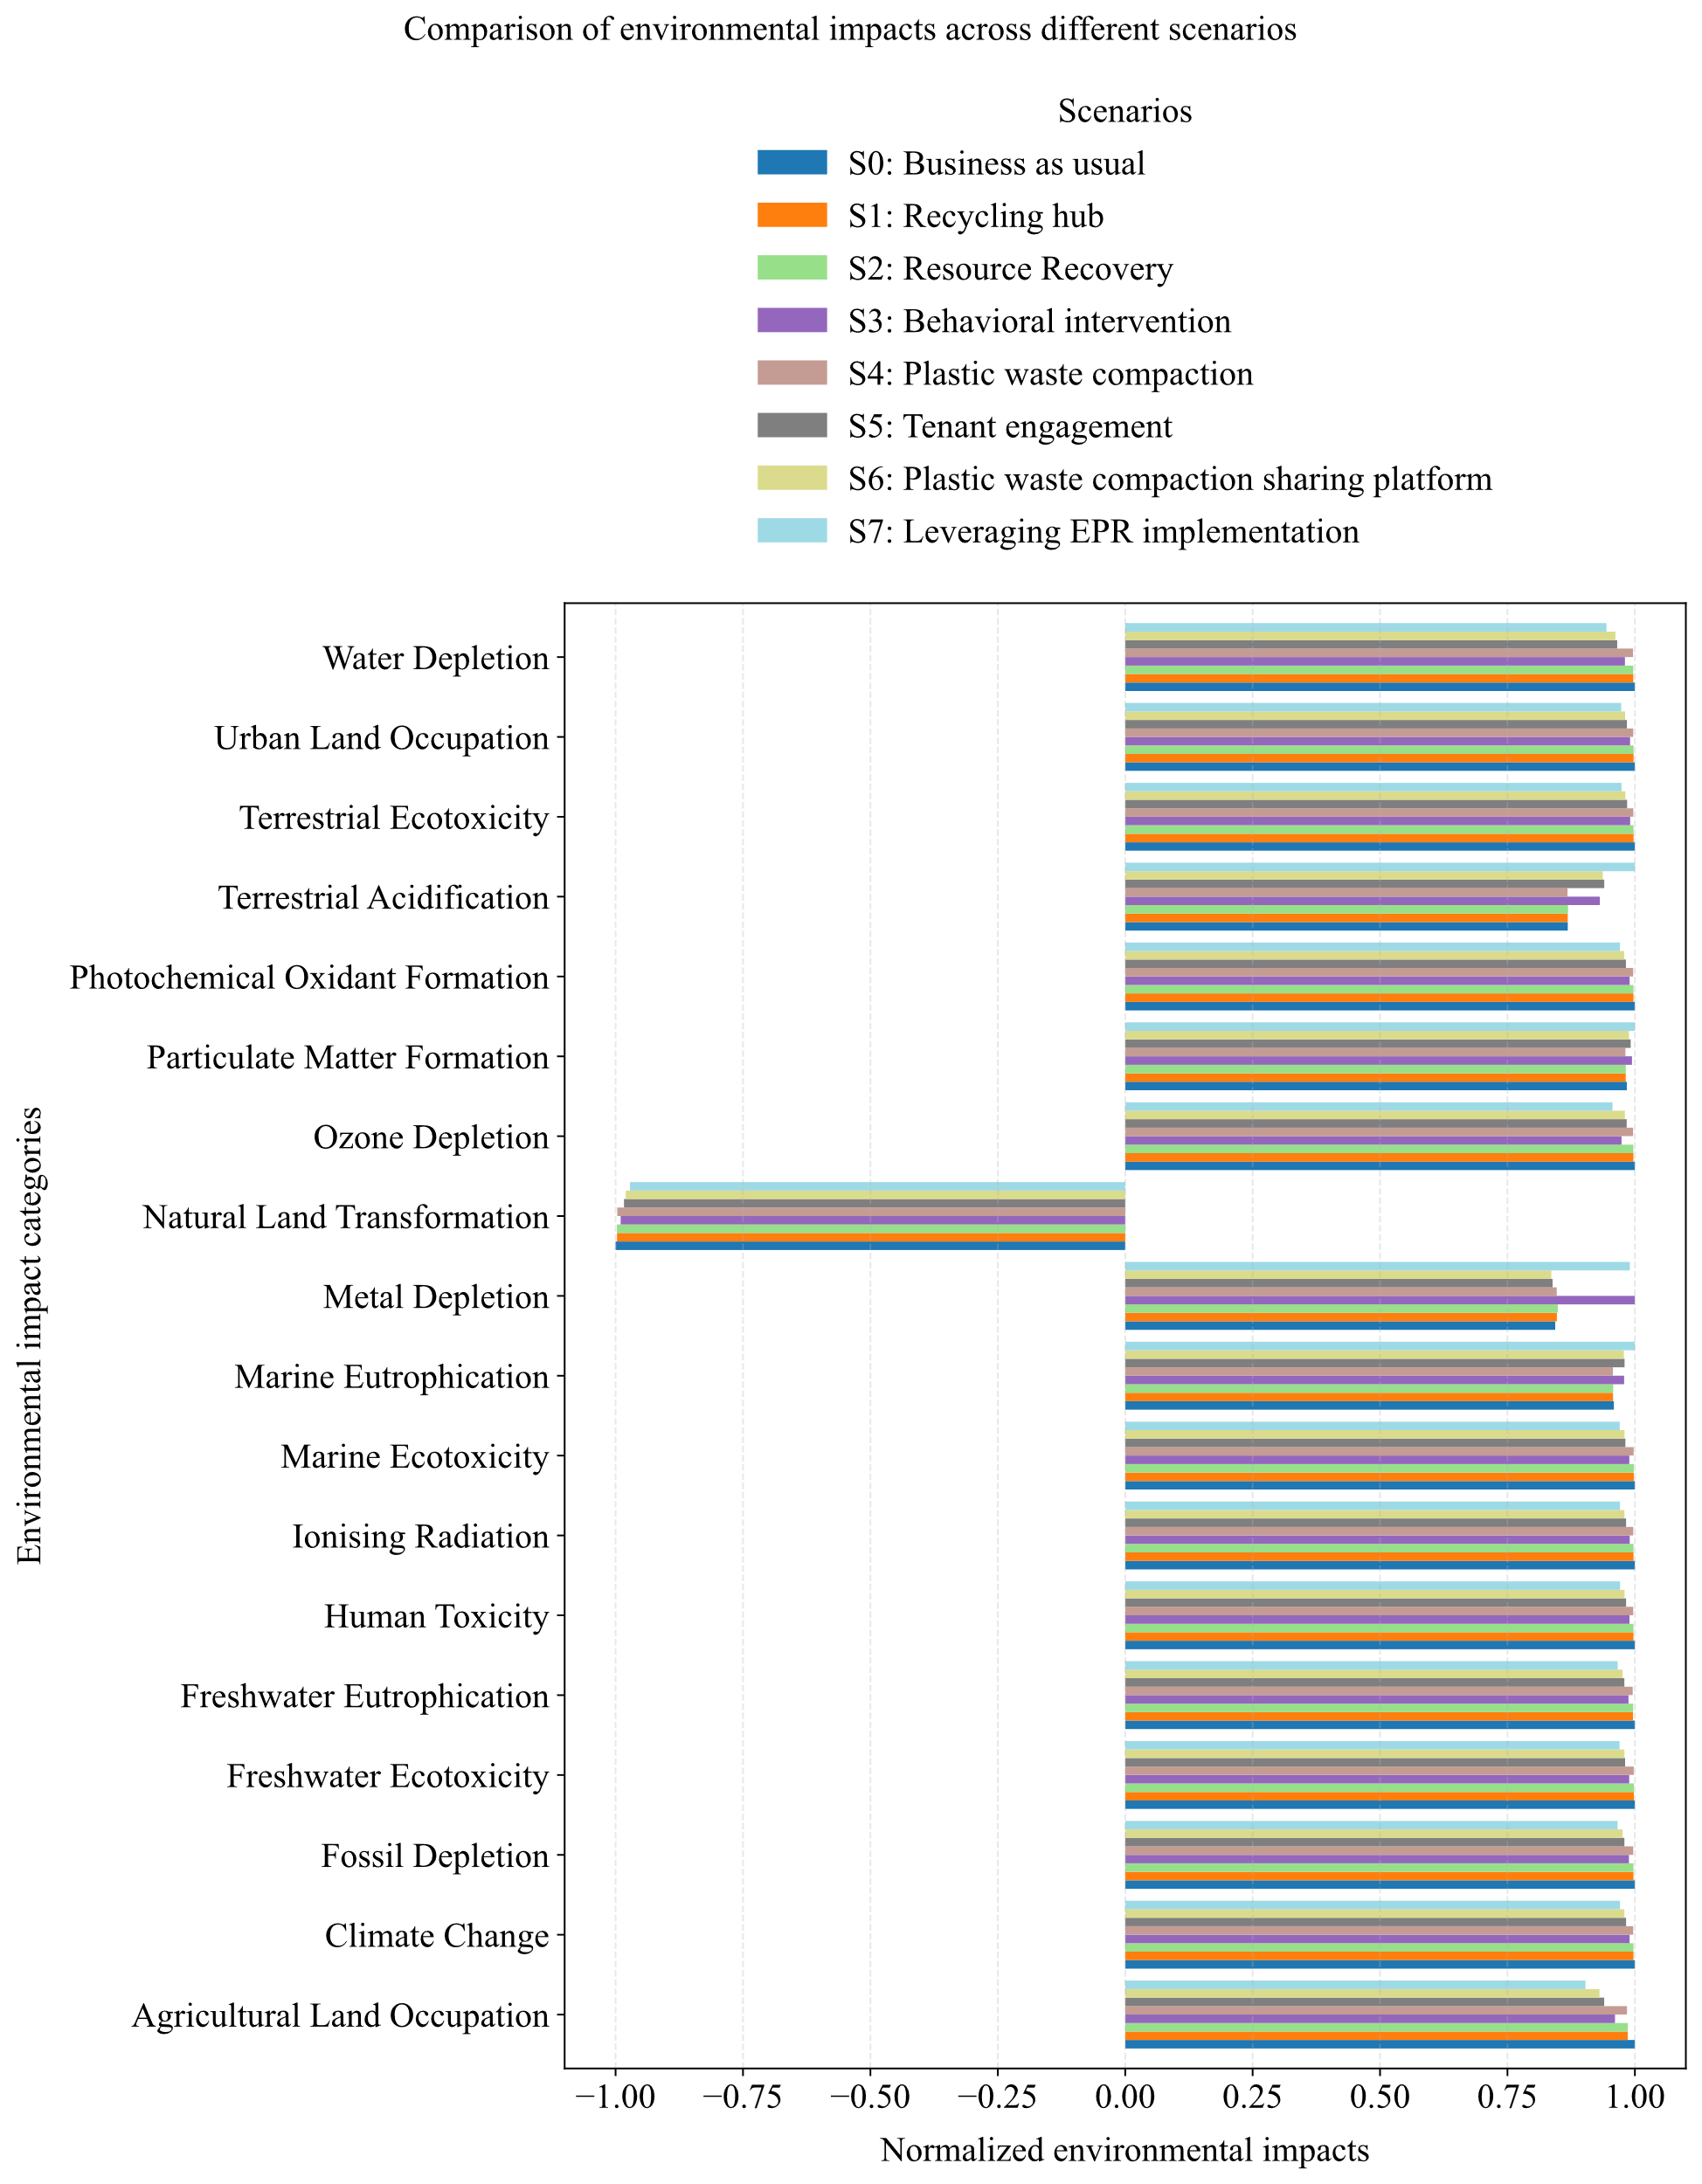
Fig. SI20. Comparison of environmental impacts across different scenarios

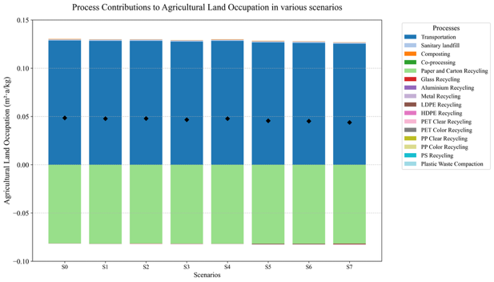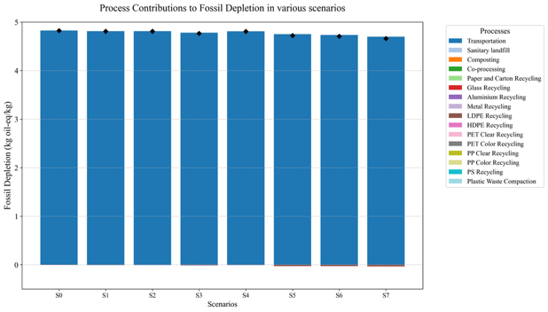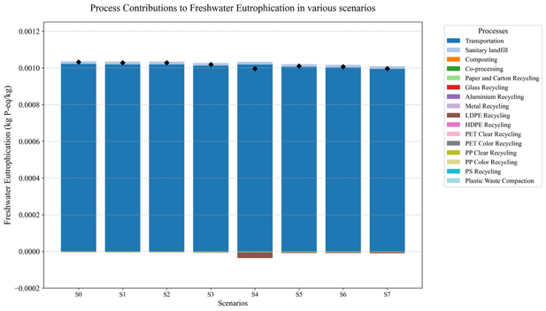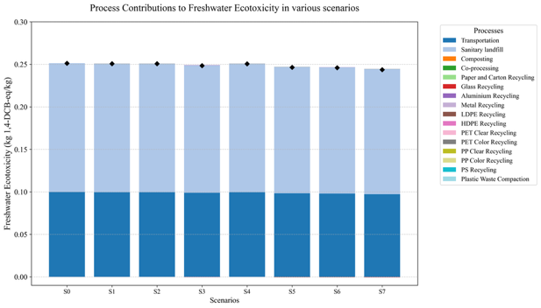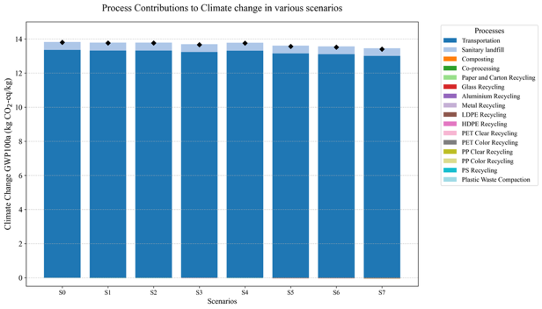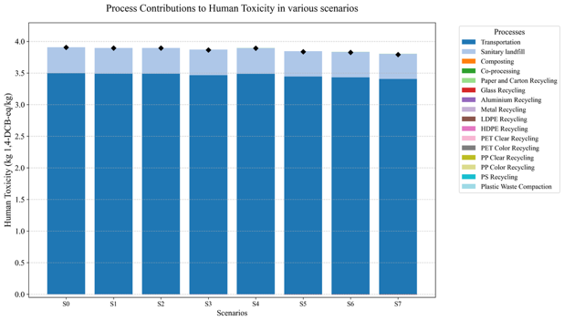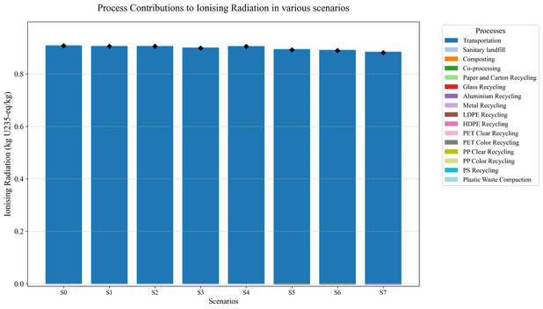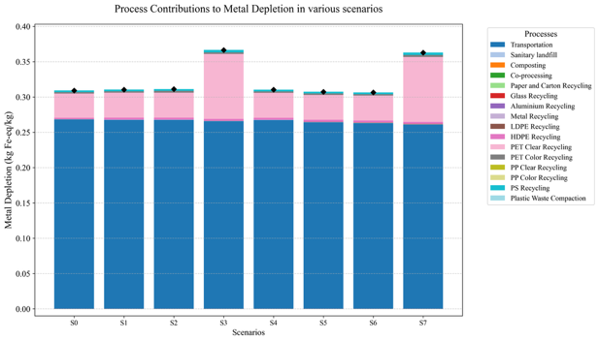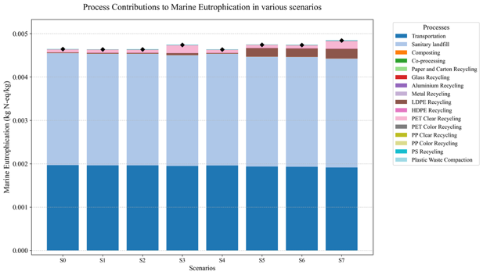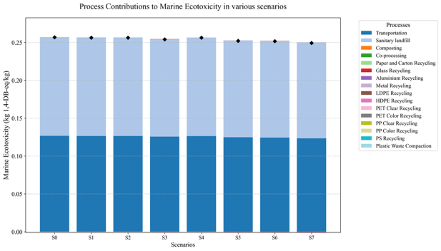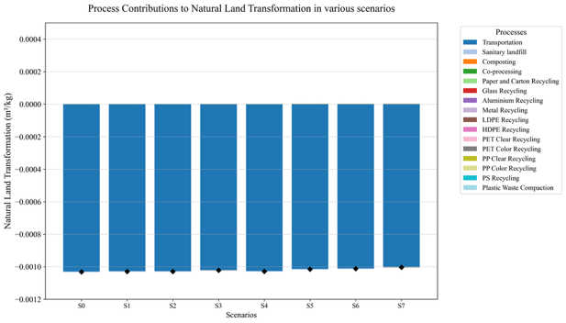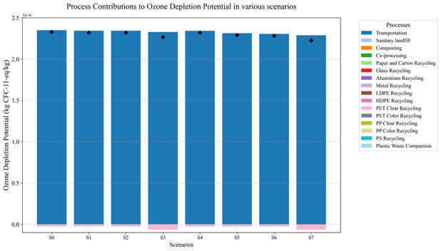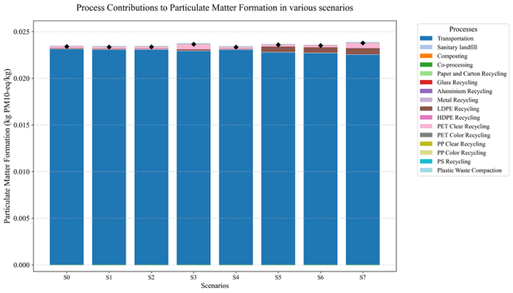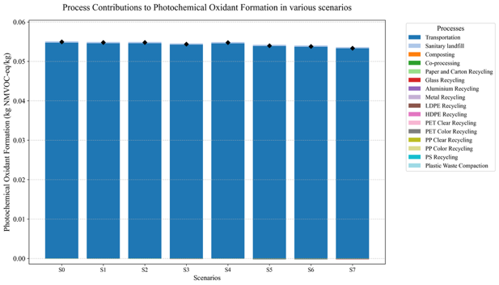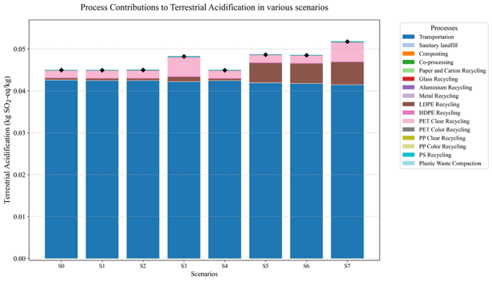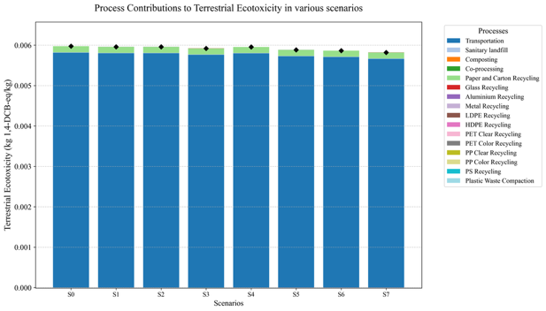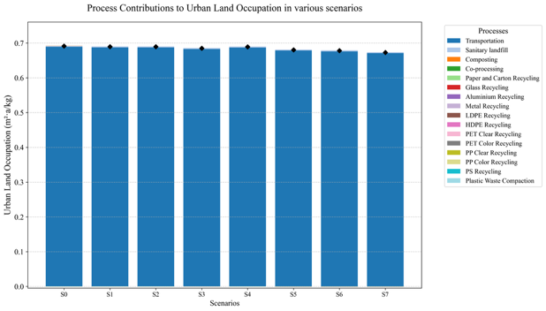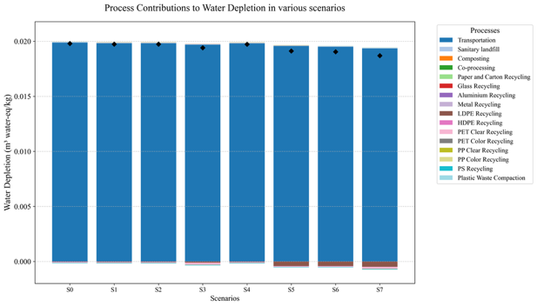
Fig. SI21. Environmental impact categories and the contribution of different processes across various scenarios

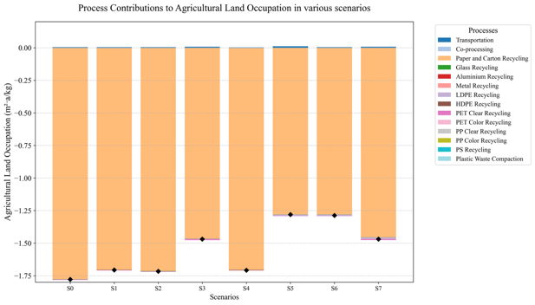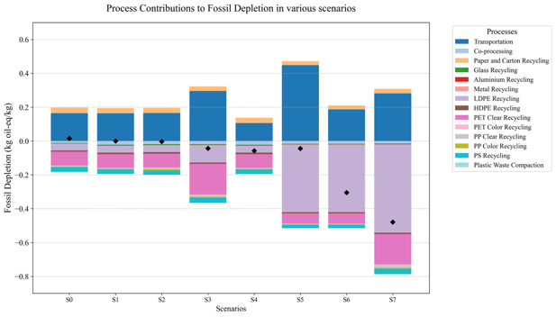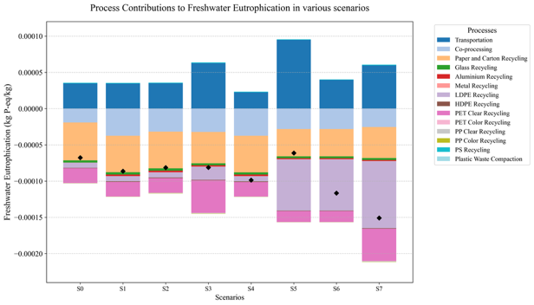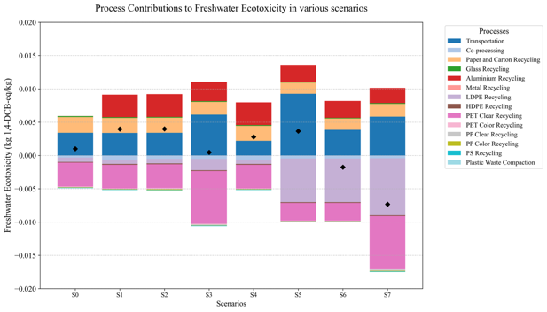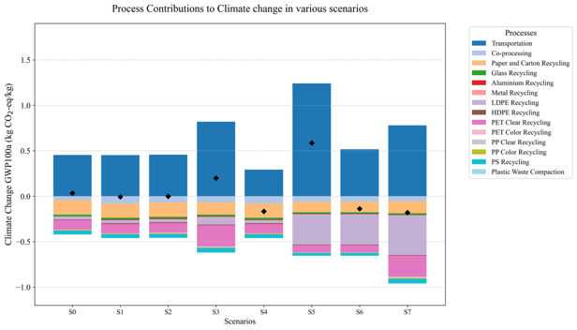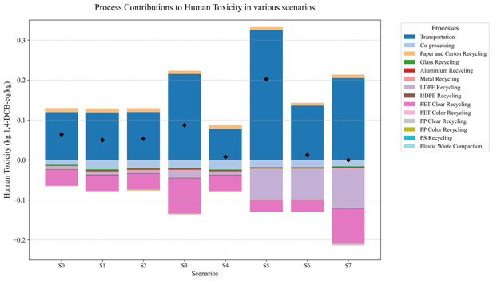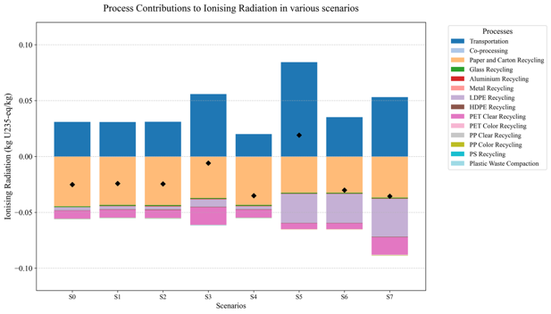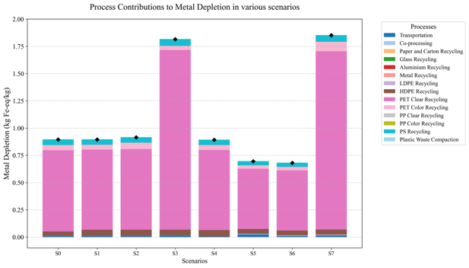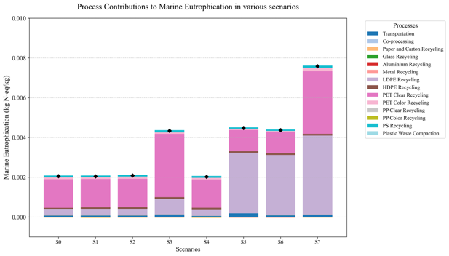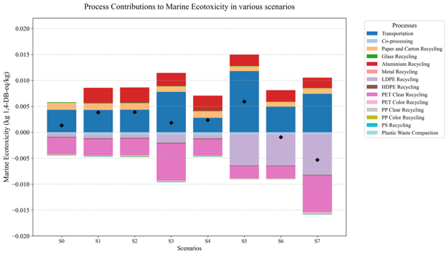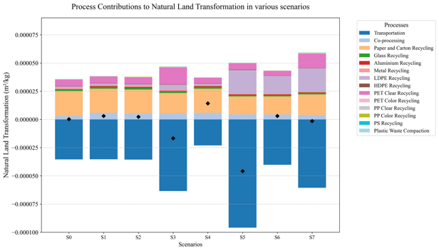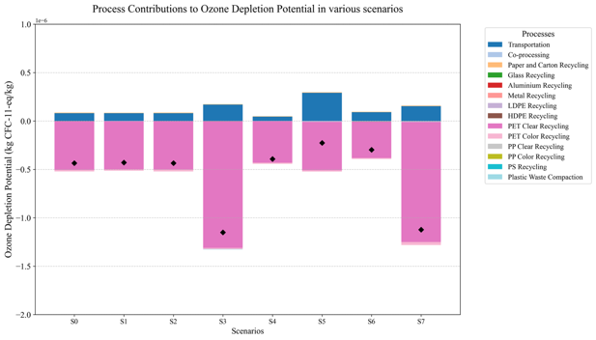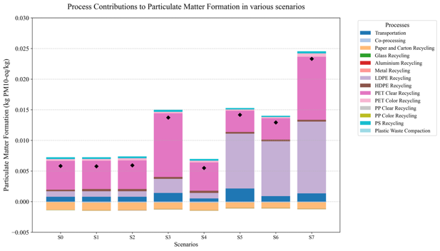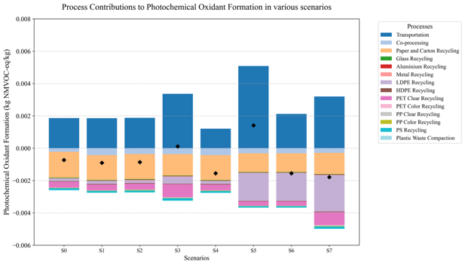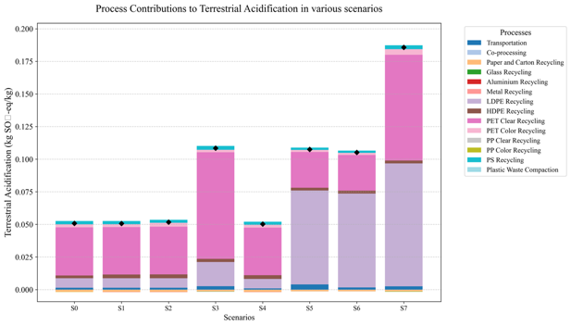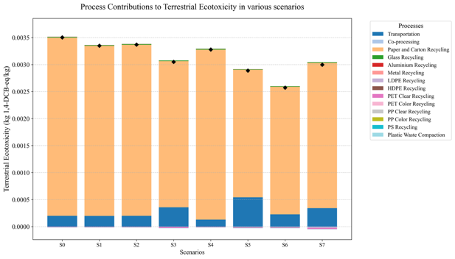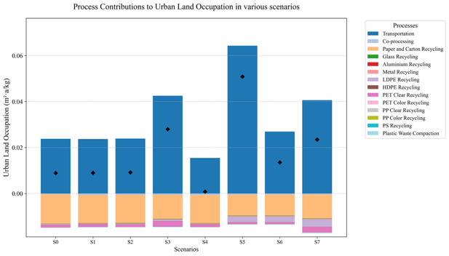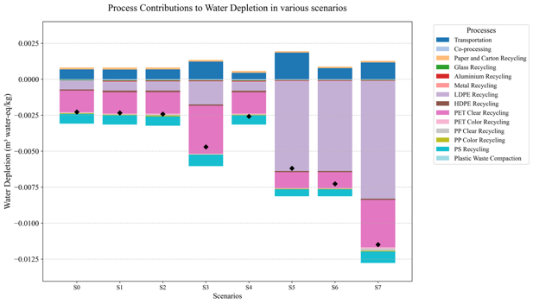
Fig. SI22. Environmental impact categories and the contribution of different processes across various scenarios excluded wet waste

Economic Impact Assessment Data

Quarterly Social Return on Investment (SROI) Analysis
Quarterly SROI were allocated based on the proportion of total annual waste transfer volume occurring in each quarter (Q1 = Day 1–90; Q2 = Day 91–180; Q3 = Day 181–270; Q4 = Day 271–360), derived from daily Vensim simulation outputs. Capital expenditures (CAPEX) were fully assigned to Q1 to reflect upfront equipment procurement, whereas operational expenditures (OPEX) were distributed according to quarterly estimated costs.
As period-specific SROI values are not directly comparable—Q1 includes the full CAPEX while Q2–Q4 only reflect operating costs—cumulative SROI was also calculated (Table SI8). The cumulative SROI at the end of quarter n is defined as the ratio of accumulated benefits to accumulated investments from Q1 through Qn. This metric allows comparison across quarters, captures the progressive realization of social value relative to invested capital, and converges to the annual SROI by year-end.
Table SI8. Quarterly SROI analysis by scenario
Scenario | Metric | Q1  (Jan–Mar) | Q2  (Apr–Jun) | Q3  (Jul–Sep) | Q4  (Oct–Dec) | Annual SROI
S1 | Period SROI¹ | 10.75 | 430.64 | 476.48 | 418.32 | 41.84
S1 | Cumulative SROI² | 10.75 | 21.36 | 32.57 | 41.84 | →41.84
S2 | Period SROI¹ | 10.73 | 430.86 | 462.38 | 436.22 | 41.92
S2 | Cumulative SROI² | 10.73 | 21.34 | 32.21 | 41.92 | →41.92
S3 | Period SROI¹ | 7.46 | 667.37 | 729.22 | 664.80 | 31.06
S3 | Cumulative SROI² | 7.46 | 15.28 | 23.64 | 31.06 | →31.06
S4 | Period SROI¹ | 5.86 | 237.57 | 252.94 | 238.18 | 25.01
S4 | Cumulative SROI² | 5.86 | 12.45 | 19.11 | 25.01 | →25.01
S5 | Period SROI¹ | 24.23 | 601.34 | 629.66 | 594.21 | 87.96
S5 | Cumulative SROI² | 24.23 | 46.86 | 68.85 | 87.96 | →87.96
S6 | Period SROI¹ | 9.26 | 247.75 | 258.48 | 244.16 | 36.15
S6 | Cumulative SROI² | 9.26 | 18.85 | 28.11 | 36.15 | →36.15
S7 | Period SROI¹ | 5.20 | 284.38 | 292.65 | 297.51 | 22.40
S7 | Cumulative SROI² | 5.20 | 11.02 | 16.78 | 22.40 | →22.40
Note: ¹Period SROI = quarterly benefit / quarterly investment. ²Cumulative SROI = accumulated benefit / accumulated investment at end of each quarter. Benefits were apportioned according to quarterly waste transfer volume fractions derived from Vensim daily outputs. CAPEX was fully assigned to Q1. The baseline scenario (S0, BAU) is excluded due to zero investment.
Across all scenarios, the quarterly SROI rankings remain consistent, with the order S5 > S2 ≈ S1 > S6 > S3 > S4 > S7, indicating that annual SROI values reliably capture year-round performance. Cumulative SROI progressively increases from Q1 to Q4, exemplified by scenario S5, which attains a cumulative SROI of 46.86 by the end of Q2, demonstrating that tenant engagement generates rapid value relative to its capital investment. The Q1 period-specific SROI is substantially lower than those in Q2–Q4 due to the full allocation of CAPEX, reflecting the financial structure rather than seasonal performance differences.

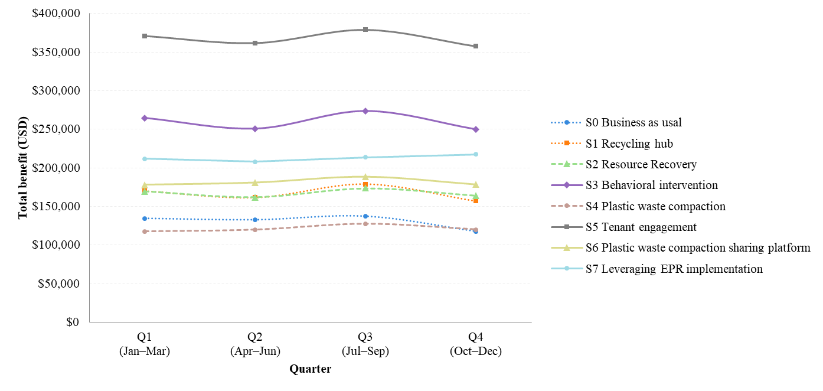
Fig. SI23. Quarterly total benefits by scenario (USD)
The seasonal stability of quarterly total benefits across scenarios is quantitatively supported by both Fig. SI23 and Table SI9. The line graph in Fig. SI23 illustrates that S5 consistently achieves the highest total benefit, while other scenarios maintain their relative rankings throughout the year. Table SI9 provides further evidence through the coefficient of variation (CV) of quarterly benefits, which ranges from 1.63% (S7) to 5.73% (S0), suggesting that seasonal fluctuations are generally moderate across scenarios. These low CV values indicate that the variations observed in quarterly benefits reflect seasonal composition dynamics captured in the Vensim lookup tables rather than changes in total waste generation. Together, the figure and table validate that scenario rankings, cumulative SROI, and annual performance measures are robust to seasonal variability.

Table SI9. Seasonal variability of quarterly total benefits by scenario: mean, standard deviation (SD), and coefficient of variation (CV). Benefits in USD. SD calculated as population standard deviation (n=4).
Scenario | Q1  (Jan–Mar) | Q2  (Apr–Jun) | Q3  (Jul–Sep) | Q4  (Oct–Dec) | Mean (USD) | STD  (USD) | CV  (%)
S0 | 134,656 | 132,837 | 137,473 | 117,719 | 133,746 | 7,658 | 5.73%
S1 | 170,126 | 161,864 | 179,053 | 157,244 | 165,995 | 8,315 | 5.01%
S2 | 169,836 | 161,947 | 173,767 | 163,959 | 166,897 | 4,692 | 2.81%
S3 | 264,705 | 250,639 | 273,831 | 249,675 | 257,672 | 10,091 | 3.92%
S4 | 117,628 | 119,917 | 127,645 | 120,226 | 120,071 | 3,768 | 3.14%
S5 | 370,876 | 361,406 | 378,398 | 357,123 | 366,141 | 8,273 | 2.26%
S6 | 178,227 | 181,115 | 188,923 | 178,496 | 179,806 | 4,326 | 2.41%
S7 | 211,808 | 207,846 | 213,869 | 217,410 | 212,839 | 3,461 | 1.63%

Annually Social Return on Investment (SROI) Analysis
Table SI10. The projected annual benefit value in terms of economic, environmental, and social dimensions
Aspect | Output | Outcome | Financial Proxy | Estimated values per year (USD) |  |  |  |  |  |  |  | Reference
 |  |  |  | S0 | S1 | S2 | S3 | S4 | S5 | S6 | S7 | Reference
Economic | Decrease in Waste to Landfill | Reduced volume of waste sent to landfills due to improved waste management practices | Volume of waste diverted (m³) × municipal solid waste collects, transfer, and disposal expense rate (USD/m³) | 494,180 | 577,742 | 578,625 | 927,278 | 394,489 | 1,354,372 | 611,025 | 713,168 | MBA data center [1]
Economic | Increased Recycling Rate | Greater quantity of waste diverted from landfills to recycling centers, thereby improving the recycling rate | Amounts of recyclable materials (kg) × market price per material (USD/kg) | 28,505 | 29,470 | 29,691 | 45,277 | 29,470 | 42,430 | 42,430 | 58,589 | Plastics Institute of Thailand [2]
Environment | Greenhouse Gas Emission Reduction | Decreased carbon emissions resulting from waste management strategies | Carbon emissions mitigated (tCO₂eq) × social cost of carbon (USD/tCO₂eq) | - | 93 | 79 | 5,312 | 474 | 10,019 | 12,323 | 18,194 | Limmeechokchai, Winyuchakrit [3]
Social | Increased Behavior in Waste Separation | Increased behavior in separating dry and clean plastic waste | Amount of plastic waste collected via recycling hubs (kg) × opportunity cost of individuals' time for engaging in plastic waste separation versus alternative activities (USD/kg) | - | 60,983 | 60,983 | 60,983 | 60,983 | 60,983 | 60,983 | 60,983 | Poyai, Pongpunpurt [4]
 |  |  | Total benefit | 522,685 | 668,288 | 669,513 | 1,038,849 | 485,416 | 1,467,802 | 726,761 | 860,934

Table SI11. The projected annual investment
Type | Detail |  | Estimated values per year (USD)
Type |  |  | S0 | S1 | S2 | S3 | S4 | S5 | S6 | S7
CAPEX | Installation of recycling hubs |  | - | 14,100 | 14,100 | 14,100 | 14,100 | 14,100 | 14,100 | 14,100
CAPEX | Implementation of behavioral intervention programs |  | - | - | - | 16,800 | - | - | - | 16,800
CAPEX | Purchase of plastic waste compactor |  | - | - | - | - | 2,550 | - | 2,550 | 2,550
CAPEX | Total capital investment (CAPEX) |  | - | 14,100 | 14,100 | 30,900 | 16,650 | 14,100 | 16,650 | 33,450
OPEX | Maintenance costs for recycling hubs |  | - | 1,500 | 1,500 | 1,500 | 1,500 | 1,500 | 1,500 | 1,500
OPEX | Electricity consumption for plastic waste compactor |  | - | - | - | - | 0.6 | - | 2.4 | 3.3
OPEX | Maintenance costs for plastic waste compactor (estimated at 20% of purchase cost) |  | - | - | - | - | 510 | - | 510 | 510
OPEX | Training fees for tenants in waste management and operational practices |  | - | - | - | - | - | 900 | 900 | 900
OPEX | Total operational investment (OPEX) |  |  | 1,500 | 1,500 | 1,500 | 2,011 | 2,400 | 2,912 | 2,913
Total capital and operational investment |  |  | - | 15,600 | 15,600 | 32,400 | 18,661 | 16,500 | 19,562 | 36,363
ROI |  |  | - | 0.89 | 0.91 | 0.40 | 0.58 | 1.57 | 1.17 | 0.61
SROI |  |  | - | 41.84 | 41.92 | 31.06 | 25.01 | 87.96 | 36.15 | 22.40
Sensitivity analysis
MSW expense rate reduce 50% |  | SROI | - | 23.32 | 23.37 | 16.75 | 14.44 | 46.92 | 20.53 | 12.59
 |  | % CHANGE | - | 44.26% | 44.24% | 46.07% | 42.26% | 46.66% | 43.20% | 43.78%
Recyclable market price reduce 30% |  | SROI | - | 41.27 | 41.34 | 30.64 | 24.54 | 87.19 | 35.50 | 21.92
 |  | % CHANGE | - | 1.35% | 1.37% | 1.35% | 1.89% | 0.88% | 1.80% | 2.16%

Shopping Mall Typology and Scenario Applicability Framework
Table SI12. Bangkok shopping mall applicability framework for CE waste management scenarios, adapted from ICSC (1999), ICSC (2012), and Omar and Baker (2009).
Mall Type (ICSC basis) | Bangkok Examples | Scale (GFA) | Governance | Similarity to Study Site | Most Applicable Scenarios | ICSC Classification Equivalent
Type 1 Luxury destination integrated complex [STUDY SITE] | ICONSIAM; EM District (EmQuartier/ EmSphere/ Emporium) | >400,000 m² | Centralized; full environmental management | HIGHEST  (directly applicable) | All S1–S7. S5 (Tenant Engagement) and S7 (EPR) priority — luxury brand sustainability commitments facilitate contractual env. obligations. S3 leverages premium design for nudge effectiveness. | Super-Regional / Fashion-Specialty [5, 6]
Type 2 Large-format mixed-use mall | CentralWorld; The Mall Group flagships (Bangkapi, Ngamwongwan) | 200,000– 830,000 m² | Centralized; professional team | HIGH  (similar scale and governance; different tenant mix) | S1, S3, S5, S6, S7 applicable. S2 (Resource Recovery) particularly relevant — higher low-value plastic volumes from mass-market tenant restocking. S4/S6 efficient given high combustible packaging. | Regional / Sub-Regional [6]
Type 3 Mid-market destination mall | Terminal 21; MBK Center; Siam Square One | 100,000– 300,000 m² | Centralized; higher tenant turnover | MODERATE  (high footfall; different margins and tenant mix) | S3 most transferable — large consumer footfall amplifies nudge reach. S4 (Compaction) viable. S5 constrained by tenant margin structure. S6 viable with stable lease terms. | Regional (lower range) / Specialty [6, 7]
Type 4 Community / lifestyle mall | The Commons; Samyan Mitr Town | 5,000– 30,000 m² | Single developer; small team; limited environmental capacity | LIMITED  (different scale and waste composition) | S3 most feasible — concentrated, design-conscious visitor profile responds well to nudge interventions. S6 (Shared Compaction Platform) viable if adapted to smaller equipment. Framework transferable after reparameterization. | Neighborhood / Lifestyle [5, 7]
Type 5 Neighborhood retail / value mall | BigC-anchored strips; Lotus's plaza; Budget community centers | 10,000– 50,000 m² | Decentralized or single anchor; no dedicated environmental management | LOWEST  (different waste composition, economic model, and governance) | SDM-LCA-SROI framework transferable in principle; specific SROI values not directly applicable. Avoided disposal cost sensitivity holds universally. Municipal-level mandates more impactful than voluntary programs at this scale. | Neighborhood / Community [6, 7]
Notes: The study site is an anonymized luxury destination shopping complex in central Bangkok (Type 1); site identity not disclosed per institutional confidentiality agreements. Bangkok examples are cited for typological illustration only and do not imply endorsement or similarity in waste management performance. GFA = gross floor area. ICSC classification equivalents are indicative; individual centers may exhibit hybrid characteristics [8]. Scenario codes follow Table 2 of the main manuscript.
References:
[1] MBA data center, Bangkok Educates Officials on the New Waste Fee Collection System, Encouraging Citizens to Sort Waste to Reduce Fees. 2024.
[2] Plastics Institute of Thailand, Feasibility Study for Smart Recycling Hub in the Bangkok, Metropolitan Area, and EEC. 2025, Chula Unisearch.
[3] Limmeechokchai, B., P. Winyuchakrit, and P. Pita. The Role of Discount Rate and Social Cost of Carbon in Long Term Climate Policy on Renewable Electricity in Thailand. in 2022 International Conference and Utility Exhibition on Energy, Environment and Climate Change (ICUE). 2022. 26–28 Oct. 2022. https://doi.org/10.1109/ICUE55325.2022.10113526.
[4] Poyai, T., P. Pongpunpurt, U. Leknoi, P. Painmanakul, and N. Chawaloesphonsiya, Plastic waste management in urban areas: Key takeaways from the “Send Plastic Home” project in Bangkok, Thailand. Process Safety and Environmental Protection, 2024. 190: p. 1222–1232. https://doi.org/10.1016/j.psep.2024.08.013.
[5] Omar, U.S. and M. Baker, First Steps Toward a Shopping Center Typology for Southeast Asia, Asia-Pacific and Beyond. 2009, International Council of Shopping Centers (ICSC): New York, USA.
[6] International Council of Shopping, C., Asia-Pacific Shopping Centre Classification Standard. 2012, International Council of Shopping Centers (ICSC): New York, USA.
[7] International Council of Shopping, C., ICSC Shopping Center Definitions. 1999, International Council of Shopping Centers (ICSC): New York, USA.
[8] DeLisle, J.R., Shopping Center Classifications: Challenges and Opportunities. 2009, Runstad Center for Real Estate Studies, University of Washington: Seattle, WA, USA.

