Supplementary Materials

Global lockdown potential impact on achieving Sustainable Development Goals

Hideyuki Doi, Takeshi Osawa, and Narumasa Tsutsumida

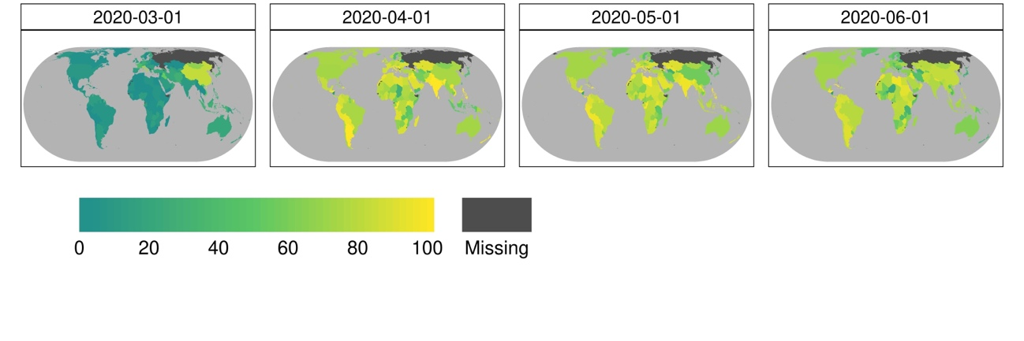

Figure S1 Country-level COVID-19 GRSI from 1 March 2020 to 1 June 2020. The index illustrated the degree of lockdown for the COVID-19 pandemic.

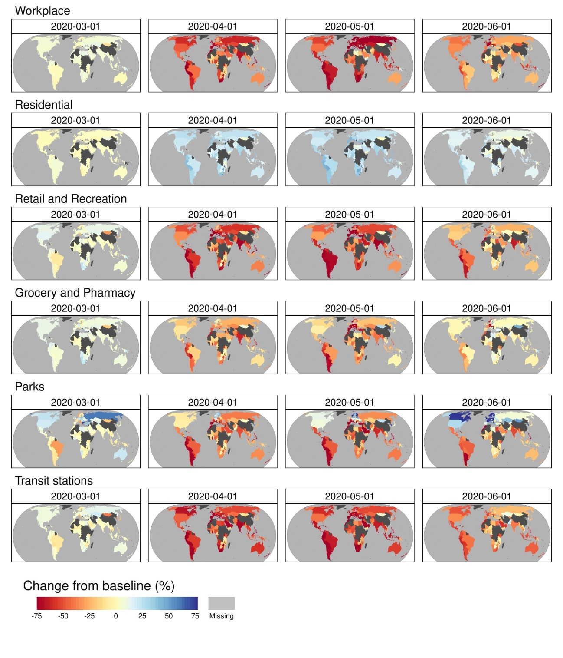

Figure S2. Mobility changes in the workplace, residential areas, retail and recreation, grocery and pharmacy, parks, and transit stations from the baseline (the median value is from the five weeks from 3 January 2020 to 6 February 2020), from 1 March 2020 to 1 June 2020.

