Supplemental Materials

How attractive is the participation in a Living Lab study?
Experimental evidence and recommendations

Additional Information about Study 1a and 1b
In these conjoint studies, which we conducted with representative samples of the Austrian population, we identified nine crucial dimensions by which Living Labs could differ. These studies were fully exploratory; hence, we did not develop precise hypotheses regarding which dimensions might be more or less attractive to participants as a proxy for participation in a potential Living Lab.
Materials and Methods
We set up an online questionnaire by using LimeSurvey (2012) and Pavlovia (Open Science Tools Limited, 2020). The data collection was conducted via the Talk Online Panel (https://talkonlinepanel.com/at/impressum). The questionnaire was similar in both studies: After participants gave their informed consent, they had to answer to several socio-demographic questions (e.g., they indicated their age, sex, education, household size and other variables, which can be found in the variable list online). This was followed by a short explanatory video to introduce the participants to the topic and the conjoint part (see Hainmueller et al., 2014; Thaller et al., 2021), where they were presented with eight (1a) or five (1b) pages. On these pages, participants had to compare two Living Lab profiles consisting of eight dimensions (variables) with two to three aspects (levels) each. In total, there were k = 1,944 and k = 1,296 possible profiles in Study 1a and 1b, respectively.
Dimensions and aspects were generated based on our previous projects in the domain of green energy and user participation (e.g., Corcoran et al., 2020), previous considerations of how to define Living Labs in the published literature (e.g., Westerlund et al., 2017; Chronéer et al., 2019), digital law perspectives (e.g., Wendland, 2019), and, most importantly, consultations with other Living Lab study organization teams, such as those working in the projects ENERGISE and schools4energy or the permanent research facility ZEB Living Lab Trondheim, are summarized in the document “LL_executive_summaries” (https://osf.io/k45zj). Based on this input, the team of authors held group discussions and collectively decided which dimensions would work best in the context of a conjoint study. However, the space constraints of these studies prevented us from including more dimensions (or more aspects per dimension), as this would have hampered the statistical power and meaningfulness of the results (see below). All dimensions and their aspects are depicted in Figure 1 in the main article and an example page is shown in Figure S1.
Aspects for each dimension were randomly drawn, and we programmed the experiment so that the two profiles depicted on each page were not identical. In Study 1a, we identified a programming error, which we eliminated for Study 1b. As their main task, participants had to indicate on a seven-point rating scale how attractive they found each profile (dependent variable 1, ranging from 1 = “not at all” to 7 = “very much”) and had to choose their preferred profile (dependent variable 2, 0 = not chosen, 1 = chosen). After all profile ratings had been made, they answered items on three short scales that addressed their future orientation (considerations about future consequences, three items, e.g., “I consider how things might be in the future, and try to influence those things with my day to day behavior.”, ranging from 1 = “not at all” to 6 = “very much”, Vilar et al., 2020), present orientation (considerations about immediate consequences, three items, e.g., “I only act to satisfy immediate concerns, figuring the future will take care of itself.”, ranging from 1 = “not at all” to 6 = “very much”), and technical affinity (four items, e.g., “I like testing the functions of new technical systems.”, ranging from 1 = “not at all” to 6 = “very much”, Wessel et al., 2019).
Sample and Power
We aimed to recruit approximately 500 participants per study. Initially, 1,536 (1a) and 1,363 (1b) participants clicked on the link to the study, but the dropout rate was high due to the reading task. Eventually, we could analyze nearly 500 completed samples as highlighted in Table 1. A power analysis for conjoint experiments (Lukac & Stefanelli, 2020) revealed that this sample size would be sufficient to identify average marginal component effects (i.e., the effects of individual aspects of one dimension relative to each other and controlled for effects of other dimensions) of AMCE = 0.05 (power ≥ .88, tasks ≥ 5, levels ≤ 3, alpha error probability = .05). Hence, we determined that point estimates of these effect sizes would only be interpreted if the point estimate surpassed this threshold, while also being statistically significantly different from zero.
Results
We used the R packages cjoint (Barari et al., 2018, Hainmueller et al., 2014), which is suitable to AMCEs of conjoint experiments, lme4 (Bates et al., 2022) for linear effects of other predictors, and jmv (Selker et al., 2022) for descriptive statistics. Information about the latter is depicted in Table 1 in the main text.
All but one aspect showed means for attractiveness ratings that were slightly above the scale midpoint in both Study 1a and 1b (see Figure S2, panel a, evidence column). The conjoint analysis for Study 1a revealed the largest effect for the AMCE between no financial incentives (M1) and medium (M2) and large incentives (M3), both AMCEs > .15. Much smaller effects showed on dimension E: If Living Labs were advertised as featuring direct interactions with other participants (E1), they were less attractive as compared to those that featured no interaction (E3). Moreover, a duration of more than six months (L3) was preferred slightly less than a duration of one month (L1).
As these analyses were exploratory, we attempted to replicate them in Study 1b. However, we also suspected that the incentive dimension could have been too salient for the participants: They potentially mainly made their decision based on the financial reward offered. Hence, we replaced dimension M with the focus dimension F in Study 1b and kept all the other dimensions the same. The results reveal a similar pattern of means as seen before. No emphasis on exchange with other participants (E3) was more attractive than a direct emphasis on exchange with others (E1), although the point estimate for this AMCE did not surpass the threshold of 0.05. However, the point estimates for a shorter Living Lab duration (L3 vs. L1) did. Additionally, participants found it slightly less attractive to move to a new flat to participate in a Living Lab (S2) as compared to staying in their own flat (S1). All these effects narrowly passed the threshold of AMCE = .05. However, the new focus condition F did not make a difference. Detailed results can be found in Figures S3 and S4, as well as in Tables S1 and S3.
Additionally, we determined for Study 1a and b whether the future orientation (CFC), present orientation (CIC) and technical affinity (ATI) would predict the ratings for attractiveness (all items and translations in Figure S5). We treated these variables as categorical grouping variables based on tercile bins (i.e., low, medium and high) because this allowed a power analysis to be conducted for t-tests and the identification of non-linear relationships (see Hainmueller et al., 2019 ). Slope coefficients (b) can be interpreted in similar ways as AMCEs: Effects larger than b ≥ 0.05 are statistically significant, sufficiently powered and can be interpreted as small effects (and larger).
In Study 1a, we found that only people displaying medium levels of technical affinity showed higher attractiveness ratings (b = 0.07) than people displaying low levels of technical affinity. In Study 1b, people with high CIC, CFC, or ATI showed somewhat larger effects (0.05 < b > 0.10) than people with low values on these scales. However, given the low effect sizes and the exploratory nature of this analysis, one should treat these results with great caution. Detailed information about these results can be found in Table S2 and S4 below.

Additional Information on Study 2
Sample and Power
We recruited participants via the Talk Online Panel. Sample information is provided in Table 1 in the main paper. We calculated the effects that we could find, assuming that we would gather data from 500 participants (holding constant alpha = .05 and power = .90 in a two-tailed test). This sample size would be sufficient to detect very small within-participants effects of dz ~ .15 in a repeated-measures design and small between-participants effects of d ~ 0.36 (two-tailed, alpha = .05, power = .90, group sizes of n = 500/3 = 166) (Faul et al., 2007).
Materials
We created three different flyer types for focus, emphasizing technical, green and social aspects. These flyers are presented in Figure S6 to S8. Using one attention check variable (by asking what a Living Lab is), we automatically excluded participants that gave incorrect answers.
After participants rated their two Living Lab flyers, we asked them to think about what could make the participation in a Living Lab additionally attractive to them. The goal of this exploratory content analysis (as in Seuntjens et al., 2014, Study 1 ) was to see if any generated answer by participants would outperform financial incentives (as we intuitively assumed that this would be an answer that would occur given the Study 1a results). They had to give up to three short answers in text boxes. In total, n = 372 participants provided at least one answer.
Results
We present all relevant results in the main paper. Here, we additionally show statistical information starting with Table S5. Comparisons of simple effects are provided for main effects or highest-order interactions if their test statistic F showed a p-value of p < .05.
In this regard, we report results from three-way ANOVAs, which include (beside focus and exchange) the moderating variables participants’ age (Table S7 and S8), CFC (future orientation, Table S11 and S12), CIC (present orientation, Table S13 and S14), or ATI (technical affinity, Table S9 and S10). As one can see, the standardized mean differences were consistently above the threshold (d > .36) for people high in CFC and ATI as compared to people low in CFC and ATI, calculated from large t-values of t > 3.5. This means that these both CFC and ATI seemed to be the best psychological predictors for whether participants find Living Labs attractive.
Next, we checked whether the flyer design itself influenced the effect of the two within-participants conditions (i.e., exchange). This was not the case for either attractiveness or for choice (see Table S15 -S16).
Finally, we analyzed the content of the text boxes. We coded all answers and assigned them to twelve broad categories, which are depicted in Figure S8. Most answers were too vague to readily categorize them (residual category: 46%). However, from among the categorizable answers, the financial rewards (31%), user friendliness of the devices (28%), financial savings through Living Labs (27%), and an emphasis on data protection (22%) were the strongest factors that motivated participants to take part in a Living Lab study. Notably, aspects like social exchange, environment and sustainability, or fun were mentioned less than 10% of the time.
Overall, as these aspects were intuitively generated, we could confirm the main finding of Study 1a, that is, that financial aspects – and especially rewards for participation and clearly stated financial savings as a result of using Living Labs – seem to be crucial for promotion strategies.

Figure S1. Study setup. Living Lab profiles were depicted next to each other and participants had to indicate their preference on rating scales (below profiles) and had to choose their preferred Living Lab (by clicking on the profile); Translation: “LivingLab A bietet …” = “LivingLab A offers …”; “gar nicht ansprechend” = “not at all attractive”; “äußerst ansprechend“ = “very attractive“; “Weiter” = “Continue”.

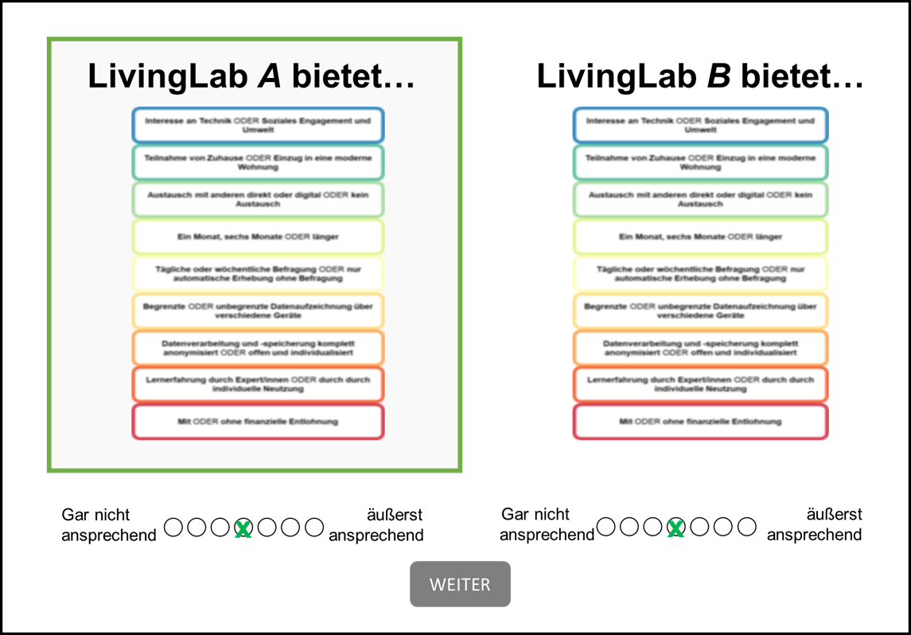

Figure S2. Conjoint dimensions. Panel a shows all aspects of the dimensions in the translated form; Panel b shows the original formulations in German language

a
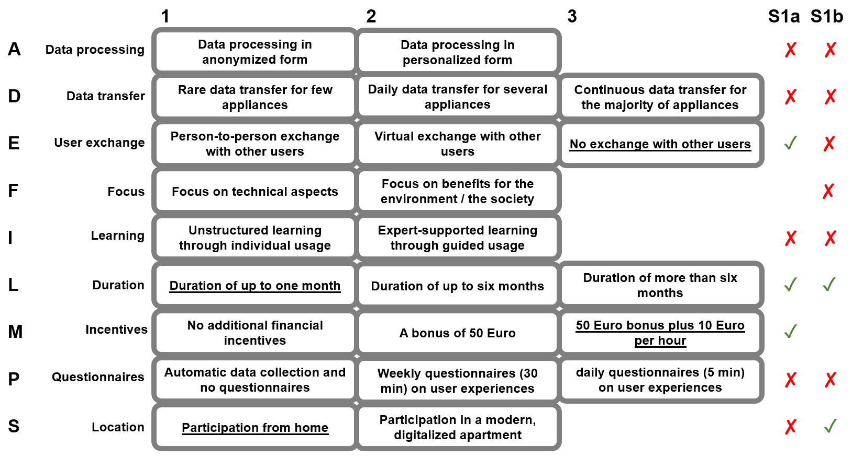

b
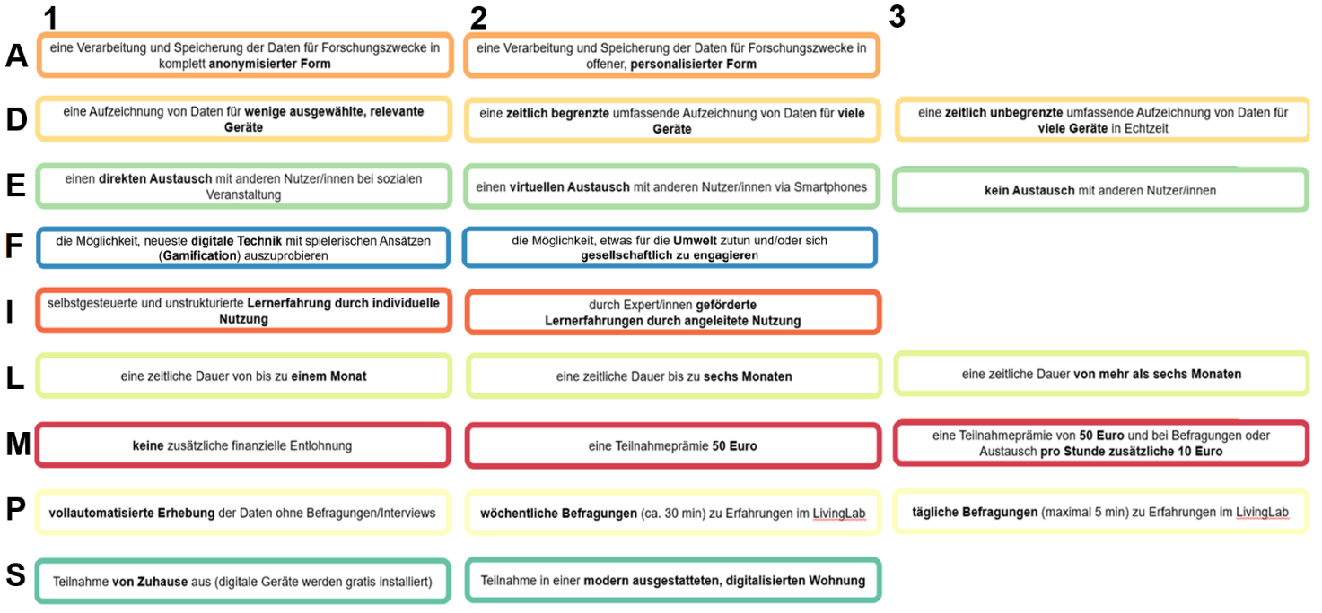

Figure S3. Results from Study 1a and b for attractiveness. Panel a and b show box plots and means with 95% confidence intervals (in red) for the raw ratings (1 to 7) of Study 1a and b respectively; Note that means cluster relatively closely in the range of 4 to 5 in both studies; also note that dimension M was only used in Study 1a and dimension F was only used in Study 1b. Panel c and d show the AMCEs with 95% confidence intervals for Study 1a and b, respectively; note that aspect 1 per dimension is always reference category; AMCE of 0.16 would be equal to one scale point.
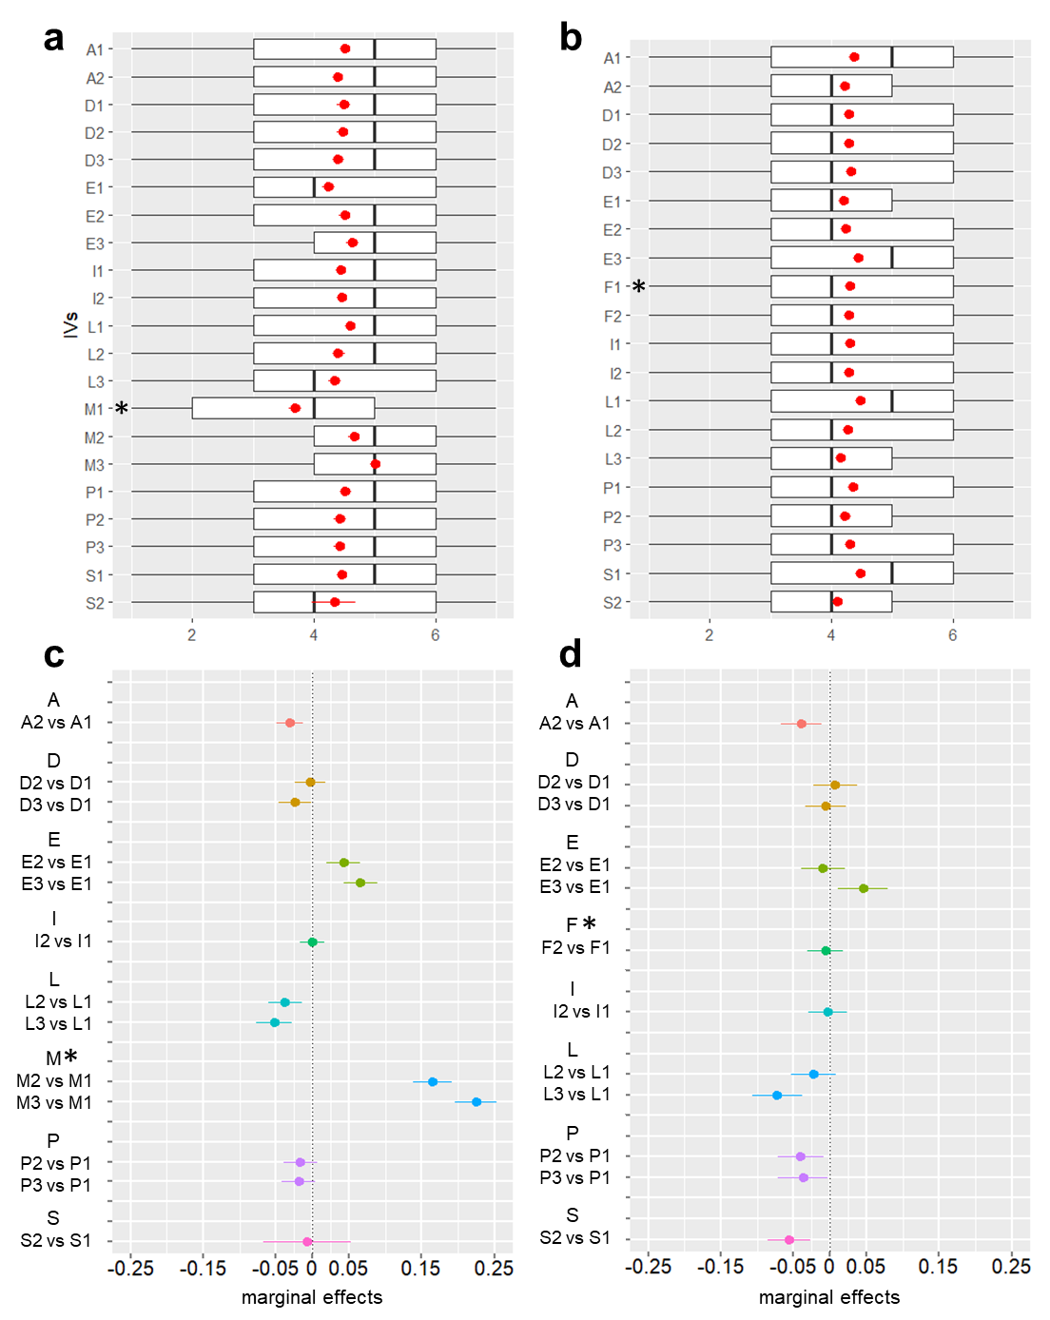
Figure S4. Results from Study 1a and b for choice. Choice was a dichotomous variable (i.e., Living Lab selected = 1, or not selected = 0); AMCEs with 95% confidence intervals are relative to reference category 1 per dimension; Dimension M was only used in Study 1a and dimension was only used on Study 1b.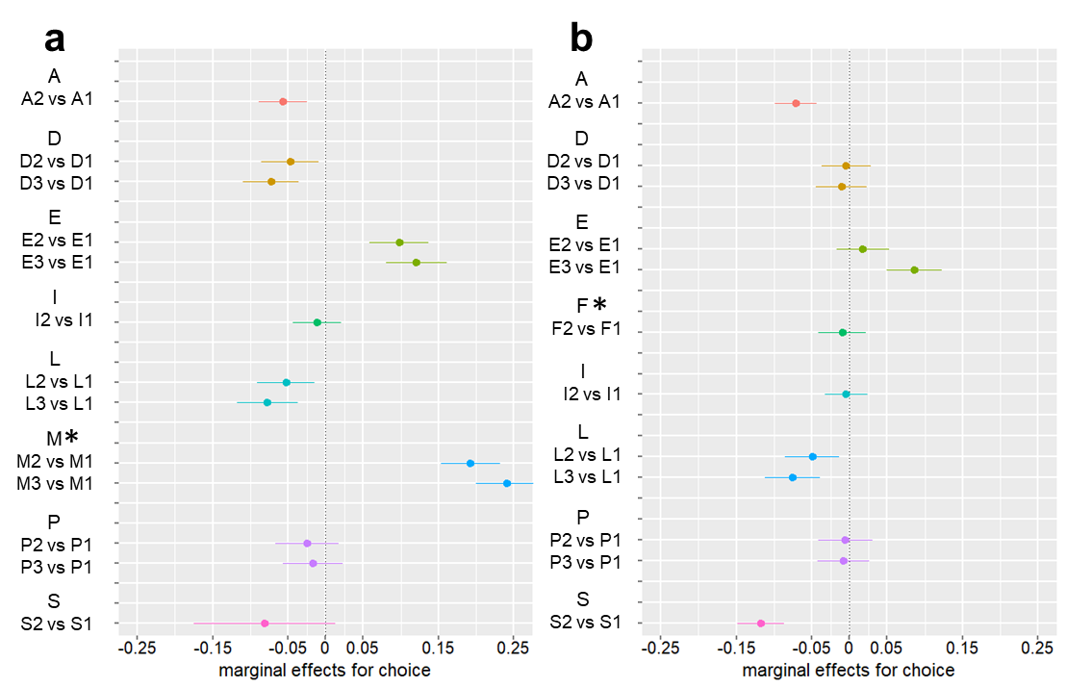

Figure S5. Depiction of the items for CFC, CIC, and ATI with English translation (see also https://osf.io/p2az6/)

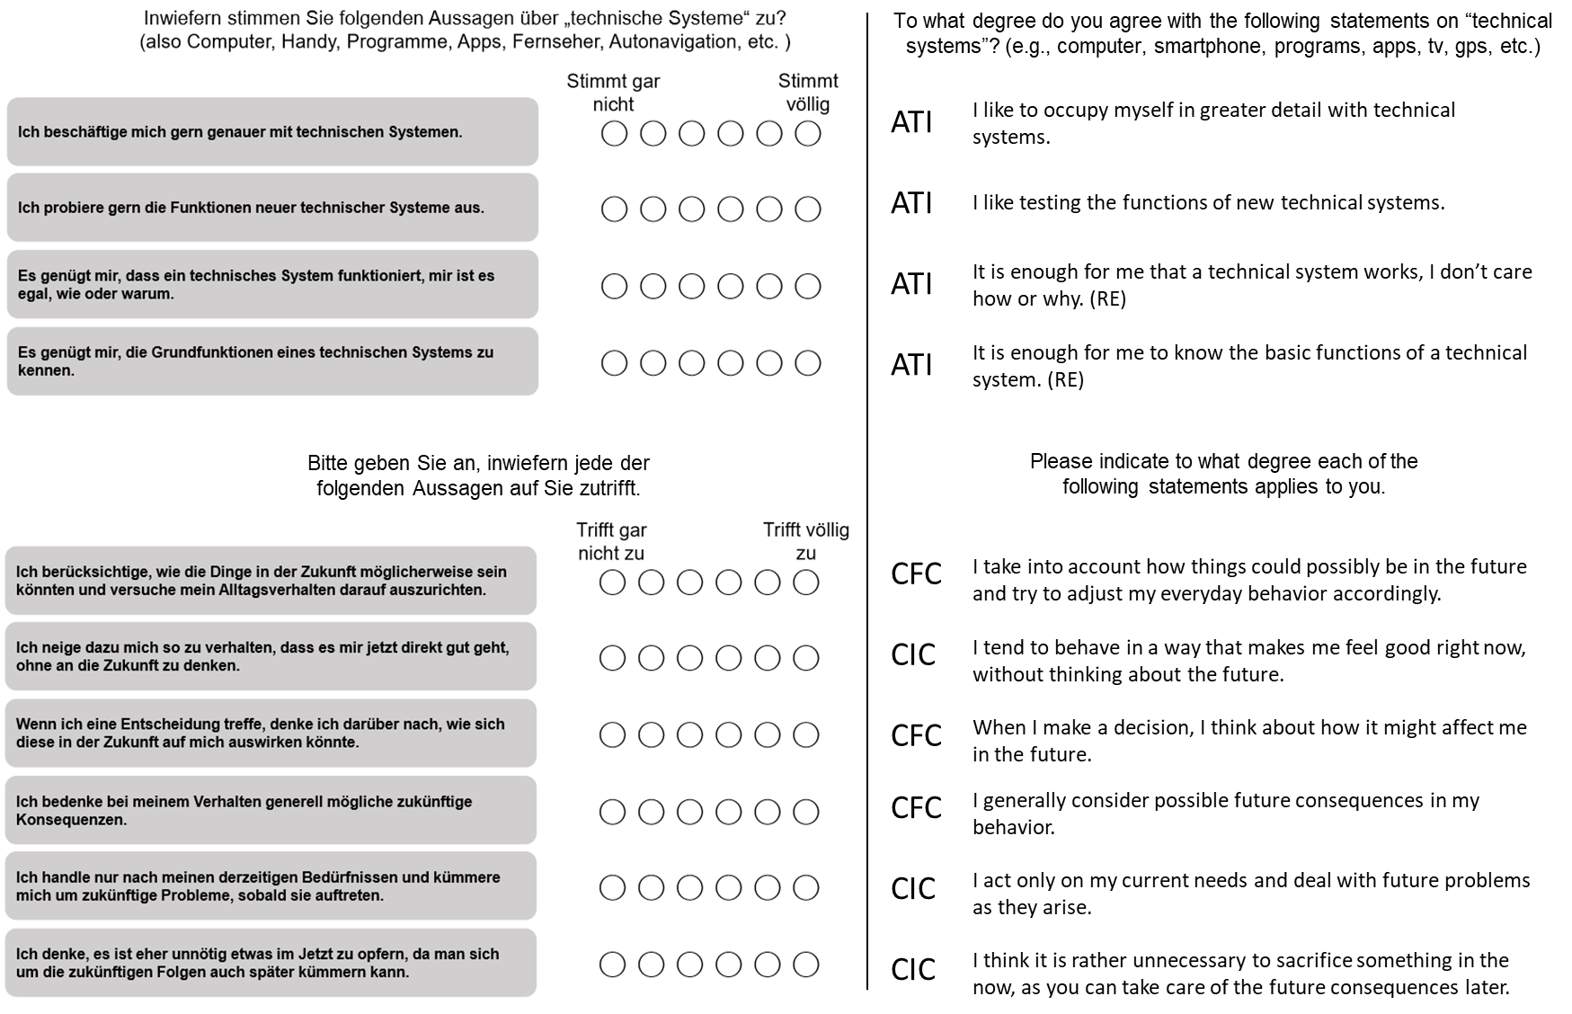
Table S1. R output for AMCEs for in Study 1a. Upper part: attractiveness; lower part: choice

------------------------------------------
Average Marginal Component Effects (AMCE):
------------------------------------------
Attribute Level Estimate Std. Err z value Pr(>|z|)
a_id -0.03054278 0.0093700 -3.259622 1.1156e-03 **
d_id -0.00306662 0.0110200 -0.278277 7.8080e-01
d_id -0.02416168 0.0115690 -2.088476 3.6755e-02 *
e_id 0.04283580 0.0116518 3.676324 2.3662e-04 ***
e_id 0.06614944 0.0118370 5.588379 2.2920e-08 ***
i_id -0.00079345 0.0085586 -0.092708 9.2614e-01
l_id -0.03738876 0.0115184 -3.246015 1.1703e-03 **
l_id -0.05246076 0.0124704 -4.206833 2.5897e-05 ***
m_id 0.16476356 0.0138126 11.928464 8.4111e-33 ***
m_id 0.22452014 0.0146863 15.287725 9.2319e-53 ***
p_id -0.01681898 0.0116822 -1.439706 1.4995e-01
p_id -0.01912285 0.0116123 -1.646778 9.9604e-02
s_id -0.00728095 0.0308679 -0.235874 8.1353e-01

------------------------------------------
Average Marginal Component Effects (AMCE):
------------------------------------------
Attribute Level Estimate Std. Err z value Pr(>|z|)
a_id -0.056244 0.016429 -3.42352 6.1817e-04 ***
d_id -0.047195 0.019309 -2.44418 1.4518e-02 *
d_id -0.072634 0.018705 -3.88305 1.0315e-04 ***
e_id 0.098194 0.020071 4.89225 9.9689e-07 ***
e_id 0.120555 0.020642 5.84017 5.2148e-09 ***
i_id -0.010984 0.016450 -0.66774 5.0430e-01
l_id -0.052644 0.019651 -2.67891 7.3862e-03 **
l_id -0.077221 0.020733 -3.72453 1.9568e-04 ***
m_id 0.192397 0.020009 9.61574 6.8612e-22 ***
m_id 0.241266 0.020895 11.54651 7.6880e-31 ***
p_id -0.024817 0.021320 -1.16403 2.4441e-01
p_id -0.016689 0.020500 -0.81409 4.1560e-01
s_id -0.081072 0.047773 -1.69704 8.9689e-02
---

Number of Obs. = 3712
---
Number of Respondents = 464
---
Signif. codes: 0 '***' 0.001 '**' 0.01 '*' 0.05

Table S2. R output for Study 1a results for the scales CFC, CIC and ATI (Tech). Note that only TECHg2 (vs. TECHg1) reached statistical significance (based on critical t value > 1.96).

------------------------------------------
Linear mixed model fit by REML ['lmerMod']
------------------------------------------

Formula: rating ~ 1 + TECHg + CICg + CFCg + (1 | sub)
Data: df1aFINAL
Control: lmerControl(optimizer = "bobyqa", optCtrl = list(maxfun = 2e+05))

REML criterion at convergence: 635.7

Scaled residuals:
Min 1Q Median 3Q Max
-3.5132 -0.5948 0.0661 0.6432 3.3109

Random effects:
Groups Name Variance Std.Dev.
sub (Intercept) 0.03067 0.1751
Residual 0.05574 0.2361
Number of obs: 3712, groups: sub, 464

Fixed effects:
Estimate Std. Error t value
(Intercept) 0.543590 0.023696 22.941
TECHg2 0.070039 0.021231 3.299
TECHg3 0.003938 0.023945 0.164
CICg2 -0.005995 0.021754 -0.276
CICg3 0.015113 0.024626 0.614
CFCg2 -0.012194 0.022223 -0.549
CFCg3 0.021750 0.023223 0.937

Table S3. R output for AMCEs for in Study 1b. Upper part: attractiveness; lower part: choice

------------------------------------------
Average Marginal Component Effects (AMCE):
------------------------------------------
Attribute Level Estimate Std. Err z value Pr(>|z|)
a_id -0.0258514 0.0079860 -3.23710 1.2075e-03 **
d_id -0.0027893 0.0089966 -0.31004 7.5653e-01
d_id 0.0031160 0.0093820 0.33213 7.3979e-01
e_id 0.0043525 0.0101702 0.42796 6.6868e-01
e_id 0.0393641 0.0107191 3.67234 2.4034e-04 ***
f_id -0.0012714 0.0082890 -0.15339 8.7809e-01
i_id -0.0027658 0.0081554 -0.33913 7.3451e-01
l_id -0.0321481 0.0101136 -3.17871 1.4793e-03 **
l_id -0.0543684 0.0102604 -5.29884 1.1654e-07 ***
p_id -0.0198799 0.0102522 -1.93908 5.2491e-02
p_id -0.0088061 0.0100233 -0.87857 3.7964e-01
s_id -0.0627470 0.0090362 -6.94396 3.8126e-12 ***

------------------------------------------
Average Marginal Component Effects (AMCE):
------------------------------------------
Attribute Level Estimate Std. Err z value Pr(>|z|)
a_id -0.0709076 0.014237 -4.98060 6.3389e-07 ***
d_id -0.0040952 0.016865 -0.24283 8.0814e-01
d_id -0.0107086 0.017145 -0.62459 5.3224e-01
e_id 0.0180255 0.017969 1.00312 3.1580e-01
e_id 0.0860458 0.018705 4.60024 4.2201e-06 ***
f_id -0.0096105 0.015822 -0.60740 5.4358e-01
i_id -0.0045069 0.014381 -0.31338 7.5399e-01
l_id -0.0491654 0.018240 -2.69542 7.0300e-03 **
l_id -0.0759088 0.018654 -4.06925 4.7164e-05 ***
p_id -0.0053708 0.018456 -0.29100 7.7105e-01
p_id -0.0083519 0.017444 -0.47879 6.3209e-01
s_id -0.1175061 0.016024 -7.33331 2.2454e-13 ***
---
Number of Obs. = 4910
---
Number of Respondents = 491
---
Signif. codes: 0 '***' 0.001 '**' 0.01 '*' 0.05

Table S4. R output for Study 1b results for the scales CFC, CIC and ATI (Tech). Note that TECHg2 and TECHg3 (vs. TECHg1), CICg3 (vs. CICg1) and CFCg3 (vs. CFCg1) reached statistical significance (based on critical t value > 1.96).

------------------------------------------
Linear mixed model fit by REML ['lmerMod']
------------------------------------------

Formula: rating ~ 1 + TECHg + CICg + CFCg + (1 | sub)
Data: df_LL2
Control: lmerControl(optimizer = "bobyqa", optCtrl = list(maxfun = 2e+05))

REML criterion at convergence: 241.8

Scaled residuals:
Min 1Q Median 3Q Max
-2.9951 -0.6650 0.0061 0.6595 3.5485

Random effects:
Groups Name Variance Std.Dev.
sub (Intercept) 0.02365 0.1538
Residual 0.05139 0.2267
Number of obs: 4860, groups: sub, 486

Fixed effects:
Estimate Std. Error t value
(Intercept) 0.463817 0.020654 22.456
TECHg2 0.041739 0.018317 2.279
TECHg3 0.073556 0.019579 3.757
CICg2 0.036115 0.018837 1.917
CICg3 0.081977 0.020906 3.921
CFCg2 -0.007707 0.019825 -0.389
CFCg3 0.058697 0.019388 3.028
Figure S5. Flyer for technical aspects (and exchange: individual exploration).




Figure S6. Flyer for green aspects (and exchange: with other users and scientists). Marked area contained the within-participant manipulation, as both versions were shown


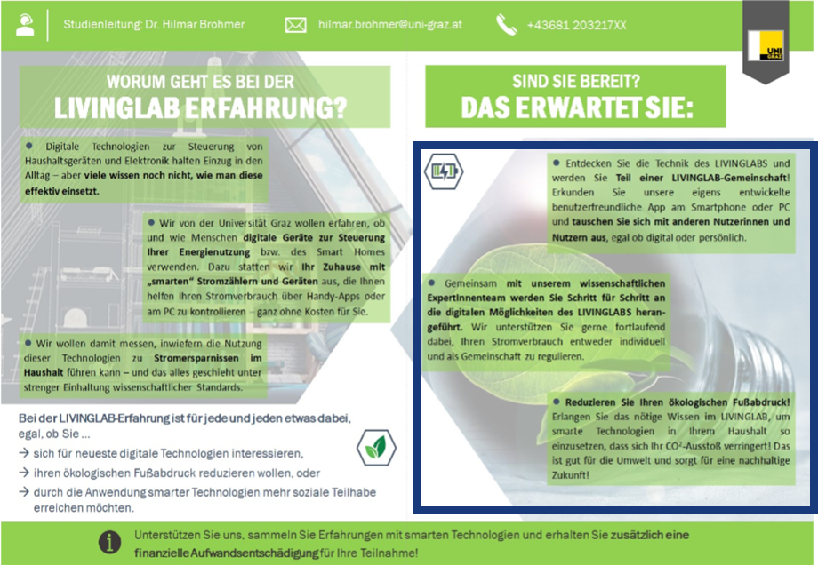
Figure S7. Flyer for social aspects (and exchange: individual exploration).


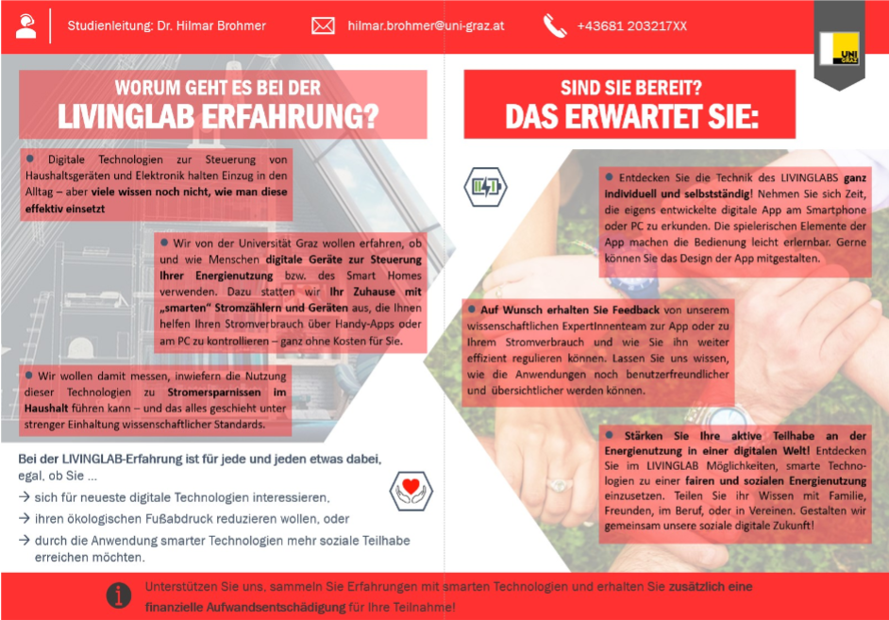
Table S5. Study 2 ANOVA results for DV attractiveness. a and b show global effects; c shows marginal means

a

Within Subjects Effects
 |  | Sum of Squares |  | df |  | Mean Square |  | F |  | p |  | η²_{p}
indiv_vs_many |  | 1.263 |  | 1 |  | 1.263 |  | 2.148 |  | 0.143 |  | 0.004
indiv_vs_many ✻ condition |  | 0.409 |  | 2 |  | 0.204 |  | 0.348 |  | 0.706 |  | 0.001
Residual |  | 306.213 |  | 521 |  | 0.588
Note. Type 3 Sums of Squares

b

Between Subjects Effects
 |  | Sum of Squares |  | df |  | Mean Square |  | F |  | p |  | η²_{p}
condition |  | 8.995 |  | 2 |  | 4.498 |  | 1.355 |  | 0.259 |  | 0.005
Residual |  | 1728.986 |  | 521 |  | 3.319
Note. Type 3 Sums of Squares

c

Estimated Marginal Means - indiv_vs_many ✻ condition
 |  |  |  |  |  |  |  | 95% Confidence Interval
condition |  | indiv_vs_many |  | Mean |  | SE |  | Lower |  | Upper
1 |  | indvidual |  | 5.103 |  | 0.099 |  | 4.908 |  | 5.297
 |  | many |  | 4.979 |  | 0.101 |  | 4.781 |  | 5.178
2 |  | indvidual |  | 5.019 |  | 0.111 |  | 4.801 |  | 5.237
 |  | many |  | 4.968 |  | 0.113 |  | 4.745 |  | 5.191
3 |  | indvidual |  | 4.845 |  | 0.105 |  | 4.639 |  | 5.051
 |  | many |  | 4.810 |  | 0.107 |  | 4.600 |  | 5.021

Table S6. Study 2 ANOVA results for DV choice. a and b show global effects; c shows marginal means

a
Within Subjects Effects
 |  | Sum of Squares |  | df |  | Mean Square |  | F |  | p |  | η²_{p}
indiv_vs_many |  | 0.000 |  | 1 |  | 0.000 |  | 0.000 |  | 0.988 |  | 0.000
indiv_vs_many ✻ condition |  | 1.554 |  | 2 |  | 0.777 |  | 1.421 |  | 0.242 |  | 0.005
Residual |  | 284.937 |  | 521 |  | 0.547
Note. Type 3 Sums of Squares

b
Between Subjects Effects
 |  | Sum of Squares |  | df |  | Mean Square |  | F |  | p |  | η²_{p}
condition |  | 1.943 |  | 2 |  | 0.971 |  | 0.171 |  | 0.842 |  | 0.001
Residual |  | 2951.793 |  | 521 |  | 5.666
Note. Type 3 Sums of Squares

c
Estimated Marginal Means - indiv_vs_many ✻ condition
 |  |  |  |  |  |  |  | 95% Confidence Interval
condition |  | indiv_vs_many |  | Mean |  | SE |  | Lower |  | Upper
1 |  | indvidual |  | 4.462 |  | 0.126 |  | 4.214 |  | 4.709
 |  | many |  | 4.359 |  | 0.126 |  | 4.111 |  | 4.607
2 |  | indvidual |  | 4.503 |  | 0.141 |  | 4.226 |  | 4.781
 |  | many |  | 4.529 |  | 0.142 |  | 4.251 |  | 4.808
3 |  | indvidual |  | 4.425 |  | 0.133 |  | 4.163 |  | 4.687
 |  | many |  | 4.500 |  | 0.134 |  | 4.237 |  | 4.763

Table S7. Three way interaction with AGE (groups: 1 = "<36", 2 = "<53", 3 = "≥53") for attractiveness.

a

Within Subjects Effects
 |  | Sum of Squares |  | df |  | Mean Square |  | F |  | p |  | η²_{p}
attractiveness |  | 1.341 |  | 1 |  | 1.341 |  | 2.297 |  | 0.130 |  | 0.004
attractiveness ✻ condition |  | 0.484 |  | 2 |  | 0.242 |  | 0.414 |  | 0.661 |  | 0.002
attractiveness ✻ age_group |  | 3.171 |  | 2 |  | 1.586 |  | 2.715 |  | 0.067 |  | 0.010
attractiveness ✻ condition ✻ age_group |  | 1.813 |  | 4 |  | 0.453 |  | 0.776 |  | 0.541 |  | 0.006
Residual |  | 300.768 |  | 515 |  | 0.584
Note. Type 3 Sums of Squares

b
Between Subjects Effects
 |  | Sum of Squares |  | df |  | Mean Square |  | F |  | p |  | η²_{p}
condition |  | 8.159 |  | 2 |  | 4.079 |  | 1.250 |  | 0.287 |  | 0.005
age_group |  | 5.638 |  | 2 |  | 2.819 |  | 0.864 |  | 0.422 |  | 0.003
condition ✻ age_group |  | 43.082 |  | 4 |  | 10.770 |  | 3.300 |  | 0.011 |  | 0.025
Residual |  | 1681.056 |  | 515 |  | 3.264
Note. Type 3 Sums of Squares

c
Estimated Marginal Means - age_group ✻ condition ✻ attractiveness
 |  |  |  |  |  |  |  |  |  | 95% Confidence Interval
attractiveness |  | condition |  | age_group |  | Mean |  | SE |  | Lower |  | Upper
indvidual |  | 1 |  | 1 |  | 5.308 |  | 0.170 |  | 4.973 |  | 5.642
 |  |  |  | 2 |  | 5.028 |  | 0.162 |  | 4.710 |  | 5.346
 |  |  |  | 3 |  | 4.966 |  | 0.180 |  | 4.611 |  | 5.320
 |  | 2 |  | 1 |  | 4.685 |  | 0.187 |  | 4.318 |  | 5.052
 |  |  |  | 2 |  | 5.217 |  | 0.202 |  | 4.820 |  | 5.615
 |  |  |  | 3 |  | 5.182 |  | 0.185 |  | 4.818 |  | 5.546
 |  | 3 |  | 1 |  | 4.967 |  | 0.177 |  | 4.618 |  | 5.315
 |  |  |  | 2 |  | 4.500 |  | 0.177 |  | 4.152 |  | 4.848
 |  |  |  | 3 |  | 5.093 |  | 0.187 |  | 4.726 |  | 5.460
many |  | 1 |  | 1 |  | 4.908 |  | 0.174 |  | 4.566 |  | 5.249
 |  |  |  | 2 |  | 5.139 |  | 0.165 |  | 4.814 |  | 5.463
 |  |  |  | 3 |  | 4.862 |  | 0.184 |  | 4.501 |  | 5.223
 |  | 2 |  | 1 |  | 4.500 |  | 0.191 |  | 4.125 |  | 4.875
 |  |  |  | 2 |  | 5.217 |  | 0.207 |  | 4.812 |  | 5.623
 |  |  |  | 3 |  | 5.218 |  | 0.189 |  | 4.847 |  | 5.589
 |  | 3 |  | 1 |  | 4.900 |  | 0.181 |  | 4.545 |  | 5.255
 |  |  |  | 2 |  | 4.533 |  | 0.181 |  | 4.178 |  | 4.889
 |  |  |  | 3 |  | 5.019 |  | 0.191 |  | 4.644 |  | 5.393

Table S8. Three way interaction with AGE for choice.

a
Within Subjects Effects
 |  | Sum of Squares |  | df |  | Mean Square |  | F |  | p |  | η²_{p}
choice |  | 0.000 |  | 1 |  | 0.000 |  | 0.000 |  | 0.990 |  | 0.000
choice ✻ condition |  | 1.677 |  | 2 |  | 0.839 |  | 1.532 |  | 0.217 |  | 0.006
choice ✻ age_group |  | 0.503 |  | 2 |  | 0.251 |  | 0.459 |  | 0.632 |  | 0.002
choice ✻ condition ✻ age_group |  | 2.647 |  | 4 |  | 0.662 |  | 1.209 |  | 0.306 |  | 0.009
Residual |  | 281.877 |  | 515 |  | 0.547
Note. Type 3 Sums of Squares

b
Between Subjects Effects
 |  | Sum of Squares |  | df |  | Mean Square |  | F |  | p |  | η²_{p}
condition |  | 1.801 |  | 2 |  | 0.901 |  | 0.161 |  | 0.851 |  | 0.001
age_group |  | 34.683 |  | 2 |  | 17.341 |  | 3.096 |  | 0.046 |  | 0.012
condition ✻ age_group |  | 34.188 |  | 4 |  | 8.547 |  | 1.526 |  | 0.193 |  | 0.012
Residual |  | 2884.233 |  | 515 |  | 5.600
Note. Type 3 Sums of Squares

c
Post Hoc Comparisons - age_group
Comparison
age_group |  |  |  | age_group |  | Mean Difference |  | SE |  | df |  | t |  | p_{bonferroni}
1 |  | - |  | 2 |  | -0.070 |  | 0.179 |  | 515.000 |  | -0.391 |  | 1.000
 |  | - |  | 3 |  | -0.421 |  | 0.180 |  | 515.000 |  | -2.336 |  | 0.060
2 |  | - |  | 3 |  | -0.351 |  | 0.182 |  | 515.000 |  | -1.932 |  | 0.162

d

Estimated Marginal Means - age_group ✻ condition ✻ choice
 |  |  |  |  |  |  |  |  |  | 95% Confidence Interval
choice |  | condition |  | age_group |  | Mean |  | SE |  | Lower |  | Upper
indvidual |  | 1 |  | 1 |  | 4.492 |  | 0.218 |  | 4.064 |  | 4.921
 |  |  |  | 2 |  | 4.347 |  | 0.207 |  | 3.940 |  | 4.754
 |  |  |  | 3 |  | 4.569 |  | 0.231 |  | 4.116 |  | 5.022
 |  | 2 |  | 1 |  | 4.111 |  | 0.239 |  | 3.641 |  | 4.581
 |  |  |  | 2 |  | 4.543 |  | 0.259 |  | 4.034 |  | 5.053
 |  |  |  | 3 |  | 4.855 |  | 0.237 |  | 4.389 |  | 5.320
 |  | 3 |  | 1 |  | 4.400 |  | 0.227 |  | 3.954 |  | 4.846
 |  |  |  | 2 |  | 4.217 |  | 0.227 |  | 3.771 |  | 4.662
 |  |  |  | 3 |  | 4.685 |  | 0.239 |  | 4.215 |  | 5.155
many |  | 1 |  | 1 |  | 4.385 |  | 0.217 |  | 3.958 |  | 4.811
 |  |  |  | 2 |  | 4.306 |  | 0.206 |  | 3.901 |  | 4.711
 |  |  |  | 3 |  | 4.397 |  | 0.230 |  | 3.945 |  | 4.848
 |  | 2 |  | 1 |  | 3.907 |  | 0.238 |  | 3.440 |  | 4.375
 |  |  |  | 2 |  | 4.652 |  | 0.258 |  | 4.146 |  | 5.159
 |  |  |  | 3 |  | 5.036 |  | 0.236 |  | 4.573 |  | 5.500
 |  | 3 |  | 1 |  | 4.533 |  | 0.226 |  | 4.090 |  | 4.977
 |  |  |  | 2 |  | 4.183 |  | 0.226 |  | 3.740 |  | 4.627
 |  |  |  | 3 |  | 4.815 |  | 0.238 |  | 4.347 |  | 5.282

Table S9. Three-way interaction with ATI (technical affinitiy) for attractiveness

a
Within Subjects Effects
 |  | Sum of Squares |  | df |  | Mean Square |  | F |  | p |  | η² |  | η²_{p}
attract |  | 1.438 |  | 1 |  | 1.438 |  | 2.428 |  | 0.120 |  | 0.000 |  | 0.005
attract ✻ group_tech |  | 0.821 |  | 2 |  | 0.411 |  | 0.693 |  | 0.500 |  | 0.000 |  | 0.003
attract ✻ condition |  | 0.527 |  | 2 |  | 0.264 |  | 0.445 |  | 0.641 |  | 0.000 |  | 0.002
attract ✻ group_tech ✻ condition |  | 0.312 |  | 4 |  | 0.078 |  | 0.132 |  | 0.971 |  | 0.000 |  | 0.001
Residual |  | 305.050 |  | 515 |  | 0.592
Note. Type 3 Sums of Squares

b
Between Subjects Effects
 |  | Sum of Squares |  | df |  | Mean Square |  | F |  | p |  | η² |  | η²_{p}
group_tech |  | 76.840 |  | 2 |  | 38.420 |  | 12.042 |  | < .001 |  | 0.014 |  | 0.045
condition |  | 8.423 |  | 2 |  | 4.211 |  | 1.320 |  | 0.268 |  | 0.002 |  | 0.005
group_tech ✻ condition |  | 10.313 |  | 4 |  | 2.578 |  | 0.808 |  | 0.520 |  | 0.002 |  | 0.006
Residual |  | 1643.060 |  | 515 |  | 3.190
Note. Type 3 Sums of Squares

c
Post Hoc Comparisons - group_tech
Comparison
group_tech |  |  |  | group_tech |  | Mean Difference |  | SE |  | df |  | t |  | p_{bonferroni}
1 |  | - |  | 2 |  | -0.127 |  | 0.142 |  | 515.000 |  | -0.895 |  | 1.000
 |  | - |  | 3 |  | -0.616 |  | 0.136 |  | 515.000 |  | -4.523 |  | < .001
2 |  | - |  | 3 |  | -0.488 |  | 0.132 |  | 515.000 |  | -3.691 |  | < .001

d
Estimated Marginal Means - group_tech ✻ condition ✻ attract
 |  |  |  |  |  |  |  |  |  | 95% Confidence Interval
attract |  | condition |  | group_tech |  | Mean |  | SE |  | Lower |  | Upper
Level 1 |  | 1 |  | 1 |  | 4.865 |  | 0.189 |  | 4.494 |  | 5.237
 |  |  |  | 2 |  | 5.074 |  | 0.165 |  | 4.749 |  | 5.398
 |  |  |  | 3 |  | 5.293 |  | 0.157 |  | 4.984 |  | 5.603
 |  | 2 |  | 1 |  | 4.864 |  | 0.206 |  | 4.460 |  | 5.267
 |  |  |  | 2 |  | 4.640 |  | 0.193 |  | 4.261 |  | 5.019
 |  |  |  | 3 |  | 5.443 |  | 0.175 |  | 5.100 |  | 5.786
 |  | 3 |  | 1 |  | 4.527 |  | 0.184 |  | 4.166 |  | 4.888
 |  |  |  | 2 |  | 4.745 |  | 0.191 |  | 4.370 |  | 5.120
 |  |  |  | 3 |  | 5.176 |  | 0.165 |  | 4.852 |  | 5.501
Level 2 |  | 1 |  | 1 |  | 4.615 |  | 0.192 |  | 4.237 |  | 4.993
 |  |  |  | 2 |  | 4.941 |  | 0.168 |  | 4.611 |  | 5.272
 |  |  |  | 3 |  | 5.267 |  | 0.160 |  | 4.952 |  | 5.581
 |  | 2 |  | 1 |  | 4.750 |  | 0.209 |  | 4.339 |  | 5.161
 |  |  |  | 2 |  | 4.640 |  | 0.196 |  | 4.255 |  | 5.025
 |  |  |  | 3 |  | 5.393 |  | 0.178 |  | 5.045 |  | 5.742
 |  | 3 |  | 1 |  | 4.418 |  | 0.187 |  | 4.051 |  | 4.786
 |  |  |  | 2 |  | 4.765 |  | 0.194 |  | 4.383 |  | 5.146
 |  |  |  | 3 |  | 5.162 |  | 0.168 |  | 4.831 |  | 5.492

Table S10. Three-way interaction with ATI (technical affinitiy) for choice

a

Within Subjects Effects
 |  | Sum of Squares |  | df |  | Mean Square |  | F |  | p |  | η²_{p}
choice |  | 0.001 |  | 1 |  | 0.001 |  | 0.002 |  | 0.960 |  | 0.000
choice ✻ group_tech |  | 0.050 |  | 2 |  | 0.025 |  | 0.046 |  | 0.955 |  | 0.000
choice ✻ condition |  | 1.213 |  | 2 |  | 0.606 |  | 1.108 |  | 0.331 |  | 0.004
choice ✻ group_tech ✻ condition |  | 3.157 |  | 4 |  | 0.789 |  | 1.443 |  | 0.219 |  | 0.011
Residual |  | 281.756 |  | 515 |  | 0.547
Note. Type 3 Sums of Squares

b
Between Subjects Effects
 |  | Sum of Squares |  | df |  | Mean Square |  | F |  | p |  | η²_{p}
group_tech |  | 235.996 |  | 2 |  | 117.998 |  | 22.679 |  | < .001 |  | 0.081
condition |  | 1.700 |  | 2 |  | 0.850 |  | 0.163 |  | 0.849 |  | 0.001
group_tech ✻ condition |  | 35.494 |  | 4 |  | 8.873 |  | 1.705 |  | 0.147 |  | 0.013
Residual |  | 2679.493 |  | 515 |  | 5.203
Note. Type 3 Sums of Squares

C
Post Hoc Comparisons - group_tech
Comparison
group_tech |  |  |  | group_tech |  | Mean Difference |  | SE |  | df |  | t |  | p_{bonferroni}
1 |  | - |  | 2 |  | -0.526 |  | 0.182 |  | 515.000 |  | -2.893 |  | 0.012
 |  | - |  | 3 |  | -1.160 |  | 0.174 |  | 515.000 |  | -6.671 |  | < .001
2 |  | - |  | 3 |  | -0.634 |  | 0.169 |  | 515.000 |  | -3.750 |  | < .001

d
Estimated Marginal Means - choice ✻ group_tech ✻ condition
 |  |  |  |  |  |  |  |  |  | 95% Confidence Interval
condition |  | group_tech |  | choice |  | Mean |  | SE |  | Lower |  | Upper
1 |  | 1 |  | Level 1 |  | 3.865 |  | 0.235 |  | 3.404 |  | 4.327
 |  |  |  | Level 2 |  | 3.865 |  | 0.235 |  | 3.403 |  | 4.327
 |  | 2 |  | Level 1 |  | 4.368 |  | 0.206 |  | 3.964 |  | 4.771
 |  |  |  | Level 2 |  | 4.338 |  | 0.206 |  | 3.934 |  | 4.742
 |  | 3 |  | Level 1 |  | 4.960 |  | 0.196 |  | 4.575 |  | 5.345
 |  |  |  | Level 2 |  | 4.720 |  | 0.196 |  | 4.335 |  | 5.105
2 |  | 1 |  | Level 1 |  | 3.932 |  | 0.256 |  | 3.430 |  | 4.434
 |  |  |  | Level 2 |  | 4.091 |  | 0.256 |  | 3.589 |  | 4.593
 |  | 2 |  | Level 1 |  | 4.120 |  | 0.240 |  | 3.649 |  | 4.591
 |  |  |  | Level 2 |  | 4.020 |  | 0.240 |  | 3.549 |  | 4.491
 |  | 3 |  | Level 1 |  | 5.230 |  | 0.217 |  | 4.803 |  | 5.656
 |  |  |  | Level 2 |  | 5.262 |  | 0.217 |  | 4.836 |  | 5.689
3 |  | 1 |  | Level 1 |  | 3.709 |  | 0.229 |  | 3.260 |  | 4.158
 |  |  |  | Level 2 |  | 3.618 |  | 0.229 |  | 3.169 |  | 4.067
 |  | 2 |  | Level 1 |  | 4.647 |  | 0.237 |  | 4.181 |  | 5.113
 |  |  |  | Level 2 |  | 4.745 |  | 0.237 |  | 4.279 |  | 5.212
 |  | 3 |  | Level 1 |  | 4.838 |  | 0.206 |  | 4.434 |  | 5.242
 |  |  |  | Level 2 |  | 5.029 |  | 0.206 |  | 4.625 |  | 5.433

Table S11. Three-way interaction with CFC (future orientation) for attractiveness

a

Within Subjects Effects
 |  | Sum of Squares |  | df |  | Mean Square |  | F |  | p
attrac |  | 1.062 |  | 1 |  | 1.062 |  | 1.791 |  | 0.181
attrac ✻ condition |  | 0.262 |  | 2 |  | 0.131 |  | 0.221 |  | 0.801
attrac ✻ group_cfc |  | 0.369 |  | 2 |  | 0.184 |  | 0.311 |  | 0.733
attrac ✻ condition ✻ group_cfc |  | 0.550 |  | 4 |  | 0.138 |  | 0.232 |  | 0.920
Residual |  | 305.315 |  | 515 |  | 0.593
Note. Type 3 Sums of Squares

b
Between Subjects Effects
 |  | Sum of Squares |  | df |  | Mean Square |  | F |  | p
condition |  | 8.753 |  | 2 |  | 4.376 |  | 1.491 |  | 0.226
group_cfc |  | 197.120 |  | 2 |  | 98.560 |  | 33.570 |  | < .001
condition ✻ group_cfc |  | 15.470 |  | 4 |  | 3.868 |  | 1.317 |  | 0.262
Residual |  | 1512.014 |  | 515 |  | 2.936
Note. Type 3 Sums of Squares

c
Post Hoc Comparisons - group_cfc
Comparison
group_cfc |  |  |  | group_cfc |  | Mean Difference |  | SE |  | df |  | t |  | p_{bonferroni}
1 |  | - |  | 2 |  | -0.545 |  | 0.137 |  | 515.000 |  | -3.995 |  | < .001
 |  | - |  | 3 |  | -1.068 |  | 0.131 |  | 515.000 |  | -8.178 |  | < .001
2 |  | - |  | 3 |  | -0.523 |  | 0.128 |  | 515.000 |  | -4.084 |  | < .001

d
Estimated Marginal Means - group_cfc ✻ condition ✻ attrac
 |  |  |  |  |  |  |  |  |  | 95% Confidence Interval
attrac |  | condition |  | group_cfc |  | Mean |  | SE |  | Lower |  | Upper
Level 1 |  | 1 |  | 1 |  | 4.609 |  | 0.193 |  | 4.230 |  | 4.987
 |  |  |  | 2 |  | 4.984 |  | 0.165 |  | 4.661 |  | 5.308
 |  |  |  | 3 |  | 5.453 |  | 0.141 |  | 5.177 |  | 5.730
 |  | 2 |  | 1 |  | 4.373 |  | 0.183 |  | 4.013 |  | 4.732
 |  |  |  | 2 |  | 5.157 |  | 0.183 |  | 4.797 |  | 5.516
 |  |  |  | 3 |  | 5.509 |  | 0.180 |  | 5.157 |  | 5.862
 |  | 3 |  | 1 |  | 4.161 |  | 0.175 |  | 3.818 |  | 4.504
 |  |  |  | 2 |  | 4.706 |  | 0.183 |  | 4.346 |  | 5.065
 |  |  |  | 3 |  | 5.522 |  | 0.160 |  | 5.209 |  | 5.836
Level 2 |  | 1 |  | 1 |  | 4.565 |  | 0.199 |  | 4.174 |  | 4.956
 |  |  |  | 2 |  | 4.889 |  | 0.170 |  | 4.555 |  | 5.223
 |  |  |  | 3 |  | 5.267 |  | 0.145 |  | 4.982 |  | 5.553
 |  | 2 |  | 1 |  | 4.431 |  | 0.189 |  | 4.060 |  | 4.802
 |  |  |  | 2 |  | 5.078 |  | 0.189 |  | 4.707 |  | 5.450
 |  |  |  | 3 |  | 5.377 |  | 0.185 |  | 5.013 |  | 5.741
 |  | 3 |  | 1 |  | 4.089 |  | 0.180 |  | 3.735 |  | 4.443
 |  |  |  | 2 |  | 4.686 |  | 0.189 |  | 4.315 |  | 5.057
 |  |  |  | 3 |  | 5.507 |  | 0.165 |  | 5.184 |  | 5.831

Table S12. Three-way interaction with CFC (future orientation) for choice

a
Within Subjects Effects
 |  | Sum of Squares |  | df |  | Mean Square |  | F |  | p |  | η²_{p}
choice |  | 0.032 |  | 1 |  | 0.032 |  | 0.058 |  | 0.809 |  | 0.000
choice ✻ condition |  | 0.577 |  | 2 |  | 0.288 |  | 0.532 |  | 0.588 |  | 0.002
choice ✻ group_cfc |  | 0.453 |  | 2 |  | 0.226 |  | 0.417 |  | 0.659 |  | 0.002
choice ✻ condition ✻ group_cfc |  | 5.227 |  | 4 |  | 1.307 |  | 2.409 |  | 0.048 |  | 0.018
Residual |  | 279.374 |  | 515 |  | 0.542
Note. Type 3 Sums of Squares

b
Between Subjects Effects
 |  | Sum of Squares |  | df |  | Mean Square |  | F |  | p |  | η²_{p}
condition |  | 5.793 |  | 2 |  | 2.896 |  | 0.546 |  | 0.579 |  | 0.002
group_cfc |  | 208.935 |  | 2 |  | 104.468 |  | 19.704 |  | < .001 |  | 0.071
condition ✻ group_cfc |  | 7.237 |  | 4 |  | 1.809 |  | 0.341 |  | 0.850 |  | 0.003
Residual |  | 2730.512 |  | 515 |  | 5.302
Note. Type 3 Sums of Squares

c
Post Hoc Comparisons - group_cfc
Comparison
group_cfc |  |  |  | group_cfc |  | Mean Difference |  | SE |  | df |  | t |  | p_{bonferroni}
1 |  | - |  | 2 |  | -0.276 |  | 0.183 |  | 515.000 |  | -1.505 |  | 0.399
 |  | - |  | 3 |  | -1.043 |  | 0.176 |  | 515.000 |  | -5.939 |  | < .001
2 |  | - |  | 3 |  | -0.766 |  | 0.172 |  | 515.000 |  | -4.454 |  | < .001

d
Estimated Marginal Means - group_cfc ✻ condition ✻ choice
 |  |  |  |  |  |  |  |  |  | 95% Confidence Interval
choice |  | condition |  | group_cfc |  | Mean |  | SE |  | Lower |  | Upper
Level 1 |  | 1 |  | 1 |  | 3.935 |  | 0.252 |  | 3.440 |  | 4.429
 |  |  |  | 2 |  | 4.111 |  | 0.215 |  | 3.689 |  | 4.534
 |  |  |  | 3 |  | 5.000 |  | 0.184 |  | 4.638 |  | 5.362
 |  | 2 |  | 1 |  | 4.000 |  | 0.239 |  | 3.530 |  | 4.470
 |  |  |  | 2 |  | 4.451 |  | 0.239 |  | 3.981 |  | 4.921
 |  |  |  | 3 |  | 5.038 |  | 0.234 |  | 4.577 |  | 5.498
 |  | 3 |  | 1 |  | 3.893 |  | 0.228 |  | 3.445 |  | 4.341
 |  |  |  | 2 |  | 4.255 |  | 0.239 |  | 3.785 |  | 4.724
 |  |  |  | 3 |  | 5.000 |  | 0.209 |  | 4.590 |  | 5.410
Level 2 |  | 1 |  | 1 |  | 4.130 |  | 0.252 |  | 3.635 |  | 4.626
 |  |  |  | 2 |  | 4.063 |  | 0.216 |  | 3.640 |  | 4.487
 |  |  |  | 3 |  | 4.698 |  | 0.185 |  | 4.335 |  | 5.060
 |  | 2 |  | 1 |  | 4.000 |  | 0.240 |  | 3.529 |  | 4.471
 |  |  |  | 2 |  | 4.431 |  | 0.240 |  | 3.960 |  | 4.902
 |  |  |  | 3 |  | 5.132 |  | 0.235 |  | 4.670 |  | 5.594
 |  | 3 |  | 1 |  | 3.893 |  | 0.229 |  | 3.443 |  | 4.342
 |  |  |  | 2 |  | 4.196 |  | 0.240 |  | 3.725 |  | 4.667
 |  |  |  | 3 |  | 5.239 |  | 0.209 |  | 4.828 |  | 5.650

Table S13. Three-way interaction with CIC (present orientation) for attractiveness

a
Within Subjects Effects
 |  | Sum of Squares |  | df |  | Mean Square |  | F |  | p |  | η²_{p}
attract |  | 1.409 |  | 1 |  | 1.409 |  | 2.376 |  | 0.124 |  | 0.005
attract ✻ condition |  | 0.318 |  | 2 |  | 0.159 |  | 0.268 |  | 0.765 |  | 0.001
attract ✻ group_cic |  | 0.376 |  | 2 |  | 0.188 |  | 0.317 |  | 0.729 |  | 0.001
attract ✻ condition ✻ group_cic |  | 0.492 |  | 4 |  | 0.123 |  | 0.207 |  | 0.934 |  | 0.002
Residual |  | 305.356 |  | 515 |  | 0.593
Note. Type 3 Sums of Squares

b
Between Subjects Effects
 |  | Sum of Squares |  | df |  | Mean Square |  | F |  | p |  | η²_{p}
condition |  | 7.928 |  | 2 |  | 3.964 |  | 1.223 |  | 0.295 |  | 0.005
group_cic |  | 58.909 |  | 2 |  | 29.455 |  | 9.085 |  | < .001 |  | 0.034
condition ✻ group_cic |  | 0.417 |  | 4 |  | 0.104 |  | 0.032 |  | 0.998 |  | 0.000
Residual |  | 1669.744 |  | 515 |  | 3.242
Note. Type 3 Sums of Squares

C
Post Hoc Comparisons - group_cic
Comparison
group_cic |  |  |  | group_cic |  | Mean Difference |  | SE |  | df |  | t |  | p_{bonferroni}
1 |  | - |  | 2 |  | 0.354 |  | 0.147 |  | 515.000 |  | 2.402 |  | 0.050
 |  | - |  | 3 |  | 0.602 |  | 0.141 |  | 515.000 |  | 4.260 |  | < .001
2 |  | - |  | 3 |  | 0.248 |  | 0.130 |  | 515.000 |  | 1.902 |  | 0.173

d
Estimated Marginal Means - attract ✻ condition ✻ group_cic
 |  |  |  |  |  |  |  |  |  | 95% Confidence Interval
group_cic |  | condition |  | attract |  | Mean |  | SE |  | Lower |  | Upper
1 |  | 1 |  | Level 1 |  | 5.458 |  | 0.197 |  | 5.071 |  | 5.846
 |  |  |  | Level 2 |  | 5.333 |  | 0.203 |  | 4.935 |  | 5.731
 |  | 2 |  | Level 1 |  | 5.439 |  | 0.213 |  | 5.020 |  | 5.858
 |  |  |  | Level 2 |  | 5.293 |  | 0.219 |  | 4.862 |  | 5.723
 |  | 3 |  | Level 1 |  | 5.256 |  | 0.208 |  | 4.847 |  | 5.665
 |  |  |  | Level 2 |  | 5.140 |  | 0.214 |  | 4.719 |  | 5.560
2 |  | 1 |  | Level 1 |  | 5.151 |  | 0.160 |  | 4.837 |  | 5.465
 |  |  |  | Level 2 |  | 4.959 |  | 0.164 |  | 4.636 |  | 5.282
 |  | 2 |  | Level 1 |  | 5.020 |  | 0.195 |  | 4.637 |  | 5.404
 |  |  |  | Level 2 |  | 5.041 |  | 0.200 |  | 4.647 |  | 5.435
 |  | 3 |  | Level 1 |  | 4.821 |  | 0.183 |  | 4.463 |  | 5.180
 |  |  |  | Level 2 |  | 4.804 |  | 0.188 |  | 4.435 |  | 5.172
3 |  | 1 |  | Level 1 |  | 4.824 |  | 0.159 |  | 4.512 |  | 5.136
 |  |  |  | Level 2 |  | 4.770 |  | 0.163 |  | 4.450 |  | 5.091
 |  | 2 |  | Level 1 |  | 4.754 |  | 0.169 |  | 4.421 |  | 5.087
 |  |  |  | Level 2 |  | 4.708 |  | 0.174 |  | 4.366 |  | 5.050
 |  | 3 |  | Level 1 |  | 4.627 |  | 0.158 |  | 4.317 |  | 4.937
 |  |  |  | Level 2 |  | 4.627 |  | 0.162 |  | 4.308 |  | 4.945

Table S14. Three-way interaction with CIC (present orientation) for choice

a
Within Subjects Effects
 |  | Sum of Squares |  | df |  | Mean Square |  | F |  | p |  | η²_{p}
choice |  | 0.006 |  | 1 |  | 0.006 |  | 0.012 |  | 0.915 |  | 0.000
choice ✻ condition |  | 2.003 |  | 2 |  | 1.001 |  | 1.823 |  | 0.163 |  | 0.007
choice ✻ group_cic |  | 0.663 |  | 2 |  | 0.332 |  | 0.604 |  | 0.547 |  | 0.002
choice ✻ condition ✻ group_cic |  | 1.328 |  | 4 |  | 0.332 |  | 0.604 |  | 0.660 |  | 0.005
Residual |  | 282.970 |  | 515 |  | 0.549
Note. Type 3 Sums of Squares

b
Between Subjects Effects
 |  | Sum of Squares |  | df |  | Mean Square |  | F |  | p |  | η²_{p}
condition |  | 5.065 |  | 2 |  | 2.532 |  | 0.448 |  | 0.639 |  | 0.002
group_cic |  | 24.783 |  | 2 |  | 12.391 |  | 2.192 |  | 0.113 |  | 0.008
condition ✻ group_cic |  | 16.708 |  | 4 |  | 4.177 |  | 0.739 |  | 0.566 |  | 0.006
Residual |  | 2911.777 |  | 515 |  | 5.654
Note. Type 3 Sums of Squares

c
Estimated Marginal Means - group_cic ✻ condition ✻ choice
 |  |  |  |  |  |  |  |  |  | 95% Confidence Interval
choice |  | condition |  | group_cic |  | Mean |  | SE |  | Lower |  | Upper
Level 1 |  | 1 |  | 1 |  | 4.458 |  | 0.254 |  | 3.960 |  | 4.957
 |  |  |  | 2 |  | 4.575 |  | 0.206 |  | 4.171 |  | 4.980
 |  |  |  | 3 |  | 4.351 |  | 0.204 |  | 3.950 |  | 4.753
 |  | 2 |  | 1 |  | 5.000 |  | 0.275 |  | 4.460 |  | 5.540
 |  |  |  | 2 |  | 4.490 |  | 0.251 |  | 3.996 |  | 4.983
 |  |  |  | 3 |  | 4.200 |  | 0.218 |  | 3.771 |  | 4.629
 |  | 3 |  | 1 |  | 4.535 |  | 0.268 |  | 4.008 |  | 5.062
 |  |  |  | 2 |  | 4.536 |  | 0.235 |  | 4.074 |  | 4.997
 |  |  |  | 3 |  | 4.280 |  | 0.203 |  | 3.881 |  | 4.679
Level 2 |  | 1 |  | 1 |  | 4.188 |  | 0.255 |  | 3.687 |  | 4.688
 |  |  |  | 2 |  | 4.493 |  | 0.206 |  | 4.088 |  | 4.899
 |  |  |  | 3 |  | 4.338 |  | 0.205 |  | 3.935 |  | 4.741
 |  | 2 |  | 1 |  | 4.902 |  | 0.275 |  | 4.361 |  | 5.444
 |  |  |  | 2 |  | 4.653 |  | 0.252 |  | 4.158 |  | 5.148
 |  |  |  | 3 |  | 4.200 |  | 0.219 |  | 3.770 |  | 4.630
 |  | 3 |  | 1 |  | 4.674 |  | 0.269 |  | 4.146 |  | 5.203
 |  |  |  | 2 |  | 4.625 |  | 0.236 |  | 4.162 |  | 5.088
 |  |  |  | 3 |  | 4.307 |  | 0.204 |  | 3.907 |  | 4.707

Table S15. Flyer design effect for attractiveness (H1).
Within Subjects Effects
 |  | Sum of Squares |  | df |  | Mean Square |  | F |  | p |  | η²_{p}
indiv_vs_many |  | 0.009 |  | 1 |  | 0.009 |  | 0.015 |  | 0.901 |  | 0.000
indiv_vs_many ✻ attrflyer1_attr1 |  | 0.054 |  | 1 |  | 0.054 |  | 0.092 |  | 0.762 |  | 0.000
indiv_vs_many ✻ condition |  | 0.411 |  | 2 |  | 0.205 |  | 0.349 |  | 0.706 |  | 0.001
Residual |  | 306.159 |  | 520 |  | 0.589
Note. Type 3 Sums of Squares

Table S16. Flyer effect for choice (H2).
Within Subjects Effects
 |  | Sum of Squares |  | df |  | Mean Square |  | F |  | p |  | η²_{p}
indiv_vs_many |  | 0.094 |  | 1 |  | 0.094 |  | 0.172 |  | 0.678 |  | 0.000
indiv_vs_many ✻ condition |  | 1.557 |  | 2 |  | 0.778 |  | 1.421 |  | 0.242 |  | 0.005
indiv_vs_many ✻ attrflyer1_attr1 |  | 0.100 |  | 1 |  | 0.100 |  | 0.183 |  | 0.669 |  | 0.000
Residual |  | 284.837 |  | 520 |  | 0.548
Note. Type 3 Sums of Squares

Figure S8. Categories from the exploratory content analysis.
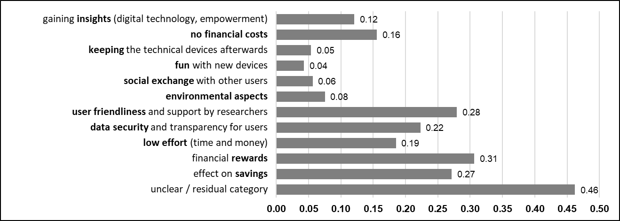

In line with Table 1, the studies were representative for the dimensions age (population M = 43 years), gender (51% women), income (population median € 2.5k brutto), and education (33% high school diploma), see sex and age: https://www.statistik.at/en/statistics/population-and-society/population/population-stock/population-by-age-/sex income: https://ooe.arbeiterkammer.at/interessenvertretung/verteilungsgerechtigkeit/einkommen/Einkommen_in_Oesterreich.html education: https://de.statista.com/statistik/daten/studie/1235943/umfrage/bildungsstand-der-bevoelkerung-in-oesterreich/
In the interest of full disclosure, we report that, due to this programming error, only half of the profiles in Study 1a could be recorded and, hence, analyzed: initially we planned with k = 3,888 profiles instead of k = 1,944. However, despite this error, statistical power for the remaining profiles was still sufficient to detect small component effects (power > .80). For detailed information about the power analysis, see the section Sample and Power.
Hainmueller, J., Mummolo, J., & Xu, Y. (2019). How much should we trust estimates from multiplicative interaction models? Simple tools to improve empirical practice. Political Analysis, 27(2), 163-192. https://doi.org/10.1017/pan.2018.46
Seuntjens, T. G., Zeelenberg, M., Breugelmans, S. M., & Van de Ven, N. (2015). Defining greed. British Journal of Psychology, 106(3), 505-525. https://doi.org/10.1111/bjop.12100

